KNN
- K nearest neighbor comes under supervised learning.
- Imagine if we have a particle classifier that classifies particles in “Gamma” and “Hadron” classes. Image the graph look like the following

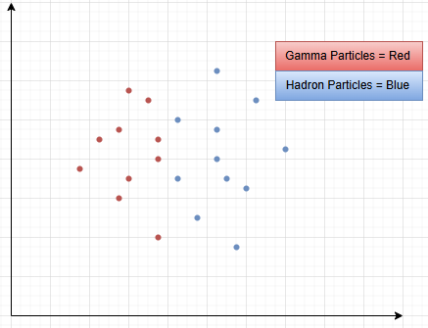

- Imagine of we want the predict a new input (black dot in this case) from this dataset. The idea of KNN is to predict using the K number of neighbors. If the value of K is six then it will only see the classification of six closed inputs. In this case the final prediction will be Hardon as they are four and Gamma particles are only two.
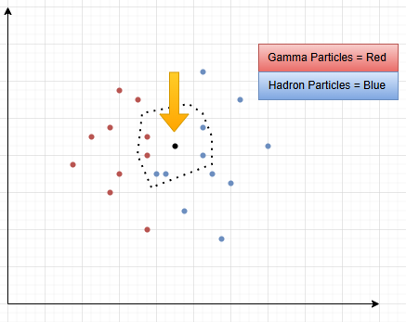

KNN Distance Measurement
- Euclidean distance: most common (straight-line distance).
- Manhattan distance: sum of absolute differences.
- Minkowski distance: general form of above.
- Cosine similarity: often used for text data.
- Hamming distance: for categorical variables.
KNN Code using scikit learn: LINK

- Importing
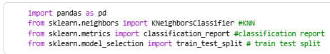
- Dataset reading
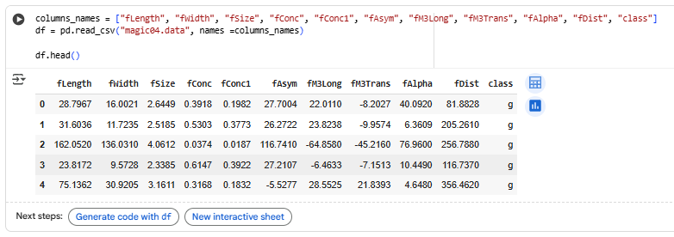
- Typecasting Gamma into one and Hadron into zero.
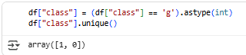
- Getting X, Y
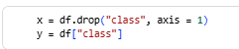
- Train, Test Splits
- Model training, prediction, and classification report
