Random Forest
- Random Forest is an ensemble learning method that combines many Decision Trees to make predictions.
- For classification it predicts the most common class (majority vote).
- For regression it predicts the average of outputs from all trees.
How Random Forest Work
- Take your dataset.
- Randomly pick some samples (with replacement — called bootstrapping).
- Build a decision tree using those samples — but!
- Each tree only looks at a random subset of features at each split.
- Repeat steps 2–3 to make many trees (like 100 or 500).

Combine the results:
- For classification → take the majority vote.
- For regression → take the average of predictions.
Random Forest code using scikit learn: LINK
- Importing
- Reading csv
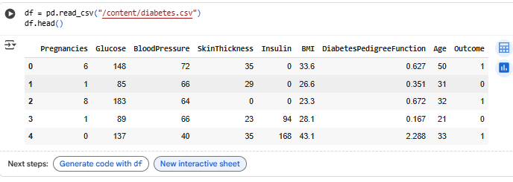
- Getting X, Y splits
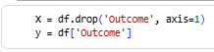
- Train Test Split
- Training and prediction
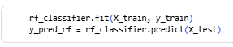
- Accuracy score
