Linear regression
- Linear regression in a way to make predictions.
- It comes under supervised learning.
- Linear regression in a linear line that passes through (or tries to pass through) all the data points.
- It is used to predict a value instead of classification

Multiple Linear regression
- Just like linear regression multiple linear regression is a prediction algorithm.
- Instead of single input, multiple linear regression uses multiple inputs and predicts a single output.

Polynomial regression

- Sometimes the relationship between x and y is not a straight line. Polynomial regression lets us fit curves by adding powers of x.
Degree 1 = Linear regression.
Degree 2 = Quadratic curve.
Degree 3 = Cubic curve.

Logistic regression

- If the output should be a class rather than of a value then logistic regression is used.
- It gives us an “S” shaped curve
- It follows the same concept as linear regression but instead of predicting a value, it predicts classes. From input data it decides which class does this input belongs to.
- It uses sigmoid activation function.
- On x-axis in the graph, there are input feature and on y-axis, there are classes (Two). The following graph best explains the logistic regression.
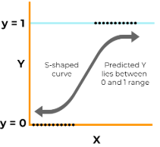

Regression Examples
Example 1
House price prediction
- Imagine we have a house price dataset. The dataset has columns like number of rooms, area of house, etc., and the last column is the price of the house. If we draw each row of this dataset in an N dimensional graph (Multiple linear regression) then linear regression line would be a line that passes through (or tries to pass through) all these points on the graph. In linear regression, there is only one input and one output.
- If we Imagine It in 2D (Linear regression) with input being number of rooms and output being price of the house then the this is how it will look

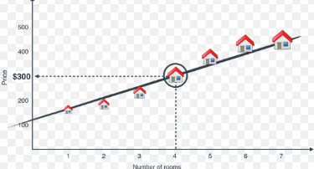

In this example, we have Number of rooms in x-axis and price on y-axis. The more the number of rooms the more the price of the house. Now if someone wants to use a have a house with 4 rooms then according to linear regression line it will have to pay $300.
Example 2
Student scores prediction
- Linear regression can be used to predict the test score of the student for example if we have study hours on x-axis and student score on y-axis.
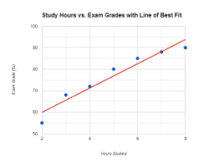
For a student who has studied for 8 hours will be most likely to have a test score of near 90.
Mathematical Equation
Formula for single input (Linear regression)
Y = mX + b
- Y = Dependent Variable, Output variable, Prediction variable. In student grade prediction Y is Exam score
- m = Slope, How much Y changes when X is changed. In simpler terms, it decides the angle of the linear regression line.
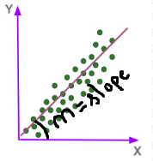

- X = Independent variable, In student grade prediction example X is hours studied
- b = Intercept. In simpler terms, it means how much the like will be away from the origin. The greater the value of b the far away the starting point of the origin.

Small value of “b” Large value of “b”
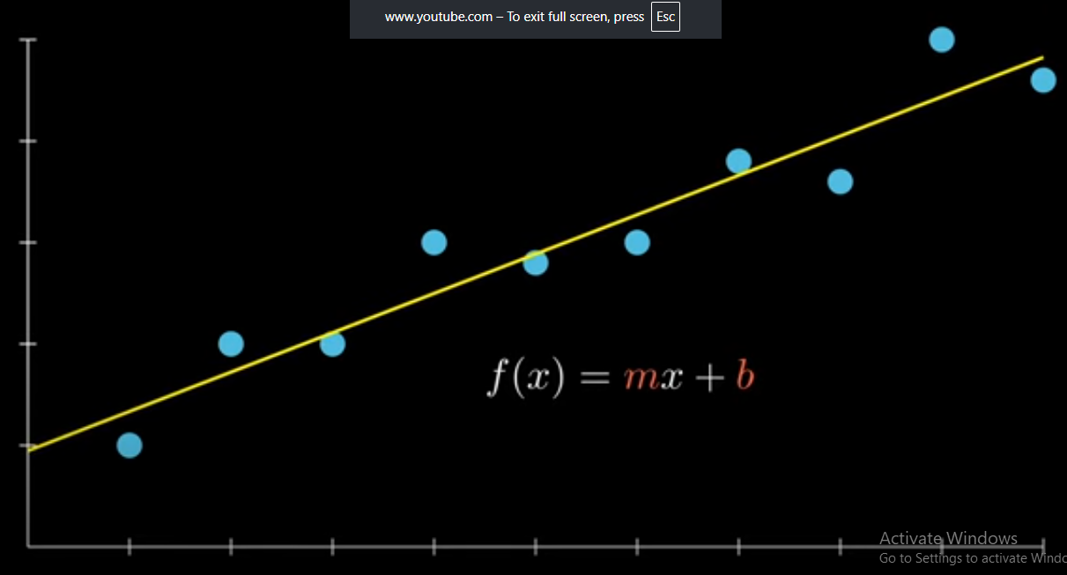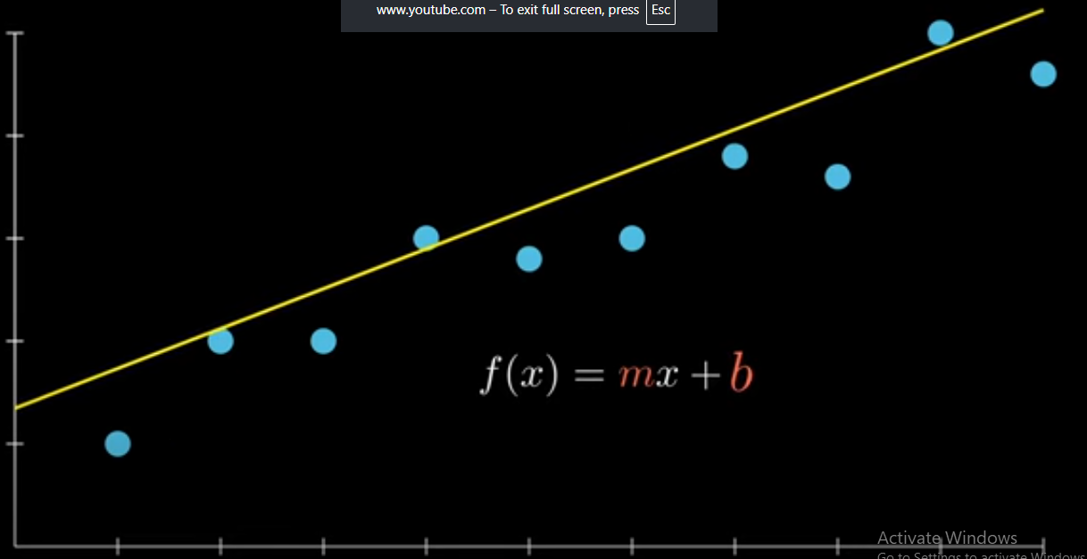
Formula for multiple inputs (Multiple linear regression)
- Y = Dependent Variable, Output variable, Prediction variable.
- B0 = Intercept. In simpler terms, it means how much the like will be away from the origin. The greater the value of b the far away the starting point of the origin.
- B1 = Slope for first input.
- B2 = Slope for second input.
.
.
.
- Bn = Slope for n input.
- X1 = first input (independent variable).
- X2 = second input (independent variable).
.
.
.
- Xn = nth input (independent variable).

Formula Polynomial regression
- y=β₀​+β₁​x¹+β₂​x²+β₃​x³+……+β_{n}x^{n}.
- y = output, predicted variable.
- β₀ = Intercept, biasness.
- x¹ = input polynomial with degree 1.
- β₁ = weight of input with degree 1.
- β ₂ = weight of input with degree 2.
- β ₃ = weight of input with degree 3.
- x² = input polynomial with degree 2.
- x^{n} = input polynomial with degree n.

Regression Limitation

- Assumes a straight line relationship in Linear regression
The biggest issue with linear regression in the “Linear” part. It assumes that the relationship is linear which results in it not completely touching all the data points on the graph. It can be good for problems with continuous increase in the data.
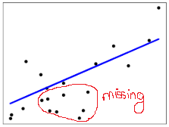

- Sensitive to outliers
Any potential outlier in the data can change all the linear regression line, which then effects the prediction

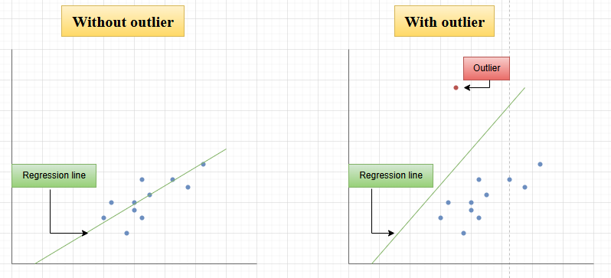

- It assumes the features are independent
The model gets confused if the things used to make prediction are highly correlated. It has a hard tame relating which feature is the deciding factor for the output prediction.

- Linear regression Cannot handle categorical data
If there are two categories like spam, not spam email, then the linear regression like would completely look off track. For this problem logistic regression is the best as it predicts the category instead of output.
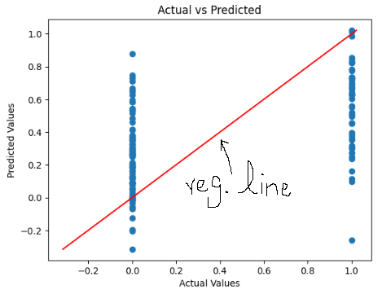

Linear Regression Cost Function
- Cost function also called loss function.
- It tells you how far away are we from the actual output.
Mean Squared Error
- Most commonly used cost function in linear regression is mean squared error.
- Smaller mean squared error value means the model is good in his prediction. Larger mean squared error value the model is poor in his predictions.
- Formula of Mean Squared Error is:
- MSE = (1/n) Σᵢⁿ (yᵢ – ŷᵢ)²
- n = Total number of records.
- i = current Value.
- yᵢ = current actual value
- ŷᵢ = current prediction
Example 1
- Actual values = [3, 5, 8]
- Predicted values = [2, 5, 9]
- Subtraction = [3-2, 5-5, 8-9] = [1, 0, -1]
- Squared = [1, 0, 1]
- Average = (1+0+1)/3 = 2/3 = 0.6666

“0.6666” is a very small number means the model’s predictions are good.

Example 2

- Actual values = [10, 20, 30, 40, 50]
- Predicted values = [2, 5, 10, 15, 20]
- Subtraction = [10-2, 20-5, 30-10, 40-15, 50-20] = [8, 15, 20, 25, 30]
- Squared = [64, 225, 400, 625, 900]
- Average = (64+255+400+625+900) / 5 = 448.8

“448.8” is a large number, which means the model’s predictions are bad.

Linear regression Code using scikit: LINK

- The dataset used is diabetes prediction dataset and it has 768 rows, 268 positive cases and 500 negative cases with the following columns pregnancies, glucose, blood pressure, skin thickness, insulin, BMI, diabetes pedigree function, age, and outcome (1 for positive diabetes and 0 for negative, when there is binary output use logistic regression instead of linear regression).

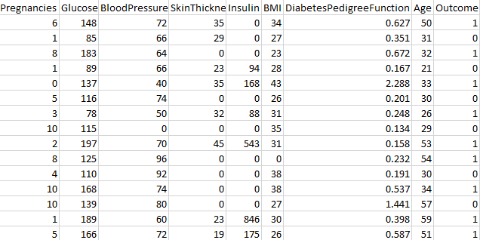

The code has four main parts
- Reading the dataset
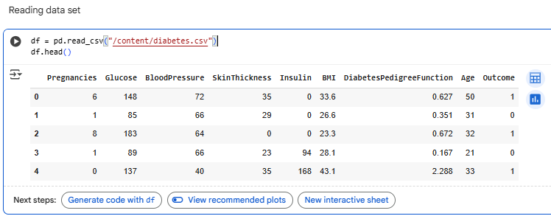
- Splitting the dataset
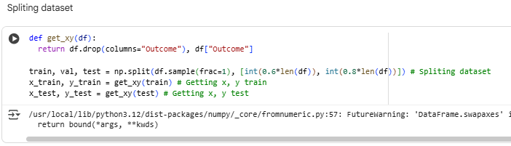
- Loading the per trained model
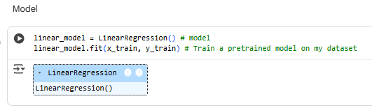
- Lastly making prediction
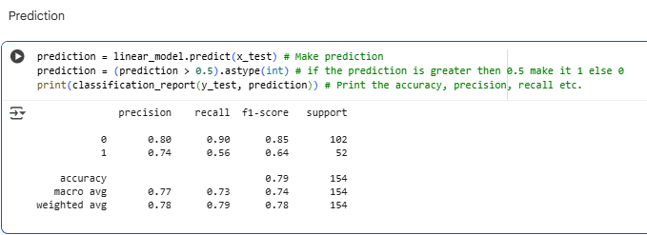
The model has an accuracy score of 79%.

Polynomial regression Code using scikit: LINK

- Importing
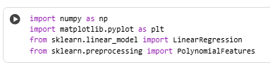
- Data
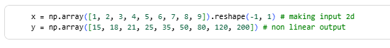
- Degree 2
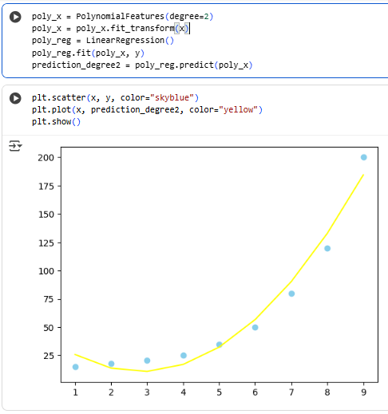
- Degree 3
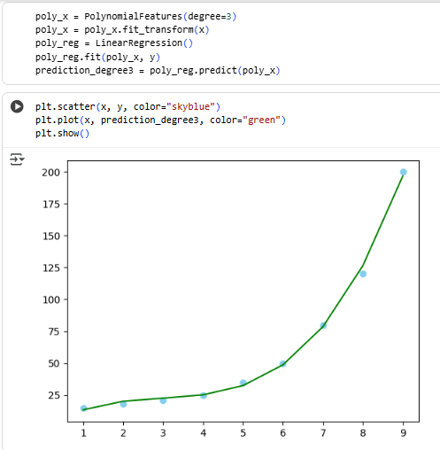
- Linear regression, degree 2 and 3 combined graph
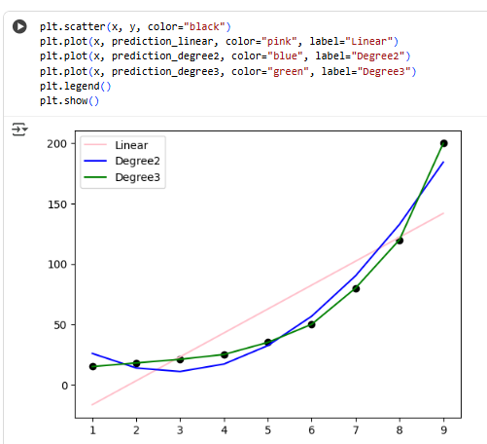

Logistic regression Code using scikit: LINK

- Importing
- Reading Dataset
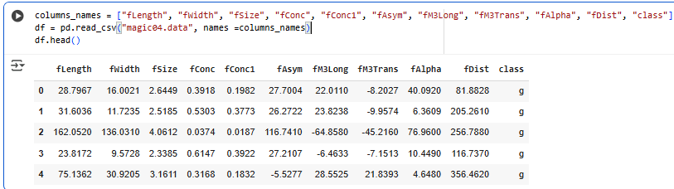
- Model
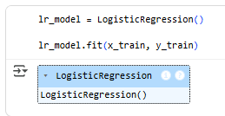
- Prediction and classification report
