Support Vector Machine
- Support Vector Machine are supervised learning machine learning algorithms used for both classification (predicting a class) and regression (predicting a value) tasks.
- Hyperplane: If there is a 2D graph then a line separates the data points. If there is a 3D graph then a plane separates the data points and in case on ND dimensions (Which is difficult to imagine) there is a hyperplane that separates the data points

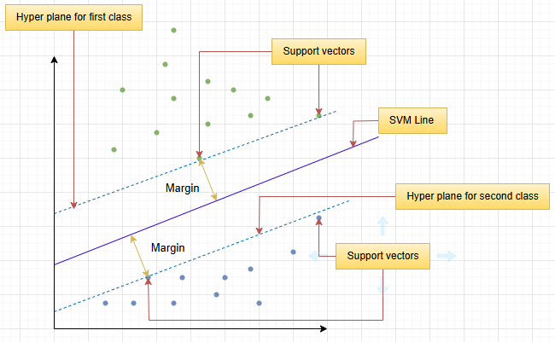
Plane for 2D

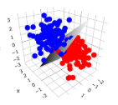
Plane for 3D

- Mathematical representation of SVMs line => w . x + b = 0.
- Support vectors: Points that are closest to the hyperplane. These points influence the orientation and position of the hyperplane.
- Margin: The margin is the distance between the hyperplane and the nearest data point of either class. SVM tries to maximize this margin improve classification accuracy.
- Kernel function: In SVM there is often an issue of perfectly separating the data points. That is where kernel functions help. They map the current dimension graph into a higher dimension graph to make them separable.

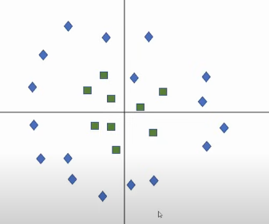

- In this graph there are 2 dimensions and it is difficult to separate using a line. Therefore with the help of a kernel function it can be changed to a new 3D dimension and it can look like

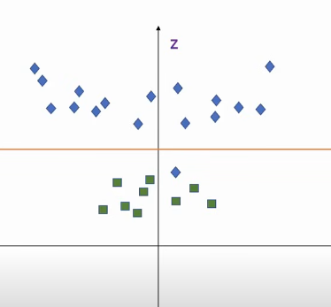

- Now it is perfectly separable.
Types of Support Vector Machine kernels

- Linear Kernel: A straight line.

- Polynomial Kernel. A curved line.

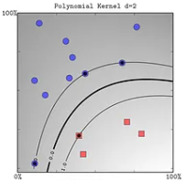

- RBF kernel. Creates Curved boundaries.

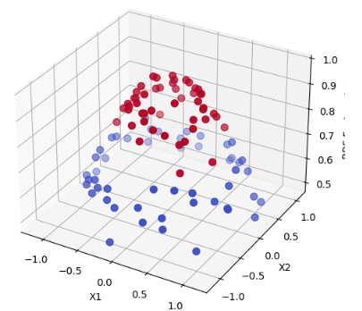

- Sigmoid. Creates “S” shaped kernel

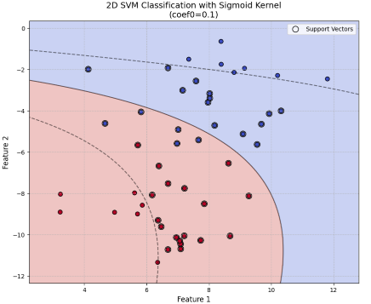

Support Vector Machine code using scikit: LINK
- Importing
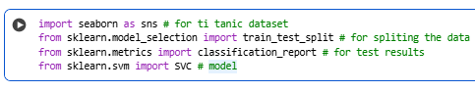
- The dataset used in this project is titanic dataset from seaborn.
- Loading the dataset
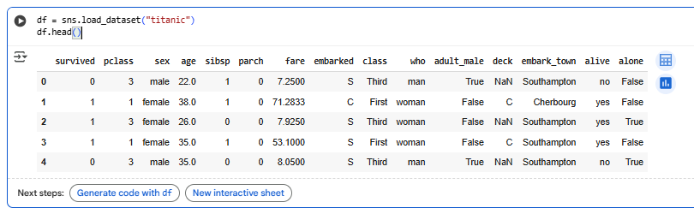
- Selecting only binary (relevant) columns
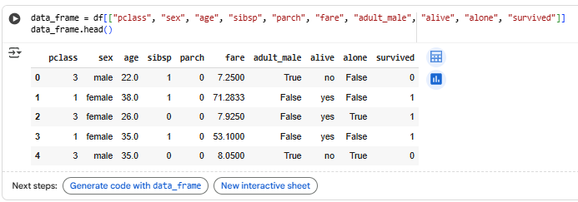
- Converting binary text outputs into words and dropping null values
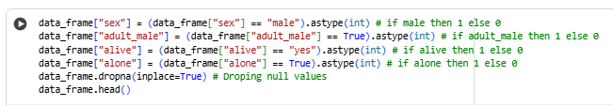
- Getting data and label
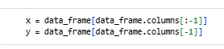
- Getting train, test splits
- Mode, prediction, and classification report
