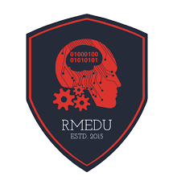

**DEPARTMENT OF ROBOTICS & MECHATRONICS ENGINEERING**

**University of Dhaka**

**Course : Digital Image Processing an Robot Vision**

**Course Code : 4112**

**Lab Task 1 : Image Enhancement by different techniques**

**Submitted by:** Syed Nazmus Sakib

AE-172-009

**Submitted to: Md Mehedi Hasan**

**Assistant Professor**

**Robotics and Mechatronics Engineering**

**University of Dhaka**

**Date of Submission:** 25.10.2025