**RSE3 – Research Science Evidence**

**Project Management and Leadership**

**[01] Management, leadership and effective communication**

[[K2.6 & B1.6]](https://live.onefile.co.uk/standards/form.aspx?StandardID=0&UnitID=RESSLAO_01#01) (Distinction): Provides an example of when they have led a process leading to the achievement of an organisational objective and how their project management skills had a positive impact on quality and cost

Leadership plays a vital role in the industry; it shows the responsibility and the trust of a person in the project towards their organization.

This course has given me a new ability to adapt a new communication style, because different communication styles are the most frequently cited cause of poor communication. Every employee’s motivation is different, so knowing how to tailor your communication is essential to influencing others and reaching organisational goals.

The KSB classes helped me to become an essential leader, as one of the features I have learned as when I need to talk and more importantly when I need to listen. So, I can ask my colleagues opinions, ideas and feedback. And at the same time, they do share actively engage in the conversation, pose questions, invite them to elaborate and take notes.

Is has helped me to be more transparent more like a senior manager by speaking openly about the company’s goals, opportunities and challenges.

It has helped me to build trust amongst the team and foster an environment where employees feel empowered to share their ideas and collaborate.

My thoughts are strategic initiative, clear about what I want to see achieved by the end of each milestone.

I always use TED which stands for

* "Tell me more."
* "Explain what you mean."
* "Define that term or concept for me."

Most of the time whenever we get a new project I was involved starting from the initial phases, as I’m coming from the technical side, I use to attend those meeting to understand the business perspective and the leadership role from the technical side.

Based on the criticality of the business use case I use to provide my suggestion on the billing area and use to negotiate with the client. As based on the service the cost must be implement and the time frame for the end-to-end development.

As my suggestion looks promising to the leadership team as well as client the contract got signed and delivered on time.

We have delivered the project in three phases, I use to run the Scrum team with my 3 developers and use to closely track the project and its features.

We were successfully able to deliver the end-to-end project in 6 months and got rewarded from the clients as well.

My project leading technique has not only delivered the project on time but also had a positive impact on quality and cost.

**[01] Management, leadership and effective communication**

[[K2.4 & B1.4]](https://live.onefile.co.uk/standards/form.aspx?StandardID=0&UnitID=RESSLAO_UOE_01_#01) (Pass): Describes examples of how their project management was used in their employer’s environment with regard to quality, cost and time

Based on my project management I always use to provide efficient solutions to the team and the leadership team either it would be related to a project or a quality tool.

Recently based on my efficient feedback and testing rigorously to one of the Workera tool it has been benefited to the company to decide whether to go with that tool or not.

I have started testing the Workera tool based on 3 angles

1. Quality of a tool 🡪 What are we gaining with the help of this tool.
2. Cost 🡪 How much are we paying for this tool
3. Time 🡪 How much value for the time if we are spending this tool.

Finally, I have decided to go with the tool and provided my positive feedback which has helped to the organization to purchase a license and it is helping now for all the employees as part of the career progression of an organization.

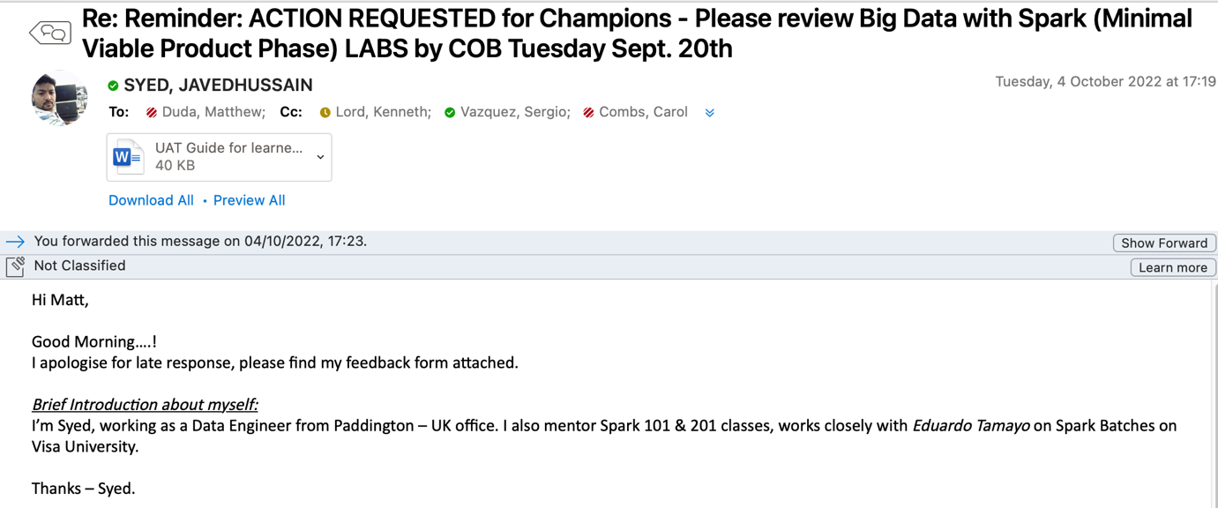

Currently we are using the workera tool for all our learning which is helping everyone in their career progression and migrating to the latest technologies.

**[03] Entrepreneurial and enterprise**

[[K7.1]](https://live.onefile.co.uk/standards/form.aspx?StandardID=0&UnitID=RESSLAO_UOE_01_#03) (Pass): Provides an example of where they have used market analysis tools (SWOT / PESTLE / feasibility studies) to assess the impact of the project on the business, including decisions made in terms of value for money

A SWOT analysis can be a highly useful tool for determining how any technical support system is faring. SWOT, which stands for strengths, weaknesses, opportunities and threats, tells you how support services are doing today and how you can best make changes to adapt to the future. Strengths and weaknesses identify internal conditions, while opportunities and threats deal with external changes that your tech support operations will need to face in the future.

When we apply it to an everyday problem -- what direction to follow in our organization or where to move -- I think it provides the basis for strategy selection.

* Strengths: by our organization we know what our strengths are.
* Weaknesses: by our organization we know what our weaknesses are.
* Opportunities: At any given time, there are distinct opportunities in the real world.
* Threats: To be unaware of threats is a prelude to failure.

Matching strengths to opportunities are a very good strategy.

Whenever we signed a project, we need to check the impact of a project on the business and its strengths that can be our business capabilities, patents skills, reputation and access to resources.

We look at the project cost so based on that we can come up with the decisions either to hire a new full-time employee or a contractor based on the project duration and cost.

We used SWOT to analyse the business high costs and the opportunities can be our business or lack or resources. We followed a simple model and SWOT tool during planning which helped the organization to bring the real picture out.

It has really helped us to look out for opportunities that show up commensurate with our capabilities and inner resources and grab them. We have also created new opportunities using our strength and unique selling proposition.

The SWOT analysis helped us not only for the decisions made in terms of value for money but also helped in career planning, self-development

**[04] Development of self and others**

[[K8.3]](https://live.onefile.co.uk/standards/form.aspx?StandardID=0&UnitID=RESSLAO_01#04) (Distinction): Describes an example of when they have coached or mentored colleagues, peers or team members and identifies the benefits of this

As part of my daily job, I use to provide a training of our organization employees. I also play a role of instructor in my company.

Every quarter I take two batches on technology and prepare them for their project as well.

I conduct office-hours every week so that if anyone having any technical issues, they will join the call and I will try to help them on the call itself.

I also helped my peers on their project technical issues and at the global level.

Any new joiner joins in our project I use to be a mentor for him and, I use to take care of entire on-boarding process, there access, cluster access and KT plan.

I have also received very good feedback from multiple peers from my project and from the global team.

As one of the projects Datamart where Data Scientist have issue while accessing the global datamart table, we have come up with Europe region datamart which helped them to extract the data in very less time. This helped everyone to access data in no time where earlier they must wait for 10-15 min just to extract the dataset.

I have helped them in the low-latency mart, as there is a new requirement for the clients, they need an analysis report for every 10 min and we don’t have that feature, I have started designing the application in Kafka and developed one project of a Low Latency. This project got a good feedback and help our clients to receive data for every 10 min.

This is the low latency behaviour I have come up with and the new tech stack we have introduced in our project. Received multiple feedbacks on this project.

**[04] Development of self and others**

[[K8.2]](https://live.onefile.co.uk/standards/form.aspx?StandardID=0&UnitID=RESSLAO_UOE_01_#04) (Pass): Provides examples of when they have effectively coached and mentored colleagues, peers or team members (including non-technical colleagues) to address identified skills gaps, using appropriate methods

I have mentored multiple colleagues in my team and took multiple knowledge training sessions to the team, conducting trainings on multiple tech stack and making awareness to the peers or team members how the technology is being changes and how we need to proceed further.

I have worked on multiple projects with the Data Scientist team where I need to provide dataset as I’m a Data Engineer and need to perform lot of analysis before providing the dataset to the team.

Sometime the business people use to join the project meeting where they are lack of technical knowledge so we need to discuss in a manner so that non-technical colleagues who are form business side understand the architecture and the business and the deliverables.

My trainings and knowledge sharing sessions helped multiple colleagues in their projects and fasten their deliveries. By my teaching skills I also received very good feedback as part of instructor and a badge from our own Visa University.

I have taken multiple Automation session for the Data Scientist for the automation of their Machine Learning model using Airflow which have helped them in their deliveries and saved lot of manual work.

I train my team members based on their skills gaps and take personal training sessions to help them on their project.

*From LinkedIn profile:*

**[05] Commercial and Business Issues**

[[S3.2]](https://live.onefile.co.uk/standards/form.aspx?StandardID=0&UnitID=RESSLAO_01#05) (Distinction): Describes an analysis of the relevance of intellectual property on the outcome of the project and the impact this could have on the organisation

Intellectual property protection is critical to fostering innovation. Without protection of ideas, businesses and individuals would not reap the full benefits of their inventions and would focus less on research and development.

Intellectual property rights help protect creations of the mind that include inventions, literary or artistic work, images, symbols, etc.

Your IP rights are important because they can:

* set your business apart from competitors
* be sold or licensed, providing an important revenue stream
* offer customers something new and different
* form an essential part of your marketing or branding
* be used as security for loans

Whenever we come with a new feature/idea we need to file a patent it helps the organization so that rival’s company cannot steal our idea. Because if they do so then we can file a case among them.

Intellectual property theft is one someone steals an idea, creative expression, or invention from an individual or a company. IP theft can refer to someone stealing patents, copyrights, trademarks, or trade secrets. This includes names, logos, symbols, inventions, client lists, and more. Intellectual property theft cases are exceptionally common and require smart intellectual property management software in order to be avoided.

We have our own page on Intellectual property and there are some rules have defined as mentioned below

**Staff**

All Visa Staff are required to be aware of the Policy and report activity they reasonably   
 believe violates this Policy. This requirement applies to any such inappropriate activity   
 involving Visa Staff, consultants, clients, vendors, agencies, customers, and/or any other   
 party that has a business relationship with the Company. Any activity that is contrary to this   
 Policy, the Visa Code of Business Conduct and Ethics or law can lead to disciplinary action   
 up to and including employment termination.

**Patent Protection**

All Visa Staff who participate in developing any potentially patentable innovation, such as any new solution to a problem, or new creation or enhancement of a product, service or technology, whether derived from a pre-existing product, solution, technology, data or idea or independently conceived, including database, methodology or know-how, must disclose their innovation to IPS and Visa Legal. In advance of conducting a pilot, proof-of-concept, trial, new or updated service, product, or technology initiative, Visa Staff should contact IPS and Visa Legal to determine if additional analyses should be conducted.

Our organization have filed several patents, due to which most of the idea/innovation is registered without company. Filling a patent give lot of benefits to the organization as firstly the new idea gets registered with our organization name and people will get to know who have brought this feature to the public. It just gives a brand name to the organization and how much productive they are.

There are some inventions titles mentioned below

1. Advanced Custom Audience Producer
2. Demographic segmentation for Visa US consumer credit cards enabled by credit bureau data
3. Framework for using Visa transactional data to identify US consumer credit cards with distinct travel booking behaviours on airlines and hotels
4. etc…

**Why Patents are Important**

If solving today's problem or meeting tomorrow's needs, there is probably an invention worth disclosing. And in order to keep our organization on the cutting edge, we need to make sure our ideas, innovations and products have the necessary patents so that we can keep ahead of the game.

**Our organization patent process**

1. Background
2. Novelty
3. Invention Must Do More Than Combine Known Technologies
4. Invention Must Be Directed to a Technical Improvement
5. Technical Enablement (Details on How the Invention Works)
6. Relevance to VISA’S Ecosystem
7. Sensitivity of the Invention
8. Disclosing on social media

Whenever we file a patent, we need to consider the opensource software we will be using for   
 the development. All Open-Source Software (OSS) must be registered through the   
 Technology Governance portal before it is used. No Open-Source Software (OSS) may be   
 installed in production or non-production environments prior to review and approval by both   
 Security and Legal.

**[07] Project Management and Leadership**

[[S5.4]](https://live.onefile.co.uk/standards/form.aspx?StandardID=0&UnitID=RESSLAO_01#07) (Distinction): Can describe examples of when they have adapted scientific strategy or delivery to consistently meet requirements. e.g. client, regulatory, ethical, geographic

Strategy is comprised of three parts: Vision, Goals, and Initiatives:

Vision describes who the customers are, what customers need, and how you plan to deliver a unique offering.

Goals are quantifiable and define what you want to achieve in the next quarter, year, or 18 months.

Initiatives are the high-level efforts that will help you achieve your goals.

Our product vision should enhance the overall company strategy, your outlook for the product, and where both are headed. A good vision understands who the customers are, what they need, and your go-to-market plan. It captures the essence of what you aim to achieve, the opportunities you have, and the threats that you face.

Whenever we get a new requirement from the client, we use to gather in a full fledge manner and based on that SLA used to get sign. Because until we understand what our customer needs it’s difficult to build and release a winning product, a strong product vision is essential. It is equally important to explain this vision to all teams and stakeholders. When everyone involved in a new product update or launch shares the same strategic vision, implementation runs more smoothly.

We follow the SCRUM pattern by logging the each feature on Jira and based on that task use to get split among the team along with the deadline, we are pretty much sure that on so and so timelines we will be ready with that new feature including testing. Daily we use to have a stan-up calls where I use to take the updates from the team.

Our product goals include

* Increase revenue by 30%
* Expand into five new countries
* Increase mobile adoption by 100%
* Reduce the number of support tickets by 10%
* Performance improvements
* UI Improvements
* Better reporting
* Language localization

If our client agrees for the delivery of a project on phases wise, we use to deliver the project on a phases.

* Scrum is more prescriptive than Kanban
* Basically, Kanban can be applied to visualize and improve the flow of work, regardless of the methodology being used to do the work.
* Scrum is an iterative, incremental work method that provides a highly prescriptive way in which work gets completed. Scrum teams have defined processes, roles, ceremonies and artifacts.
* Work is broken up into Sprints or set amounts of time in which a body of work must be completed before the next Sprint can begin. A sprint can be any length of time, although two-week and 30-day sprints are among the most common.
* Scrum status updates and prioritization meetings are led by Scrum Masters. A Scrum Master is a person on a Scrum team who is responsible for ensuring the team live by the standards set by Scrum.
* Kanban can be customized to fit the processes and work systems your team and / or company already has in place. Once a work method has been either adopted or developed based on Agile principles, your team can begin using Agile tools like Kanban boards and project forecasting tools to help manage projects, workflows and processes in a way that works best for everyone.

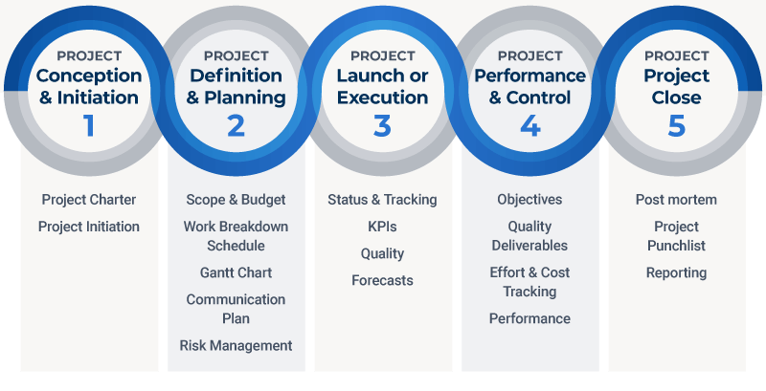

**Project Planning**

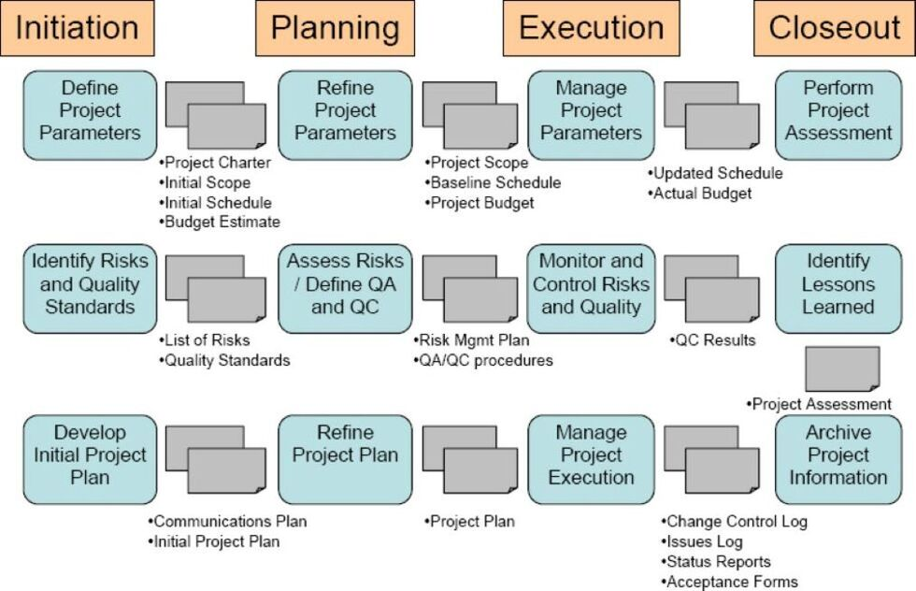

**[07] Project Management and Leadership**

[[S5.1]](https://live.onefile.co.uk/standards/form.aspx?StandardID=0&UnitID=RESSLAO_UOE_01_#07) (Pass): Describes the key elements of effective project plans to manage scope, schedules, budget and risk

A good project plan is one of the most essential elements of success in project management. From preventing scope creep, overblown budgets, and missed deadlines to minimizing stress and frustration. An ounce of prevention in project planning is worth a pound of cure.

The project plan in our team is created by the Project Manager, but everyone who must manage projects in their roles can benefit from creating projects. A project plan saves you the time it takes to recreate the same project over again.

Team members and stakeholders involved in the project and its results may provide input, expertise, costs, and other relevant information to be added and approved before the project manager puts the finishing touches on the project plan.

**Key elements:**

1. Define your goals and objectives
2. Set success metrics
3. Clarify stakeholders and roles
4. Set your budget
5. Align on milestones, deliverables, and project dependencies
6. Outline your timeline and schedule
7. Share the communication plan
8. Monitoring
9. List of requirements and project objectives
10. Project scope statement
11. List of deliverables and estimated due dates
12. Detailed project schedule
13. Risk assessment and management plan
14. Defined roles and responsibilities
15. Resource allocation
16. Quality Assurance (QA) plan
17. Communication plan

At the end of the estimated project period, the project is completed and handed over. The outcomes and deliverables are reviewed and quantified, and the success/failure of a project is determined. The teams review performance, success and failures, and take with them the learnings from the project for continuous improvement of their own performance as well as the performance of the organization.

[[S5.2]](https://live.onefile.co.uk/standards/form.aspx?StandardID=0&UnitID=RESSLAO_UOE_01_#07) (Pass): Describes examples of when they have organised resources, budgets, tasks and people and co-ordinated team activities to meet project requirements and quality processes

As part of leading the team I’m more involved into a assigning task and coordination with the development team but coming to budget planning and organising resources use to be taken care by manager.

I got involved in the budget planning meeting but there I can just keep my suggestion in front of the table but my manager and the leadership team who must take the call.

I played a bigger role in the resource planning session, where sometimes we need to decide to do we need to go with hiring a full-time employee or a contractor. There are various factors which using which we need to come up to a decision.

Daily I use to conduct scrum calls using which I use to interact with the entire team and taking the status of the development of the application.

[[S5.3]](https://live.onefile.co.uk/standards/form.aspx?StandardID=0&UnitID=RESSLAO_UOE_01_#07) (Pass): Describes how to adapt scientific strategy/delivery to be consistent with requirements. e.g. client, regulatory, ethical, geographic

Strategy is comprised of three parts: Vision, Goals, and Initiatives:

Vision describes who the customers are, what customers need, and how you plan to deliver a unique offering.

Goals are quantifiable and define what you want to achieve in the next quarter, year, or 18 months.

Initiatives are the high-level efforts that will help you achieve your goals.

Our product vision should enhance the overall company strategy, your outlook for the product, and where both are headed. A good vision understands who the customers are, what they need, and your go-to-market plan. It captures the essence of what you aim to achieve, the opportunities you have, and the threats that you face.

Whenever we get a new requirement from the client, we use to gather in a full fledge manner and based on that SLA used to get sign. Because until we understand what our customer needs it’s difficult to build and release a winning product, a strong product vision is essential. It is equally important to explain this vision to all teams and stakeholders. When everyone involved in a new product update or launch shares the same strategic vision, implementation runs more smoothly.

We follow the SCRUM pattern by logging the each feature on Jira and based on that task use to get split among the team along with the deadline, we are pretty much sure that on so and so timelines we will be ready with that new feature including testing. Daily we use to have a stan-up calls where I use to take the updates from the team.

Our product goals include

* Increase revenue by 30%
* Expand into five new countries
* Increase mobile adoption by 100%
* Reduce the number of support tickets by 10%
* Performance improvements
* UI Improvements
* Better reporting
* Language localization

If our client agrees for the delivery of a project on phases wise, we use to deliver the project on a phases.

* Scrum is more prescriptive than Kanban
* Basically, Kanban can be applied to visualize and improve the flow of work, regardless of the methodology being used to do the work.
* Scrum is an iterative, incremental work method that provides a highly prescriptive way in which work gets completed. Scrum teams have defined processes, roles, ceremonies and artifacts.
* Work is broken up into Sprints or set amounts of time in which a body of work must be completed before the next Sprint can begin. A sprint can be any length of time, although two-week and 30-day sprints are among the most common.
* Scrum status updates and prioritization meetings are led by Scrum Masters. A Scrum Master is a person on a Scrum team who is responsible for ensuring the team live by the standards set by Scrum.
* Kanban can be customized to fit the processes and work systems your team and / or company already has in place. Once a work method has been either adopted or developed based on Agile principles, your team can begin using Agile tools like Kanban boards and project forecasting tools to help manage projects, workflows and processes in a way that works best for everyone.

**[08] Developing others**

[[S8.2]](https://live.onefile.co.uk/standards/form.aspx?StandardID=0&UnitID=RESSLAO_01#08) (Distinction): Compares and contrasts a range of coaching and mentoring techniques and how each is selected to suit the situation and the person being coached / mentored

First, we need to listen to a person to whom we are going to be coached or mentored. We need to understand him and his strengths and weakness and the requirement of him to which he want to be get mentored.

Based on all factors we should come up with a mentoring plan which contains what are the key concepts which we will be focussing on while doing the mentoring sessions and the output of the sessions.

What will be the time period of the mentoring, during some interval of time we always should conduct assignment so that we will get to know till what point the mentee has reached so that according to that we can do modification on the training plan.

There are some techniques which every mentor has to adopt if he wants to become a successful mentor

1. Listening actively
2. Building trust
3. Encouraging
4. Identifying goals and current reality
5. Help mentees to grow their network
6. Foster a better mindset
7. Encourage risk taking
8. Pass on concrete skills
9. Build a mutual beneficial relationship

I have mentored many people as part of my career, from freshers to experienced persons. I have also become an official trainer for my organization and taken multiple sessions on the tech stack.

After taking classes for two months, I got an opportunity to conduct session globally and got a side position of an instructor in my organization. Received Go Beyond from the “Head of Visa University”

**What skills do you need to be a mentor?**

1. Positivity
2. Emotional intelligence
3. Good Communication skills
4. A desire to help
5. Ask questions that help mentees think about what they want to achieve.
6. Help mentees develop a personal mission statement.
7. Encourage mentees to set SMART (Specific, Measurable, Achievable, Relevant, and Time-bound) goals.
8. Celebrate accomplishments
9. Plan a structure of learning
10. Check-in
11. Share highs and lows of the week
12. Check status on agreed goals
13. Dive into the topic of discussion
14. Share feedback: how is this relationship going?
15. Wrap up, confirm action items, schedule next meeting

Probably all mentors do some teaching or instructing as part of their mentoring. The skill is especially important in formal mentoring. This seldom means that you’ll give formal speeches and lectures. Instead, your instructing will usually be more informal—from modelling specific behaviours to conveying ideas and processes one-on-one, in a tutoring mode. You’ll be a “learning broker” as you assist your mentees in finding resources such as people, books, software, websites, and other information sources.

Teach your mentees new knowledge, skills, and attitudes by explaining, giving effective examples, and asking thought-provoking questions.

Help your mentees gain broader perspectives of their organizations including history, values, culture, and politics.

Demonstrate or model effective behaviours, pointing out what you’re trying to do and help them monitor performance and refocus steps as needed.

One skill that separates superb mentors from very good ones is an ability to inspire their mentees to greatness. By setting an example yourself and helping your mentees experience other inspirational people and situations, you can help them onto future paths that excite and motivate even beyond their original dreams. Mentors vary in their ability to be inspiring. See if you can, do inspiring actions yourself which challenge your mentees to improve, help them observe others who are inspiring, arrange other inspirational experiences for them, challenge them to rise above the mundane and do important things in life.

Use the Encouraging skill much more often than the skill of Providing Corrective Feedback

Another distinguishing characteristic of effective mentors is their willingness and ability to protect their mentees from disasters. One of your tasks is to prevent your mentees from making unnecessary mistakes as they learn to take appropriate risks. This skill of Managing Risks builds closely on the core skill of Building Trust, identified earlier. Some refer to this risk management process as helping mentees step out on the branch. Make suggestions to help them avoid major mistakes (business, career, financial, personal, and other) in judgment or action.

**[09] Team Working**

[[B1.1]](https://live.onefile.co.uk/standards/form.aspx?StandardID=0&UnitID=RESSLAO_01#09) (Distinction): Compares and contrasts collaborative working techniques and how / why these should be selected. Draws on ideas and theories on team working to justify decisions on communication styles and working practices.

A collaborative, efficient team is a goal that every company would love to achieve. But great collaboration doesn’t come easily, it takes time, effort, and research into the best collaboration techniques that will work for your team.

Collaboration techniques are simply the behaviours and practices that you and your team employ to work together better. They can refer to anything from your communication methods to your company culture to the tools you use day-to-day. Finding the collaboration techniques that work for your team can help them feel more empowered, appreciated, and motivated to do their best work.

Think about all the tasks you complete in a typical workday. Imagine how hard it would be to do your job effectively without the help and support of your teammates. Collaboration is the cornerstone of efficient business, providing employees with a sense of purpose, community, and opportunities to grow and learn from one another.

There are several ways to encourage collaboration within your team, don’t be afraid to get creative with your efforts, and be sure to include your team in brainstorming. Here are just a few examples of how to get started.

**Team building games**

Allowing your team time to get to know each other will help them feel more comfortable collaborating and asking for support. You can encourage team building with an office sports team, for example, or a quick ice-breaker session at the beginning of your weekly meetings. Find a way for your team to work together in a fun, casual setting, and watch them become more comfortable collaborating at work.

**Cross-departmental communication**

Maybe your immediate team does a great job of collaborating with each other, but when it comes to cross-departmental projects, it falls apart. Try to educate your team and others about everyone’s roles and responsibilities. Get to know each other and your points of contact for each kind of project. When every team feels heard and respected, it can work wonders for collaboration across the board.

**Celebration of efforts**

When a team member smashes a goal or reaches a great achievement, it calls for a celebration. Showing appreciation to your team members while including the rest of the team in the good wishes is a great way to boost morale and improve relationships across the team.

**Connect your team members**

Getting a project team to a high level of functionality requires trust and communication. This applies to all teams but is especially important when a team also includes remote employment. It is important for any project manager to create an environment where team members feel comfortable voicing their opinions and can find and request help from other members.

To achieve this trust, be sure to set time for informal discussion and personal communication. Keep the first five minutes of any meeting informal or create a “random” channel for more light-hearted topics on your communication applications.

**Transparency**

Being open and honest with your team might seem like standard procedure, but very often, project managers feel that being all things to all people is the best way of enhancing project team collaboration. While this may work for a while, it can also lead to discord among team members who are told different things at various times or lose direction due to confused goals.

**Establish team goals.**

To drive success in team members it's important to set measurable goals for each on a quarterly basis. The purpose of these goals is to provide team members with achievable wins. These wins have a magical way of breaking down barriers and creating positive momentum individually and collectively.

**Foster cohesion between team members.**

Cohesive teams are more successful. They are successful because each person on the team is included in as many large decisions as possible. When team members feel this type of inclusion, they feel the perceived significance of their role, causing them to naturally perform better. To be the most effective, teams should participate in daily huddles where each member discusses their goals and objectives for day.

Your communication style is the way you interact with others and it determines how you speak, act and react in various situations. Here are the four primary communication styles:

**1. Passive**

Passive communicators are typically quiet and don’t seek attention. They may act indifferent during debates and rarely take a strong stance or assert themselves. They don’t usually share their needs or express their feelings, so it may be difficult to know when they are uncomfortable or need help with an important project.

You can identify a passive communicator by these tendencies:

* Inability to say no
* Poor posture
* Easy-going attitude
* Lack of eye contact
* Soft voice
* Apologetic demeanour
* Fidgeting

**2. Aggressive**

Aggressive communicators frequently express their thoughts and feelings and tend to dominate conversations, often at the expense of others. They may also react before thinking, which can negatively affect relationships and decrease productivity in the workplace. While an aggressive communication style might command respect in certain leadership situations, it’s often intimidating to those who respond better to a calm approach.

These are a few signs of an aggressive communicator:

* Interrupting people while they’re speaking
* Invading personal spaces
* Presenting an overbearing posture
* Using aggressive gestures
* Maintaining intense eye contact

**3. Passive-aggressive**

Passive-aggressive communicators appear passive on the surface but often have more aggressive motivations driving their actions. While their words might sound agreeable, their actions don’t always align with what they say. They can quietly manipulate a situation into one that benefits them. Some passive-aggressive communicators use this approach because they feel powerless or manipulated, though that isn’t necessarily the case.

Passive-aggressive communicators may use the following approaches:

* Muttering
* Using sarcasm
* Exhibiting denial
* Presenting a happy face when they’re clearly upset
* Giving the silent treatment

**4. Assertive**

The assertive style is typically the most respectful and productive type of communication in the workplace. Assertive communicators share their thoughts and ideas confidently, but they’re always respectful and polite. They readily take on challenges but know how to say *“no”* when it’s required. These individuals understand their own limits and protect their boundaries without acting overly aggressive or defensive.

When you’re with an assertive communicator, you’ll notice their ability to make others feel comfortable. They’re the ones that you seek out because you know they can easily facilitate a productive discussion.

Assertive behavior exhibits itself through:

* Expansive gestures
* Collaborative and sharing tendencies
* Healthy expression of ideas and feelings
* Good posture
* A clear voice
* Friendly eye contact

I follow all these approaches for collaboration, communication and to generate a healthier environment in the team and finally great deliverables from the team.

**[09] Developing others**

[[S8.1]](https://live.onefile.co.uk/standards/form.aspx?StandardID=0&UnitID=RESSLAO_UOE_01_#09) (Pass): Describes examples of when they have applied a range of coaching and mentoring techniques with colleague’s peers and team members, selecting the correct method to suit the situation and the person being coached or mentored

First, we need to listen to a person to whom we are going to be coached or mentored. We need to understand him and his strengths and weakness and the requirement of him to which he want to be get mentored.

Based on all factors we should come up with a mentoring plan which contains what are the key concepts which we will be focussing on while doing the mentoring sessions and the output of the sessions.

What will be the time period of the mentoring, during some interval of time we always should conduct assignment so that we will get to know till what point the mentee has reached so that according to that we can do modification on the training plan.

There are some techniques which every mentor has to adopt if he wants to become a successful mentor

1. Listening actively
2. Building trust
3. Encouraging
4. Identifying goals and current reality
5. Help mentees to grow their network
6. Foster a better mindset
7. Encourage risk taking
8. Pass on concrete skills
9. Build a mutual beneficial relationship

I have mentored many people as part of my career, from freshers to experienced persons. I have also become an official trainer for my organization and taken multiple sessions on the tech stack.

After taking classes for two months, I got an opportunity to conduct session globally and got a side position of an instructor in my organization. Received Go Beyond from the “Head of Visa University”

**What skills do you need to be a mentor?**

1. Positivity
2. Emotional intelligence
3. Good Communication skills
4. A desire to help
5. Ask questions that help mentees think about what they want to achieve.
6. Help mentees develop a personal mission statement.
7. Encourage mentees to set SMART (Specific, Measurable, Achievable, Relevant, and Time-bound) goals.
8. Celebrate accomplishments
9. Plan a structure of learning
10. Check-in
11. Share highs and lows of the week
12. Check status on agreed goals
13. Dive into the topic of discussion
14. Share feedback: how is this relationship going?
15. Wrap up, confirm action items, schedule next meeting

Probably all mentors do some teaching or instructing as part of their mentoring. The skill is especially important in formal mentoring. This seldom means that you’ll give formal speeches and lectures. Instead, your instructing will usually be more informal—from modelling specific behaviours to conveying ideas and processes one-on-one, in a tutoring mode. You’ll be a “learning broker” as you assist your mentees in finding resources such as people, books, software, websites, and other information sources.

Teach your mentees new knowledge, skills, and attitudes by explaining, giving effective examples, and asking thought-provoking questions.

Help your mentees gain broader perspectives of their organizations including history, values, culture, and politics.

Demonstrate or model effective behaviours, pointing out what you’re trying to do and help them monitor performance and refocus steps as needed.

One skill that separates superb mentors from very good ones is an ability to inspire their mentees to greatness. By setting an example yourself and helping your mentees experience other inspirational people and situations, you can help them onto future paths that excite and motivate even beyond their original dreams. Mentors vary in their ability to be inspiring. See if you can, do inspiring actions yourself which challenge your mentees to improve, help them observe others who are inspiring, arrange other inspirational experiences for them, challenge them to rise above the mundane and do important things in life.

Use the Encouraging skill much more often than the skill of Providing Corrective Feedback

Another distinguishing characteristic of effective mentors is their willingness and ability to protect their mentees from disasters. One of your tasks is to prevent your mentees from making unnecessary mistakes as they learn to take appropriate risks. This skill of Managing Risks builds closely on the core skill of Building Trust, identified earlier. Some refer to this risk management process as helping mentees step out on the branch. Make suggestions to help them avoid major mistakes (business, career, financial, personal, and other) in judgment or action.

**[13] Continuing Professional Development (CPD)**

[[B7.1]](https://live.onefile.co.uk/standards/form.aspx?StandardID=0&UnitID=RESSLAO_UOE_01_#13) (Pass): Describes the importance of CPD backed up by planning and/or demonstrating intent, including relevant accreditations /licenses applicable to role

CPD, or continuing professional development, can take many forms - from peer coaching to team shadowing. And while you may not have considered it in the past, it is a tool that is quickly becoming more desirable.

You may think that once you’ve landed your dream role and you’re comfortably in your groove that you don’t need to worry about anything else, and you can sit back and relax. However, you may want to think again, as you could end up lagging behind your colleagues who might have CPD experience.

CPD, or continuing professional development, essentially ensures that you continue to be proficient and competent in your profession while also furnishing you with essential skills that could help you progress with your career. It’s not just a one-stop-shop, either – it continues and develops throughout your career.

Continued professional development, or CPD for short, is the term used to describe the supplementary learning that professionals undertake. Usually, CPD helps to augment and enhance their abilities in the workplace. However, it encompasses much more than simply learning.

Rather than being passive and reactive, CPD makes learning conscious and proactive, to enhance personal skills for application in the workplace. In addition, there are a variety of different methodologies involved, such as workshops, conferences, and e-learning or online courses.

By engaging in CPD, you’ll ensure that neither your academic nor your practical qualifications will become obsolete. CPD offers you the opportunity for upskilling, regardless of where you are in your career, your age, or even your level of education.

Not only does CPD help to enhance your skill set, but it also enables you to adapt to changes in the work environment too. In an ever-changing world, engaging in CPD can help you prepare for the jobs of the future, while also showing your commitment to self-development and professionalism.

CPD takes the learning process an extra step, ensuring that the way you’re learning – and what you’re learning – is structured, practical, and relevant. When you start in a specific industry in a new role, you will likely have completed your academic qualifications. CPD takes further steps in the learning process and allows you to focus on any specific skills and knowledge – usually over a short time period.

CPD accredited training courses, workshops and events allow professionals to use the learning time towards individual CPD requirements. CPD accreditation for training courses, seminars, presentations, e-learning and events in order to improve credibility through an industry-wide recognised quality bench-marking framework. CPD accreditation enables organisations to create discernible competitive advantage from others within their market. Taking that extra step to represent yourself as industry experts within the field increases the chances to meet more of right target audience.

Looking at these, on a granular level, is an important part of the design process. Whilst we may love the idea of overnight change, effective change is a slow process, and deciding on the steps and stages is essential if we want to make a difference. CPD should be iterative and therefore we need to understand how this will be developed over time. Just as with pupils, we need to build on prior knowledge and manage their cognitive load if we want to ensure CPD will have the desired impact. This is especially difficult with staff as you have such a wide range of experiences, prior knowledge, ideas and values which each individual brings to the table. There needs to be real clarity about what you want to achieve, why it matters, and selecting elements which are demonstrable and tangible. While we need teachers to be able to understand the theory of why we want to do particular things, we also need them to be able to see these abstract ideas in a concrete way and give them opportunities to explore what it may look like in their context.

Finally, we need to build in regular feedback loops to the conversation, where we can check progress towards our goal, consider deviation and what our next steps might be. This forms part of our assessment of the ‘impact’ of our CPD curriculum. If we have carefully considered the steps needed as part of our planning towards our final goal, then the rhythm should be part of the fabric of the school year. The more granular our approach too, the easier it is to isolate the steps taken and know what the next ones may be, and the more bespoke CPD will feel. Ongoing conversations about pupils’ outcomes will allow all to explore the impact and what is and is not working. We should not be afraid to examine that last part too - what is not working. If things are not going in the right direction and having the desired impact despite fidelity, be brave enough to change course. There is no point returning slavishly to something which isn’t set to achieve what you want. However, if the diagnostic ‘explore’ stage has been done carefully and the mechanisms chosen carefully, this should hopefully mean a slight shift of the rudder as opposed to a 180 change of direction.