INTRODUCTION:
Before we learn any technology or course we have to do some research. We have to do it in the course or technology that we are going to learn. “It is used for what purpose?” That technology what kind of applications can we develop? And most importantly, what is the demand for a particular technology? “Demand is what”? Like a job. How many jobs do we have for particular technologies? So we know all this kind of information, then we have to learn. It is not like a friend is learning Java, and my friend is learning Python…That should not be this. Any technology you want to learn, so all these points we have to know, then we have to learn any technology.
So, today being the first class, let us try to understand. How is Java different from other programming languages, and what is the demand for Java in the market?
- Why do we call ‘C language a sequential language? Because if you start executing a ‘C’ program, the execution will start from line number ‘I’, and it will continue the execution line by line, ok.
- What is mean by software mean? Generally, we use the word software. Software is nothing but a collection of programs.
- What is mean by program?
A program is nothing but a collection of lines of code.

    - What is mean by code mean?
Code is nothing but a set of instructions to a computer.

Can we give these instructions overall to the computer? Can it understand? ‘NO,’ it is human language. If you want to tell us anything we call the machine. We need to do that format, then it will be understood. Understand why WE ‘C’ is a sequence language.

- Drawback of ‘C’:
- UNNECESSARY code execution :
- The required for execution that code will also be executed.
EX: 1
2
3

50___
100
We have some 100 lines of code I want to execute 50 lines. But in ‘C’, execute from the line number because ‘C’ is a sequential language.
So, in the program code, which is not required, unnecessary code also executes, and the program will take more time for execution.
But nowadays we live in the fastest generation, we say yes\no everything we need. Fast mobile applications execute fast web applications; they have to execute, so the application should not take more time than they have to takes very little time in a ‘C’ language. What will happen because of this unnecessary code execution? The program will take more time.
- 2] No code reusability:
If we want to reuse the same code again and again for execution is not possible.
EX: 1
2
3
10___
50
Suppose there is the same code at line 10 as whatever code is there at line number ’10’ same code. We want at line number ‘50’ also. At the time of execution. So, if you start executing this program so what should happen when it comes to line number 50? Is the code at line number 10 required or not? So what should it do? It should go to line number 10, execute this code, come back again, and continue the execution from ‘51 ’. Execution should happen like this, yes or no. But ‘C’ language execution will not happen like this. Yes\no. But ’C’ language, if you want the same code again and again for execution only option we have is to copy and paste. Suppose we want some code at a line number. So again, what we will do is copy the code from line number 10 and paste the code at line number 80. And if you go through copy and paste, copy and paste, what will happen program size will become very big. The program is very big, so sometimes it will also crash. So we should not write like big big programs gone those days. In previous, lengthy programs they used to write big programs but gone their days now a days we have to write short programs very less code we have to write the program.
If you take previous Java programs, they used to write lengthy programs. For the application and projects, but nowadays not required because in Java we a new frameworks like Java hyber net, Spring Boot, Spring, using these from work in Java program, we have to write very little code. .so, how very easy it is has become a Java program nowadays, yes. So, like this in the ‘C’ language, what will happen if we want to reusable some code again and again for execution, so it is not possible?
3] No data security:
The meaning of data is that data is nothing but user information. In the C language is a class, no object; this data is a security problem. In ‘C language, see if the data related to Gmail, if it is gone, it is not a big problem. If the data related to the bank application is gone. What is meant by a bank application?
If you want to do a bank transaction, is it necessary to go to a bank? No, it is not necessary as everything has been online, as well as the bank applications with bankname.com to perform operations related to the bank. Nowadays, banking payments are very easy. In single, we can make payments, yes or no. So these are all examples of banking applications. Is the meaning that money is gone, yes or no? It is a huge loss.
- After the C language, another programming language came to the market, C++. So C++ extension of ‘C language because C++ solves all the problems of the C language. What are all the problems and drawbacks that we have discussed that C++ will solve?
- How can C++ solve the problems and drawbacks?
Because C++ is a kind of over language. It is not a sequence. It is an object-oriented programming language. And what is meant by object-oriented programming language means. The Ant language follows 4 concepts.
- Abstraction, 2. Encapsulation, 3. Inheritance, 4. Polymorphism. Any language follows 4 concepts that language is nothing but object oriented programming language.
Then what are abstraction, encapsulation, inheritance, and polymorphism that we are not going to discuss right now, just today introduction part in the coming days, we will discuss. The topic oops the concept, where we will discuss in detail along with an example.
- Next came another programming language in the market by name Java is also a very famous programming language that came in the market in the 1990s.” JAMESGOSLING” is god godfather of Java.
Now the doubt that is coming to your mind is, is a C++ object-oriented program a Java object-oriented program? Then why do we need Java in the market? That is the doubt that few people think and tell me any reason if you know why we need Java in the market already.
As we already have C++ in the market. By using C and C++, we develop a system of programming.
What is meant by system programming?
A program that executes on a particular machine. For example, if you have taken an operating system, if you install one laptop, it cannot be installed on any other laptop. Like, there are examples of some system programs, such as an antivirus and a calculator.
So if you want to develop a system program, you have to use C and C++ as programming languages. Whereas if you want to develop an internet program with a web application, we will use Java.
What is meant by an internet application?
Any application that runs on the internet is an internet application. If you want to develop this kind of application, we need Java. Since Java came on the market, we have not been using C and C++. But we use C and C++ to develop different projects. Now to develop an internet application, Java is the only technology which is available in the market, or do we have any other technologies?
We also have .NET to develop the internet applications. But there is a limitation in .NET applications. Can you enable them? What is the limitation?
The limitation is that .NET is a platform-dependent language. It meant that if we develop a .NET application, it only works on one operating system. But there isn't a single operating system on the market. There are many operating systems. So, for that, we use Java. If you develop any .NET application on Windows, you can only use it on Windows. But if you develop a Java application, you can execute it on any operating system. Because Java is a platform-independent language, it does not depend on anything like .NET. But in .NET, one new feature came by the name of .NET Core. By using .NET Core, we can develop applications. So we can execute on other operating systems. This new feature is in .NET.

JAVA ARCHITECTURE
We can develop other kinds of applications using Java like
  - standalone application
  - web application
  - enterprise application
  - servers
  - mobile apps
  - network applications
  - gaming applications
  - embedded systems
  - cloud computing
  - Big data
  - artificial intelligence
  - machine learning
  - internet of things.
📜 1.1 History of Java
- Java was developed by James Gosling at Sun Microsystems in 1995.
- Initially called Oak, later renamed Java.
- It was designed for embedded devices, but later became popular for web, desktop, and mobile applications.
- Now maintained by Oracle Corporation.

⭐ 1.2 Features of Java (With Explanation)
Feature | Description
Simple | Easy to learn, similar to C/C++ syntax.
Object-Oriented | Based on the concept of objects and classes.
Platform Independent | "Write Once, Run Anywhere" – thanks to JVM.
Secure | No pointers, bytecode verification.
Robust | Strong memory management, exception handling.
Multithreaded | Supports multithreading for concurrent tasks.
High Performance | Uses Just-In-Time (JIT) compiler.
Distributed | Supports RMI and socket programming for distributed systems.
Portable | Can be run on any device without rewriting code.
Dynamic | Supports dynamic memory allocation and linking of classes during runtime.

🧠 1.3 JVM vs JRE vs JDK – Full Explanation
🔷 1️⃣ JVM – Java Virtual Machine
🔹 What is JVM?
- JVM (Java Virtual Machine) is the heart of the Java platform.
- It is a virtual machine (software-based) that runs Java bytecode (.class files), not Java source code directly.
- It makes Java platform-independent because bytecode can run on any machine that has the appropriate JVM installed.
🔹 Key Responsibilities:
- Loads .class files (bytecode)
- Verifies code for security
- Interprets or compiles bytecode into machine code using JIT (Just-In-Time) compiler
- Manages memory (through Garbage Collection)
- Handles multithreading, exception handling, etc.
✅ Summary:
- JVM is platform-dependent (e.g., Windows JVM, Linux JVM), but bytecode is platform-independent.

🔶 2️⃣ JRE – Java Runtime Environment
🔹 What is JRE?
- JRE (Java Runtime Environment) is the package required to run Java applications.
- It contains:
  - The JVM
  - Set of core libraries (like java.lang, java.util)
  - Other runtime support files
🔹 What It Does:
- If you're only running Java applications (not developing), you only need JRE.
- You can execute .class files using:
bash
java Hello
✅ Summary:
- JRE = JVM + Libraries
- Used by end users to run Java applications.

🟡 3️⃣ JDK – Java Development Kit
🔹 What is JDK?
- JDK (Java Development Kit) is the complete package used to develop Java applications.
- It includes everything from the JRE plus:
  - Java compiler (javac)
  - Debugger, documentation tools
  - Tools like javap, javadoc, jar, etc.
🔹 What It Does:
- Converts Java source code (.java) into bytecode (.class) using:
bash
javac Hello.java
✅ Summary:
- JDK = JRE + Compiler + Development tools
- Required if you're a Java programmer or developer.

📊 JVM vs JRE vs JDK – Comparison Table
Feature | JVM | JRE | JDK
Stands For | Java Virtual Machine | Java Runtime Environment | Java Development Kit
Purpose | Runs bytecode | Runs Java programs | Develop and run Java programs
Includes | Only JVM | JVM + Libraries | JRE + Compiler + Tools
Can Compile? | ❌ No | ❌ No | ✅ Yes
Needed For | Execution engine | Running applications | Writing + Compiling + Running apps
Used By | JVM internally (all users) | End users of Java apps | Developers / Programmers

🧪 Example in Use:
Writing and running a simple Java program:
- Write Hello.java → Needs JDK
- Compile using javac Hello.java → Needs JDK
- Run using java Hello → Needs JRE (uses JVM inside)
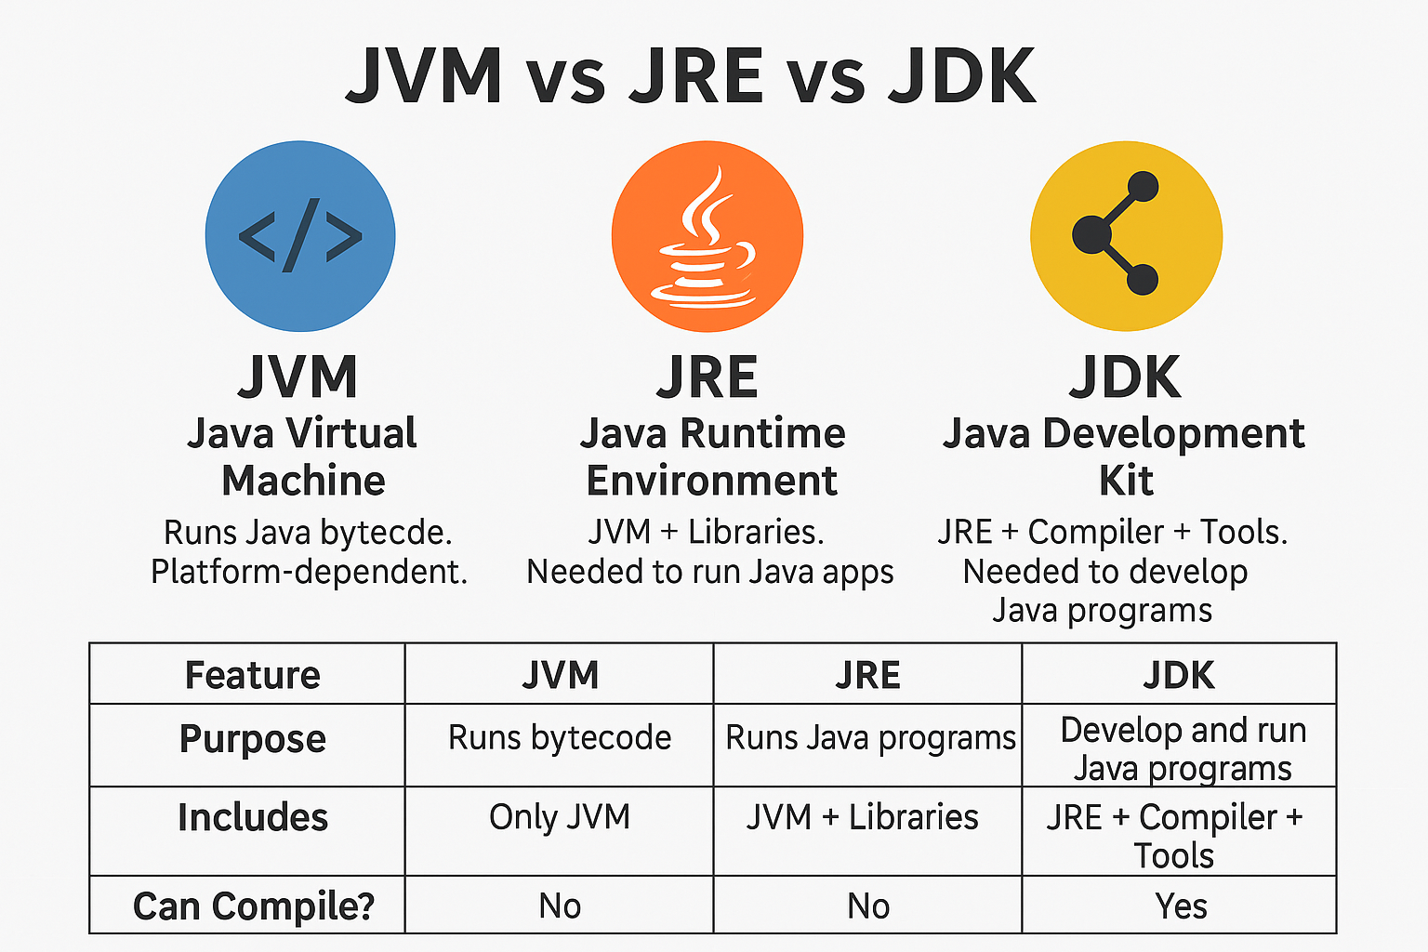

Lets see when we run the java what happened, when we created java program the extension is .java.
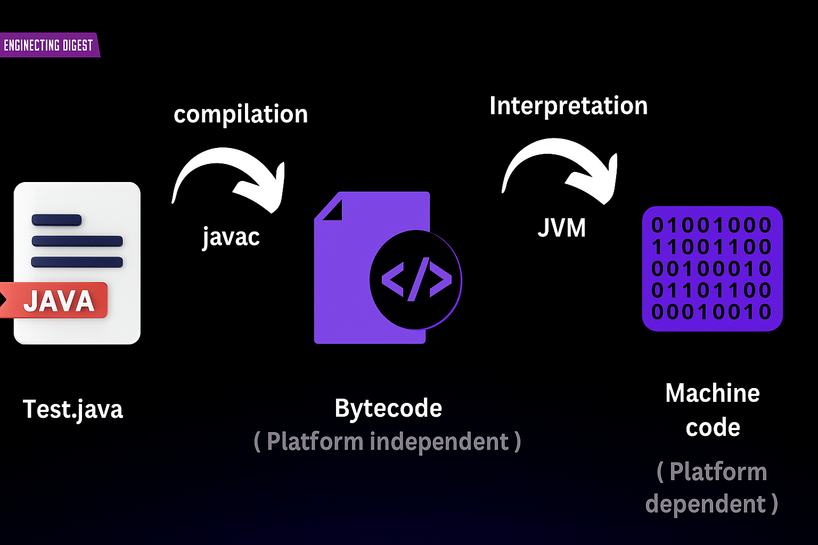
So this is our complete flow, .java is your file there you have written a program it gets converted it is inside the byte code. So what ever java you have write completely with your hand, it will be compiled inside the byte code,
Now who will compile it ? “Javac”, what is this javac ? “javac is the name of the compiler.”.
Java c compile you .java code inside bytecode. What is bytecode? “Bytecode we will not understand the bytecode , but JVM will understand it. This byte code is platform independent. That is suppose we are in windows right now, we have generated bytecode on windows and we have put the same bytecode if we put it on Mac will work, if we put on linux, will work.
Then that Bytecode goes to the JVM, what does that JVM will do? it converts that bytecode into machine code. Obviously what is machine code ? it is platform dependent, that is mac will have different machine code, Windows will have different machine code.
Right , I am telling you once again, if you write a java file, first of all it will be compiled inside the byte code, then the bytecode is interpreted line by line by JVM. Ok . The final result will be machine code. That is zero(0) and one(1), the 0 and 1 will be run,
Whatever your program does on your system, like if you are writing “Hello World” program then “Hello World” will be printed it.

Simple open one notepad and save this file I am creating one folder with name “Java”. And save this file with name “Test.java”.
Now lets write some code
class Test{

public static void main(String [] args) {

System.out.println("Hello world");
}
}
Lets saved file and go to folder we have to type cmd in address bar. In cmd pannel just enter the “javac Test.java” (first of all javac will compile)

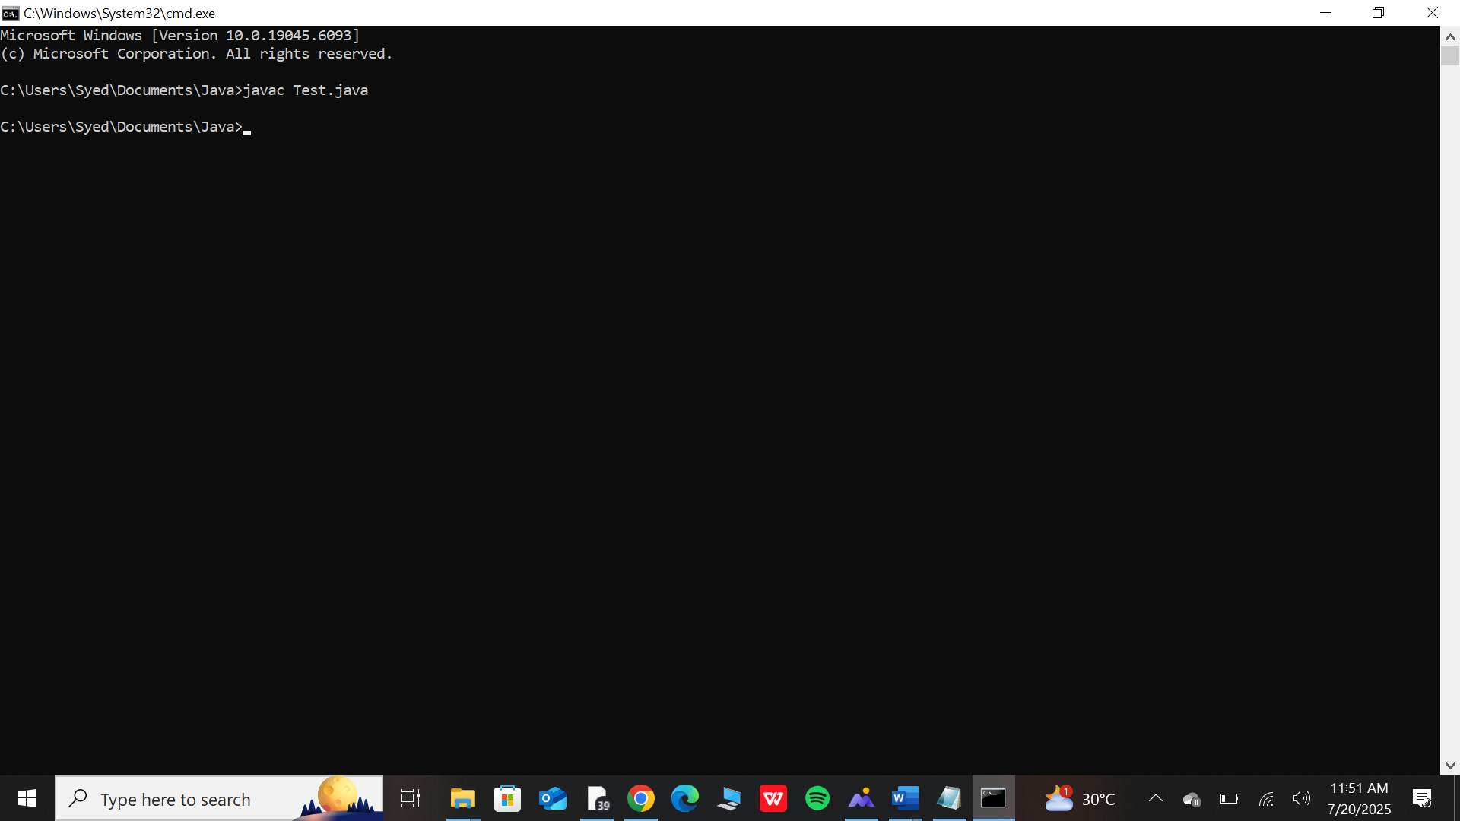
Javac test do java means that I am telling the java compiler to compile the Test.java file.
Now if I look at the file Explore (come back to created java folder) here a file has been automatically created.

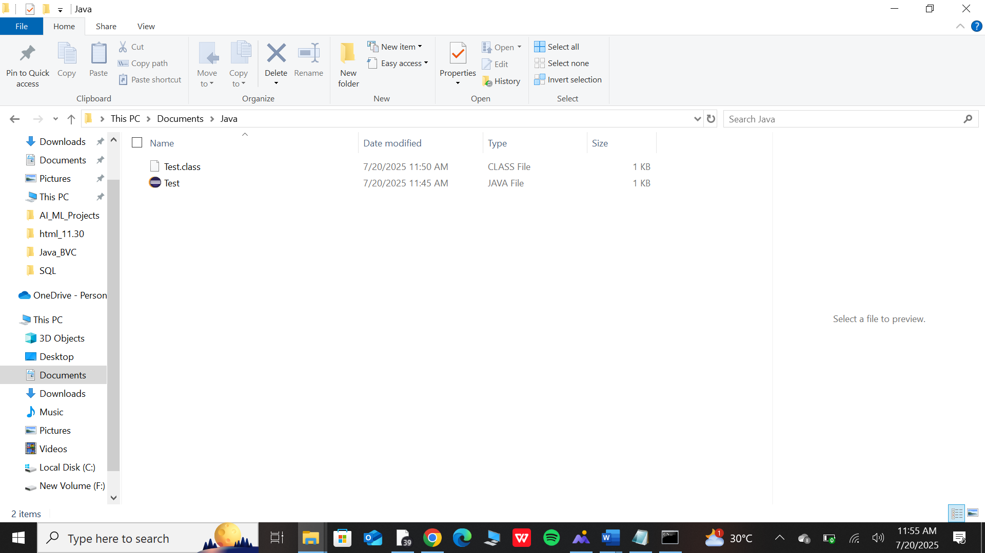
Test.class file, this is the bytecode if I open it you can seen like this.

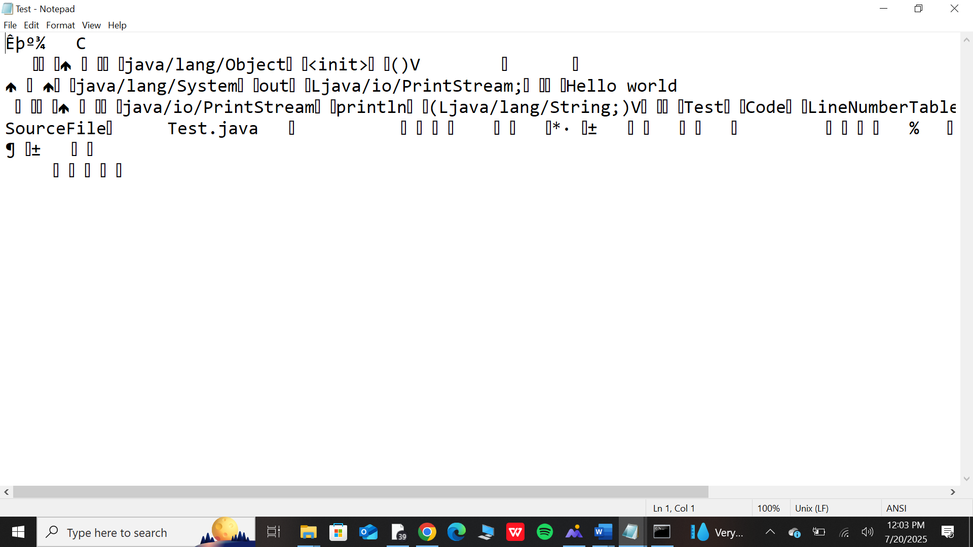
See then we will not understand it, who is the one to understand the bytecode ? JVM can understand, So again open the cmd type java Test , so we tell JVM run this Java Test, it will show like this.

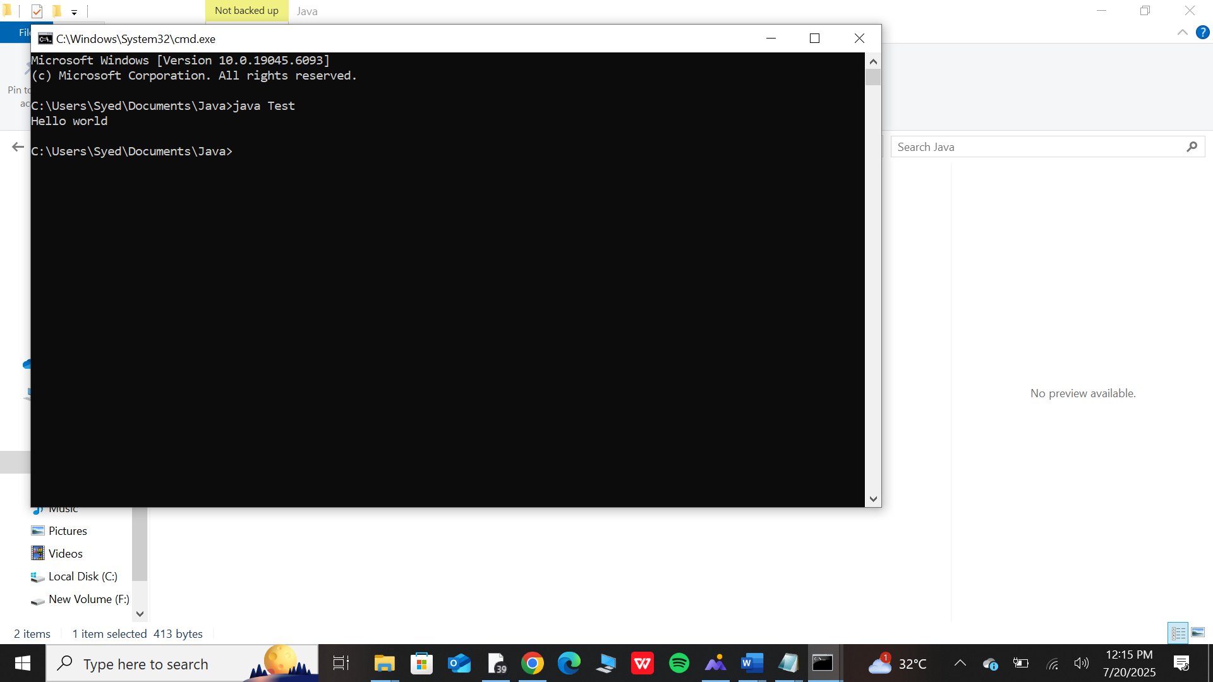
so our program has run. There are 2 steps, first compile it, then tell JVM to run this byte code which is has been created.
You must be thinking that why have I not written Test.class here and you must be thinking that what is java ? java has a compiler in it, but
What is java ? first let us see what is java go to “this pc” click on program file where our java installed we come inside the “bin” look there will be tool java. And here is a java and look here there is a java.
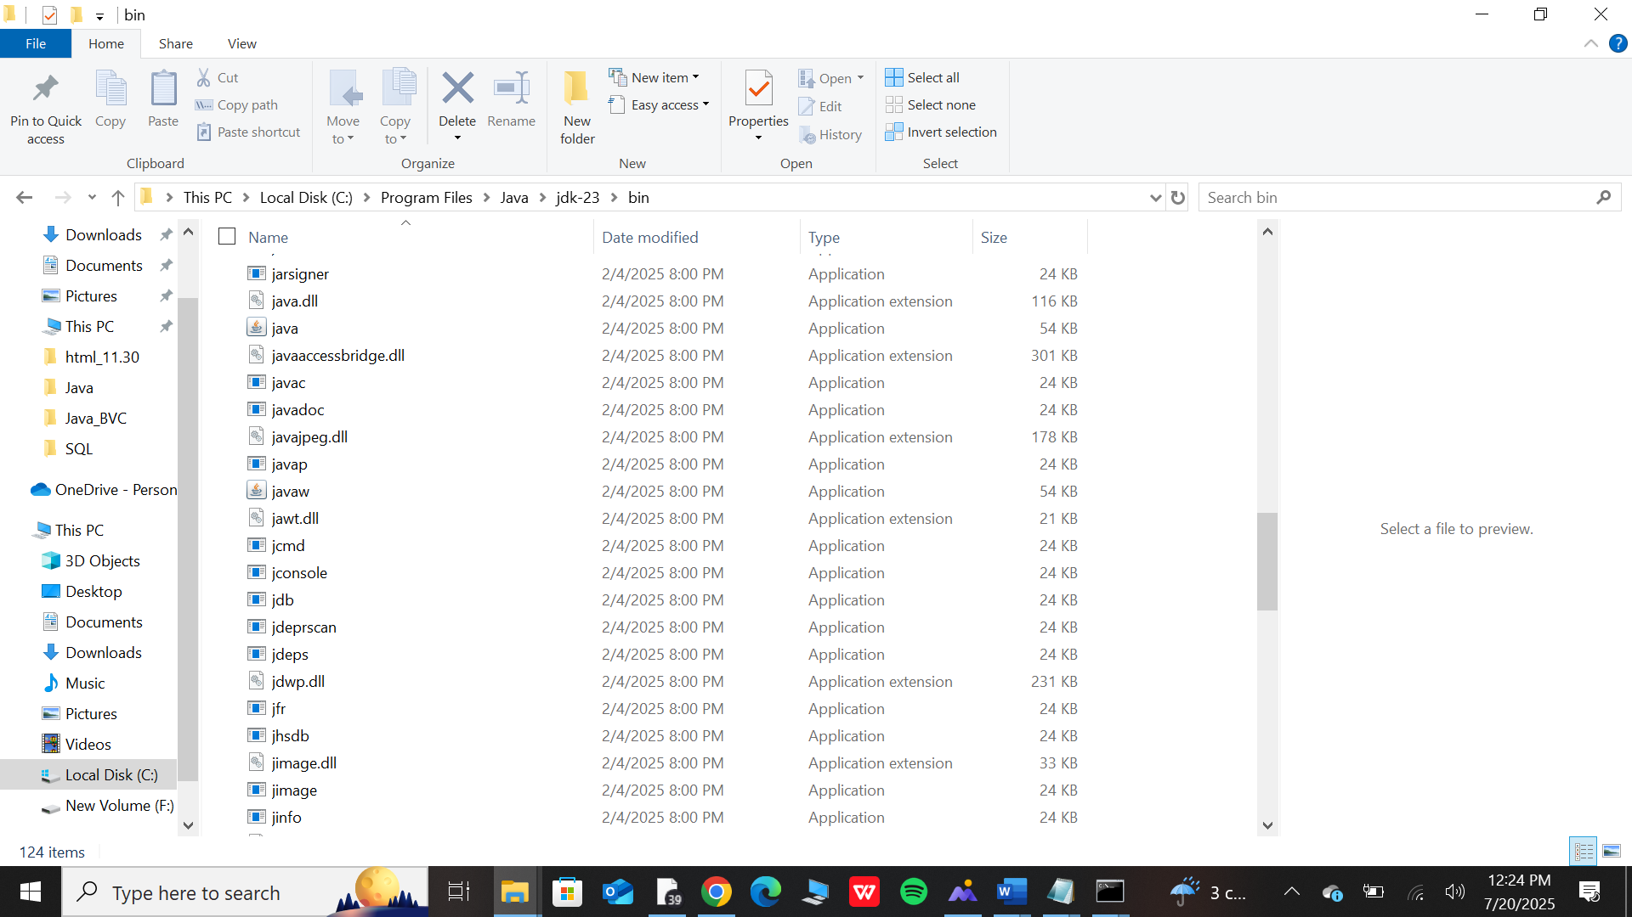
You must remember when we had set the environment variable are it was set automatically, so when we write the command java, it runs, when we write the command javac , it runs,
So “javac” comes in the compiler, there is nothing it runs “JVM” okay.
As soon as you write java and give it class, what does it means that you are instructing JVM. Run this class file, now the second thing was that why have we not put the extension here.



The file here  is with .class but we did not write .class  so there is no convention, you give only .class file to JVM, so you do not need to mention, if mention then an error will come . so there is no need to give .class.
So we have got the basic idea

The .java file is converted into bytecode, then using java compiler, then the byte code is converted into machine code and it runs, Okay. Using JVM.
What does JVM do it ? interpret it line by line. Then what is line by line ? I will tell you, when it get bytecode, then what does it do first, it parse it once, the interpreter of our JVM will parse it.
it will read it once from top to bottom and will group them, it will group the instruction, which one to run first, which one to run second , by doing this, when those things get grouped then those instructions it will run line by line, this is the story.
So two passes are done. First it will parse to group the instruction and in the second pass line by line those instructions are run which it has grouped in the first pass. So this is the reason interpreter is slow and the compiler is fast.
Overall if we see the entire program is running but you will see output of the Interpreter.

