1. What is a Variable in Java?
Definition: A variable is like a container that stores data which your program can use and change during execution.
Syntax: dataType variableName = value;
int age = 21;
String name = "Rizwan";

2. What are Data Types in Java?
Java is a strongly typed language – this means every variable must have a type.

Type | Description | Example
Primitive | Built-in data types | int, float, char
Non-Primitive | Reference types like objects | String, Array

2.1 Primitive Data Types:

Data Type | Size | Example | Description
int | 4 bytes | int x = 10; | Stores whole numbers
float | 4 bytes | float pi = 3.14f; | Stores decimal numbers (small)
double | 8 bytes | double d = 3.14159; | Stores decimal numbers (big)
char | 2 bytes | char ch = 'A'; | Stores single characters
boolean | 1 bit | boolean flag = true; | Stores true or false
byte | 1 byte | byte b = 100; | Stores small numbers
short | 2 bytes | short s = 500; | Stores small numbers
long | 8 bytes | long l = 123456789L; | Stores big numbers

2.2 Non-Primitive Data Types (Reference Types):

Type | Example
String | String s = "Hello";
Arrays | int[] nums = {1, 2, 3};
Classes | Student std = new Student();

Java Syntax
package Session_1;
public class DataTypeDemo {
public static void main(String[] args)
{
// TODO Auto-generated method stub
}
}

package Session_1;
package is a keyword used to group related classes.
Session_1 is the name of the package.
This means the file DataTypeDemo.java belongs to the Session_1 folder (or namespace).

public class DataTypeDemo {
This line defines a public class named DataTypeDemo.
public means the class is accessible from anywhere.
class is a keyword used to declare a class.
DataTypeDemo is the class name (must match the filename).

public static void main(String[] args) {
This is the main method, the entry point of any Java program.
public: Can be accessed from anywhere.
static: Belongs to the class (no object needed to run it).
void: Does not return anything.
main: Name of the method. JVM looks for this method to start execution.
String[] args: Takes input from the command line as an array of Strings.

Sample Code for Demo:
package Session_1;
// This is the class definition. In Java, everything runs inside a class.
public class DataTypeDemo {

// This is the main method. It is the starting point of any Java program.
public static void main(String[] args) {

// Declaring an integer variable named 'age' and assigning it the value 20
int age = 20;

// Declaring a float variable named 'pi' and assigning it the value 3.14
// Note: The 'f' at the end tells Java this is a float, not a double
float pi = 3.14f;

// Declaring a character variable named 'grade' and assigning it the value 'A'
char grade = 'A';

// Declaring a boolean variable named 'isPassed' and assigning it true
boolean isPassed = true;

// Declaring a String variable named 'name' and assigning it the value "Rizwan"
// Strings are used to store words or text
String name = "Rizwan";

// Printing the value of name variable to the console
System.out.println("Name: " + name);

// Printing the value of age variable
System.out.println("Age: " + age);

// Printing the value of grade variable
System.out.println("Grade: " + grade);

// Printing the value of isPassed variable
System.out.println("Passed: " + isPassed);

// Printing the value of pi variable
System.out.println("Pi Value: " + pi);
}
}
Variables store data.
Data types define the kind of data:
- int → whole numbers
- float/double → decimal numbers
- char → single character
- boolean → true/false
- String → words or sentences

What is an Identifier in Java?
In Java, an identifier is the name used to identify:
- a class
- a method
- a variable
- an object
- or any other user-defined element in your program.

Definition:
An identifier is the name given to a Java variable, method, class, interface, etc., to uniquely identify it in the code.

Think of it like this:
Just like we give names to people to identify them, Java uses identifiers to name and refer to code components.

Rules for Identifiers in Java:
- Can contain letters, digits, underscores, and dollar signs
  - e.g., myVariable, student_name, _total
- Cannot begin with a digit
  - ❌ 1number → invalid
- No special characters allowed except _ and $
- No Java keywords allowed
  - ❌ int, class, static cannot be identifiers
- Case-sensitive
  - Student and student are different identifiers

What are Java Keywords?
Java keywords are reserved words that have special meaning to the Java compiler.
They cannot be used as:
- Variable names
- Method names
- Class names
- or any identifier

abstract | assert | boolean | break | byte
case | catch | char | class | const (*)
continue | default | do | double | else
enum | extends | final | finally | float
for | goto (*) | if | implements | import
instanceof | int | interface | long | native
new | null (**) | package | private | protected
public | return | short | static | strictfp
super | switch | synchronized | this | throw
throws | transient | try | void | volatile
while

Operators in java
What is an Operator in Java?
An operator in Java is a symbol that performs a specific operation on one, two, or more operands (values or variables) and produces a result.
// Number Operations
System.out.println(5 + 6); // Addition
System.out.println(6 - 5); // Subtraction
System.out.println(10 / 2); // Division (gives quotient)
System.out.println(10 / 2); // Floor division (same in Java for integers)
System.out.println(10 % 2); // Modulus
System.out.println(10 * 2); // Multiplication

/* comparasion operators(Relational operators)These operators compare the values on either sides of them and decide the relation among them.
They are also called Relational operators*/

System.out.println("5 > 2? " + (5 > 2));
System.out.println("5 < 2? " + (5 < 2));
System.out.println("5 >= 2? " + (5 >= 2));
System.out.println("5 <= 2? " + (5 <= 2));
System.out.println("5 == 3? " + (5 == 3));
System.out.println("5 == 5? " + (5 == 5));

}

Assignment Operators in Java:
Assignment operators are used to assign values to variables. Java supports compound assignment operators for shorthand operations.

Operator | Description | Example | Equivalent
= | Assign | a = 10 | assign 10 to a
+= | Add and assign | a += b | a = a + b
-= | Subtract and assign | a -= b | a = a - b
*= | Multiply and assign | a *= b | a = a * b
/= | Divide and assign | a /= b | a = a / b
%= | Modulus and assign | a %= b | a = a % b

public class OperatorDemo {
public static void main(String[] args) {

// Assignment Operators
int a = 82;
int b = 27;
a += b; // a = a + b => a = 82 + 27 = 109
System.out.println("a += b => " + a); // Output: 109

a = 25;
b = 12;
a -= b; // a = a - b => a = 25 - 12 = 13
System.out.println("a -= b => " + a); // Output: 13

a = 24;
b = 4;
a *= b; // a = a * b => a = 24 * 4 = 96
System.out.println("a *= b => " + a); // Output: 96

}
}

Logical Operators in Java:
Logical operators are used to combine two or more conditions (boolean values).
// Logical AND
boolean result1 = (1 == 1) && (0 == 1); // true && false => false
System.out.println("1 AND 0 = " + result1); // Output: false

// Logical OR
boolean result2 = (1 == 1) || (0 == 1); // true || false => true
System.out.println("1 OR 0 = " + result2); // Output: true

// Logical AND
boolean result3 = (1 == 1) && (1 == 1); // true && true => true
System.out.println("1 AND 1 = " + result3); // Output: true

What are Bitwise Operators in Java?
Bitwise operators are used to perform operations on individual bits of integer (binary) values.
public class BitwiseDemo {
public static void main(String[] args) {
int a = 10;
int b = 6;

System.out.println("a & b = " + (a & b)); // Output: 2
System.out.println("a | b = " + (a | b)); // Output: 14
System.out.println("a ^ b = " + (a ^ b)); // Output: 12

}
}

What are Shift Operators in Java?
Shift operators are used to move (shift) the bits of a number left or right by a specified number of positions.
Left Shift Operator (<<)
Shifts bits to the left, adding 0s from the right.
Each left shift by 1 is like multiplying the number by 2.

🔹 Right Shift Operator (>>)
Shifts bits to the right, discarding bits on the right.
Each right shift by 1 is like dividing the number by 2 (integer division).
public class ShiftOperatorDemo {
public static void main(String[] args) {
int x = 10;

System.out.println("x << 1 = " + (x << 1)); // 20
System.out.println("x << 2 = " + (x << 2)); // 40
System.out.println("x << 3 = " + (x << 3)); // 80

System.out.println("x >> 1 = " + (x >> 1)); // 5
System.out.println("x >> 2 = " + (x >> 2)); // 2
System.out.println("x >> 3 = " + (x >> 3)); // 1
}
}

Conditional Control Statements
What are Control Statements?
Control statements in Java help you to control the flow of execution of the program based on conditions or loops.
Types of Control Statements
Java control statements are mainly divided into:
- Decision-making statements
- Looping statements
- Jump statements

1. Decision-making Statements
These are used to execute a block of code based on a condition.
1.1 if-condition: An if statement is a conditional control structure that executes a block of code only if a specified condition is true.

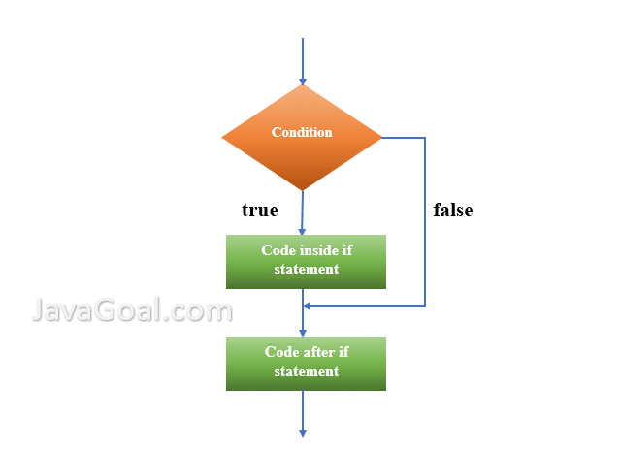
Syntax
if (condition) {
// Code to execute if condition is true
}
Explanation:
- The condition is usually a boolean expression (true/false).
- If the condition evaluates to true, the code inside the block runs.
- If the condition is false, the block is skipped.
int age = 20;
if (age >= 18) {
System.out.println("You are eligible to vote.");
}

If-else: An if-else statement is a conditional control structure that allows the program to execute one block of code if a condition is true, and a different block if the condition is false.

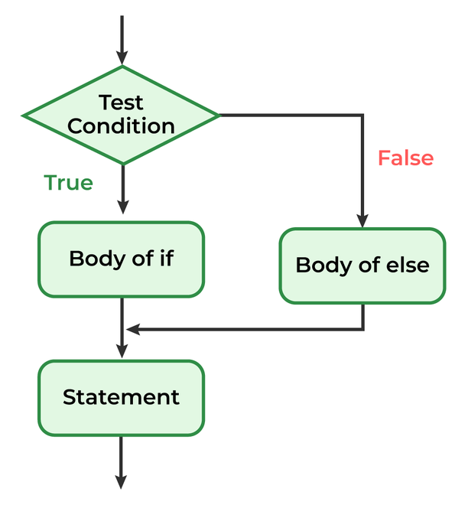
Syntax
if (condition) {
// Code to execute if condition is true
} else {
// Code to execute if condition is false }

Explanation:
- The program checks the condition.
- If the condition is true, the if block runs.
- If the condition is false, the else block runs.

public class Main {
public static void main(String[] args) {
int a = 10;
int b = 20;

if (a > b) {
System.out.println("A is Greater than B");
} else {
System.out.println("B is Greater than A");
}
}
}

Definition of Nested if Condition:
A nested if condition is a conditional structure where one if statement is placed inside another if or else block. It allows checking multiple related conditions in a hierarchical or step-by-step manner.
Syntax
if (condition1) {
if (condition2) {
// Executes if both condition1 and condition2 are true
} else {
// Executes if condition1 is true but condition2 is false
}
} else {
// Executes if condition1 is false
}

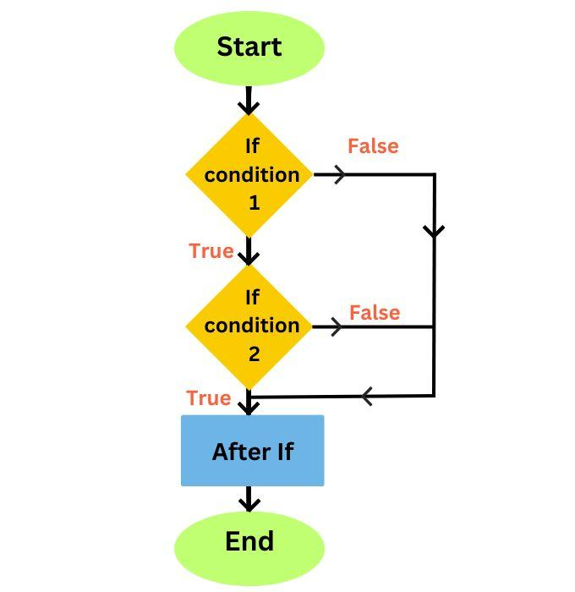

int marks = 85;

if (marks >= 60) {
if (marks >= 80) {
System.out.println("Distinction");
} else {
System.out.println("First Class");
}
} else {
System.out.println("Fail");
}

If-else-if ladder: An if-else-if ladder is a control structure used to check multiple conditions one by one. It allows a program to choose one option among many based on which condition is true first.

if (condition1) {
// Code block if condition1 is true
} else if (condition2) {
// Code block if condition2 is true
} else if (condition3) {
// Code block if condition3 is true
} else {
// Code block if none of the above conditions are true
}

• The program checks each condition from top to bottom.
• As soon as one condition is true, its block executes and the rest are skipped.
• If no condition matches, the else block runs

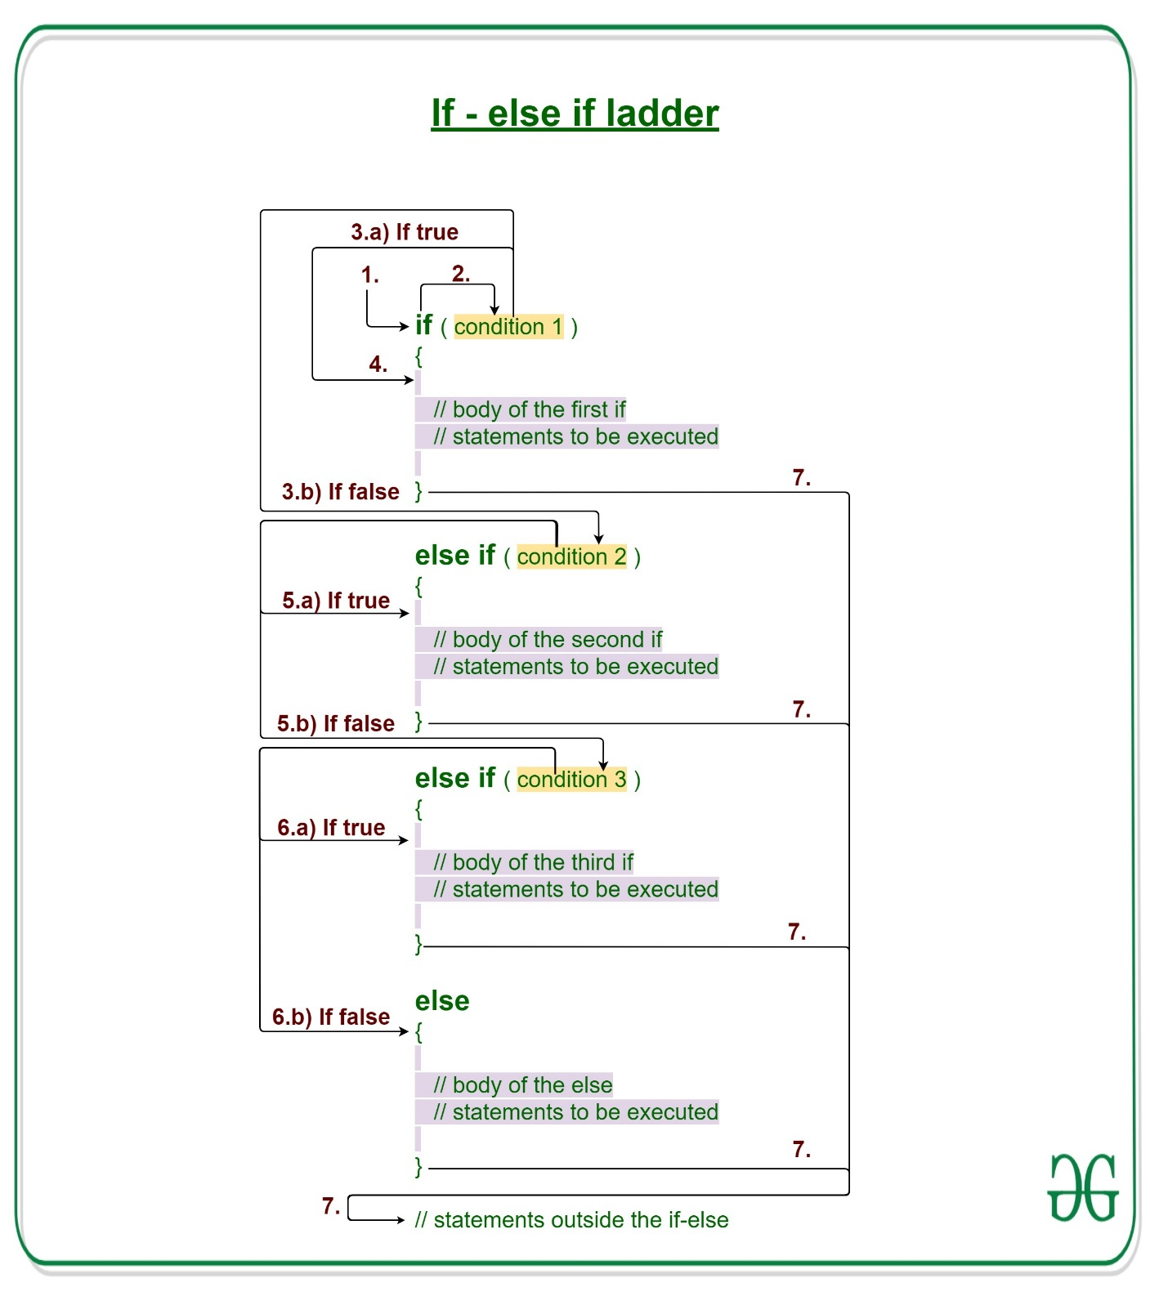

public class Main {
public static void main(String[] args) {
int val = 88;

if (val >= 100) {
System.out.println("value is equal or greater than 100");
} else if (val < 10 && val >= 0) {
System.out.println("value is greater than 10 but less than 100");
} else if (val < 0) {
System.out.println("value is less than 0");
} else {
System.out.println("value is equal or less than 10");
}
}
}

Switch-statements:
A switch statement is a control structure used to select one option among multiple choices based on the value of a single variable or expression.
It is an alternative to using multiple if-else-if statements when checking the same variable against different constant values.
Syntax:
switch (expression) {
case value1:
// Code to execute if expression == value1
break;
case value2:
// Code to execute if expression == value2
break;
...
default:
// Code to execute if no case matches
}

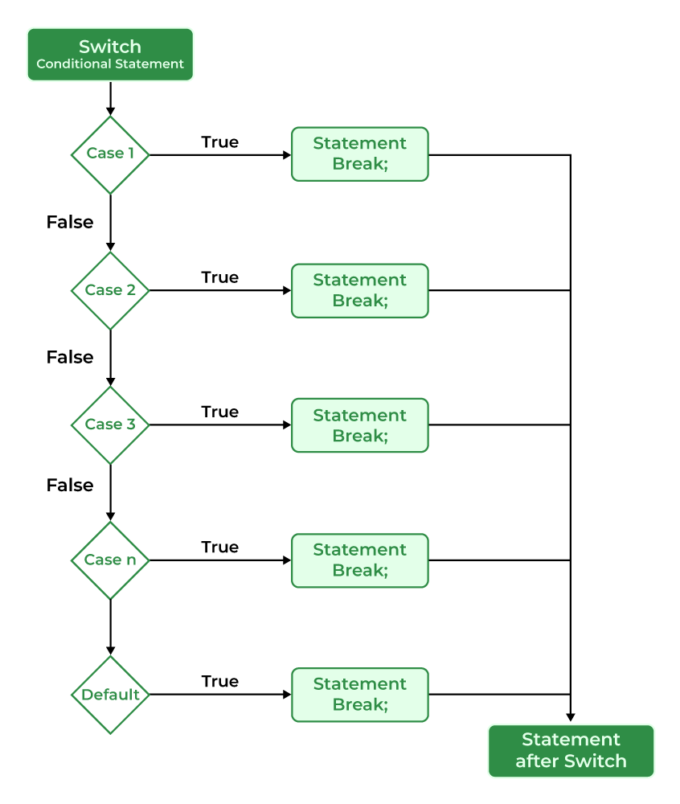

int day = 3;

switch (day) {
case 1:
System.out.println("Monday");
break;
case 2:
System.out.println("Tuesday");
break;
case 3:
System.out.println("Wednesday");
break;
default:
System.out.println("Invalid day");
}
Key Points:
- The switch expression must result in a byte, short, int, char, String, or enum.
- break is used to exit the switch after a matching case.
- default runs if no case matches (optional but recommended).

Looping Statements
A loop statement in programming is a control structure that repeats a block of code multiple times as long as a specified condition is true.
Purpose:
- To reduce code repetition.
- To automate repetitive tasks like printing, calculations, or processing data.
Types of loops

Loop Type | Description
for loop | Repeats code a specific number of times.
while loop | Repeats code while a condition is true.
do-while loop | Executes code at least once, then repeats while the condition is true.

for loop
Syntax:
for (initialization; condition; increment) {
// loop body
}
Example:
for (int i = 1; i <= 5; i++) {
System.out.println("i = " + i);
}
While loop
Syntax:
while (condition) {
// loop body
i++
}
Example:
int i = 1;
while (i <= 5) {
System.out.println(i);
i++;
}

do-while-loop:
syntax:
do {
// loop body
} while (condition);
Example:
int i = 1;
do {
System.out.println(i);
i++;
} while (i <= 5);

Jump Statements in Java
Jump statements in Java are used to control the flow of execution by transferring control to another part of the program. They allow a program to exit or skip certain blocks under specific conditions.

Types of Jump Statements in Java:
Jump Statement | Description
break | Exits a loop or switch statement immediately.
continue | Skips the current iteration and moves to the next loop cycle.
return | Exits from a method and optionally returns a value.

break:
for (int i = 1; i <= 5; i++) {
if (i == 3) break;
System.out.println(i);
}

continue:
for (int i = 1; i <= 5; i++) {
if (i == 3) continue;
System.out.println(i);
}

Ascii values: ASCII (American Standard Code for Information Interchange) is a character encoding standard that assigns unique numerical values to represent characters. It was developed in the 1960s to facilitate the exchange of information between different computer systems and devices.
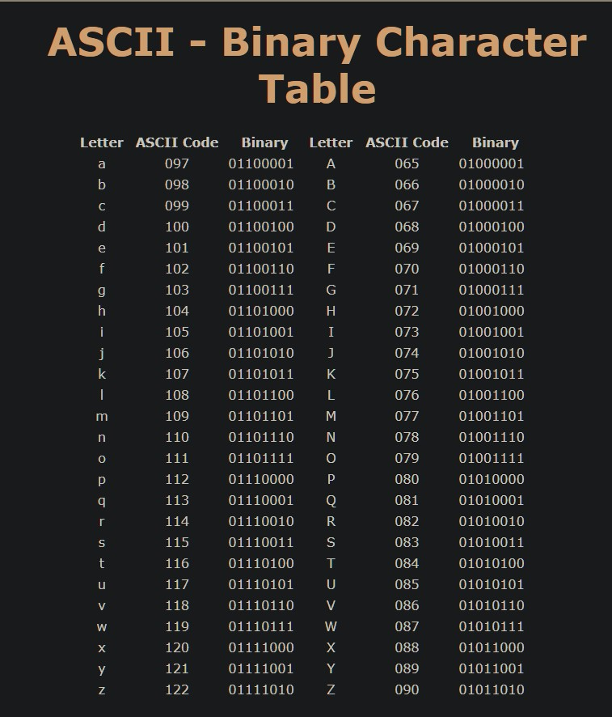

Array(1D, 2D, Jagged Arrays)
- What is an Array?
• A collection of similar data types stored in contiguous memory.
• Arrays are fixed in size and index starts from 0.
• Improves performance and readability when working with large datasets.

- Why Arrays?
- Instead of 100 individual variables, use 1 array of size 100.
- Arrays allow looping, sorting, searching, etc.

Declaration & Initialization
Rules for Array Instantiation:
1. At the time of array initializing an array compulsory we should specify the size otherwise we will get compile time error.
2. We can give array size as zero also.
3. We can’t have negative values as array size.
4. The allowed data types to specify array size are byte, short, char, int.
5. The maximum allowed array size in java is maximum value of int size.
6. Whenever we are creating an array every element is initialized with default value automatically

int[] arr = new int[5]; // Declaration with size
arr[0] = 10; // Assigning value
int[] arr2 = {10, 20, 30, 40}; // Declaration with initialization

//Java Program to illustrate how to declare, instantiate, initialize
//and traverse the Java array.
public class Main{
public static void main(String args[]){
//declaration and instantiation of an array
int a[]=new int[5];
a[0]=10;//initialization
a[1]=20;
a[2]=70;
a[3]=40;
a[4]=50;
//traversing array
for(int i=0;i<a.length;i++){//length is the property of array
System.out.println(a[i]);
}
}
}

In Java, you can declare, instantiate, and initialize an array in a single line, as demonstrated below:
int a[]={33,3,4,5};//declaration, instantiation and initialization
//Java Program to illustrate the use of declaration, instantiation
//and initialization of Java array in a single line
public class Main{
public static void main(String args[]){
//declaration, instantiation and initialization of an array
int a[]={33,3,4,5};
//traversing array
for(int i=0;i<a.length;i++)//length is the property of array
System.out.println(a[i]);
}
}

/*int a[]={33,3,4,5};

//Accessing Elements
/*System.out.println(a[0]);
System.out.println(a[1]);
System.out.println(a[2]);
System.out.println(a[3]);*/

//Update values
/*a[0]=45;
System.out.println(a[0]);*/

What is a 2D Array?
- It is an array of arrays.
- Acts like a matrix or table (rows & columns).
Declaration & Initialization
int arr[][]={{1,2,3},{4,5,6},{7,8,9}};
- This declares and creates a 2D array (matrix) with 3 rows and 3 columns.
- So, the total number of elements = 3 x 3 = 9.
- By default, all elements in this matrix are initialized to 0 (default value for int).

Program 1: Matrix Addition
public class MatrixAddition {
public static void main(String[] args) {

// Create first 2x2 matrix 'a' with values
int[][] a = {{1, 2},
{3, 4}};

// Create second 2x2 matrix 'b' with values
int[][] b = {{5, 6},
{7, 8}};

// Create a new 2x2 matrix 'sum' to store the result of addition
int[][] sum = new int[2][2];

// Loop through each row (i = 0 and 1)
for (int i = 0; i < 2; i++) {

// Loop through each column (j = 0 and 1)
for (int j = 0; j < 2; j++) {

// Add corresponding elements from a and b, store in sum
// Example: sum[0][0] = a[0][0] + b[0][0] = 1 + 5 = 6
sum[i][j] = a[i][j] + b[i][j];
}
}

// Print the final result (sum of the matrices)
System.out.println("Sum of matrices:");

// Use enhanced for loop to print each row of the result
for (int[] row : sum) { // for each row in sum matrix
for (int val : row) { // for each value in that row
System.out.print(val + " "); // print the value with space
}
System.out.println(); // move to the next line after each row
}
}
}

Program-2 : Print Diagonal elements
// Create a 3x3 matrix (2D array) with 3 rows and 3 columns
int[][] matrix = {
{1, 2, 3}, // row 0
{4, 5, 6}, // row 1
{7, 8, 9} // row 2
};

// Print a label to indicate we're showing diagonal elements
System.out.println("Diagonal Elements:");

// Loop through each row, using the same index for row and column
for (int i = 0; i < 3; i++) {
// Access the element where row index and column index are the same
// This gives the main diagonal elements
System.out.print(matrix[i][i] + " "); //1 5 9
}
}
}

Program-3: Transpose of a Matrix
Transposing a matrix means:
- Rows become columns
- Columns become rows

Example: Original Matrix:
1 2 3
4 5 6
After Transpose Matrix:
1 4
2 5
3 6

public class MatrixTranspose {
public static void main(String[] args) {

// Step 1: Create the original matrix with 2 rows and 3 columns
int[][] original = {
{1, 2, 3}, // Row 0
{4, 5, 6} // Row 1
};

// Step 2: Create an empty transpose matrix with 3 rows and 2 columns
// Because after transpose, rows become columns and columns become rows
int[][] transpose = new int[3][2];

// Step 3: Copy elements from original to transpose by swapping row and column index
// original[i][j] becomes transpose[j][i]
for (int i = 0; i < original.length; i++) { // Loop through rows of original (0 to 1)
for (int j = 0; j < original[0].length; j++) { // Loop through columns (0 to 2)
transpose[j][i] = original[i][j]; // Swap and assign values
}
}

// Step 4: Print the transposed matrix
System.out.println("Transposed Matrix:");

// Loop through rows of transpose matrix
for (int i = 0; i < transpose.length; i++) {
// Loop through columns of transpose matrix
for (int j = 0; j < transpose[0].length; j++) {
// Print each element followed by space
System.out.print(transpose[i][j] + " ");
}
// Print a new line after each row
System.out.println();
}
}
}

Reverse Diagonal- Program:
What is Reverse Diagonal?
In a square matrix, the reverse diagonal elements are the ones that go from top-right to bottom-left.
Example: Original Matrix
1 2 3
4 5 6
7 8 9
Reverse diagonal elements: 3, 5, 7
(index positions: [0][2], [1][1], [2][0])
// Loop through each row of the matrix
for (int i = 0; i < matrix.length; i++) {

// For reverse diagonal: Column index goes from right to left
// matrix.length - 1 - i means:
// i = 0 => j = 2 (last column)
// i = 1 => j = 1 (middle column)
// i = 2 => j = 0 (first column)
int j = matrix.length - 1 - i;

// Print the element at reverse diagonal position [i][j]
System.out.print(matrix[i][j] + " ");
}

What is a Jagged Array?
- A jagged array is an array of arrays, where each sub-array can have a different size.
- Useful when rows of data have different lengths.
Declaration & Initialization
// Declaration & Initialization of a jagged (irregular) 2D array in Java

// Declare a 2D array with 3 rows, but columns are not defined yet (jagged array)
int[][] jagged = new int[3][];

// Initialize the first row with 2 elements
jagged[0] = new int[]{1, 2}; // Row 0 → [1, 2]

// Initialize the second row with 3 elements
jagged[1] = new int[]{3, 4, 5}; // Row 1 → [3, 4, 5]

// Initialize the third row with 1 element
jagged[2] = new int[]{6}; // Row 2 → [6]

// Print the jagged array
for (int i = 0; i < jagged.length; i++) {
for (int j = 0; j < jagged[i].length; j++) {
System.out.print(jagged[i][j] + " ");
}
System.out.println(); // Newline after each row
}

Summary Chart to Revise
Type | Shape | Fixed Rows | Fixed Columns | Use Case
1D Array | Linear | Yes | N/A | Simple lists (marks, prices)
2D Array | Table | Yes | Yes | Matrix, chess board
Jagged Array | Irregular Row | Yes | No | Varying data like marks

