1. What is Web Application?
You open Google, YouTube, or Gmail in your browser.
You don’t install anything on your computer.
You just open a website and start using it.
That is called a Web Application.

Simple Example
Think of a Restaurant 🍔
- You → Customer
- Waiter → Browser
- Kitchen → Server
- Food → Response

Step-by-Step
- You order food → (Request)
- Waiter takes order to kitchen → (Browser sends request)
- Kitchen prepares food → (Server processes data)
- Waiter brings food → (Response shown in browser)
This whole system = Web Application

Technical Meaning
A Web Application is:
A software program that runs on a web server and is accessed through a web browser using the internet.

Components of Web Application

Client (User Side)
- Browser
- Mobile
- Laptop
Examples:
- Chrome
- Edge
- Firefox
Sends request

Web Server (Backend)
- Runs application logic
- Processes request
Examples:
- Apache Tomcat
- Node Server
- IIS
Handles business logic

Database
- Stores data
Examples:
- PostgreSQL
- MySQL
- Oracle
Saves information

How Web Application Works

User → Browser → Server → Database
↓
Response Sent Back
Example:
Student submits registration form:
Fill Form → Click Submit
↓
Servlet receives data
↓
JDBC saves into PostgreSQL
↓
JSP shows Success Page

Real-Life Web Application Examples
- Gmail
- Facebook
- Amazon
- Online Banking
- College Portal
- Student Result System

Website vs Web Application
Website | Web Application
Only information | Interaction
Read-only | Read + Write
Static | Dynamic

Example:
- College website → Website
- Student Login Portal → Web Application

A Web Application is a software application accessed through a web browser that interacts with a server and database to provide dynamic content.
Website = Reading Book
Web Application = Using App Online

HTTP Request & Response

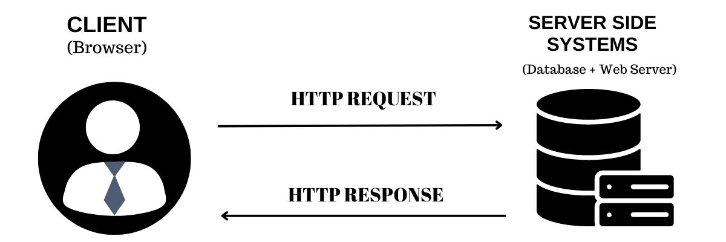
this concept is very important because Servlets work on HTTP Requests and Responses.

What is HTTP?
HTTP stands for:
HyperText Transfer Protocol
It is a communication protocol used to transfer data between client (browser) and server over the internet.

In simple words:
HTTP is the language used by browsers and servers to talk to each other.
Example:
- When you open google.com
- Your browser sends a request
- Server sends a response

What is HTTP Request?
An HTTP Request is a message sent by the browser to the server asking for something.
Example:
When a user:
- Opens a website
- Submits a form
- Clicks a login button
The browser sends a request to the server.

Example
Student clicks Login
Browser → Server
"Please check my username and password"
This message is called an HTTP Request.
-----------------------------------------------------------------------------------

What is HTTP Response?
An HTTP Response is the reply sent by the server back to the browser.
Example:
Server processes login details and sends response:
Server → Browser
"Login Successful"
or
Server → Browser
"Invalid Username or Password"
This reply is called an HTTP Response.

Request–Response Cycle
The communication works like this:
User → Browser → HTTP Request → Server
↓
User ← Browser ← HTTP Response ← Server

Example Flow
- User opens website
- Browser sends HTTP Request
- Server processes request
- Server sends HTTP Response
- Browser displays webpage

Real Example (Student Login System)

Step 1
Student fills form
Username: Rizwan
Password: 1234

Step 2
Browser sends request:
POST /login
username=Rizwan
password=1234

Step 3
Servlet processes request
  - Check database

Step 4
Server sends response
Login Successful
Welcome Rizwan

HTTP Request Methods
There are different types of requests.

GET
Used to retrieve data from server
Example: www.website.com/products
Characteristics:
- Data visible in URL
- Less secure
- Used for fetching data

POST
Used to send data to server
Example:
- Login
- Registration
- Payment
Characteristics:
- Data not visible in URL
- More secure
- Used for form submission

HTTP Request Components
An HTTP Request contains:
Request Method
GET
POST
PUT
DELETE
URL
/login
/register
/products

Headers
Information about request.
Example:
Content-Type
User-Agent
Body
Actual data sent.
Example:
username=rizwan
password=1234

HTTP Response Components
Server sends response containing:
Code | Meaning
200 | Success
404 | Page Not Found
500 | Server Error
403 | Forbidden

HTTP Response – Status Codes
When a server sends a response to the browser, it also sends a StatusCode.
A Status Code tells the browser whether the request was successful or if some error occurred.
It is a 3-digit number sent in the HTTP Response.
Status Code | Meaning | Explanation
200 | OK / Success | The request was successful and the webpage is displayed correctly.
404 | Page Not Found | The requested webpage or resource does not exist on the server.
403 | Forbidden | The server understood the request but does not allow access to the resource.
500 | Internal Server Error | Something went wrong on the server while processing the request.

Simple Example
When you open a webpage:
- Browser sends HTTP Request
- Server processes it
- Server sends HTTP Response + Status Code
Example response:
HTTP/1.1 200 OK
Content-Type: text/html
Here:
- 200 → Request successful
- Webpage loads normally

Headers
Information about response.
Example:
Content-Type: text/html

Body
Actual webpage content.
Example:
HTML page
JSON data
Image

Where Servlet Uses This?
Servlet handles:
- HttpServletRequest → Request from client
- HttpServletResponse → Response to client
Example Servlet Code:
protected void doPost(HttpServletRequest request, HttpServletResponse response) {
String username = request.getParameter("username");
PrintWriter out = response.getWriter();
out.println("Welcome " + username);
}
request → getting data from user
response → sending result to browser

Simple Real-Life Example:
Think of Online Food Order 🍕
Customer → Request
Restaurant → Response
Order Pizza → Request
Pizza Delivered → Response
Same way:
Browser → Request
Server → Response

HTTP Request is a message sent from client to server asking for a resource, and HTTP Response is the message sent from server back to the client with the requested data.

Static vs Dynamic Website
This is an important basic concept before learning Servlets and JSP, because Servlets and JSP are used to build Dynamic Websites.

1. What is a Static Website?
A Static Website is a website where the content remains the same for every user.
The server simply sends the fixed HTML page to the browser.
There is no database and no backend processing.

Example
A simple webpage like:
- College information page
- Company profile page
- Personal portfolio

Technologies Used
- HTML
- CSS
- Basic JavaScript

How Static Website Works:
User → Browser → Request → Web Server → HTML Page → Browser
The server directly sends the page without any processing.

Example
If 100 users open the same page:
➡ All users will see exactly the same content.

2. What is a Dynamic Website?
A Dynamic Website generates different content for different users.
The content is created dynamically using server-side programming and database.

Example
- Gmail
- Facebook
- Amazon
- Online Banking
- Student Portal
Each user sees different data.
Example:
- Student A → Sees his marks
- Student B → Sees his marks

Technologies Used
Frontend:
- HTML
- CSS
- JavaScript
Backend:
- Java (Servlets, JSP)
- Python
- PHP
- Node.js
Database:
- PostgreSQL
- MySQL
- Oracle

How Dynamic Website Works:
User → Browser → Request
↓
Web Server
↓
Server-side Program
(Servlet / JSP)
↓
Database
↓
Generate Result
↓
Send Response

Static vs Dynamic Website
Feature | Static Website | Dynamic Website
Content | Same for all users | Different for each user
Server Processing | No | Yes
Database | Not used | Used
Technologies | HTML, CSS | Servlet, JSP, JDBC
Speed | Faster | Slightly slower
Example | Portfolio Website | Gmail, Amazon

Relation with Our Training
In Our Java Web Development Training:
Technology | Purpose
HTML | Static pages
Servlet | Process request
JSP | Display dynamic data
JDBC | Connect database
PostgreSQL | Store data
Together they create a Dynamic Web Application.

One-Line Definition
Static Website: A website with fixed content that does not change for users.
Dynamic Website: A website that generates content dynamically using server-side programming and databases.

Servlet

What is a Servlet
A Servlet is a Java program that runs on a server and handles requests from users.
In simple words:
A Servlet receives requests from the browser, processes them, and sends responses back to the browser.

Simple Real-Life Example:
Think of a Restaurant System

Role | Web Application
Customer | User
Waiter | Servlet
Kitchen | Database
Food | Response

Process
- Customer orders food
- Waiter takes order to kitchen
- Kitchen prepares food
- Waiter brings food back

Same way:
Browser → Request → Servlet → Database → Servlet → Response → Browser
Here Servlet acts like the waiter.

Technical Definition:
Servlet is a server-side Java technology used to create dynamic web applications by handling HTTP requests and generating responses.

Where Servlet Runs
Servlet runs inside a Servlet Container.
Example containers:
- Apache Tomcat
- GlassFish
- Jetty
The container manages:
- Servlet lifecycle
- Request handling
- Response generation
Example flow:
Browser → Tomcat Server → Servlet → Response → Browser

How Servlet Works

Step-by-Step Flow
- User opens a webpage or submits a form
- Browser sends HTTP Request
- Web server forwards request to Servlet
- Servlet processes the request
- Servlet sends HTTP Response
- Browser displays the result

Flow diagram:
