1️. What is JDBC?
JDBC = Java Database Connectivity
It is an API in Java that allows Java programs to communicate with databases like:
- PostgreSQL
- MySQL
- Oracle
- SQL Server
Simple explanation:
JDBC is a bridge between Java application and Database.
Example:
Java Program → JDBC → Database
Real example:
Signup Form → Java Servlet → JDBC → PostgreSQL → Data Stored

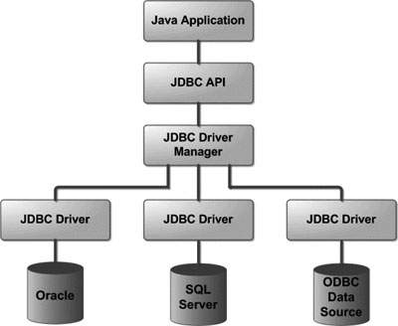

Step 1 — Java Application
Your Java program (Servlet, Java class).
Example:
LoginServlet.java

Step 2 — JDBC API
Java provides classes like:
Connection
Statement
PreparedStatement
ResultSet
These help interact with the database.

Step 3 — JDBC Driver
The driver converts Java commands into database commands.
Example driver:
postgresql.jar

Step 4 — Database
The database stores the data.
Example:
PostgreSQL
Table: users

3️⃣ JDBC Workflow Steps (7 Minutes)
Students must remember 5 main steps.

Step 1 — Import Package
import java.sql.*;
This imports JDBC classes.

Step 2 — Load Driver
Class.forName("org.postgresql.Driver");
This loads the PostgreSQL driver.
Explain simply:
Java loads the driver so it knows how to communicate with PostgreSQL.

Step 3 — Create Connection
Connection con = DriverManager.getConnection(
"jdbc:postgresql://localhost:5432/logindb",
"postgres",
"password");
Meaning:
localhost → database server
5432 → PostgreSQL port
logindb → database name

Step 4 — Execute Query
Example insert query:
PreparedStatement ps = con.prepareStatement(
"insert into users(username,email,password) values(?,?,?)");
Then:
ps.setString(1, username);
ps.setString(2, email);
ps.setString(3, password);
ps.executeUpdate();
Explain:
executeUpdate() → insert, update, delete
executeQuery() → select

Step 5 — Close Connection
Always close resources.
con.close();
Explain:
Closing connection releases database resources.

4️⃣ Simple JDBC Example (3 Minutes)
import java.sql.*;
public class TestDB {
public static void main(String[] args) {
try{
Class.forName("org.postgresql.Driver");
Connection con = DriverManager.getConnection(
"jdbc:postgresql://localhost:5432/logindb",
"postgres",
"password");
System.out.println("Database Connected");
}catch(Exception e){
e.printStackTrace();
}
}
}
Output:
Database Connected

5️⃣ JDBC Classes Students Should Know
Class | Purpose
DriverManager | Create DB connection
Connection | Connect Java with DB
Statement | Execute SQL query
PreparedStatement | Execute parameter queries
ResultSet | Store query results

6️⃣ JDBC in Real Project
Explain using your project example:
signup.jsp
↓
SignupServlet
↓
DBConnection.java
↓
JDBC
↓
PostgreSQL
Example:
User Signup → Data stored in users table
User Login → Data validated from database

7️⃣ One-Line Summary (Tell Students)
JDBC allows Java programs to interact with databases using SQL queries.
Flow:
Java Program
↓
JDBC API
↓
JDBC Driver
↓
Database

