1. What is Inheritance?
Inheritance is the mechanism in Java by which one class can acquire the properties (fields) and behaviors (methods) of another class.
Syntax:
class Parent {
// parent fields and methods
}

class Child extends Parent {
// child fields and methods
}
2. Benefits of Inheritance:
- Code Reusability
- Method Overriding
- Supports Polymorphism
3. Types of Inheritance in Java:
- Single Inheritance
- Multilevel Inheritance
- Hierarchical Inheritance

What is Single Inheritance?
In Single Inheritance, a class (child/subclass) inherits the properties and methods of only one parent (superclass).
It allows code reuse from one class to another.
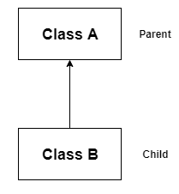
Syntax:
class Parent {
// parent class members
}

class Child extends Parent {
// child class members
}

Example Program (Single Inheritance):
class Animal {
void eat() {
System.out.println("This animal eats food");
}
}

class Dog extends Animal {
void bark() {
System.out.println("The dog barks");
}
}

public class Test {
public static void main(String[] args) {
Dog d = new Dog();
d.eat();
d.bark();
}
}

What is Multilevel Inheritance?
In Multilevel Inheritance, a class is derived from a derived class, meaning:
- Class C inherits from Class B
- Class B inherits from Class A
So, Class C indirectly inherits the properties and methods of Class A.
📌This forms a chain of inheritance.
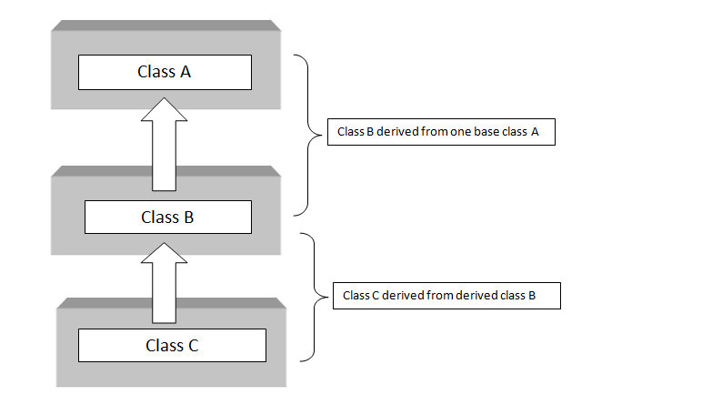
Syntax:
class A {
// base class
}
class B extends A {
// derived from A
}
class C extends B {
// derived from B (also indirectly inherits A)
}

Example Code:
//Base class (Parent)
class Animal {
int legs; // Instance variable to store number of legs
int hands; // Instance variable to store number of hands

// Constructor to initialize Animal's legs and hands
Animal(int legs, int hands) {
this.legs = legs; // 'this' keyword refers to the current object's variable
this.hands = hands;
}

// Method to display Animal's legs and hands
void show() {
System.out.println("Animal has " + legs + " legs and " + hands + " hands");
}
}

//Child class of Animal
class Dog extends Animal {

// Constructor of Dog class, calls parent (Animal) constructor using 'super'
Dog(int legs, int hands) {
super(legs, hands); // Call to superclass constructor to initialize inherited fields
}

// Method overriding: Dog provides its own version of the show() method
void show() {
System.out.println("Dog has " + legs + " legs and " + hands + " hands");
}
}

//Child class of Dog (Multilevel Inheritance: Animal -> Dog -> Puppy)
class Puppy extends Dog {

String weight; // Additional property for Puppy class

// Constructor for Puppy: initializes legs, hands (from Dog/Animal), and weight
Puppy(int legs, int hands, String weight) {
super(legs, hands); // Call to Dog (which internally calls Animal)
//The super keyword in Java is used to refer to the immediate parent class of a class.
this.weight = weight; // Initialize own property
}

// Method overriding: Puppy gives its own version of show() including weight
void show() {
System.out.println("Puppy has " + legs + " legs, " + hands + " hands, and weighs " + weight);
}
}

//Main class with entry point of the program
public class Single_inheritance {
public static void main(String[] args) {

// Creating an object of Animal with 4 legs and 0 hands
Animal a = new Animal(4, 0);
a.show(); // Calls Animal's show() method

// Creating a Dog object with 4 legs and 0 hands
Dog dog = new Dog(4, 0);
dog.show(); // Calls Dog's overridden show() method

// Creating a Puppy object with 4 legs, 0 hands, and 5kg weight
Puppy puppy = new Puppy(4, 0, "5kg");
puppy.show(); // Calls Puppy's overridden show() method
}
}

What is Hierarchical Inheritance?
In Hierarchical Inheritance, multiple child classes inherit from a single parent class.
📌 One parent class, but many child classes.

Animal ← (Parent)
/ \
Dog Cat ← (Children)
Example Program
// Parent class
class Animal {
void eat() {
System.out.println("Animal is eating");
}
}

// Child class 1
class Dog extends Animal {
void bark() {
System.out.println("Dog is barking");
}
}

// Child class 2
class Cat extends Animal {
void meow() {
System.out.println("Cat is meowing");
}
}

// Main class
public class TestHierarchicalInheritance {
public static void main(String[] args) {
// Dog object can access both Dog and Animal methods
Dog d = new Dog();
d.eat(); // inherited from Animal
d.bark(); // from Dog

// Cat object can access both Cat and Animal methods
Cat c = new Cat();
c.eat(); // inherited from Animal
c.meow(); // from Cat
}
}

What is Polymorphism?
Polymorphism means:
"One thing, many forms"
In Java, it means the same method (or function) can do different things depending on the object calling it.

🧸 Real-Life Example (Like a 10-year-old)
Imagine you have a remote control with a play button:
- If you use it on a TV, it plays a show.
- If you use it on a music player, it plays music.
- If you use it on a game console, it starts a game.
🔁 One button → Different actions → depending on the device.
That’s polymorphism!

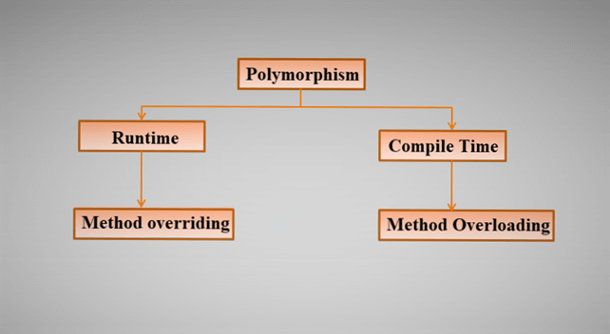

Type | Also Called | How It Works
Compile-time | Method Overloading | Same method name, different parameters
Runtime | Method Overriding | Subclass gives a new version of parent method

Compile-time Polymorphism (Method Overloading)
Compile time is the phase when the Java source code (.java file) is converted into bytecode (.class file) by the Java compiler (javac).
Method overloading:
Method Overloading is a concept in Java OOPs (Object-Oriented Programming) where multiple methods in the same class have the same name but different parameters (different number or types of arguments).

Why Use Method Overloading?
- To improve readability and reusability of code.
- To perform different tasks with the same method name depending on the arguments passed.

Rules of Method Overloading:
- Methods must have the same name.
- Must have different number or types of parameters.
- Return type can be same or different, but it does NOT matter in overloading.

public class Calculator {
// Method with 2 int parameters
public int add(int a, int b) {
return a + b;
}
// Method with 3 int parameters
public int add(int a, int b, int c) {
return a + b + c;
}

// Method with 2 double parameters
public double add(double a, double b) {
return a + b;
}

public static void main(String[] args) {
Calculator calc = new Calculator();

System.out.println(calc.add(2, 3)); // Output: 5
System.out.println(calc.add(1, 2, 3)); // Output: 6
System.out.println(calc.add(2.5, 3.5)); // Output: 6.0
}
}

What is Runtime Polymorphism? in Java:
Runtime is when your compiled Java program is executed using the Java Virtual Machine (JVM).
Polymorphism means "many forms." In Java, Runtime Polymorphism means:
The decision of which method to run is made during the program’s execution (at runtime), not while compiling.
This is done using Method Overriding.
What Is method overriding:
Method overriding in Java is a feature of object-oriented programming that allows a subclass to provide a specific implementation for a method that is already defined in its superclass.

🏠 Simple Analogy (ELI10 Style):
Imagine you have a remote control (Parent class) and two TVs (Child classes – SamsungTV and SonyTV).
Even though you press the same button (e.g., powerOn()),
- The SamsungTV will play Samsung’s startup sound
- The SonyTV will play Sony’s startup sound
Same method name, but different behavior depending on the object.
That’s runtime polymorphism!

// Parent class
class Animal {
void sound() {
System.out.println("Animal makes a sound");
}
}

// Child class 1
class Dog extends Animal {
@Override
void sound() {
System.out.println("Dog barks");
}
}

// Child class 2
class Cat extends Animal {
@Override
void sound() {
System.out.println("Cat meows");
}
}

// Main class
public class TestPolymorphism {
public static void main(String[] args) {
Animal a; // reference of parent

a = new Dog(); // Dog object
a.sound(); // Output: Dog barks

a = new Cat(); // Cat object
a.sound(); // Output: Cat meows
}
}
What’s happening here?
- The method sound() is overridden in both Dog and Cat.
- The reference variable a is of type Animal (parent), but it refers to different child objects.
- At runtime, Java checks what object a actually refers to and calls the right method.
  - new Dog() → calls Dog’s version of sound()
  - new Cat() → calls Cat’s version of sound()
🎯 This is runtime polymorphism (method overriding).

Rules of Method Overriding:
- Same method name and parameters as in the parent class.
- Child class gives its own version of the method.
- Happens only with inheritance.
- Must be non-static, because static methods are not overridden.

Where & Why We Use Method Overloading (Compile-time Polymorphism)
🔧 Use Case: Utility methods / calculators / services
When you want to perform similar operations with different inputs.
🔧 Use Case: Utility methods / calculators / services
When you want to perform similar operations with different inputs.

Where & Why We Use Method Overriding (Runtime Polymorphism)
🔧 Use Case: When working with parent-child class hierarchy — like in frameworks, web apps, or games.

What is a Block in Java?
A block in Java is a group of zero or more statements enclosed within curly braces {}.
It is used to group code together logically and control where and how code is executed.

Types of Blocks in Java (with Simple Examples):
1. Instance Initialization Block (IIB)
📌 Runs every time an object is created, before the constructor.
class Example {
// Instance Initialization Block (IIB)
// This block runs **every time** an object is created,
// and it runs **before the constructor**.
{
System.out.println("Instance block called");
}

// Constructor: Called after the instance block when a new object is created.
Example() {
System.out.println("Constructor called");
}

// Main method: Starting point of program execution
public static void main(String[] args) {

// Creating first object of Example class
// This will trigger:
// 1. Instance block
// 2. Then constructor
Example obj1 = new Example();

// Creating second object of Example class
// Again, it will trigger:
// 1. Instance block
// 2. Then constructor
Example obj2 = new Example();
}
}
2. Static Block
📌 Runs only once when the class is loaded (before the main() method or any object is created).
class StaticExample {

// Static block: This block is executed only **once**
// when the class is **loaded into memory** by the JVM,
// before the main method or any object creation.
static {
System.out.println("Static block executed");
}

// Main method: The entry point of any Java application.
// This is executed after the static block.
public static void main(String[] args) {
System.out.println("Main method executed");
}
}
Output:
Static block executed
Main method executed

3. Local Block / Method Block
📌 Used inside a method to group statements — typically in if, for, while, etc.

Example:
class LocalBlockExample {
public static void main(String[] args) {
int x = 10;
if (x > 5) {
// This is a block inside if condition
System.out.println("X is greater than 5");
}
}
}

4. Synchronized Block (Advanced/Multithreading)
📌 Used to prevent thread conflicts in multithreaded code.
// Define a class named SyncExample
class SyncExample {

// Method to print multiplication table for a given number 'n'
// This method contains a synchronized block to ensure thread safety
void printTable(int n) {

// Synchronized block ensures that only one thread
// can execute this block on the same object at a time
synchronized(this) {

// Loop to print n * 1 to n * 5
for (int i = 1; i <= 5; i++) {
// Print the multiplication step
System.out.println(n + " * " + i + " = " + (n * i));

// Pause for 500 milliseconds to simulate delay and visualize thread behavior
try {
Thread.sleep(500); // Makes the current thread sleep for 0.5 seconds
} catch (Exception e) {
System.out.println(e); // Print exception if any
}
}
}
}

// Main method: entry point of the Java program
public static void main(String[] args) {

// Create a shared object of SyncExample
SyncExample obj = new SyncExample();

// Create first thread t1 using lambda expression
// It will call printTable(2) on shared object
Thread t1 = new Thread(() -> obj.printTable(2));

// Create second thread t2 using lambda expression
// It will call printTable(5) on the same shared object
Thread t2 = new Thread(() -> obj.printTable(5));

// Start both threads
t1.start(); // Starts execution of thread t1
t2.start(); // Starts execution of thread t2
}
}

2 * 1 = 2
2 * 2 = 4
2 * 3 = 6
2 * 4 = 8
2 * 5 = 10
5 * 1 = 5
5 * 2 = 10
5 * 3 = 15
5 * 4 = 20
5 * 5 = 25

What is Aggregation in Java?
Aggregation is a concept in Java where one class has a reference to another class, meaning it "has-a" relationship.
It’s a form of association that represents a "whole-part" relationship, but with weaker bonding — the child (part) can exist independently of the parent (whole).

Real-Life Example:
A Library has-a set of Books.
Even if the library is closed, books still exist — this is aggregation.

// Book class - This is the "part" in the aggregation relationship.
// A Book object can exist independently without a Library.
class Book {
String title; // Instance variable to store the title of the book

// Constructor to initialize the book's title
Book(String title) {
this.title = title;
}
}

// Library class - This is the "whole" in the aggregation relationship.
// It has a reference to a Book object (i.e., it "has-a" Book)
class Library {

// Aggregation: Library has a Book
Book book; // This is not creating a Book object here, just referencing it

// Constructor: Accepts a Book object as a parameter and assigns it
Library(Book book) {
this.book = book; // Aggregation: linking existing book to library
}

// Method to display book details from the library
void showBook() {
System.out.println("Library has book: " + book.title);
}

// Main method: entry point of the Java program
public static void main(String[] args) {

// Create a Book object independently (not inside Library)
Book b1 = new Book("Java Programming"); // Book can exist independently

// Pass the Book object to the Library constructor
Library lib = new Library(b1); // Aggregation: Library uses existing book

// Call the method to show book title from the library
lib.showBook();
}
}

