

The Sims™ 4

THE SIMSTM 4: ISLAND LIVING
Browse this pack’s content and get inspired by more fashion, furniture, hairstyles, and décor. Imagine what you’ll make next!

Engage in Local Culture

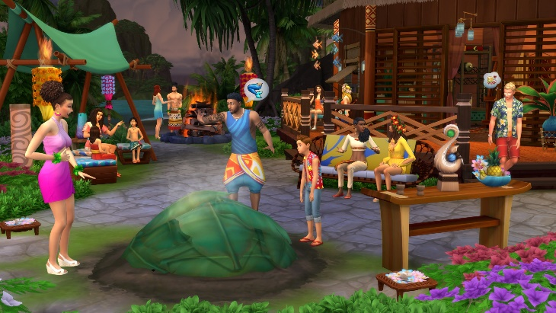
Tradition runs deep on Sulani, and your Sims get to experience everything it has to offer. Immerse Sims in their newfound lifestyle by attending a pit barbecue event, learning about local folklore, tasting tropical delicacies and chatting with ancestors from the island.

