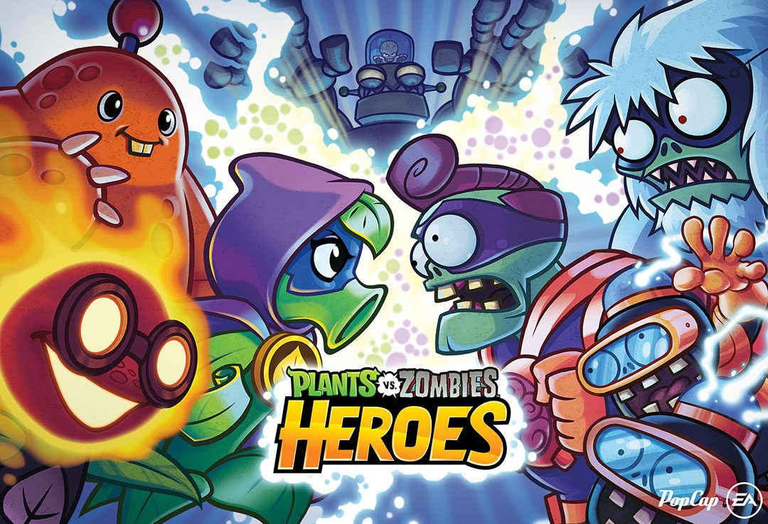

PLANTS VS. ZOMIES HEROES

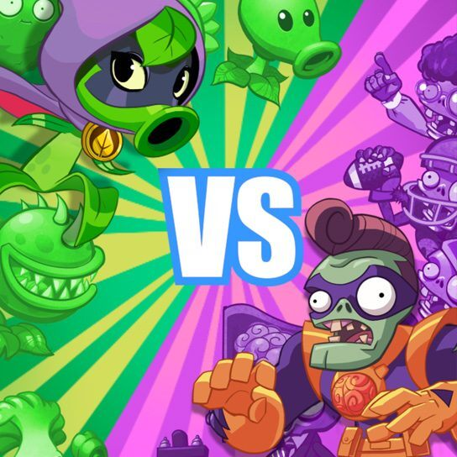

ABOUT THIS GAME:
Plants vs. Zombies Heroes is a digital collectible card game in the Plants vs. Zombies series, developed by Pop Cap Games and published by Electronic Arts. On March 10, 2016, it underwent a soft launch in some countries on iOS, before being internationally released on October 18, 2016.

