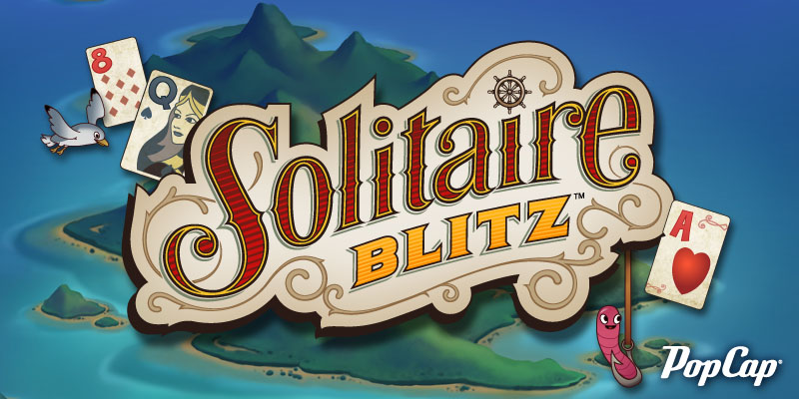

ABOUT THIS GAME:
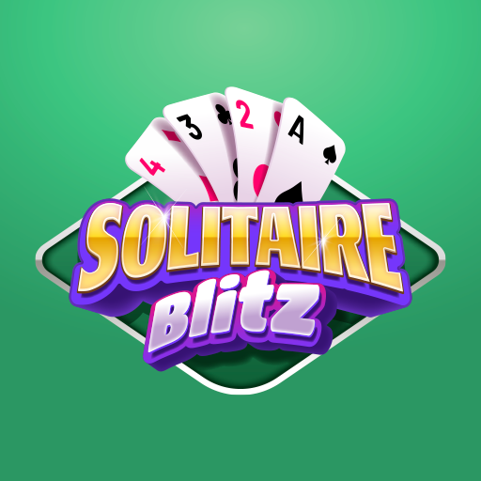 Solitaire Blitz brings exciting multiplayer game play with the perennial Klondike Classic - all for FREE. Featuring smooth gameplay, a classy look, and quirky twists, Solitaire Blitz has something for everyone. Discover multiple tournament formats, weekly challenges, and leagues to connect with the community

