
About This Game:
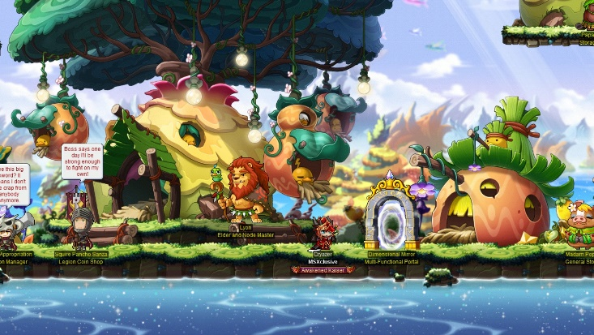
Maple Story is a free-to-play, 2D, side-scrolling massively multiplayer online role-playing game, developed by the South Korean company Wizet. Several versions of the game are available for specific countries or regions and published by various companies. Wikipedia
Initial release date: April 29, 2003
Developers: Nexon, Wizet
Genres: Massively multiplayer online role-playing game, MORE
Composers: M2U, Studio EIM, CODASOUND, ASTERIA
Series: Maple Story
Mode: Multiplayer video game
Publishers: Nexon, Gamania Digital, Nexon America Inc.

