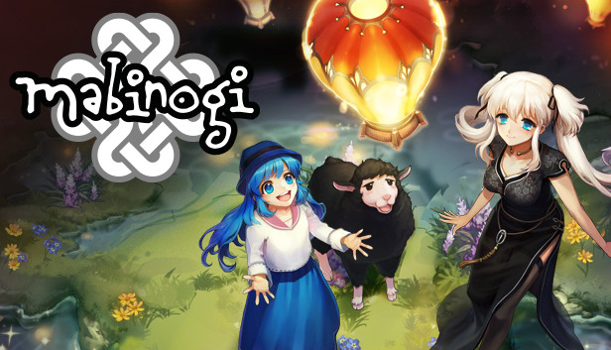
About This Game:
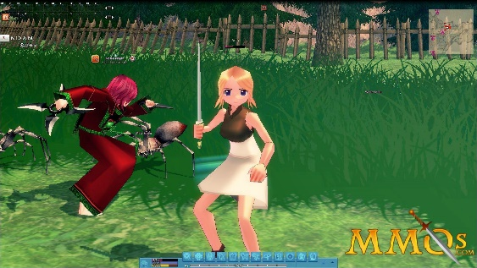
The world's most expressive MMORPG, where you create a unique character and live your fantasy life. Enter the mystical land of Erin, where a century-old battle threatens the balance of the known world. Explore exotic locales, defeat mighty foes, and follow the path to destiny.
Mabinogi is a massively multiplayer online role-playing game released by Nexon and developed by dev studio. The name of the game is taken from the Welsh word Mabinogi, a Welsh anthology of legend, and the settings for the game are loosely based on Welsh mythology. Wikipedia
Developers: Nexon, dev CAT studio, NEXON Korea
Engine: Source
Initial release date: June 22, 2004
Platform: Microsoft Windows
Publishers: Nexon, Gamania Digital, Nexon America Inc.
Genres: Massively multiplayer online role-playing game, MORE
Mode: Multiplayer video game

