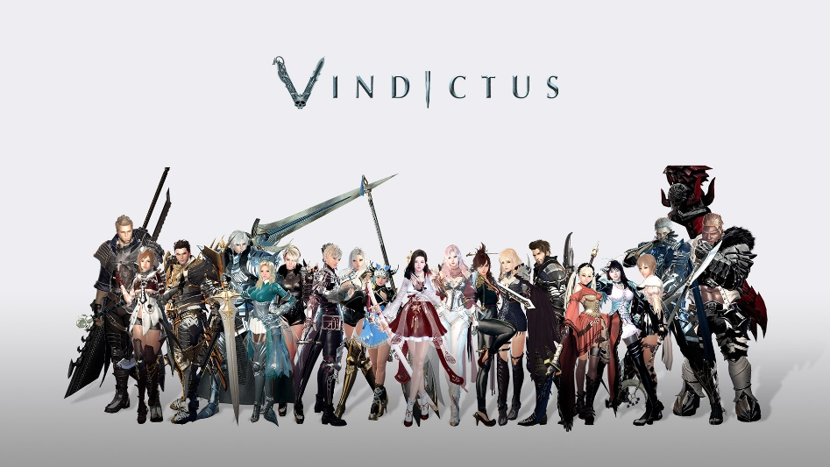
About This Game:
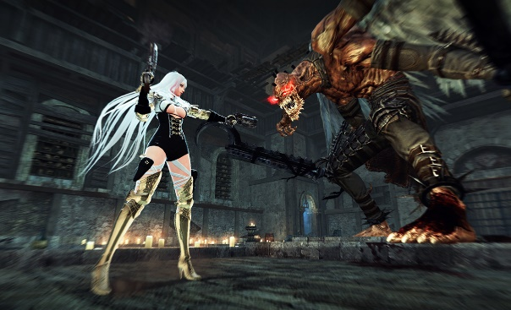
Vindicates is an action massively multiplayer online role-playing game created by dev CAT, an internal studio of Korean free-to-play game publisher Nexon. Vindicates is a prequel to the MMORPG Mabinogi and is known as Mabinogi Heroes in Asia. Wikipedia
Developers: Nexon, dev CAT studio, dev CAT
Engine: Source
Platform: Microsoft Windows
Publishers: Nexon, Tiancity, NEXON Korea Corp. & NEXON America Inc.
Initial release date: January 21, 2010
Mode: Multiplayer video game
Genres: Massively multiplayer online role-playing game, MORE

