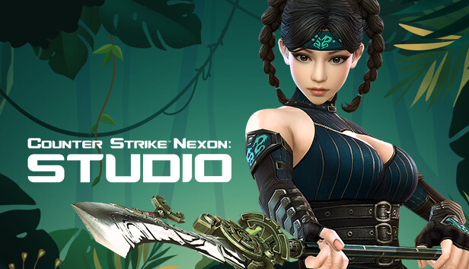
About This Game:
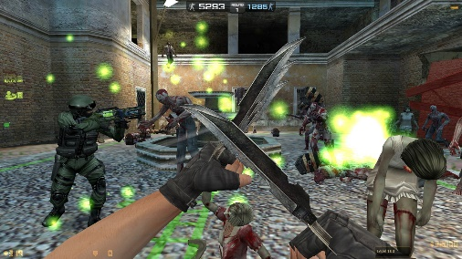
Counter-Strike Nexon: Studio is a Free to Play MMOFPS offering competitive PvP and PvE action including content from the original Counter-Strike and all-new game modes, map creation function, weapons, and hordes of Zombies! Recent Reviews: Mixed (169) - 61% of the 169 user reviews in the last 30 days are positive.07-Oct-2014

Counter-Strike Nexon: Studio on Steam
https://store.steampowered.com › app › CounterStrike_Ne...

Developer: Valve Corporation, Nexon Korea Corporation
Platform: Microsoft Windows
Publishers: Nexon, Nexon Europe S.A.R.L.
Series: Counter-Strike
Genres: Action game, Free-to-play, Casual game, Massively Multiplayer
Initial release date: October 7, 2014

