
About This Game:
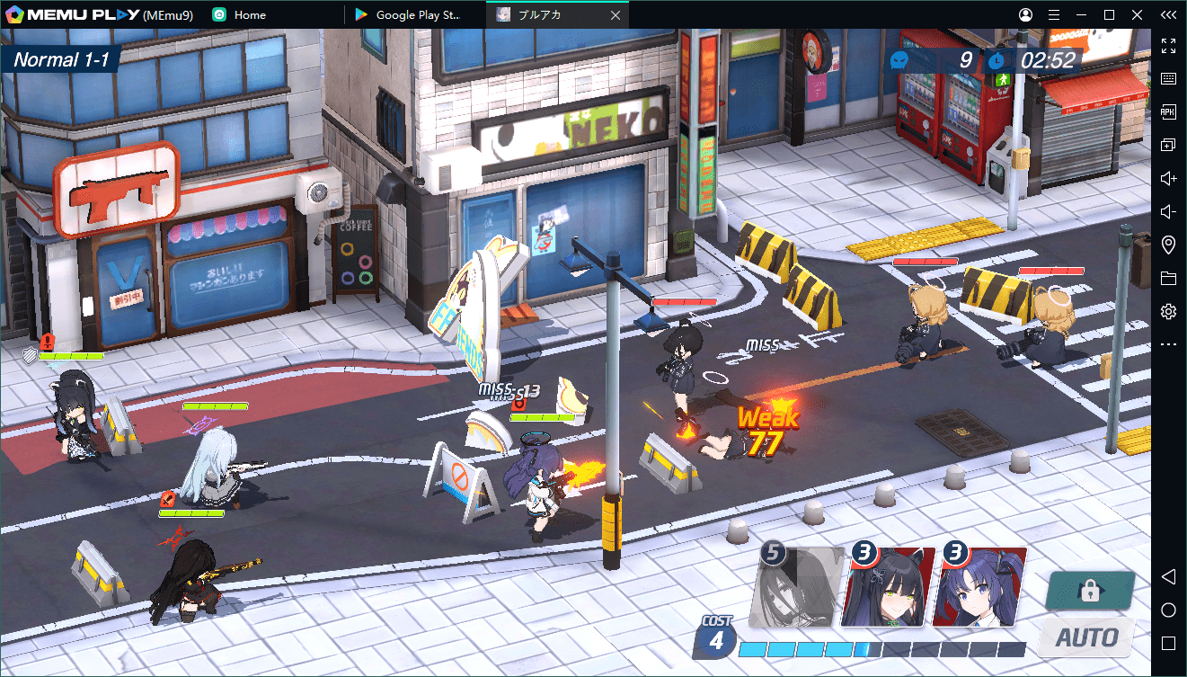
Blue Archive is a role-playing game developed by Nexon Games, a subsidiary of Nexon. It was released in 2021 for Android and iOS, first in Japan by Yostar and worldwide later that year by Nexon. The game is free-to-play with Gacha game mechanics as a means to obtain new characters.
Developers: Nexon, NEXON Games Co., Ltd.
Platforms: iOS, Android
Publishers: Nexon, Yostar, Inc., NEXON Korea
Genre: Tactical role-playing game
Initial release date: February 4, 2021
Original author: Nexon
Composers: Mitsukiyo, KARUT

