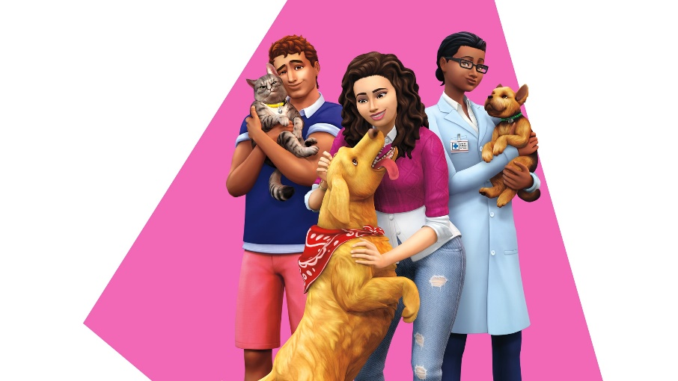

The Sims™ 4 : CATS & DOGS

Create cats and dogs

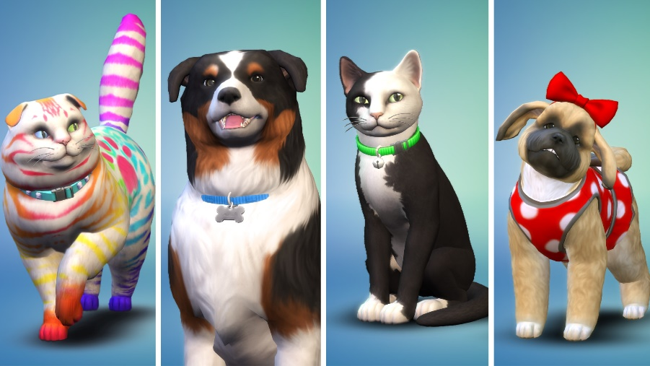
Use the powerful Create A Pet tool to customize your Sims’ perfect cats, dogs, puppies, and kittens. Choose from a variety of breeds, give them distinct personalities, and directly manipulate their features. Easily personalize their coats with unique patterns to create your real-life pets, dream pets, or something more fanciful. For the first time, complete their looks with expressive outfits and accessories.

