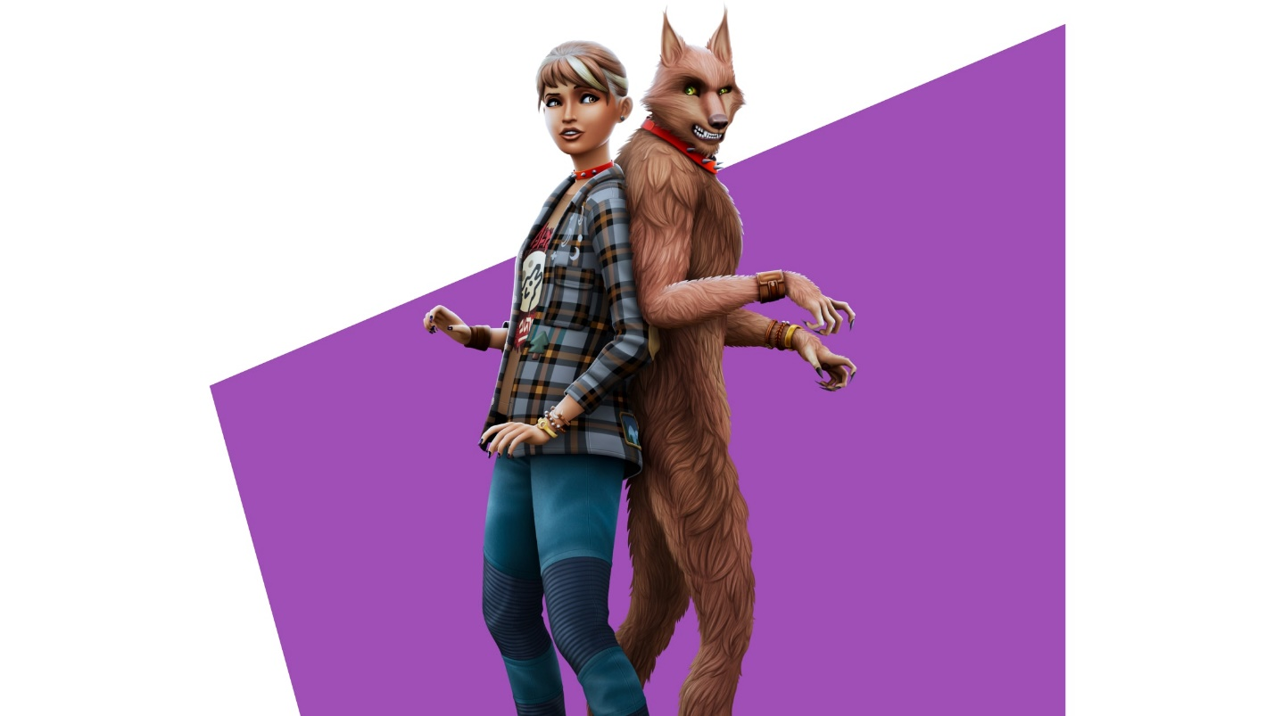

The Sims™ 4:WEREWOLVE

Life on the Wild Side:
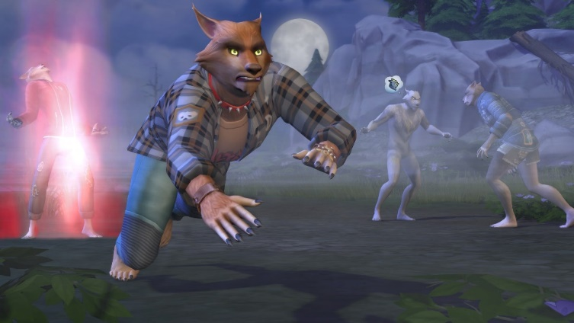

What big teeth you’ll have! Transform into a werewolf and embrace (or fight) your animalistic nature. Beyond rocking a fearsome form werewolf Sims will have unique temperaments and abilities, be affected by the phase of the moon, and experience wolf-specific life events.

