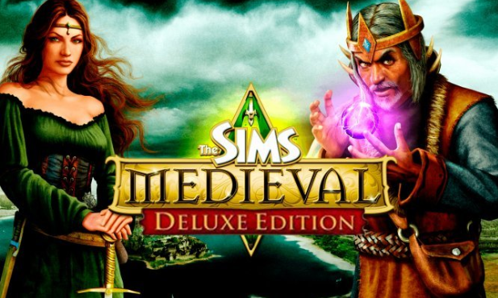

## **The Sims™ 4**

## **Medival: Deluxe Edition.**

***The Sims Medieval: Deluxe Edition*** (also known as ***The Sims Medieval: Deluxe Pack***) is the first and only compilation of *The Sims Medieval* games. It includes [*The Sims Medieval*](https://sims.fandom.com/wiki/The_Sims_Medieval) base game and its [adventure pack](https://sims.fandom.com/wiki/Expansion_pack), [*Pirates and Nobles*](https://sims.fandom.com/wiki/The_Sims_Medieval:_Pirates_and_Nobles)*.* It was released in mid-December 2011.[[1]](https://sims.fandom.com/wiki/The_Sims_Medieval:_Deluxe_Edition#cite_note-SimsVIP-1) It is currently only available for PC download on Origin.[[2]](https://sims.fandom.com/wiki/The_Sims_Medieval:_Deluxe_Edition#cite_note-Origin.com-2)

**DESCRIPTION:**

Do you ever wish you lived in that glorious time when men were knights, women were princesses, and cities were kingdoms ruled by kings in large castles? Or would you rather be a pirate out hunting for rare treasure with a hook for a hand and a parrot on your shoulder? Download The Sims Medieval Deluxe Pack for your PC and you can have it both ways