## https://cdn.cloudflare.steamstatic.com/steam/apps/3380/header.jpg?t=1584806787

## ***DYNOMITE DELUXE***

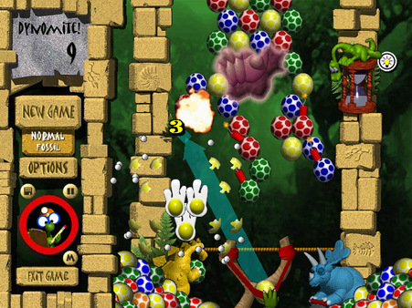

##### ***ABOUT THIS GAME:***

**It's prehistoric egg-blasting fun! Use your slingshot to match three or more dyno eggs of the same color... and watch them explode! Can you blast all the eggs before Mama Brontosaurus tramples your game?**