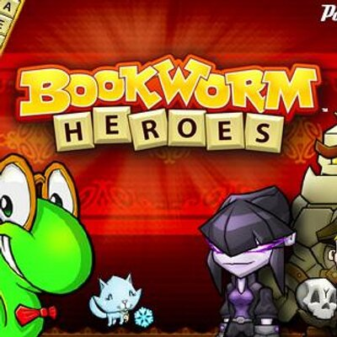

##### ***ABOUT THIS GAME:***



**Bookworm is a word-forming puzzle video game by Pop Cap Games. From a grid of available letters, players connect letters to form words. As words are formed, they are removed from the grid and the remaining letters collapse to fill the available space.**