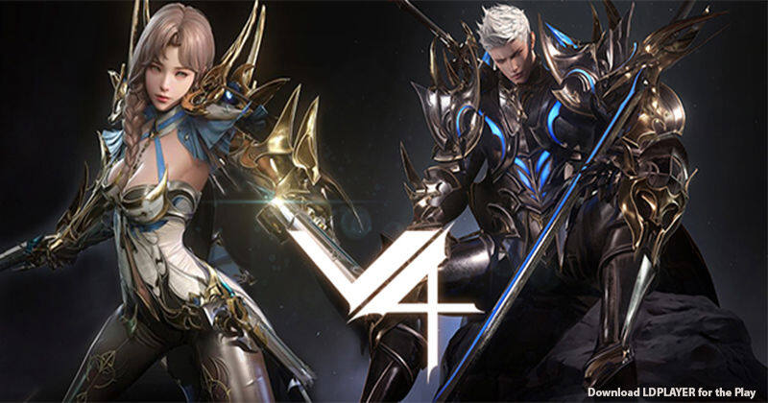

V4 Gaming

About this Game:

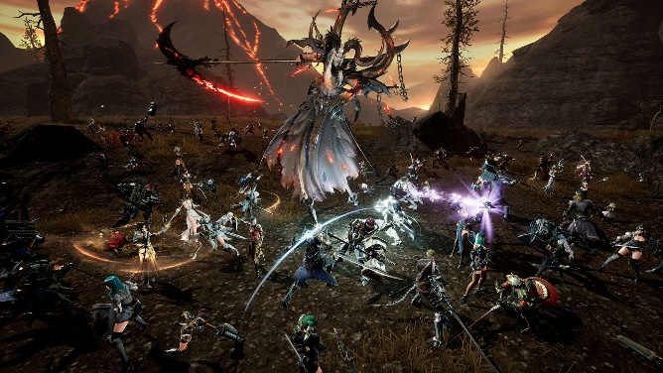

Raise your weapon and deal critical damage across a gorgeous open world in the newest cross-platform MMORPG!  
  
Explore a breathtaking world rendered in exquisite detail, customize your character exactly the way you desire, and level up your gear to prepare for massive battles across dimensions! Will you bring peace? Or war? Enter the world of V4 and discover victory beyond boundaries!