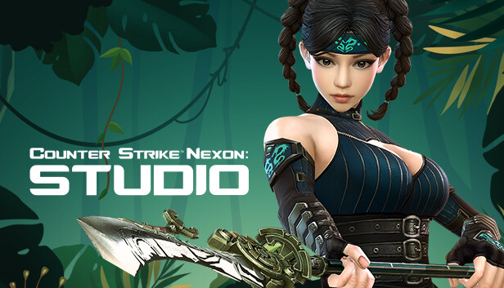

About This Game:

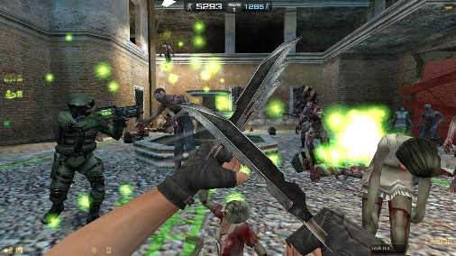

Counter-Strike Nexon: Studio is a Free to Play MMOFPS offering competitive PvP and PvE action including content from the original Counter-Strike and all-new game modes, map creation function, weapons, and hordes of Zombies! Recent Reviews: Mixed (169) - 61% of the 169 user reviews in the last 30 days are positive.07-Oct-2014

### **[Counter-Strike Nexon: Studio on Steam](C:\\Users\\n.comp\\Desktop\\html\\e-project\\E.project Tangoline\\document\\Counter-Strike Nexon: Studio on Steamhttps:\\store.steampowered.com › app › CounterStrike_Ne)**

[https://store.steampowered.com › app › CounterStrike\_Ne...](C:\\Users\\n.comp\\Desktop\\html\\e-project\\E.project Tangoline\\document\\Counter-Strike Nexon: Studio on Steamhttps:\\store.steampowered.com › app › CounterStrike_Ne)

**Developer:**[Valve Corporation, Nexon Korea Corporation](https://www.google.com/search?bih=730&biw=1517&rlz=1C1UEAD_enPK1023PK1023&hl=en-US&q=Valve+Corporation,+Nexon+Korea+Corporation&si=AEcPFx7eHRJU0tWbjC5cc2C2rVygfPuoetC2JDc0IDqLp89f-MxxPLIzVn1gbeEMKjmkd4pAvPwEJta3YbE44GCAHHypdk9zGrN7sA7X0nBZZevUKPoEfpJtwFRMLmxLMWyknarNmz4RQydN7-m_Hg77h0wYdIcALe5rI1YyDNCNas4_2-vHyFGTqcEHnEY2oNy-mUznJrQVe5ia4GT0FFNvn6FRP2XVyItfBA4AGZbpMczNFyhVRF-8tFZLcxvwJf6UHSOdejnW&sa=X&ved=2ahUKEwjr__24t_P8AhWXUqQEHbjkBC4QmxMoAHoECHQQAg)

**Platform:**[Microsoft Windows](https://www.google.com/search?bih=730&biw=1517&rlz=1C1UEAD_enPK1023PK1023&hl=en-US&q=&si=AEcPFx6l3RvH8SFlhHZyn7jIc6m2bU9vmoFvFAMQv2WWSYjXN6KOY9Zc3989XIph-eI6gQkLvN5PtUEQTm2jY4IibNWZvXE8F7JKufC7U0v6yd5U4pGKSvBHiwEGYvjLco9kWB1qwIhsoI6iiSv1CvSG6DJUIPZT1hT3vozrIfTeKFvpfPTegbPABB2ha_u1YmsfP18dtBsA&sa=X&ved=2ahUKEwjr__24t_P8AhWXUqQEHbjkBC4QmxMoAHoECHMQAg)

**Publishers:**[Nexon](https://www.google.com/search?bih=730&biw=1517&rlz=1C1UEAD_enPK1023PK1023&hl=en-US&q=Nexon&si=AEcPFx7HnMxbNS2egwqbd2fGseeWkZi3ZCVlQ3vY-NLoLE7SWY2TSBgmXrm6MsqUMyhE1Ahjj15eoZzKujCAExddjytmSai7p0Lj2FYk02Zc0CKJS2g9r5c7AYD8SRJ363xfs0aJ-CmzGWScIs6R8t5SseQJGBToa6HMoqjiIXFNfLFEUjaM0IUvsDwPcbvkwhsoR9siiEkePR-w22WgV938QyKikcv5f4yIHG8OCzMJ8I_b6L7j2OOdMscRwN3aFyp1j5eynQ6p&sa=X&ved=2ahUKEwjr__24t_P8AhWXUqQEHbjkBC4QmxMoAHoECGkQAg), [Nexon Europe S.A.R.L.](https://www.google.com/search?bih=730&biw=1517&rlz=1C1UEAD_enPK1023PK1023&hl=en-US&q=Nexon+Europe+S.A.R.L.&si=AEcPFx7eHRJU0tWbjC5cc2C2rVygfPuoetC2JDc0IDqLp89f-CfqOXJbr0CRSPJgDNijbq8ifB37mYGACoYAtt-nnQ0kbCkyToEOmXYdBfPGEqgSy6GXhNgPT6ETVDunEW8rCj0gxlqVVvHK-l-vFLuTwPdc8WYVuqVZHEXznVOvHkliM121jnIn9AJcHhcErh3HXpJuXgA2oNOSeISo2cTkP-ai0MGquwqnnBRHO6F8L7uQHcncNc1U0Mmmu9vcyrI17wyXw52TabGSYinDs7R-gl8wNcMRGg%3D%3D&sa=X&ved=2ahUKEwjr__24t_P8AhWXUqQEHbjkBC4QmxMoAXoECGkQAw)

**Series:**[Counter-Strike](https://www.google.com/search?bih=730&biw=1517&rlz=1C1UEAD_enPK1023PK1023&hl=en-US&q=Counter-Strike&si=AEcPFx7HnMxbNS2egwqbd2fGseeWkZi3ZCVlQ3vY-NLoLE7SWUzG665Jj3y_SWkwOCURnHImigE-HgQeSrSCvErfSsBwN_K61uUnzZ-h9Has9CEio-BWtYjzZB3xYjFF7GXmCoDkcrVT8uXhsgVM5_1MkXtsjceAsiG957_NmsI66johhLzp1ttQbCuqk5FC0-pxbsx-5bpUm7fFFXM7tFn1SfdJyuXwrQ%3D%3D&sa=X&ved=2ahUKEwjr__24t_P8AhWXUqQEHbjkBC4QmxMoAHoECGAQAg)

**Genres:**[Action game](https://www.google.com/search?bih=730&biw=1517&rlz=1C1UEAD_enPK1023PK1023&hl=en-US&q=&si=AEcPFx5y3cpWB8t3QIlw940Bbgd-HLN-aNYSTraERzz0WyAsdLr-5PWX3hxNCOsw7UdRoCp48hrOS7DoTyUrbm5TeFCCO9Vyl_RL_ujM7OW3B9l6fXi8EQKMYBOhu6_t7TbkLFJBTTgWXlxJivagrjZwmIYjSUwdadIw07z_YY-UWaVJ6iREctcY66-0FHoeKCiZ5IIu_CYdEFWBqz8X_4CIcyL8yyGNOmzPMUVYvG-xDaCpWuXkFUkIXSo7nOJPVbzYJQkMyoi325pANV2Mf0AnMCEkXDCfTw%3D%3D&sa=X&ved=2ahUKEwjr__24t_P8AhWXUqQEHbjkBC4QmxMoAHoECGQQAg), [Free-to-play](https://www.google.com/search?bih=730&biw=1517&rlz=1C1UEAD_enPK1023PK1023&hl=en-US&q=&si=AEcPFx5y3cpWB8t3QIlw940Bbgd-HLN-aNYSTraERzz0WyAsdDSXMy6UGMXEYjkuekPjETj_us3MNAgoiwKFQc3jC58D4rDPb7dJ7lBr3-1viGVcH_MfMGMdZhPbr9g20fsJpiqHm-2G0aNAri57VSsdJhusms9OSxi1DElOH3KCv7RhgIThsh_Xioq6j80iEHXvvjXwqtzn1O0vSBDdAsWwoiQ0F8fizrsOEcH-JoRdDDCz-coUIPykd2fPFlkvKtF9mH9DMPHWdXh8i_PSdULiesyvM4wPbQ%3D%3D&sa=X&ved=2ahUKEwjr__24t_P8AhWXUqQEHbjkBC4QmxMoAXoECGQQAw), [Casual game](https://www.google.com/search?bih=730&biw=1517&rlz=1C1UEAD_enPK1023PK1023&hl=en-US&q=&si=AEcPFx5y3cpWB8t3QIlw940Bbgd-HLN-aNYSTraERzz0WyAsdOps7FfVVPNdojJHuoRSERWWwyAV8gAtpYcicFvNPEo7gDM-n5nGaRN7Gqu69HYv0ouaJDtjrJpBdjxJx0c44vPa3yGs5svBclUXujoemXcaBBioXGGoS6rBj5eLmVOx0y5bAjnuCf2NpAvl4albkG4a50oqBDHoVNYI0PwzVWf9ownnLfRqe3tTN-ttZglPIFIjb1F33UnooN0nN6OC8pMZehDOsVIN1l8GjEpnNtbVkl9OSA%3D%3D&sa=X&ved=2ahUKEwjr__24t_P8AhWXUqQEHbjkBC4QmxMoAnoECGQQBA), [Massively Multiplayer](https://www.google.com/search?bih=730&biw=1517&rlz=1C1UEAD_enPK1023PK1023&hl=en-US&q=&si=AEcPFx7eHRJU0tWbjC5cc2C2rVygfPuoetC2JDc0IDqLp89f-Hnehh9yocw-ir4uBeWK-EvlwteO9Fht_-pZ6twn8gJDtUDN5SNHsGfyQLsaOjs8ky1QRwFRPL5L9C_hXr9vtjwZ0ITiLEtf1ugQGAilP60n6sfPFjpW-SVETA4dfDuiukzZJ1LLqcbXgR75P0tcfeqoslulgssLd8ZI4MDxNCnxRzyKD_D31GBbYkBpLT08oBLBg4bjZuZElQIc-8bpKRKowvaHfAQegRyRbvaMZSMA_URdFg%3D%3D&sa=X&ved=2ahUKEwjr__24t_P8AhWXUqQEHbjkBC4QmxMoA3oECGQQBQ)

**Initial release date:**October 7, 2014