

About This Game:

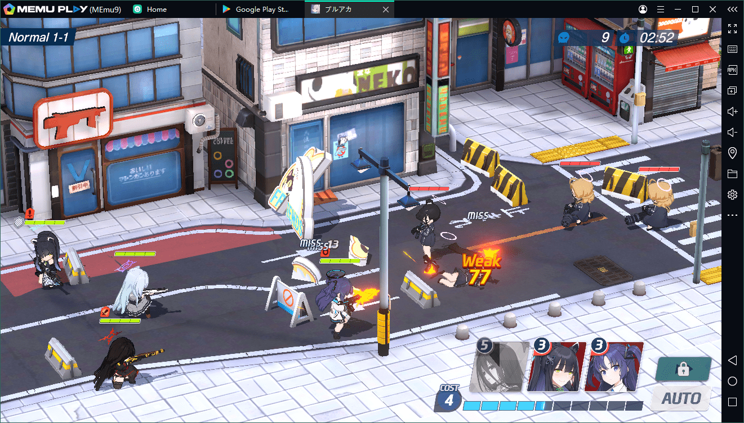

Blue Archive is a role-playing game developed by Nexon Games, a subsidiary of Nexon. It was released in 2021 for Android and iOS, first in Japan by Yostar and worldwide later that year by Nexon. The game is free-to-play with Gacha game mechanics as a means to obtain new characters.

**Developers:**[Nexon](https://www.google.com/search?sa=X&bih=666&biw=1498&rlz=1C1UEAD_enPK1023PK1023&hl=en-US&q=Nexon&si=AEcPFx7HnMxbNS2egwqbd2fGseeWkZi3ZCVlQ3vY-NLoLE7SWY2TSBgmXrm6MsqUMyhE1AiNXIqBu69OOuN7RjkmdHyyR6jek57WqiZXFl4NZ7eALQLR3GxE5y82c1nV97azv8CTMxqS8yHkJyeX872H6K8cxRjv51kSBtY5qMdvaqkl5ymELgBe_zzBYolYmyF7yfcDdz2SIhAMid5qbxr90PtkzWPlnoAx0akqIwob_aUNzQstADRTy-Kd2IKF4d4CZIvT7IZetStGcCbNg9khwW0IaD0RDQ%3D%3D&ved=2ahUKEwixsf3PuvP8AhVDU6QEHXd7CWsQmxMoAHoECGoQAg), [NEXON Games Co., Ltd.](https://www.google.com/search?sa=X&bih=666&biw=1498&rlz=1C1UEAD_enPK1023PK1023&hl=en-US&q=NEXON+Games+Co.,+Ltd.&si=AEcPFx7eHRJU0tWbjC5cc2C2rVygfPuoetC2JDc0IDqLp89f-Pqajjo9Cc1KzjJkuQ6z_gG5-nmbJoxecDz_ZzSmCGjJPLaI7Q0coCSVLdrM119yiF3LdP1ypUUYb0GJxKREcexN-aYdj6QNMGey30axv7AkRIKmH-2xfBqAKJ31NDQ5Yxh9AxXrWTjf1z3EK9xUT1IlcmNIHJXywqsdu7CkuN6izJz2hXpEb5MDYBVMpfyqsK6o2C7B3uceIHt-3z8r2GvWP7xGXyRRnroiu8-J0CCfd9qCKOHOnpY9PDeCgELO6jQc-jCsZiLYywBoM5wRj7bvGfPY&ved=2ahUKEwixsf3PuvP8AhVDU6QEHXd7CWsQmxMoAXoECGoQAw)

**Platforms:**[iOS](https://www.google.com/search?sa=X&bih=666&biw=1498&rlz=1C1UEAD_enPK1023PK1023&hl=en-US&q=&si=AEcPFx7HnMxbNS2egwqbd2fGseeWkZi3ZCVlQ3vY-NLoLE7SWSp_QWIc9ciUpsN-ZcQZYKHF8sO0F_HdTYZkHecAo0ijc8Qd6DC0ina9GIgETnAIwU1S8xu36amx3XyhXtR-d2_PYxMzhtd3xJIcAs1wTBjMHM-LxKYk5e2ZM1LX30djyKzPLJgMgy26dzQ0xHPZf-aUtfehfMk1qTQDe5Xpa-u8Dl6FZUqHRCqYUQE7p9psQ4FC4DBUuZutkSn7qTc8wHGXOrpfCOo7v4ZbdSlSt-tvdnXw-Q%3D%3D&ved=2ahUKEwixsf3PuvP8AhVDU6QEHXd7CWsQmxMoAHoECGUQAg), [Android](https://www.google.com/search?sa=X&bih=666&biw=1498&rlz=1C1UEAD_enPK1023PK1023&hl=en-US&q=&si=AEcPFx7HnMxbNS2egwqbd2fGseeWkZi3ZCVlQ3vY-NLoLE7SWUVHq5reWXDK7ATmZCJkUKvPjD4zcSpOOcqi4OLzTQABORjHlkQk2TtPruQveimUBE2BTP3QZh3CMHaM_UK05oN0bRp3qWQG3Bq154DkdKjWdSZC-TNwwrOT75pb6OsQsqDK-t3wC28x077W9tL620jMmGSXB4Jy3uo-gO1bom5Soadg-hdbvEvvDirJzOMHJwkT7yhHj5zmPMN6_KA4h6G2_0wXxMaudBls55jxwbpelQsyMA%3D%3D&ved=2ahUKEwixsf3PuvP8AhVDU6QEHXd7CWsQmxMoAXoECGUQAw)

**Publishers:**[Nexon](https://www.google.com/search?sa=X&bih=666&biw=1498&rlz=1C1UEAD_enPK1023PK1023&hl=en-US&q=Nexon&si=AEcPFx7HnMxbNS2egwqbd2fGseeWkZi3ZCVlQ3vY-NLoLE7SWY2TSBgmXrm6MsqUMyhE1Ahjj15eoZzKujCAExddjytmSai7p0Lj2FYk02Zc0CKJS24pwxUzmrYxgkoYCk4HcS9poIDw45BmdGGtTxH5DwjKt2xGRIiZq8dFKJ1d7r05tY9v-OLvHCedBGCiSmm856SgUYvzKV1jxWX0rJ4acf-8lF7yibMzprx9fQ0GCIXKOimNx3waUxLHIrjFmvnzUiL6HRdW&ved=2ahUKEwixsf3PuvP8AhVDU6QEHXd7CWsQmxMoAHoECGMQAg), [Yostar, Inc.](https://www.google.com/search?sa=X&bih=666&biw=1498&rlz=1C1UEAD_enPK1023PK1023&hl=en-US&q=Yostar,+Inc.&si=AEcPFx7eHRJU0tWbjC5cc2C2rVygfPuoetC2JDc0IDqLp89f-HXi7Ff73HDonA4ZCkFbnDoXcnPoobsd8SL_rqHqZQETpsnN6iDoQs-j2ptxyydcBviGFGjQ8ipTqbtAGyC48-5f6lvrhb4_teZ4cVAQm2FJ0Km15HVeUAzDn4o6AEq9sEgLiCrx-CvspWdZI1B_sUH2auMRlzTMArc9livFBliFZTYfOvSXStzZySw8D02ZSnmoqkama5CBsC1IZJEW1j-MVYmqAJRKakQhrxYNKc39eZKj9Q%3D%3D&ved=2ahUKEwixsf3PuvP8AhVDU6QEHXd7CWsQmxMoAXoECGMQAw), [NEXON Korea](https://www.google.com/search?sa=X&bih=666&biw=1498&rlz=1C1UEAD_enPK1023PK1023&hl=en-US&q=NEXON+Korea+Corporation&si=AEcPFx4IkMgAgMJkMTLSH7WR6YtBj6EFtw5Le3AcsuhiKcMgwiN_Msp8EQ1uxtox49Sv_MuhjQoym7wrTzx78oLw63pBcvSJ-N9gZJ8gkkrZpYSPrXnd3GJRO4OwIokaEZ9JSl52jh4J4SMK1UbRjkaWUhj1B1d7ylXIBqHEXU3oded8O1oo7YKAJvSs7UWl8KQiiJPAekCTnSDCFslwLXjtq6p-xIBDaW0b3Cn9hDKI-XxJ9GR2B_s1caYze_jY5WHeqaOFRkWWcl_naAtG_A7TaVT5RmYyIQ%3D%3D&ved=2ahUKEwixsf3PuvP8AhVDU6QEHXd7CWsQmxMoAnoECGMQBA)

**Genre:**[Tactical role-playing game](https://www.google.com/search?sa=X&bih=666&biw=1498&rlz=1C1UEAD_enPK1023PK1023&hl=en-US&q=&si=AEcPFx5y3cpWB8t3QIlw940Bbgd-HLN-aNYSTraERzz0WyAsdBUqW5RT3pNJ5ArTZzGKd4v3GYkr8_jxRolg_K-GNo-nnsc2lB3BqlbNkybDhlULVCDlhrnqSKPNhpTAjoxyFs-RXCp7GeYt0h7u5qVmF5Mb7ta-9SBZCLLzAe_vALAbx6UAwE0SgdnV_vHP7P9VzaFxgvpN&ved=2ahUKEwixsf3PuvP8AhVDU6QEHXd7CWsQmxMoAHoECGIQAg)

**Initial release date:**February 4, 2021

**Original author:**[Nexon](https://www.google.com/search?sa=X&bih=666&biw=1498&rlz=1C1UEAD_enPK1023PK1023&hl=en-US&q=Nexon&si=AEcPFx7HnMxbNS2egwqbd2fGseeWkZi3ZCVlQ3vY-NLoLE7SWY2TSBgmXrm6MsqUMyhE1AiBJrfaxx4Zdd9-2IJmKpVnK2wJ-gTjJGh1KMVKXWumwXbYGa0mYIUEbL-hyLMoV2ysJayGsD4rxC2og7G-o0HyPdccFMeZNXvUhOqkgqW4ITEak3OkdN_qLmW_Wd6AUvpTlXoT&ved=2ahUKEwixsf3PuvP8AhVDU6QEHXd7CWsQmxMoAHoECGEQAg)

**Composers:**[Mitsukiyo](https://www.google.com/search?sa=X&bih=666&biw=1498&rlz=1C1UEAD_enPK1023PK1023&hl=en-US&q=Mitsukiyo&si=AEcPFx7eHRJU0tWbjC5cc2C2rVygfPuoetC2JDc0IDqLp89f-KT7H3G_ahhGThVQPqEkGrcg9i9QynF_4fDf6ihiKFBNoqVgSm7qLfllbE8xx-e1apafk4Zy_q2REccGBcfpUSAu91pfQydtuUtNOlUiZ9GIEMJpKxqkfKzmkqLIpTEvppeHB0H_8a_-g-oISIMf3SPeDnP2CiUNjspeK1MsflusT-nucU_WceCj2XiVShO3GoQEgMKnR7M4EeU-Wcu99RKpWl5FUoe9rQT50xrT-p4y6pFx7w%3D%3D&ved=2ahUKEwixsf3PuvP8AhVDU6QEHXd7CWsQmxMoAHoECGkQAg), KARUT