

***About This Game:***

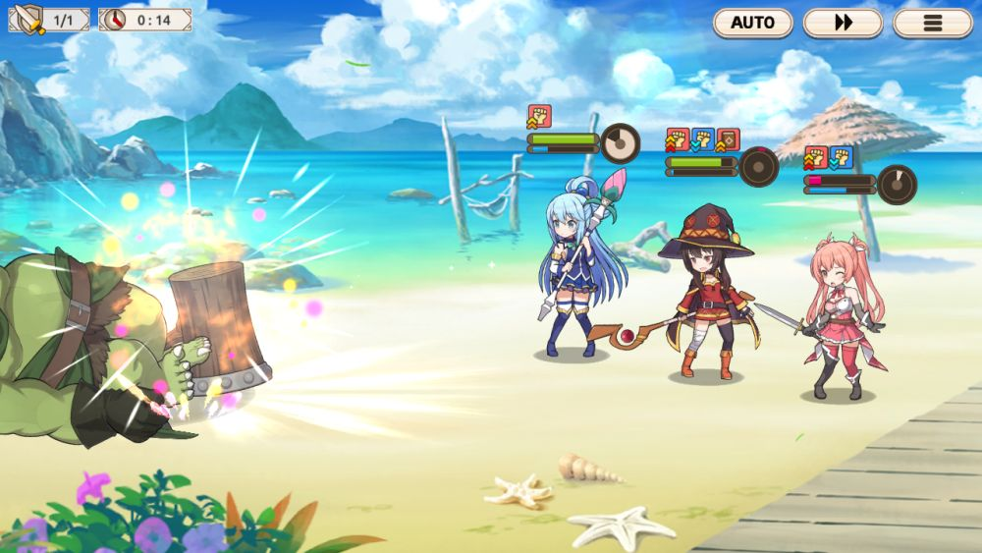

A Spectacular Anime RPG brimming with fantasy, laughter, and EXPLOSIONS!  
KonoSuba: Fantastic Days is here to transport you to another world.  
  
You have been summoned, brave traveler, to a world threatened by the Devil King's army in the first KonoSuba mobile game ever to be released globally. The journey may be long and perilous, but do not fear! You won't be going empty-handed...joining your party will be all the KonoSuba characters you know and love, along with some fresh new faces.