

## **The Sims™ 4 : SEASONS.**

## ***What's included in The Sims™ 4 Seasons***

Browse this pack’s content and get inspired by more fashion, furniture, hairstyles, and décor. Imagine what you’ll make next!

## **Experience Impactful Weather**

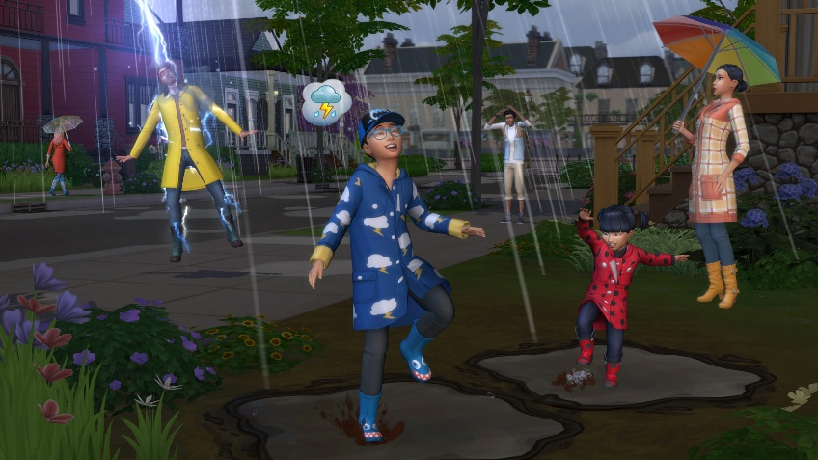

Enjoy four stunning seasons and dynamically changing weather that affects all aspects of your Sims’ lives. From hot and sunny to blustery and snowy, every world’s climate is unique and impacts your Sims’ choices, relationships and daily activities. Control the elements to summon thunderstorms, clear up overcast skies or jump between seasons.