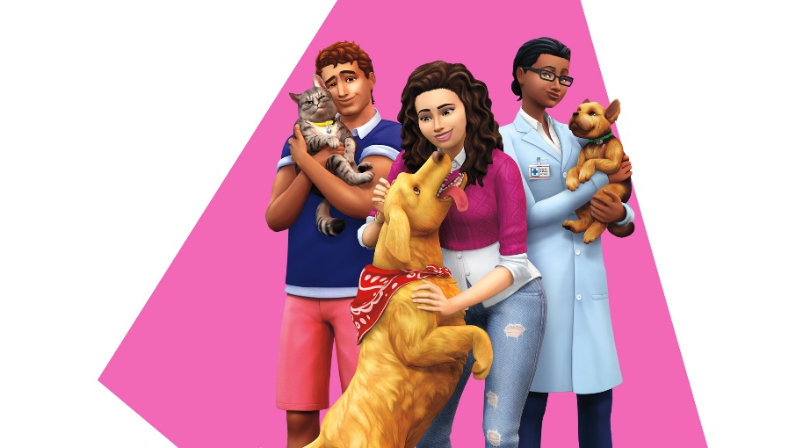

## **The Sims™ 4 : CATS & DOGS**

## Create cats and dogs

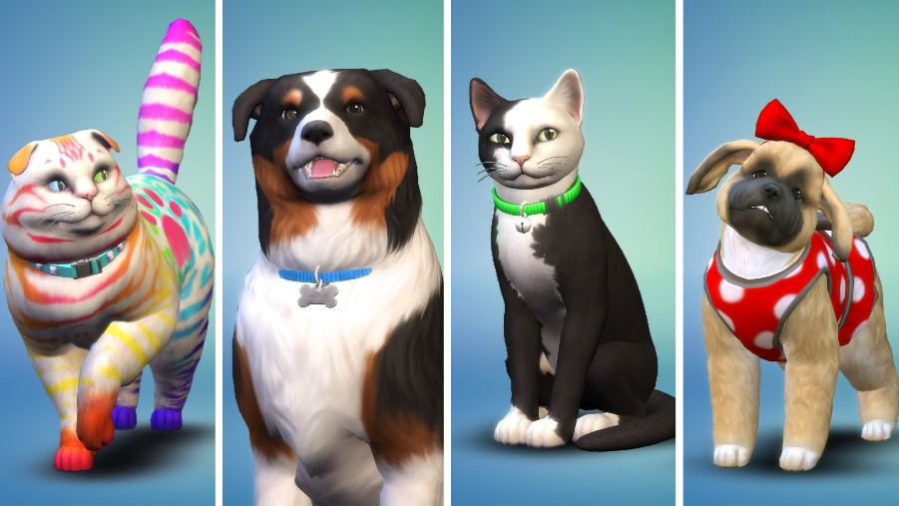

Use the powerful Create A Pet tool to customize your Sims’ perfect cats, dogs, puppies, and kittens. Choose from a variety of breeds, give them distinct personalities, and directly manipulate their features. Easily personalize their coats with unique patterns to create your real-life pets, dream pets, or something more fanciful. For the first time, complete their looks with expressive outfits and accessories.