Here is how you can create the Ansible configuration and playbook for the given use case. This script will automate the deployment of a web application using Nginx on a remote server.

**1. Inventory File (hosts.ini):**

An inventory file that defines your remote server(s).

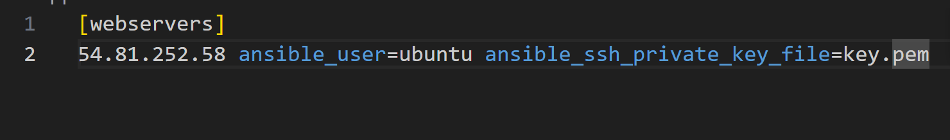

**2. Ansible Playbook (deploy-playbook.yml):**

The playbook that installs Nginx, deploys the application, and configures Nginx.

**3. Jinja2 Template (nginx_app_template.j2):**

This is a template for the Nginx configuration. It uses Jinja2 to dynamically fill in values from the playbook.

**4. Directory Structure**

Organize the files as follows:

**5. Define Variables in the Playbook**

Variables like app_name, server_name, app_source_dir, and nginx_template are defined in the playbook’s vars section. Adjust the server_name and file paths based on your setup.

**6. Execute the Playbook**

Run the following command to deploy the web application:

