**Terraform**

Installation

Setup TF Controller server

Create Security Group

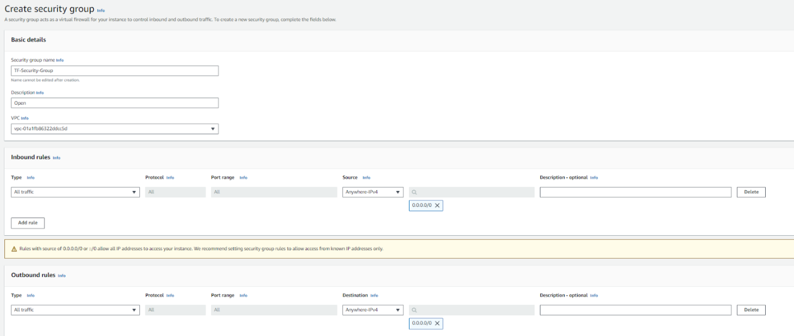

Create Server

Create New Keypair

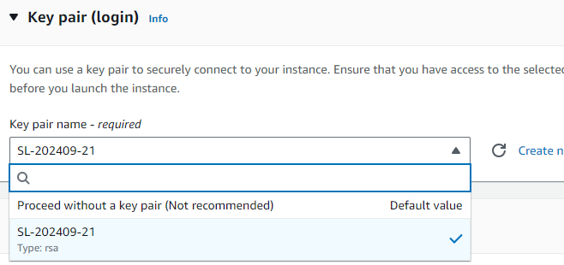

Choose the created Security Group

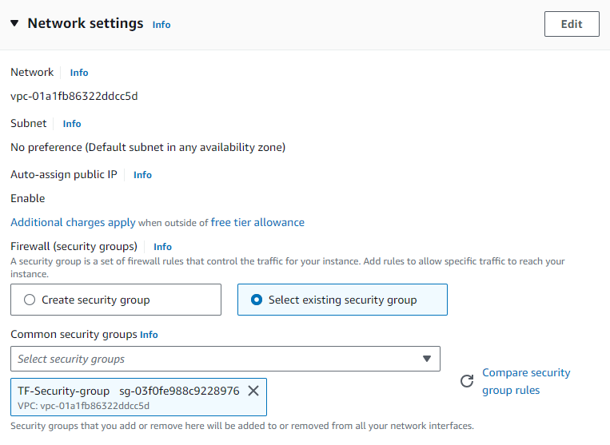

Click On Create

Install Terraform

Follow the Installation guide from the URL

<https://developer.hashicorp.com/terraform/tutorials/aws-get-started/install-cli>.

*Note: Please choose Linux Tab in the guide*

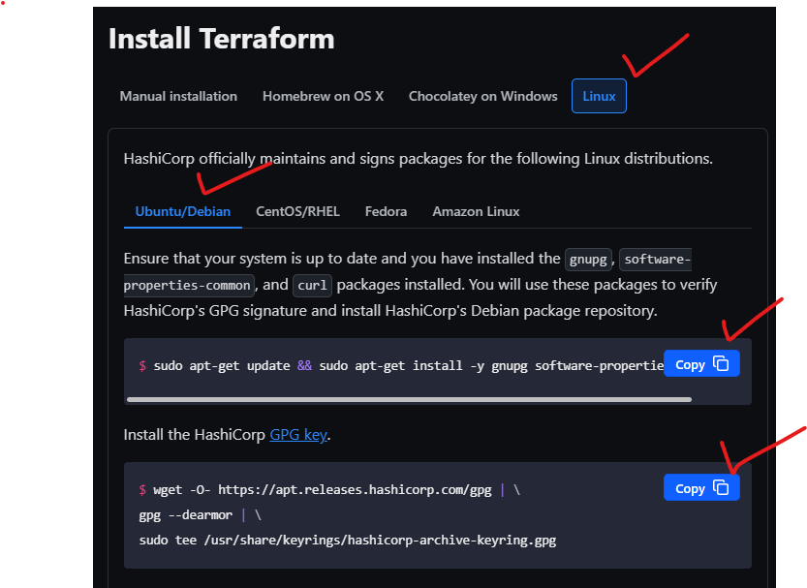

*Note: If you encounter below error, run the suggested commands*

|  |
| --- |
| E: Could not get lock /var/lib/dpkg/lock-frontend. It is held by process 7809 (unattended-upgr)  N: Be aware that removing the lock file is not a solution and may break your system.  E: Unable to acquire the dpkg frontend lock (/var/lib/dpkg/lock-frontend), is another process using it? |

Command:

|  |
| --- |
| sudo rm -f /var/lib/dpkg/lock-frontend  sudo rm -f /var/lib/dpkg/lock |

Demo

Provide Credentials to TF

Execute below command to so that TF can authenticate to AWS

|  |
| --- |
| export AWS_ACCESS_KEY_ID="Access-key-id" export AWS_SECRET_ACCESS_KEY="secret-key" export AWS_REGION="us-east-1" |

Create a terraform directory

 (e.g. ~/tf-demo)

|  |
| --- |
| mkdir ~/tf-demo cd ~/tf-demo |

Define Provider

Create manifest in tf directory (e.g. ~/tf-demo/main.tf) with following content

|  |
| --- |
| terraform {   required_providers {     aws = {       source = "hashicorp/aws"       version = "5.68.0"     }   } } provider "aws" {   # Configuration options } |

Initialize terraform

|  |
| --- |
| terraform init |

expected output:

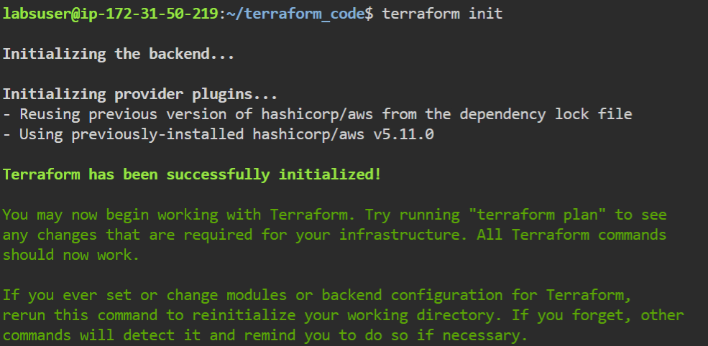

S3 Bucket

Create a file ~/tf-demo/s3.tf with below content

|  |
| --- |
| resource "aws_s3_bucket" "example" {   bucket = "your-unique-bucket-name"    tags = {     Name        = "Demo"     Environment = "MyEnv"     Owner       = "Amit"   } } |

EC2 Instance

Create a file ~/tf-demo/ec2.tf with below content

|  |
| --- |
| resource "aws_instance" "myfirstinstance" {   ami           = "ami-0e86e20dae9224db8"   instance_type = "t2.micro" } |

Apply the configuration

|  |
| --- |
| terraform plan terraform apply #(type "yes" to accept) |

Terraform commands of interest

Format files for enhance readability

|  |
| --- |
| terraform fmt |

State Management

|  |
| --- |
| terraform show #Show all resources terraform state list #List all resource from statefile terraform state show aws_s3_bucket.example #List details of a particular resource |