Customer Behaviour Data Analysis - Project Documentation
This project analyzes customer purchasing behavior using Python, MySQL, SQL, and Power BI. Data was cleaned using pandas, imported into MySQL, analyzed with SQL queries, and visualized in an interactive dashboard.

Objectives
- Clean raw customer data
- Store data in MySQL
- Perform SQL analysis
- Build interactive Power BI dashboard

Tools & Technologies
- Python (Pandas)
- Jupyter Notebook
- MySQL Workbench
- SQL
- Power BI

Workflow
- Cleaned the dataset in Python.
- Imported cleaned CSV into MySQL.
- Performed SQL analysis.
- Created interactive dashboard in Power BI.

Python Analysis Performed
- 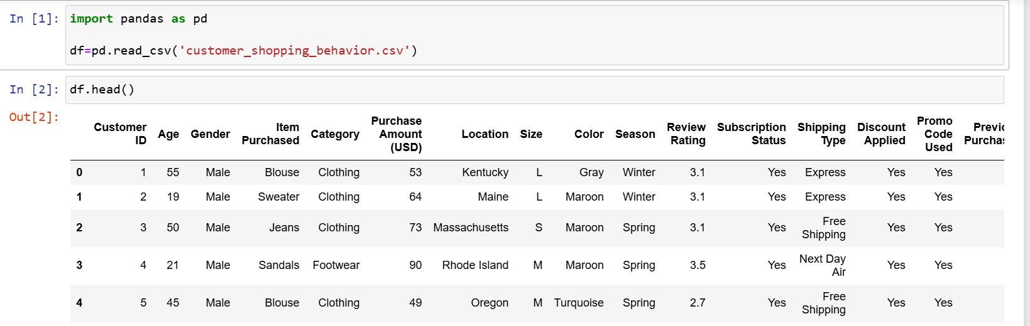
- 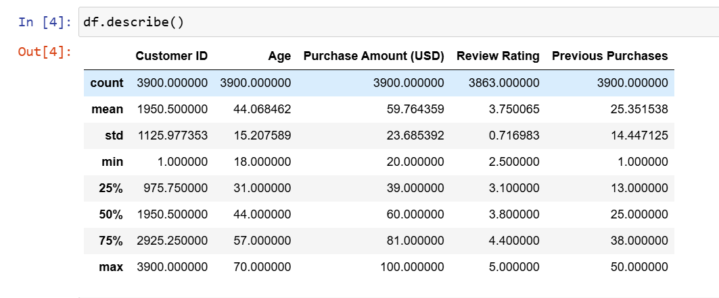

- 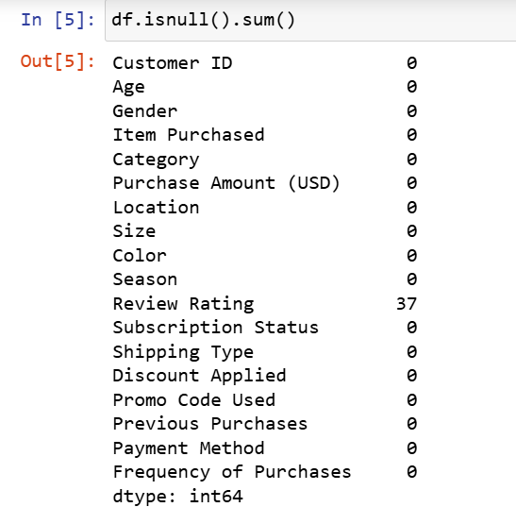
- 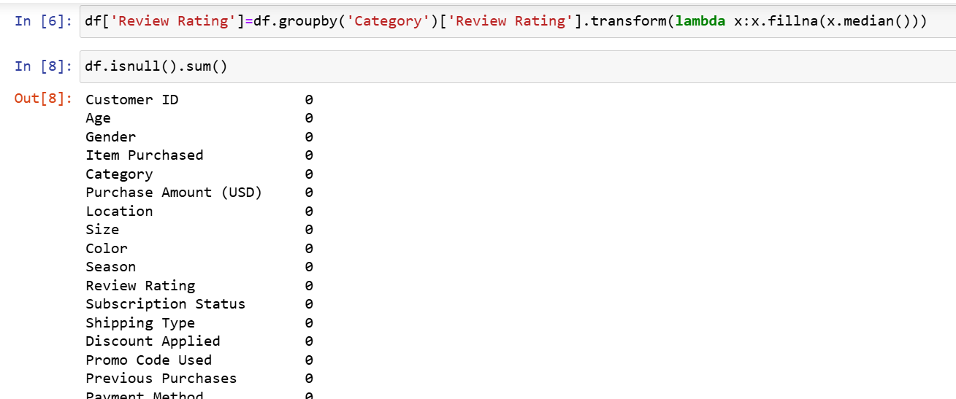

- 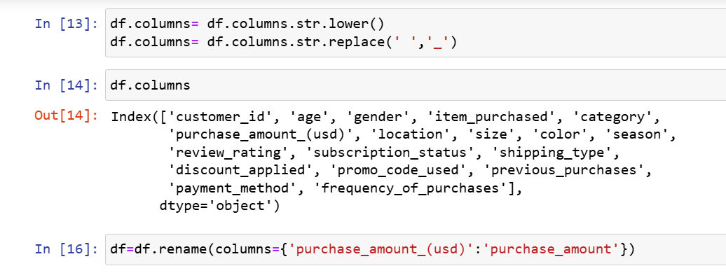
- 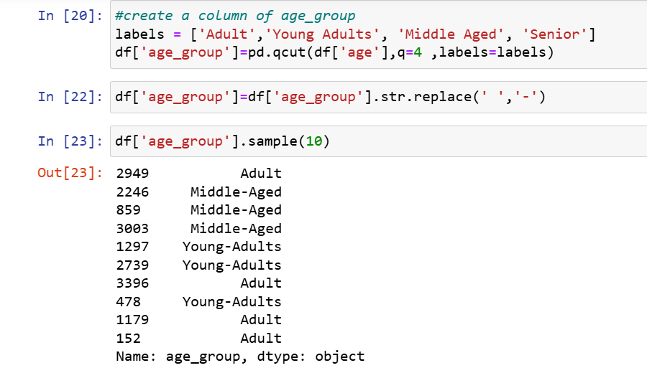
- 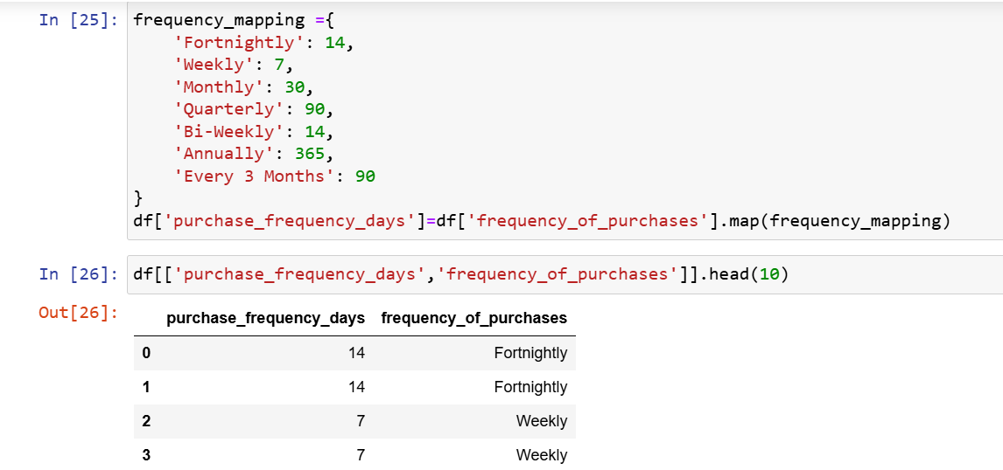

- 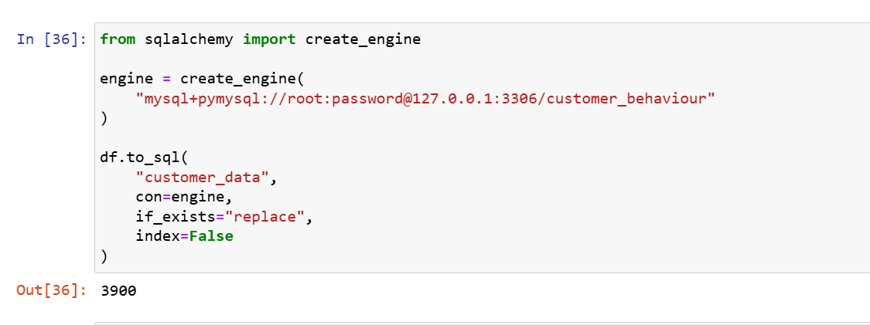

SQL Analysis Performed

Revenue by gender
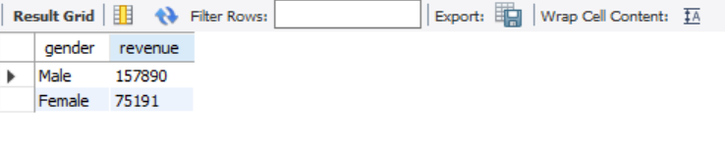

High-value discounted customers
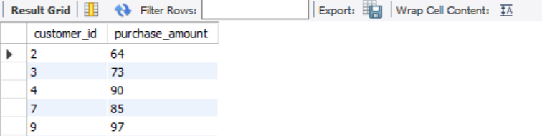

Top-rated products
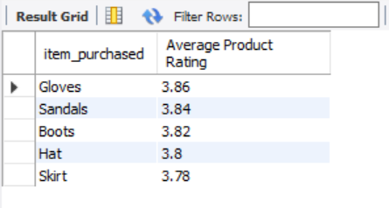

Average purchase by shipping type
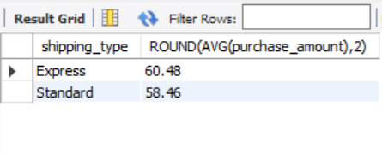

Subscription analysis
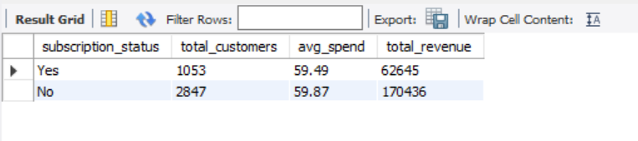

Discount rate by item
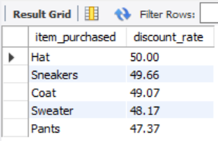

Customer segmentation
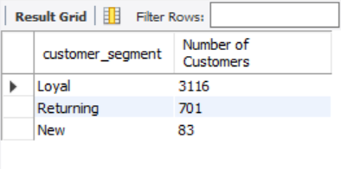

Top products by category
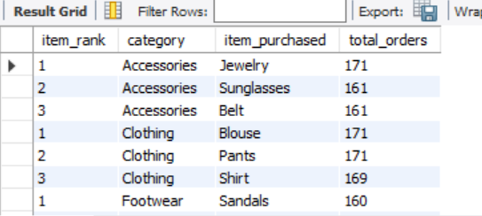

Repeat buyers
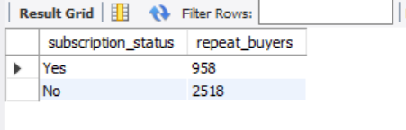

Revenue by age group
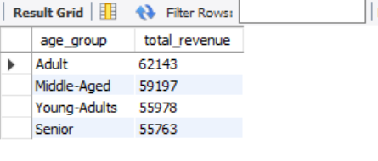

Dashboard Highlights
- KPIs: Average Purchase Amount, Average Review Rating, Total Customers
- Interactive slicers
- Category analysis
- Subscription analysis
- Age group analysis
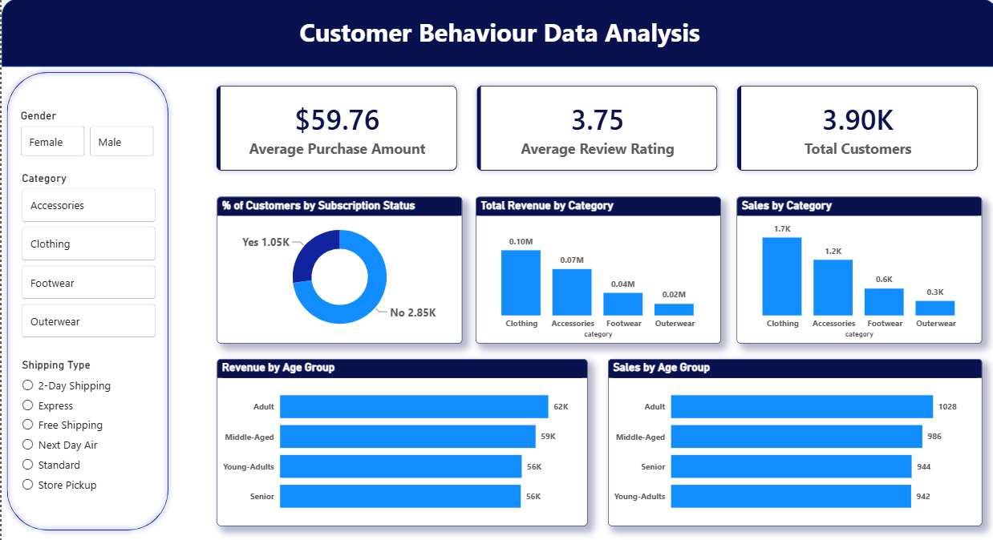

Key Insights
- Clothing generated the highest revenue.
- Adult customers contributed the highest revenue.
- Average purchase amount: $59.76.
- Average review rating: 3.75.
- Dashboard supports interactive business analysis.

