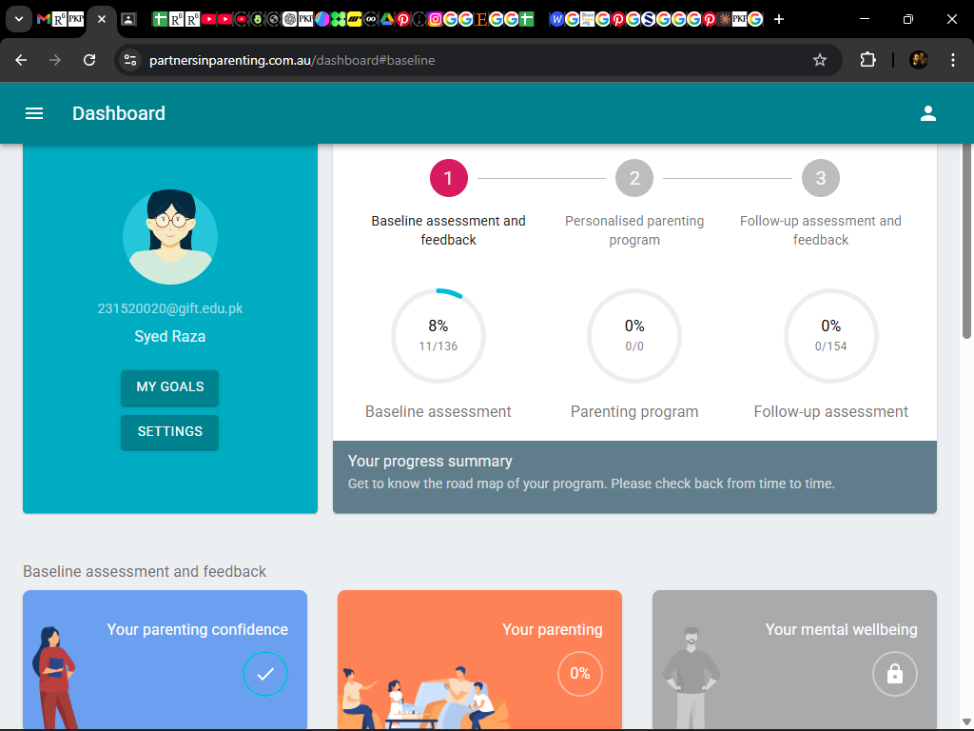

Baseline assessment and feedback

Welcome to the PiP+ program! The first stage of the program includes an initial online assessment, during which you'll receive personalised feedback. After the surveys, you'll have access to your tailored program right away. Click the button to get started.

Partners in Parenting

Partners in Parenting is a free online program that aims to prevent depression and anxiety among teenagers.
Parents have an important positive influence on their teenager’s mental wellbeing. There’s now good evidence to show that by supporting parents in their parenting we can help teenagers to stay well.
By participating in this program you’ll learn some new parenting strategies, and by completing some optional evaluation surveys, you’ll be helping us to improve the impact of the program.

Program features
- Take our parenting survey to receive personalised feedback about your parenting
- Receive feedback about your own and your teen’s mental wellbeing
- Access up to 10 interactive online modules (15-25 mins each) tailored for you
- New, expert-endorsed information about parenting through the COVID-19 pandemic
- Access to an online peer support community, to connect with other PiP parents
- Be part of a world leading research project.

Who can sign up?

Parents or guardians of a teenager aged 12 to 17 who:
- Live in Pakistan
- Are fluent in English/Urdu
- Have internet access.
Please note, our program is not designed to treat depression and anxiety conditions that have already developed. If your teenager is currently experiencing such difficulties, we recommend that you consult your GP or a mental health professional for specific assistance. However, you are still welcome to participate in this program as an additional source of support if you wish.

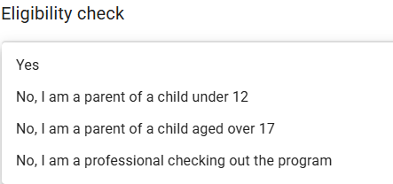

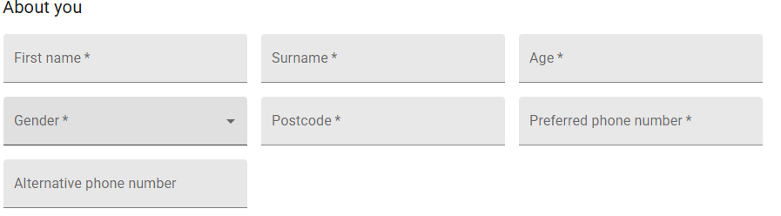

About your family
The following few questions ask some personal information about you and your family. Answering these questions will help us to learn more about the parents who use the PiP program, and who benefits most. While we’d really appreciate you answering, if you prefer not to, you can skip these questions.
Which ethnicity do you most identify with? The following includes some of the most common in Australia, if yours is not captured, please use 'Other' to specify.
Ethnicity group
What is your relationship status?
Relationship status
What is your highest level of education?
Education
What is the current total income of your household, before tax?
Income
Due to COVID-19, have any of these things happened in your household? Please check all that apply.
Job loss by one parent/guardianJob loss by two parents/guardiansReduced job hours for one parent/guardianReduced job hours for two parents/guardiansDifficulty paying bills or buying necessities (e.g., food)Parent/guardian having to work longer hoursApplied for government (financial) assistanceReceived government (financial) assistance

About your teenager
This program is designed for parents of teenagers aged between 12 and 17.
If you have multiple teenagers, please complete the information below in reference to the teenager you are most likely to apply the program strategies with.
Your teen's first name *
This is required to personalise the program to you and your teen.
Date of birth *
In dd/mm/yyyy format
School grade/year level *
If your teenager is not attending school, please select the approximate grade they would be in.
Gender *
This is required to personalise the program to you and your teen
Your relationship to them *
Is another parent also in this program? *
Is your child’s other parent (or co-parent) also taking part in this program? For example, biological parents, step-parents or other guardians.

What you're signing up for
As a parent, I understand that my participation will involve receiving the Partners in Parenting program, consisting of:
- Completing a confidential online survey to receive tailored feedback about my parenting. I will also receive feedback about my own and my teenager’s mental wellbeing.
- Receiving a copy of the Reducing teenagers’ risk of depression and anxiety disorders: Strategies for parents during the COVID-19 pandemic booklet immediately after completing the survey.
- Access to up to 10 interactive online modules, which provide more detailed parenting tips, and each take around 15-25 minutes to complete.
- Access to an optional online peer support community with other PiP parents, via Facebook.
- I understand that I will be invited to complete some optional evaluation surveys around 3-months later, to look at how my parenting approach, my teenager’s mental wellbeing, and my own mental wellbeing have changed over time.
- If I choose to join the online peer support community, I will be provided with more information about my privacy and data security before I join.
- I may also be invited to participate in an optional interview (via phone or Zoom video conferencing) with the research team to give feedback on my experience of using the program.
- I understand that I am free to use the Partners in Parenting program without completing the optional evaluation surveys, and if I do complete them I can withdraw consent and discontinue participation in the evaluation at any time without explanation. I am also able to withdraw any unprocessed identifiable data previously supplied.
- My decision whether or not to use the program or participate in the evaluation will not prejudice any future relationship I or my teenager may have with Monash University.
- I understand that all information provided by me will be kept strictly confidential within the limits of the law, unless the Partners in Parenting team deems that I, my child, or someone else is at serious risk of harm (e.g. child abuse, self-harm) that they are bound by professional codes of ethics to take reasonable action to prevent, even if this means breaching confidentiality.
- I agree that data gathered from the surveys I complete may be published in a scientific journal or conference presentation, provided that I cannot be identified.
- I understand that non-identifiable data (i.e. no one will ever be able to link my name to my responses) will be made available for future research via a secure online repository, e.g. Bridges.
Any concerns about the scientific aspects of the program and its evaluation can be directed to Associate Professor Marie Yap via email, marie.yap@monash.edu
Any complaints about the ethical aspects of the research may be directed to the Executive Officer, Monash University Human Research Ethics Committee (MUHREC), Monash University, Clayton, Vic 3800, email: muhrec@monash.edu, phone 03 9905 2058, fax 03 9347 6739.
You can view the Explanatory Statement.

Please let us know that you agree to the above
I have read and understood the information in the Explanatory Statement, and agree to participate in this program.


After you've completed the first online survey, you'll have access to your personalised parenting program. You can select up to 10 modules, based on our suggestions and your preferences. We'll suggest you complete one module per week, but you can also work through these at your own pace. Click start to select your modules and start your program.

