WEEK 4

🔐 Secure Express App

This project demonstrates core web application security mechanisms implemented in a Node.js + Express.js application as part of a cybersecurity internship.

---

✅ Features Implemented

1. Rate Limiting
Protects the server from abuse or brute-force attacks using `express-rate-limit`.

- Each IP is limited to 100 requests every 15 minutes.
- Users exceeding this limit get a `429 Too Many Requests` error.

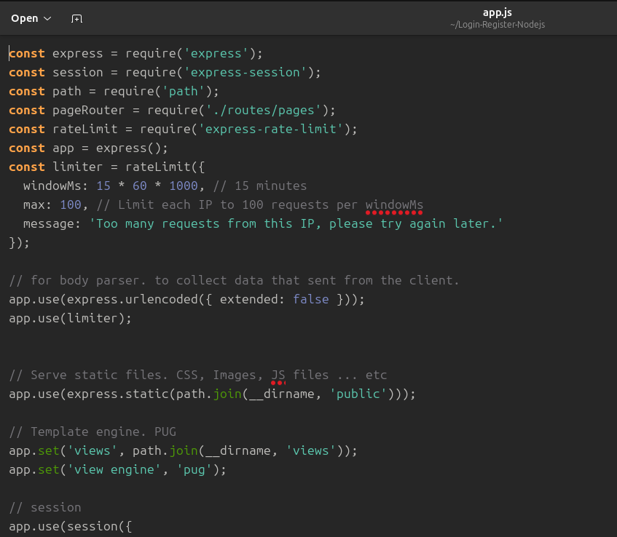
📸 Screenshot of rate limiting:
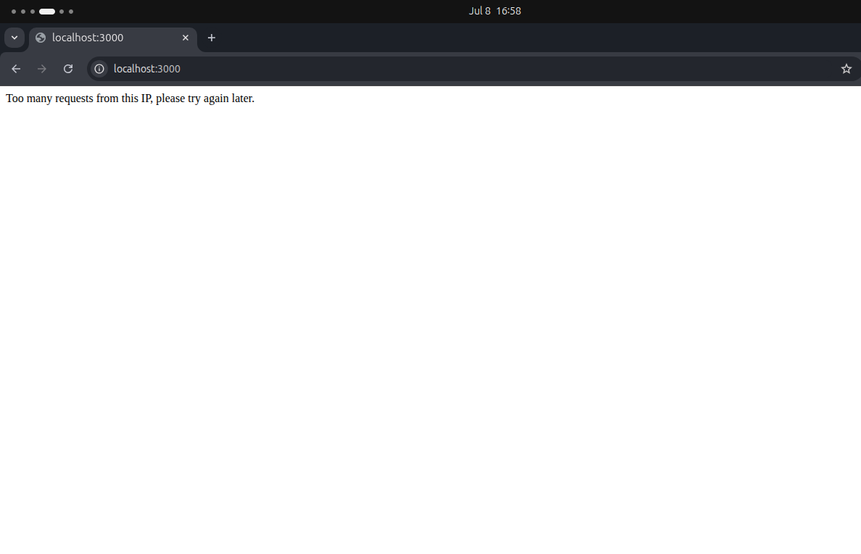

---

2. CORS (Cross-Origin Resource Sharing)
Cross-origin requests are restricted to http://localhost:3000.

- All other origins are blocked by CORS policy.
- Protects against unauthorized cross-site requests.
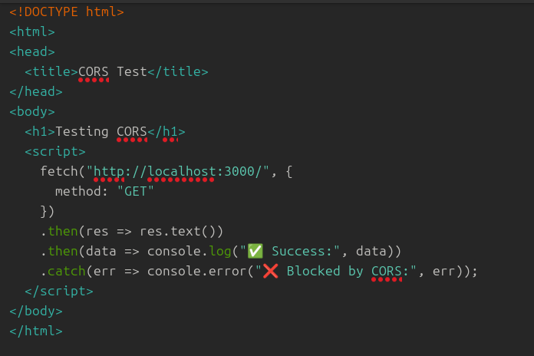
📸 Screenshot of CORS error in browser console:
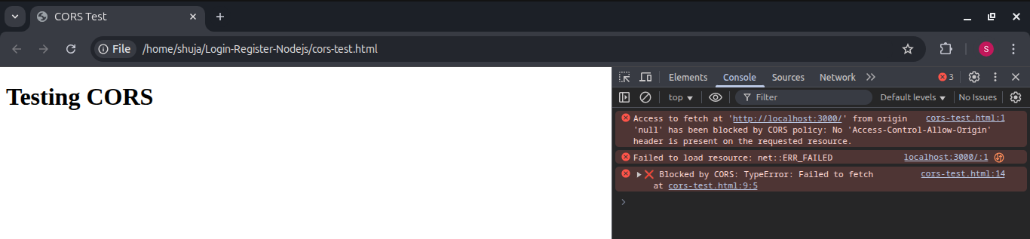

---

3. Helmet Security Headers
The app uses helmet to set critical HTTP headers for protection.

🔐 Content Security Policy (CSP)
Blocks unauthorized scripts:

helmet.contentSecurityPolicy({
directives: {
defaultSrc: ["'self'"],
scriptSrc: ["'self'"],
objectSrc: ["'none'"],
upgradeInsecureRequests: [],
}
});
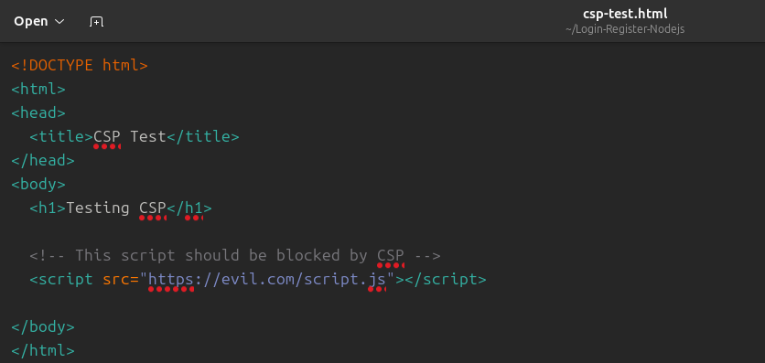
📸 CSP violation screenshot (external script blocked):
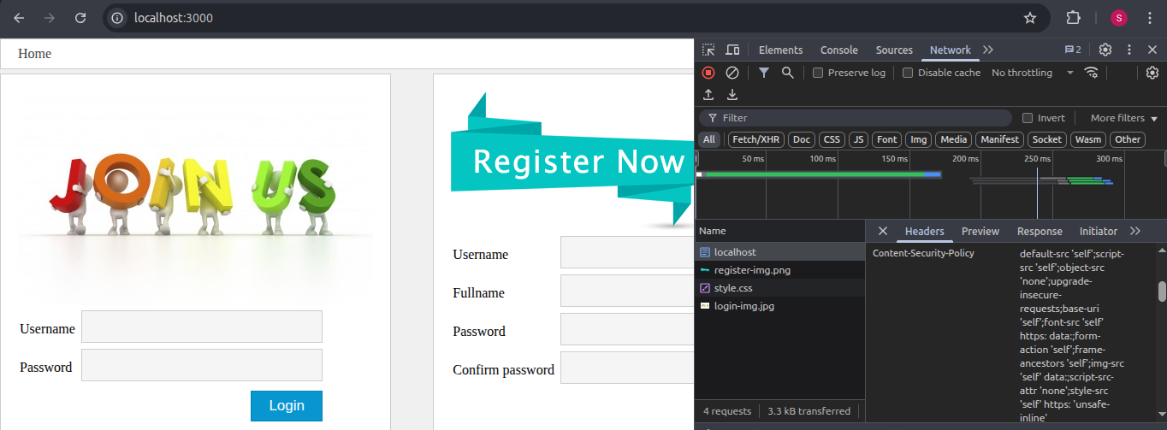
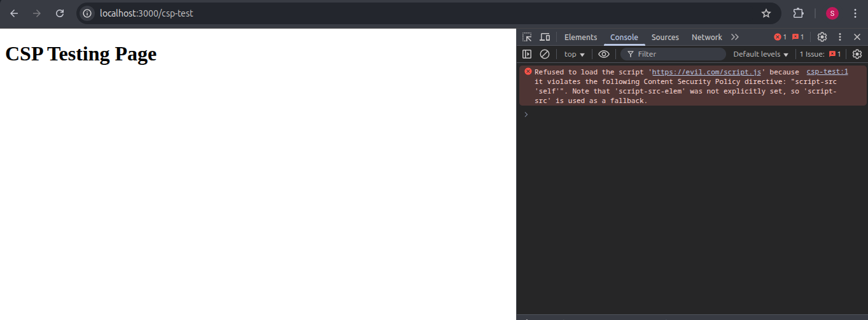
---

📦 HTTP Strict Transport Security (HSTS)
Enforces HTTPS connections:

helmet.hsts({
maxAge: 31536000,
includeSubDomains: true,
preload: true,
});

---

4. API Key Authentication
A secure route is protected with an API key.

🔓 Without API key:

curl http://localhost:3000/secure-api/data

Response:

{ "message": "❌ Unauthorized: Invalid or missing API key." }

🔐 With API key:

curl -H "x-api-key: supersecretkey123" http://localhost:3000/secure-api/data

Response:

{ "message": "✅ Access granted to secure API route." }

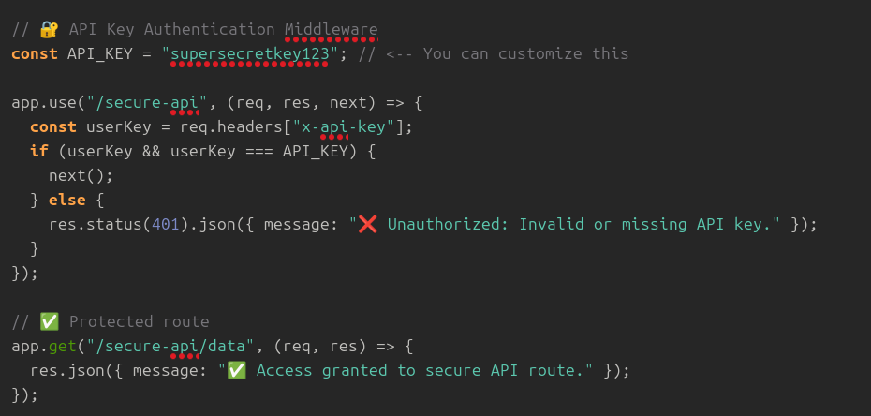
📸 Screenshot of API key test:
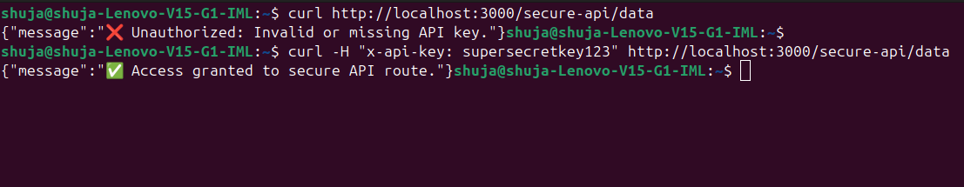

---

🧪 How to Run the Project Locally

1. Clone the Repository

git clone https://github.com/SyedShujaHaider/secure-express-app.git
cd secure-express-app

2. Install Dependencies

npm install

3. Start the Server

node app.js

The server will run at: http://localhost:3000

---

📁 Project Structure

secure-express-app/
├── app.js
├── routes/
│ └── pages.js
├── views/
│ └── *.pug
├── public/
│ └── css, js, assets
├── screenshots/
│ └── *.png <-- Put your screenshots here
└── README.md

---

🛠 Technologies Used

- Node.js
- Express.js
- Helmet
- CORS
- express-rate-limit
- API Key Authentication
- Pug
- Git/GitHub

---

🧠 Author

Syed Shuja Haider
Cybersecurity Internship – Week 4 Final Submission
🔗 GitHub Repository: https://github.com/SyedShujaHaider/secure-express-app

