Relational Database Service:

- Create MariaDB DB on EC2.
First lets create an EC2 instance and install maria db
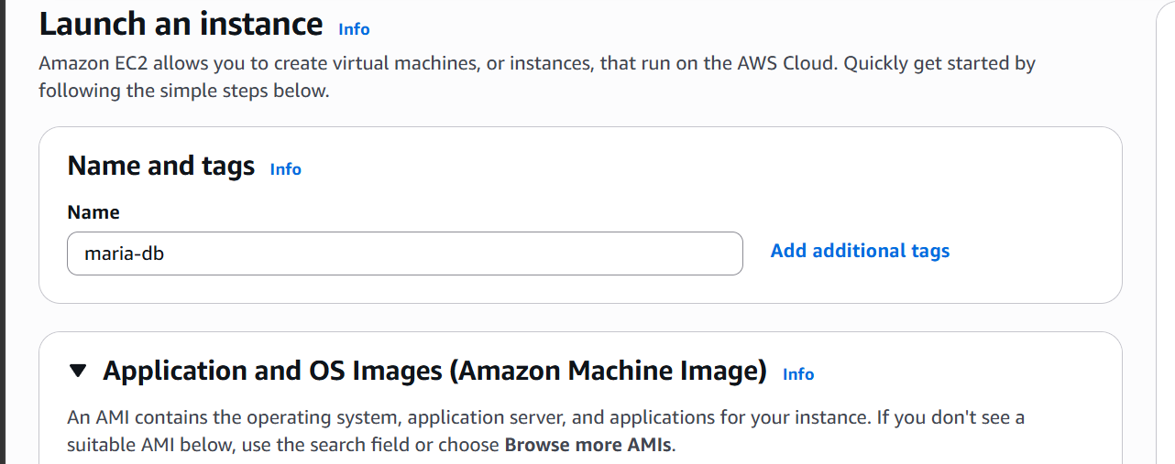
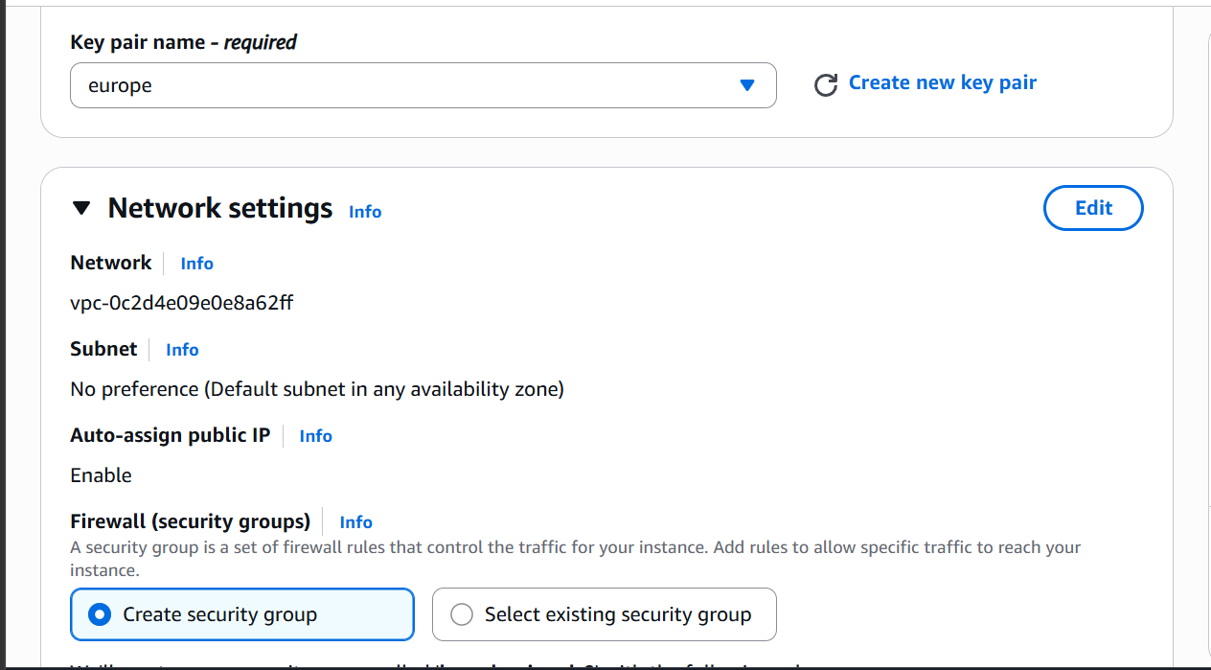
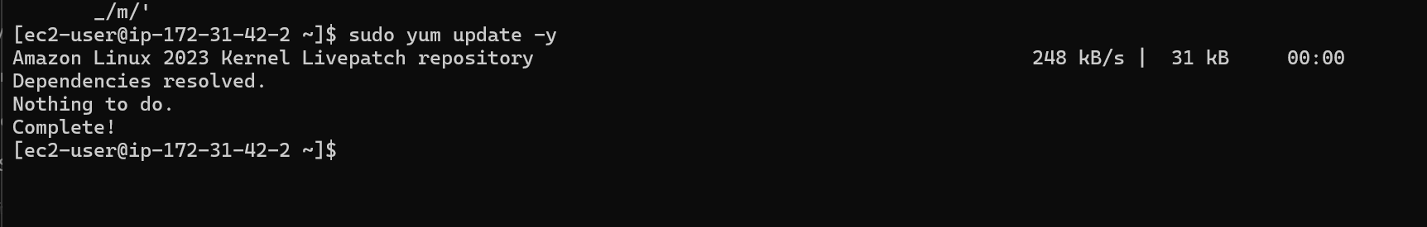

Updating the packages

Installing the maria db
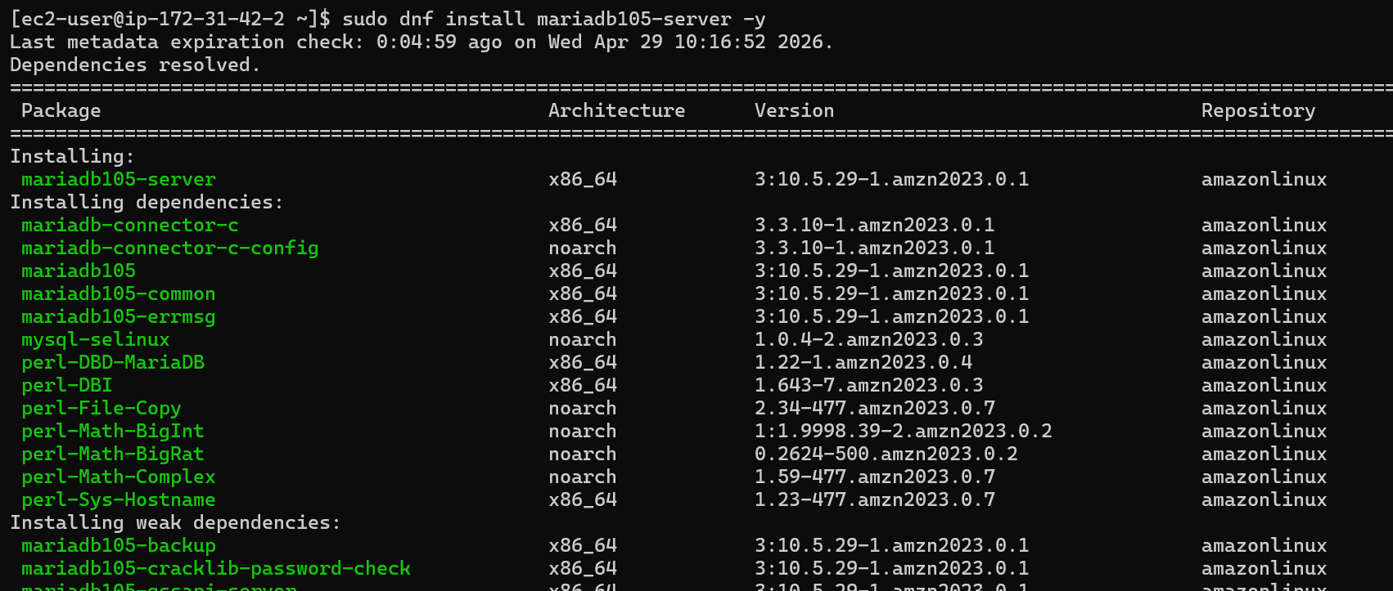

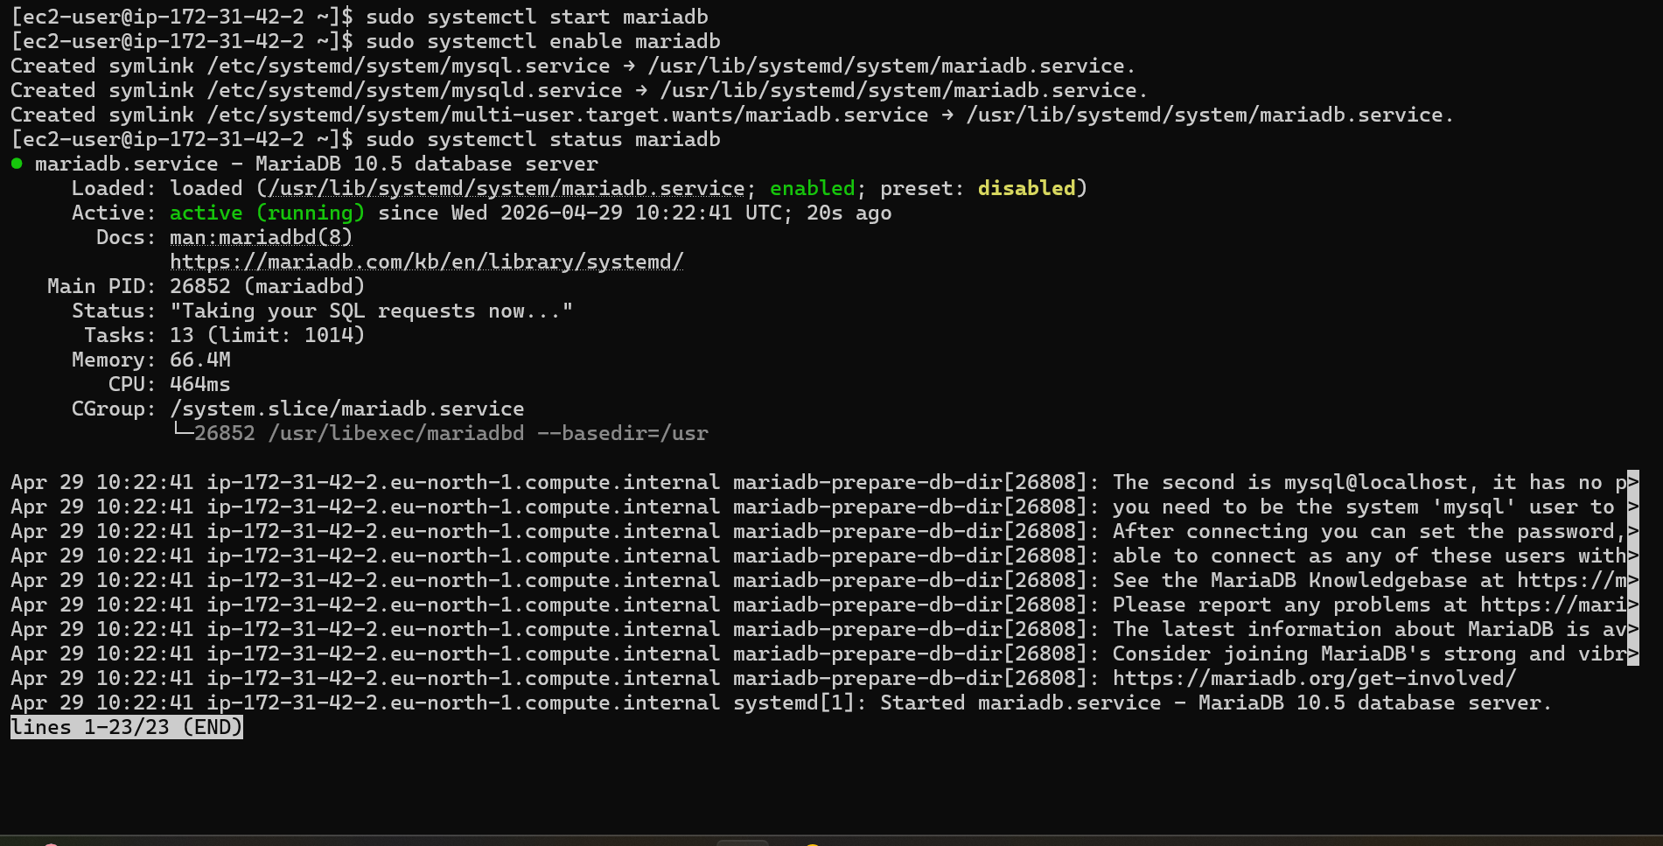

Maria db is installed and running.

- Insert some Dummy data

Lets first connect to our data base

Setting environment variables and logging into db

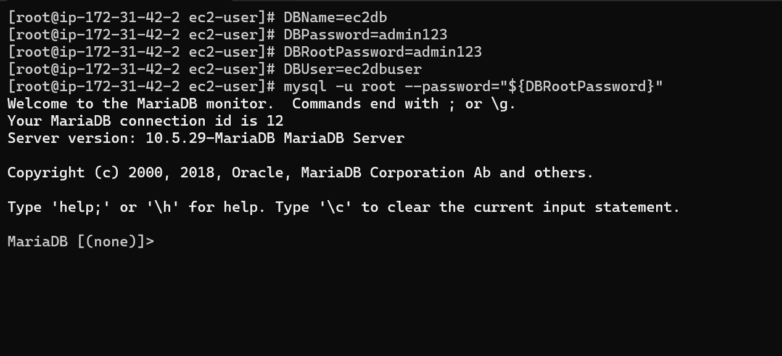

Adding values in our database

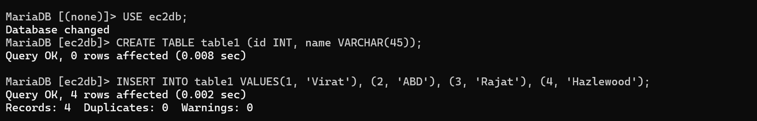

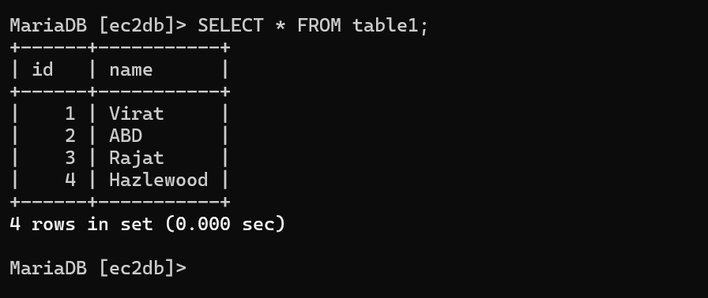

- Take backup of dummy data on EC2

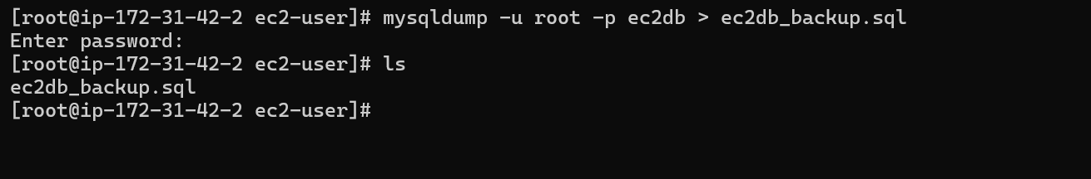

Using mysqldump utility to take backup of maria db.

- Launch Maria DB RDS instance

Navigate to RDS service
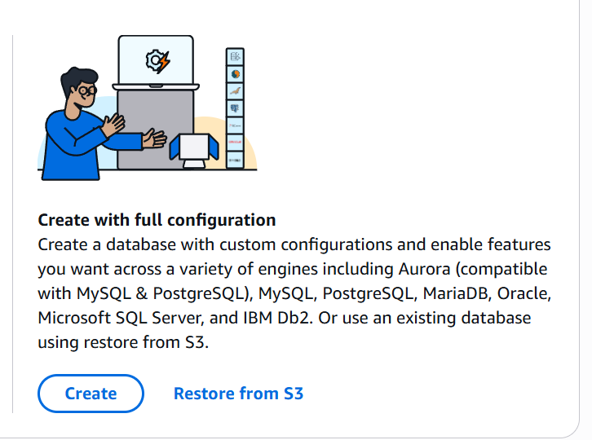

Click on create
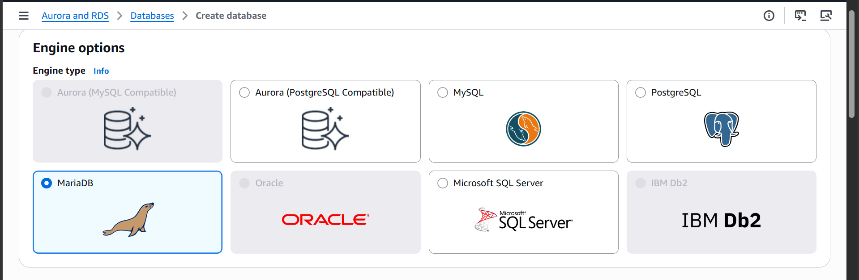

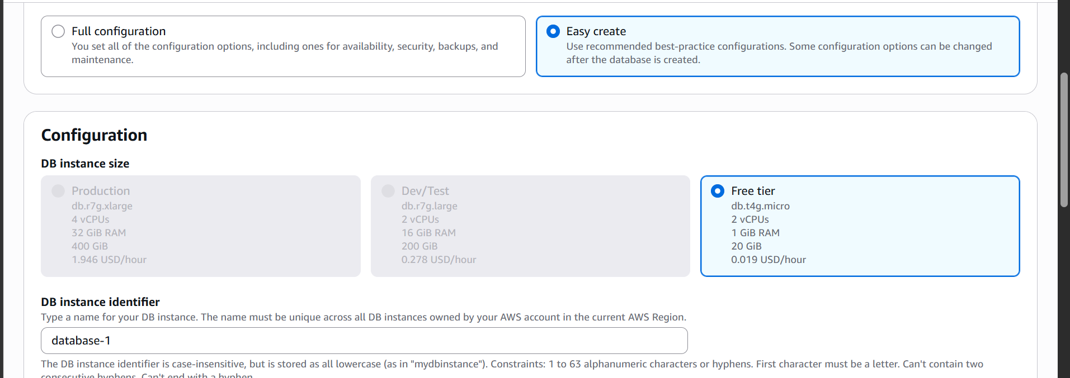

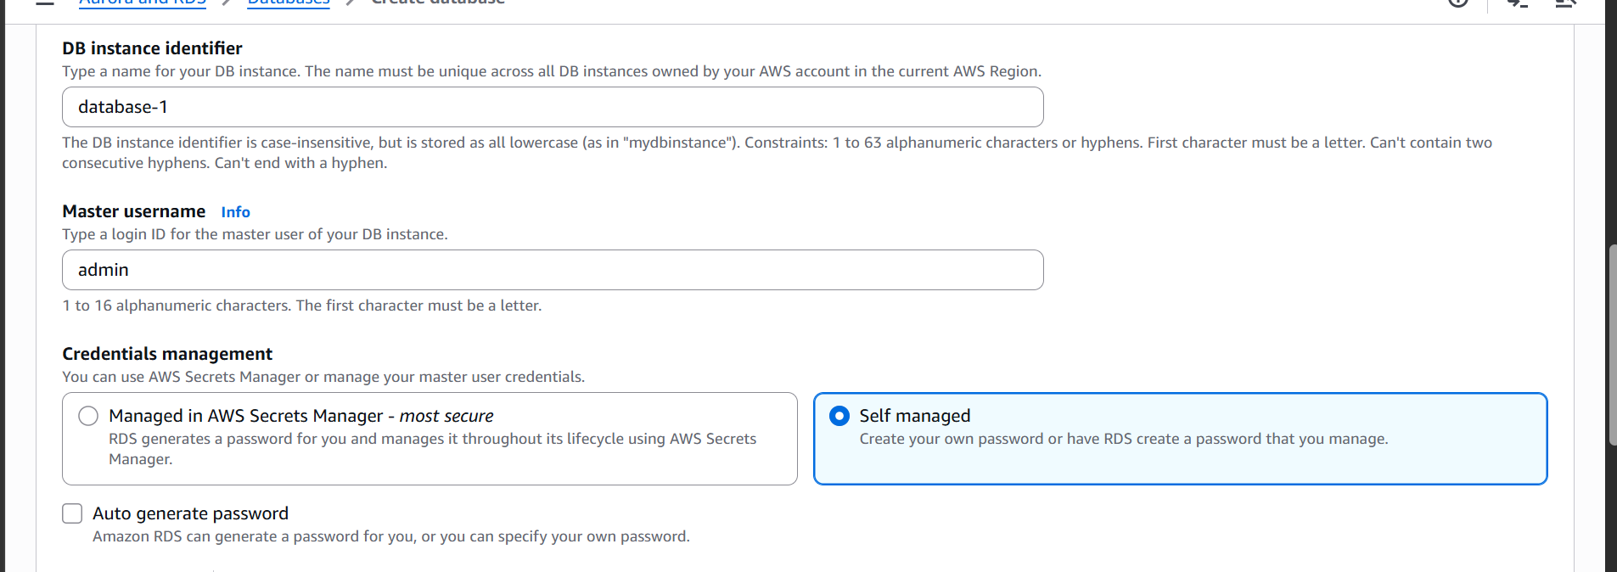

Now click on create
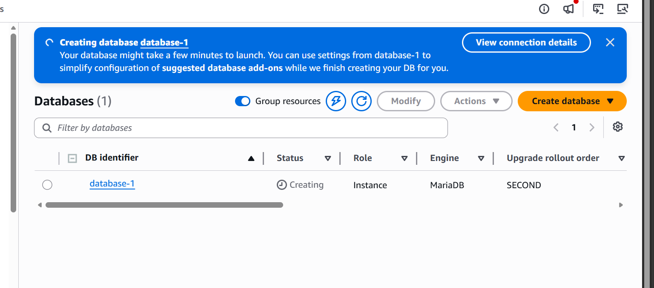

Our database is now getting created
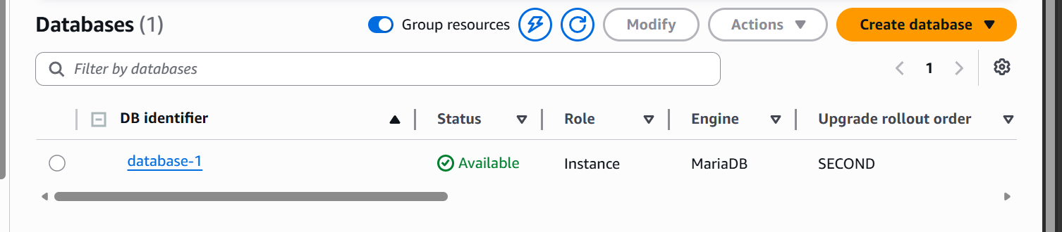
Database is available now

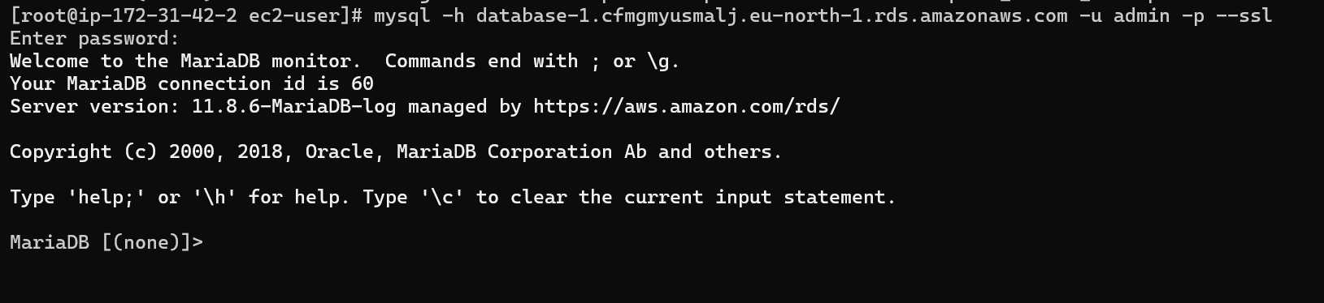

We are able to connect to our databased from our EC2 instance
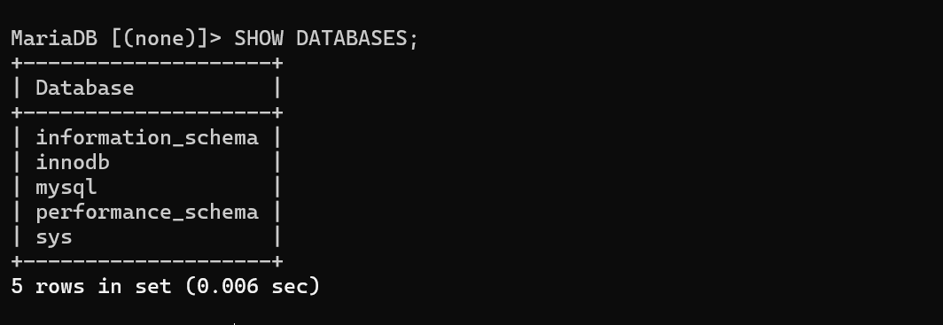

- Migrate database from EC2 to RDS
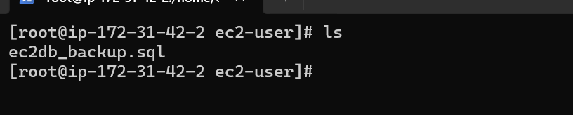

We have a backup of previous data base already

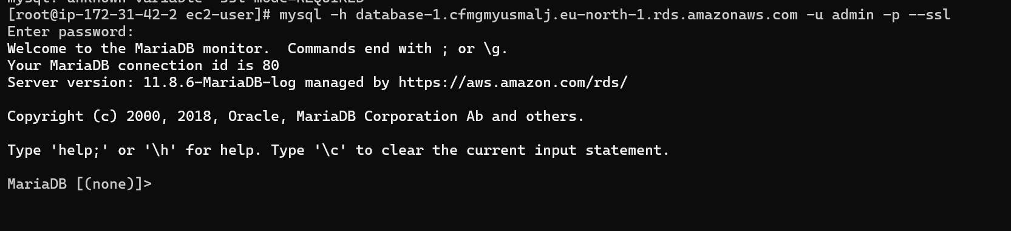
We are in our RDS database now
Creating a database
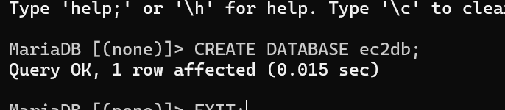
Migrating our backup file to the RDS database

Lets login to the instance and check if it is available
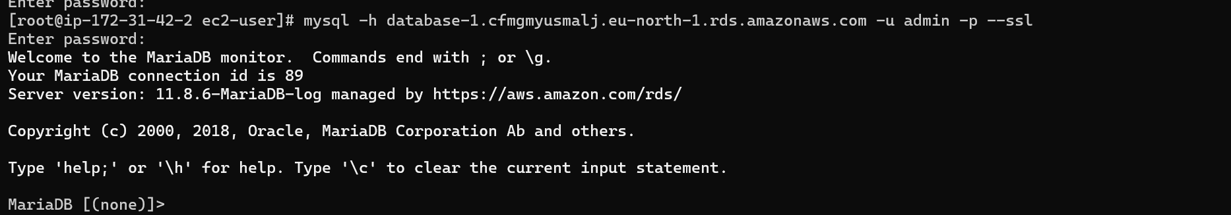
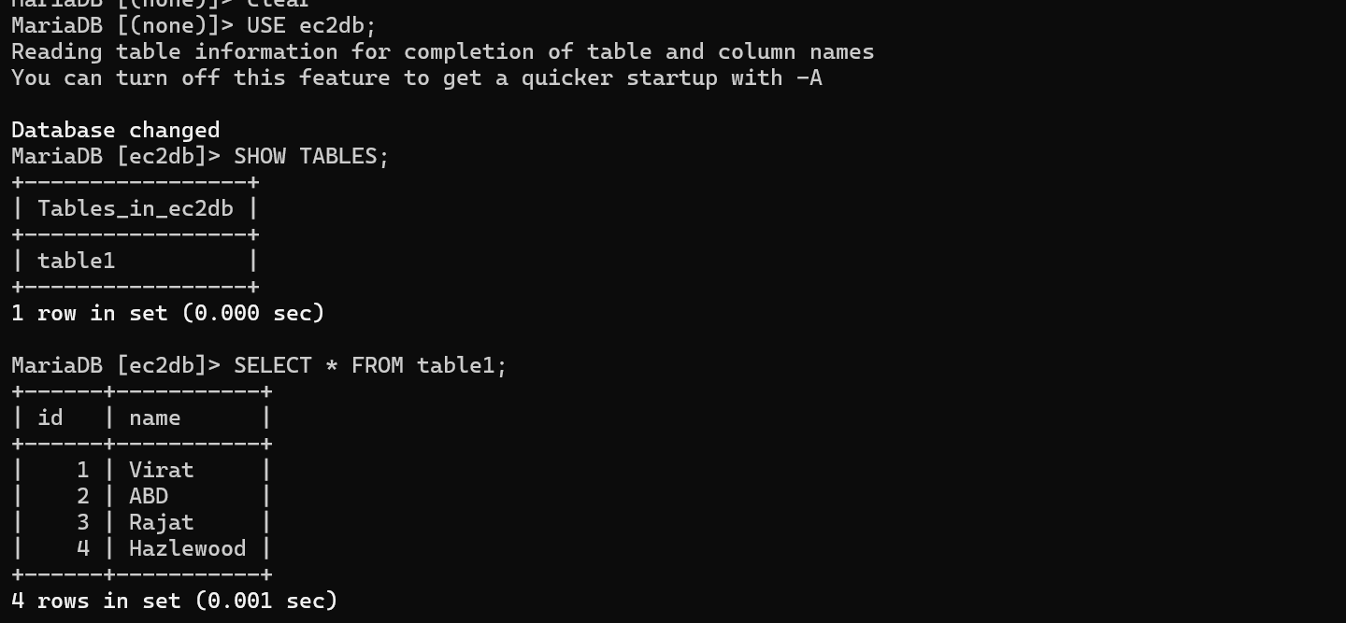

We can see that the database has been migrated from EC2 to RDS

- Install MYSQL DB on EC2
Downloading MYSQL
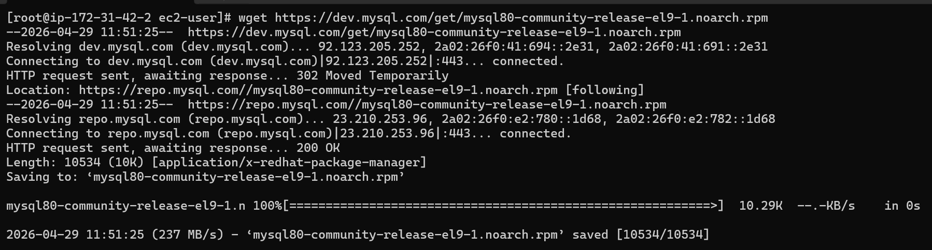

And installing it
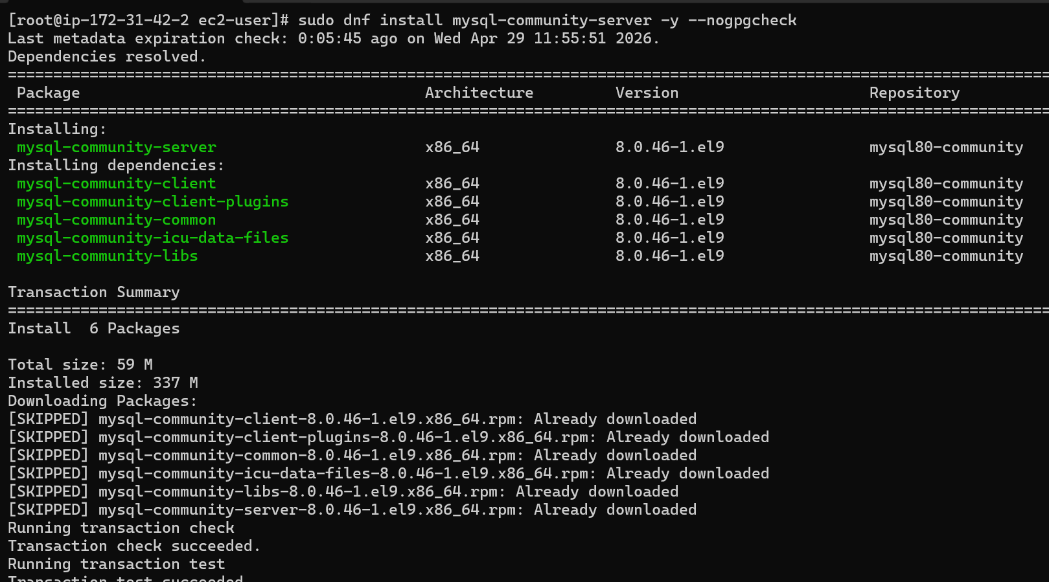
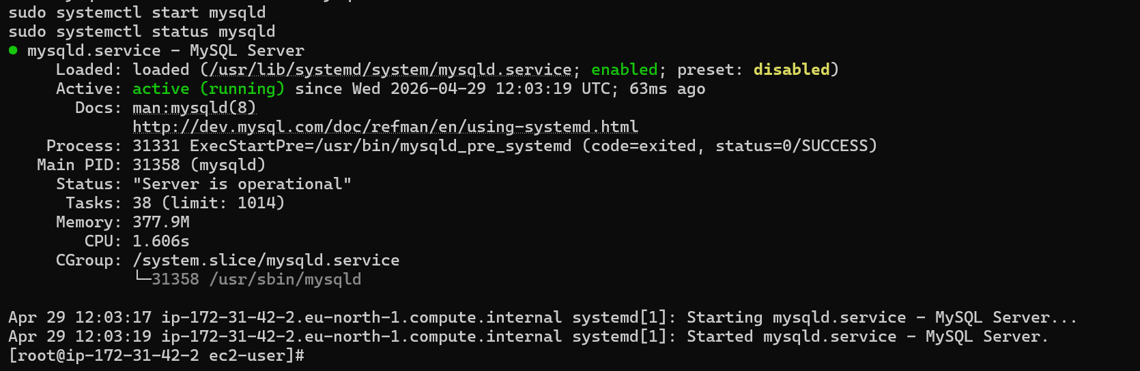

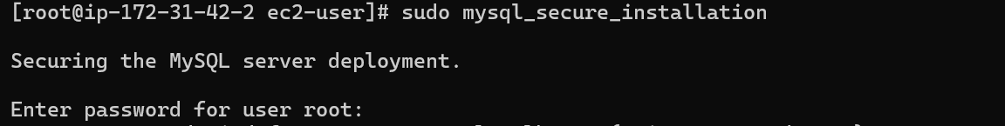

We are now able to access my sql db
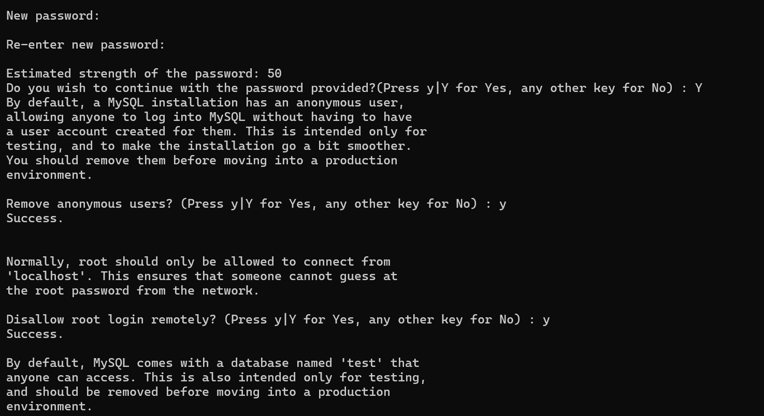
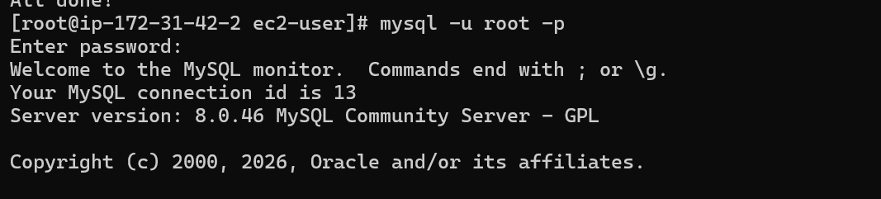

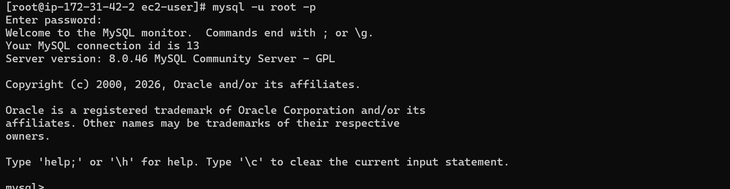

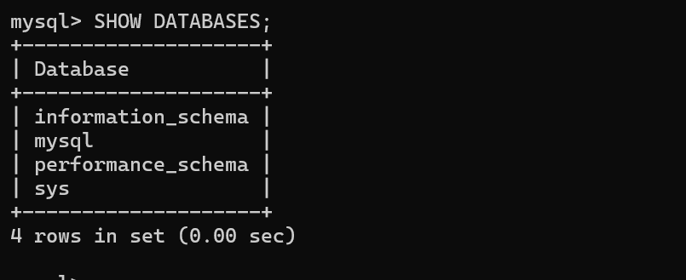

- Launch MySQL RDS image

Go to RDS service
And
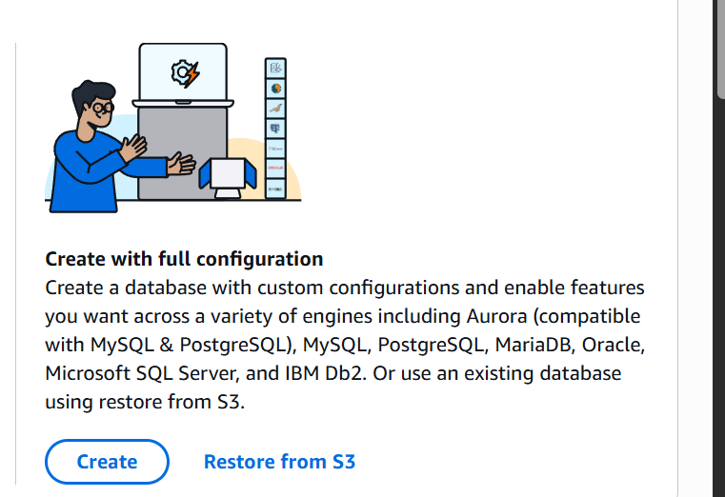
Click on create
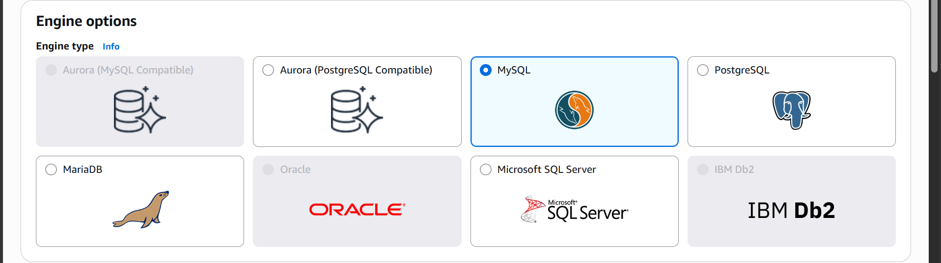

Select MySQL engine

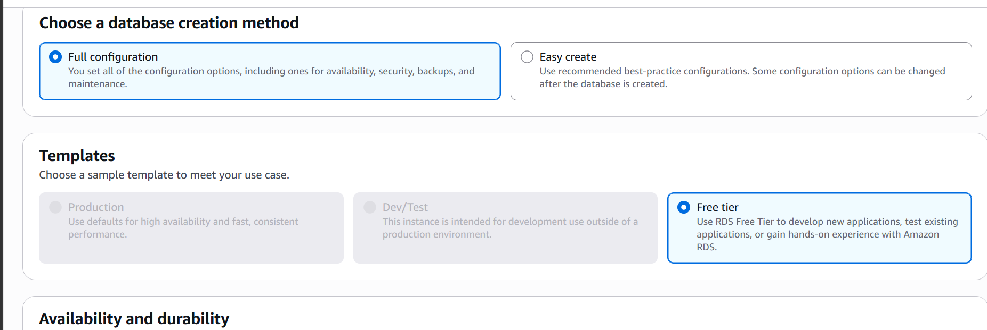

Select full configuration

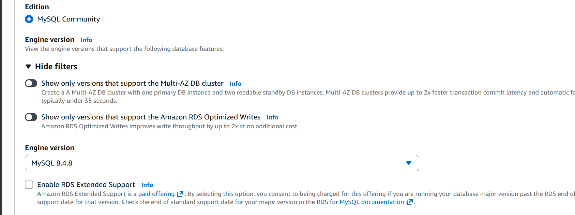

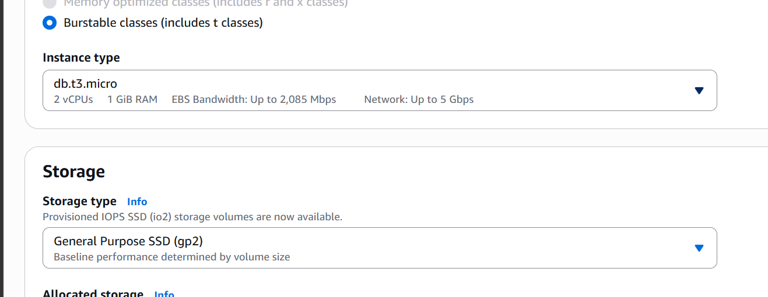

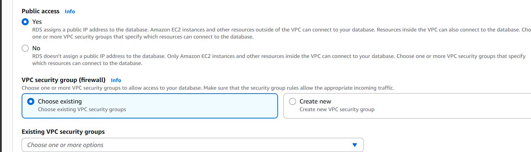

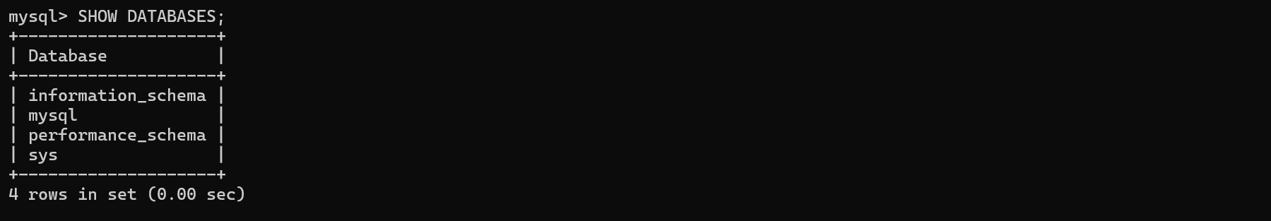

- Configure Multi AZ

Unable to configure multi AZ due to free tier restrictions

- Take Backup of DB and restore the DB

Go to the database
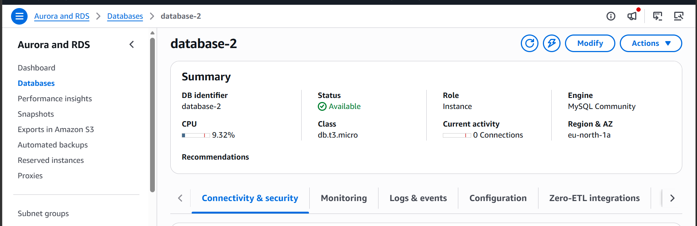

Click on actions
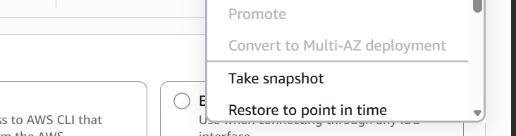

Click on take snapshot
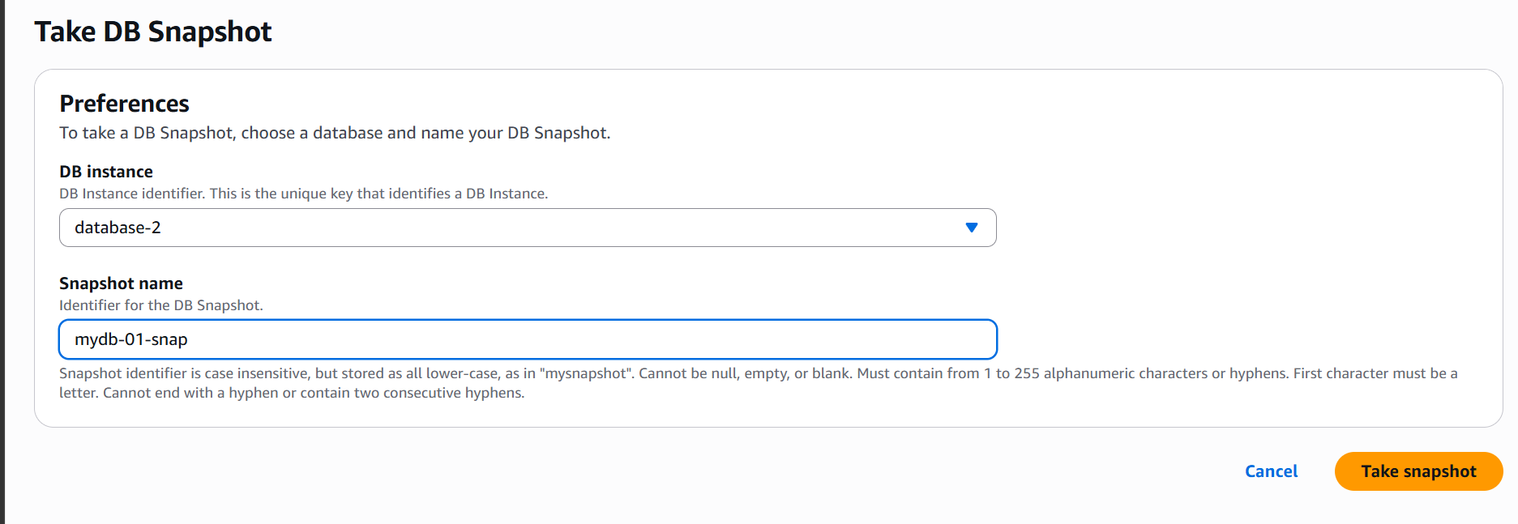
Give snapshot a name

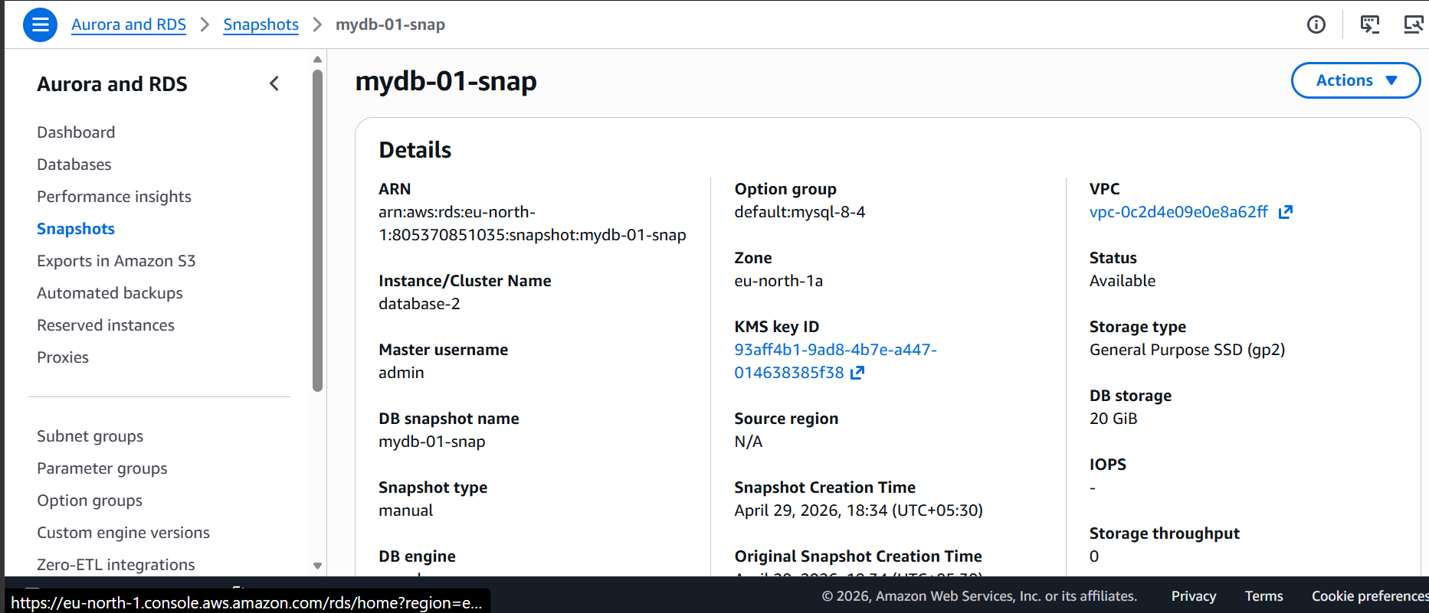

Snapshot is now created
To restore the snapshot click on actions
And then restore snapshot
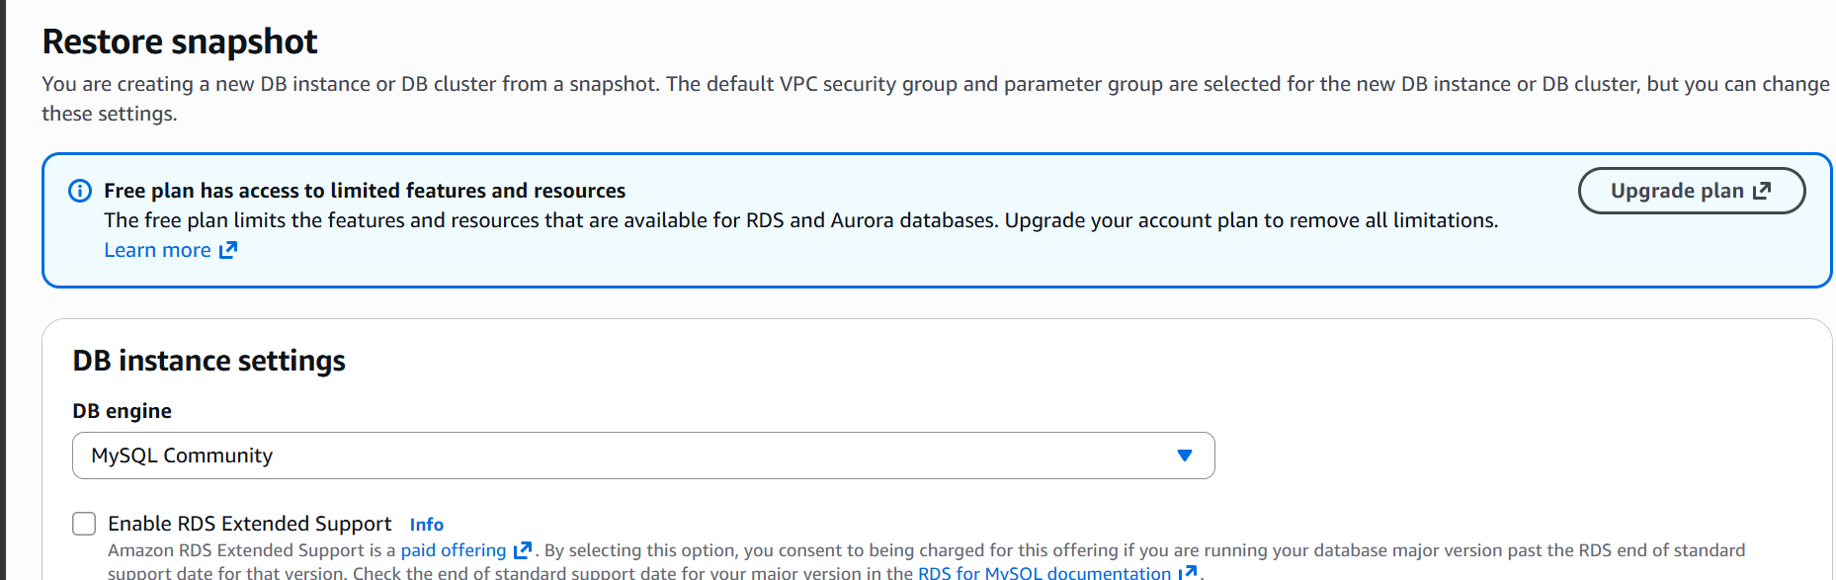
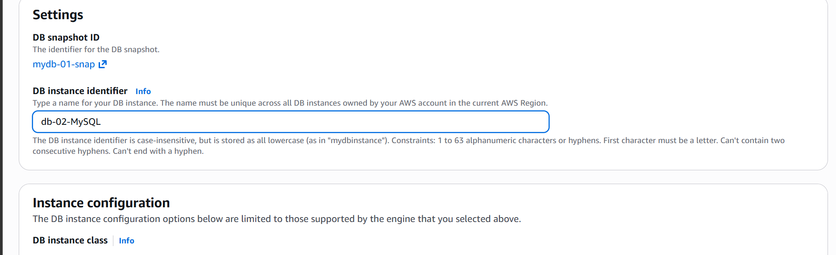

The database is getting created now
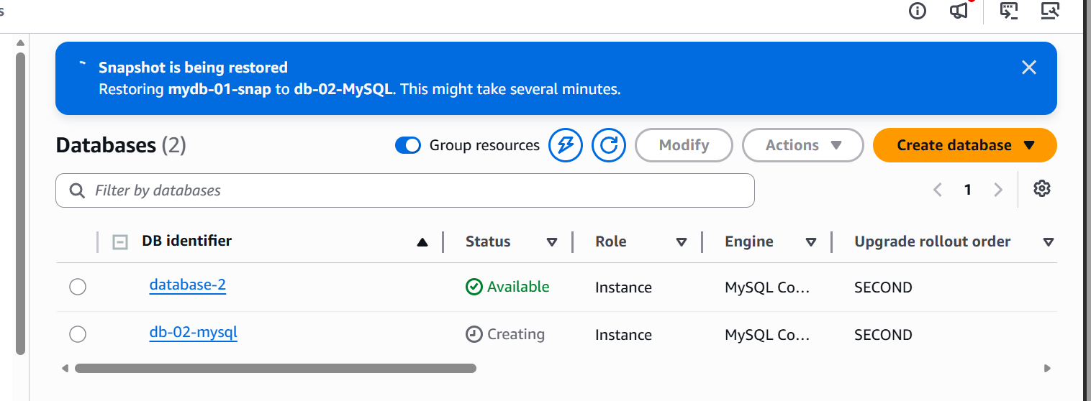

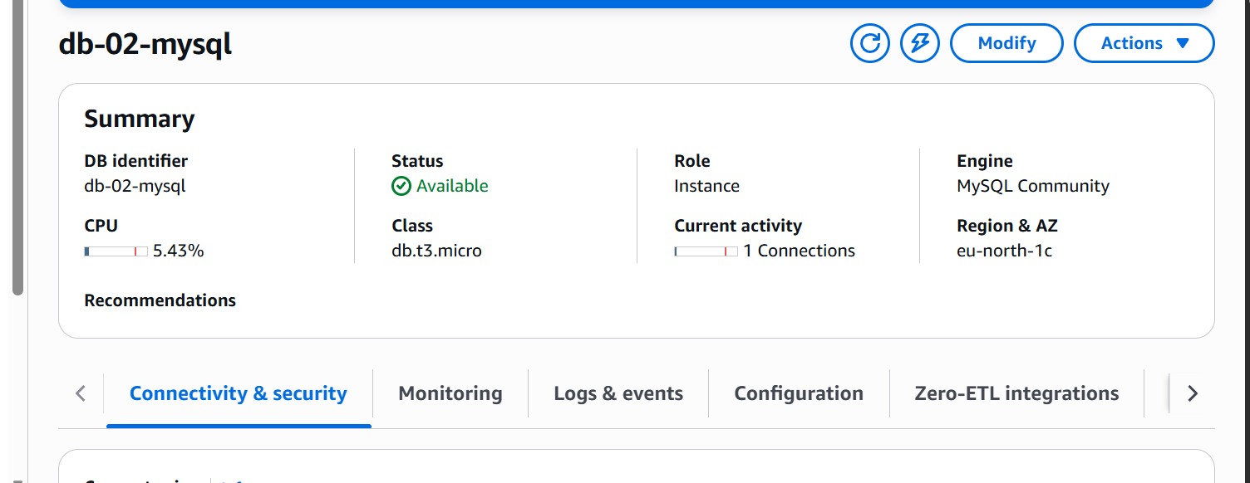

The database is restored with the snapshot

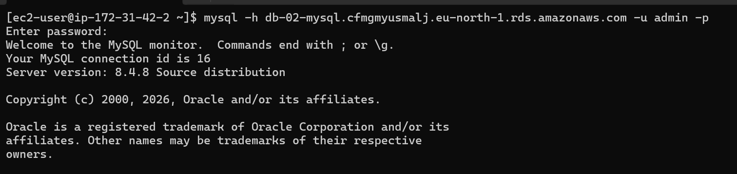

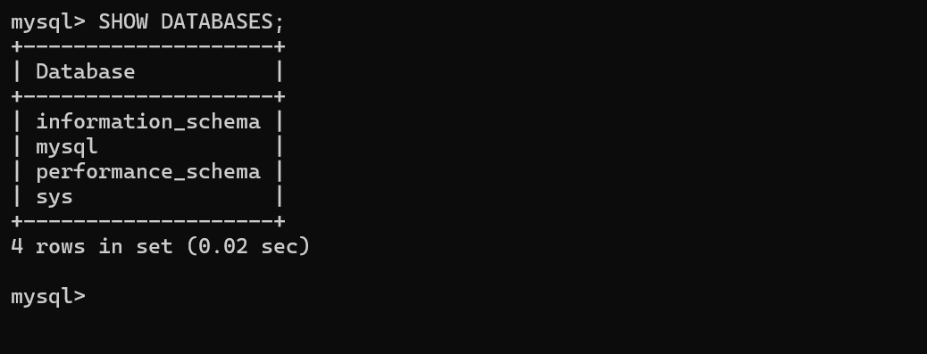

These are the databases available.

- Create a Read Replica

Go to the data base
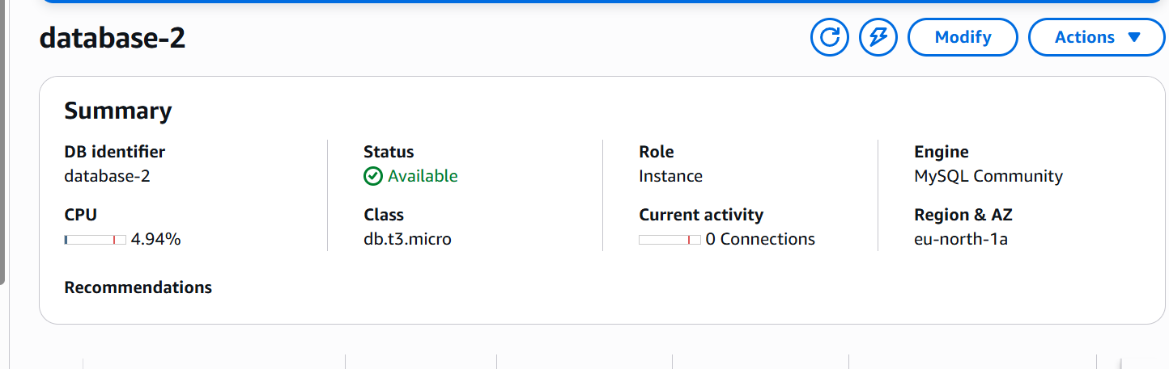

Click on actions

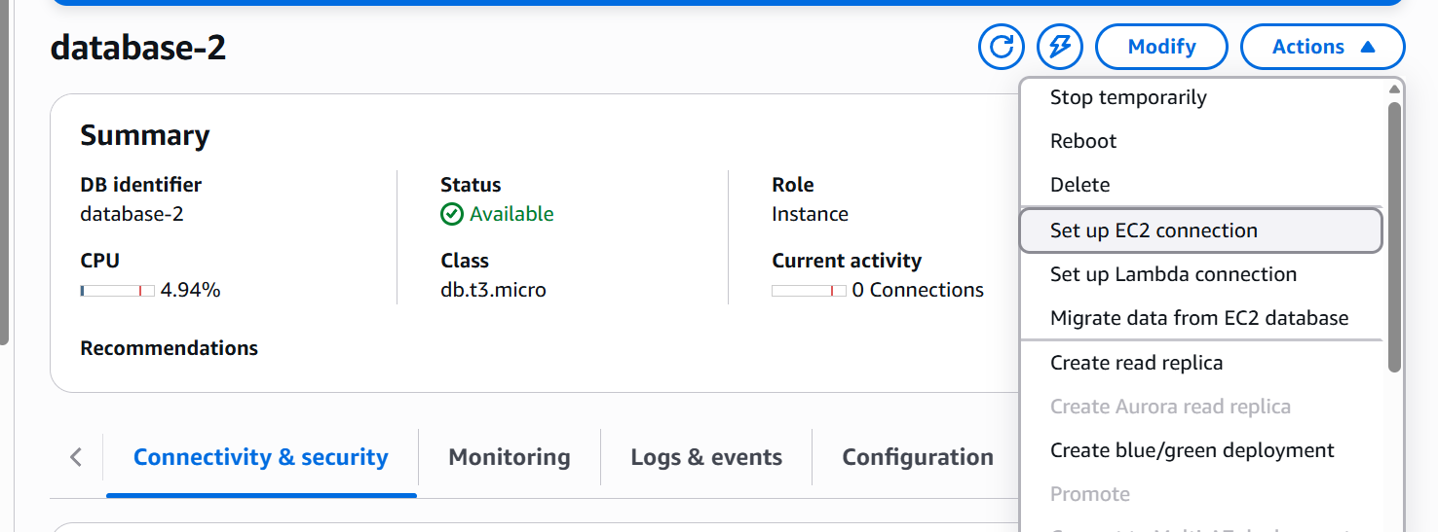

Click on create read replica
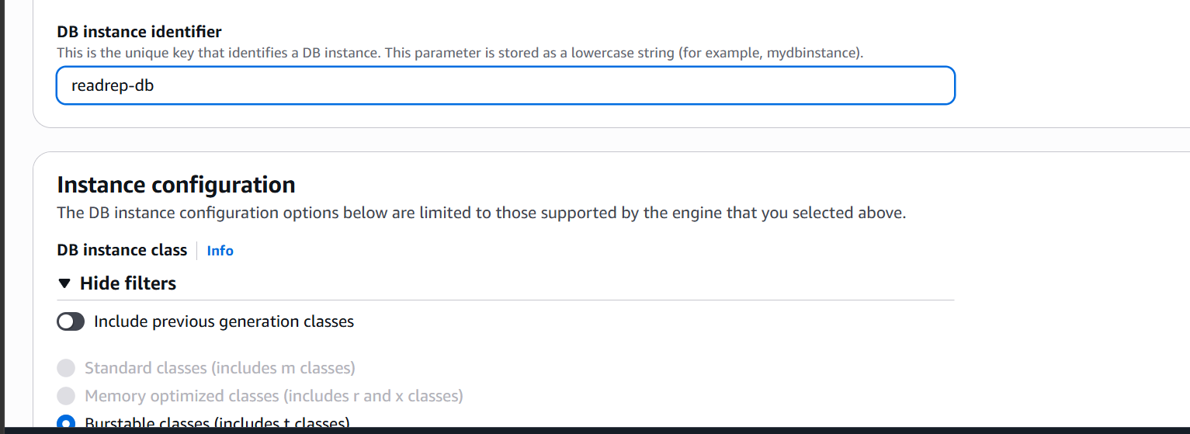

Click on create replica

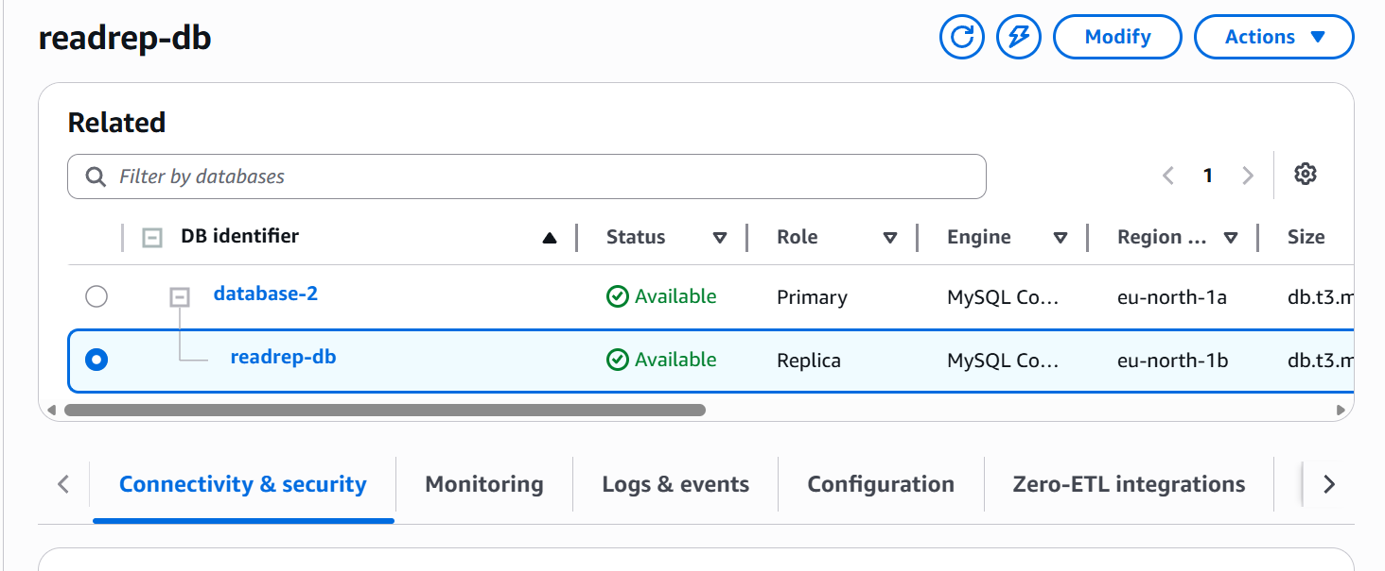

Created the read replica

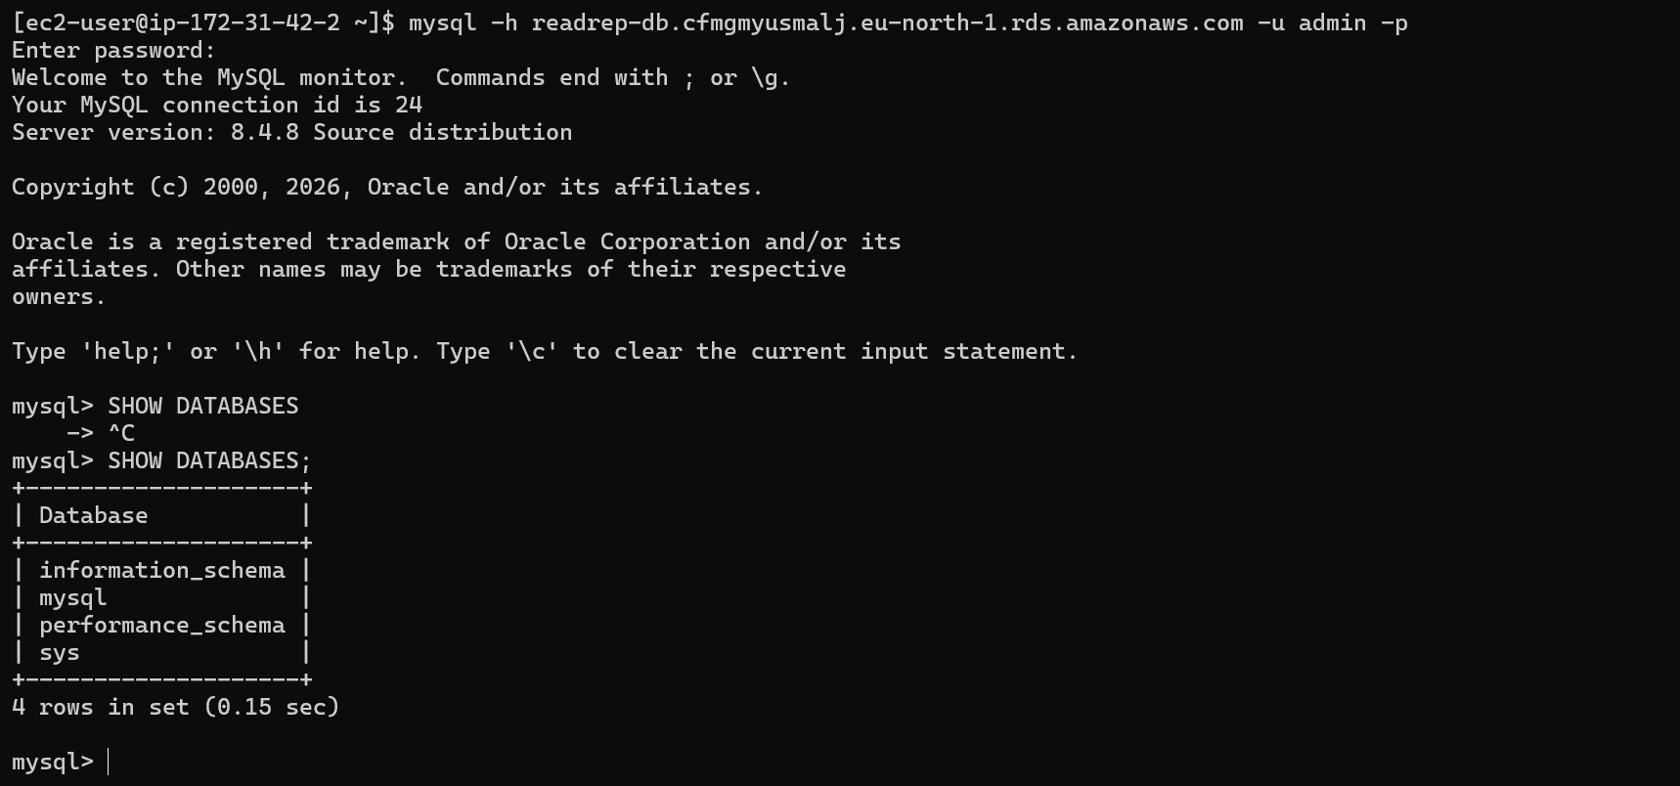

The read replica is now accessible by its endpoint and we are able to read the content of database

