Identity and Access Management (IAM)

Create one IAM user and assign EC2 and S3 full Access roles.

Creating a User:
We need to search for IAM service.
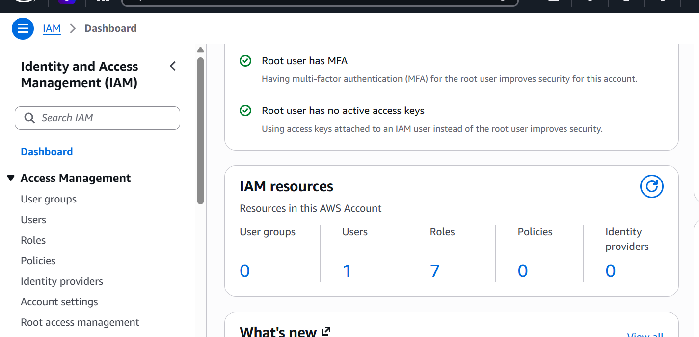
Now select users and create a user.
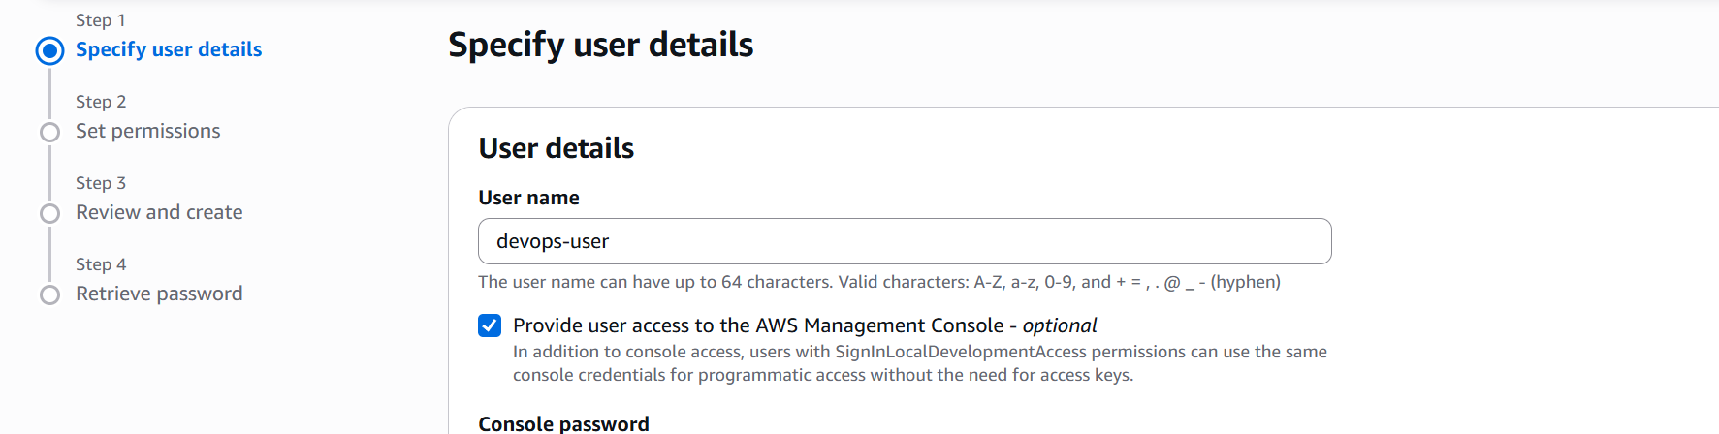

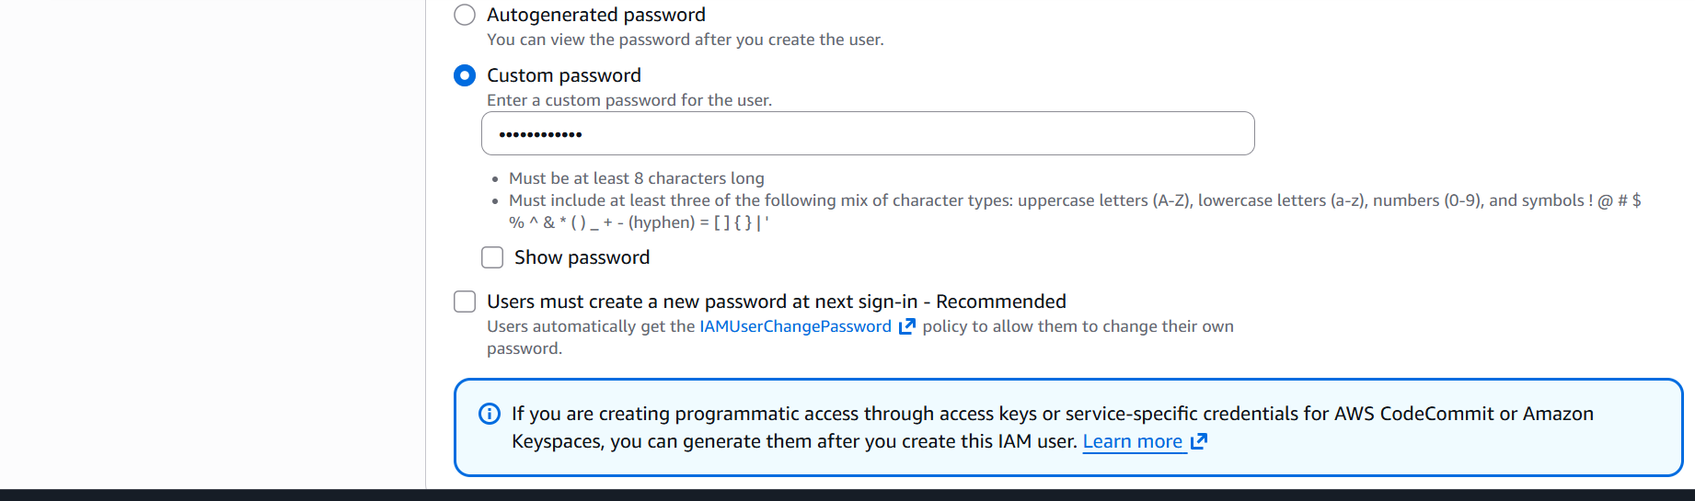
Now let us assign roles to our user.
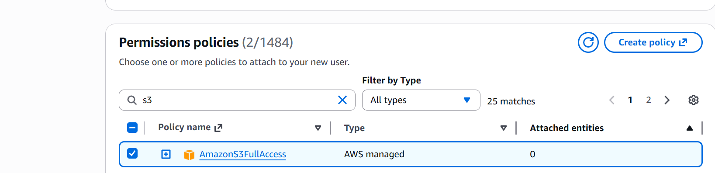

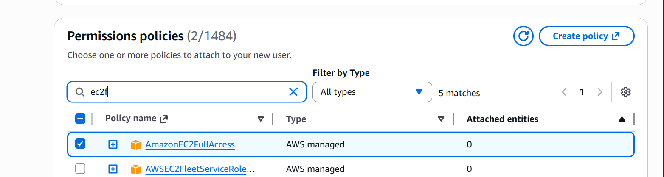

Now we can go ahead and create our user.
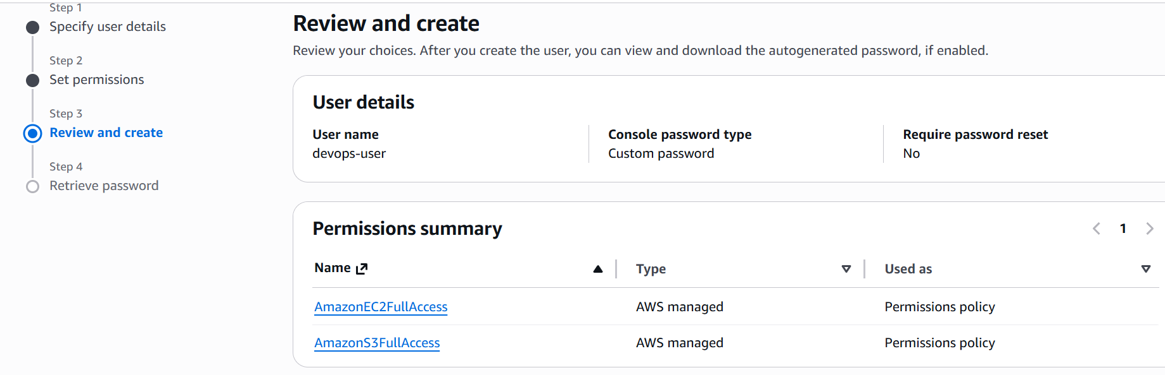


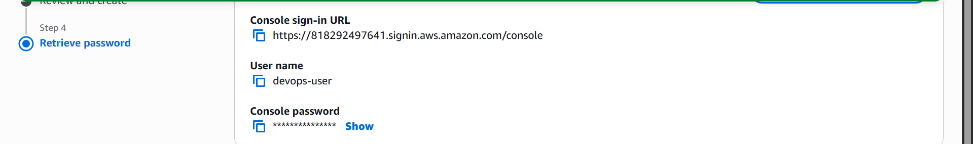

We can download the csv file or our newly created user.

Now let’s go and check our user has access to ec2 and s3.
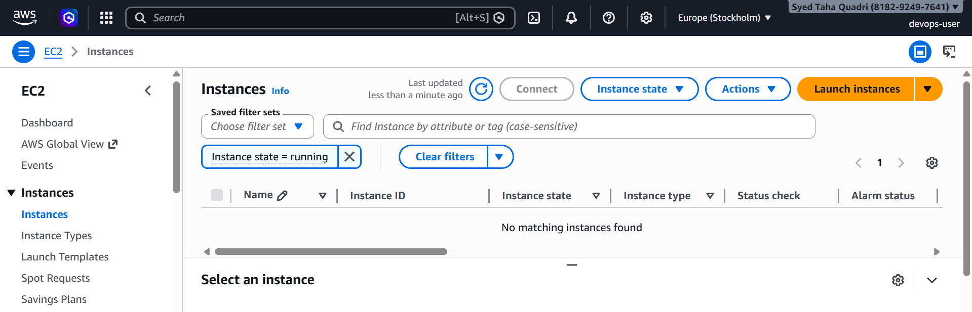

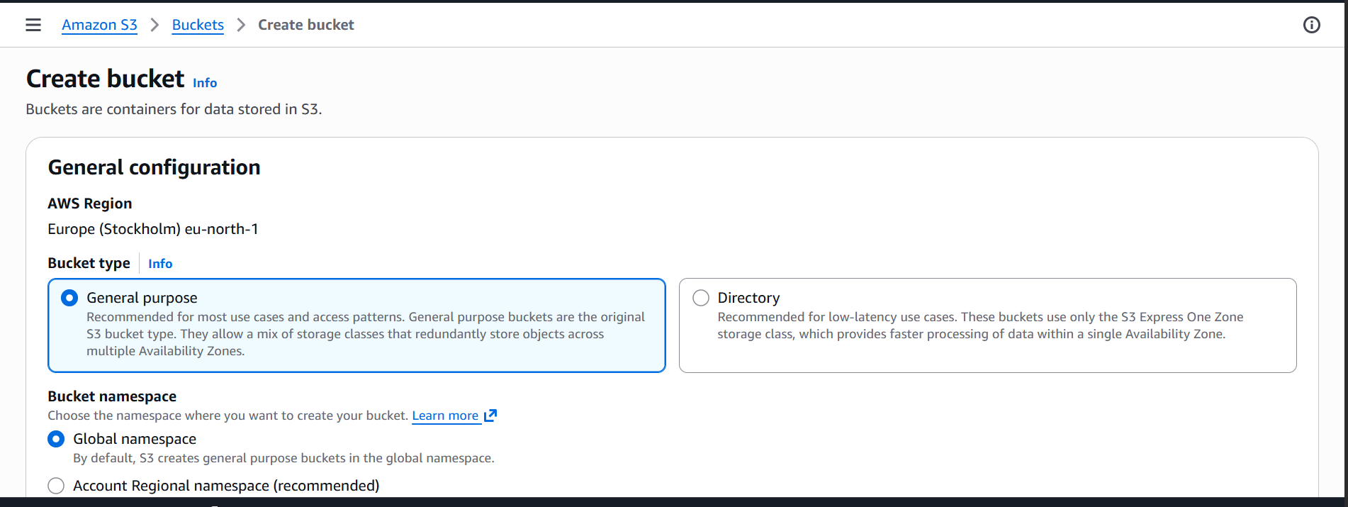

The devops user is now able to access ec2 and s3.
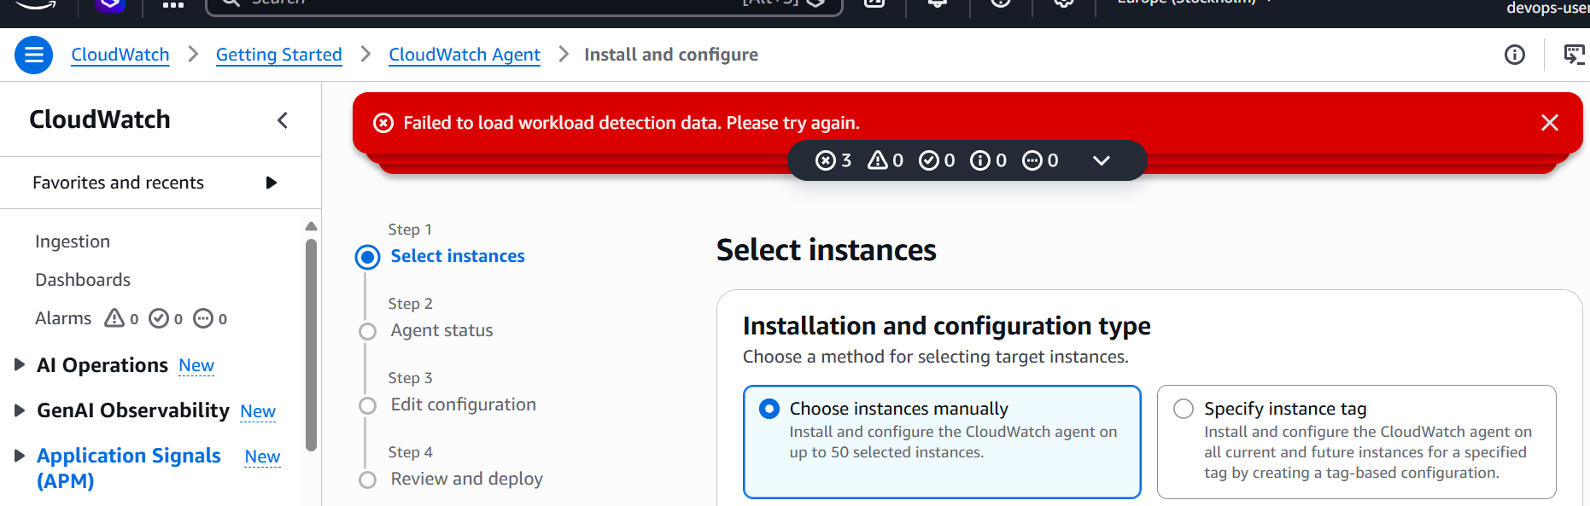

The user is not able to access anything other than ec2 and s3.

2. Create one group in IAM and assign read access for EC2.

In IAM go to user groups
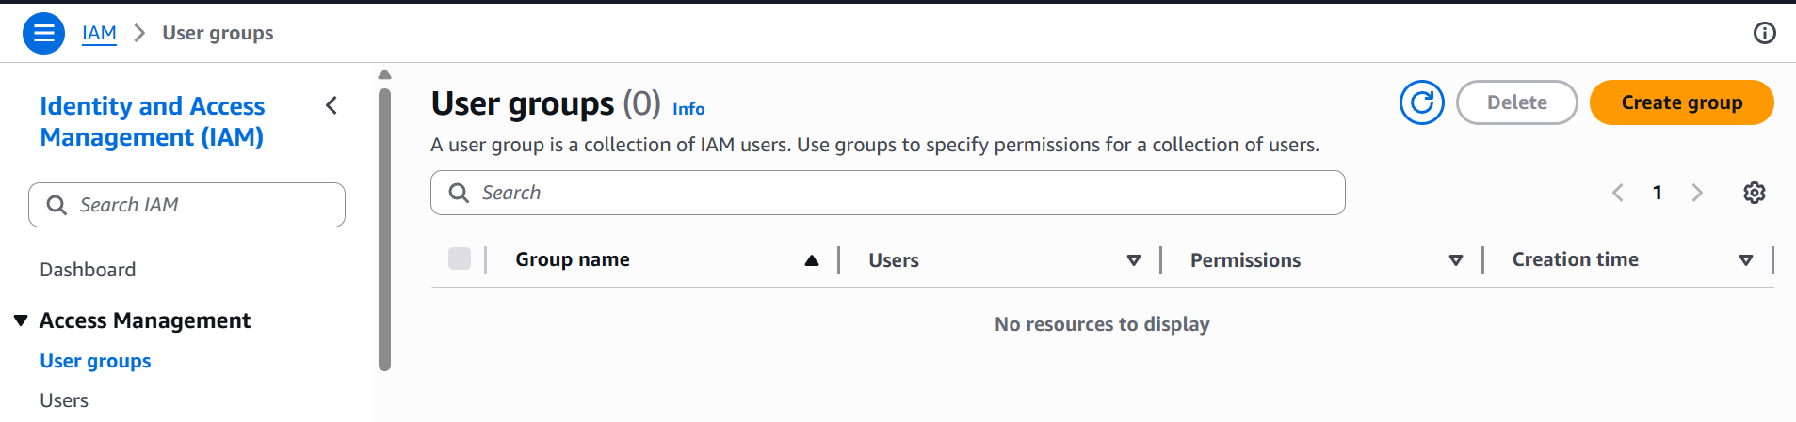

Creating a group named operations
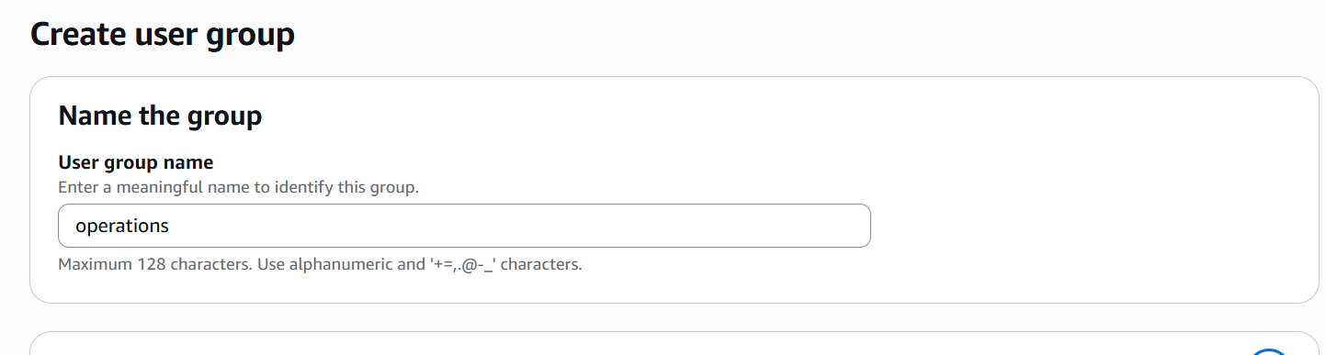
Now let’s attach ec2 read access to group.
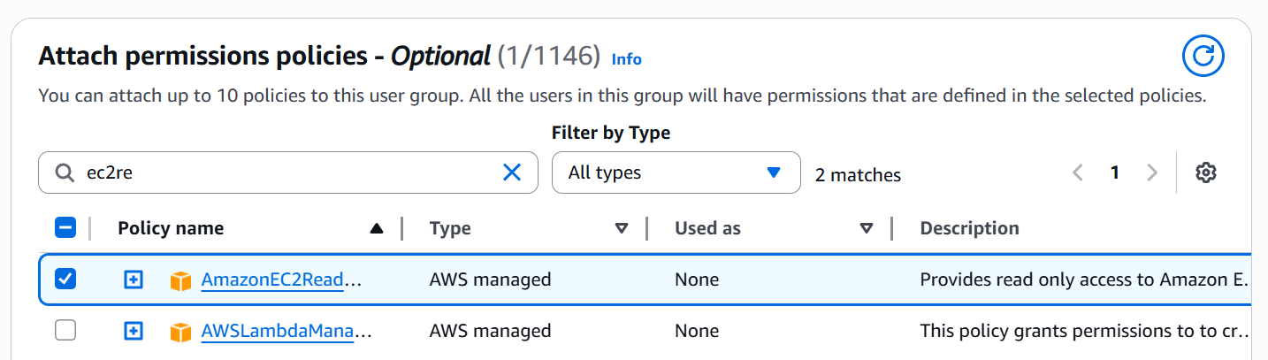

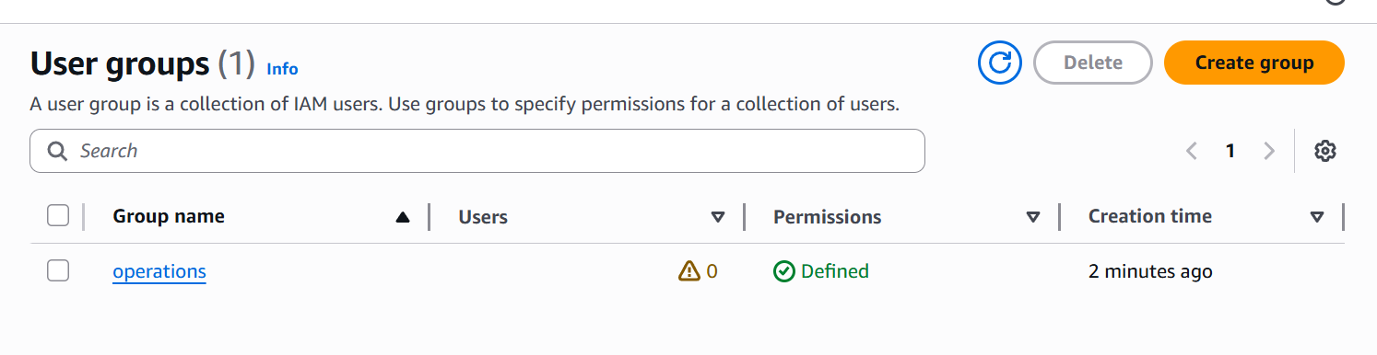

3. Now lets create a user named DevOps and add it our newly created group

Creating a new user DevOps
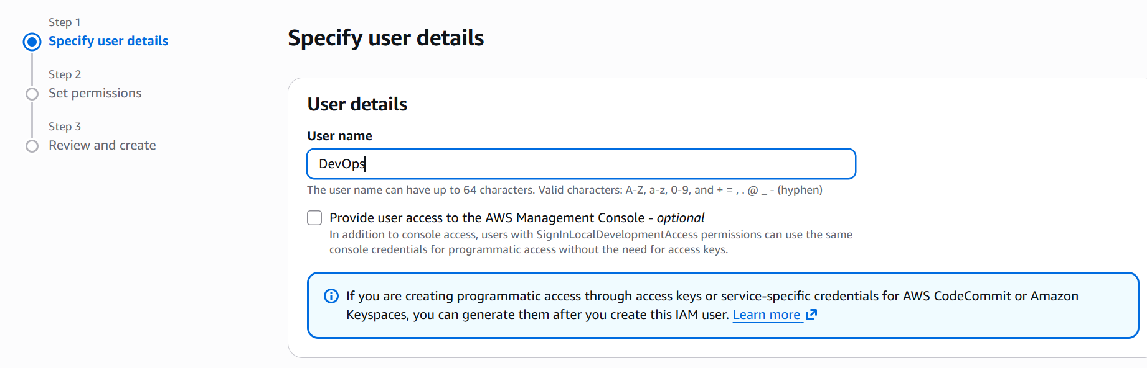

Now add the user to group operations
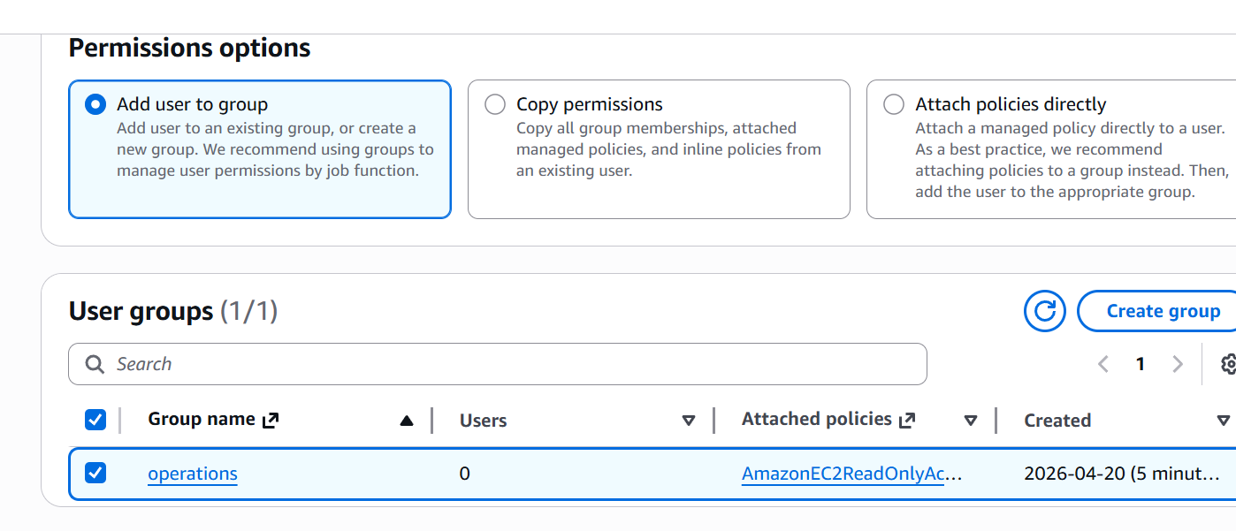

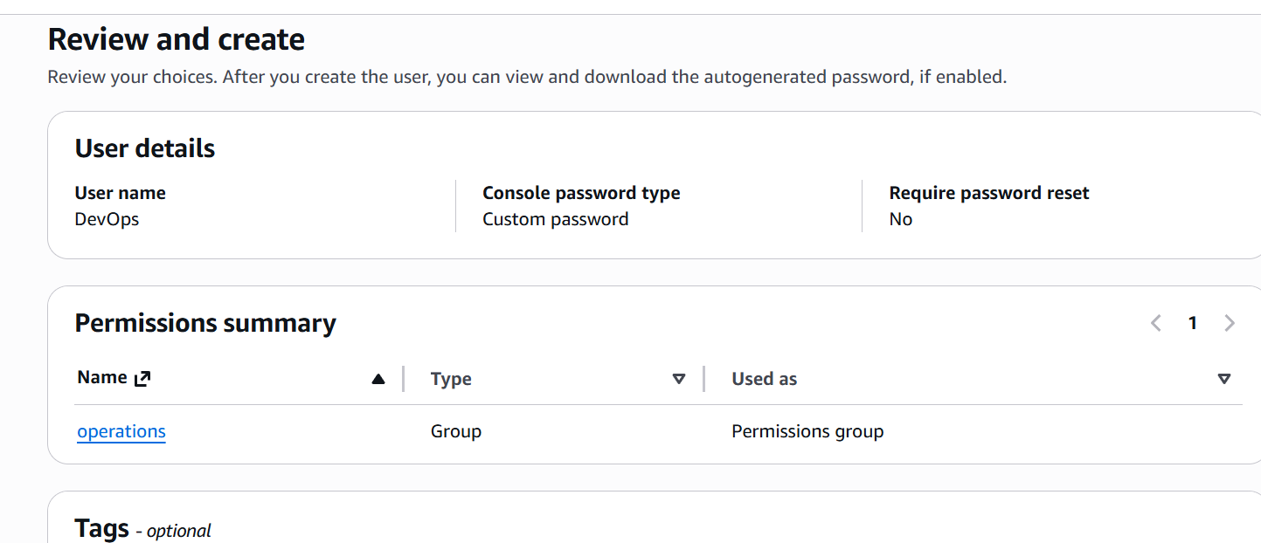
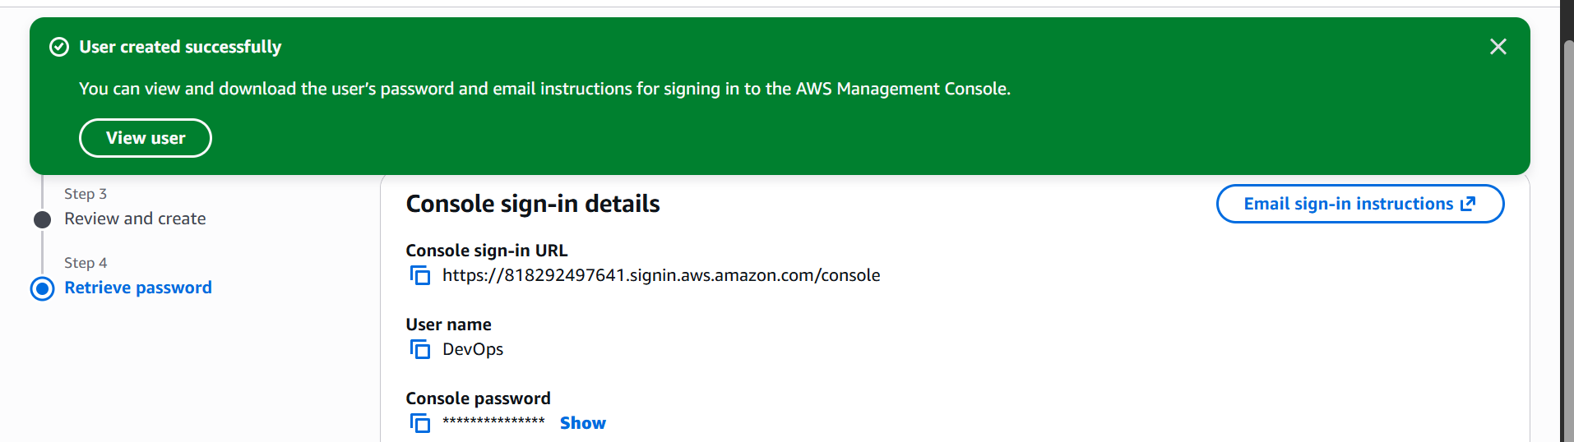

Now we have created a user named DevOps and added to the group.
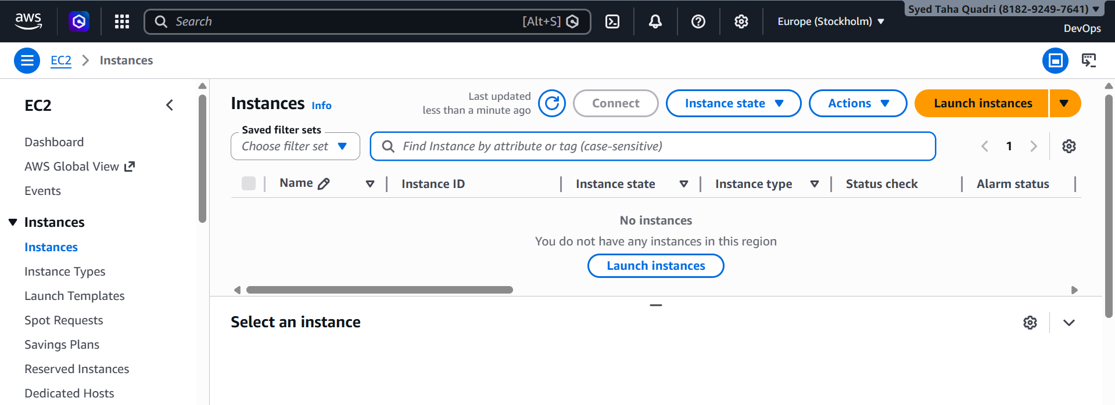

The user is not able to read the ec2 service
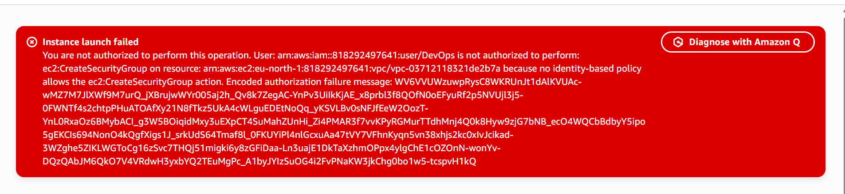
But unable to launch one as it only has read access.

4. Write a bash script to create an IAM user with VPC full access.

Here is the script to create a user with VPC full access.
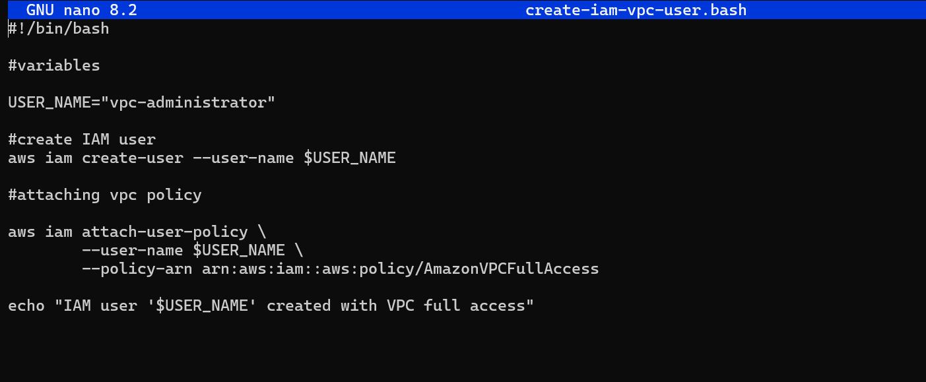
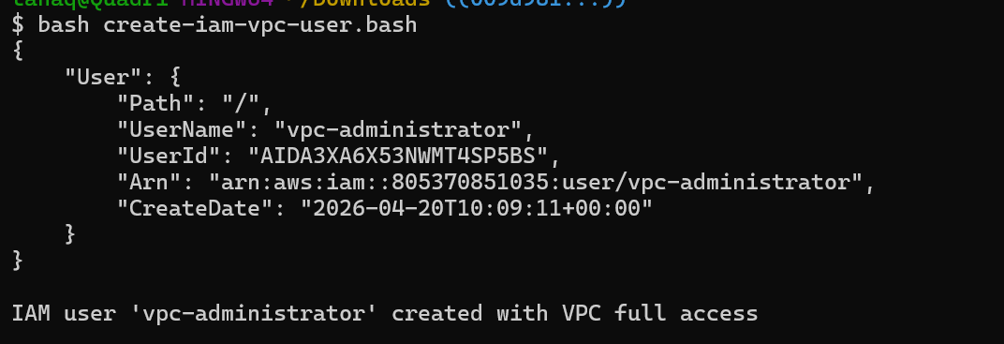
The user named vpc-administrator is created.
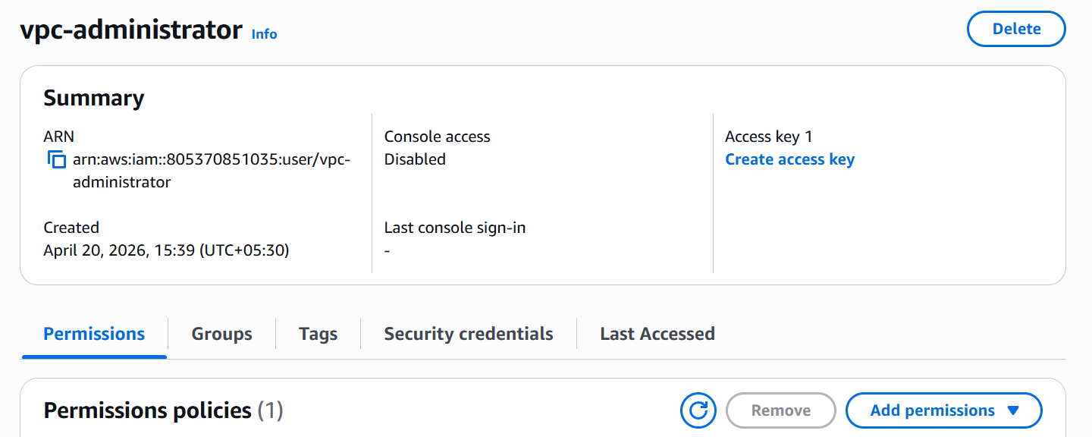
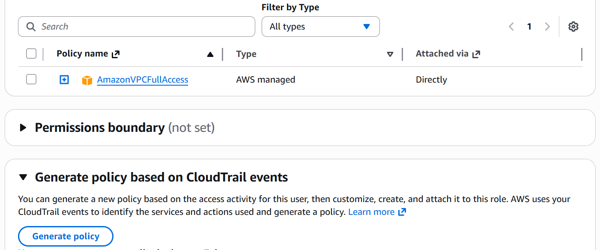

5. Create an IAM policy to allow EC2 access for a specific user in specific regions only.

Lets create a policy first
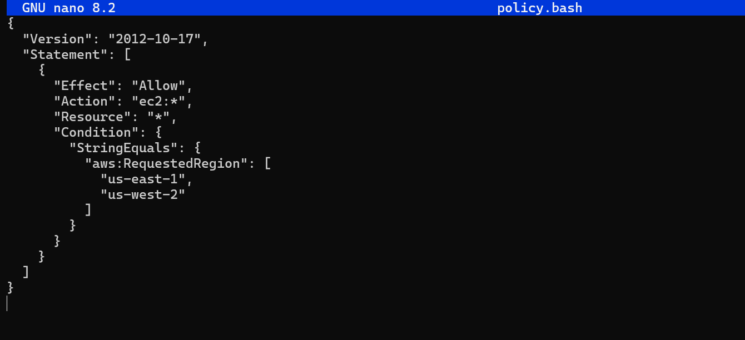

This policy allows users to create ec2 in us-east-1, us-east-2

Now let’s create this policy and attach it to our user.

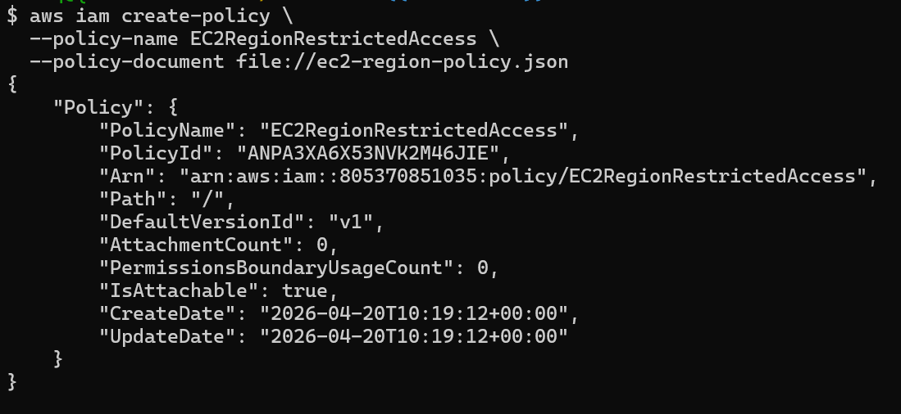

Policy created.
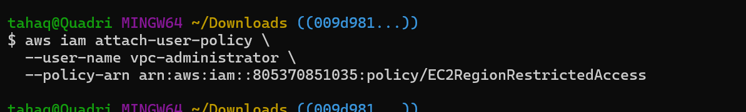
The policy is now attached to our user.
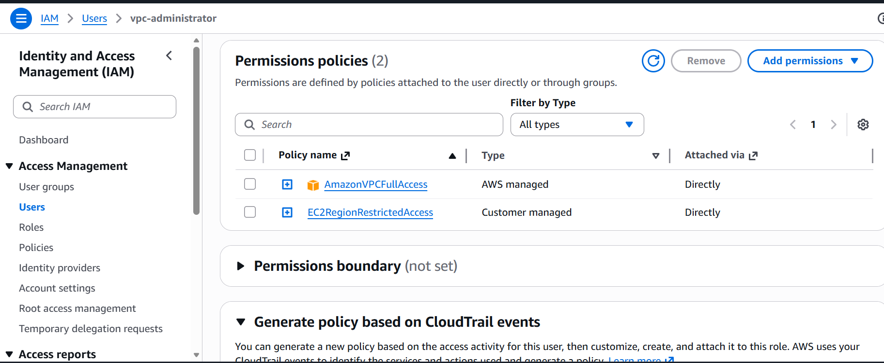

6. We have two accounts: Account A and Account B. Account A user should access an S3 bucket in Account B.

This is the bucket which I am trying to access.
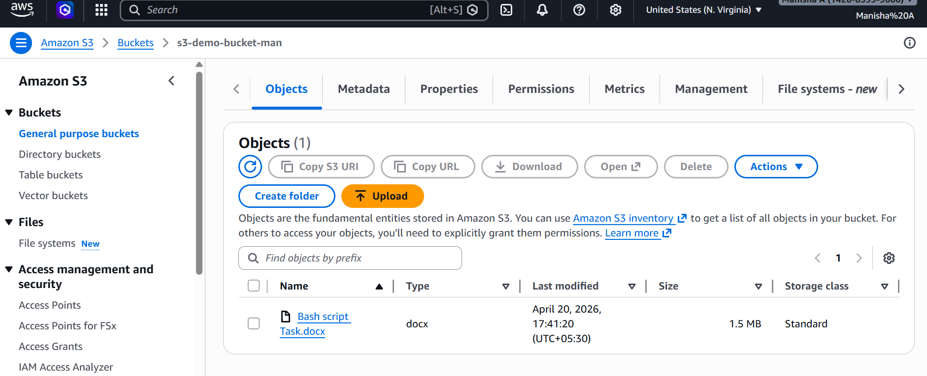
Let us now start creating a

First, we need to add to add a bucket policy in User Manisha’s account
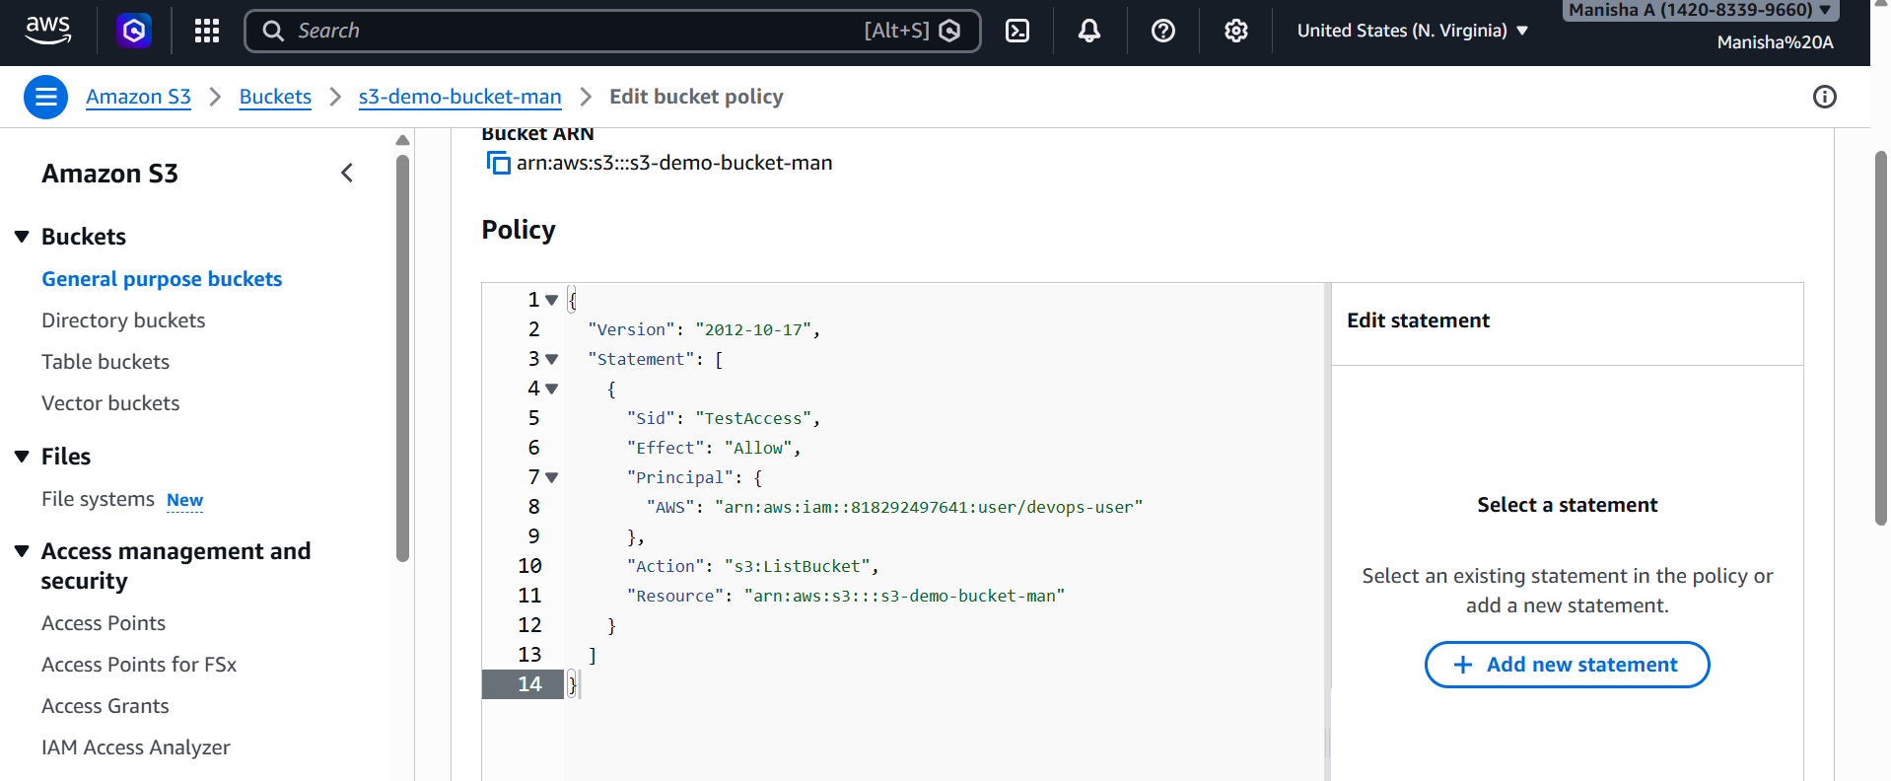

Now created a policy which allows me to access user Manisha’s s3 bucket.

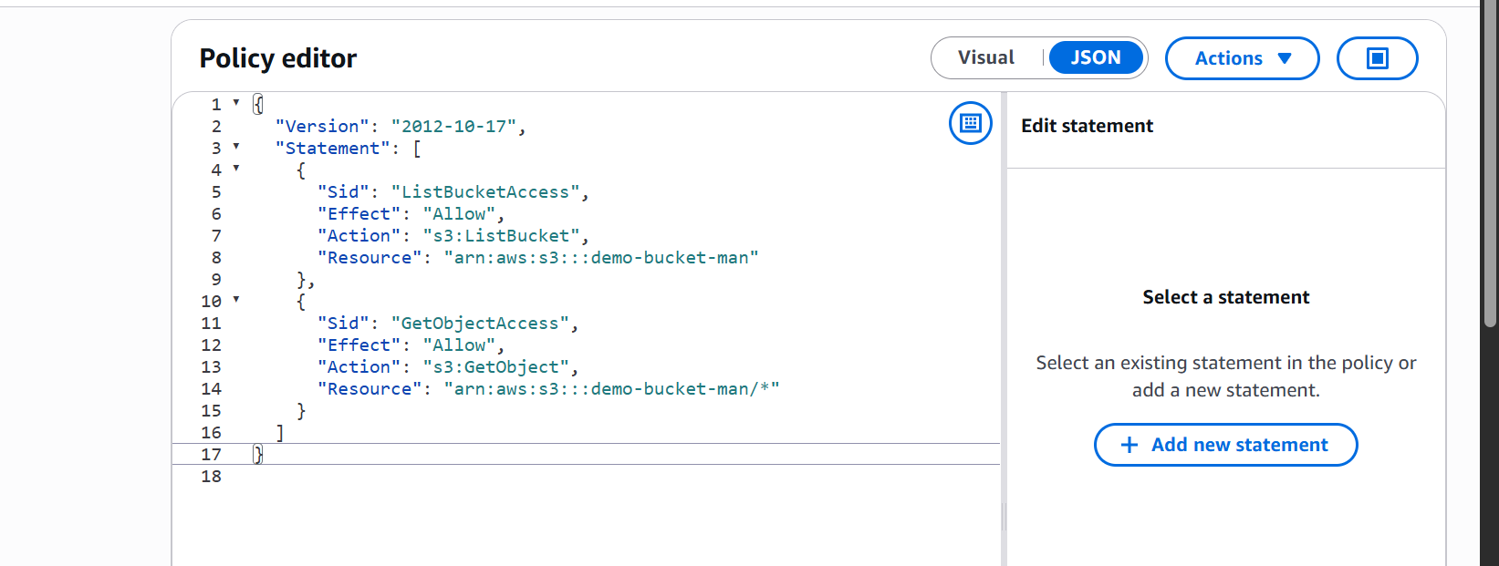
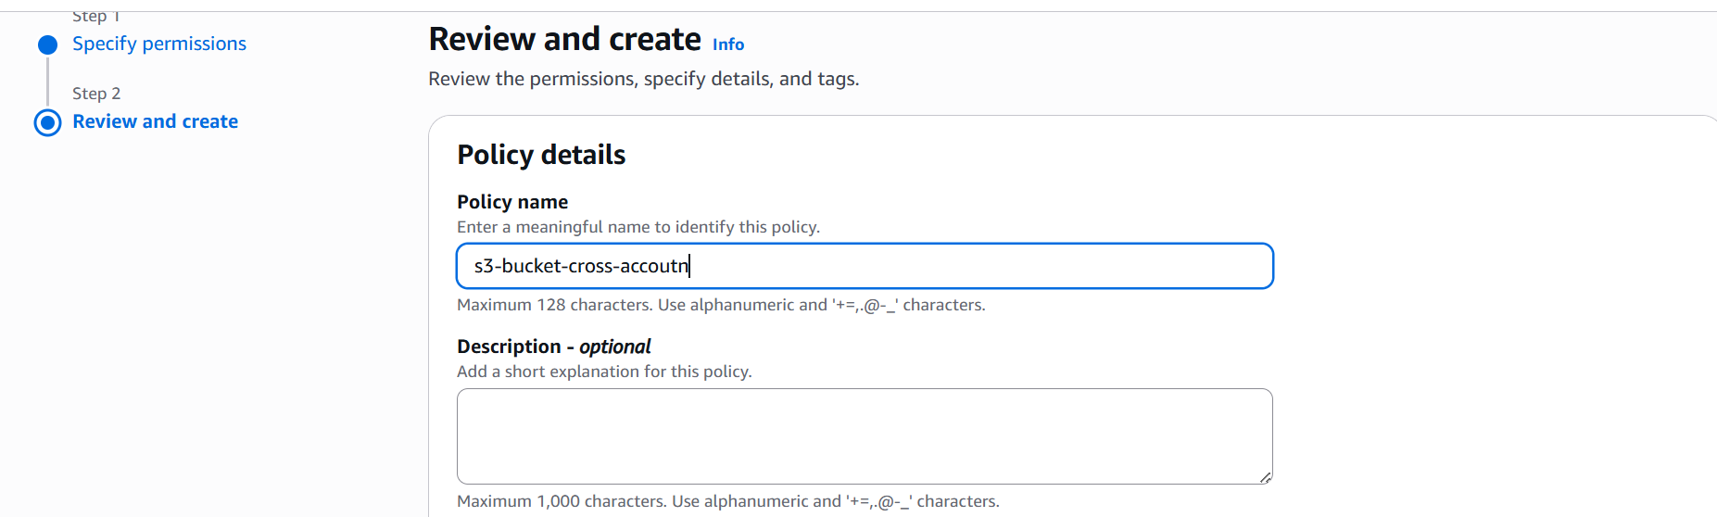
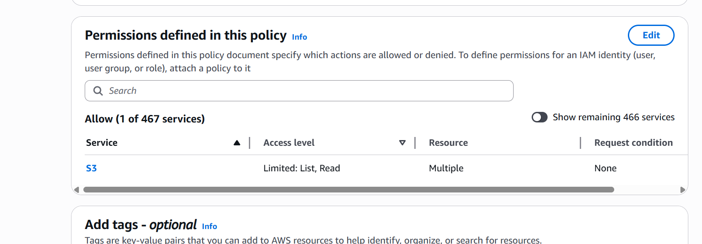

Attached the policy to a user.
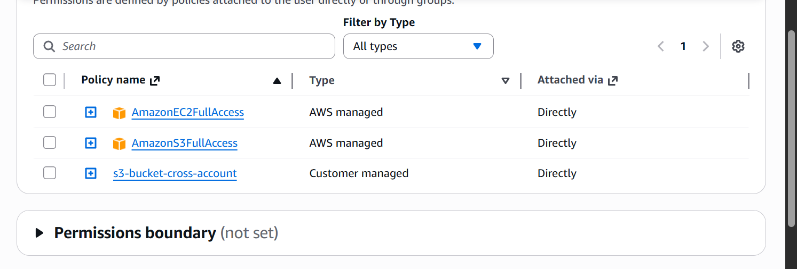

Now let us check if we are able to access user Manisha’s s3 buckets.
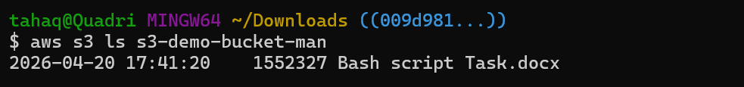
I am now able to access Manisha’s s3 buckets.

