AWS Monitoring

- Enable Cloud Trail monitoring and store the events in S3 and Cloud Watch log events.

Go to AWS Cloud trail and Click Create a trail.

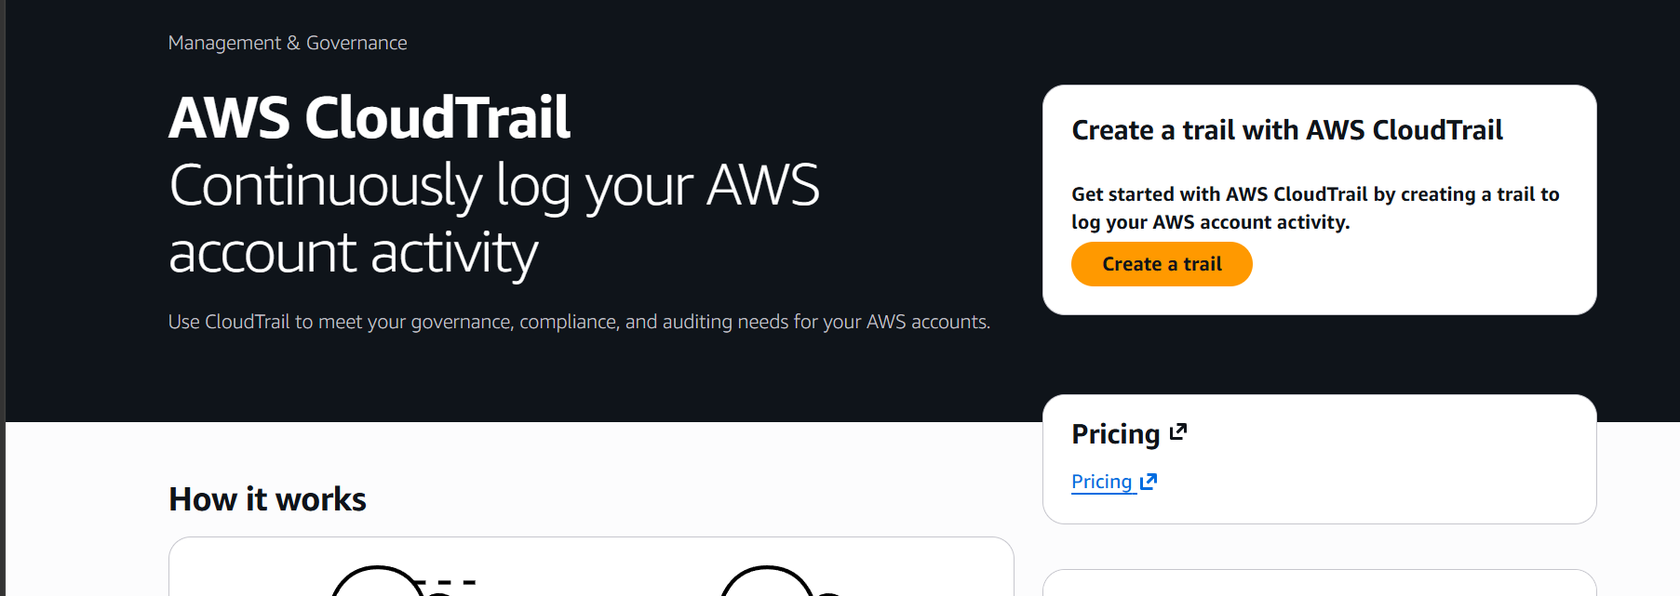

Give name and choose create new S3 bucket

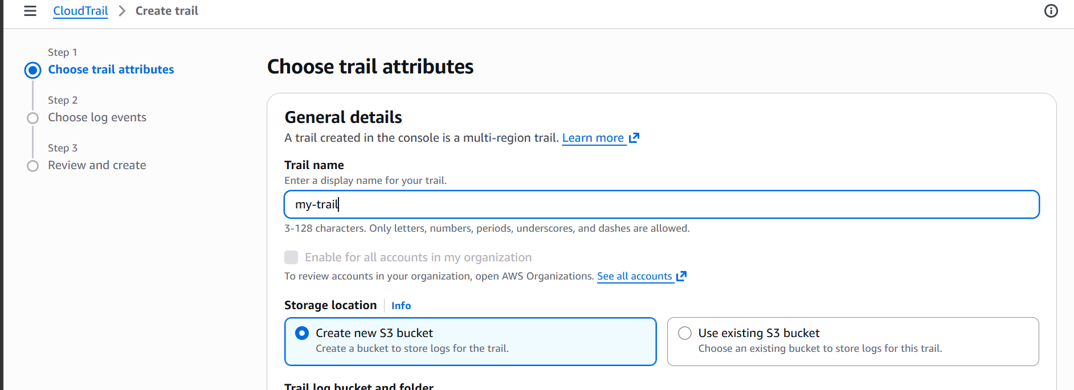

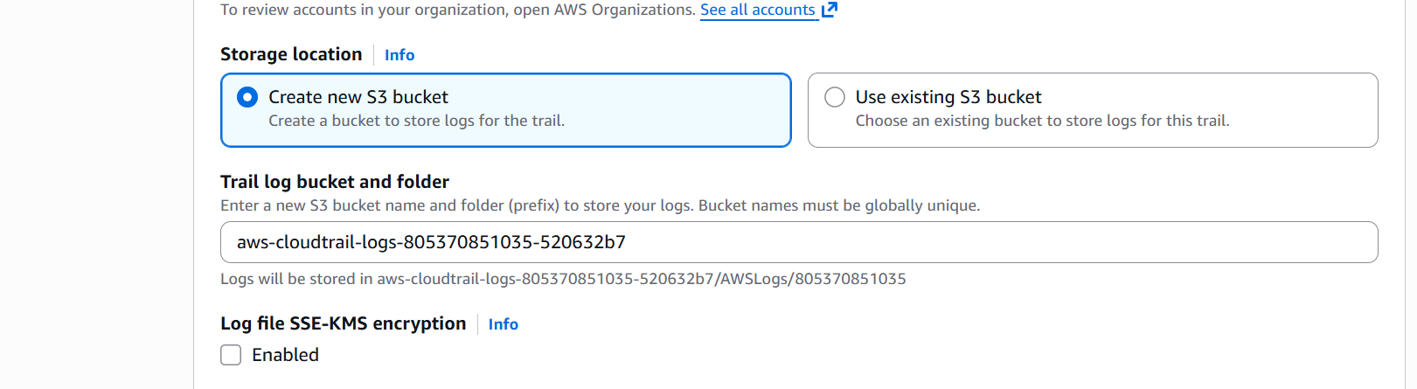

Choosing cloud watch to store logs
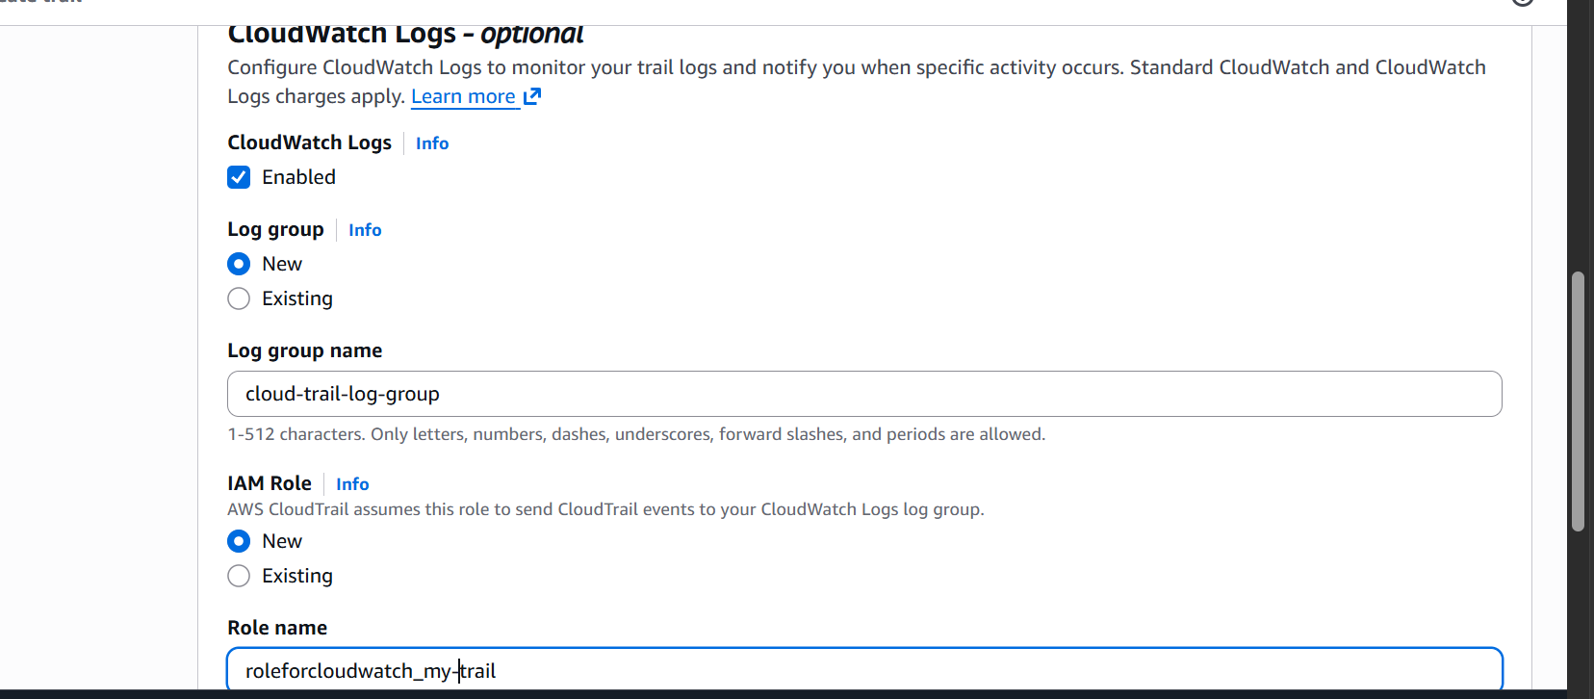

Choosing log event on what event we want cloud trail to record logs
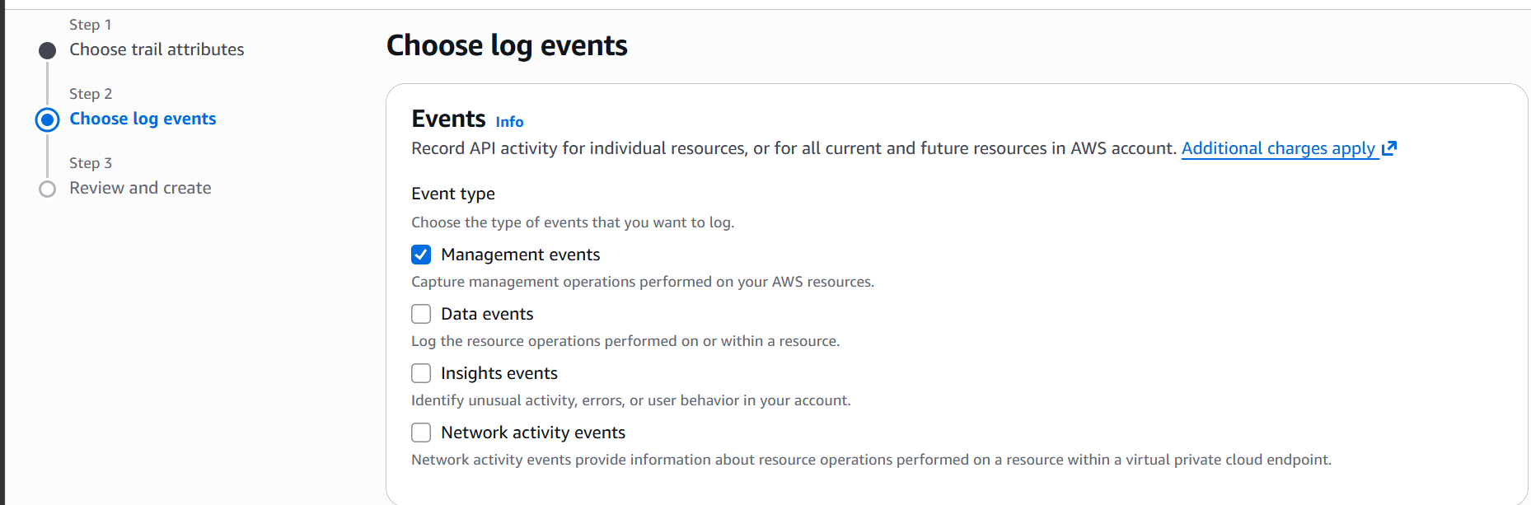

Here we have selected management events.

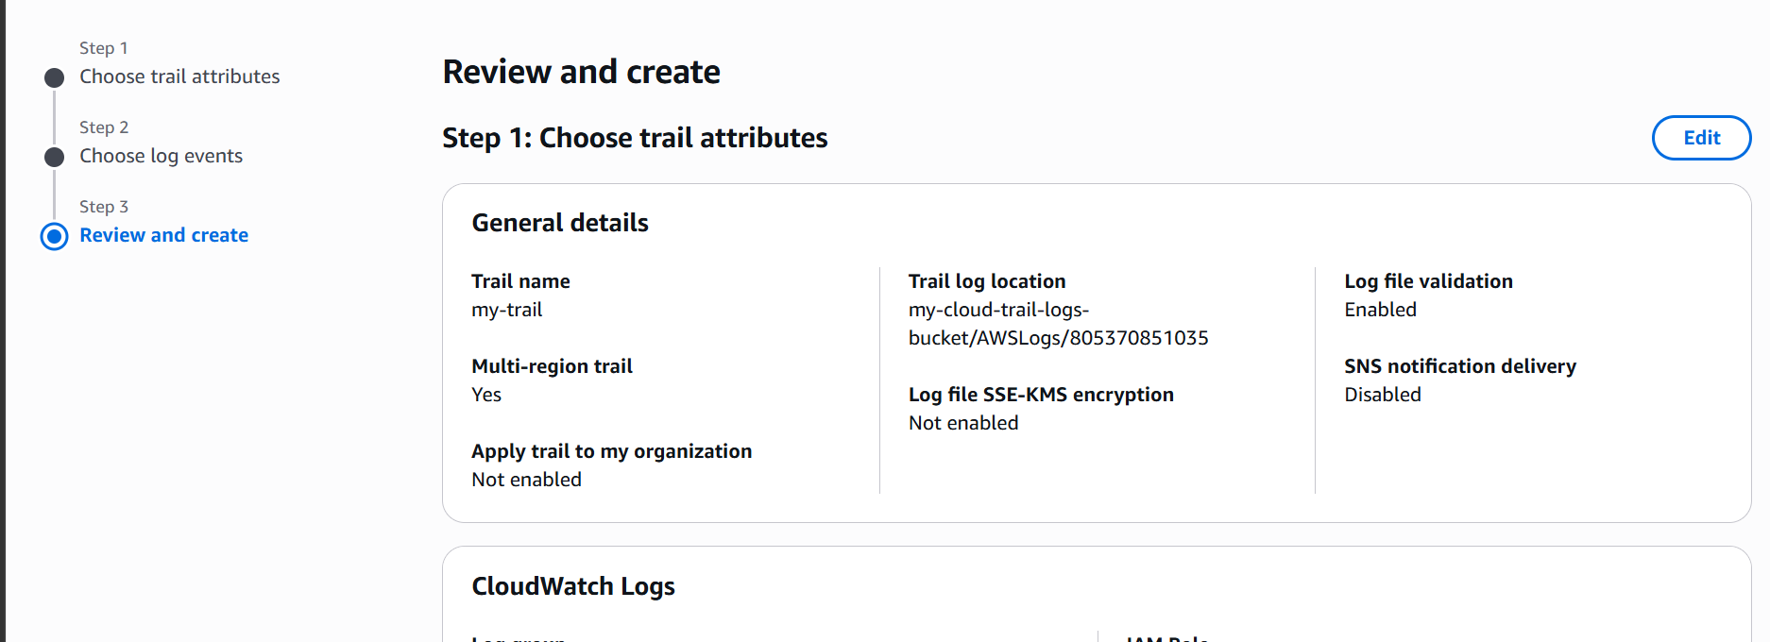

Let’s now create a cloud trail.

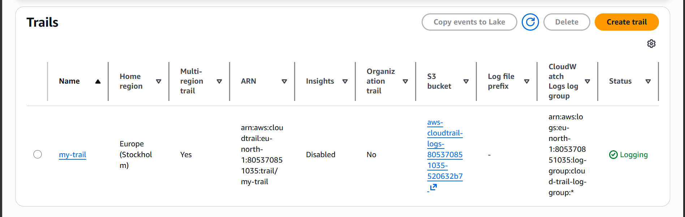

Cloud trail is now created.

- Enable SNS for CloudTrail to send alerts via email.

Lets now go the cloudtrail we just created and enable SNS via email

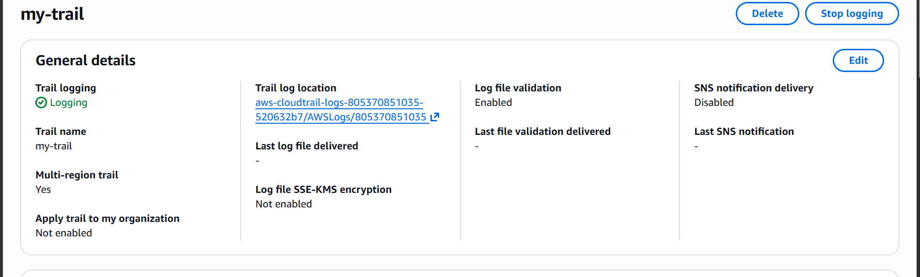

Click on edit

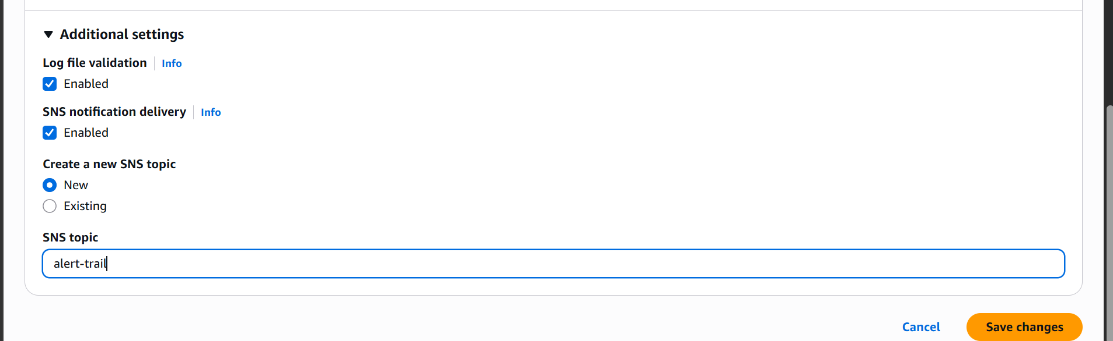
Under additional setting enable the SNS notification delivery and give a SNS topic name
Now go to SNS service and configure email
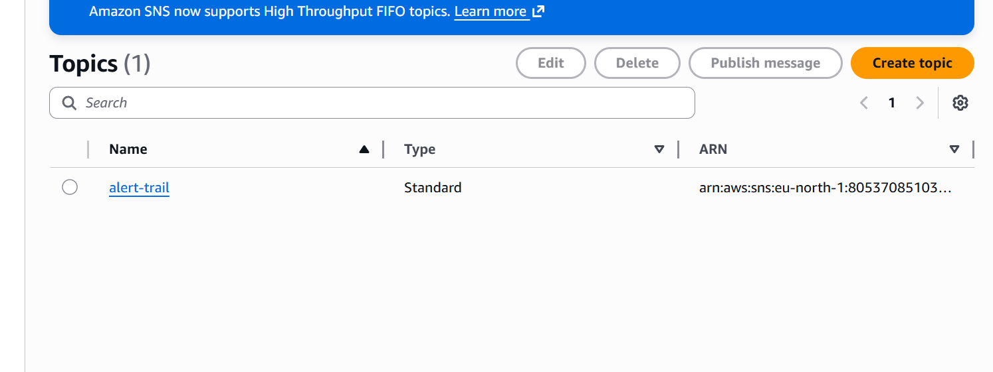

Select your topic and create subscription
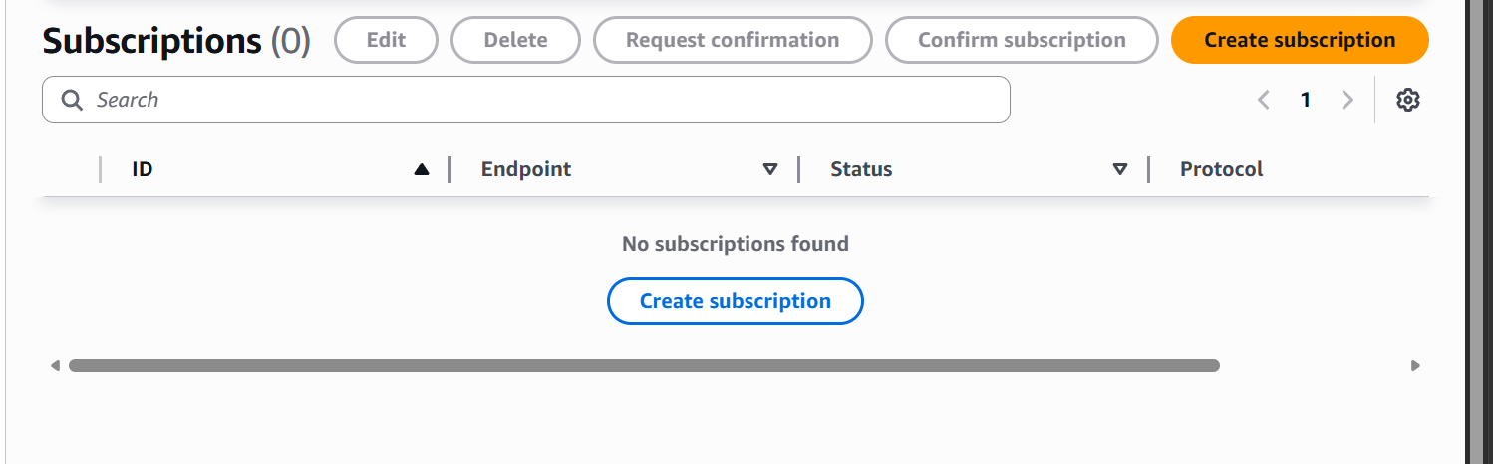

Select your topic and email as protocol and give your email address
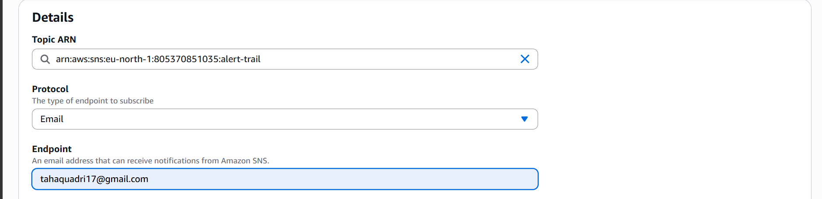
Then click on create subscription
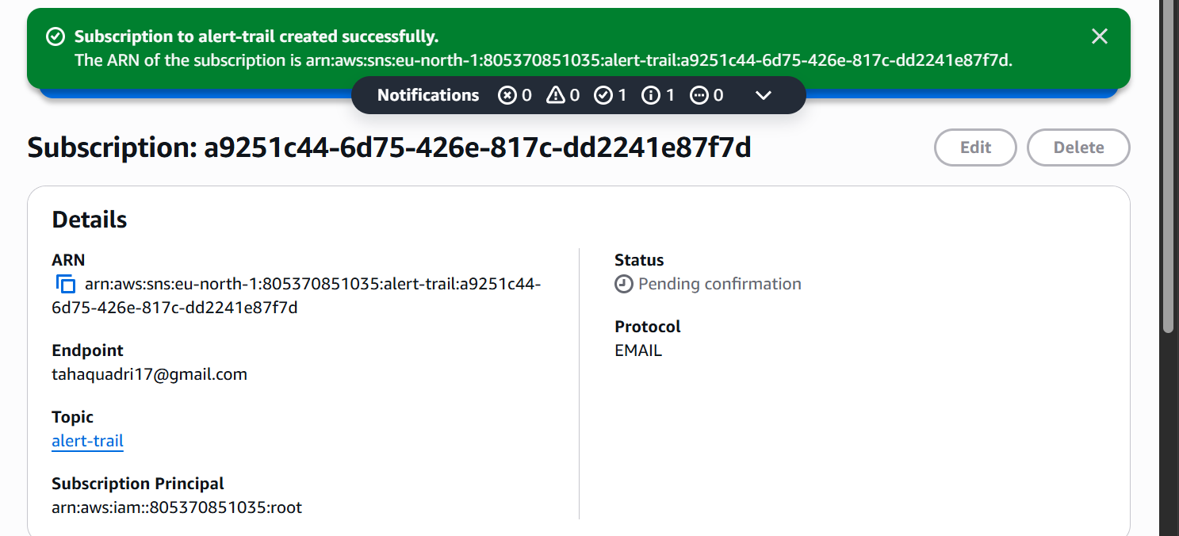

Our SNS is now configured.

- Configure Cloudwatch monitoring and record the CPU utilization and other metrics of EC2

We have this one ec2 instance
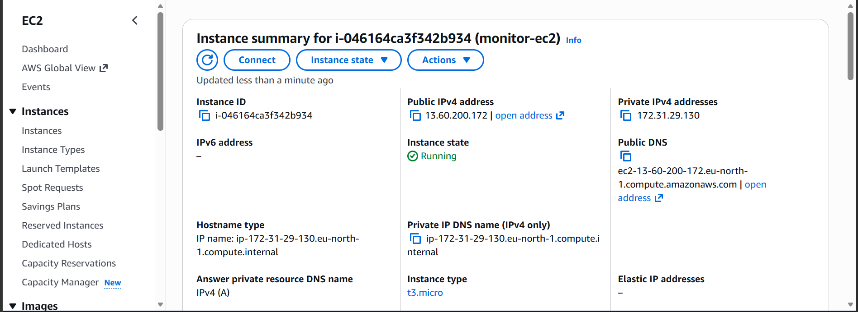

Go to monitoring and click on manage detailed monitoring
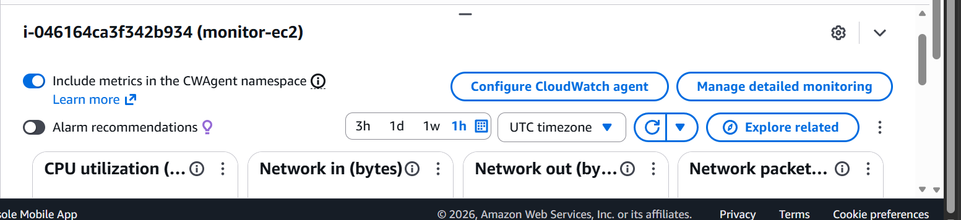

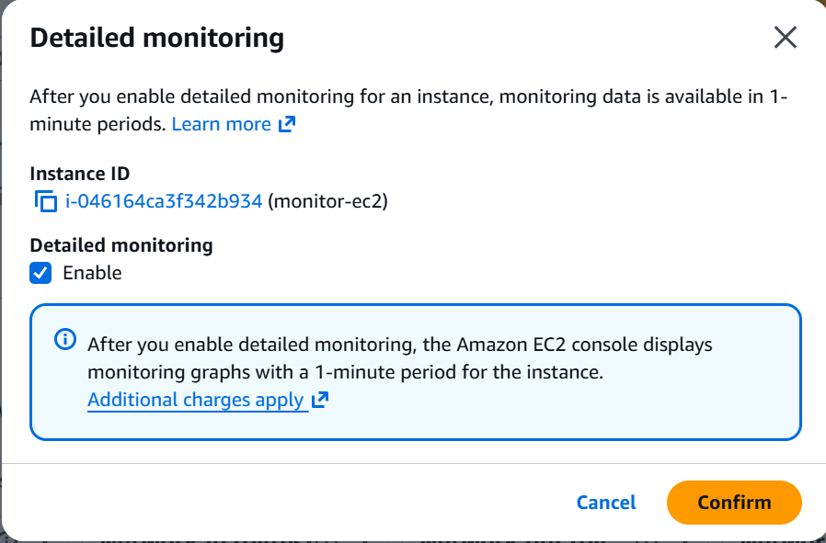

We can now monitor our CPU utilization and other metrics like Network in and Network Out

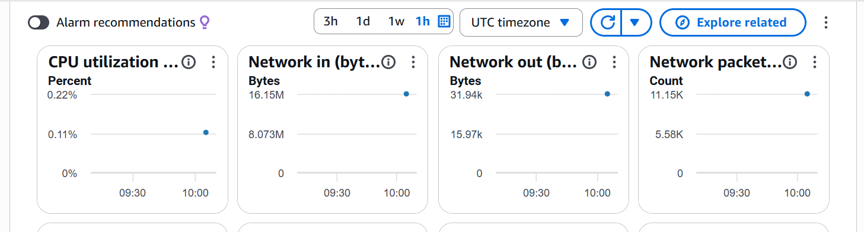

- Create one alarm to send an alert to email if the CPU utilization is more than 70 percent.

Let us go to cloudwatch and and create an alarm

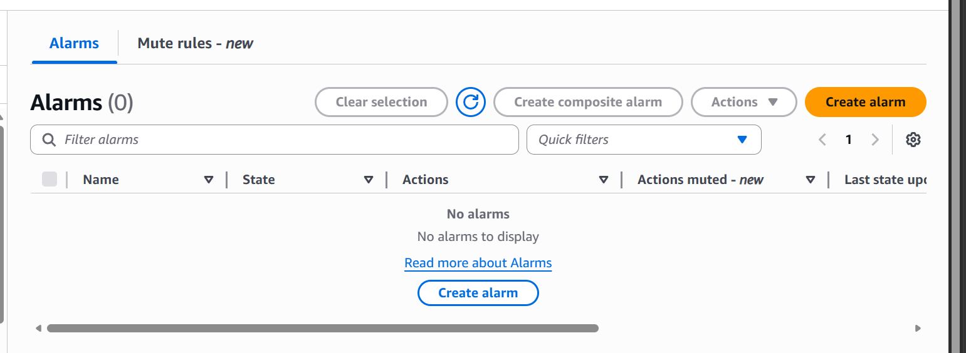

Click on create Alarm

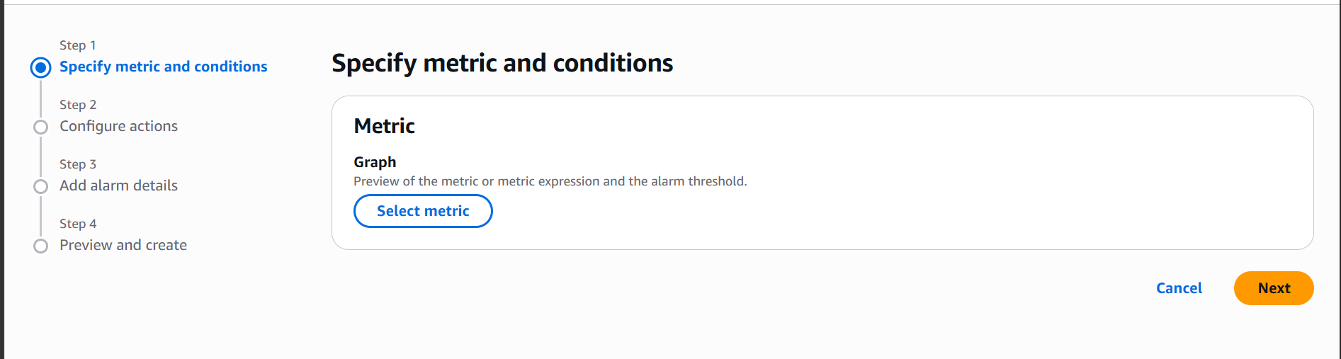

Now click on select metric
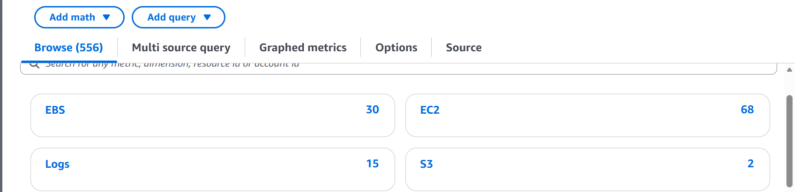

Click on EC2
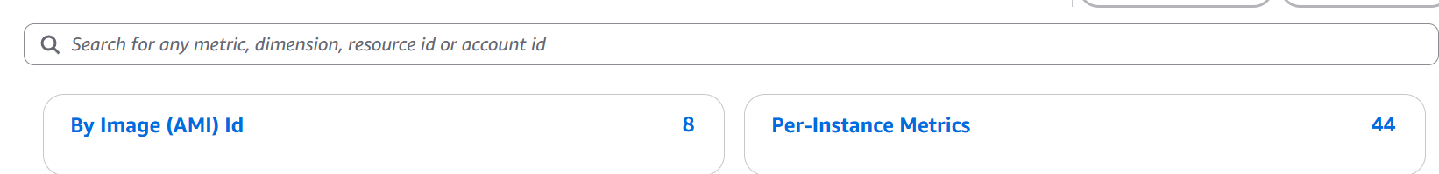

Then click on Per-Instance Metrics

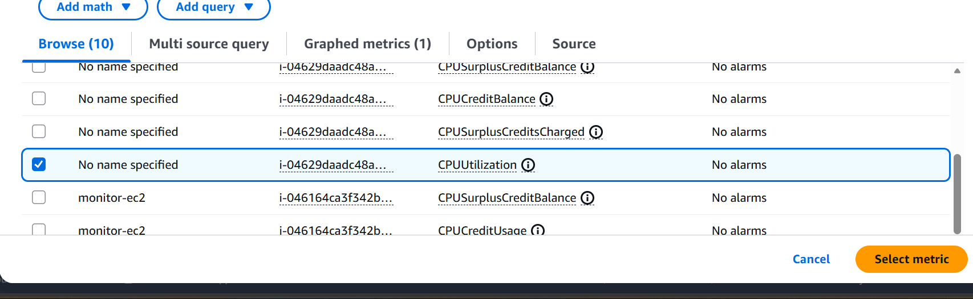

Then select CPU utilization metric.

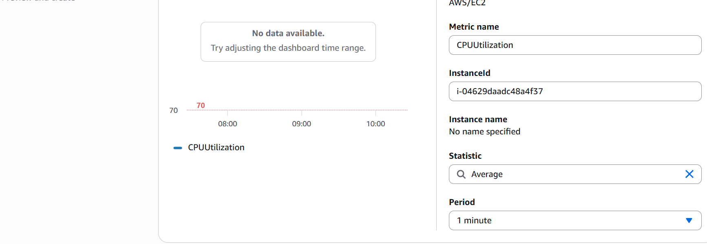

Period is 1 minute.

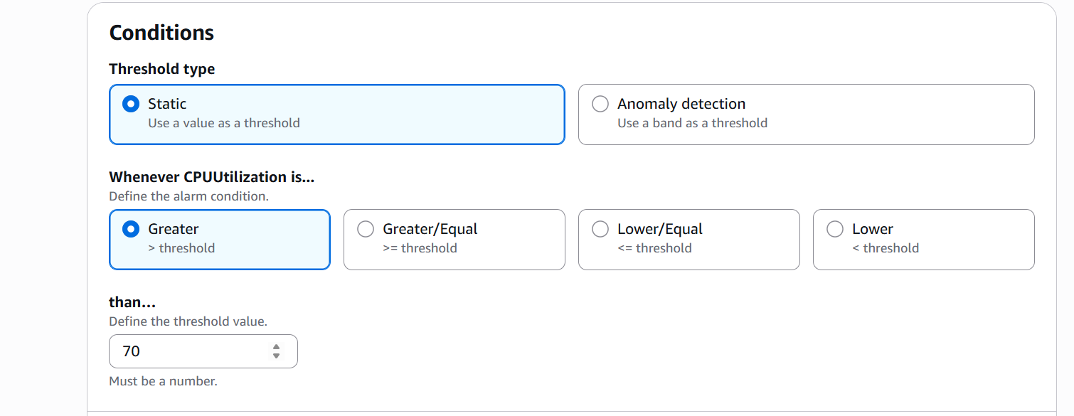

Set threshold if CPU is greater than 70 for a minute we should get alerted.

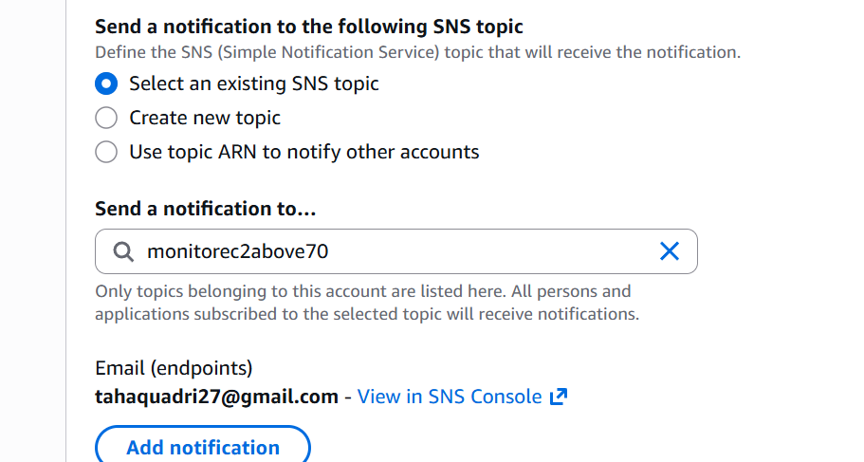

now select the SNS topic which we created earlier

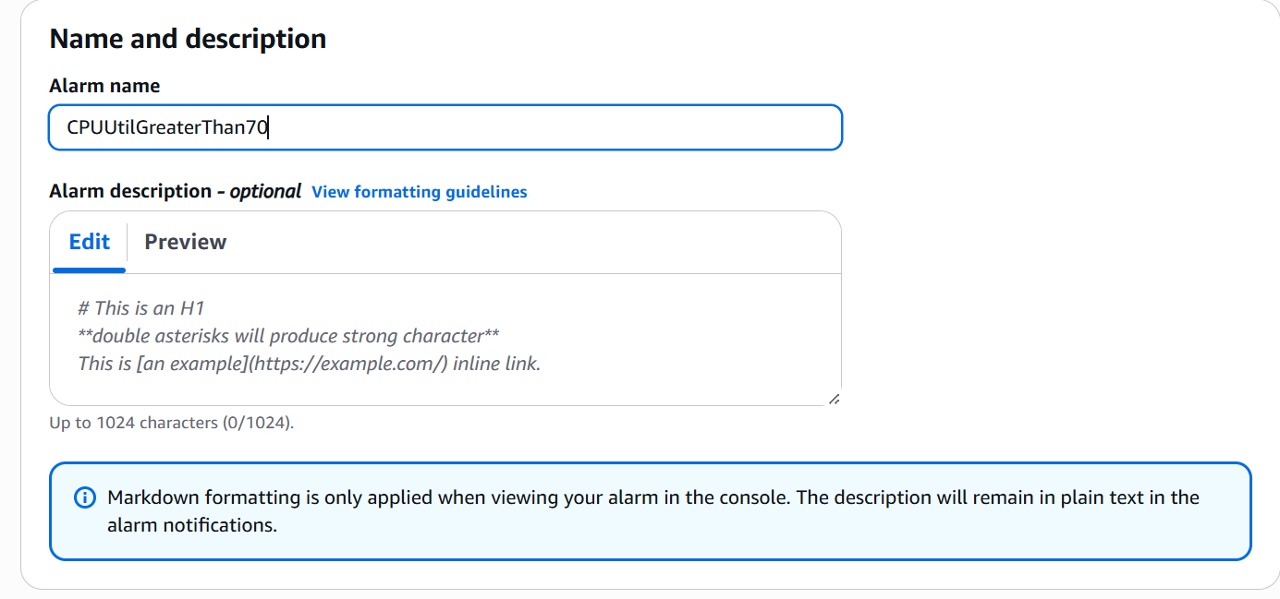

Give alarm a name.

Now preview and create

The alarm is now created lets ssh to our instance and give stress to our Cpu to check if it is working.

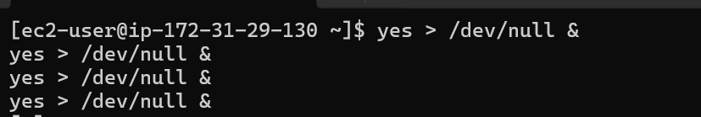

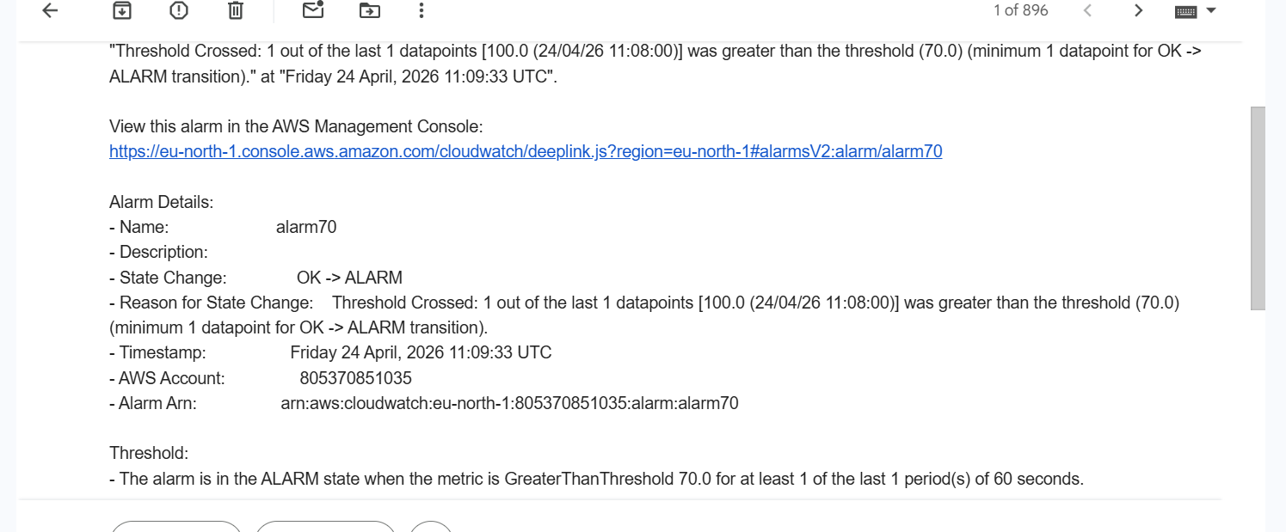

- Create a Dashboard and monitor the Tomcat Service whether it is running or not

First let us install the cloud watch agent in our instance
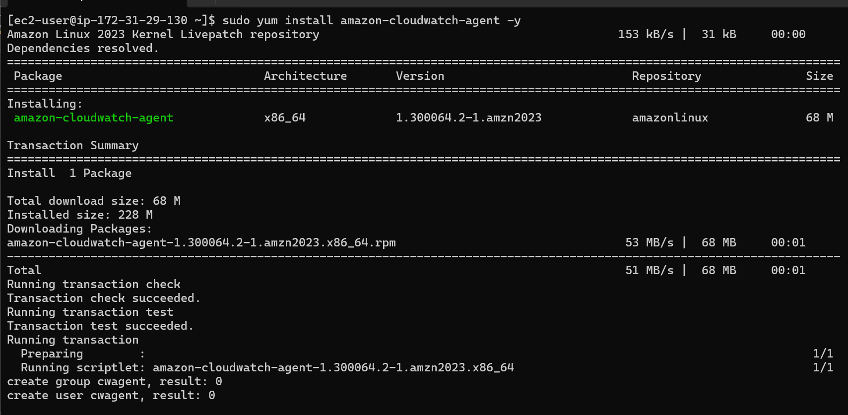

Let us download and install tomcat

For that we have to install java

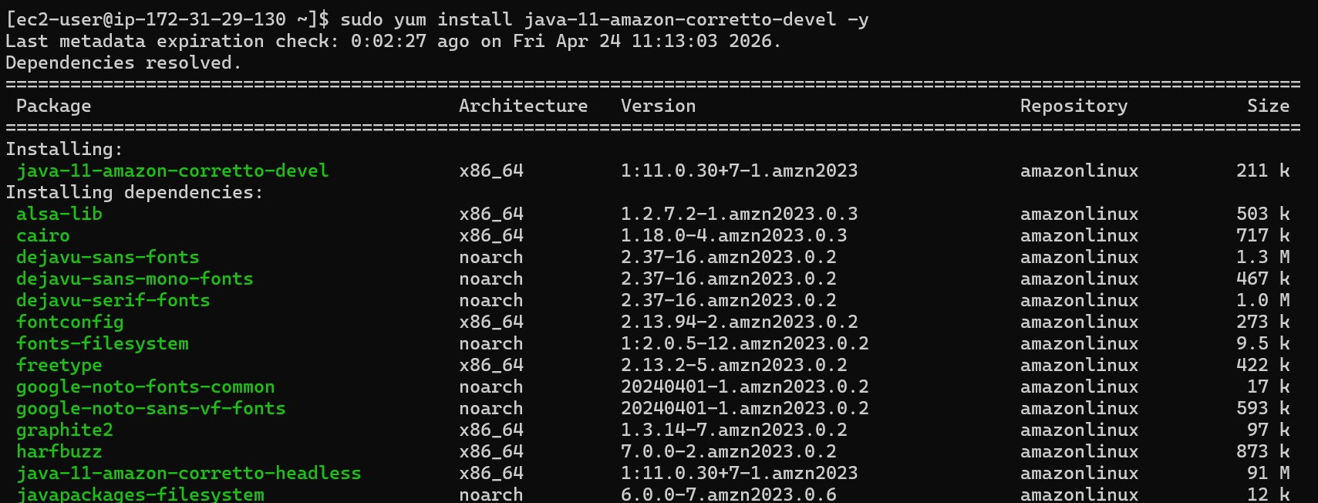

Download and extract
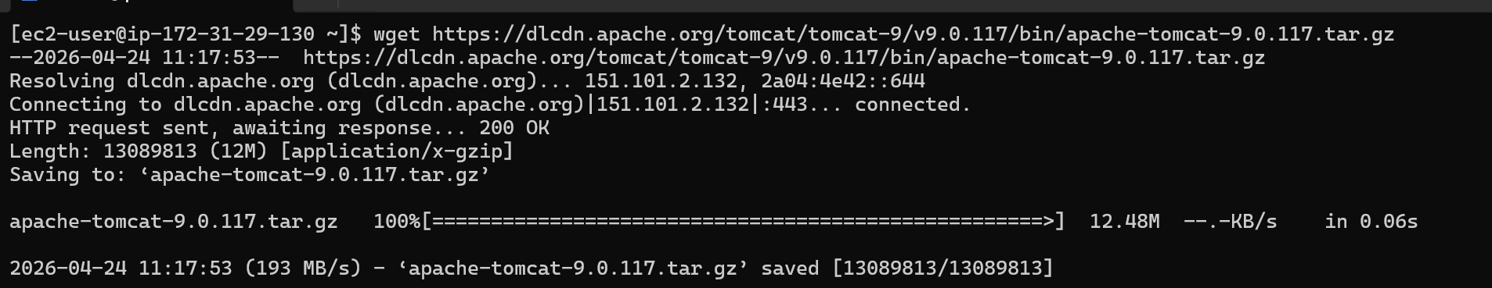

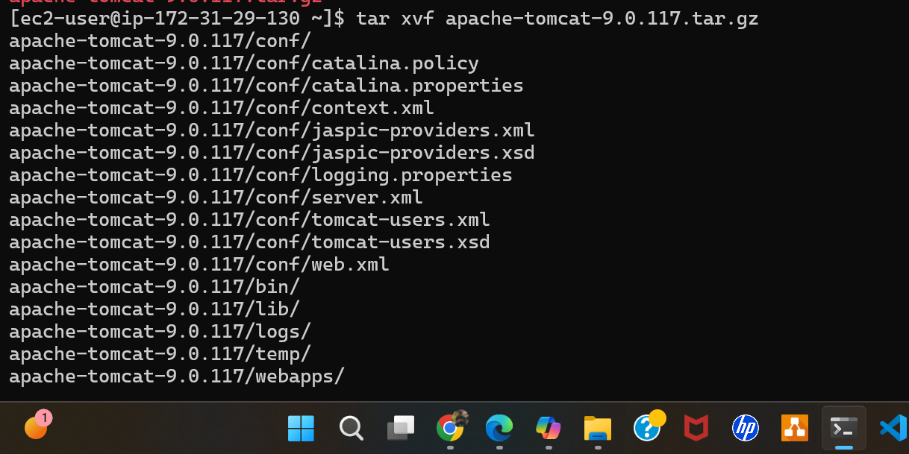
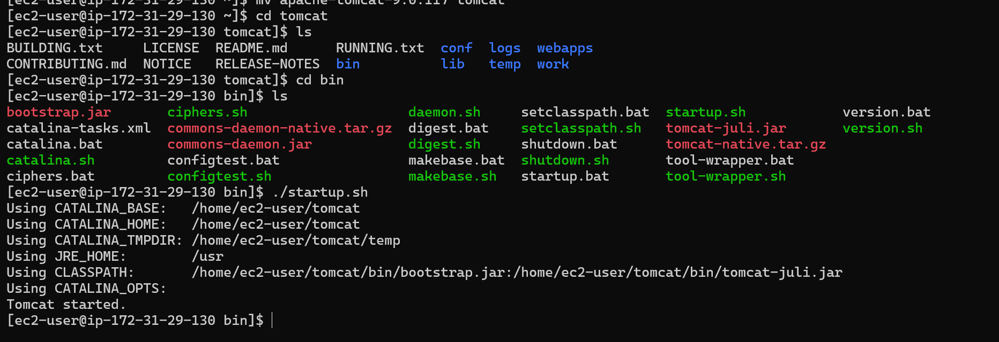

Tomcat is now started

Now let’s create a bash script to check the status and send notification

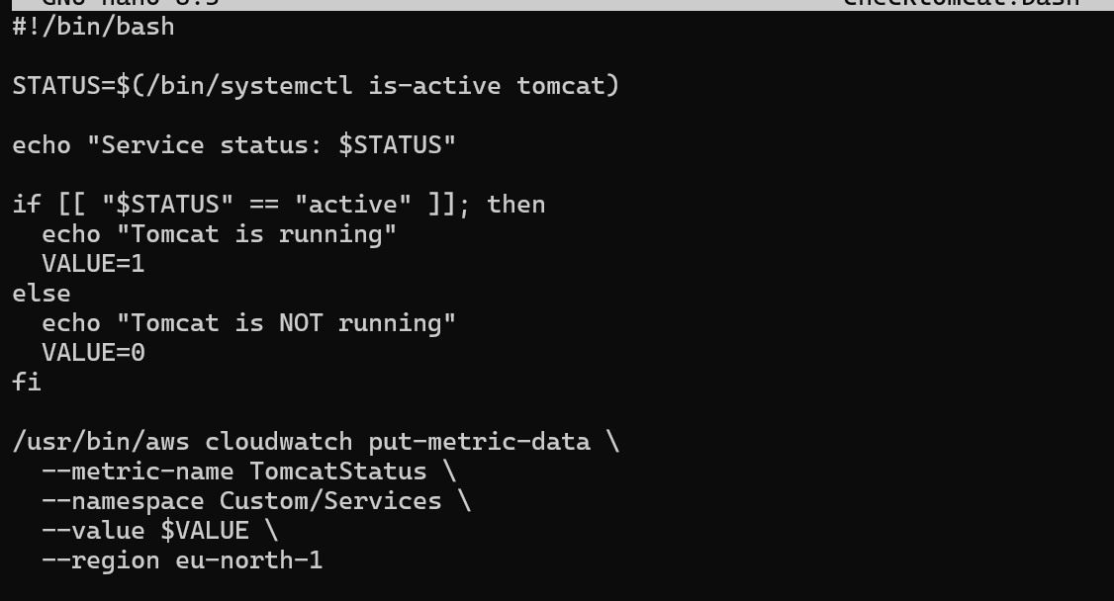

We need to configure our credentials in aws cli
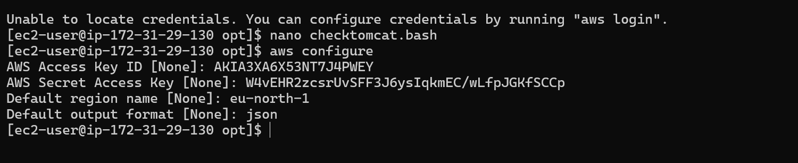

Now let us execute our script and see if tomcat is working

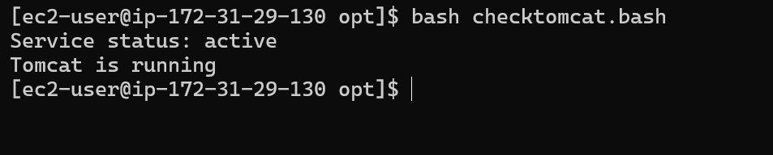
The script is now working
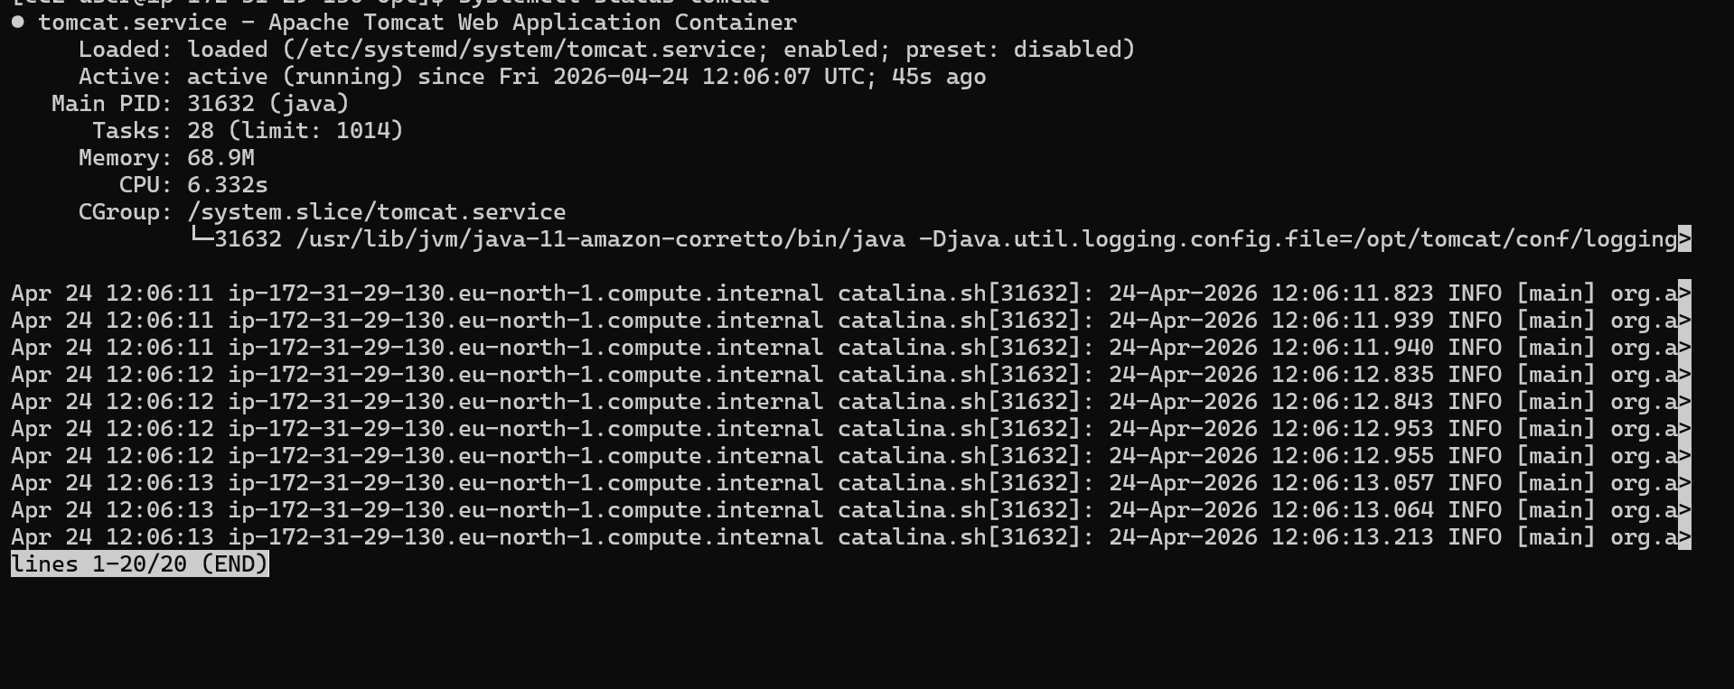

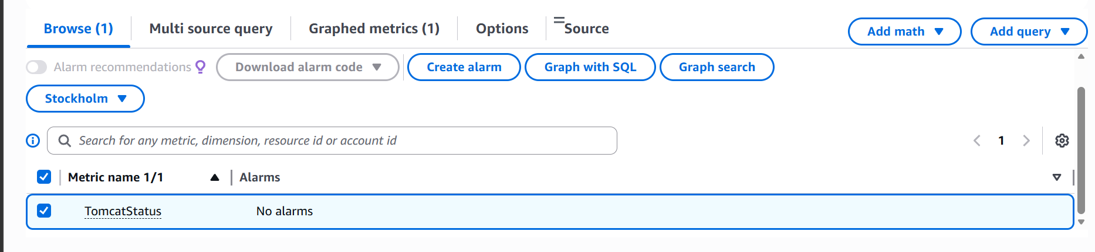

We can now see that a new custom metric has been created.
Now lets create a alarm based on that
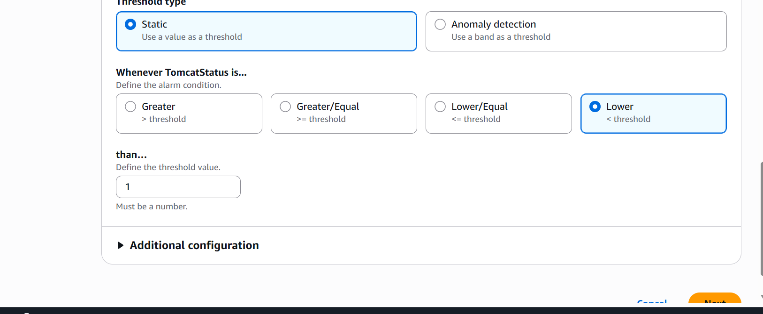

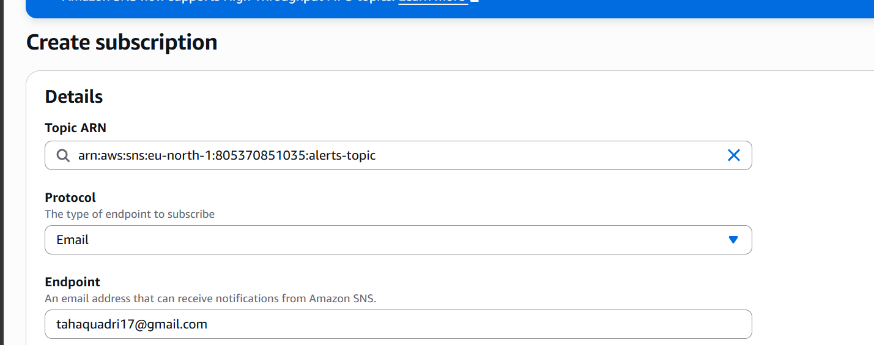

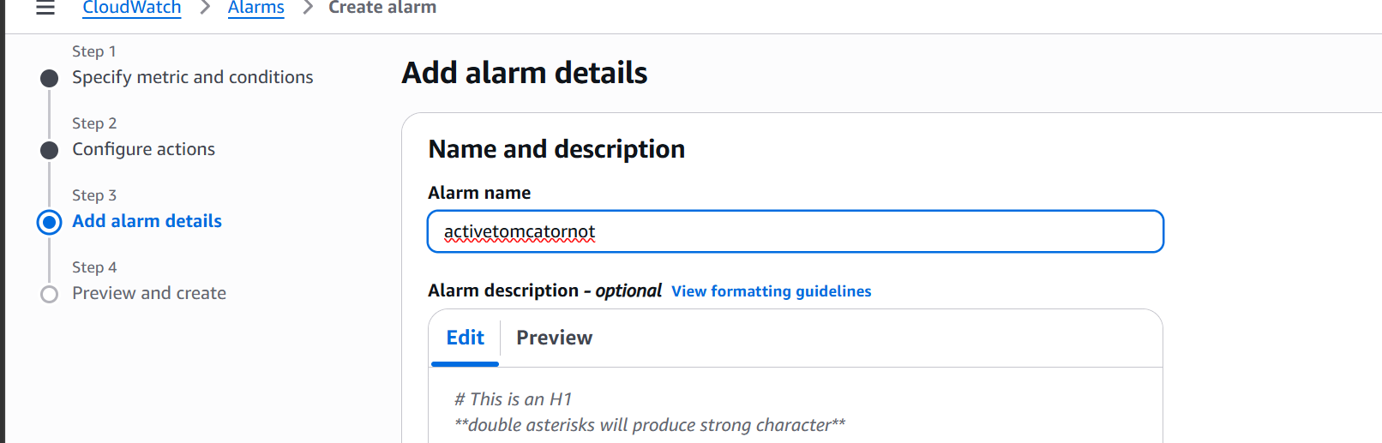

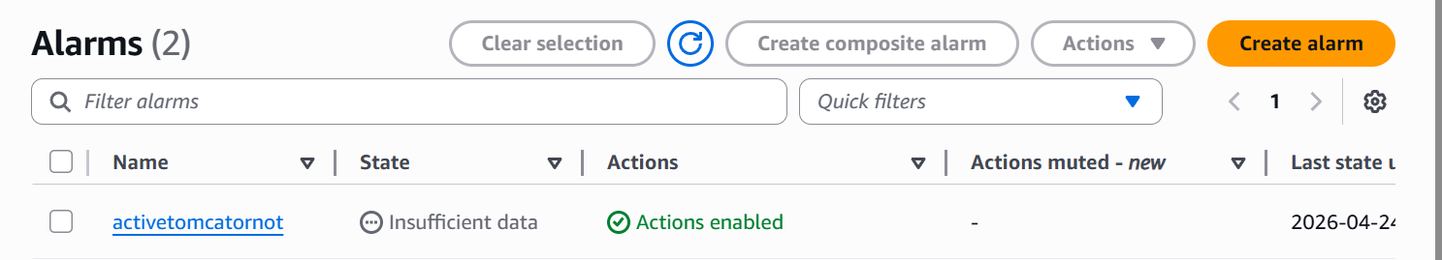

The alarm is now active

- Create a Dashboard and monitor the Nginx service to send the alert if Nginx is not running.

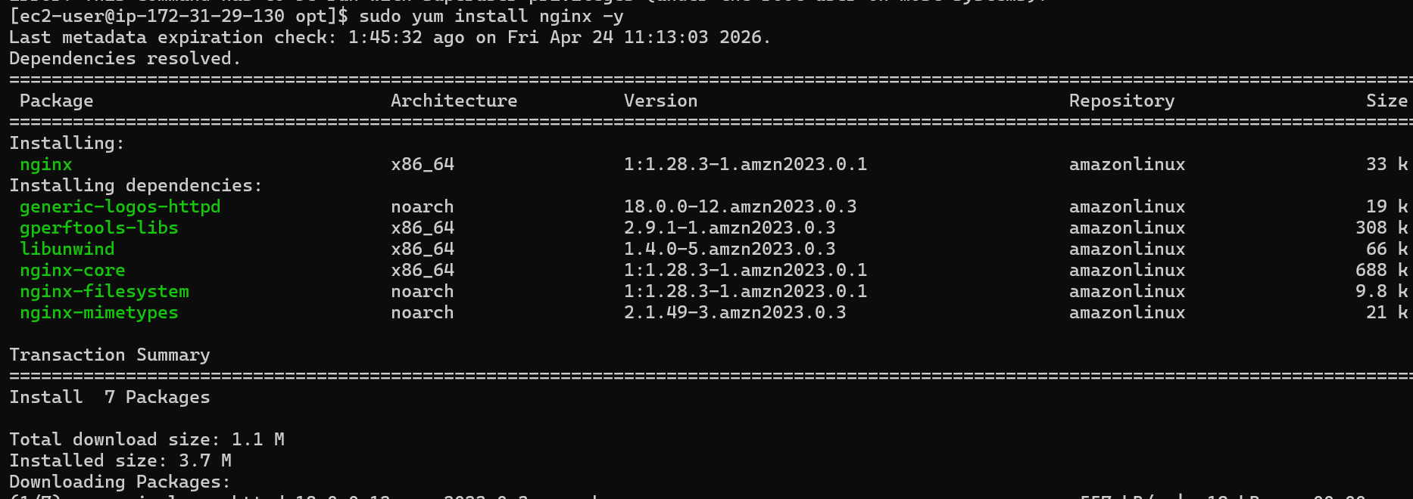

Nginx is installed

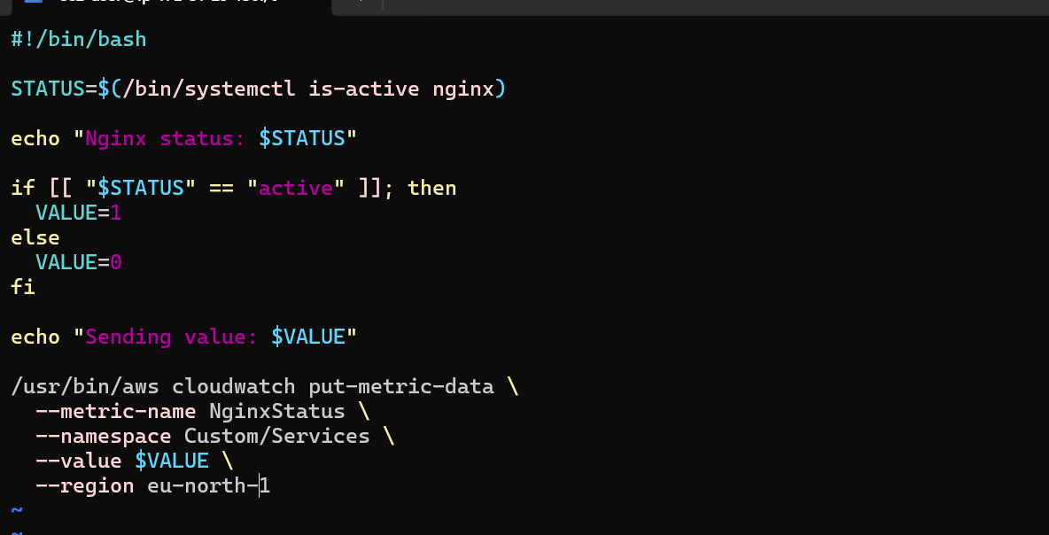

Nginx monitoring script
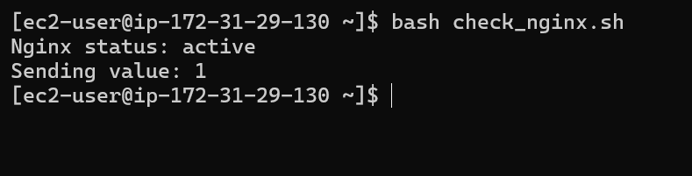nginx is now active
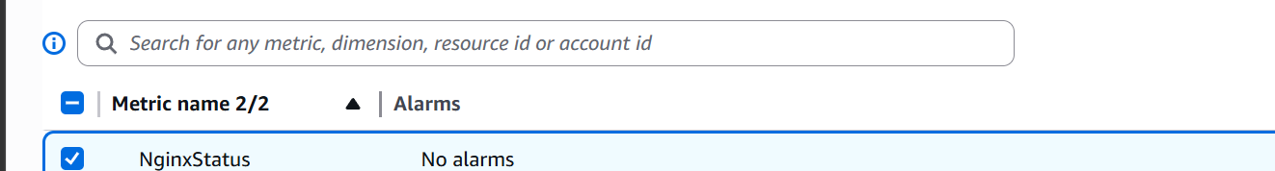
We can now see that a new metric based on nginx has been created.
Let us now create an alarm for that
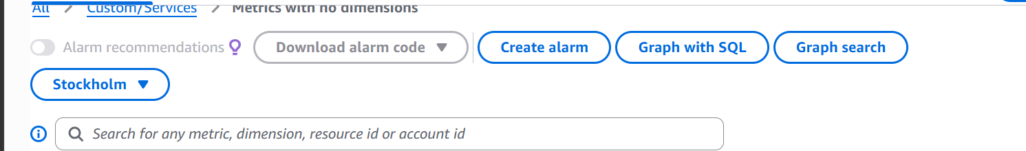

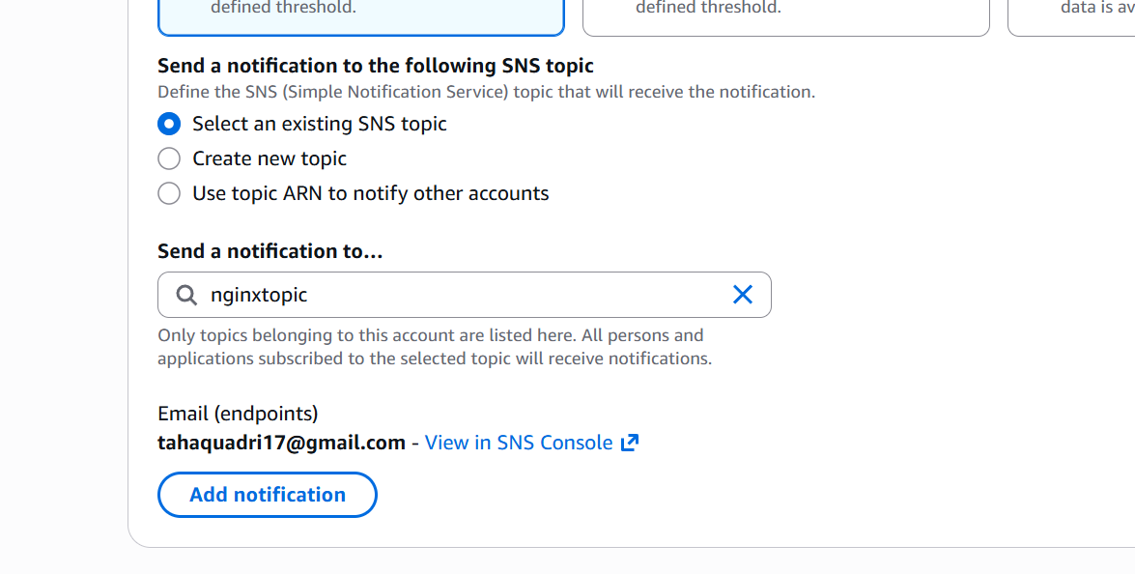

Let us now stop the service and check if we are getting alert on email

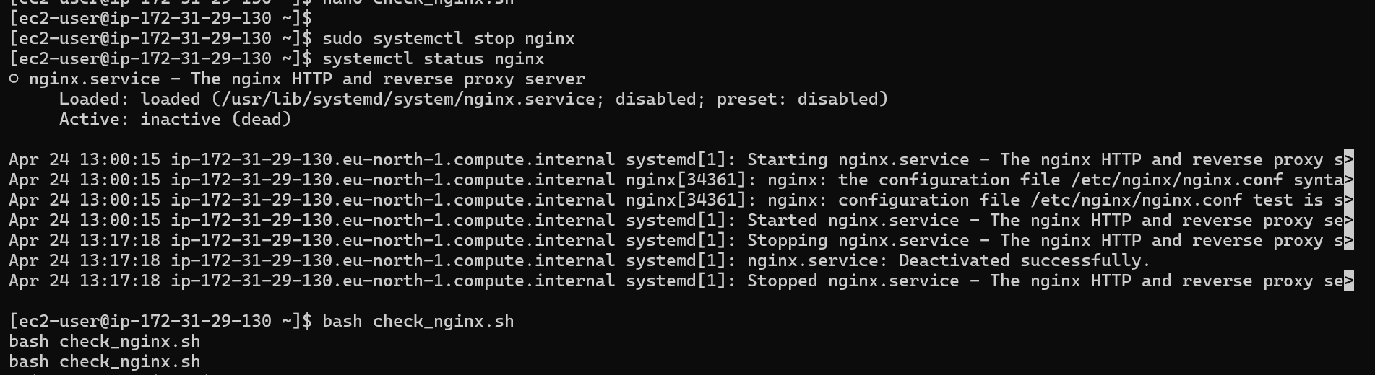
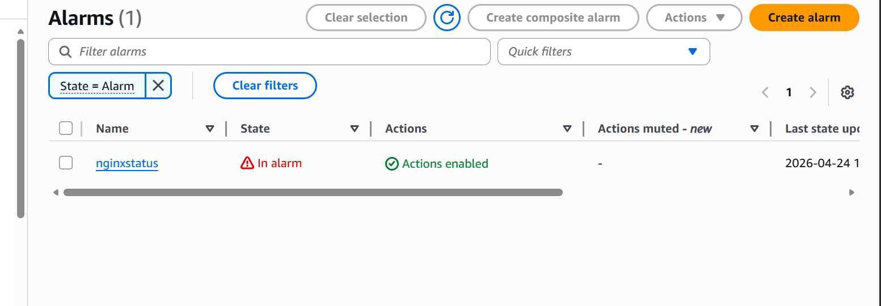

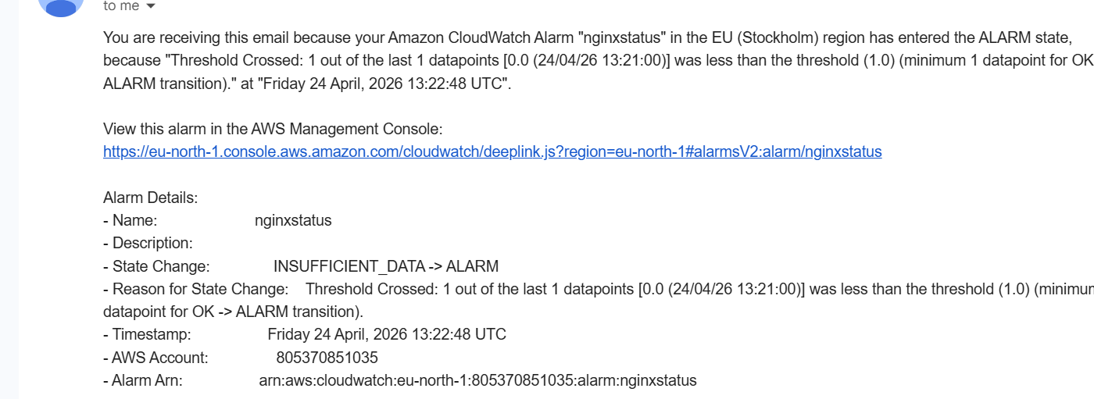

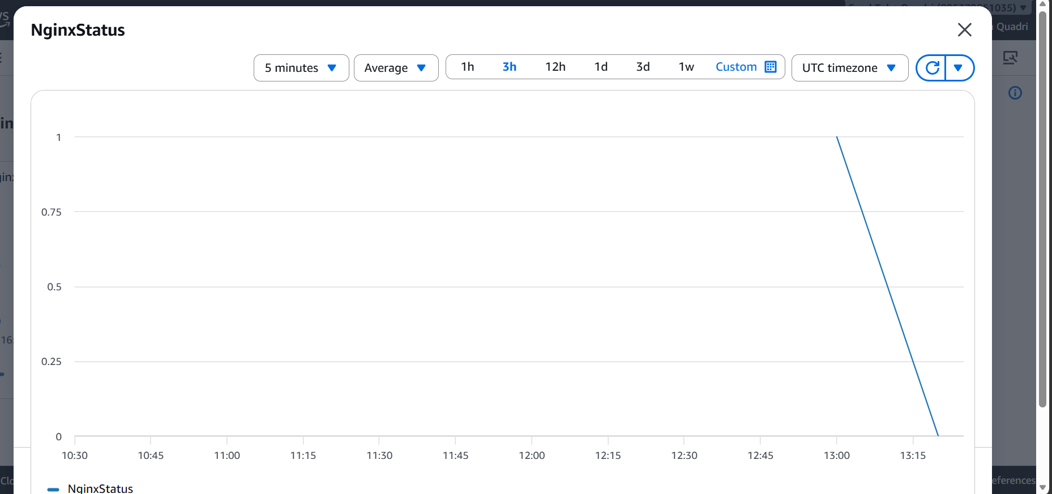

The dashboard’s been created as well.

