AWS EC2
1.Launch one EC2 using Amazon Linux 2 image and add a script in user data to install Apache.

Creating an amazon linux 2 image instance:
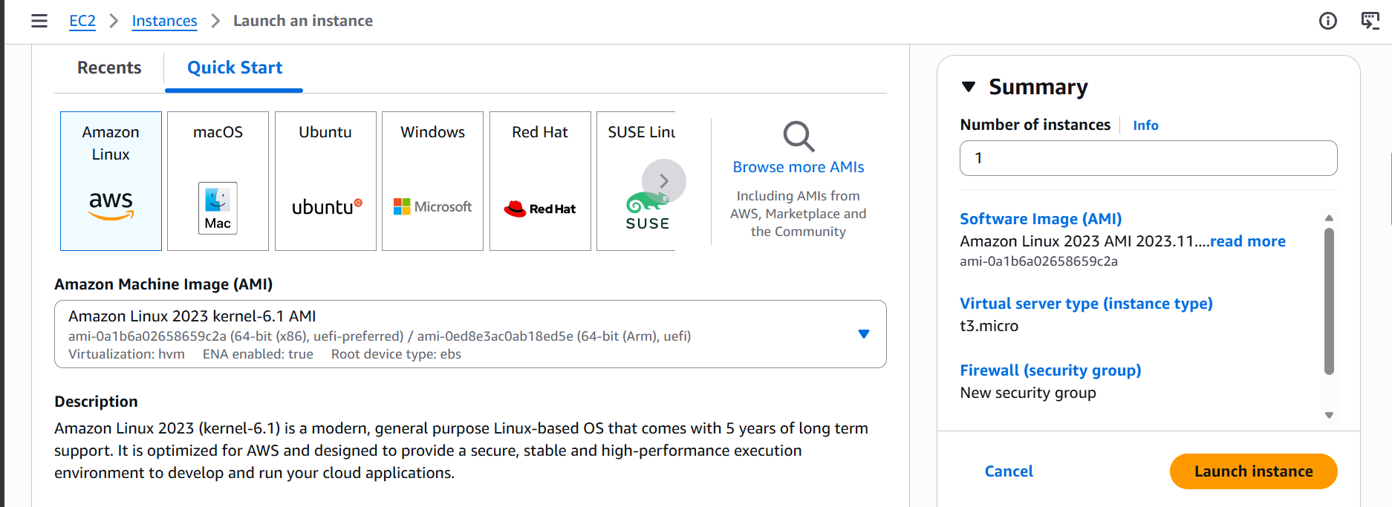

Script to install apache in ec2.
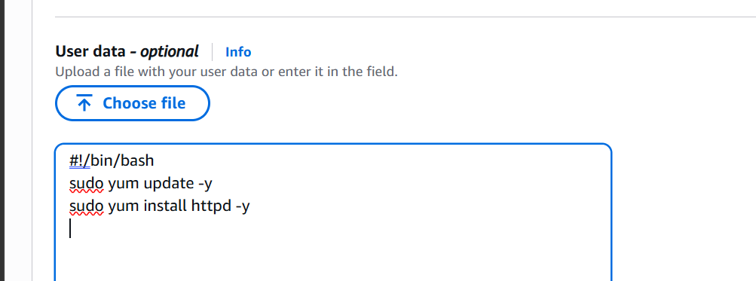

After lauching the instance we can see that apache is installed already.
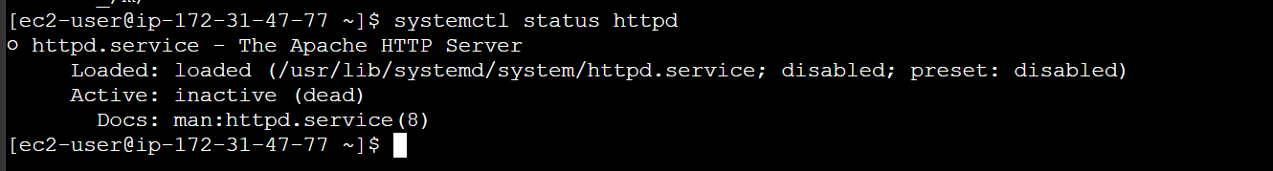

2.Launch one EC2 using Ubuntu image and add a script in user data to install Nginx.

Launching an ubuntu instance:
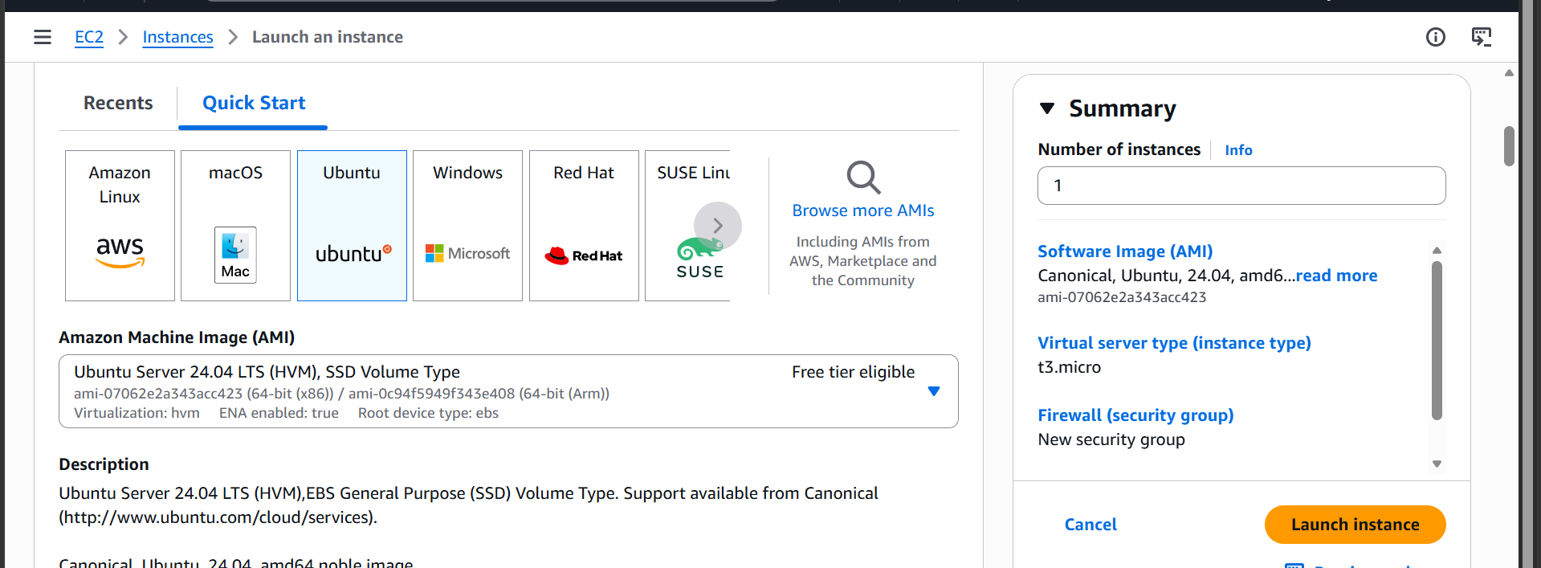

Script to install nginx:
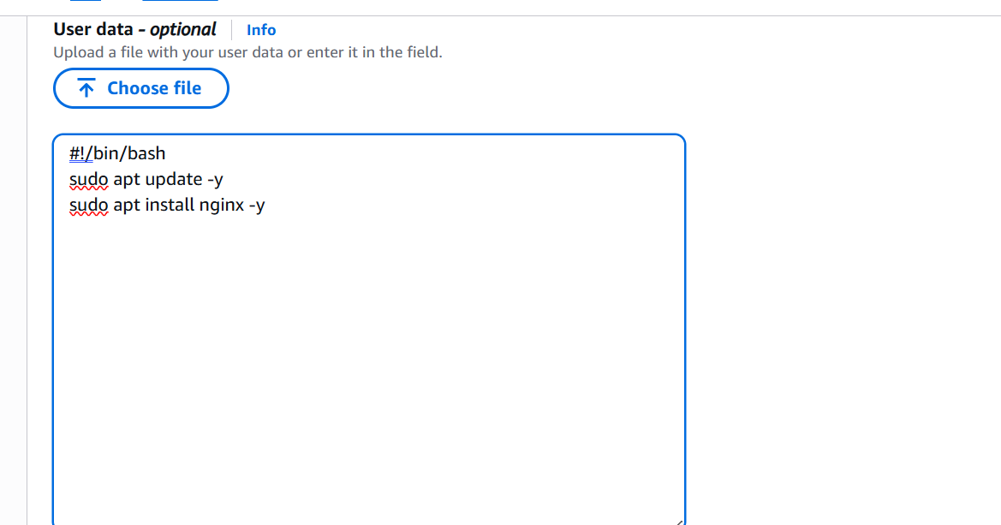

It can be seen that the nginx service is already installed.
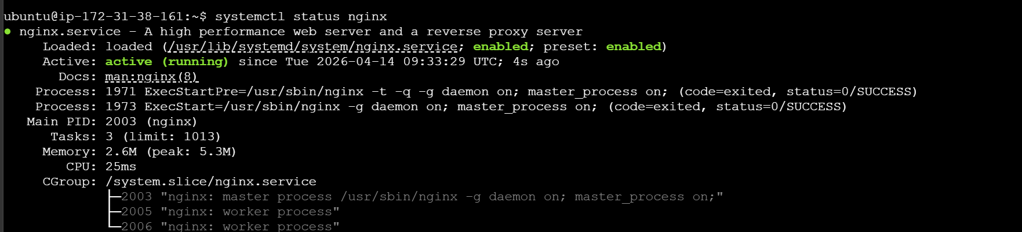
3.Launch one Windows server and install Tomcat on Windows.
We need to download the rdp file
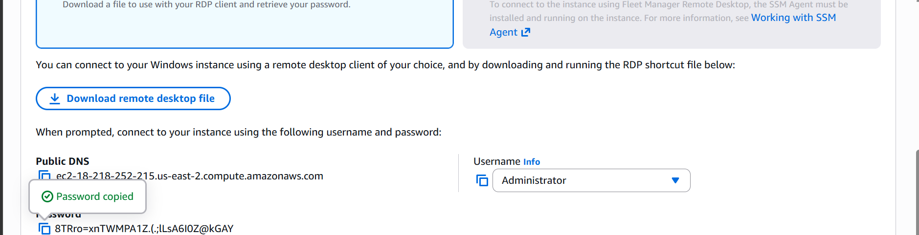
And then we can connect to the instance

Launching a windows server:
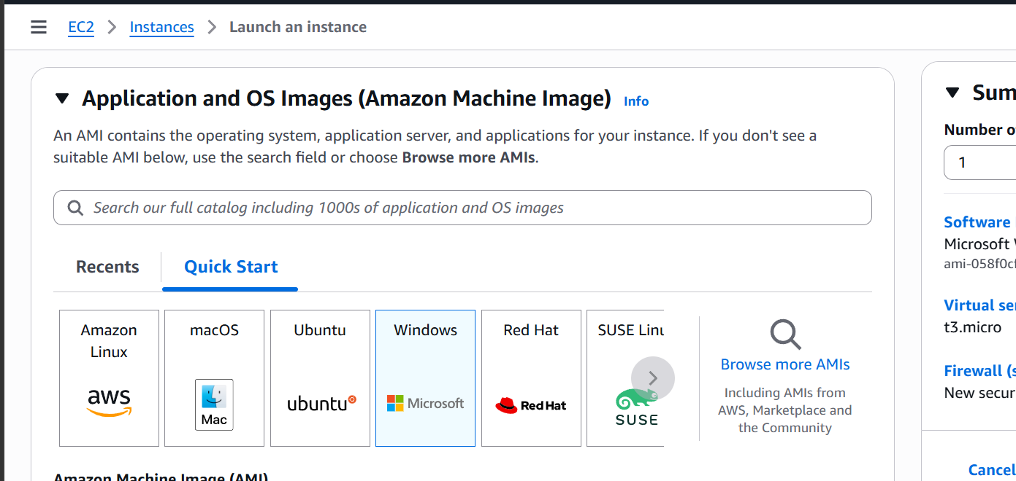

Java needs to be installed it Is a prerequisite
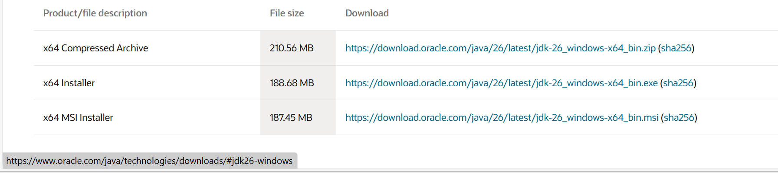

Setting path in environment variable.
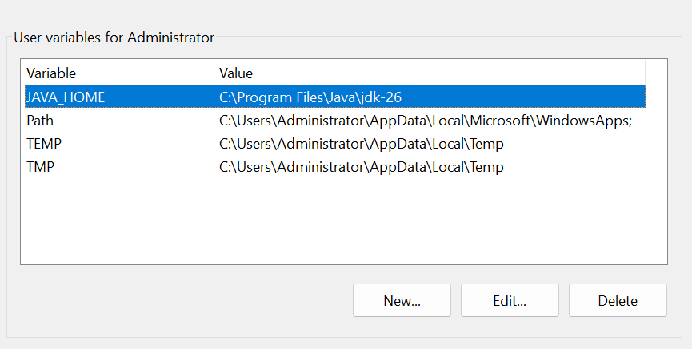

Download tomcat and install it:

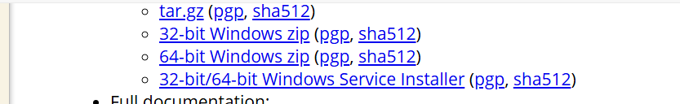

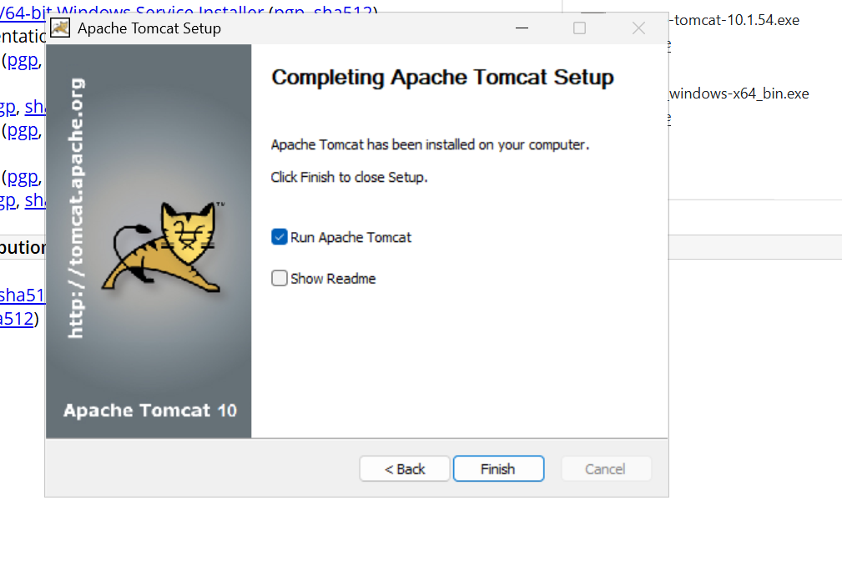

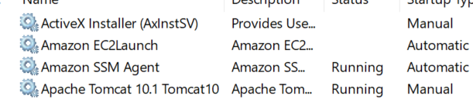

Tomcat is now running.
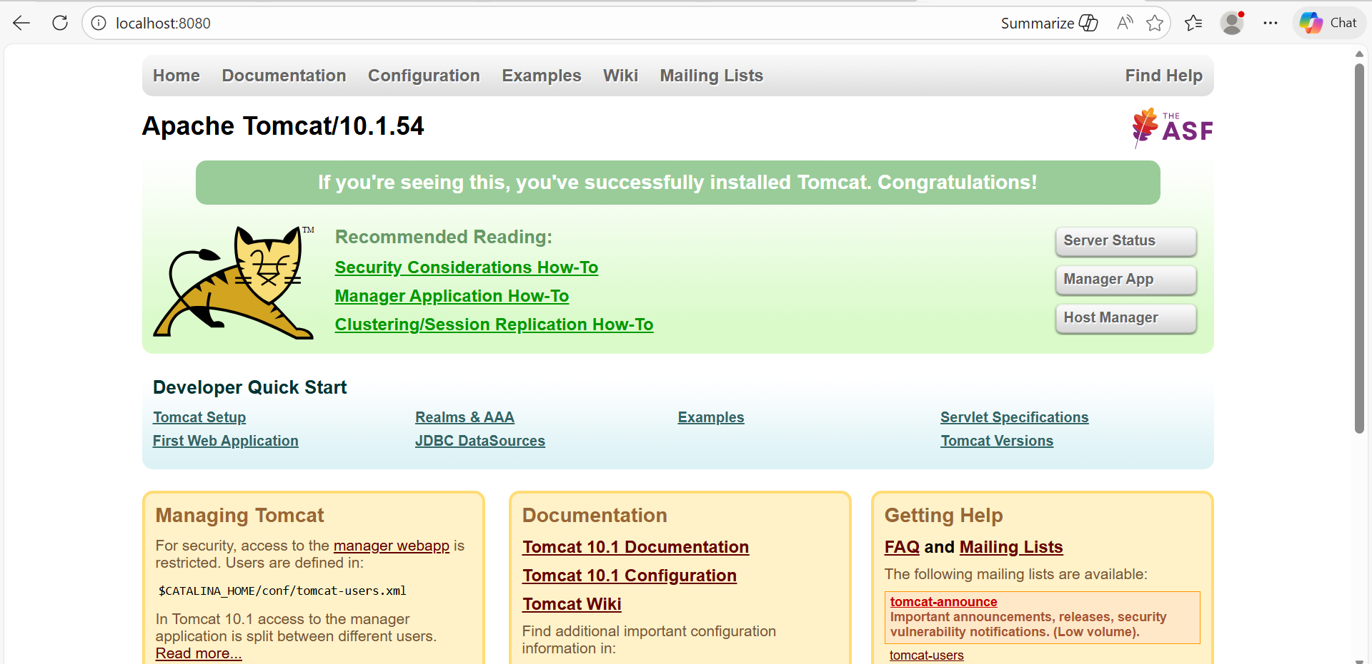

4.Take a snapshot of the instance created in Task 1.
We need to go to the snapshots section.
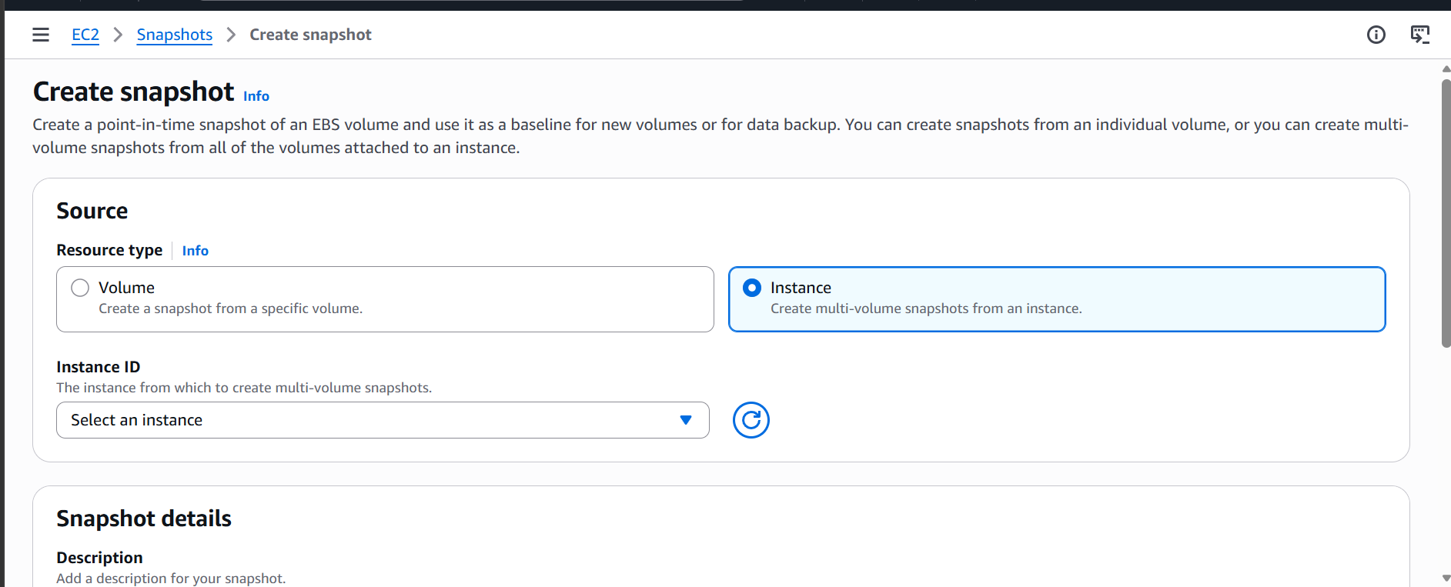
And select create snapshot and resource type instance.
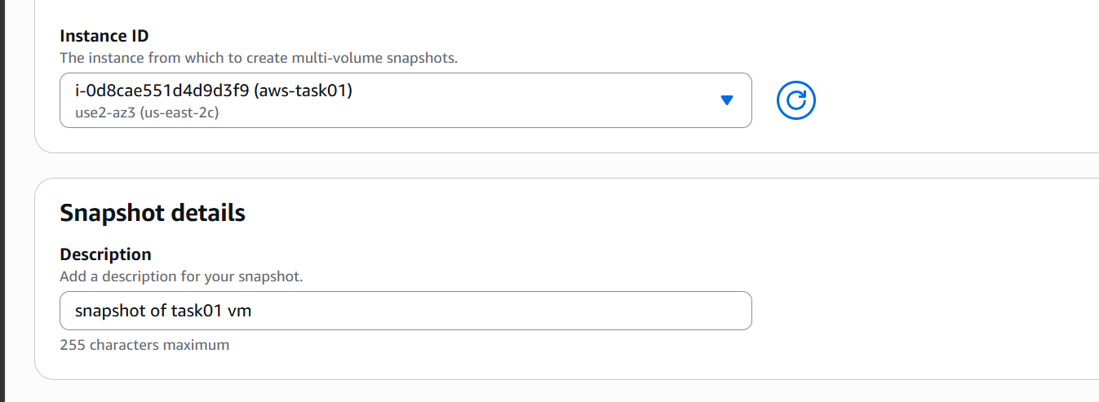
Select the instance of which we need to take a snapshot.

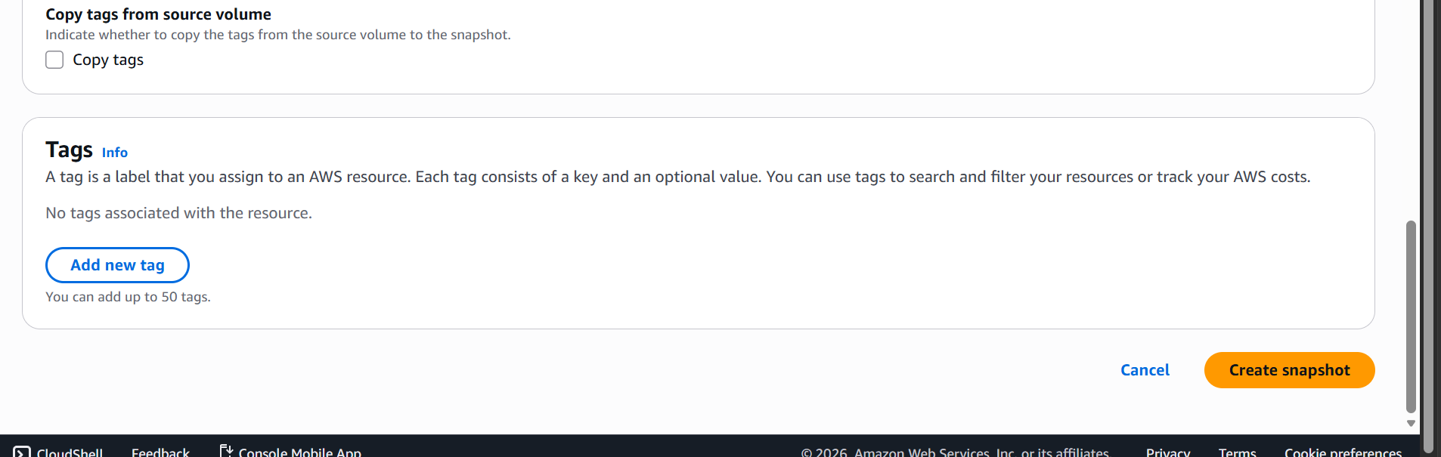
Click on create a snapshot.
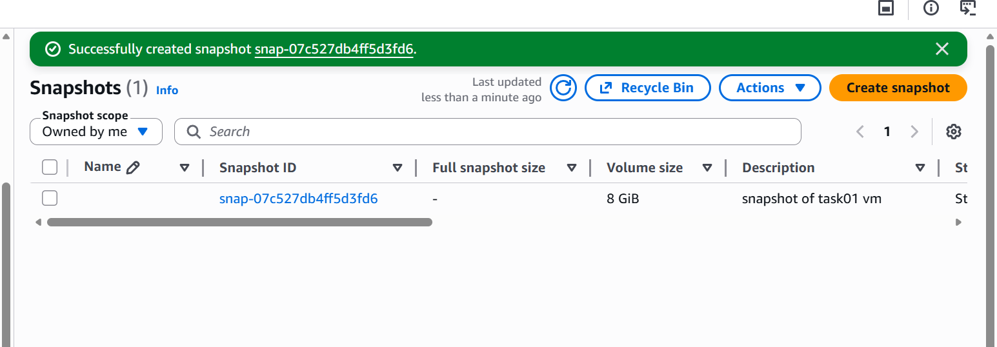
The snapshot is now created.

5.Assign password less authentication for the EC2 created in Task 2.
First let’s create a user to give ssh password less authentication
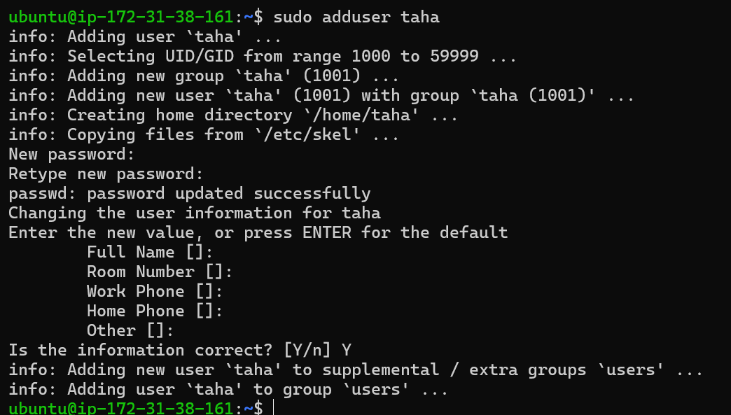
The user named taha is now created.
Now let’s generate a ssh key from the old user.
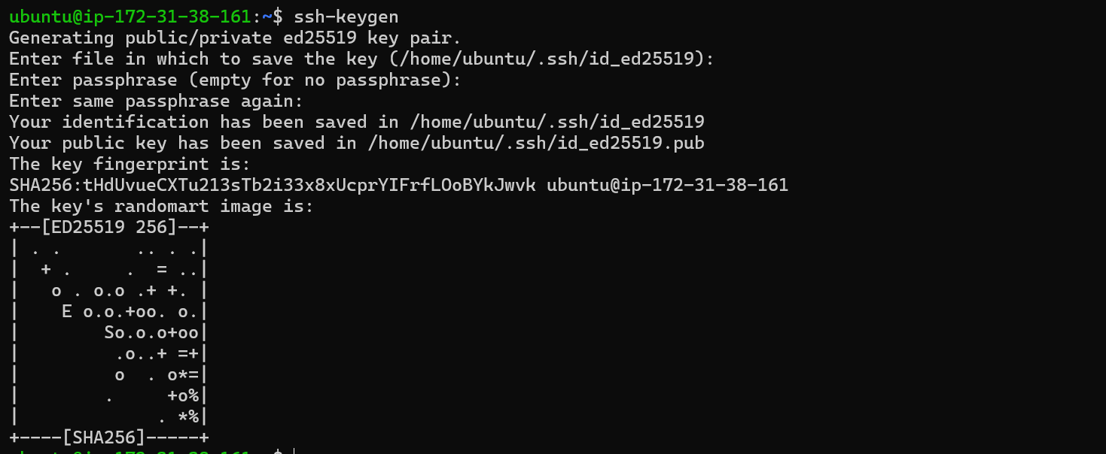
And let’s copy the public key and paste in the newly created user.
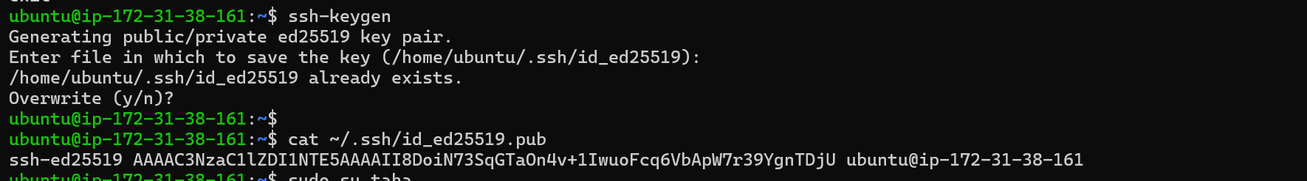
Now let’s switch to user taha and add our public key
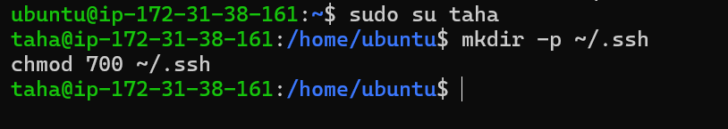
Let’s paste our key in authorized keys file.
Now we are able to ssh to the new user without password.
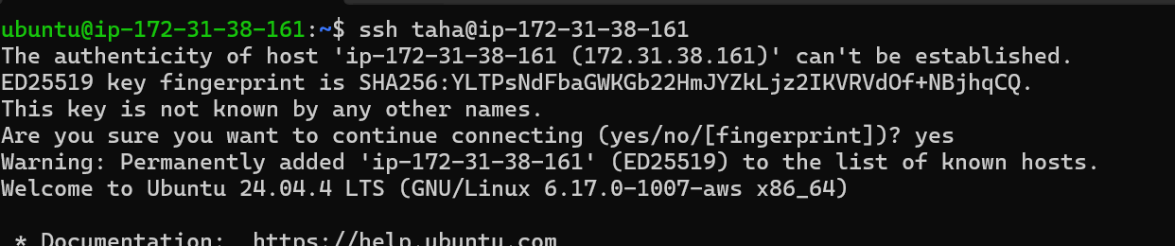

6.Launch any EC2 using the spot purchasing option.

Let’s launch an instance with the spot instance purchasing option
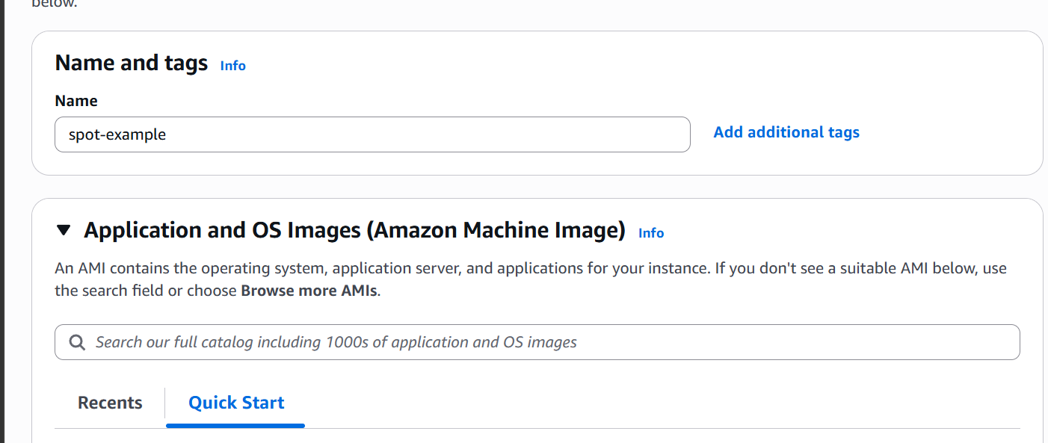
We need to select the spot instances option
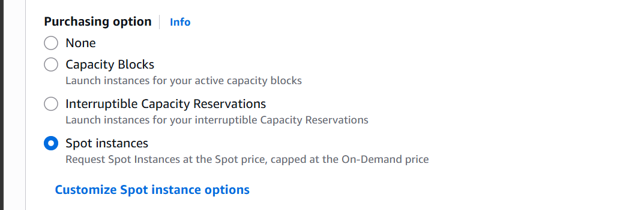

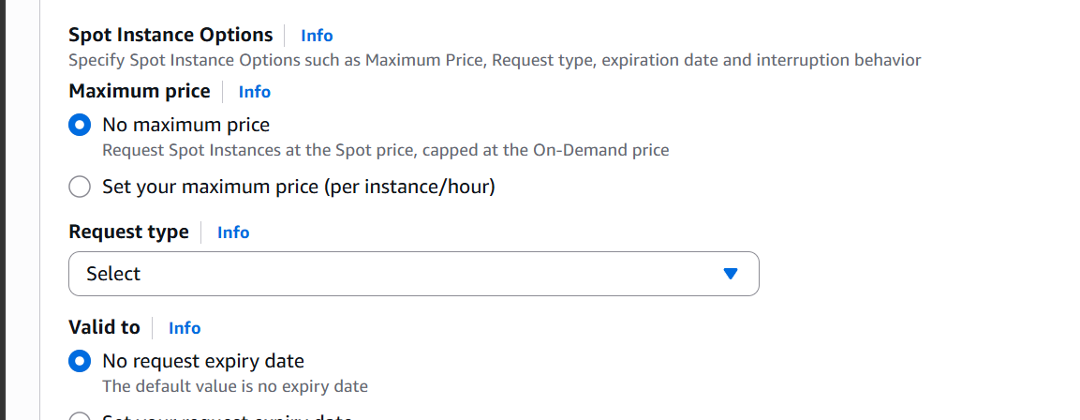
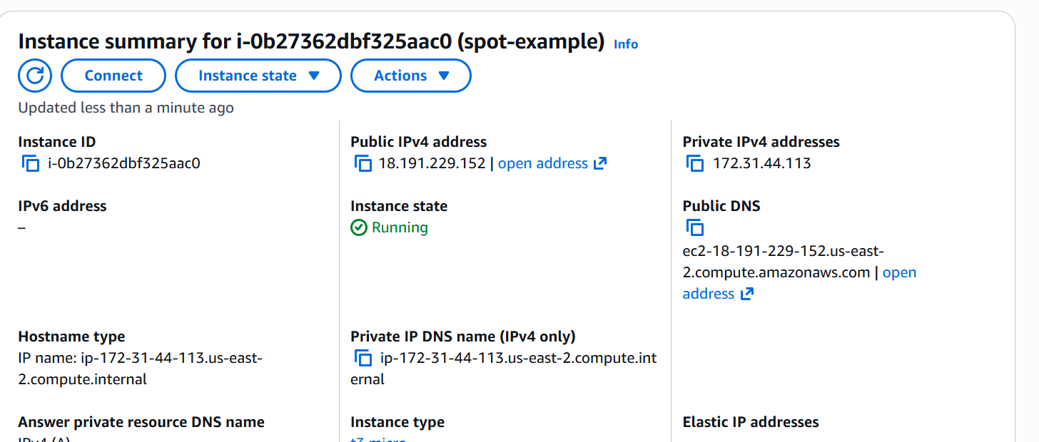
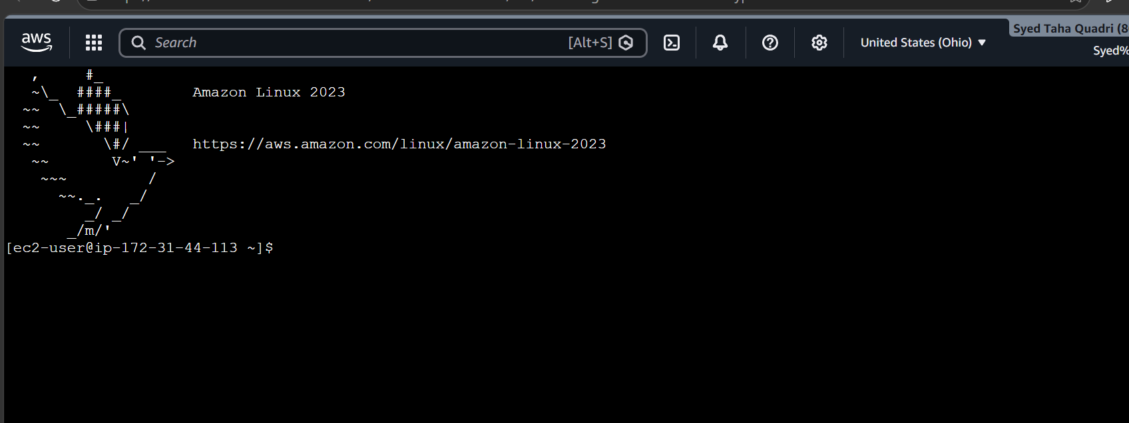

The spot instance is now launched.

7.Enable termination policy on the EC2 created in Task 2.
To enable termination policy we need to go to instance settings.
Then we can enable termination protection
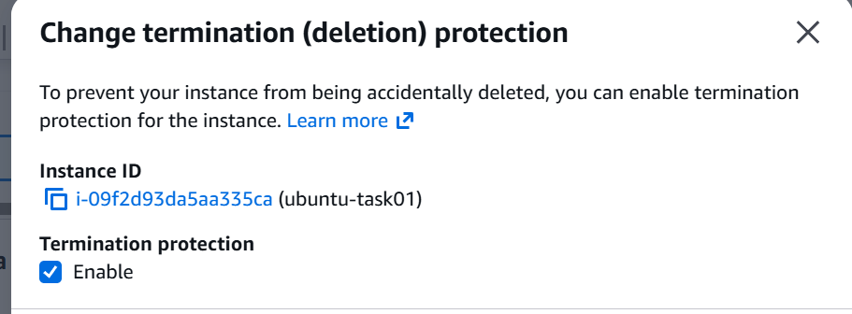
The instance now has termination protection enabled.
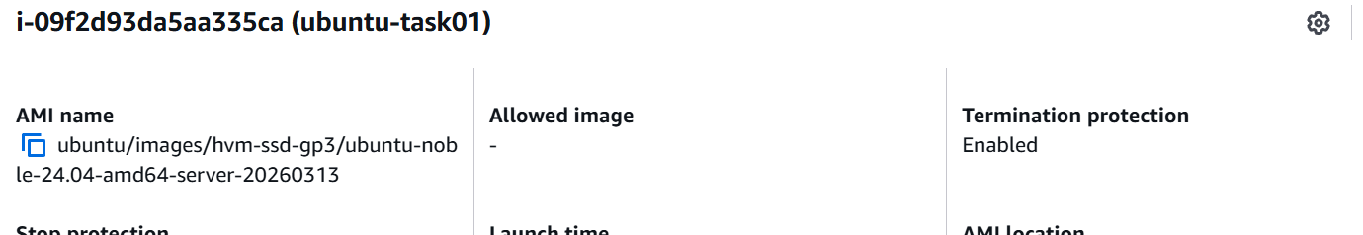

8.Launch one EC2 using AWS CLI.
Aws cli need to be installed before launching an instance using aws cli.
We can use configure our account using aws configure
We need to provide our access key and secret access key default region and output format
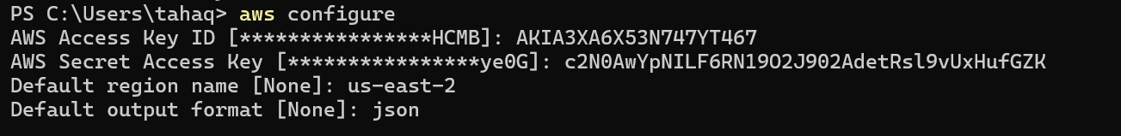
Let’s create a key pair first.
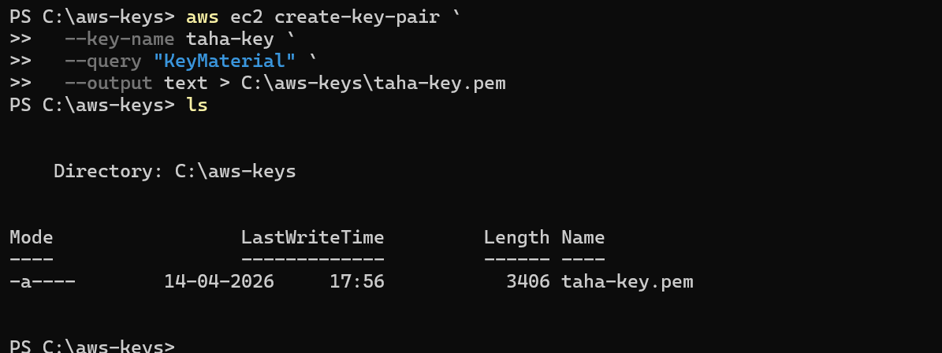
Creating a aws instance through cli.
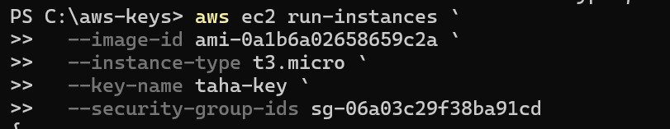
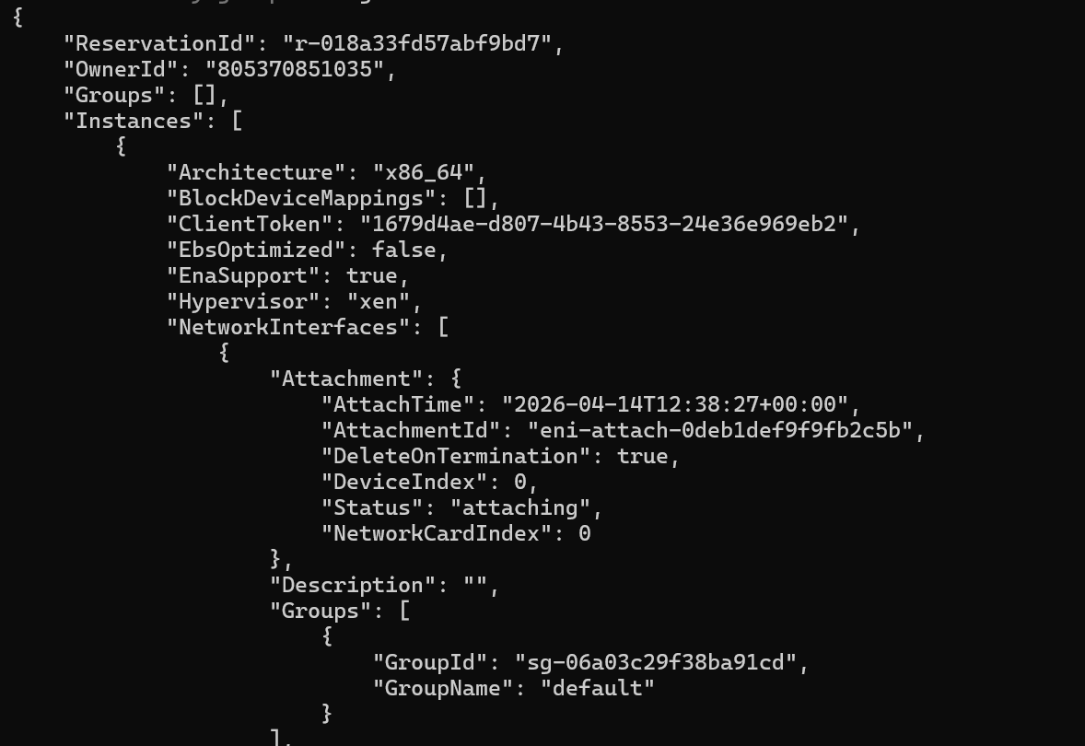
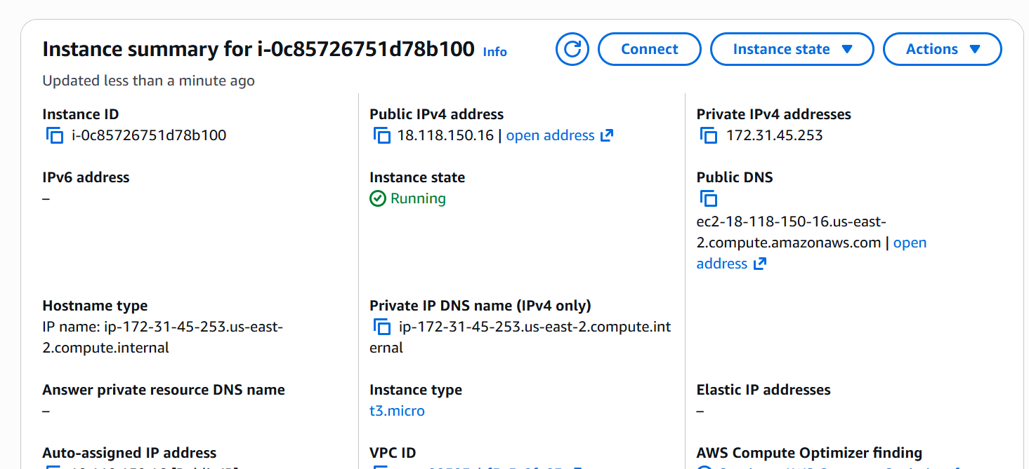

The instance is created now.

