Git and GitHub:

Git Version Control: Git is a distributed version control system used to track changes of our project/source code.
Different people can contribute to same project and can track the changes using git.

Basic Git Commands:
git --version is used to check the version of git
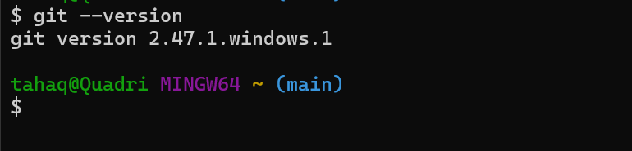

git config --list: this can be used to check the complete configuration details including our user email and user name.
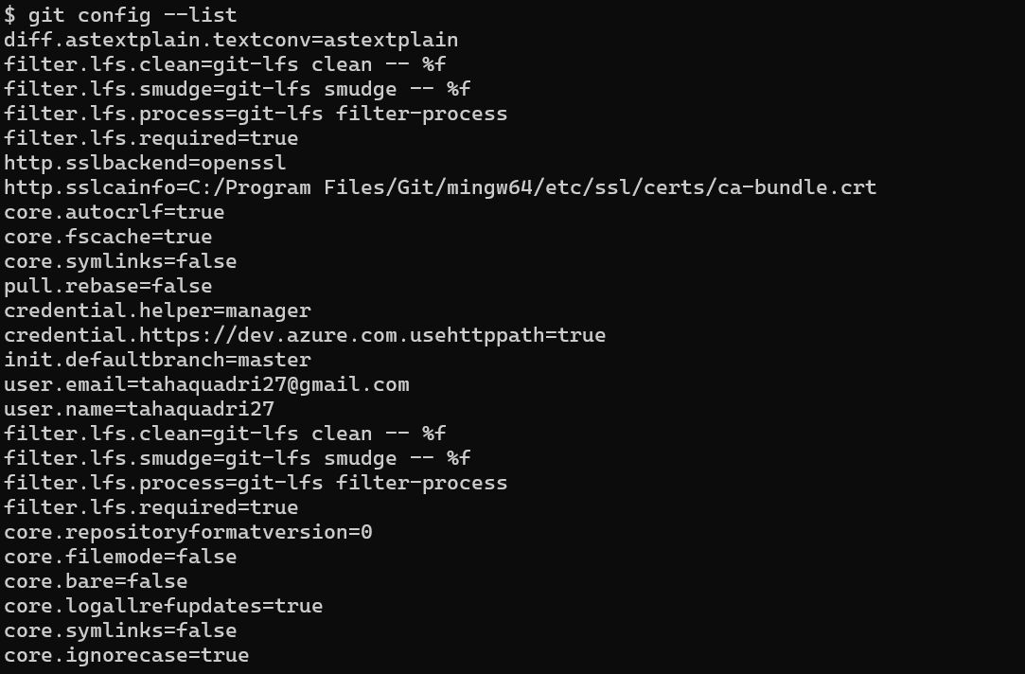

git config --global user.name: this command can be used to change or configure the username.
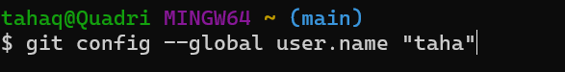

git config --global user.email: this command can be used to change or configure the user email.

git init: this command is used to initialize a git repository.
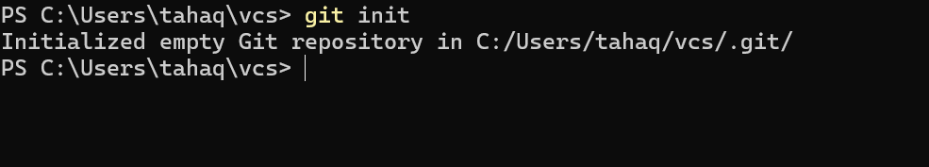

git status: this command is used to check the status of our repository it shows us the untracked files, tracked files, modified files etc.
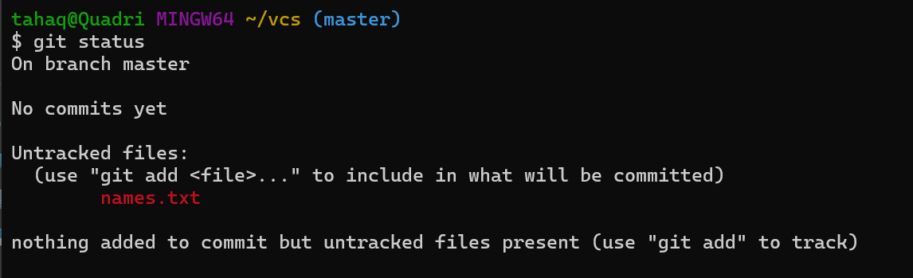

We can see that there is one untracked file “names.txt”.
If we want git to track this file, we need to use the git add command.

git add command:
git add <file name>: this command can be used to add files in the staging area,

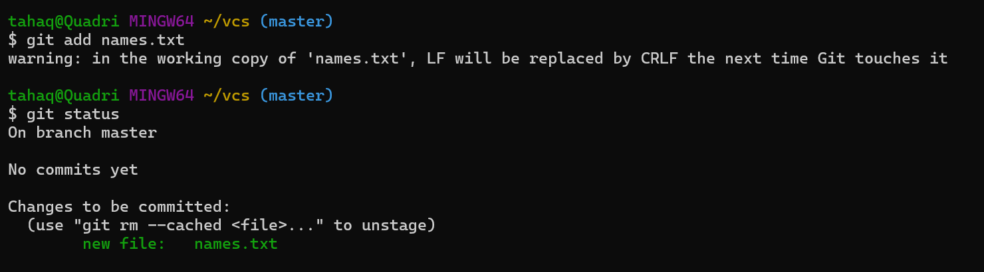
Here it can be seen that the file is now in staging area
git commit command: git commit -m “message”
once we commit it means that the git will be able to track any changes that happens to our files.
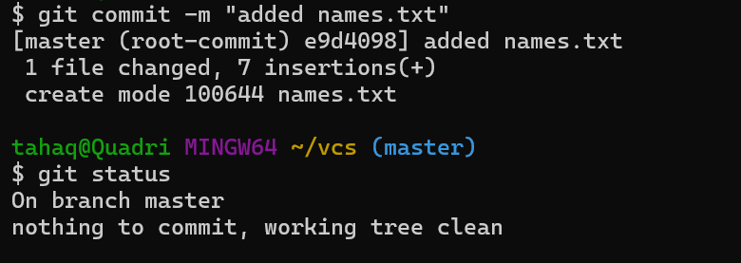
Here we have committed the file “names.txt”

The changes we have made so far are in our local repository. We can push the changes to a central repository using git push command.

First we need to add the remote repository:
git remote add origin is the command to add remote repository.
git remote -v shows the all the added remote repositories.
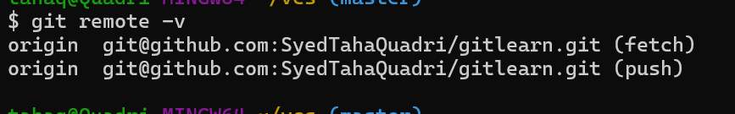

As the repository is now added we can push the changes now to remote.

Git Push Command: this can be used to push the changes to remote repository.

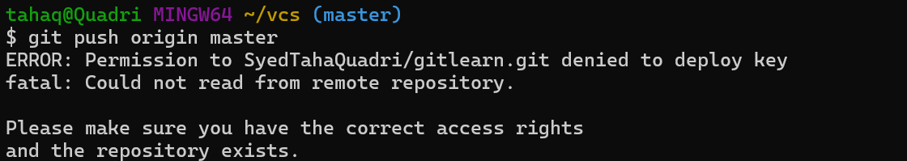
We are unable to push to remote repo because we don’t have the ssh access to remote first we need to give add ssh public key in our remote repo
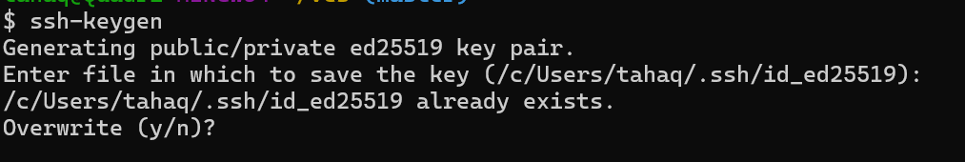
We need to add this public key in our remote repo (GITHUB)
we should go to settings and then SSH and GPG keys
and then click on New SSH key.
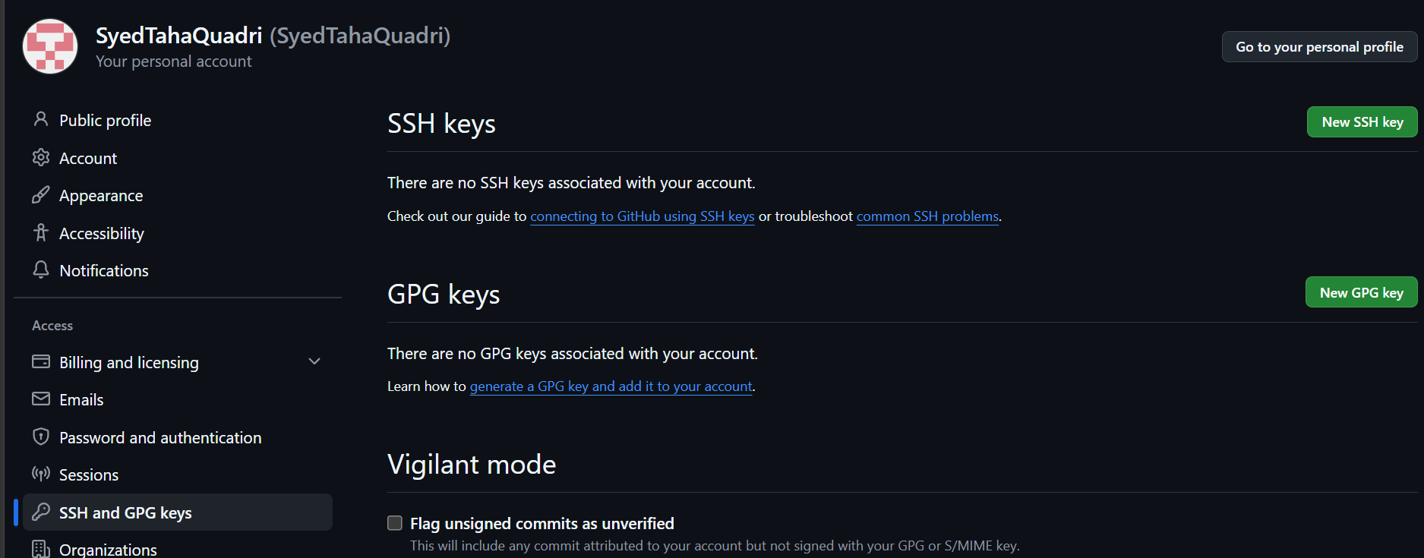
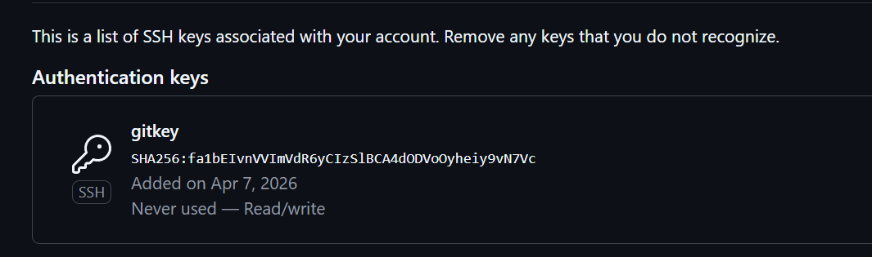
We have now added the public key in the github repository so we will be able to push changes now.
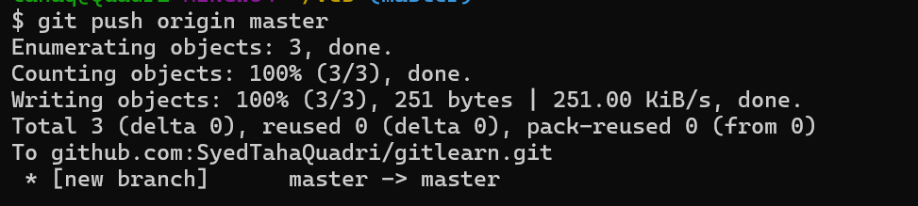
The changes have been pushed to remote repository successfully.
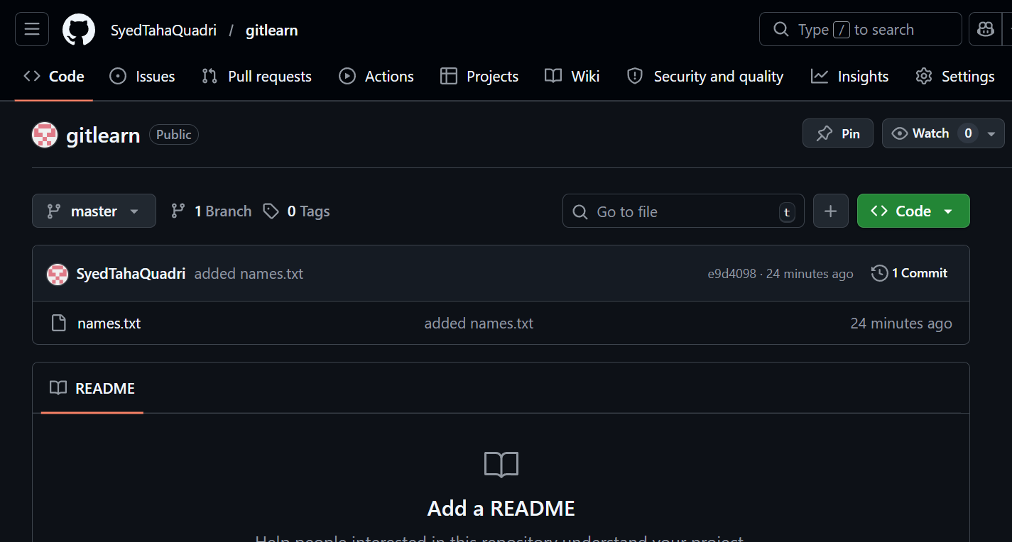

Git pull command: git pull command can be used if there are changes in the remote repo but not in our local repo.
Git pull will pull all the changes made earlier and the new changes done on the remote repo
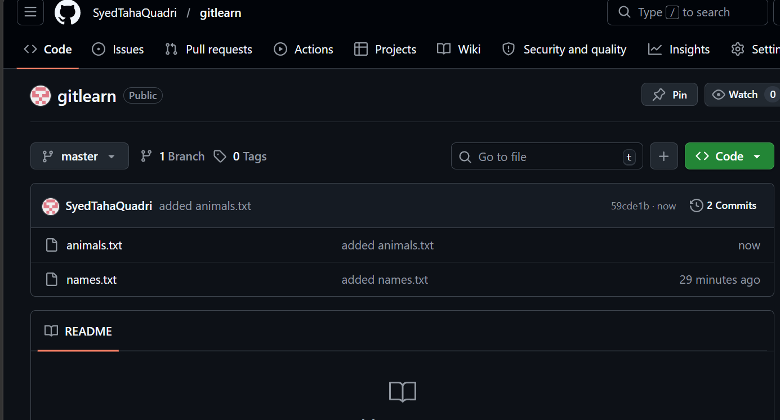
It can be seen that there are changes in my remote repo now a file “animals.txt”
Is added.
Now let’s check in our local repo if we have the changes already or not.
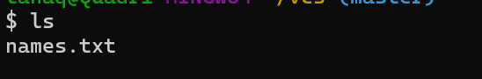
We do not have the file animals.txt here
To have the changes from the remote we can use git pull command
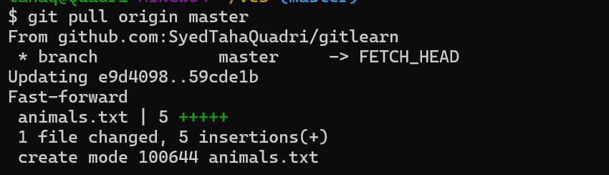

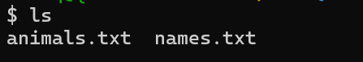
The remote repo and local repo are same now.

Git clone command: git clone <repo url> this command can be used to download the remote repository in our local machine.
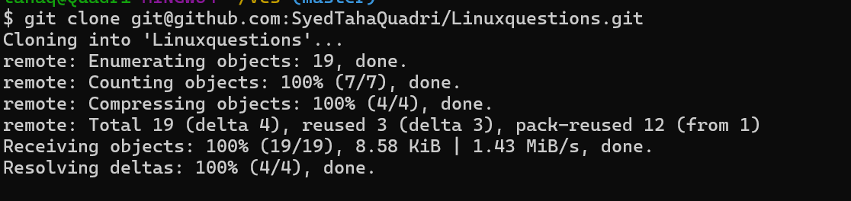
Here I have cloned the repository Linuxquestions.

Git fork command: git fork can be used to download the repository and start working on top that. 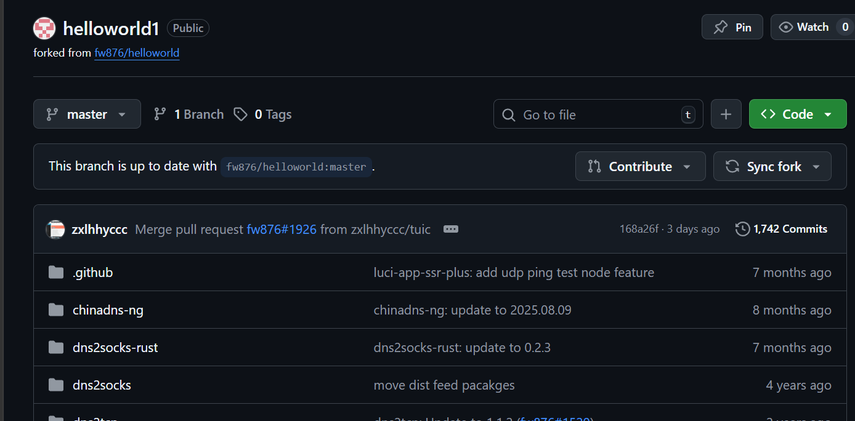
I can make my own changes in this fork.
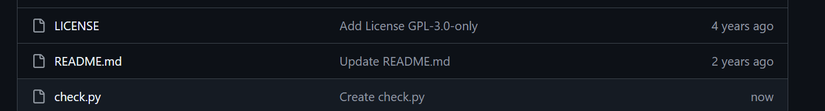

Here I have added a file check.py
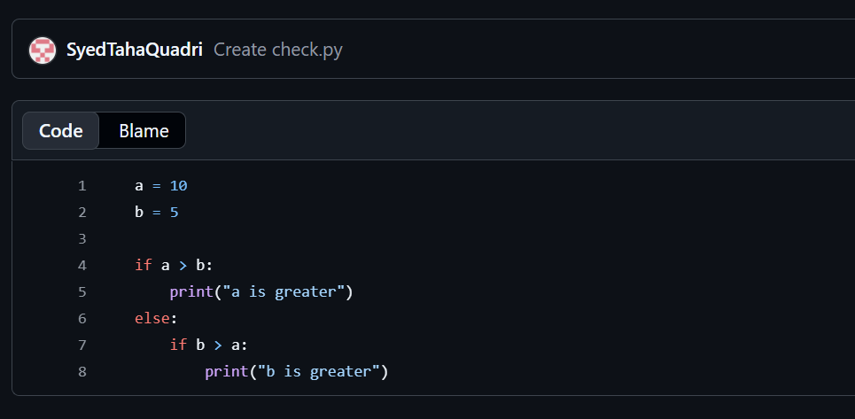


Git revert: this command allows us to go to previous commits
I have created a new repo which now has two commits.
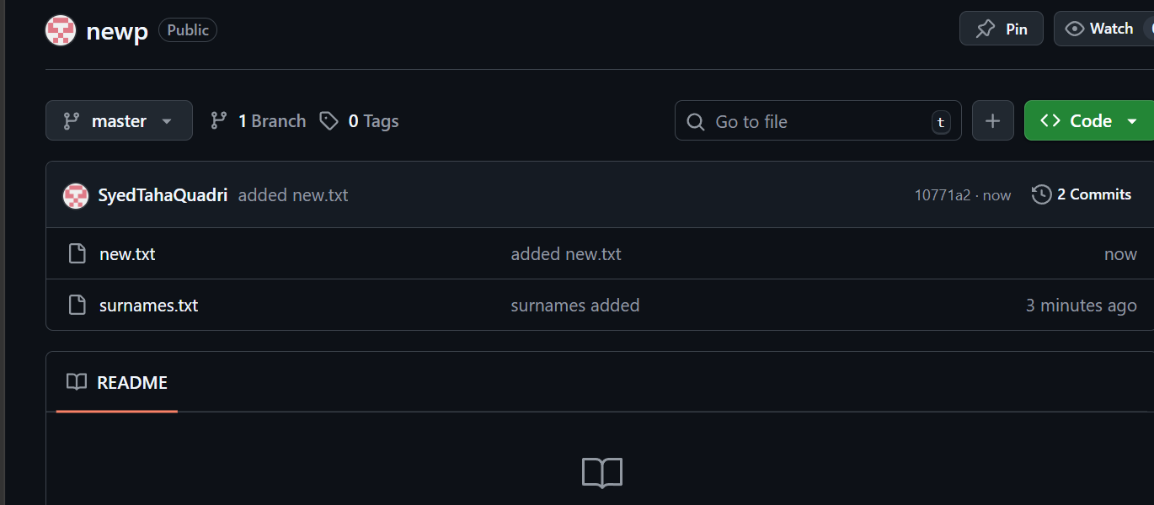
I want to go to the first remove the changes after the first commit
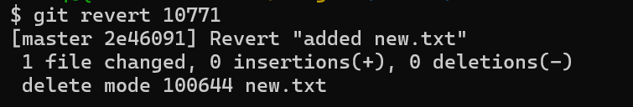
We only have one file left now.
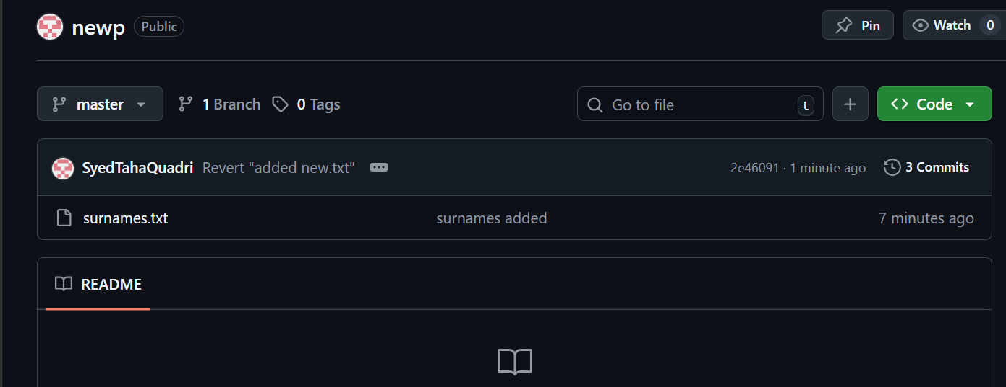

Git reset: this command allows us to remove tracked files.
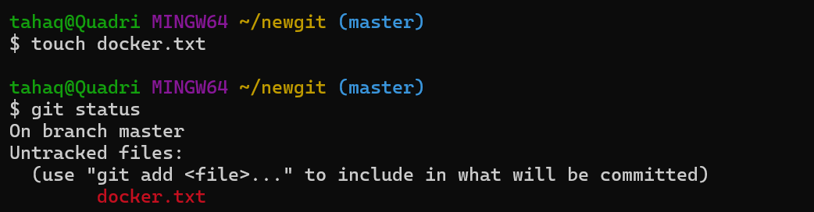
Here I have created a file “docker.txt” which is now untracked
The file is now tracked
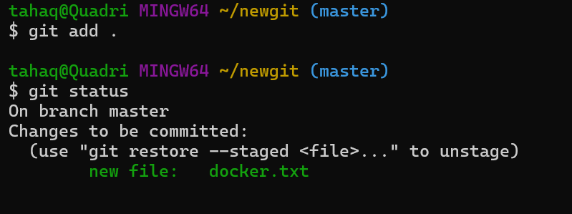
If we want this file to be untracked again, we can use ‘git reset’ command.
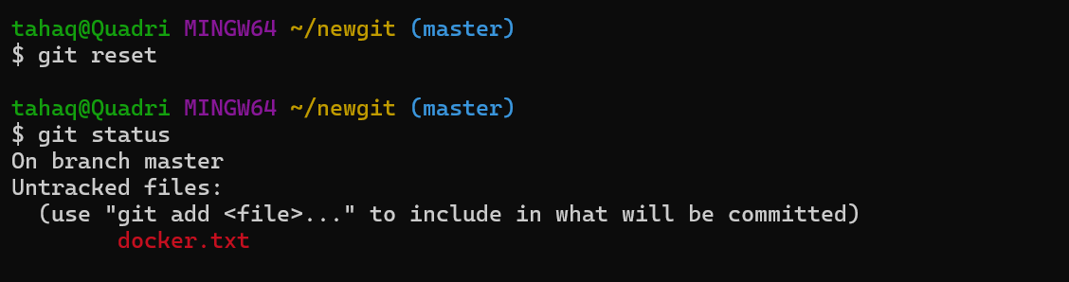
The file is untracked again.

