Git and Github Task:
1:Install git:
to install git in linux we can use command yum install git.
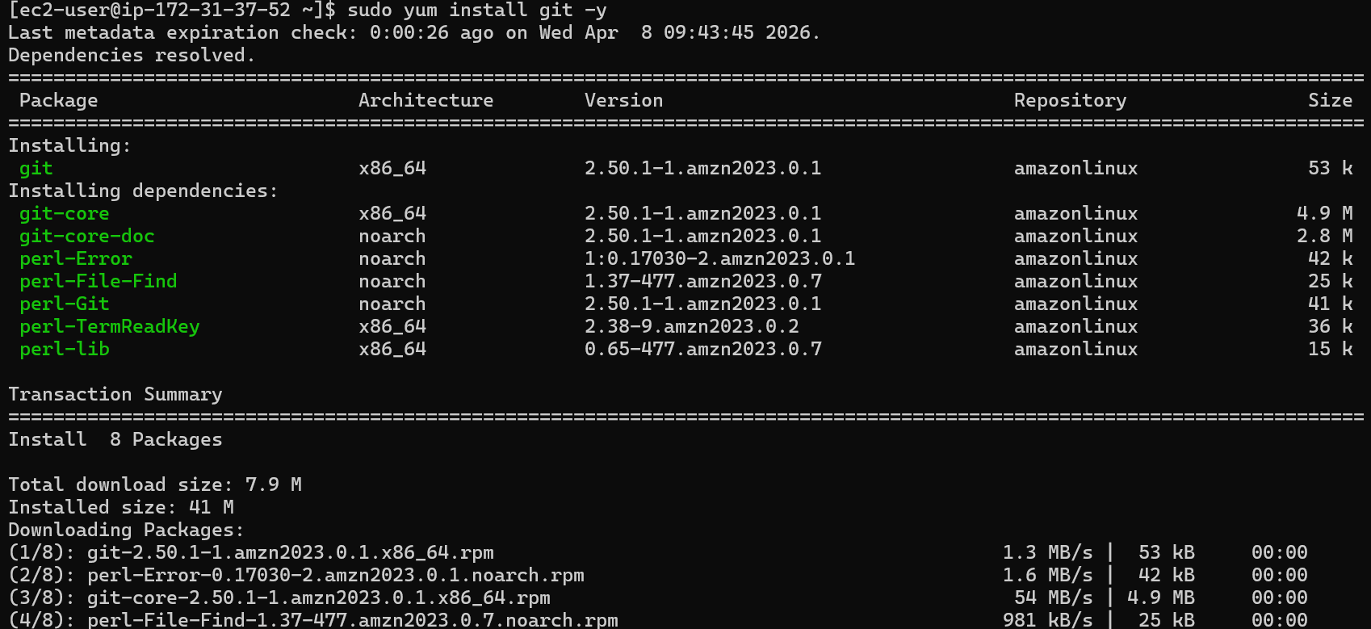
Git is now installed.
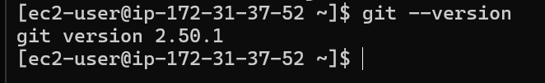

2. Create a Repo in github with README.md and .ignore file.
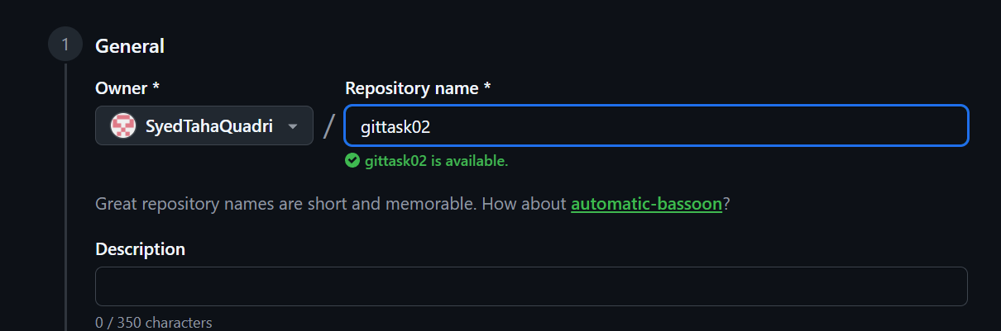
At the time of creating a repository in github we can specify if we want to add a README.md and .ignore file.
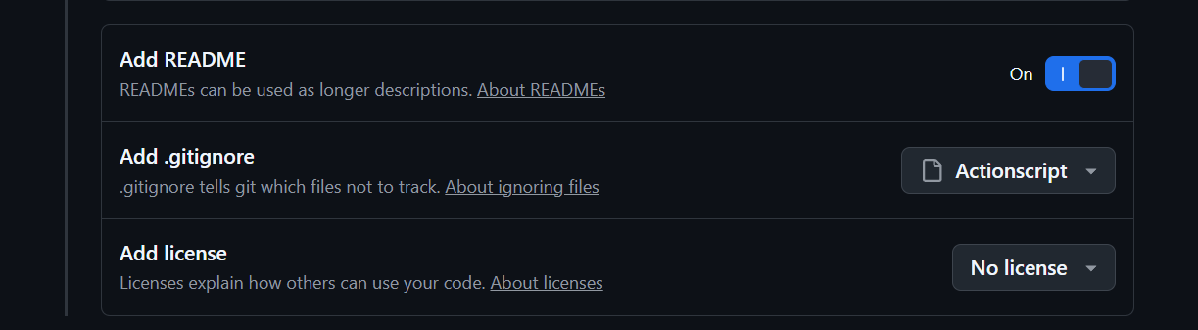
The .ignore and README files have been added.
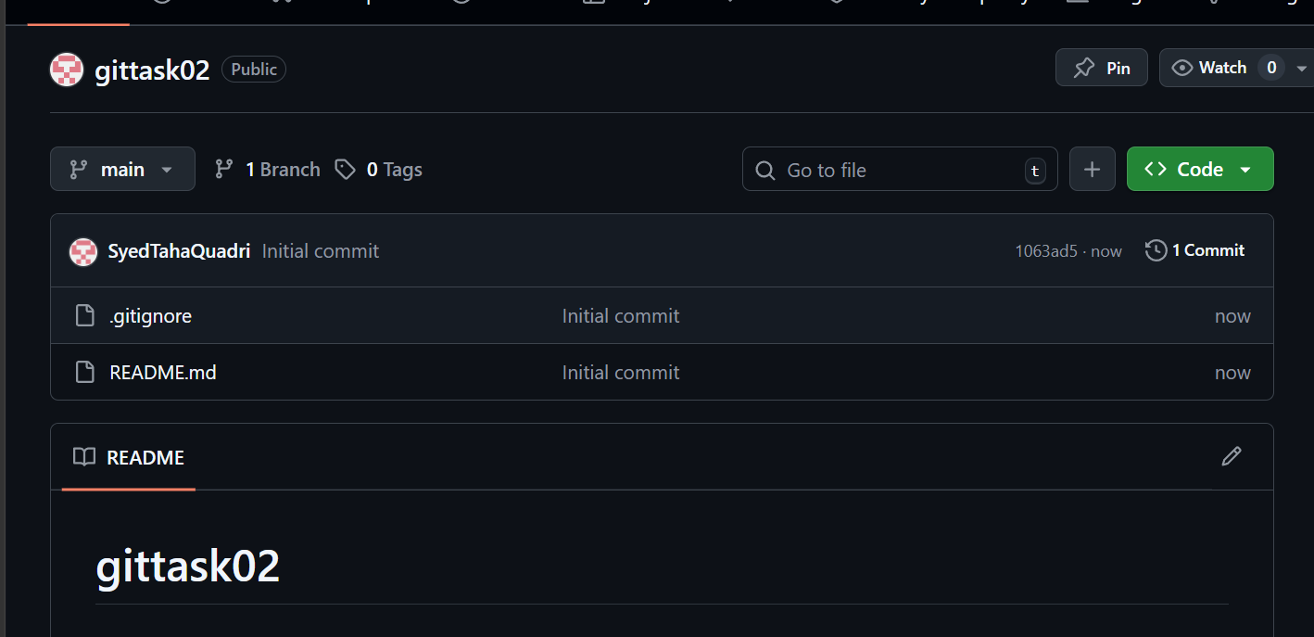

3. Cloning the created repo in local machine:
We can use git clone command:
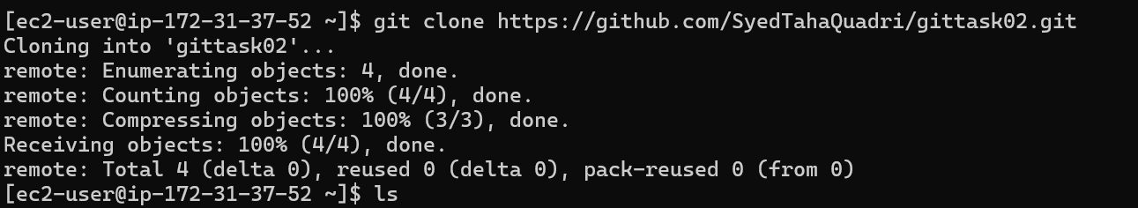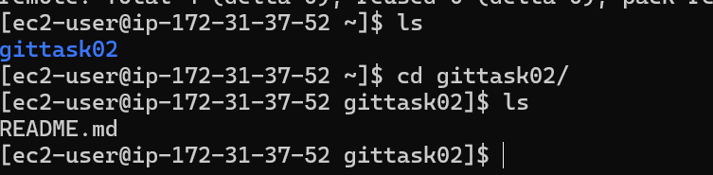
We have cloned the remote repository.
4.Create two files in local repo:
We have now created two new files in local repository.
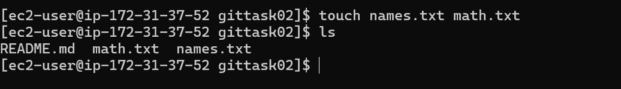

5. Commit two files and push to central Repository.
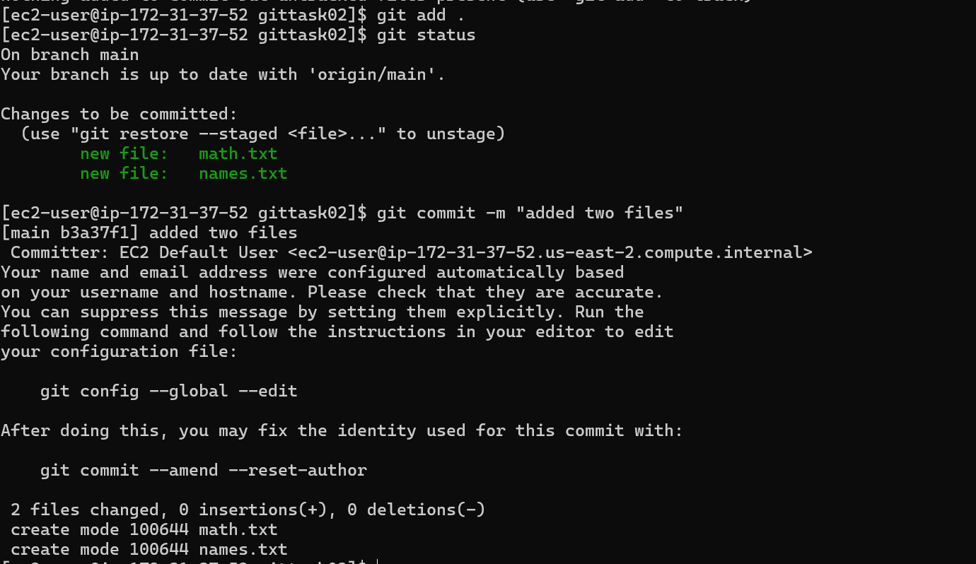
Two files have now been committed.
We have now pushed the files to github.
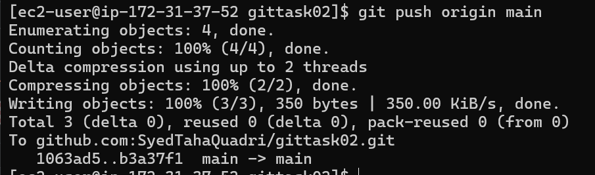
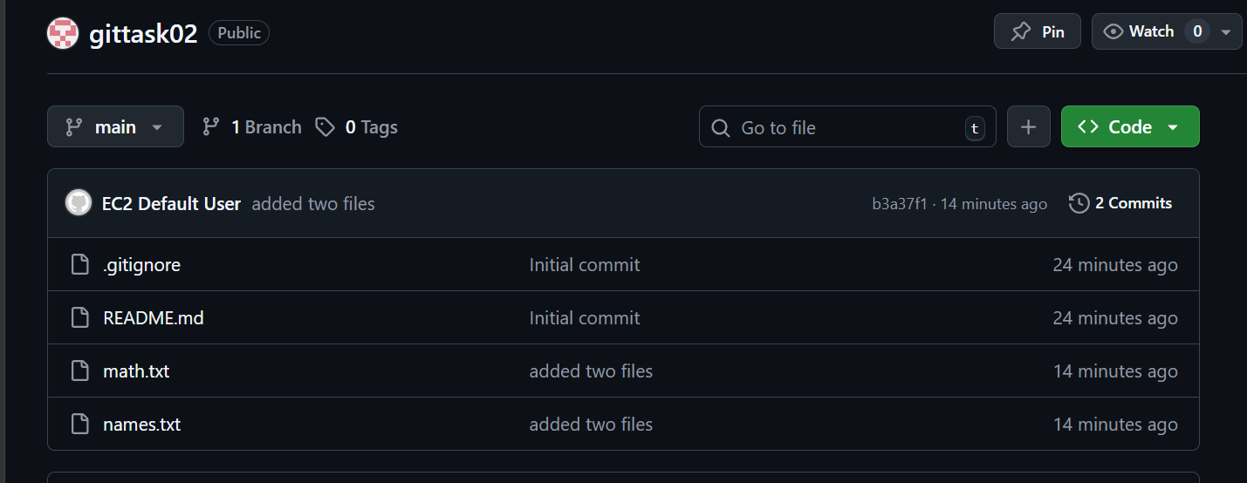

6. Create a branch in local and sample file and push to github.
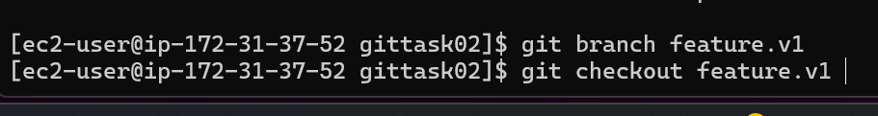
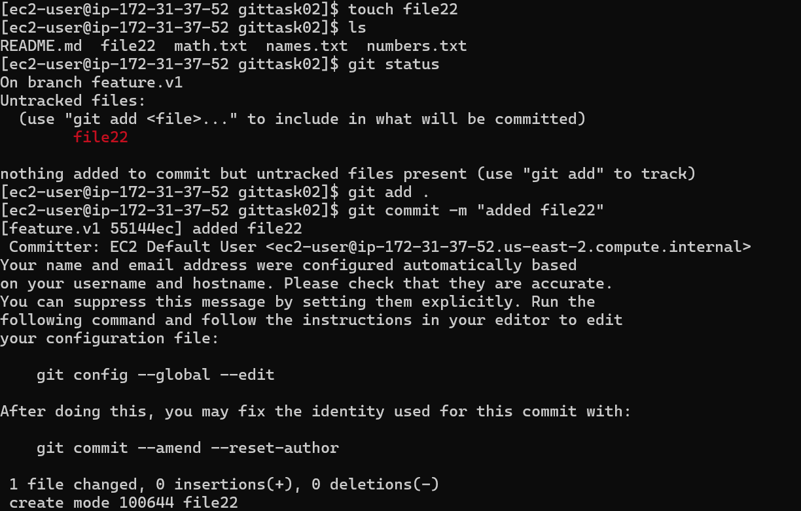
Created a new file file22 and commited
Same has been pushed to github.
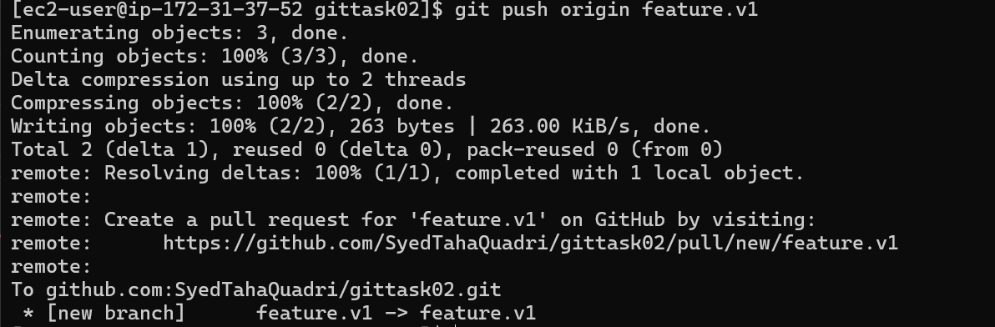

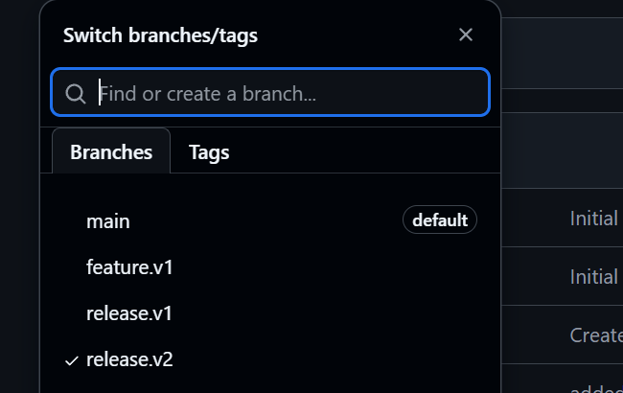

7.Create a branch in github and clone it in local :
We have now created a new branch release.v1 in github

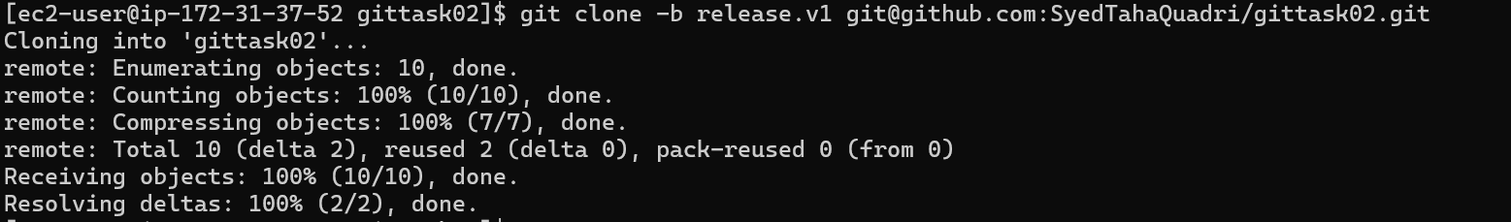
By using git clone -b branch name <Repo URL> we have cloned the release branch.


8.Merge the created branch to main in local:
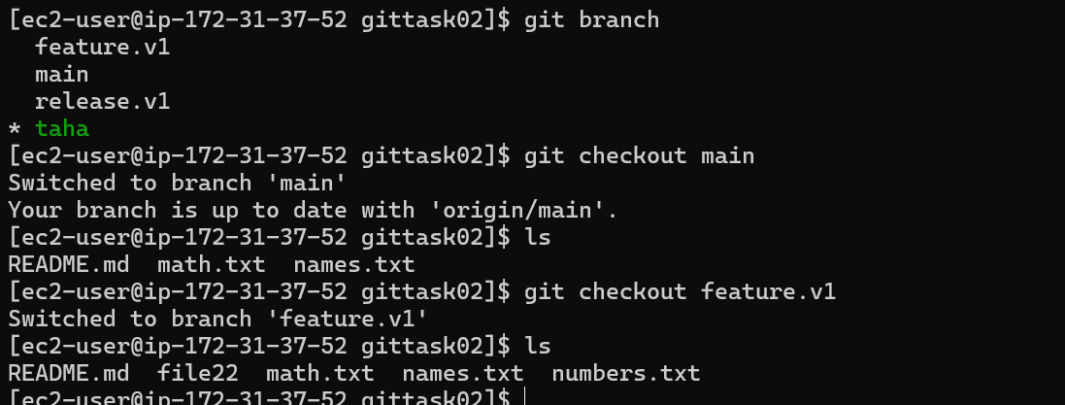
in GitHub with pull request.

9.Merge the created branch with master in github by sending a pull request.

We have now created a new branch named taha
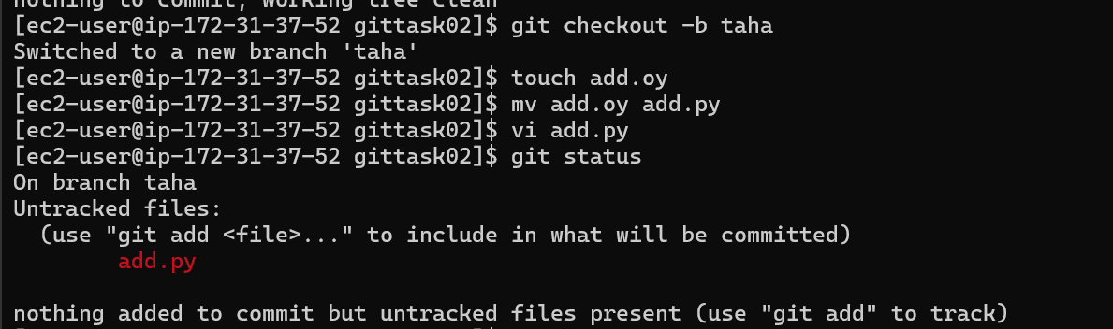
And we have a file add.py py let’s push it to remote.
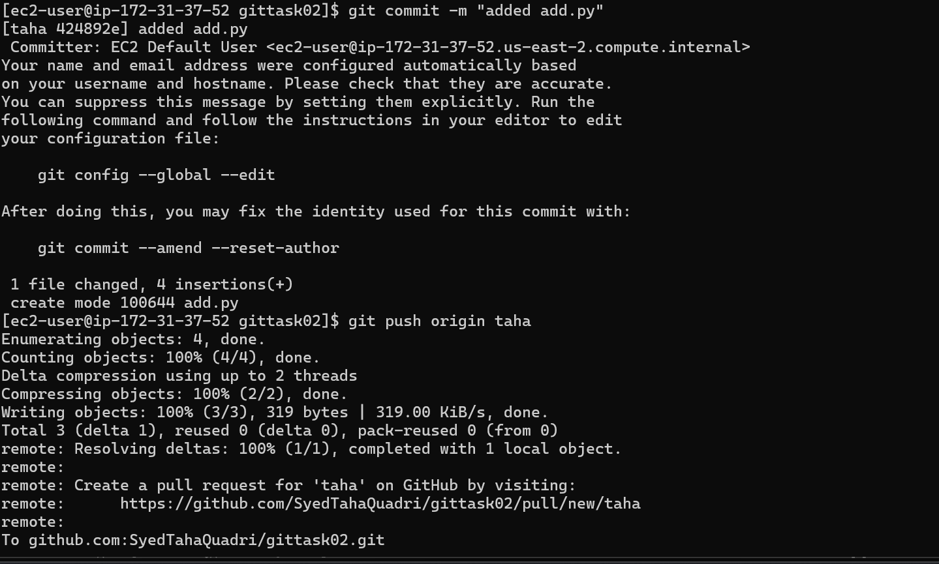

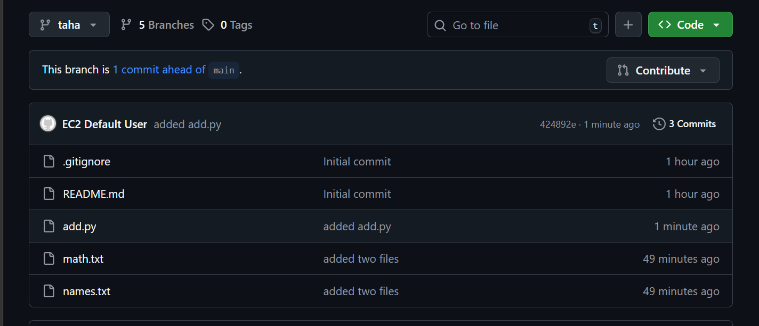
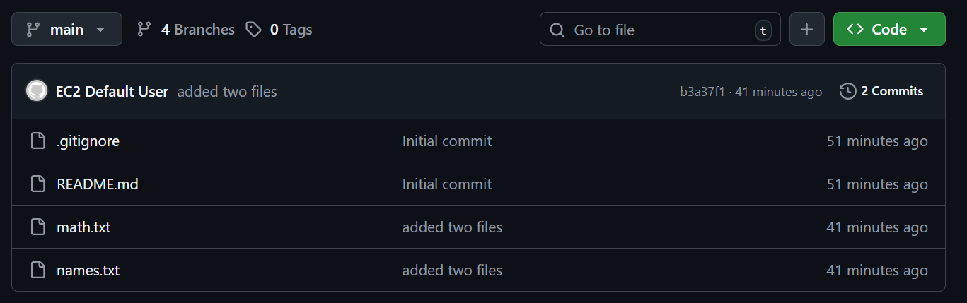
Now main does not have the file add.py which the branch taha has.
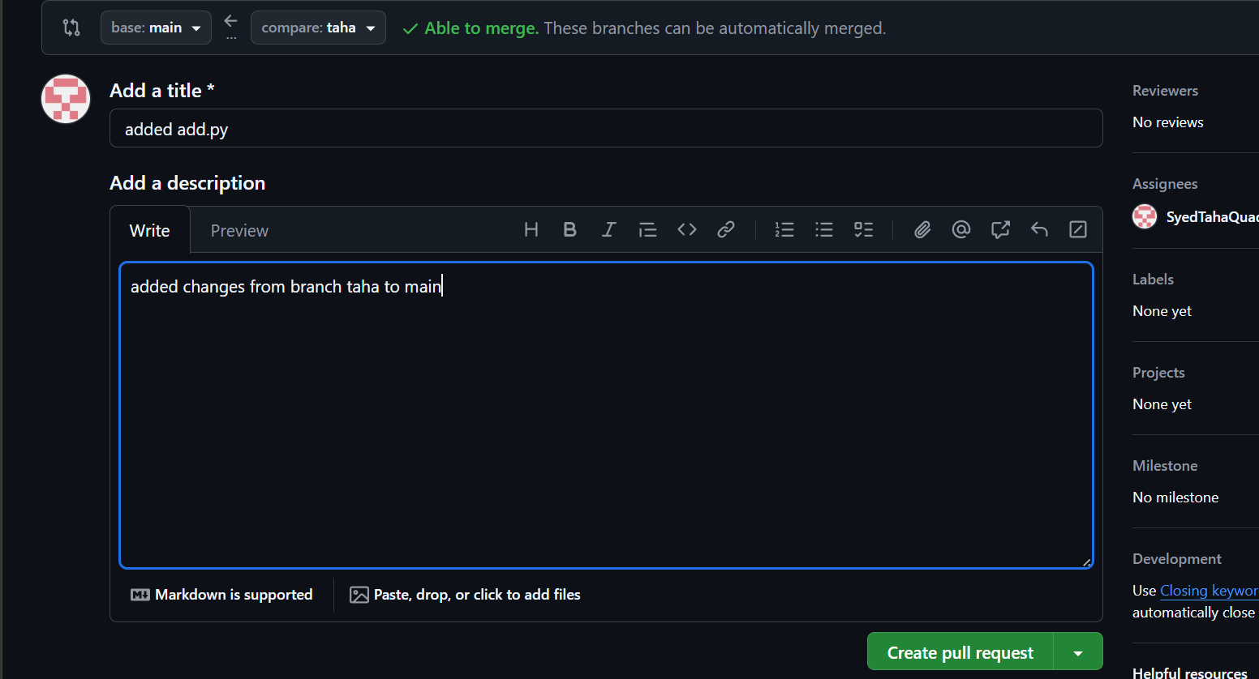
Creating a pull request.
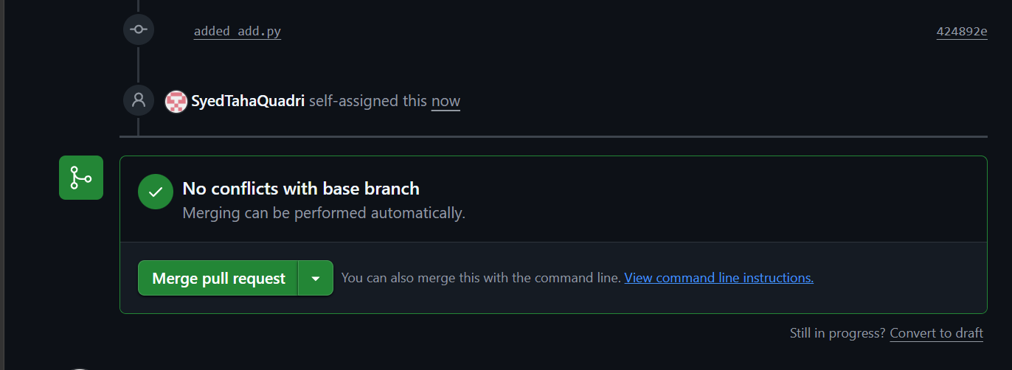
Merged the PR
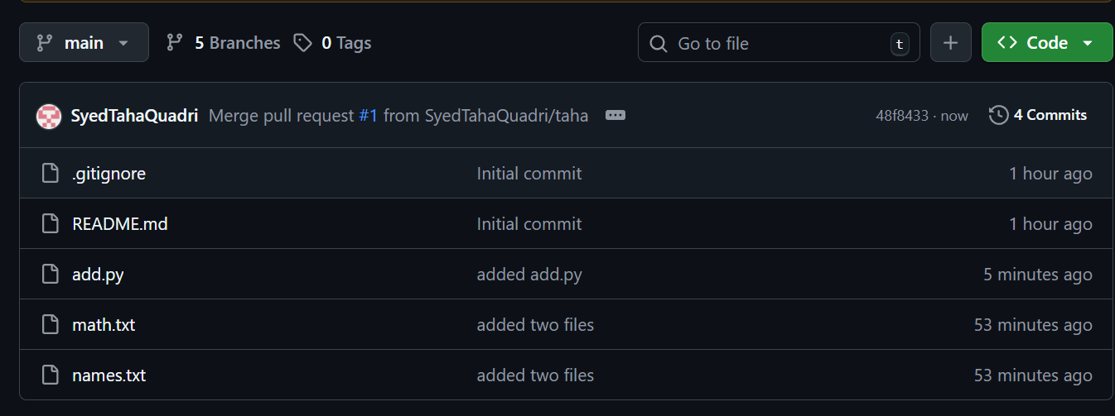
Now the main branch has the changes of taha branch.

10. Create a file in local and send that to branch in github.

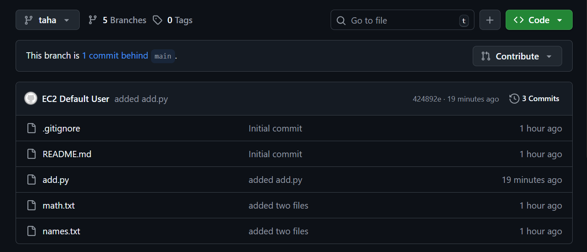
These are all the files in the taha branch now.
Let’s add a file from local.
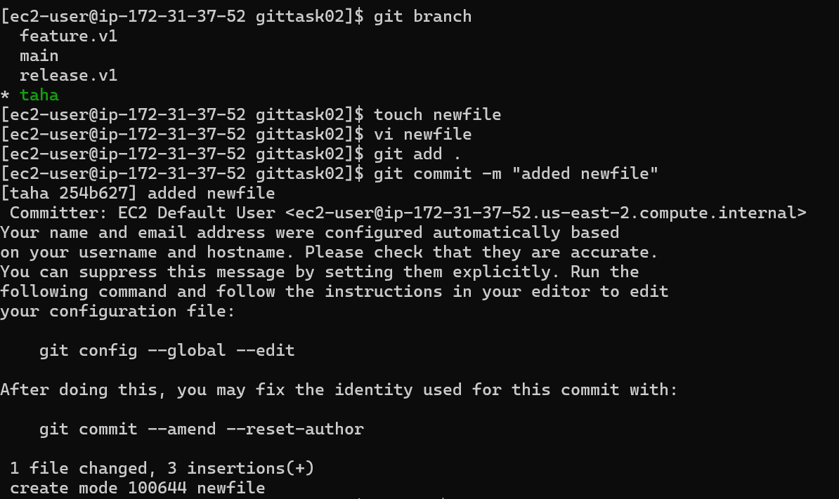
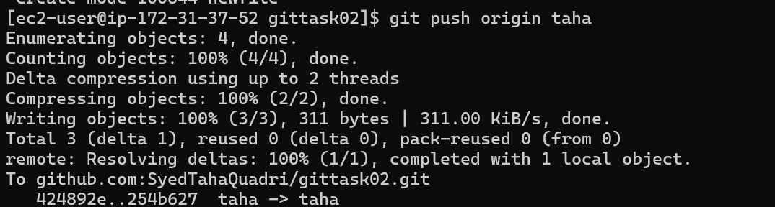

The file have been added to the branch taha.

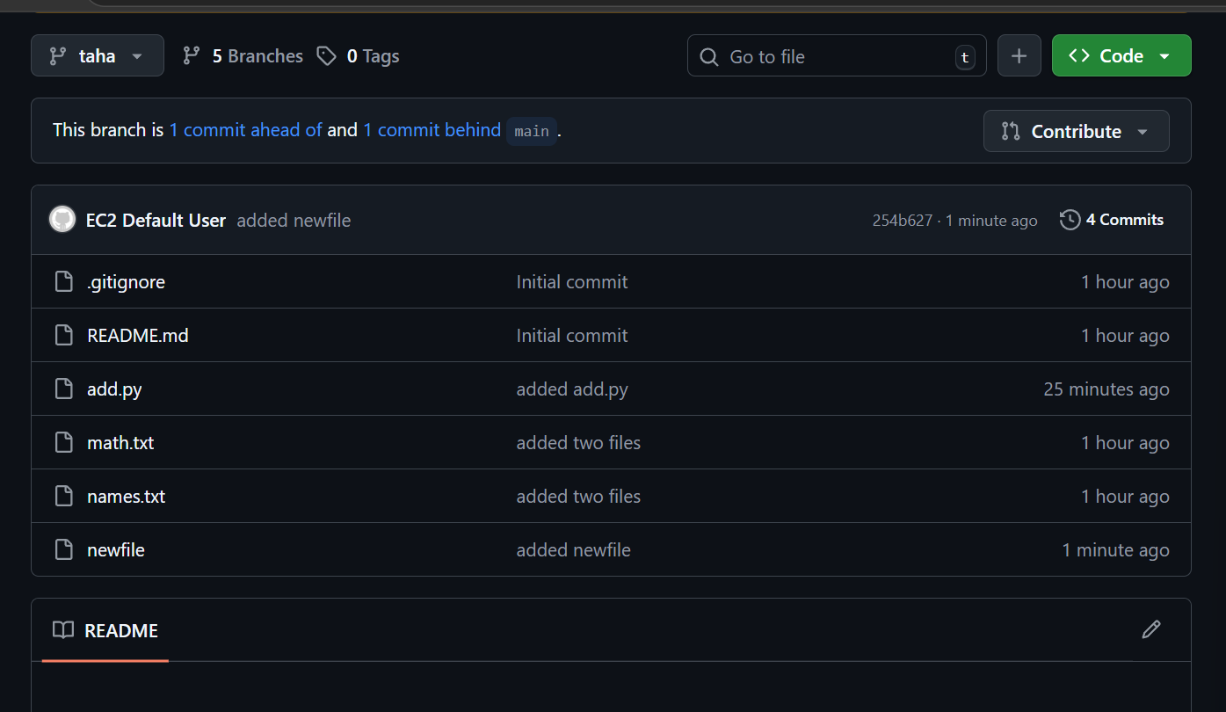

11.Clone only a branch from github to local.

First lets create a new branch in github

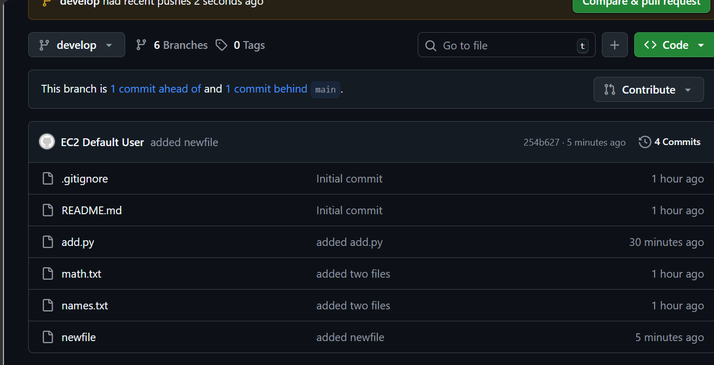
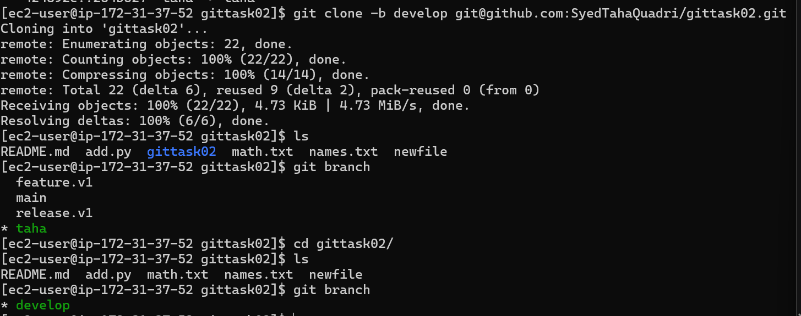
Here we have just cloned a specific branch named develop in our local.

12. create a file with all passwords and make that untrackable to git.
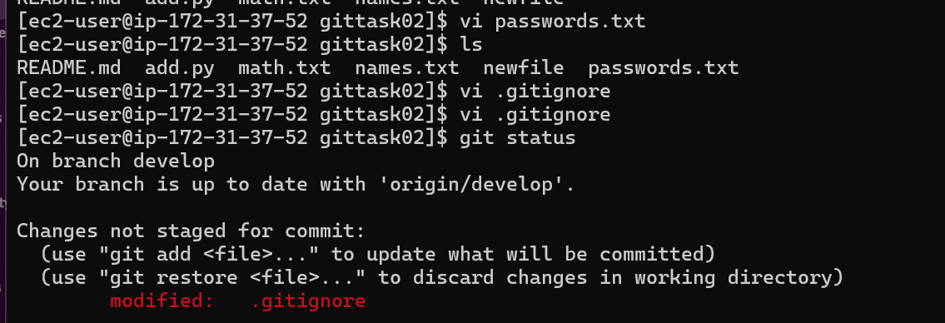
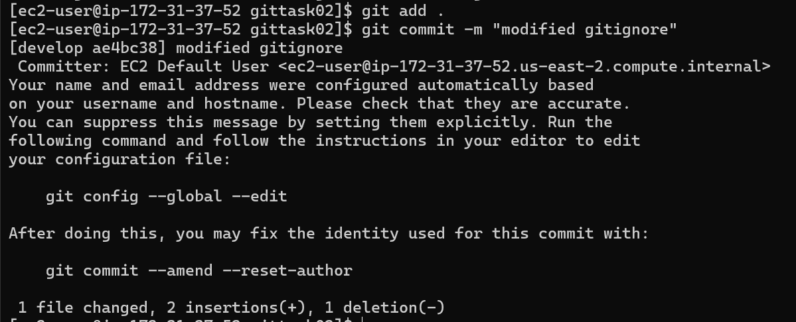
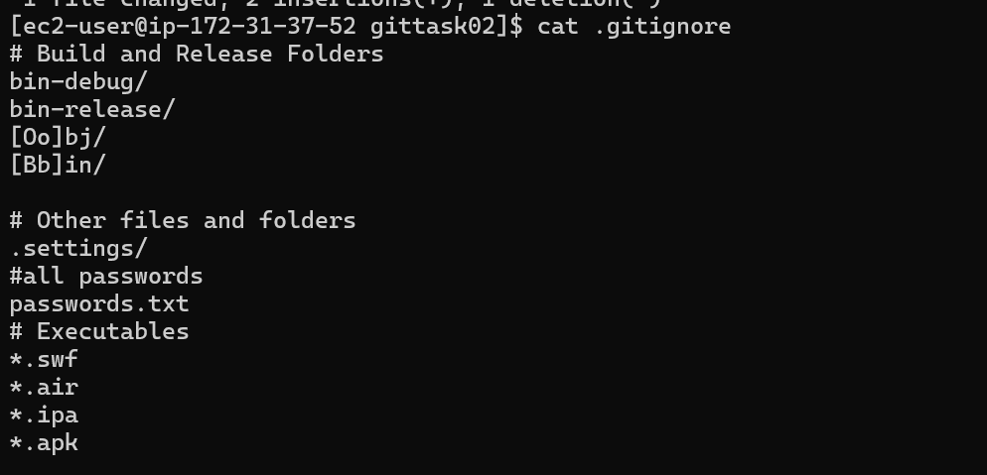

Here we have add the file passwords.txt in .gitignore file.
Git is unable to track the content of the passwords.txt file
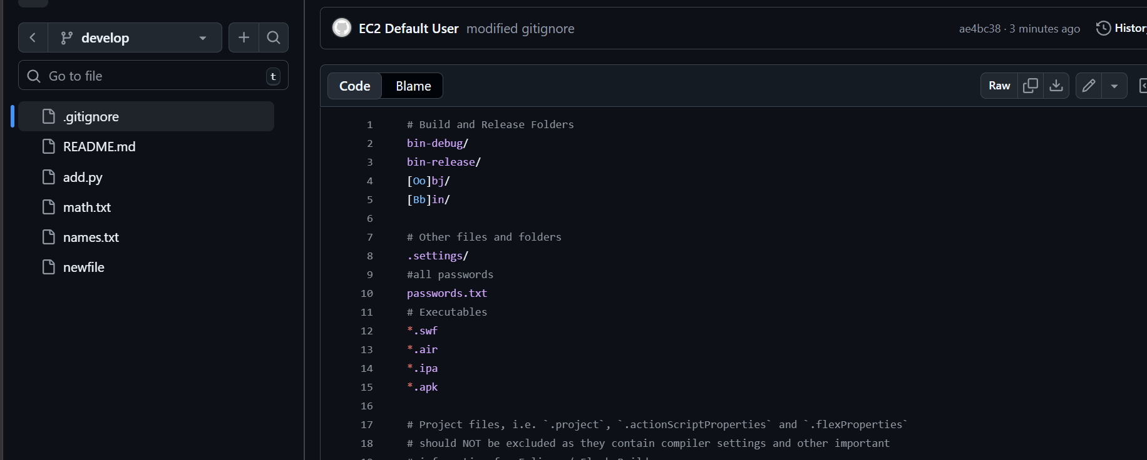
13. Make a commit and make that commit reset without savings changes.
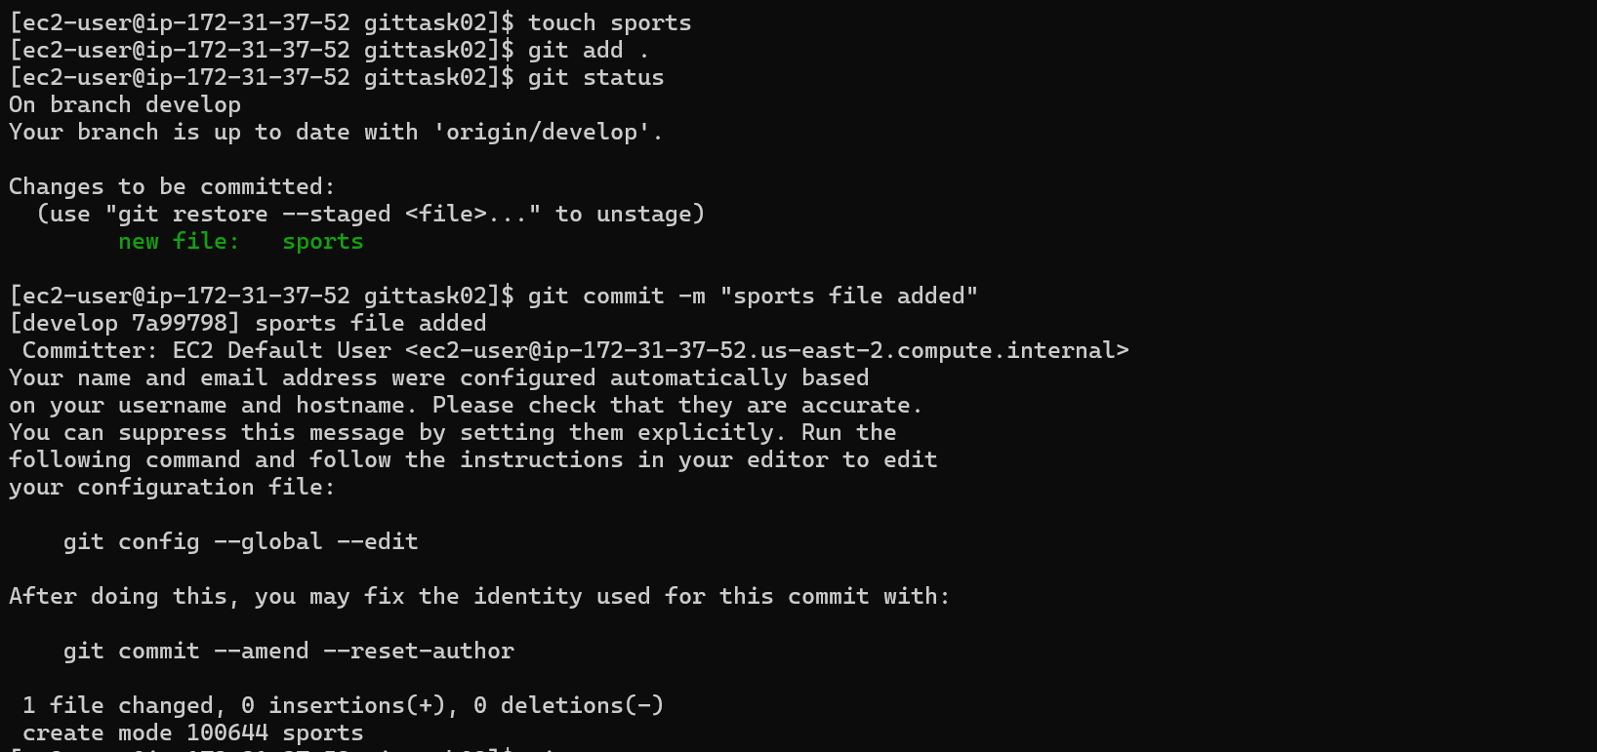
Now we have added a sports file and commited as well.
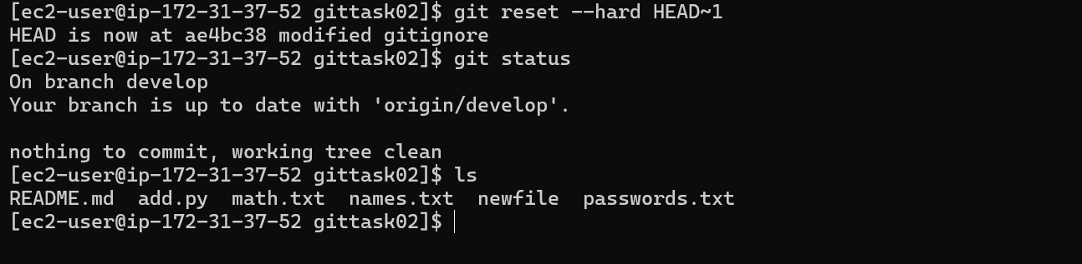
The commit is now reset to the old commit.

14.Revert a commited commit to the older version.
Here we have a file named taha.txt
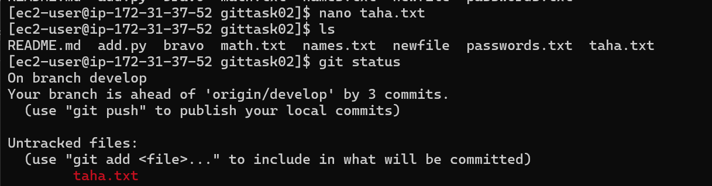
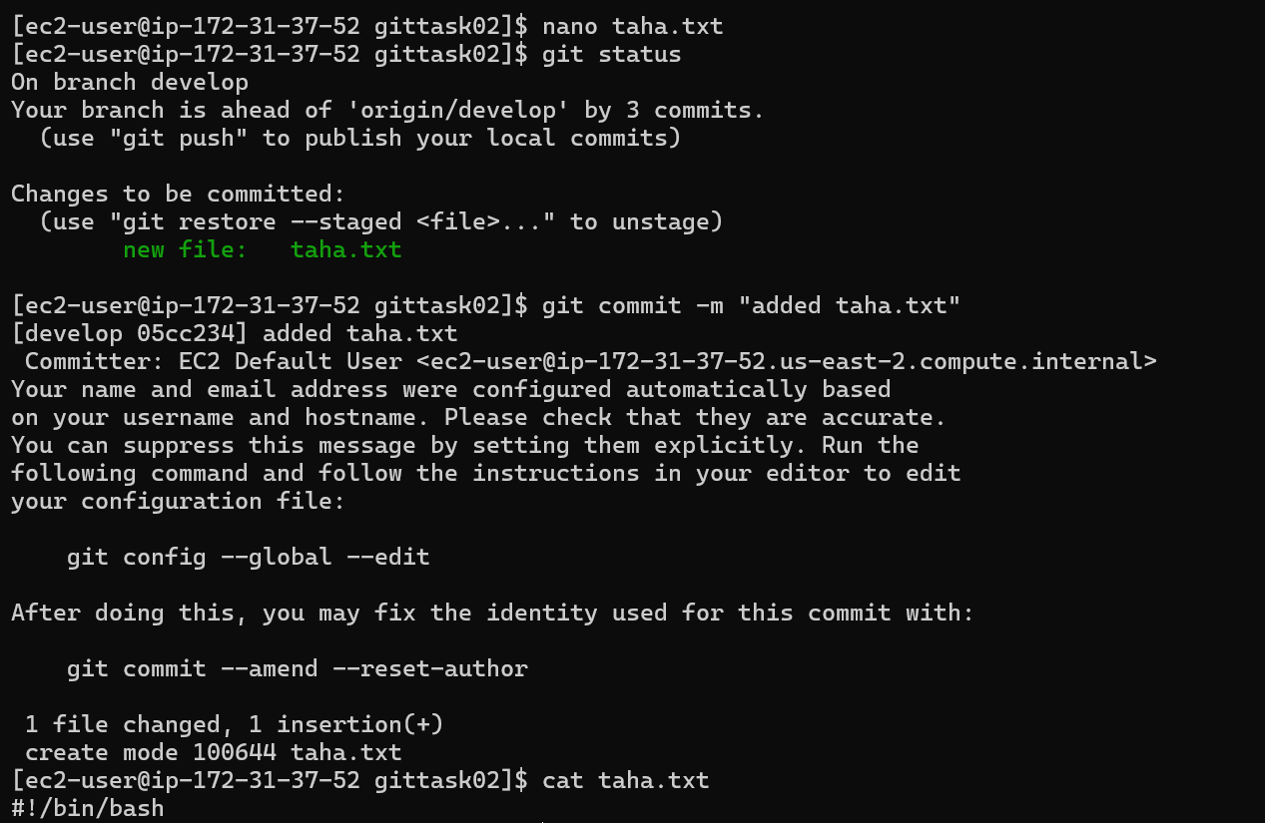
We have commited the file taha.txt
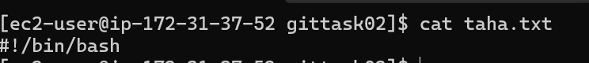
We have now made changes in taha.txt
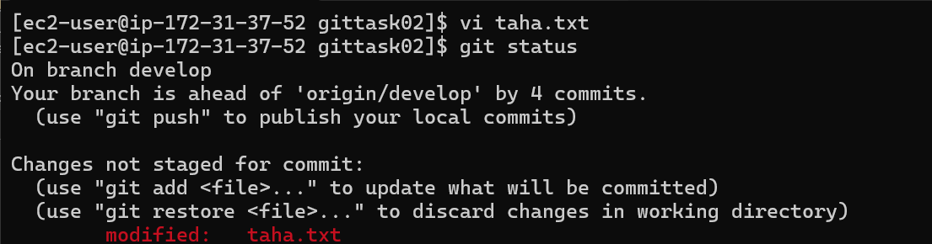
Git revert can be used here to get back to previous commit.
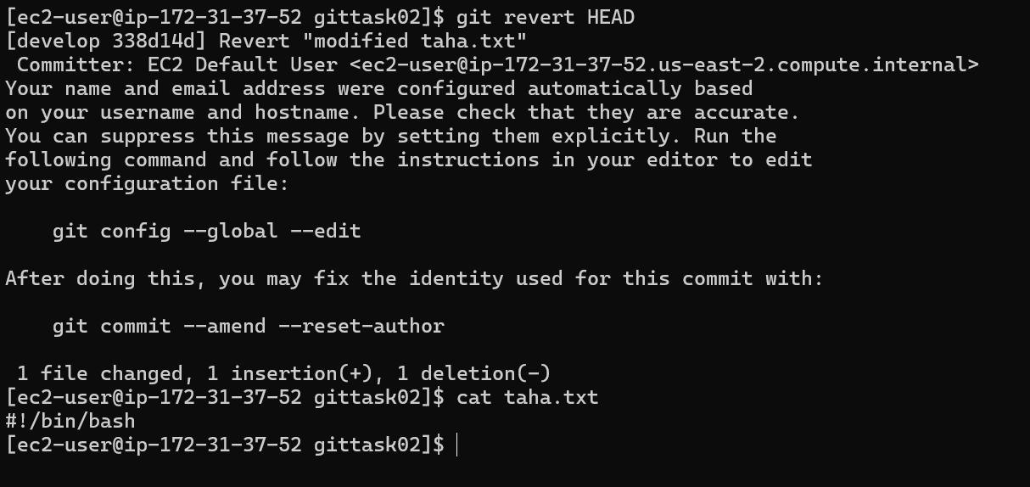
The file is back to the older version now.

15. Push a file to stash without saving the changes and work on another file.
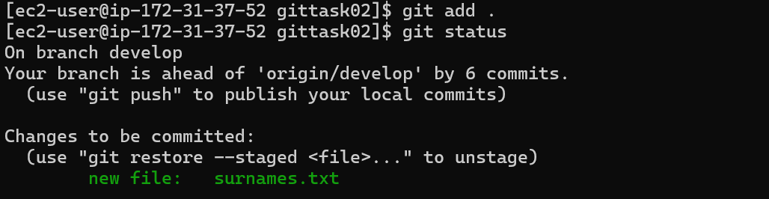
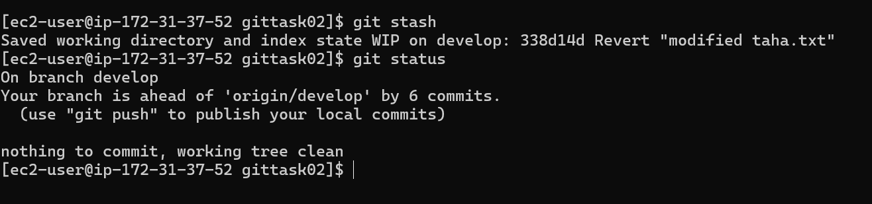
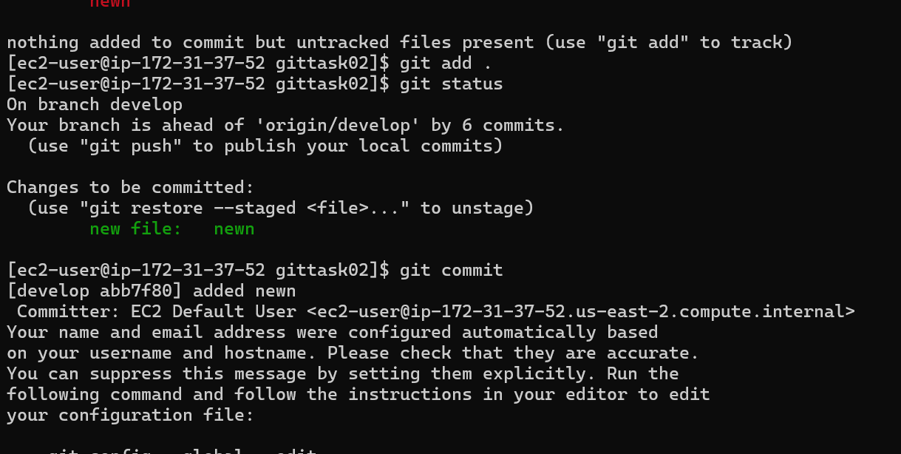
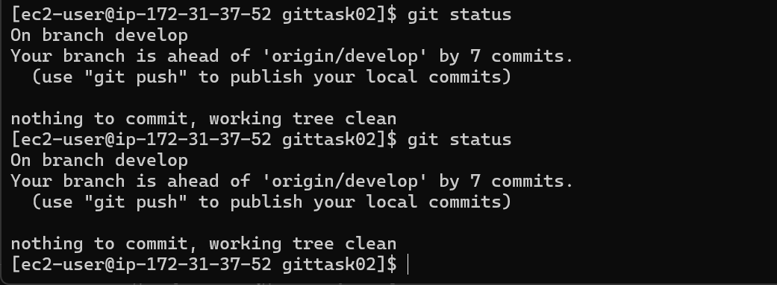

16.Undo the stash file and start working on that again.
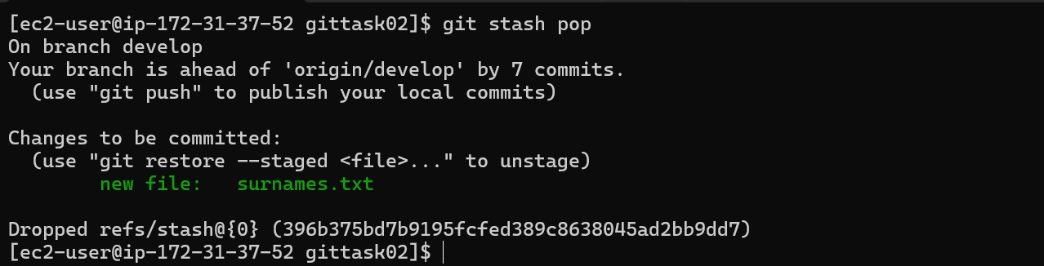
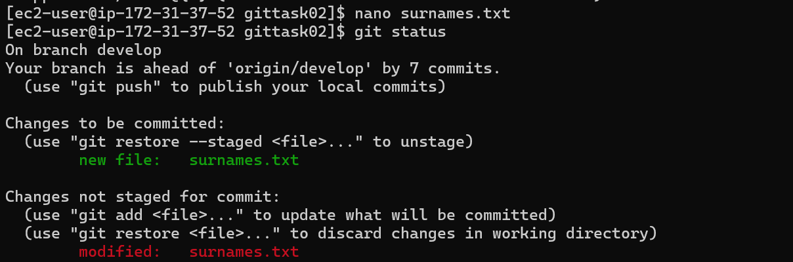
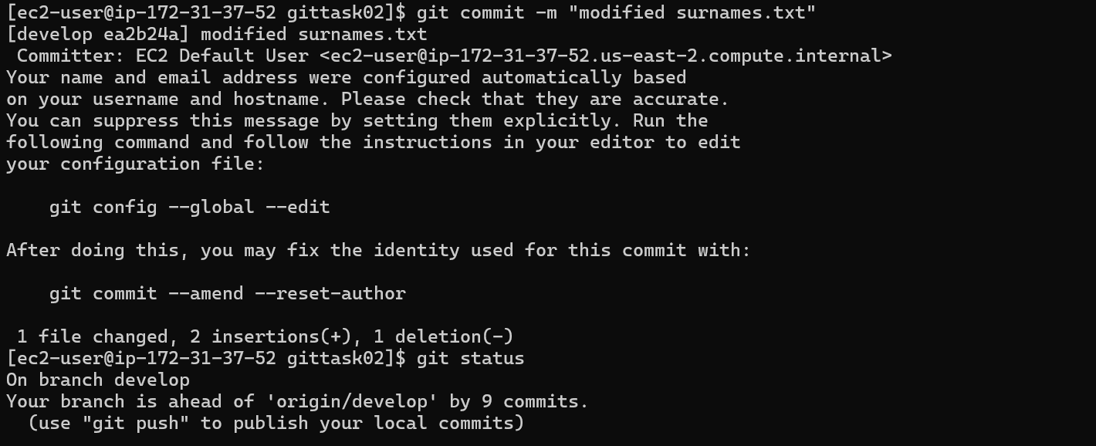

17. Generate a SSH keygen and configure in Github.
To generate a ssh key we need to run command ssh-keygen in our local machine
After that we should copy the public key from .ssh dir and we should paste in github SSH and GGP section.
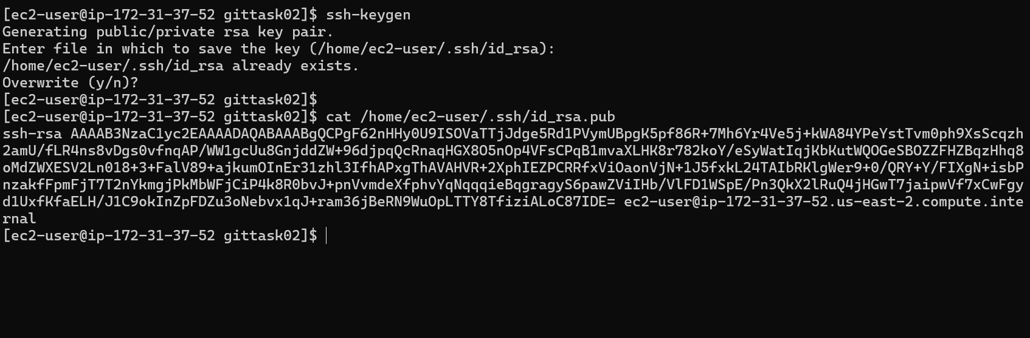


The new key has been added now.

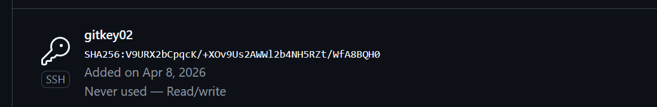

18.Configure webhooks to github.
We need to go to the repository settings.


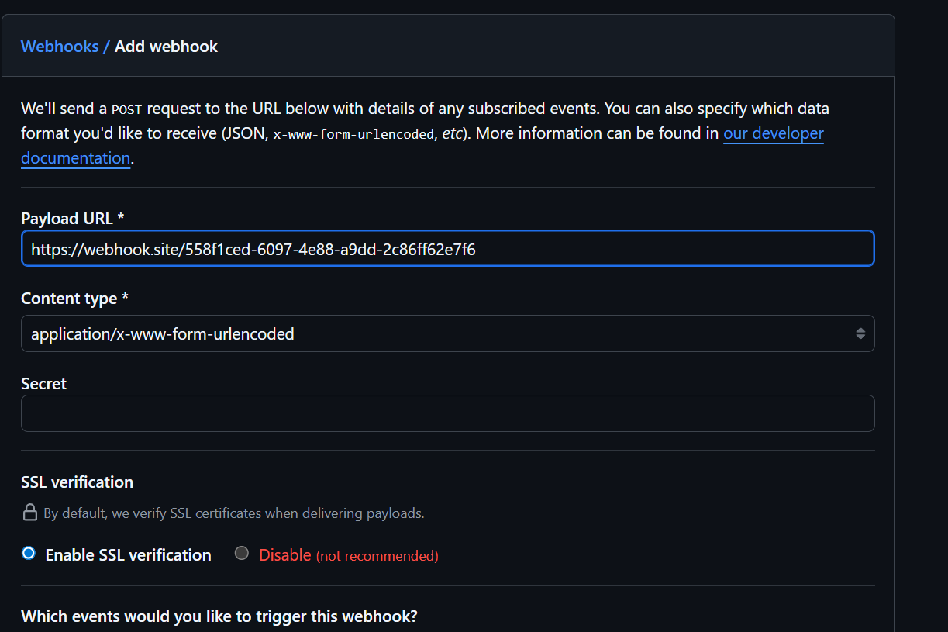



19.Basic understanding of .git directory
This directory is created when we initialize the repository by git init.
.git directory contains all the information of your project’s history.
It is like the database of your repository
What is inside git?
Head : this is a pointer to your current branch
Config : has repository settings user info etc
Objects: contain all the commits
Refs/: holds references to branches
Logs: history of branch
Hooks: scripts that run automatically on event
If we delete the .git directory we won’t be able to manage the project.

20. Check all the logs of git
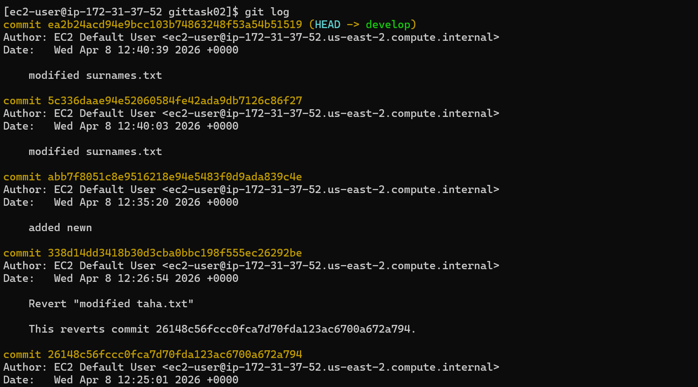
We can check the logs of a specific branch like this
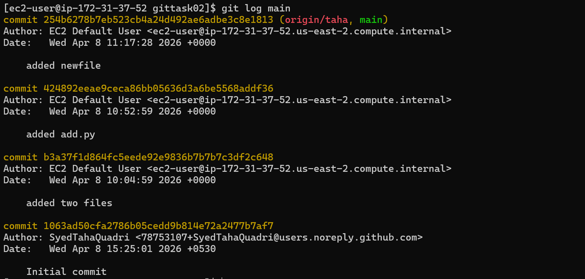

21. Rename a commit message
We are at the main branch and this is our latest commit
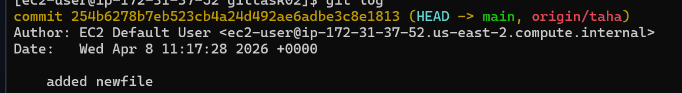
We have now changes the commit message
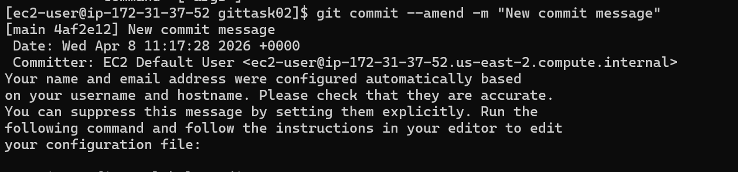
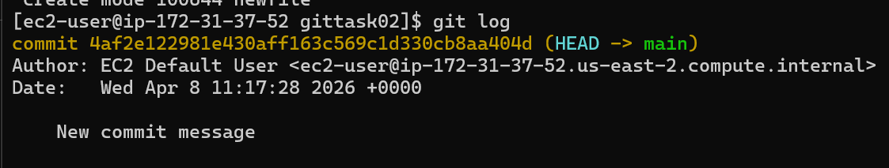

22.Merge multiple commits into a single commit
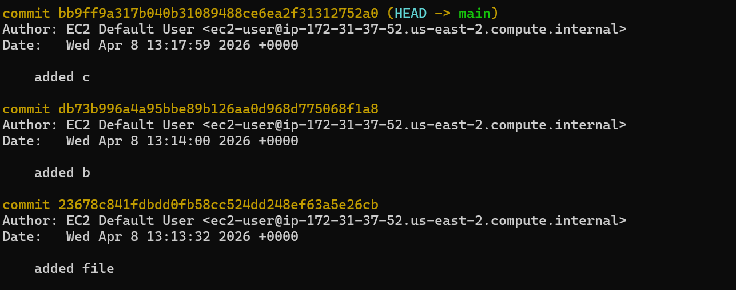
These are the three latest commits
git rebase -i HEAD~3
this is the command to merge multiple commits to a single commit
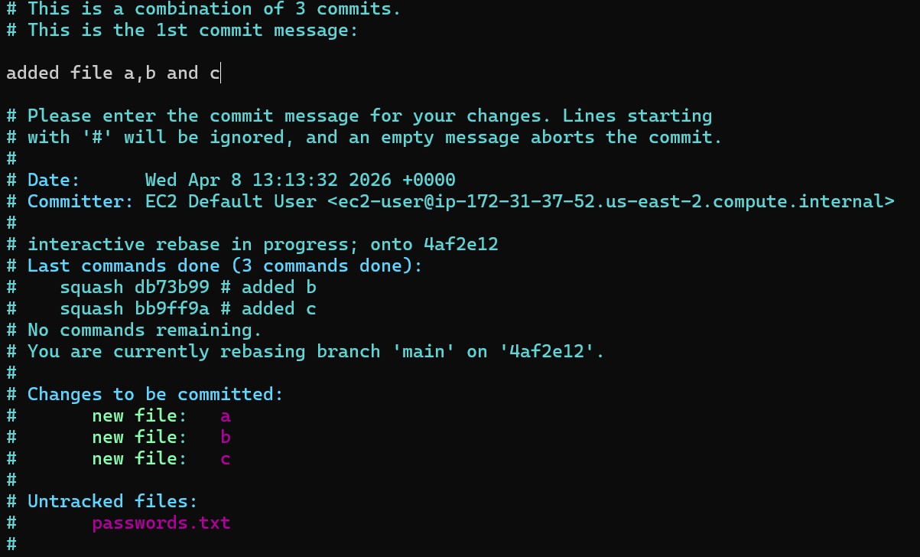
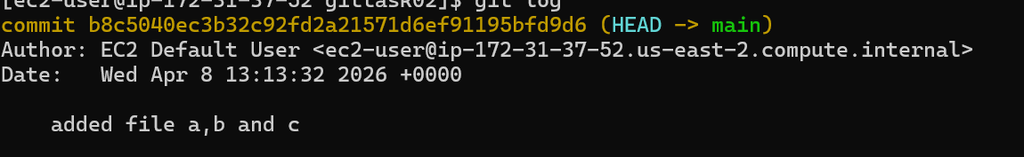
The three commits have been merged In a single commit now.

