Shell Scripts:
Basic shell scripts:
Printing output to screen
First let’s make a separate directory where we can have all our scripts.
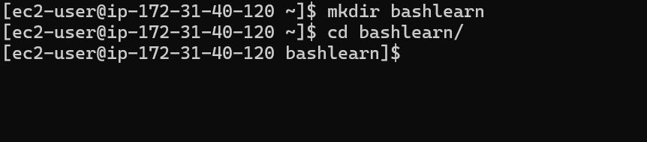
Now let’s create our first shell script.
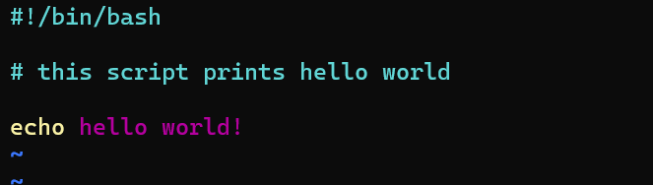

Now let’s give the proper permissions to our script.
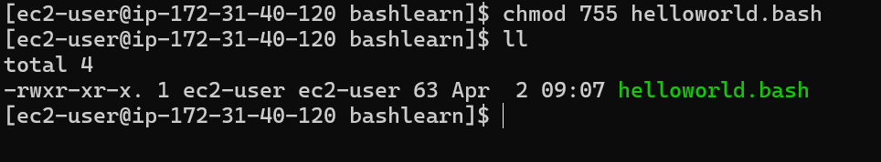
We can execute our script now.
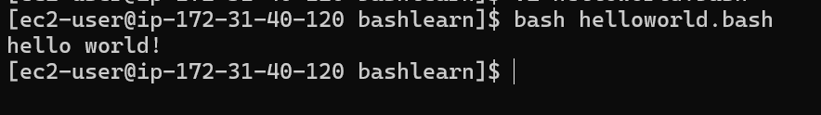

We can add lines between our output to make it look better
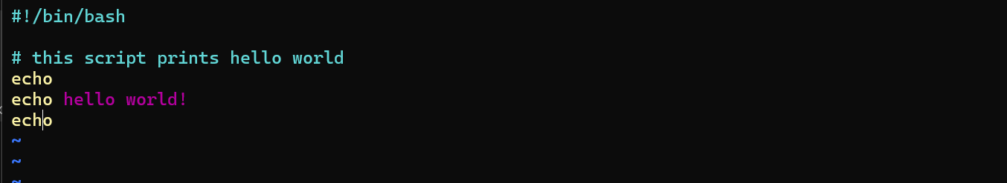
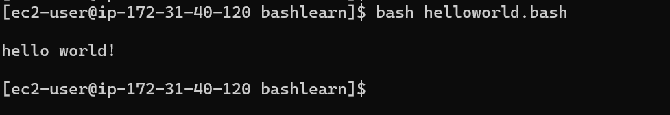
The output looks a little better now.

Basic operations through script:
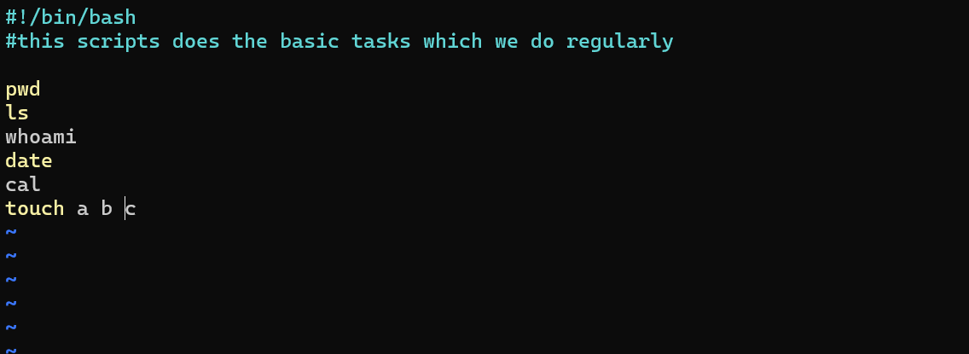
Here we are performing basic tasks with a script
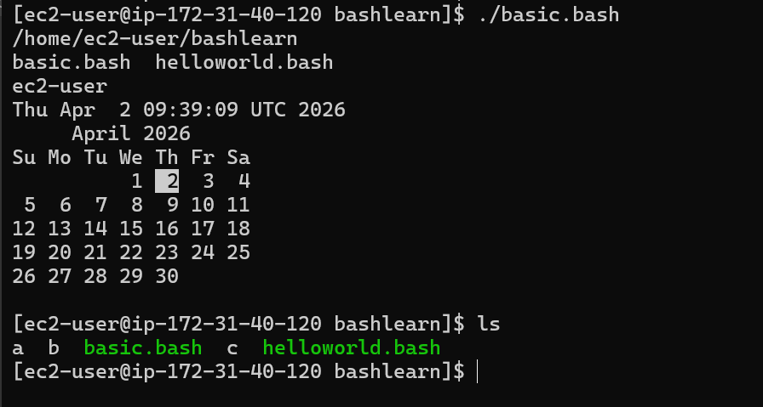

Here we can see that the scripts have printed the present working directory, listed the contents, printed the user’s name, printed the date, printed the calendar, and created three files.

Basic administration script:
This script performs the basic admin tasks
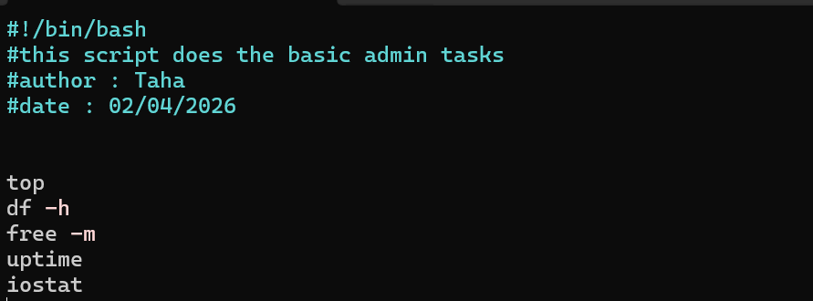
When we execute this script only the output of top will be visible so as it gives us the continuous info of cpu so we need to exit from that then we will be able to see output of the other commands.
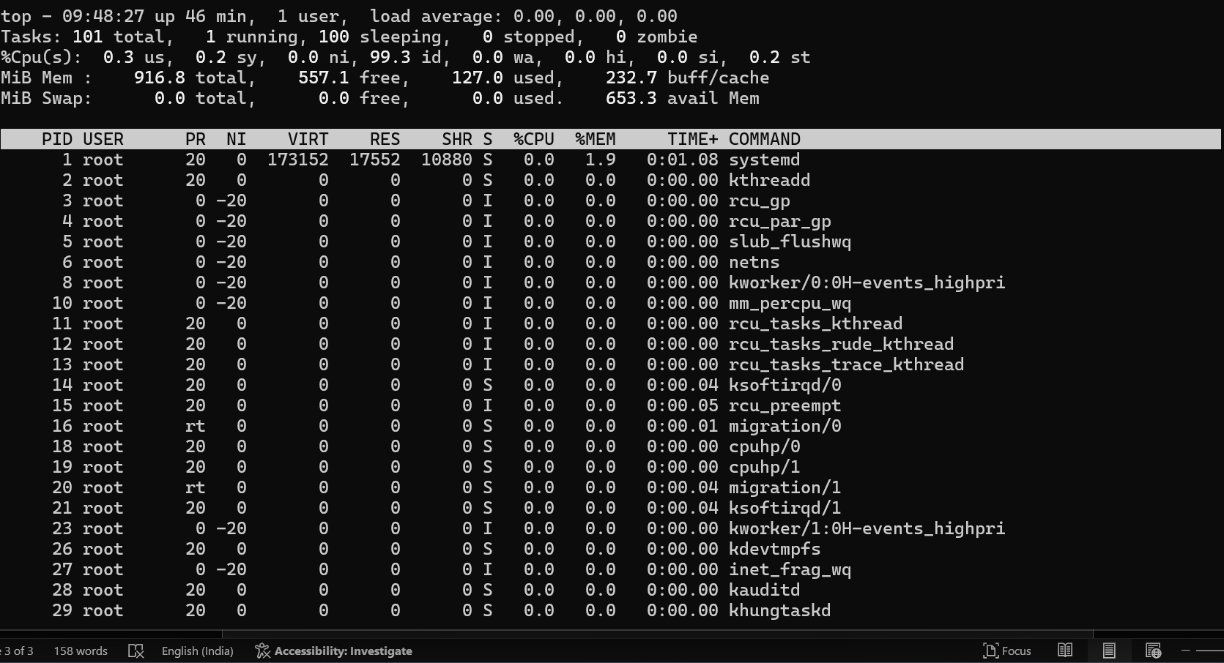
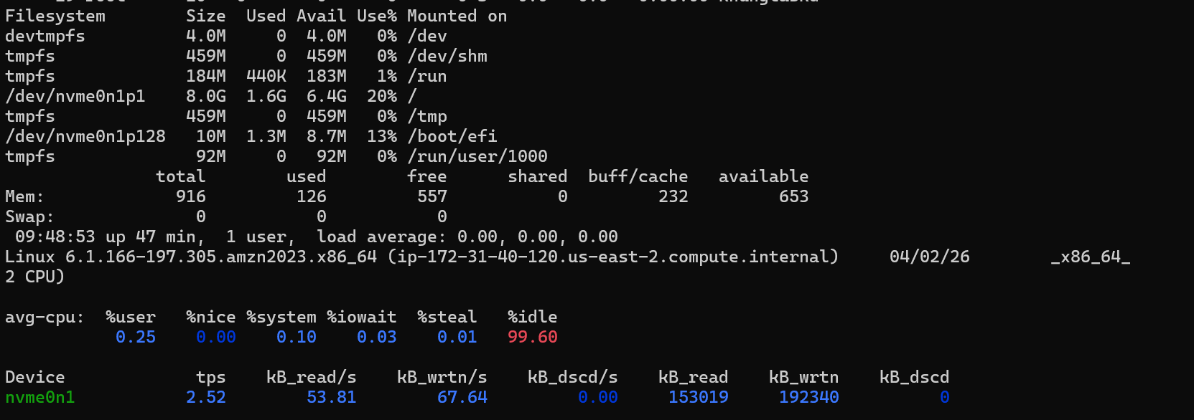

Variables in bash:

This script demonstrates the usage of variables.
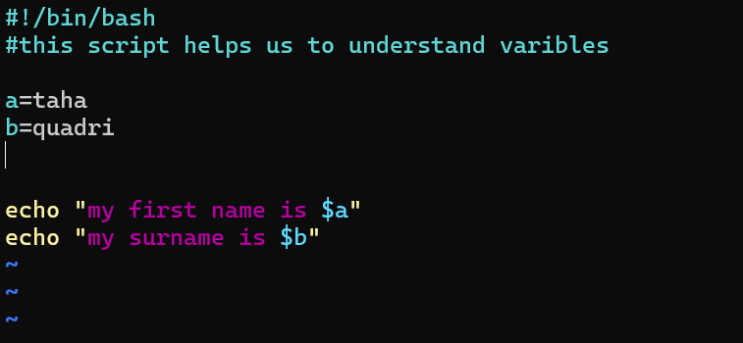

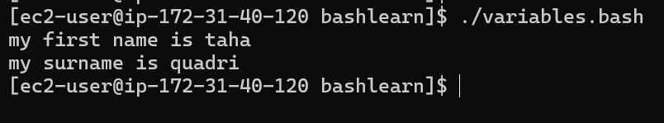

Understanding input and output function:
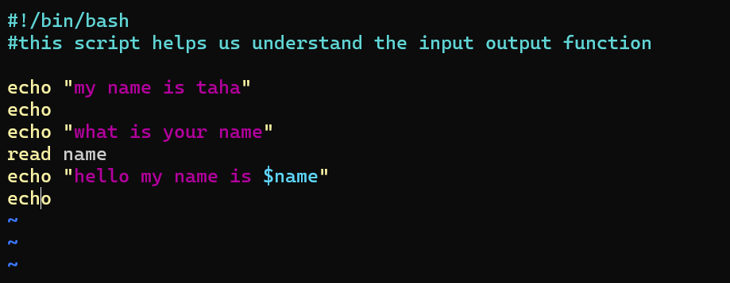
This script takes input from user and displays it in the output
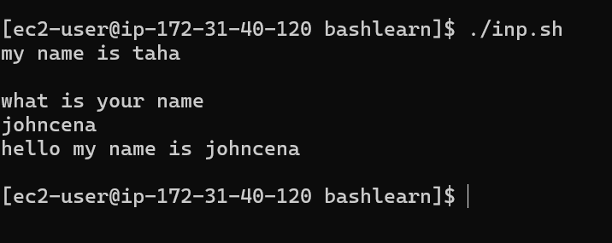

Using command as a variable:
Here we have used a command as a variable hostname is a command to know the name of the machine
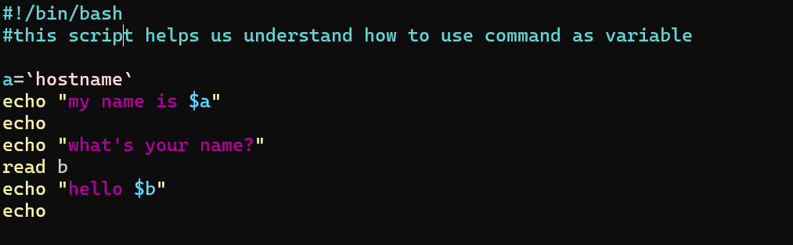
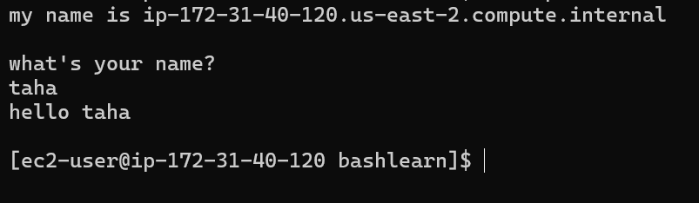
More commands in a script;

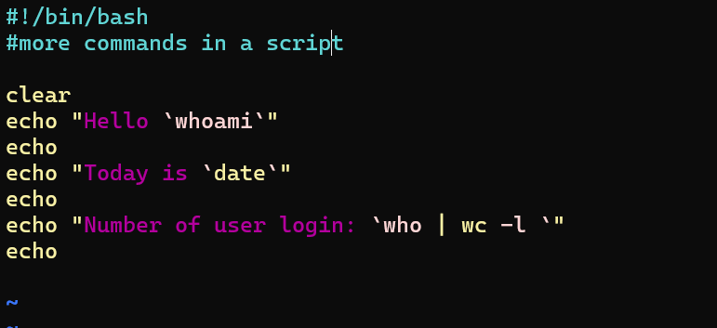
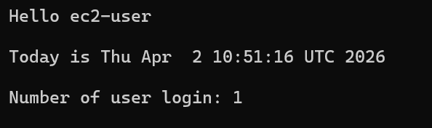

whoami: command to check the current user
date : command to check date
who | wc -l : command to check no of logged in users.

Script to rename a file:
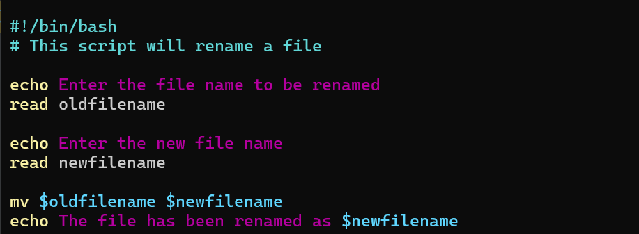

The file inp.sh is now renamed to input.bash

Case scripts:
This script allows us to execute commands based on the choice
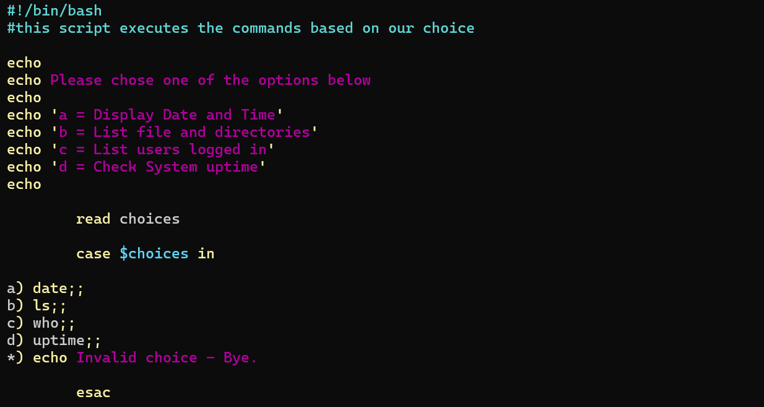

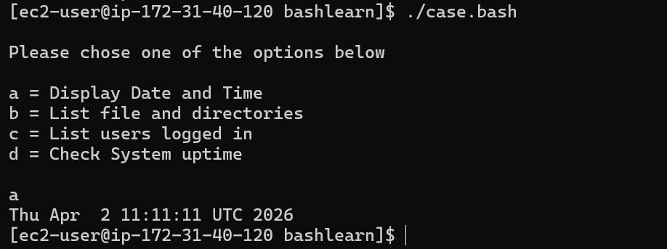

Script to check the state of backup.
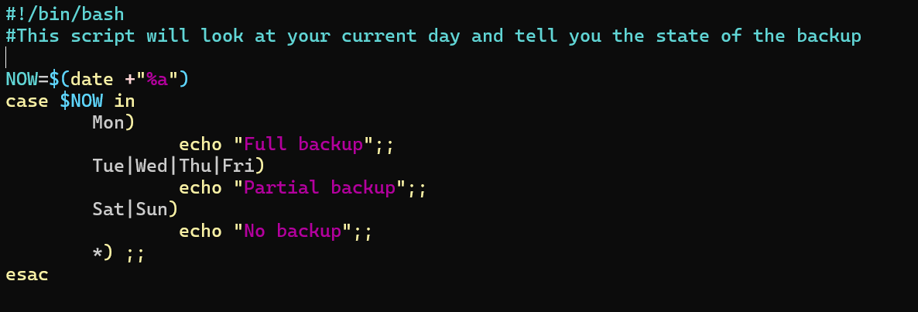
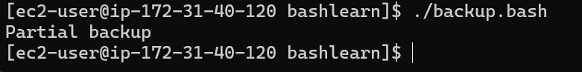

Scrtip to run welcome for a number of times:
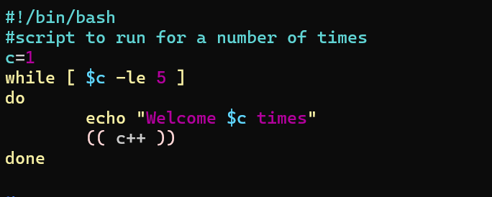
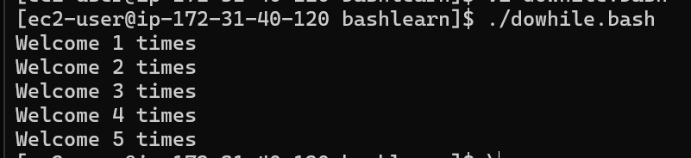

Script to run for a number of seconds:

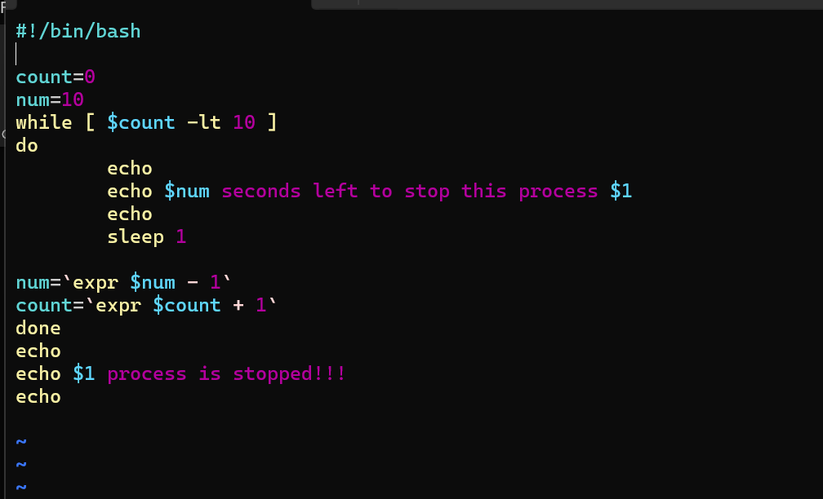

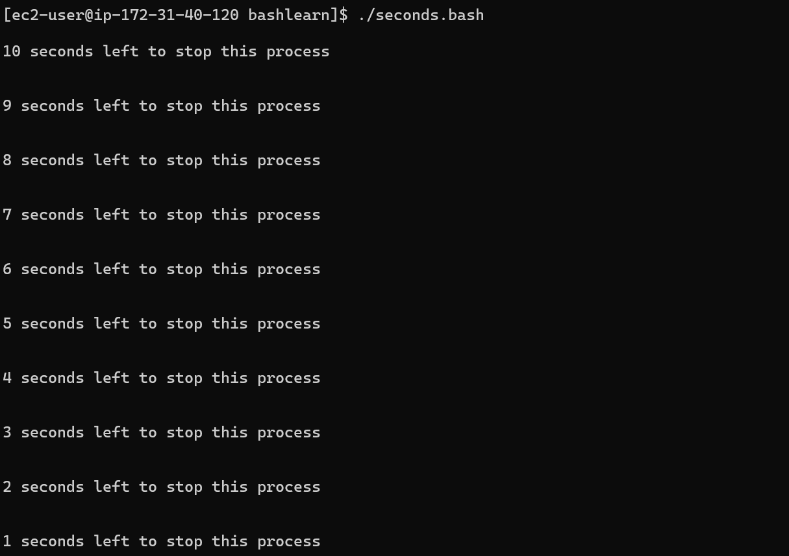

For loop:
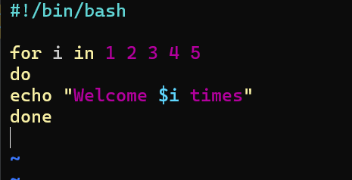
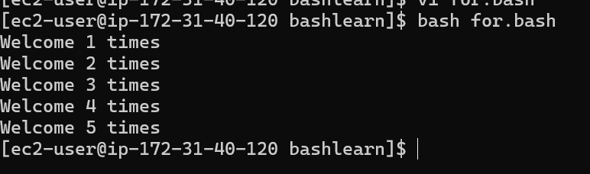

One more example;
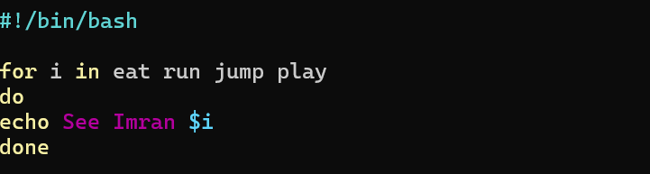

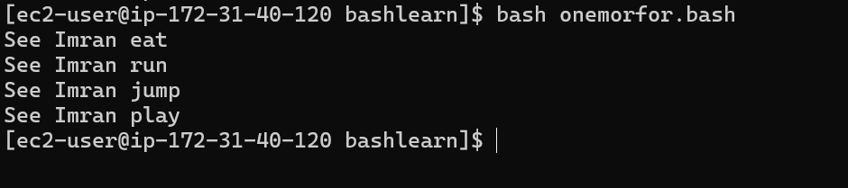
Creating 5 files using for loop;
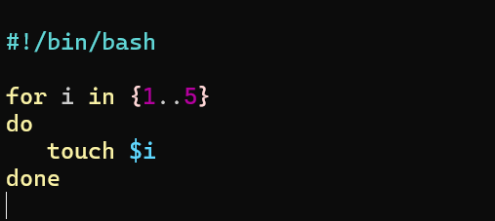
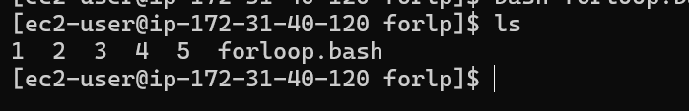

Deleting the same files:
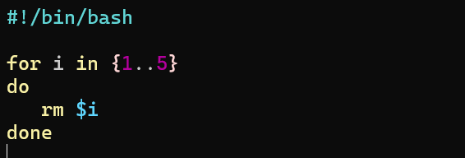
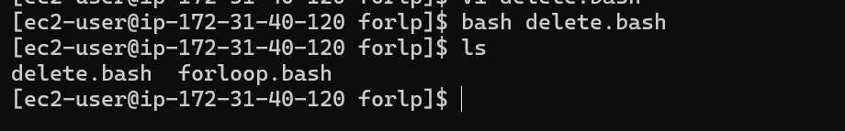

Specify days in for loop;
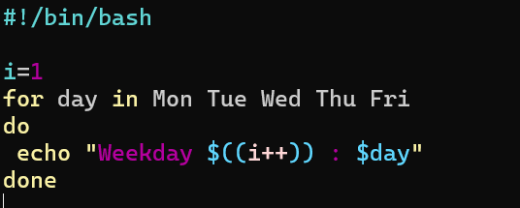

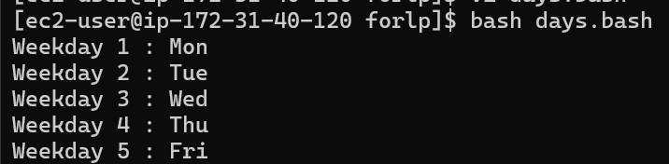

Listing all the users from /etc/passwd.

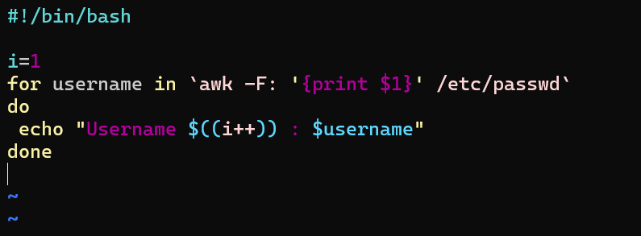
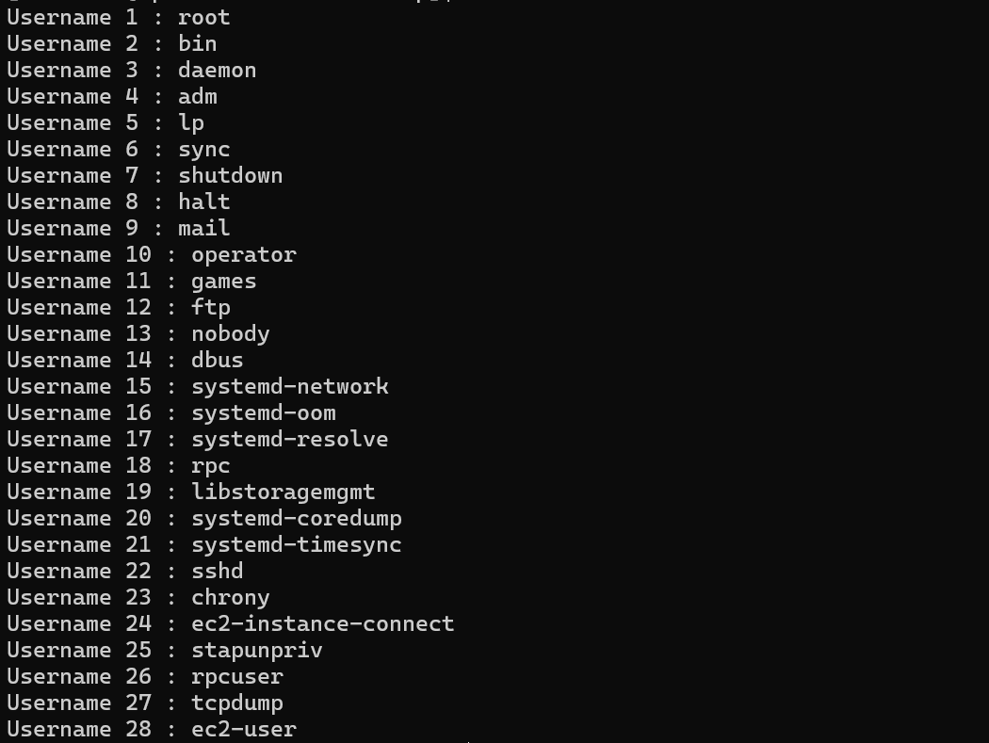

Check the variable:
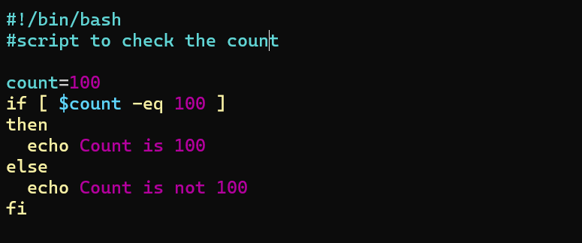
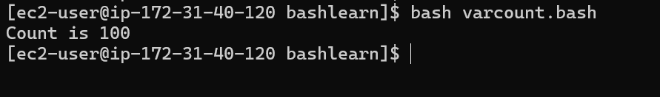

Check if a file error.txt exist.
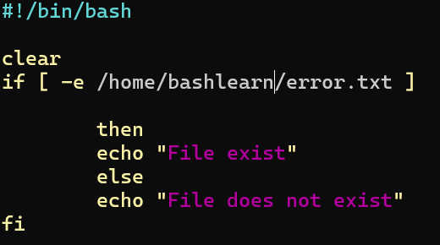

Script to check if a variable value is met:
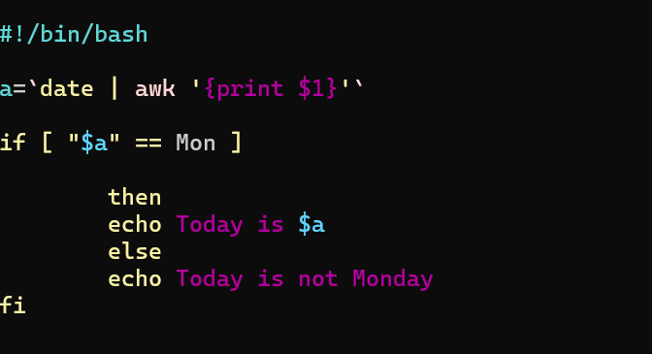
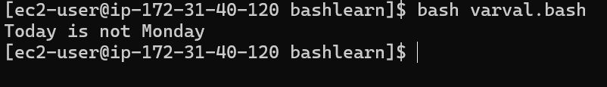

Check the response and then output:

