Jenkins Task

Install Jenkins and run on port 8081
First lets launch an ec2 instance and install Jenkins
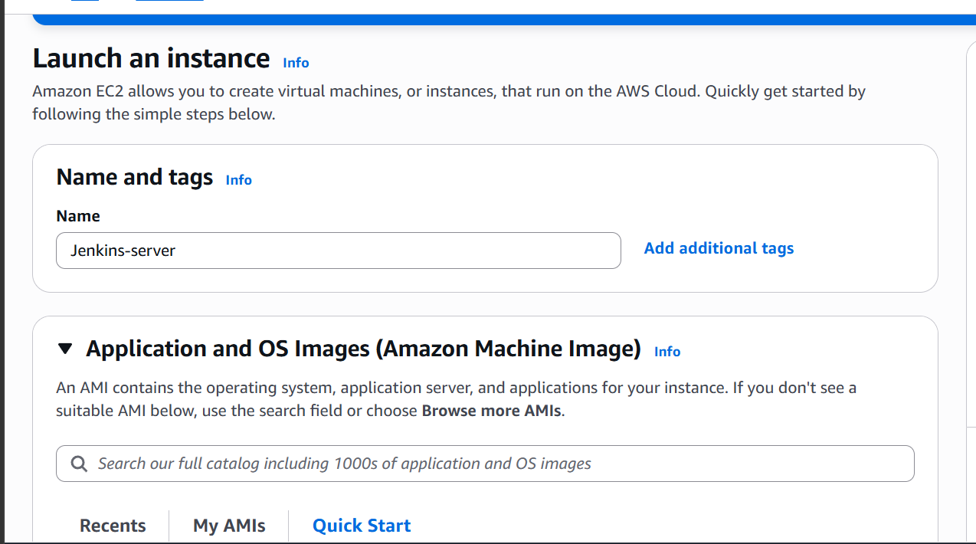

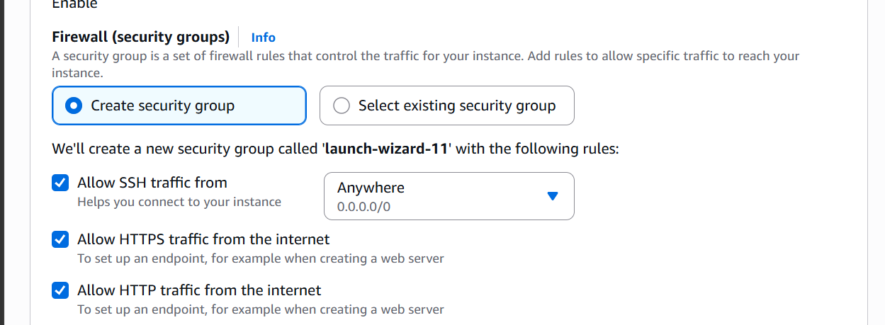

open port 8081 to access Jenkins
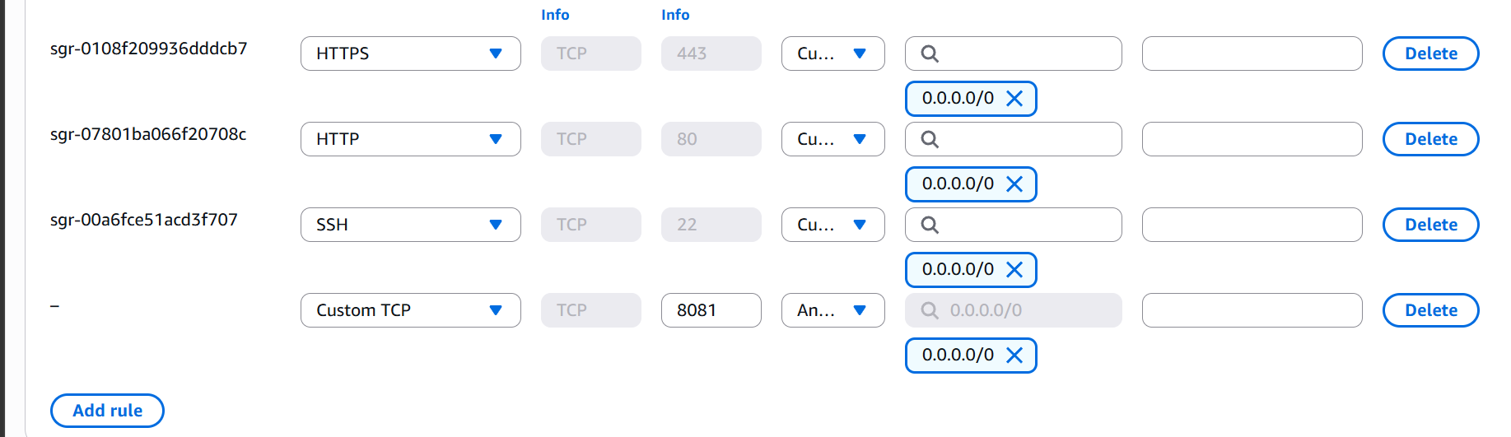

Now lets ssh into our virtual machine and install Jenkins
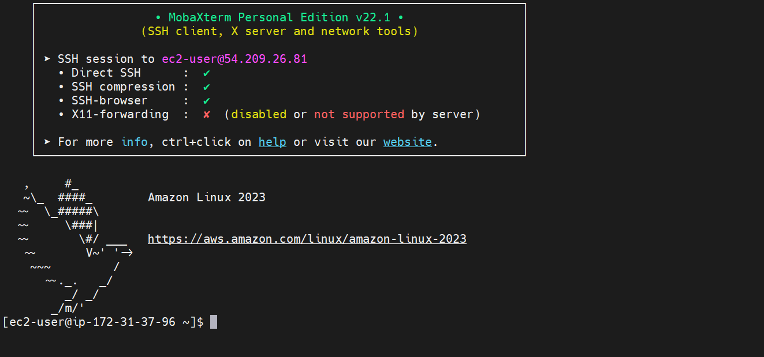

Jenkins package is now downloaded
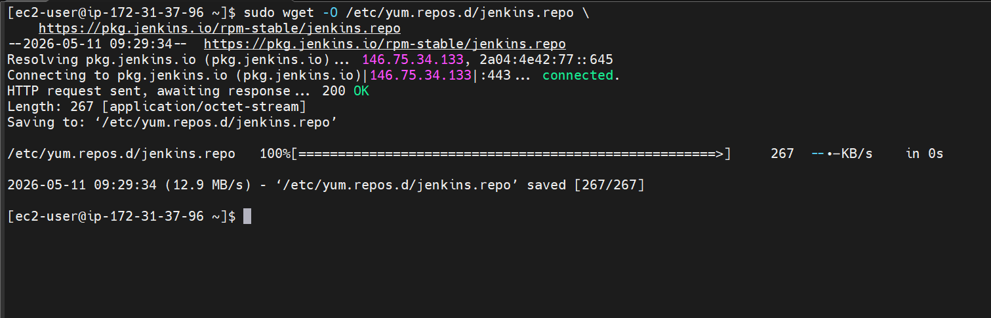
Import a key file from Jenkins-CI to enable installation from the package:

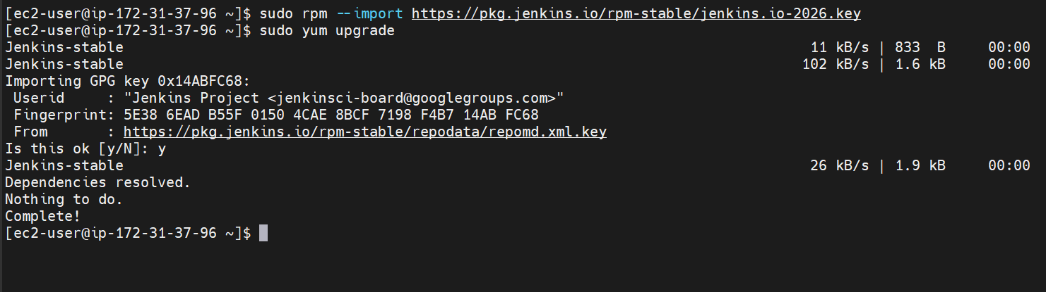

Now let’s install java
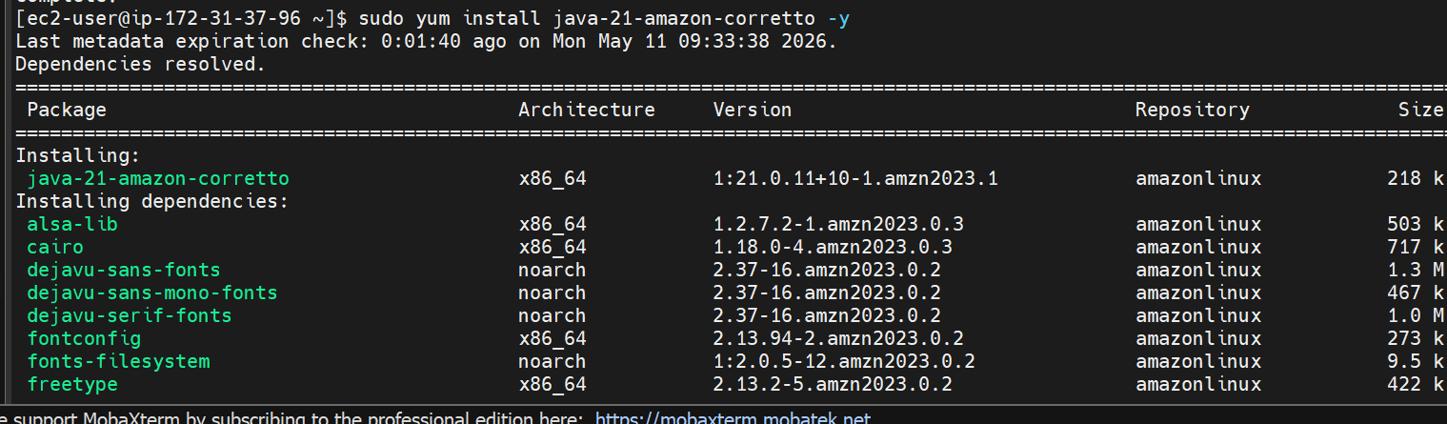
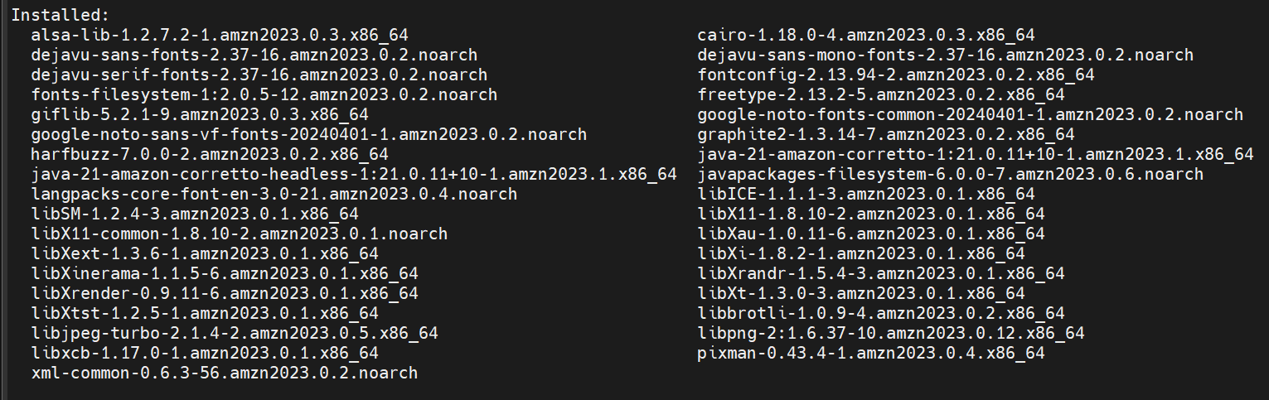
Finally now let’s install Jenkins
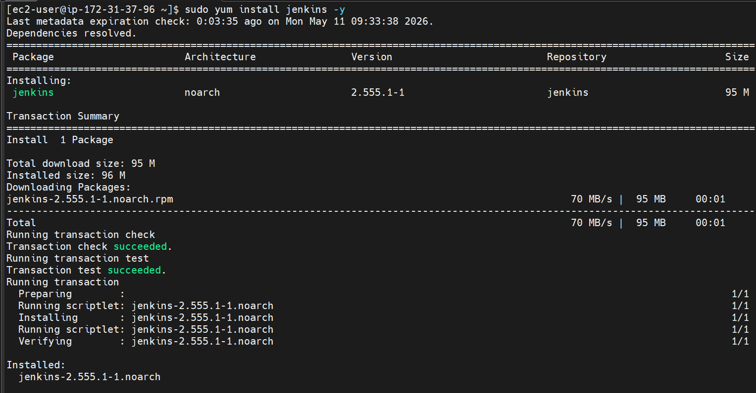
Enable the Jenkins service to start at boot and start Jenkins as service
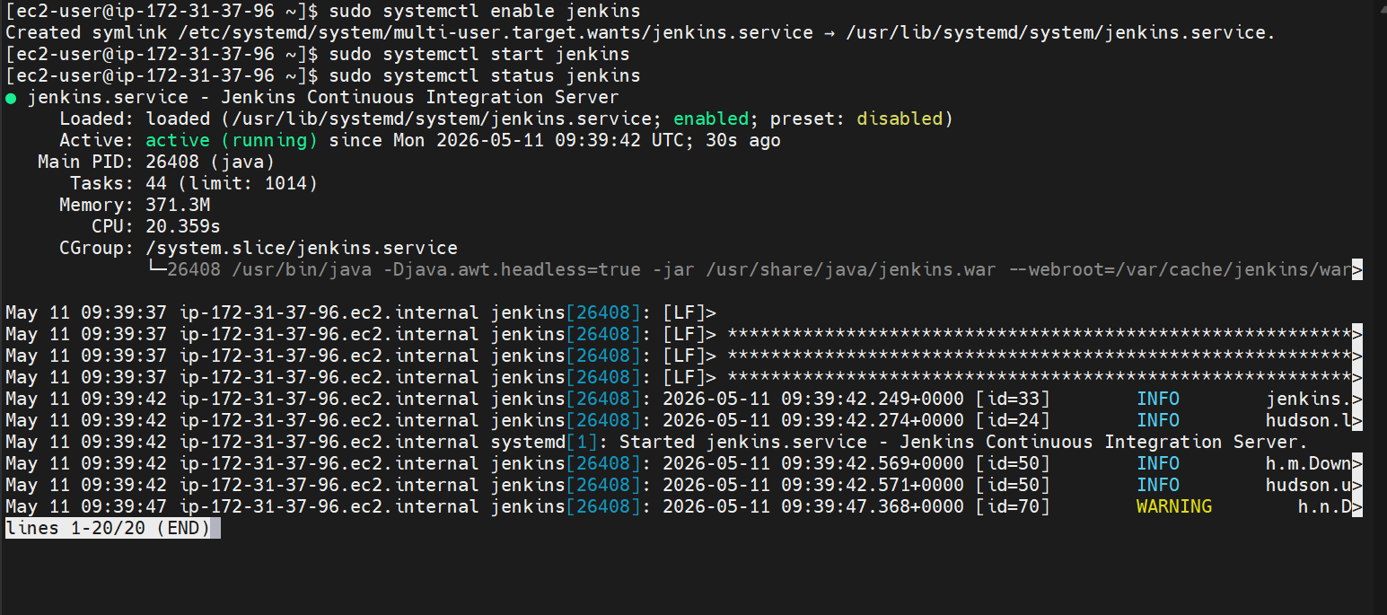
We can see that Jenkins service is running
Now lets run it on port 8081
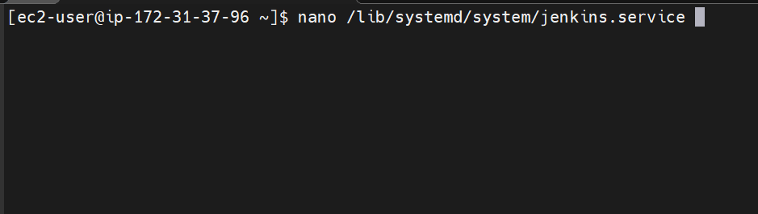
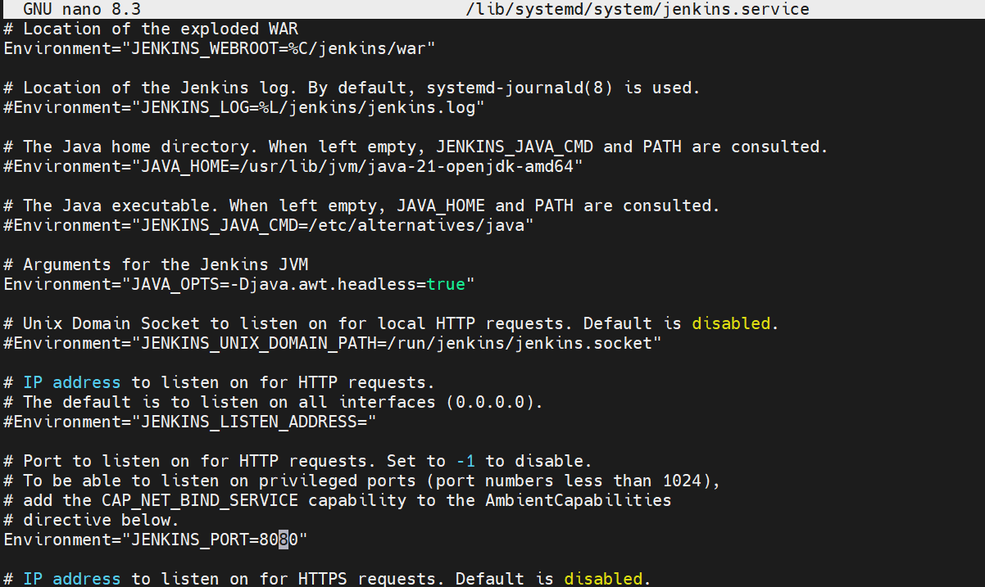

Now lets change the port from 8080 to 8081
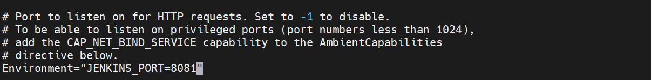
We are now able to access Jenkins on port 8081
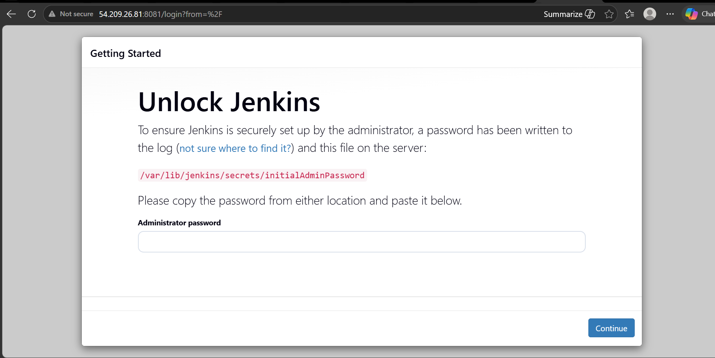

2. Secure Jenkins Server:
Let us now login to Jenkins and secure it by changing the password
First lets copy the initial password
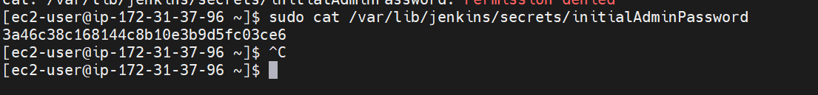
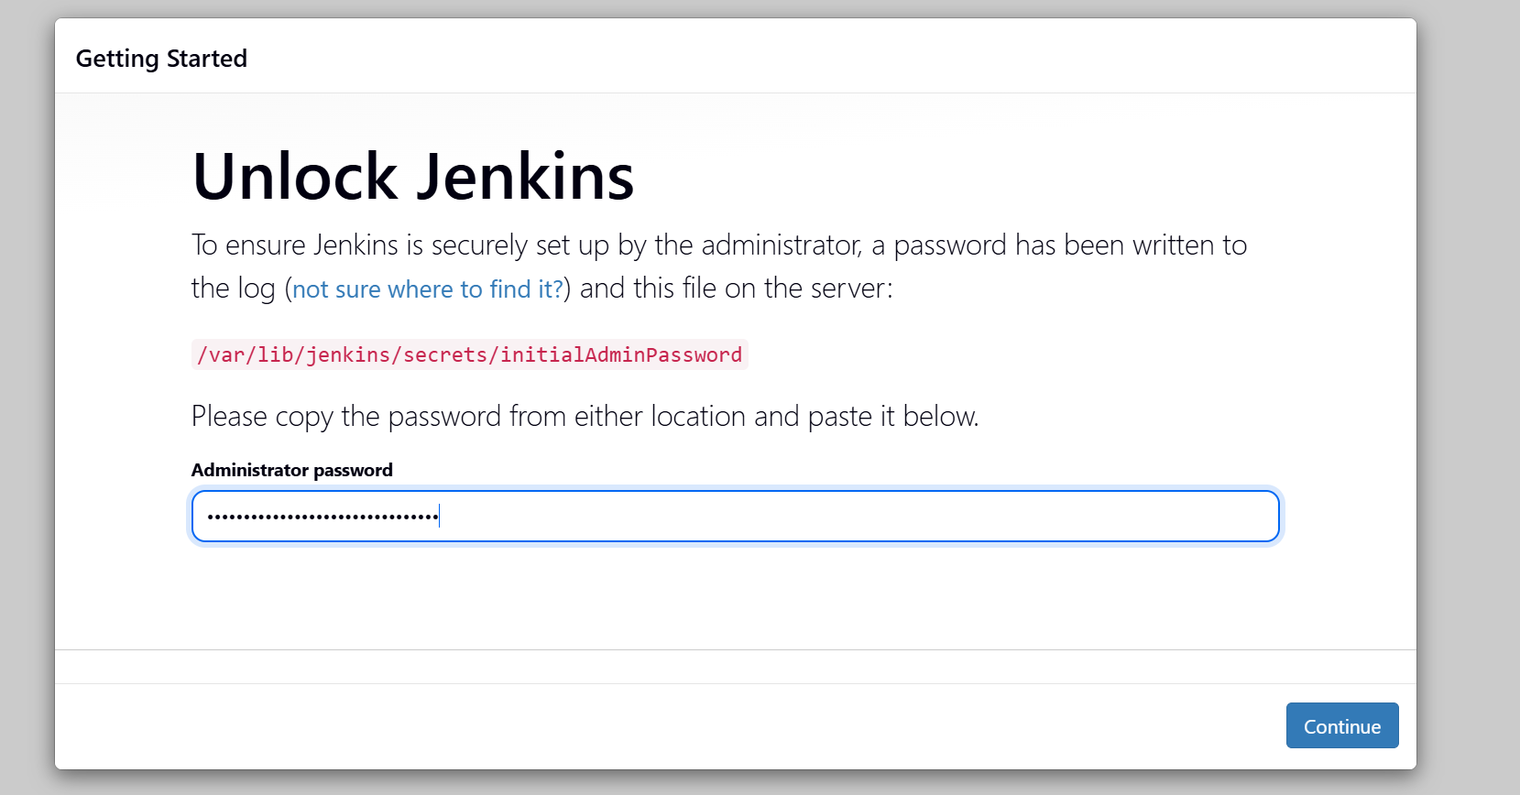
Install suggested plugins
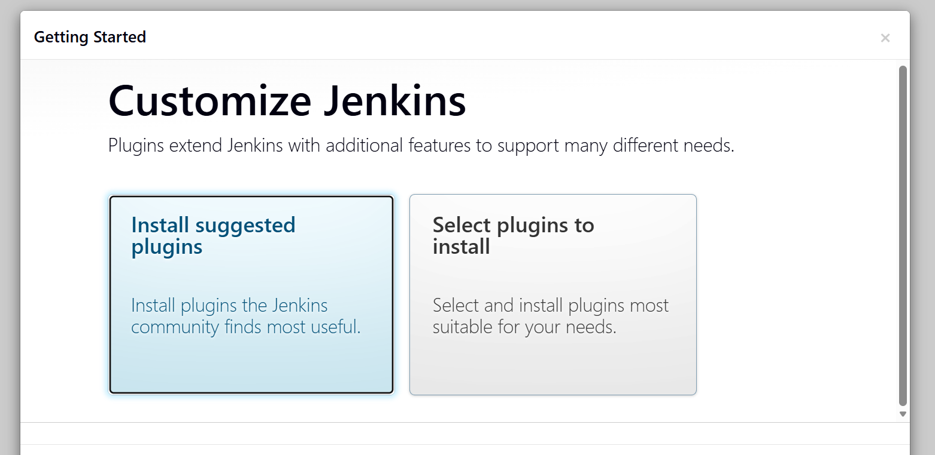
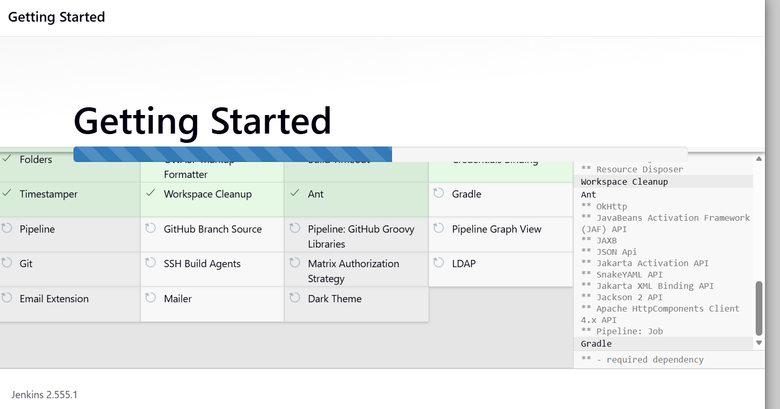

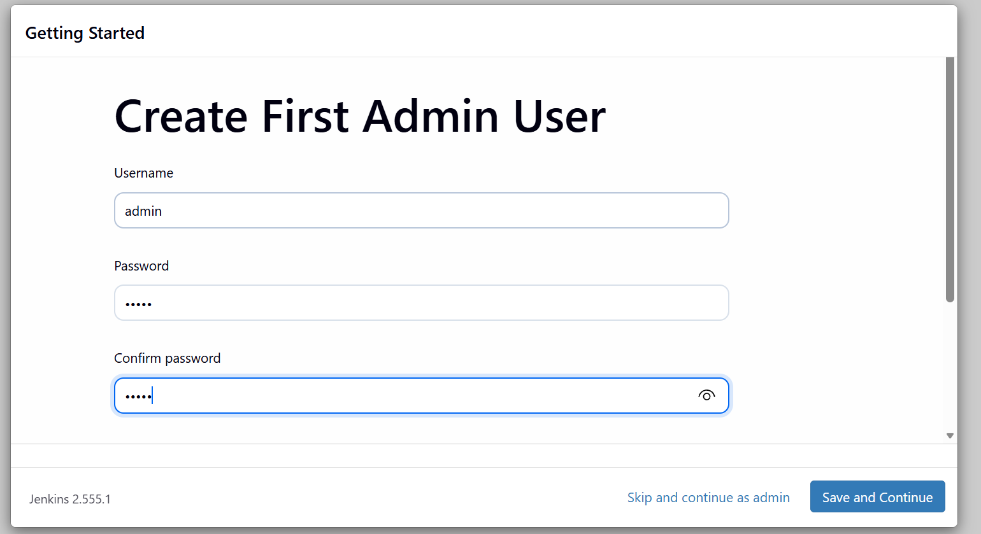

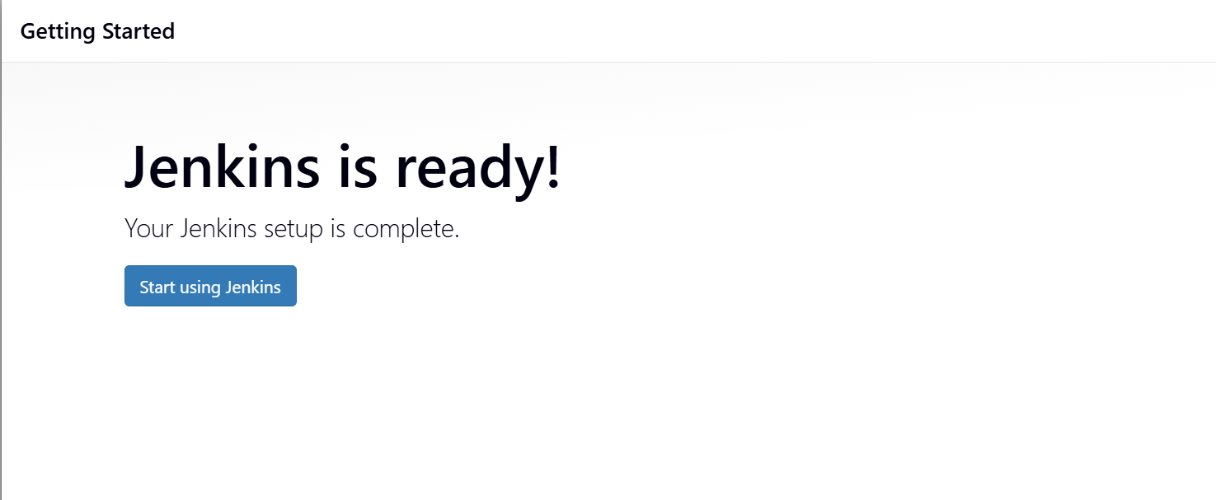

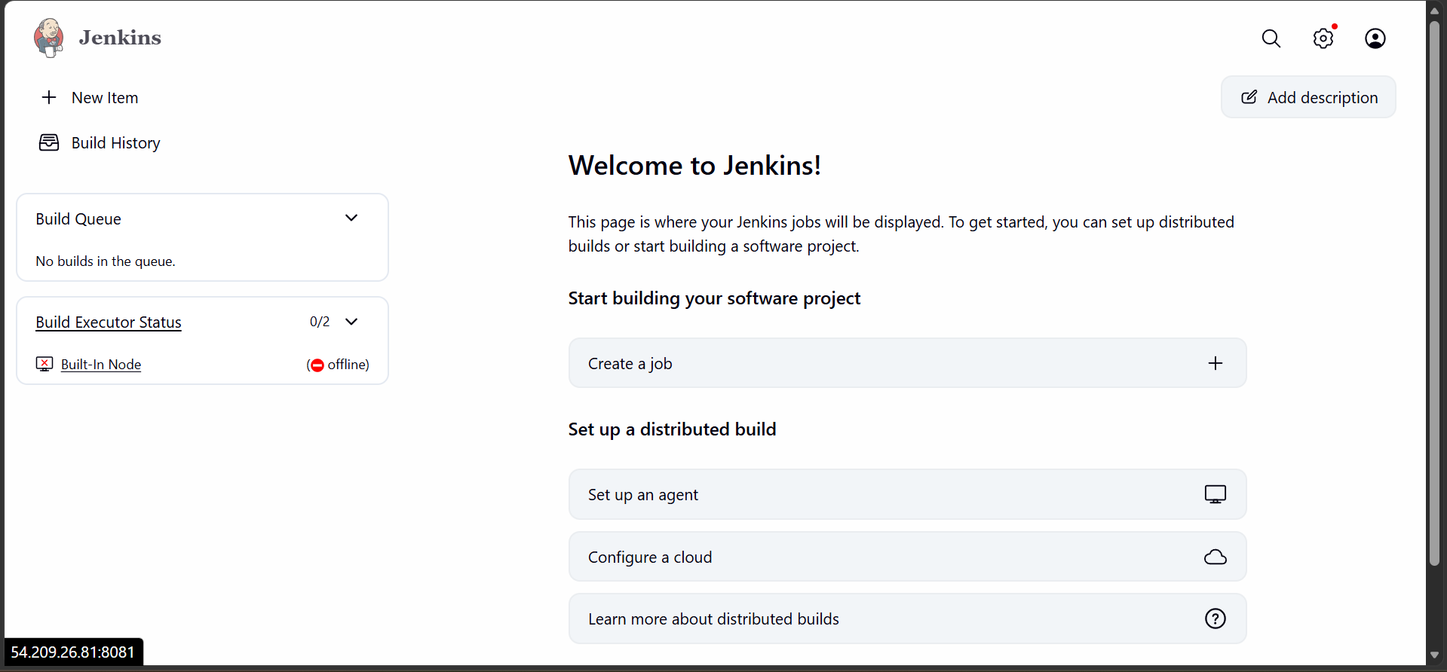
The password is now changed means our Jenkins is secure

3. Create user called DevOps, Testing in Jenkins with limited access
Go to manage Jenkins page
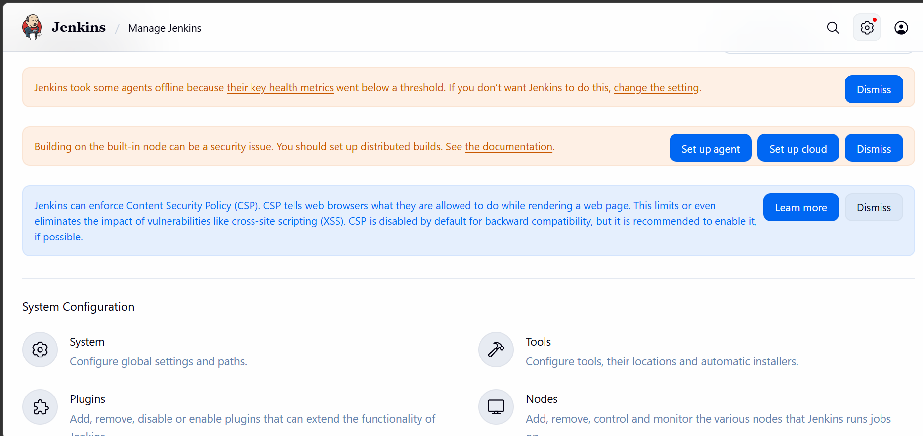

Go to security section
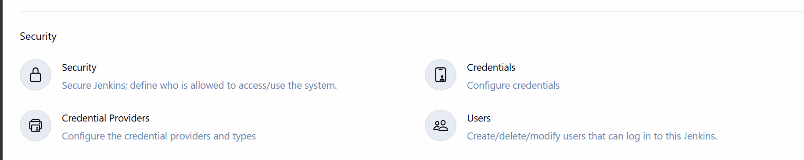
Click on users
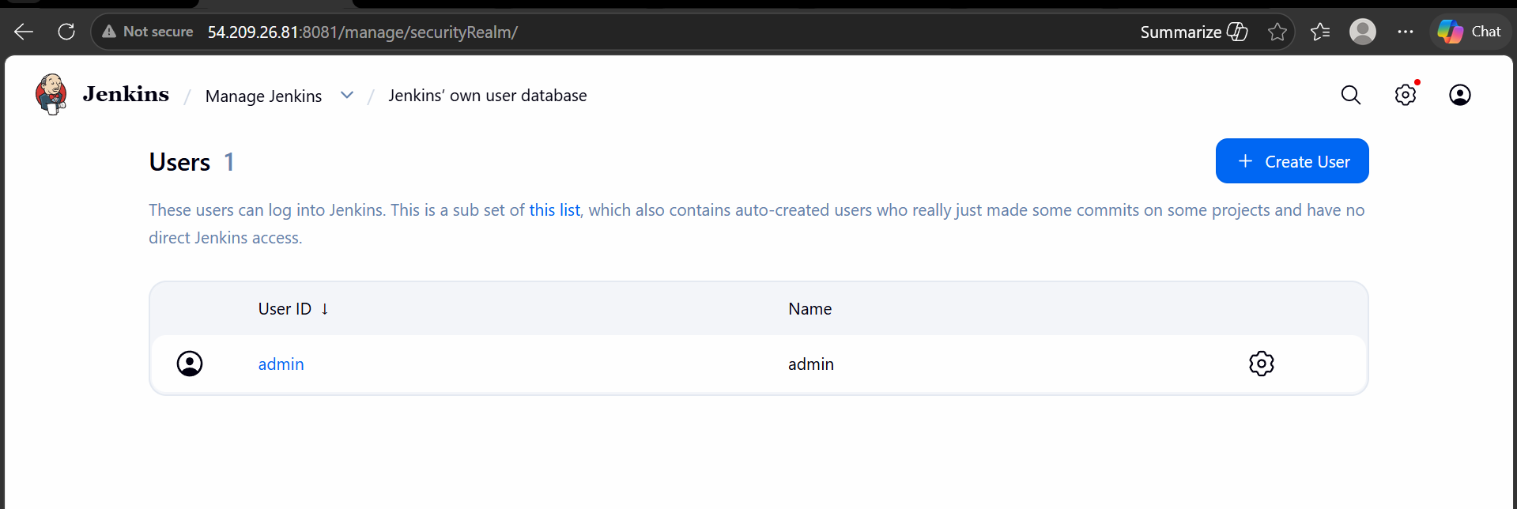
Now click on create user
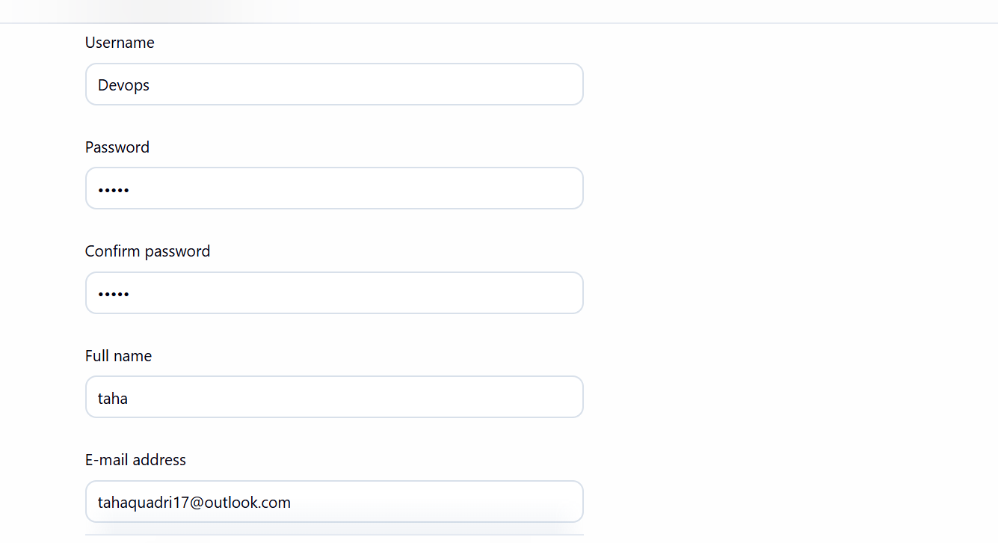
We have now created the user named DevOps
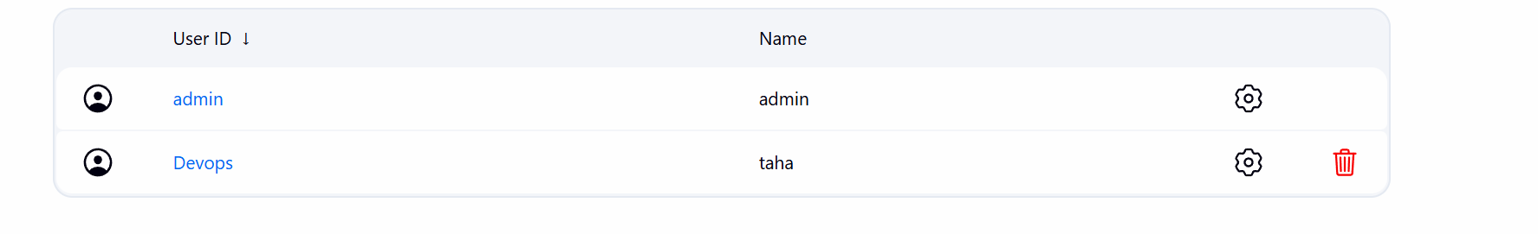
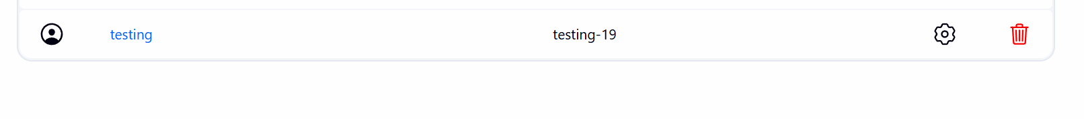

We have one more user testing

Now go to manage Jenkins and plugins search for the below plug-in

Under manage Jenkins go to security select project based matrix authorization strategy
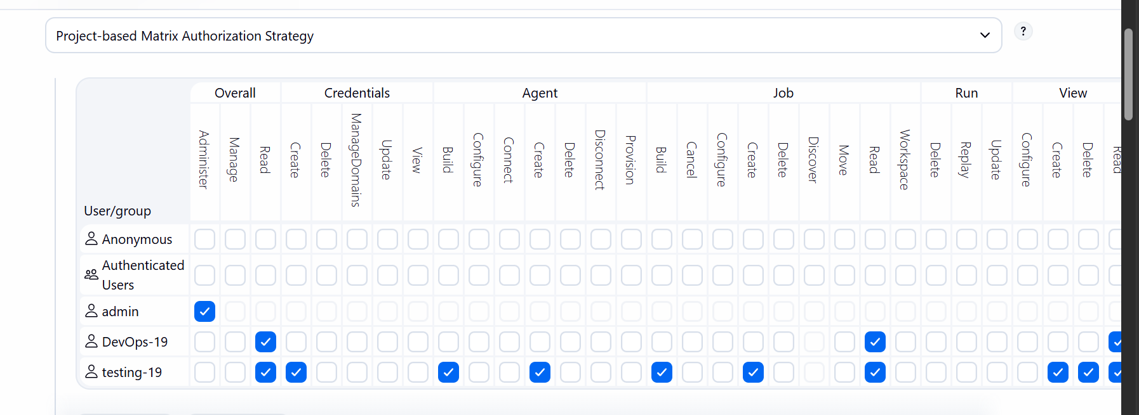

Now the devops user only has read access
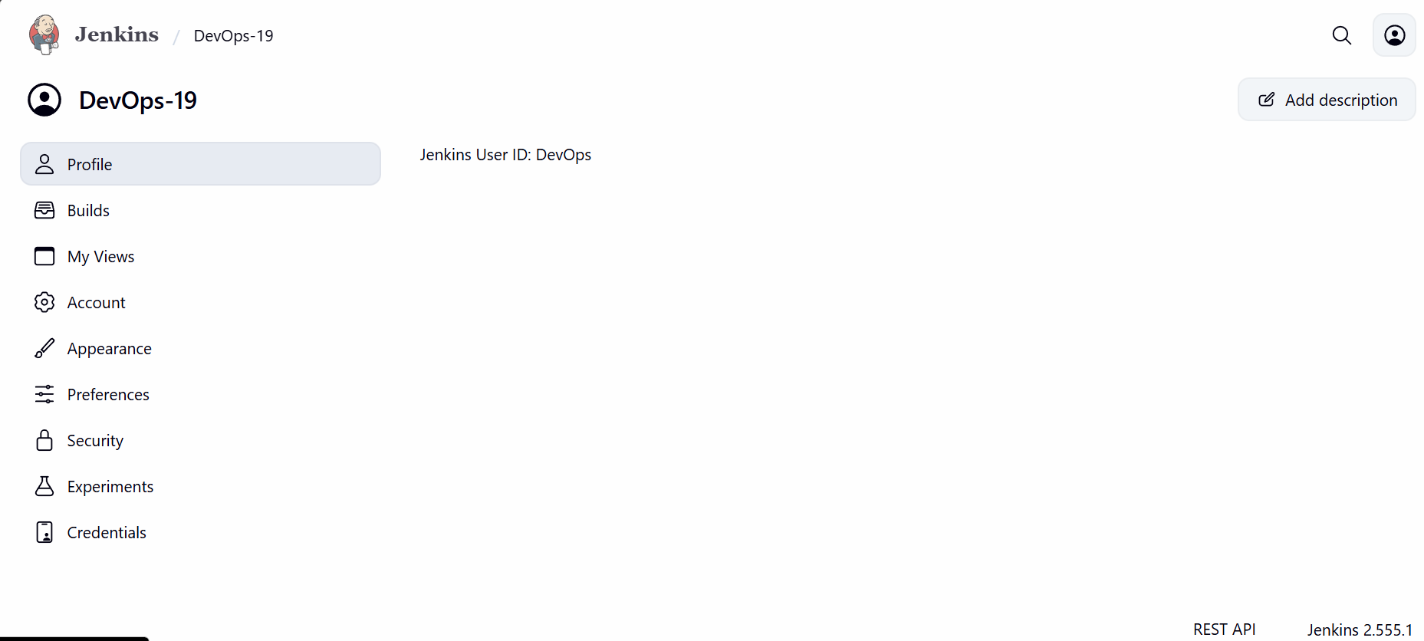
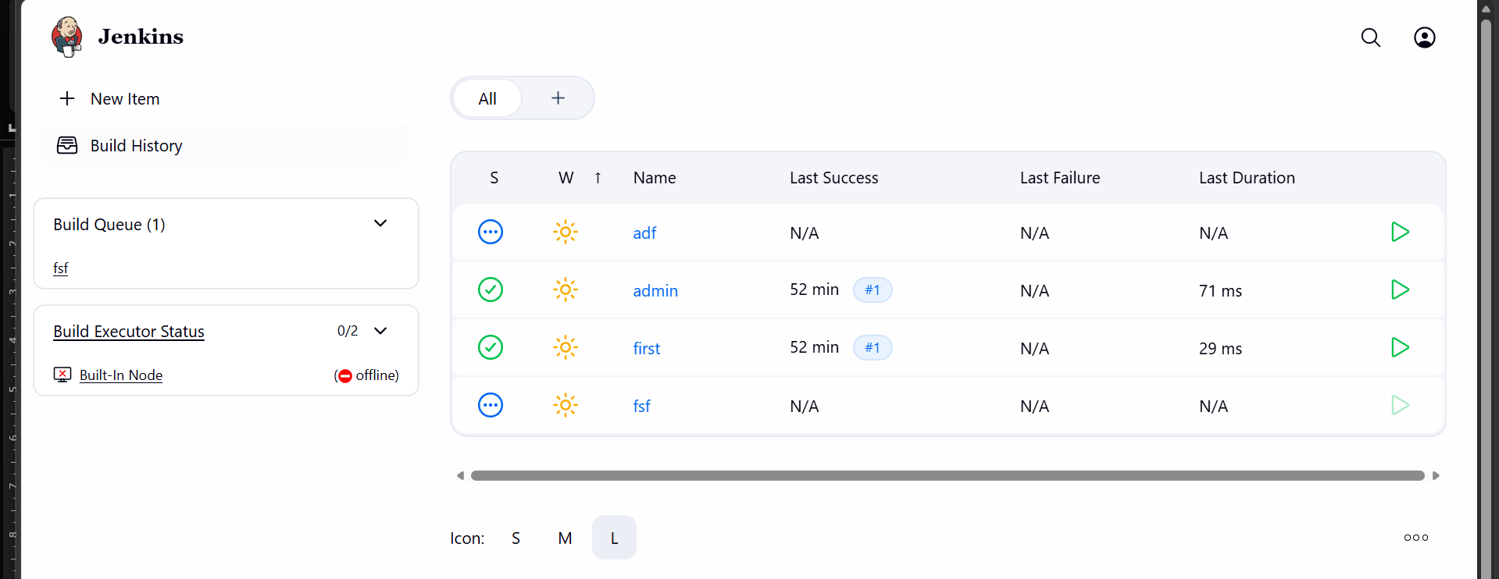
The user testing is able to create items
This way only admin has access to perform all the operations

4.Configure labels and restrict the jobs to execute based on label only.
For this go to manage Jenkins
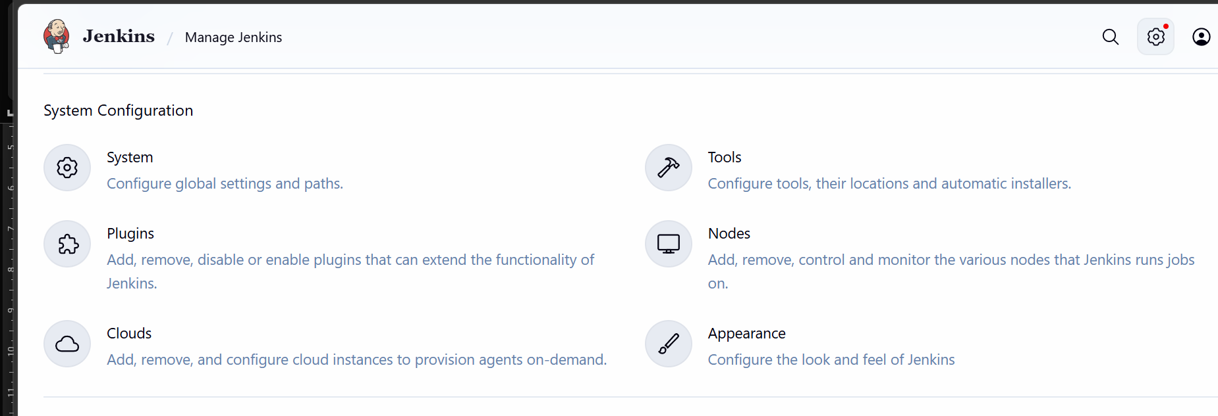

Click on nodes
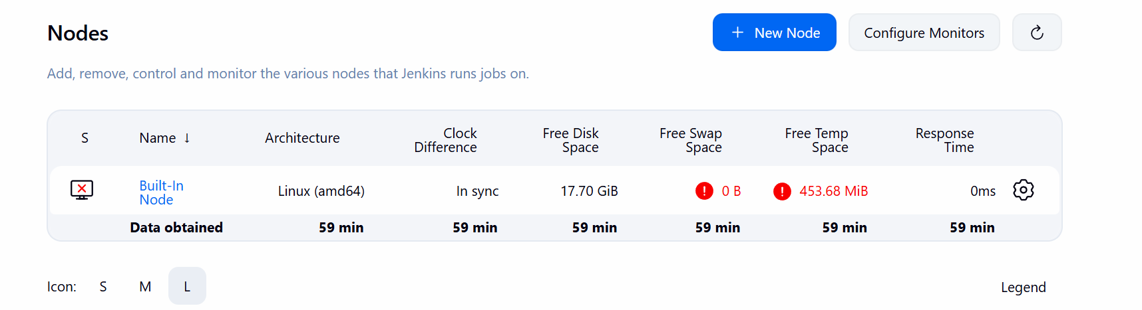
Click on built in node
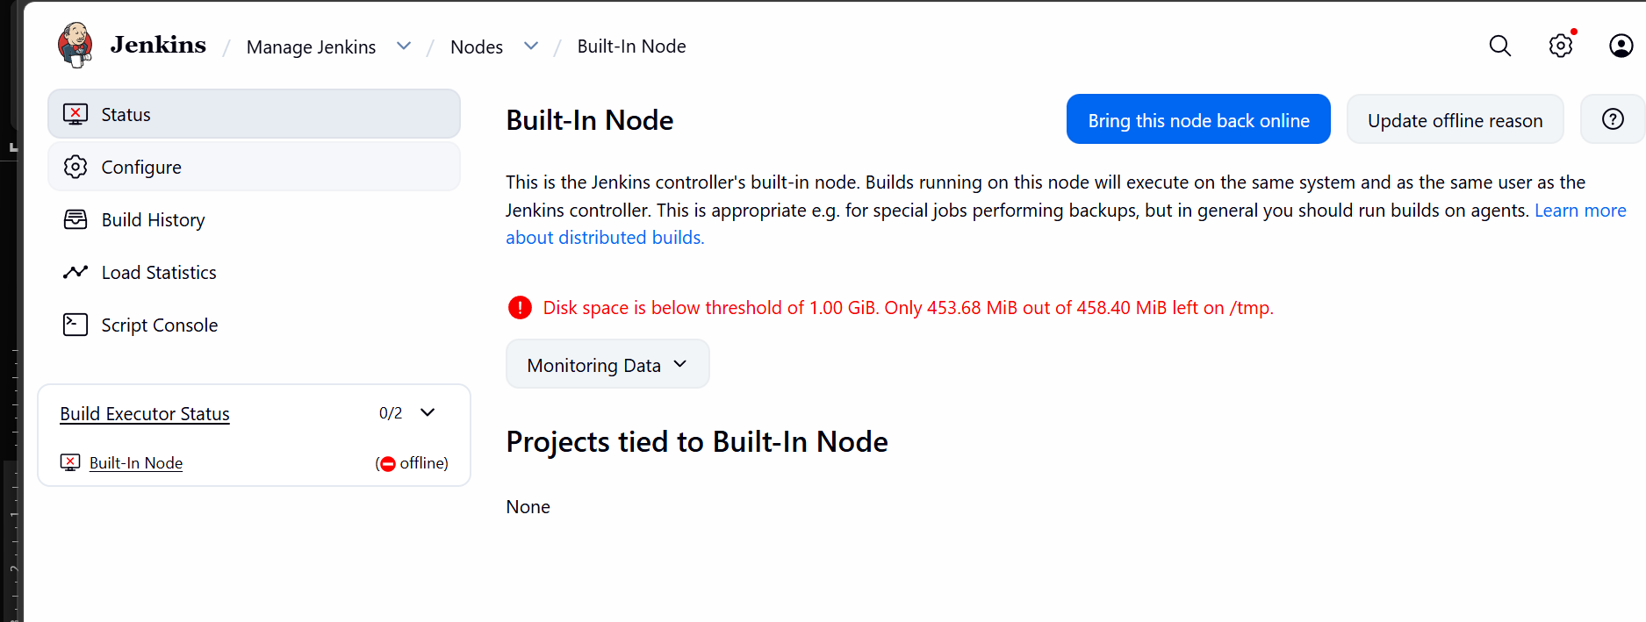
Unable to get into built-in node due to space issue so increasing the instance size
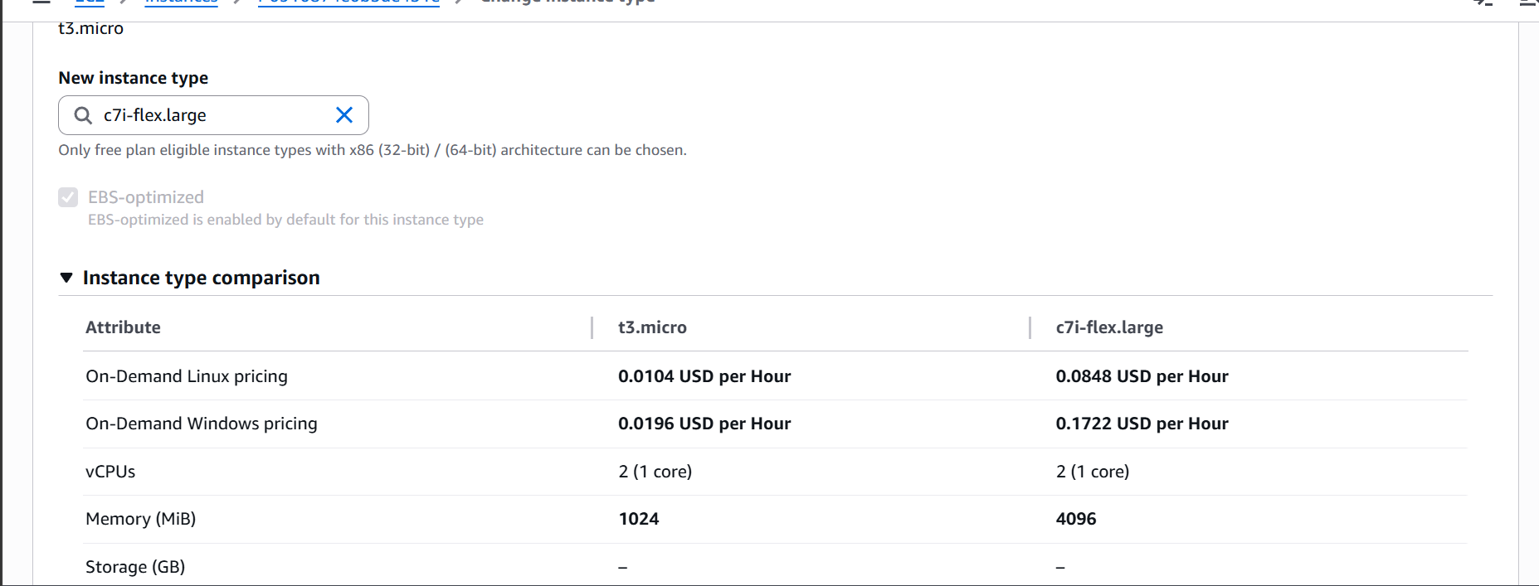

Go to manage Jenkins, nodes and built in nodes
Click on the node and configure the node to add the label
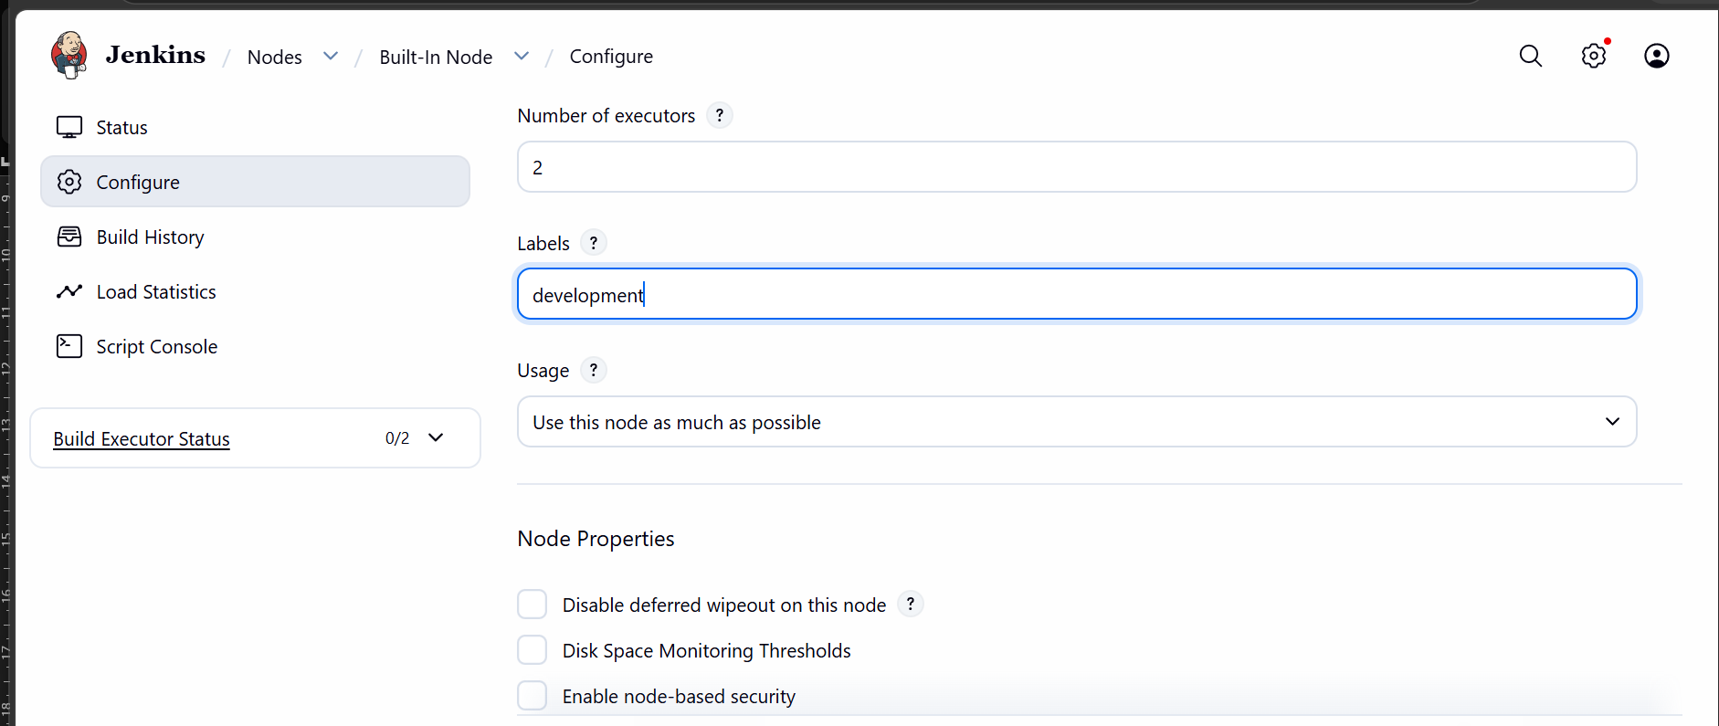

Now create a new build
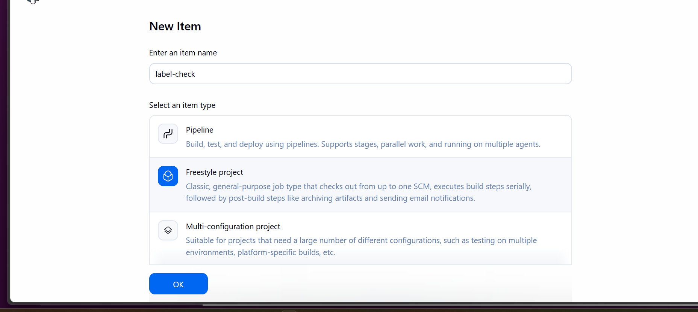
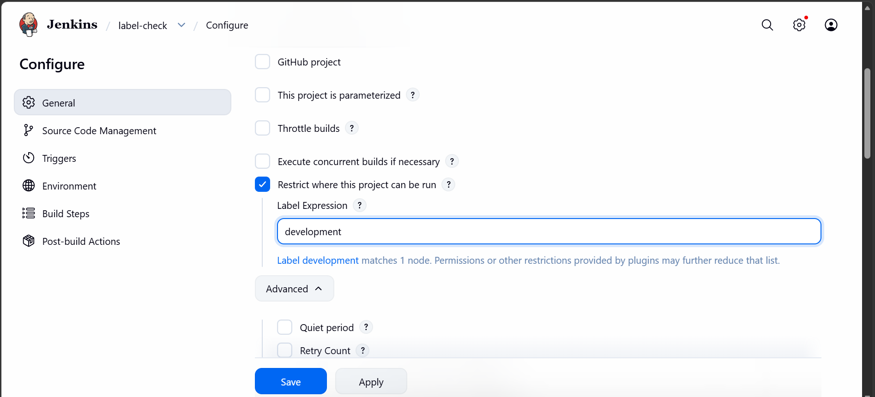
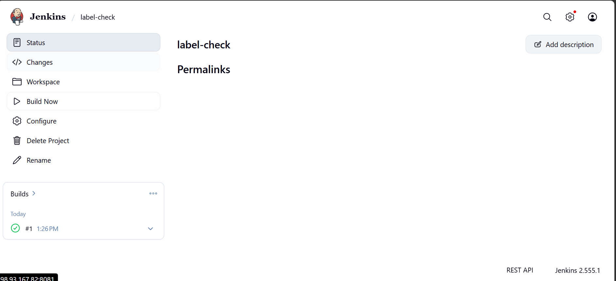

We are able to create a build based on the label.

5. create 3 sample jobs using the url
Lets create 3 jobs based on the url:
https://github.com/betawins/Techie_horizon_Login_app.git

go to Jenkins and create a new item
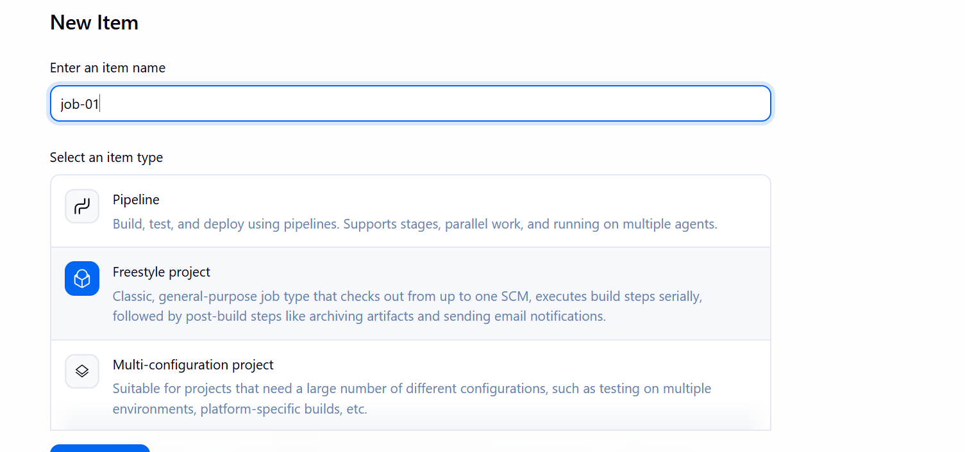
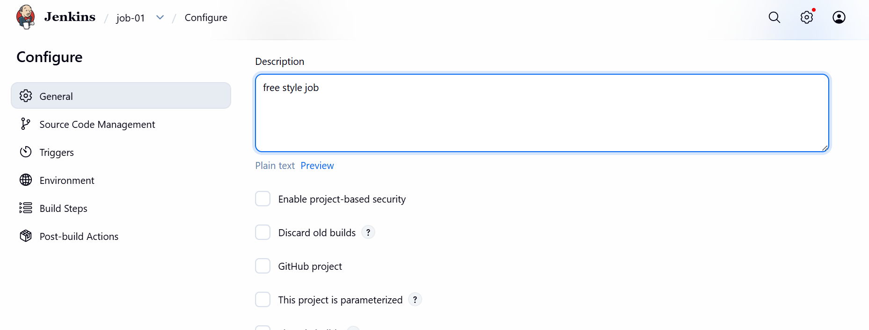

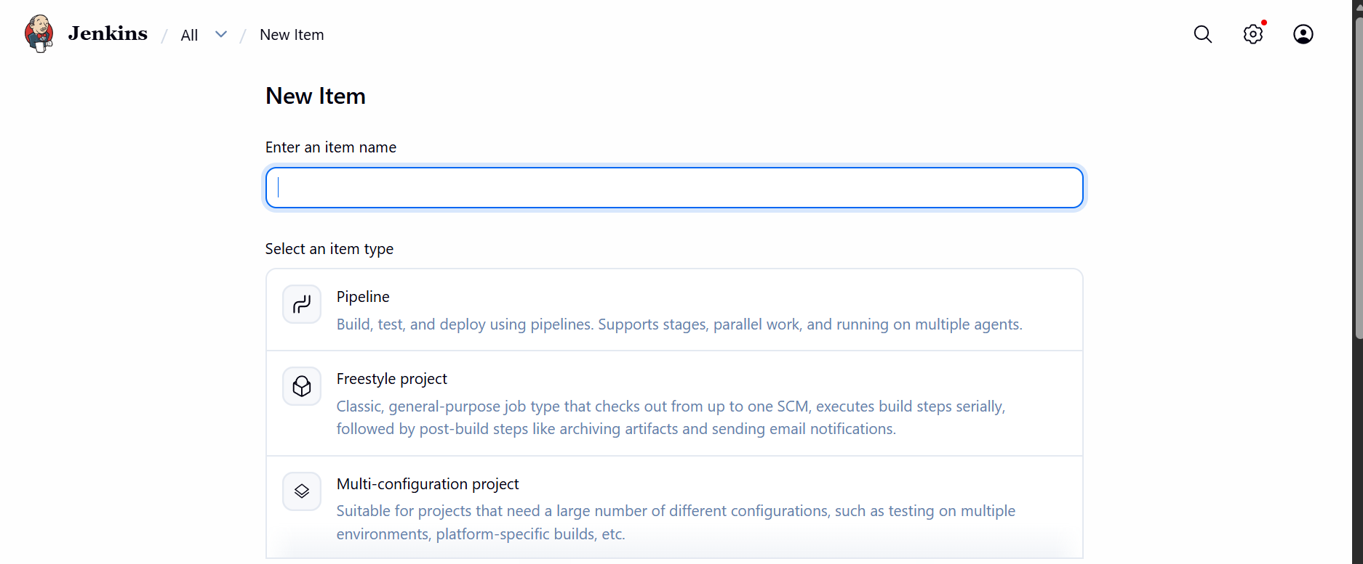
Select freestyle project
Now go to source code management
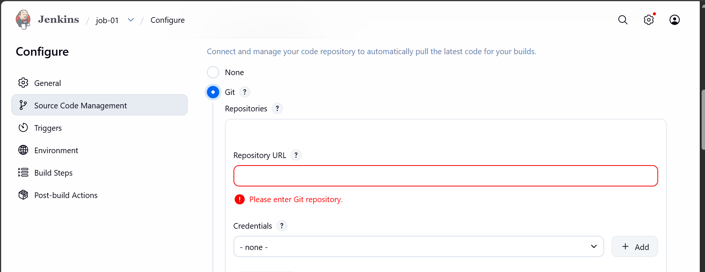

Click on git and paste the url
It throughs error
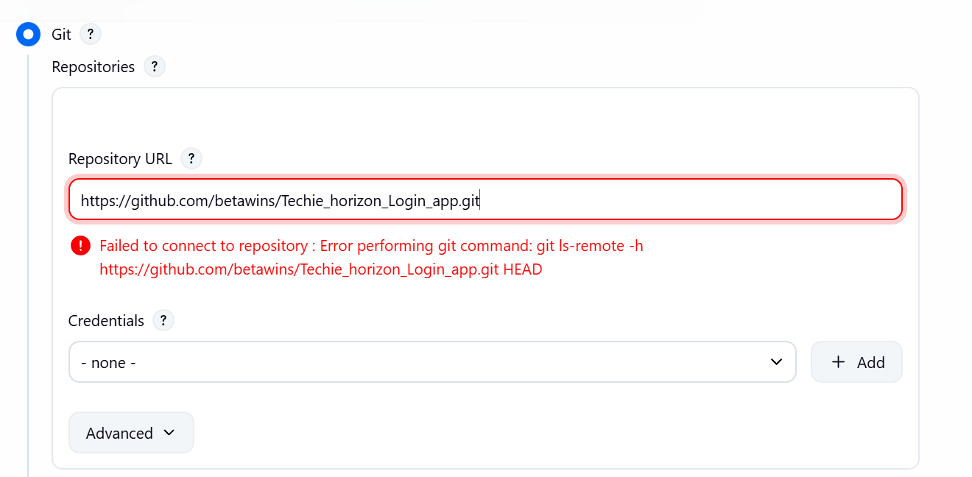

So we need to install git in the Jenkins server first
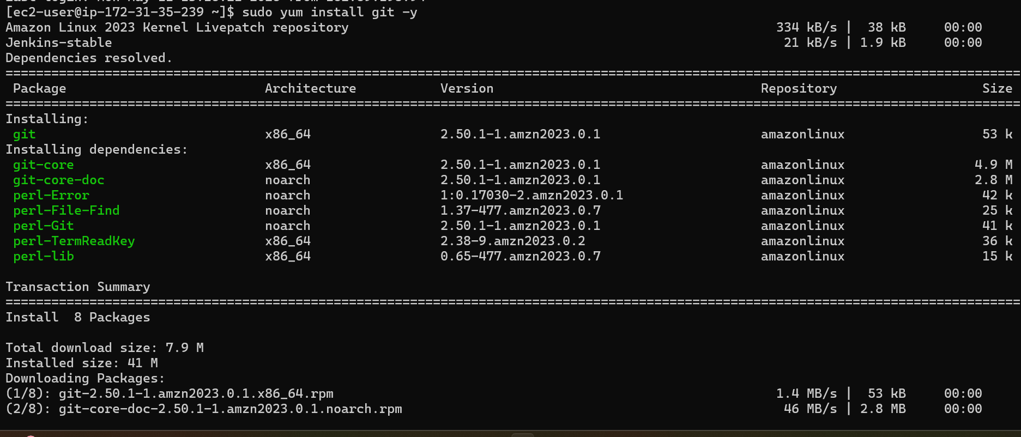

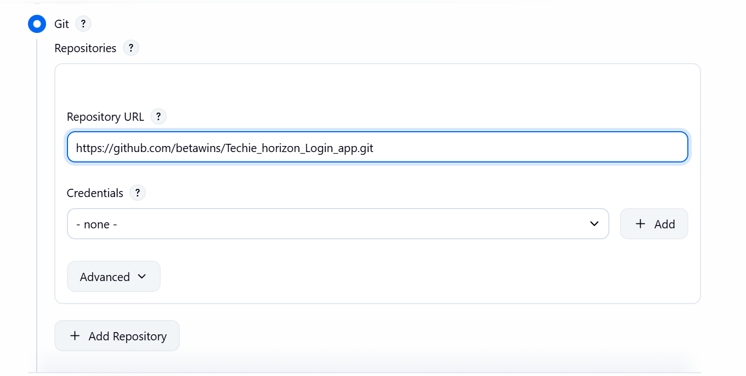

Now we are able to access the repo
Add a build step
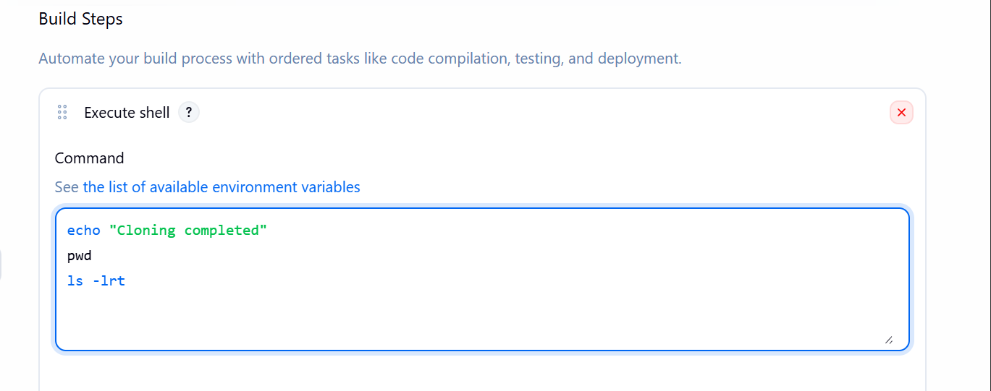
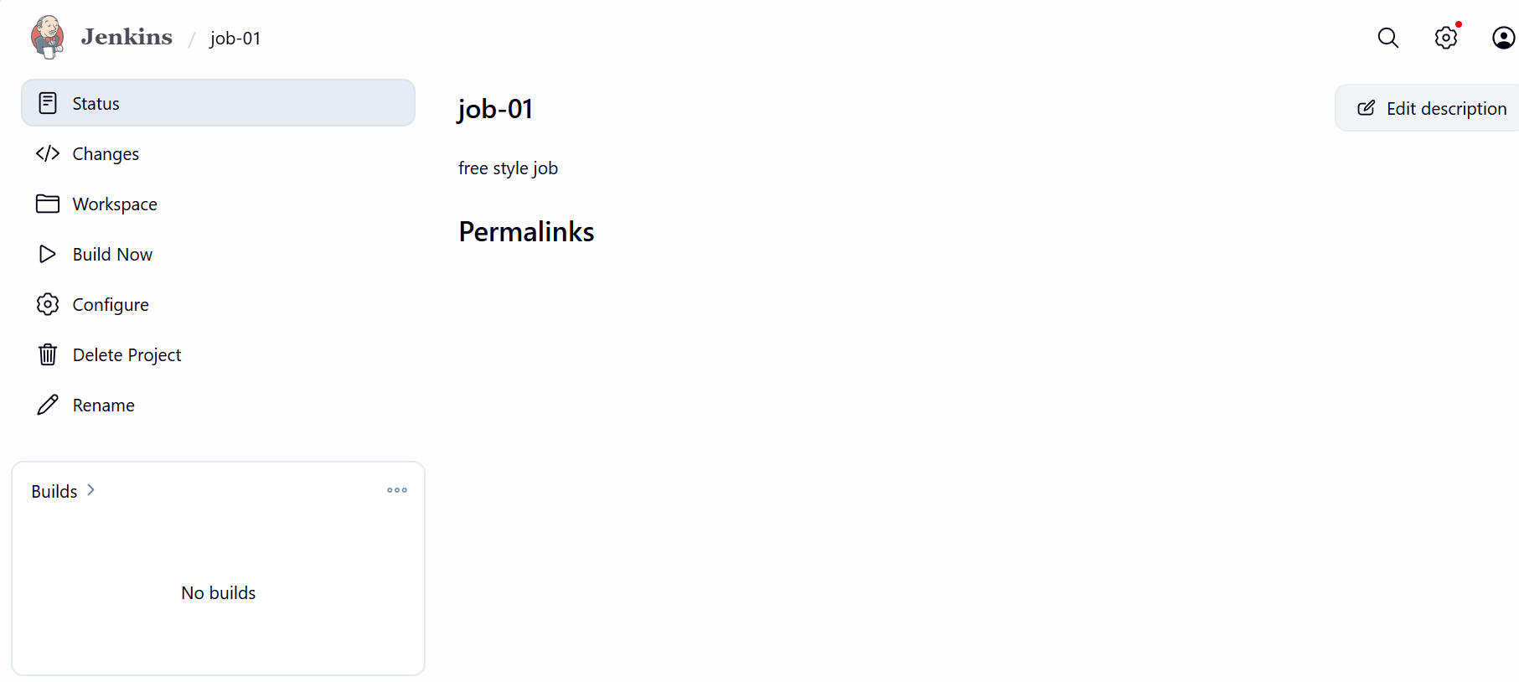
Job is created let us build it
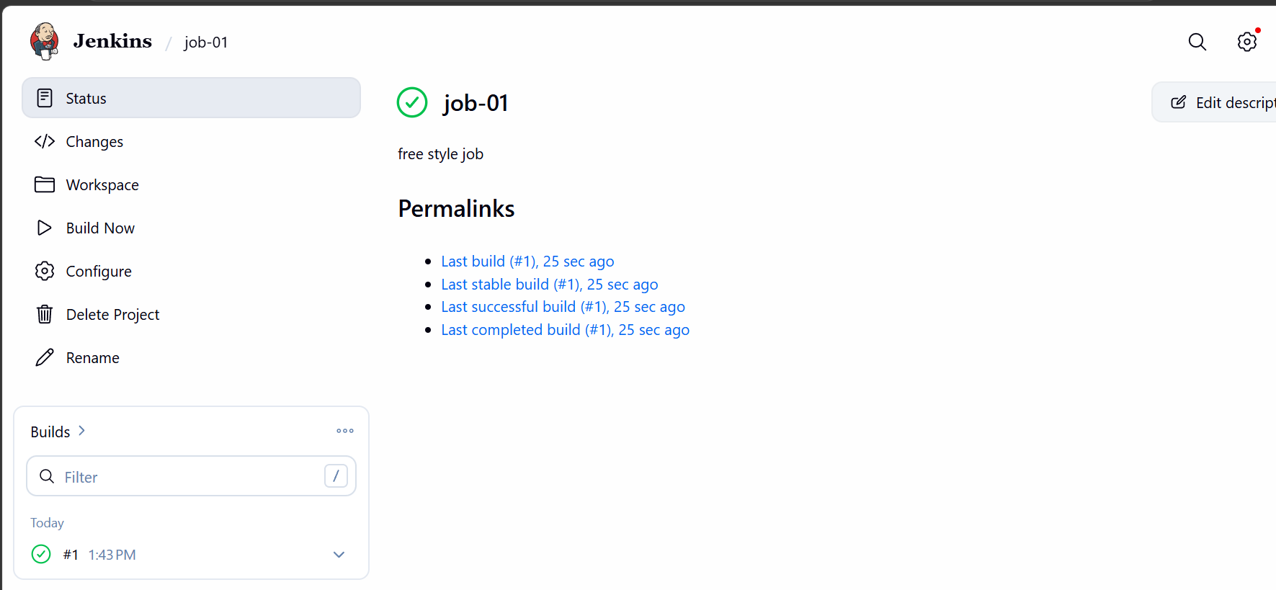
The job ran successfully now lets create another
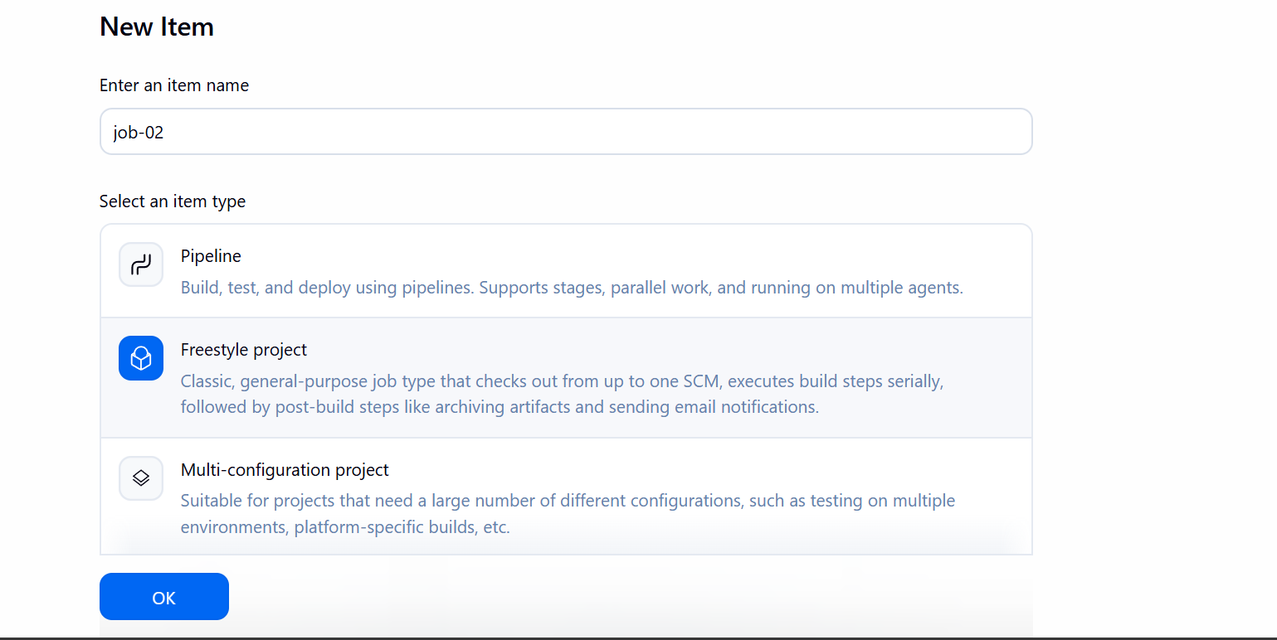
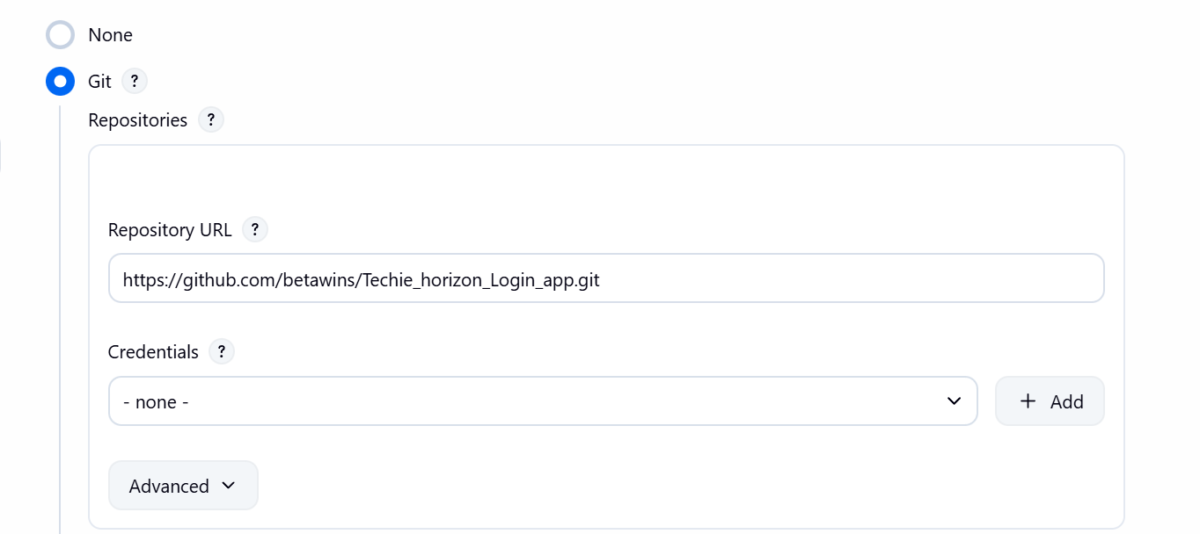
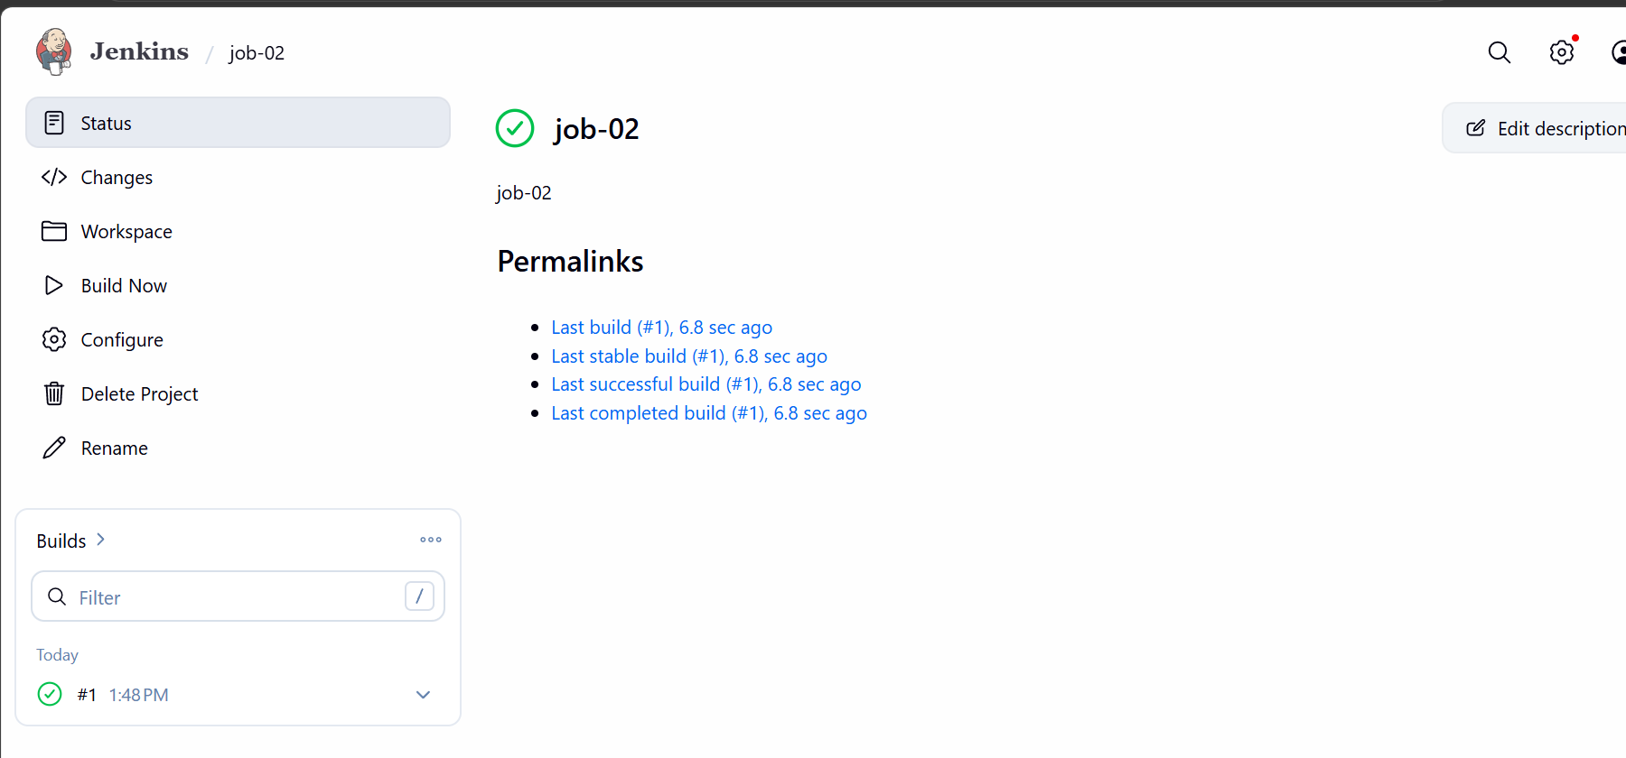
Second build also successful
Creating one more job
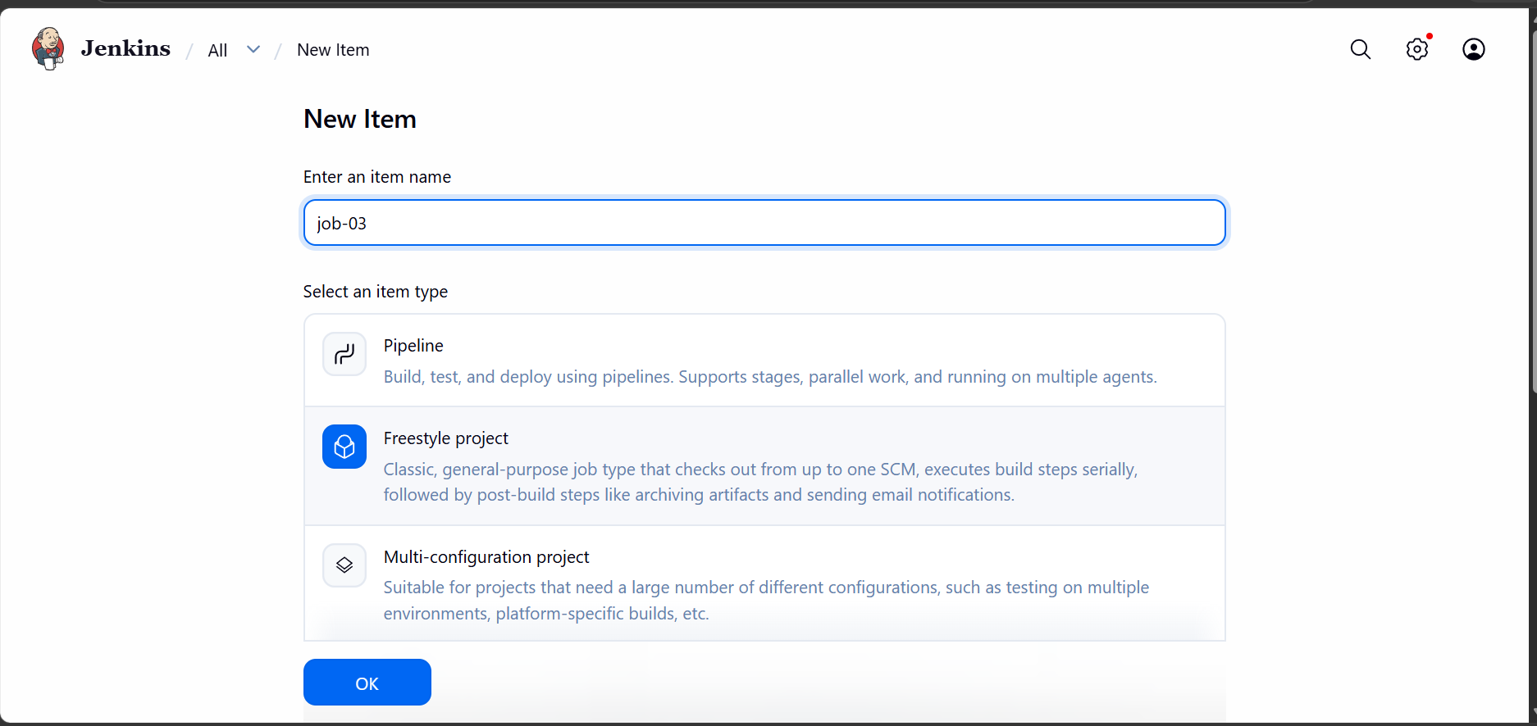
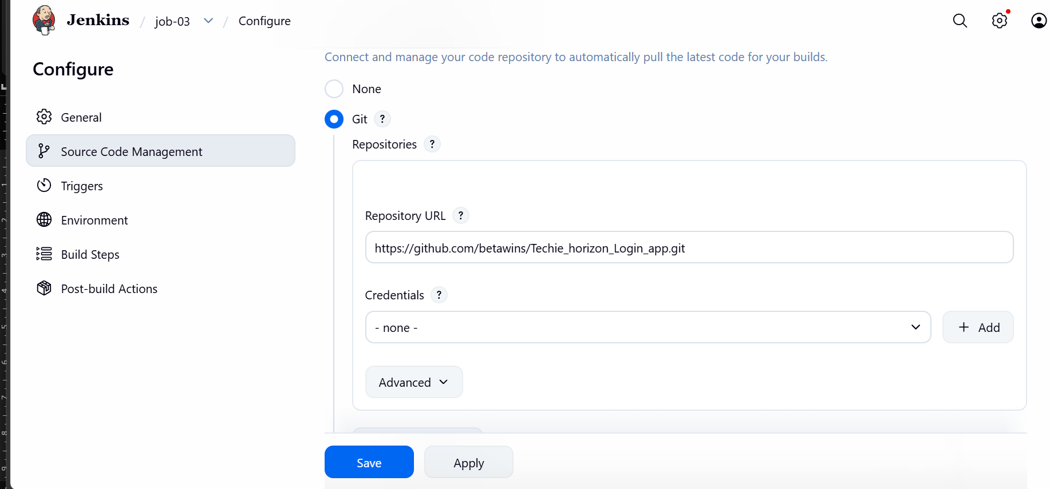
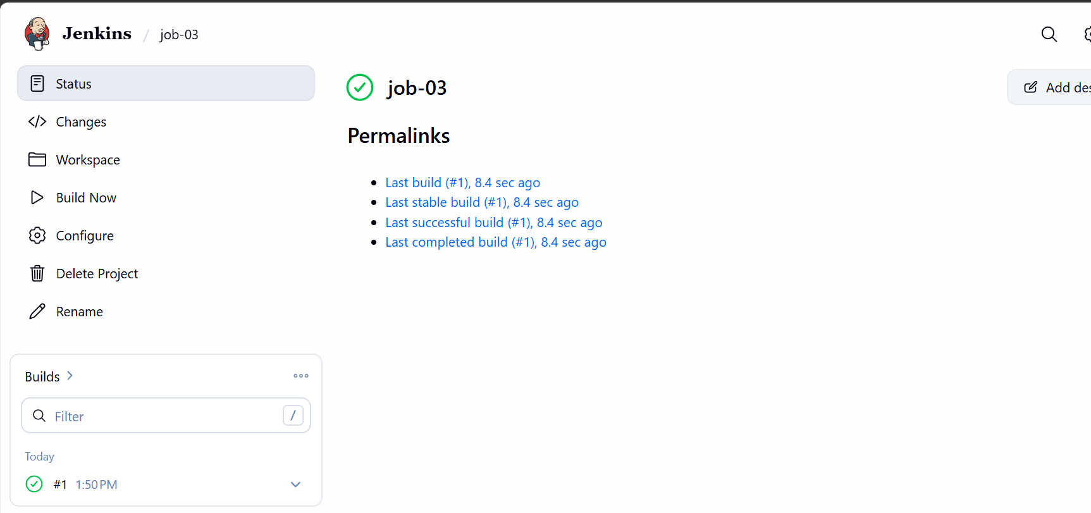
This job is completed as well.

06. Create one Jenkins job using GitHub Private repository.
Lets create a private repo in github
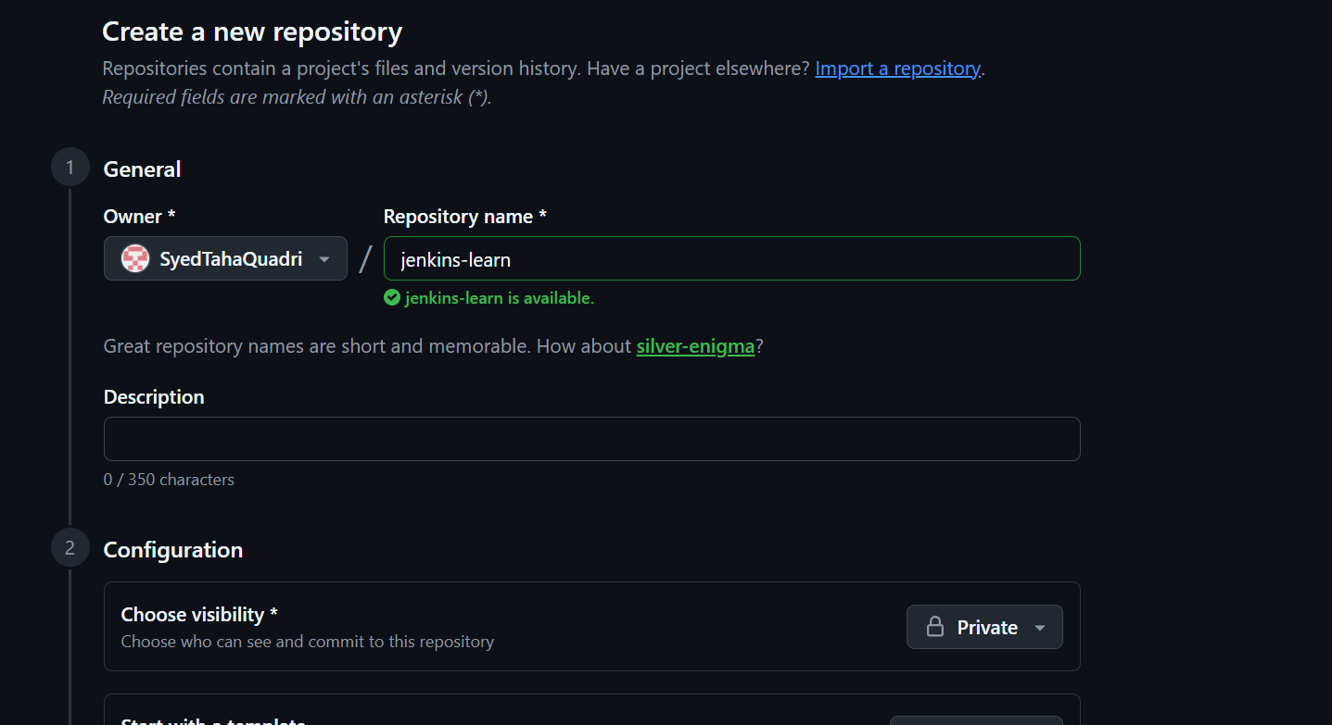

Create a personal access token in github
Go to settings and developer options
And create a personal access token
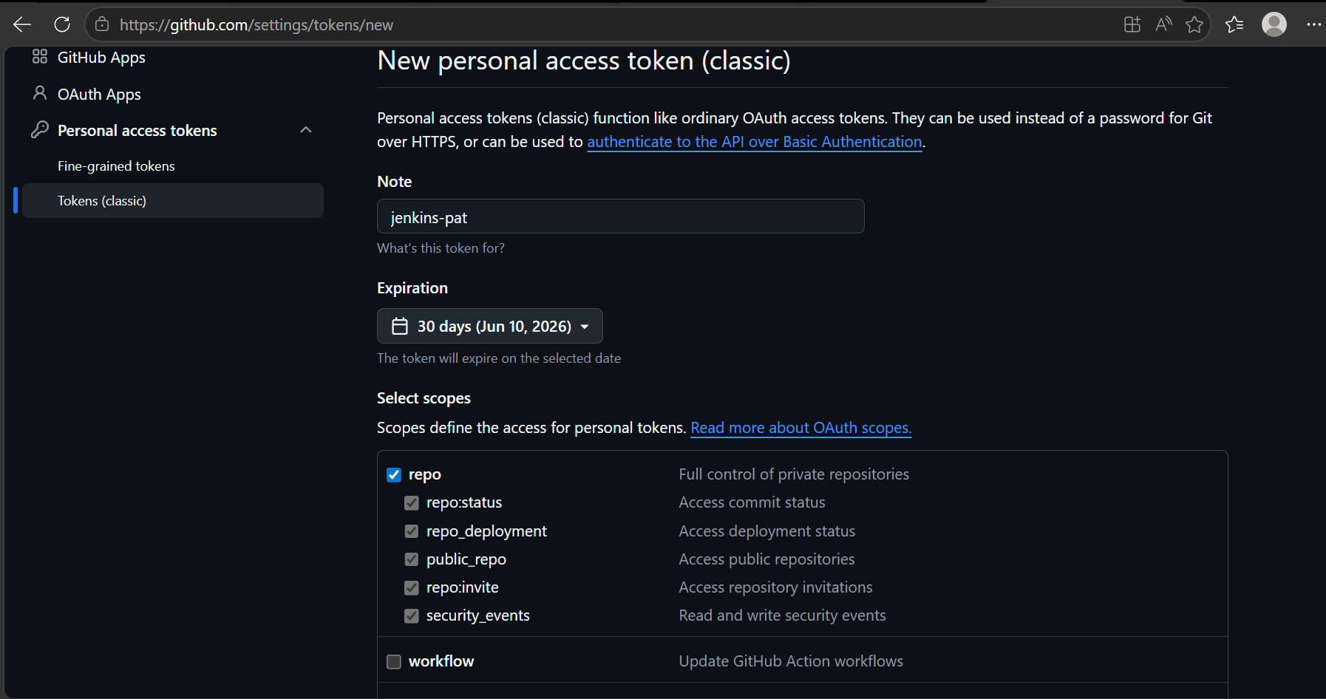
Generate the token and make sure to copy it
We have now created the pat
Lets add it in Jenkins
Go to manage Jenkins and security
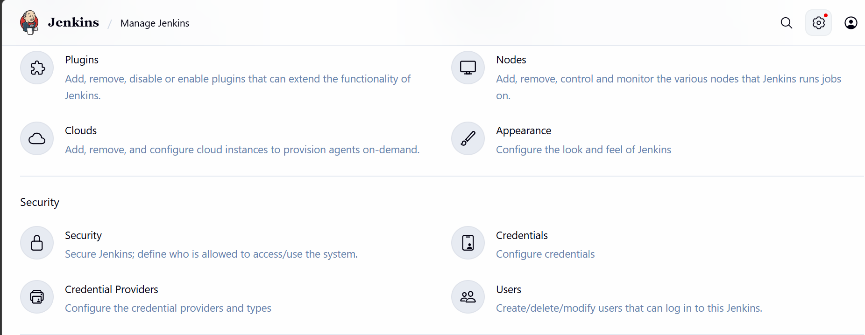
Click on credentials
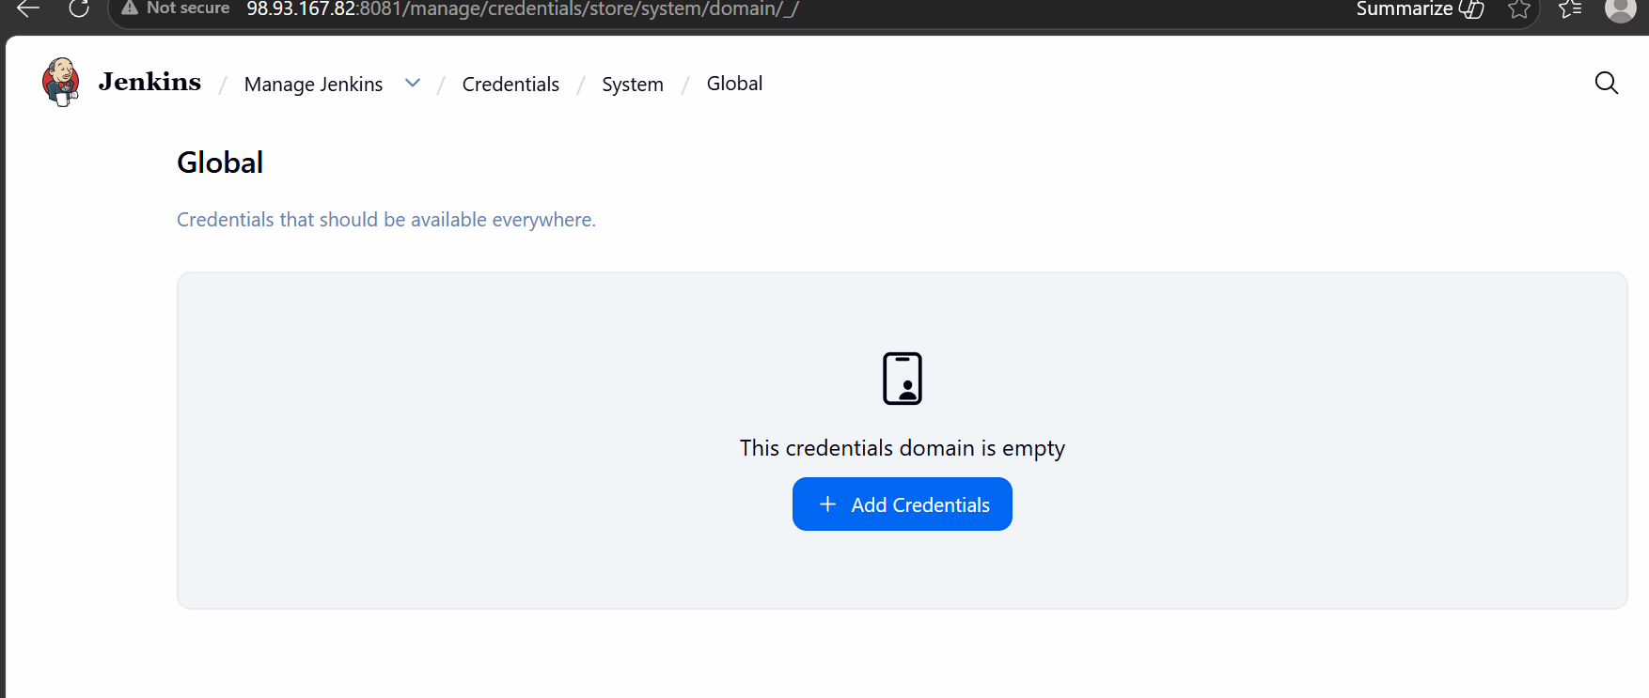
Click on add credentials
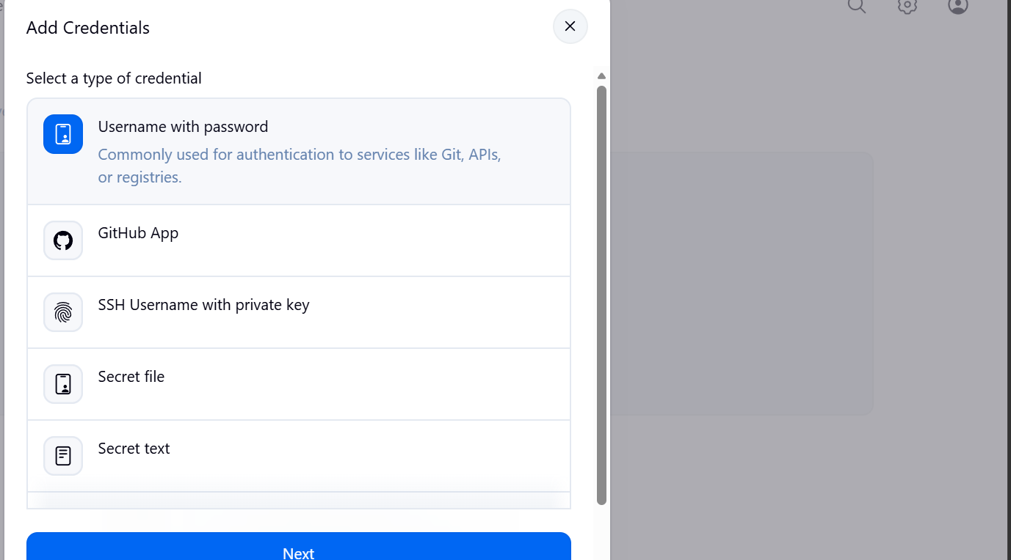
Select username and password
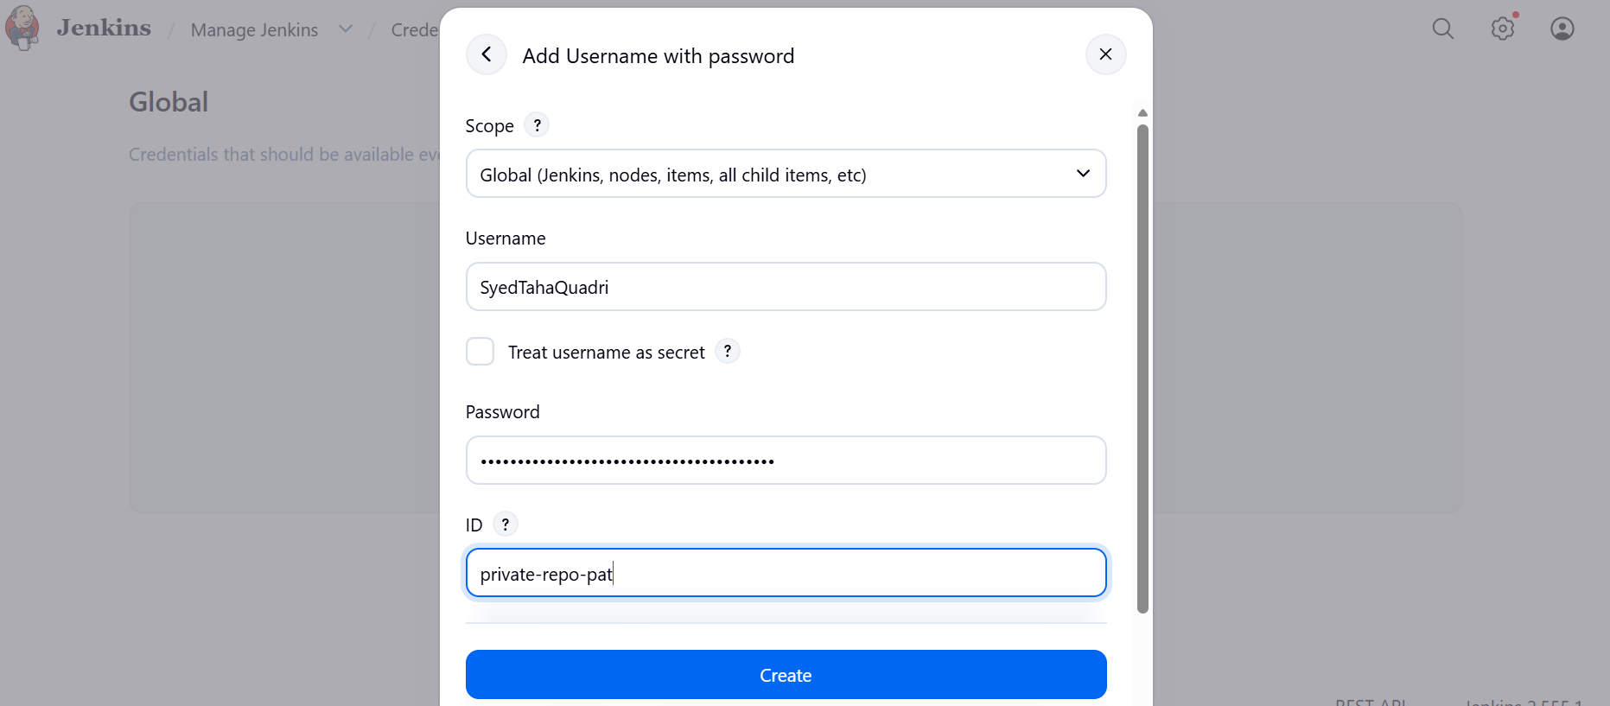
Add your github username and pat as password
Click on create
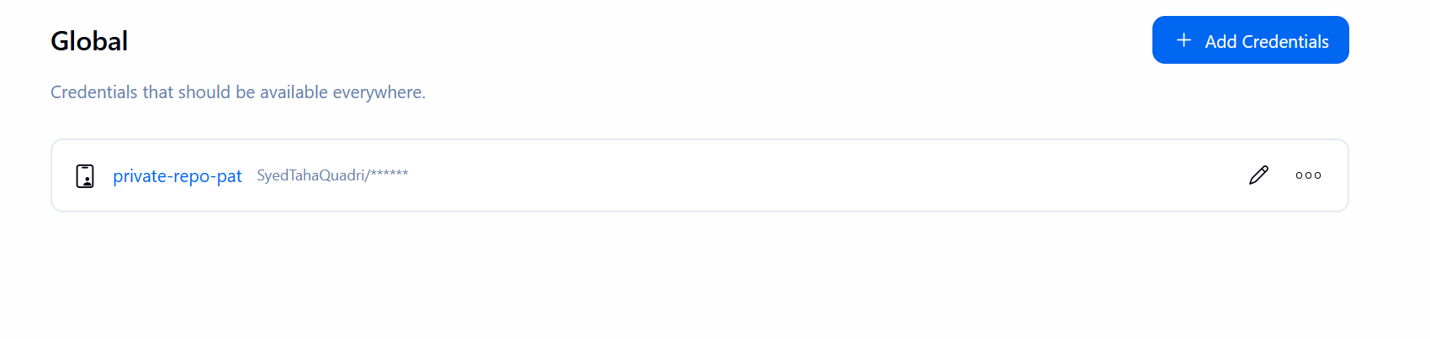
We have added the pat in Jenkins credentials
Now let us create a job using our private repo
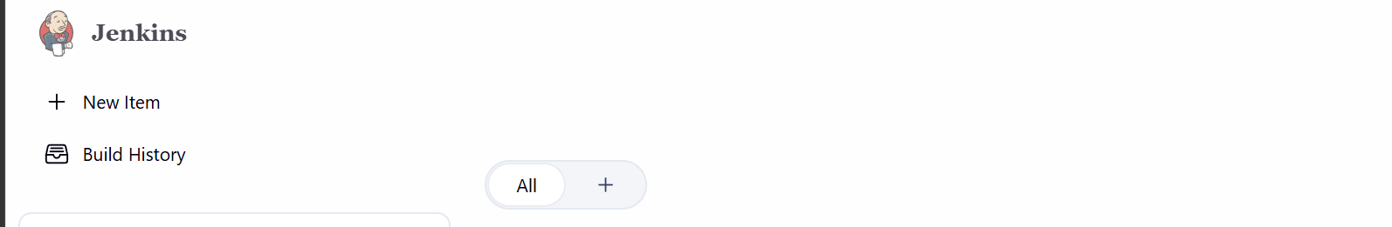
Click on new item

Give a name and select freestyle project
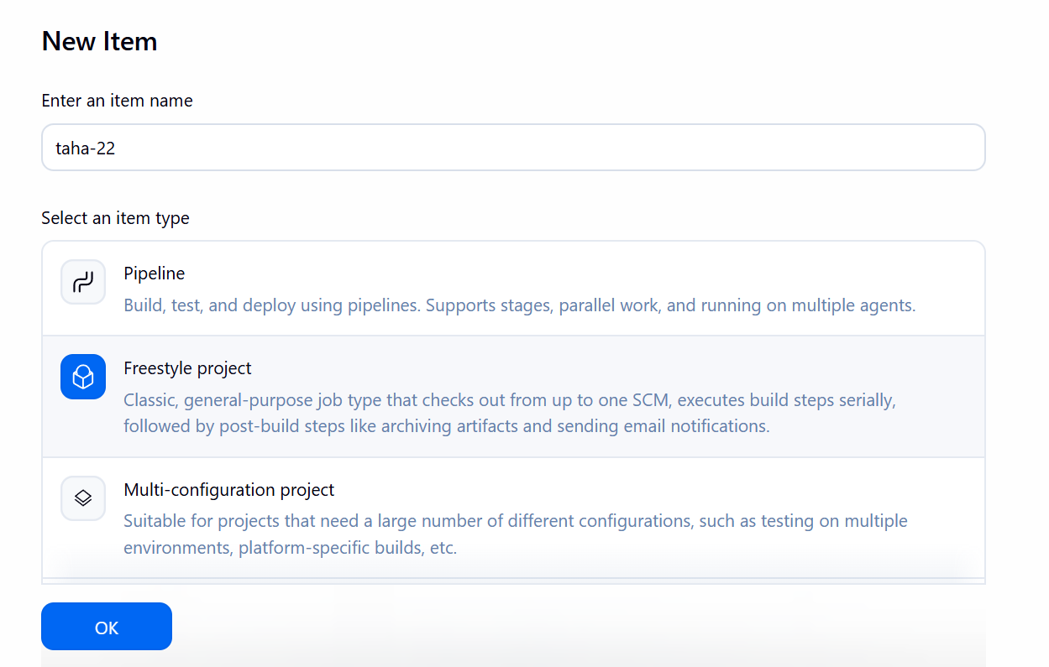

Under source code section select git and add the repository and select the credentials as well.
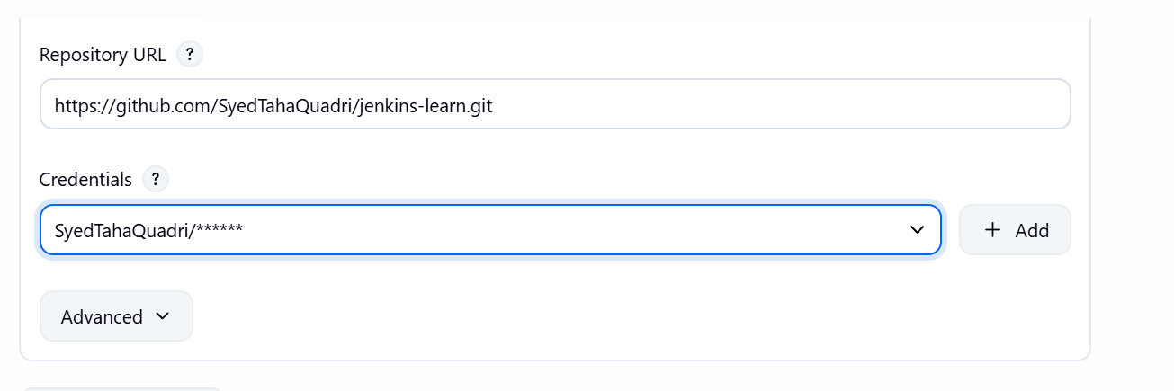

Go ahead and apply
Now lets us build the job
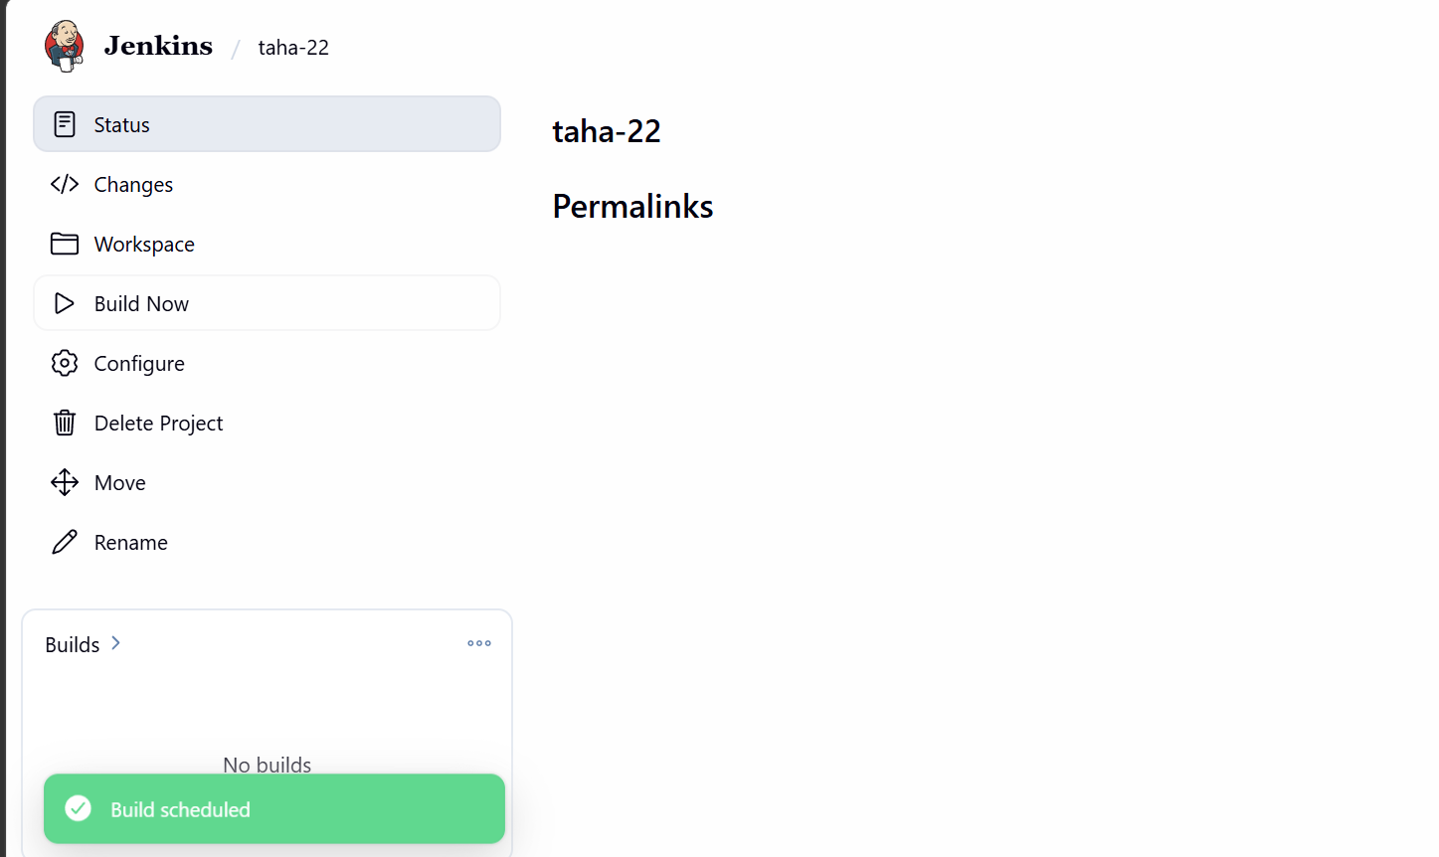
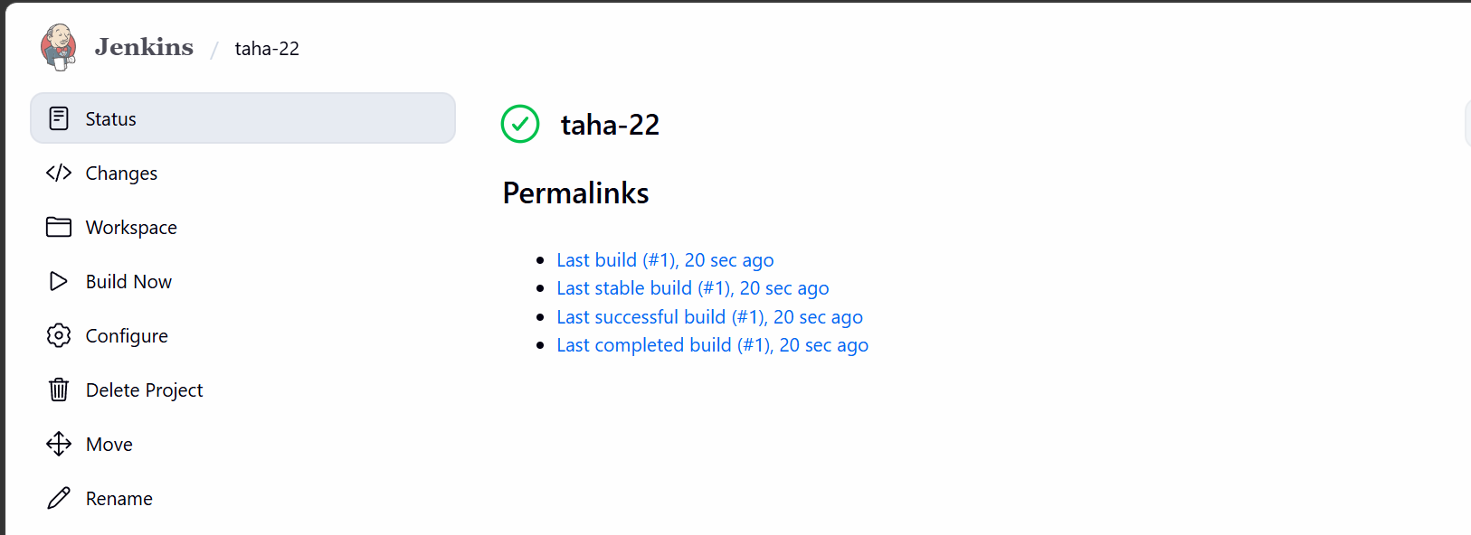

The build is now successful.

