Jenkins Task-02

- Configure 2 slave machines in the Jenkins master
First let’s setup the Jenkins master
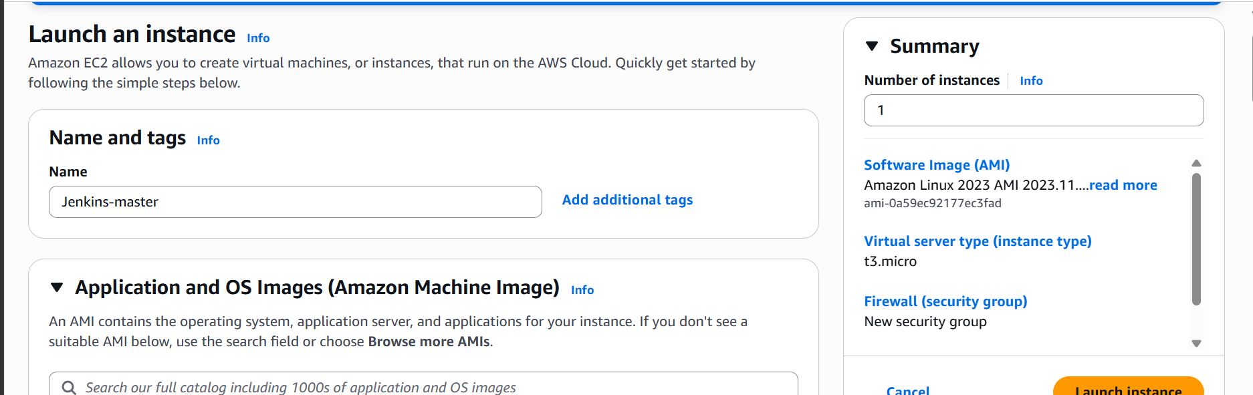
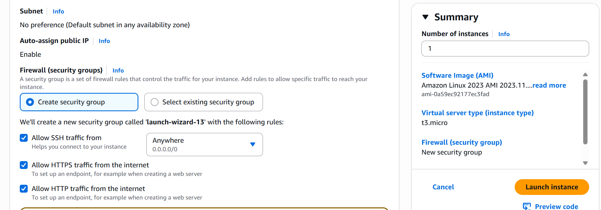

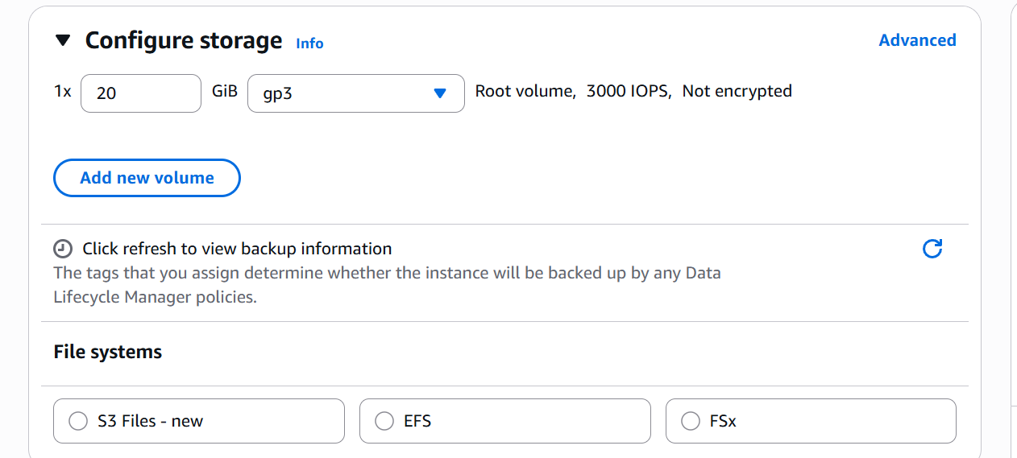
Instance is launched let’s ssh and install Jenkins
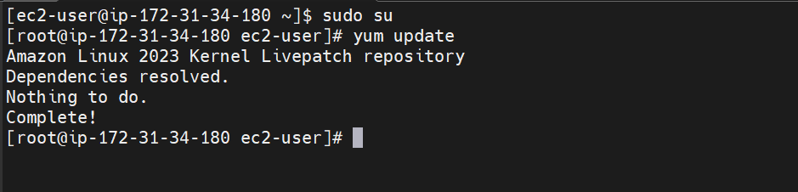
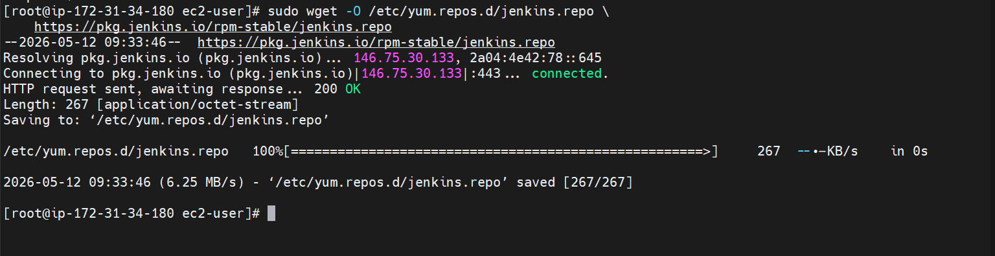
Jenkins Package installed
Import keys
Installing Java
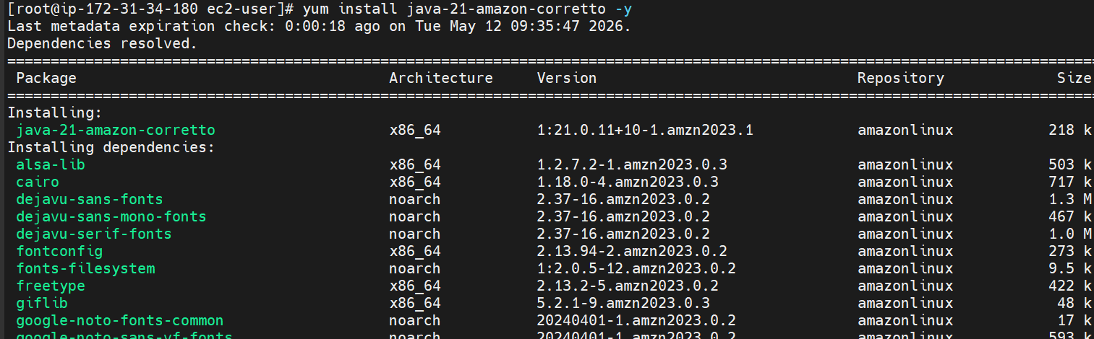
Now install Jenkins
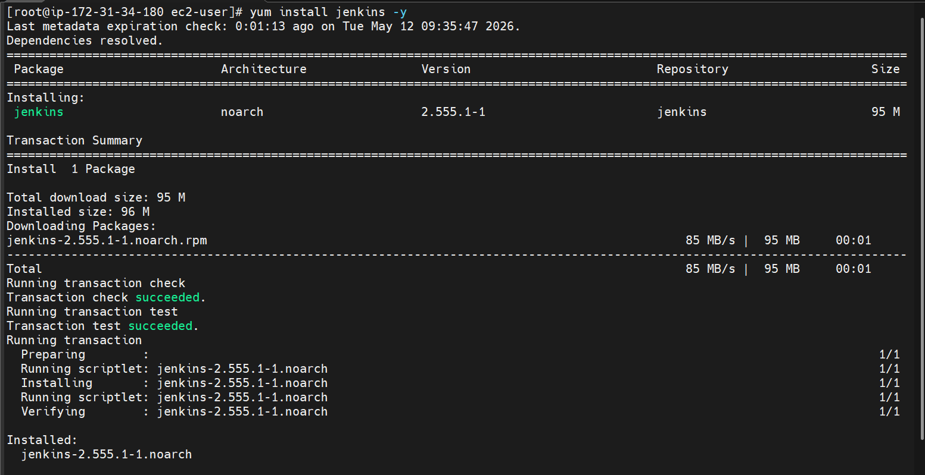

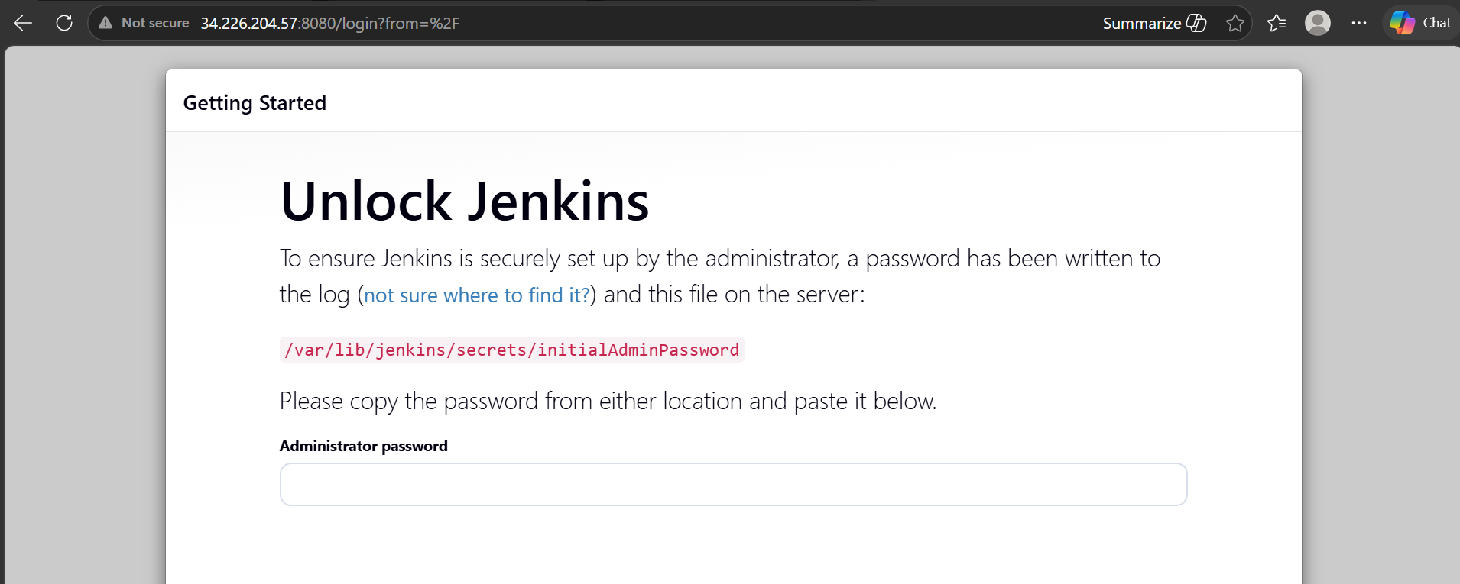

Jenkins running
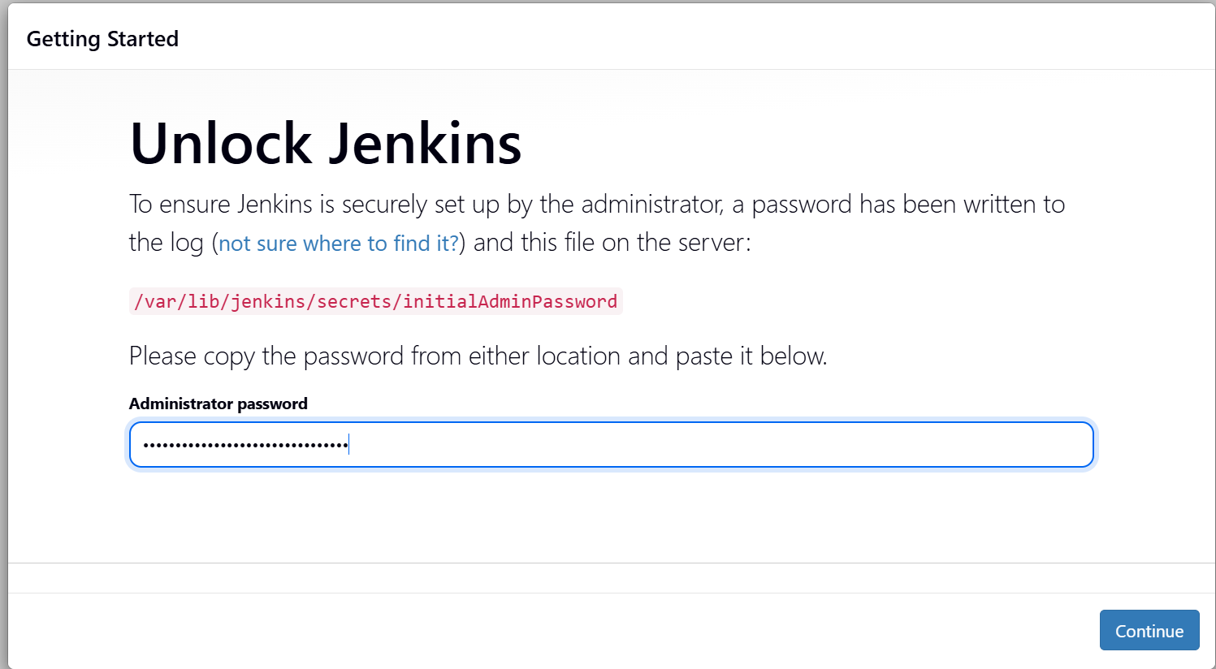

Creating first admin user
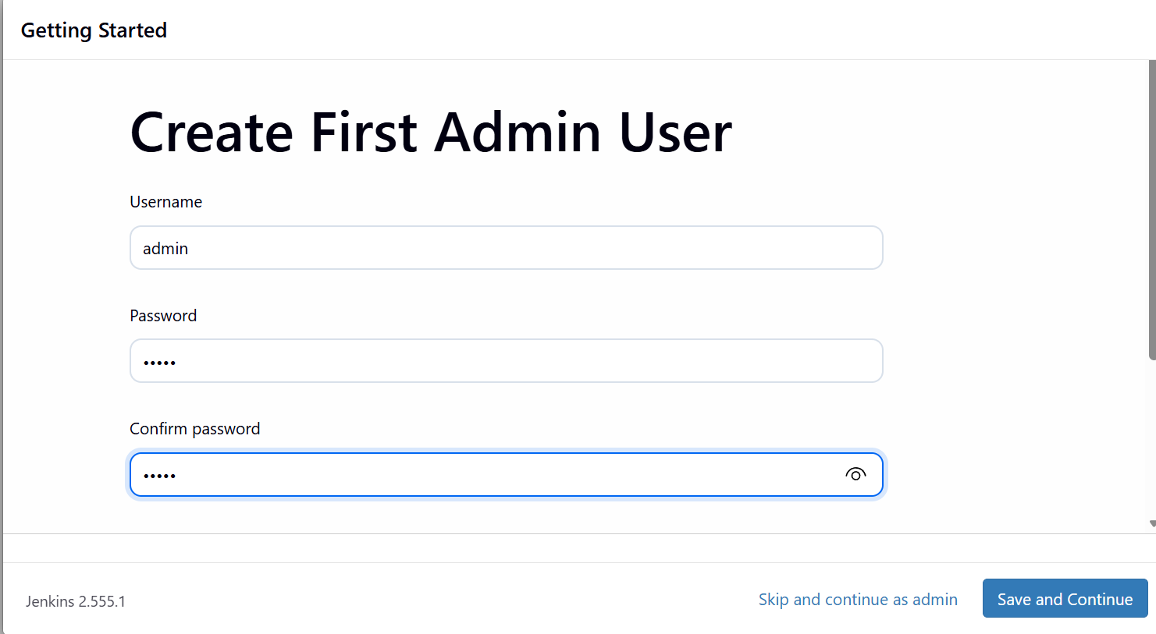

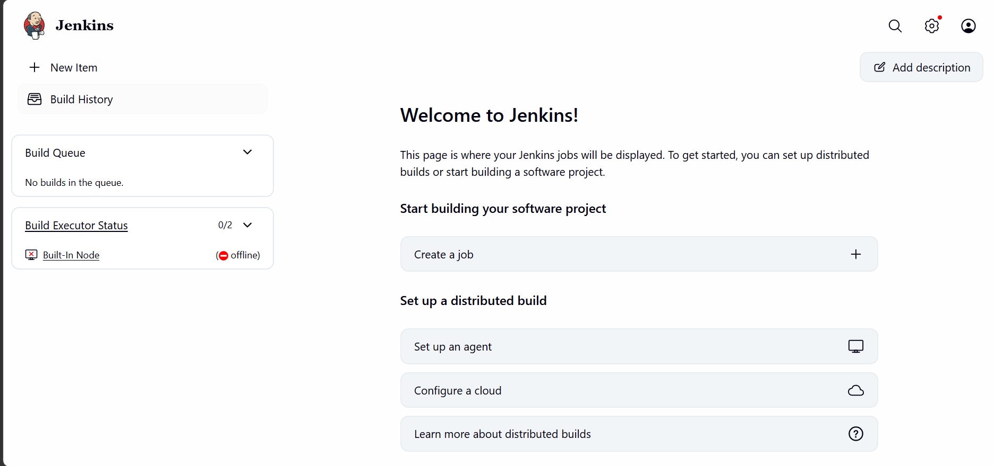
We are now logged in to our Jenkins GUI
Let’s now launch slave instances
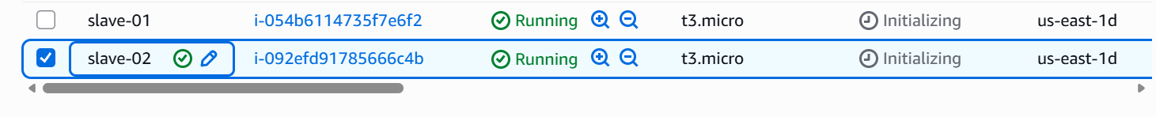
We have two more instances launched
Lets now ssh into them and install java
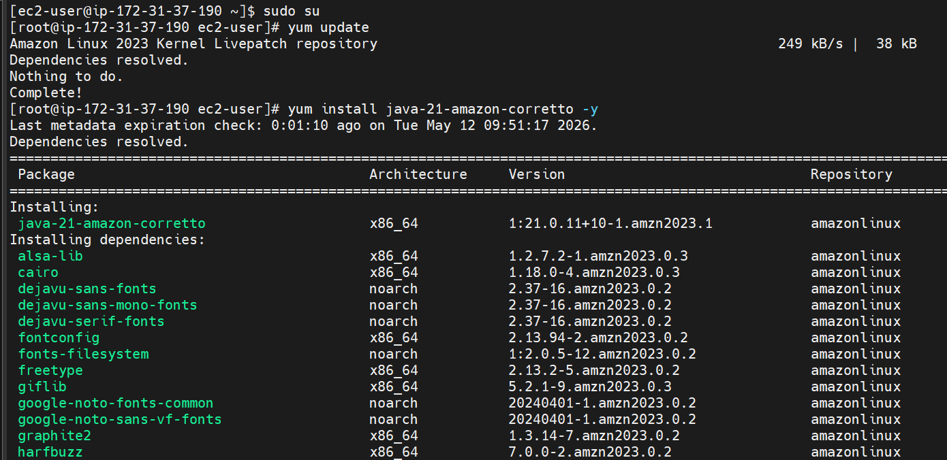

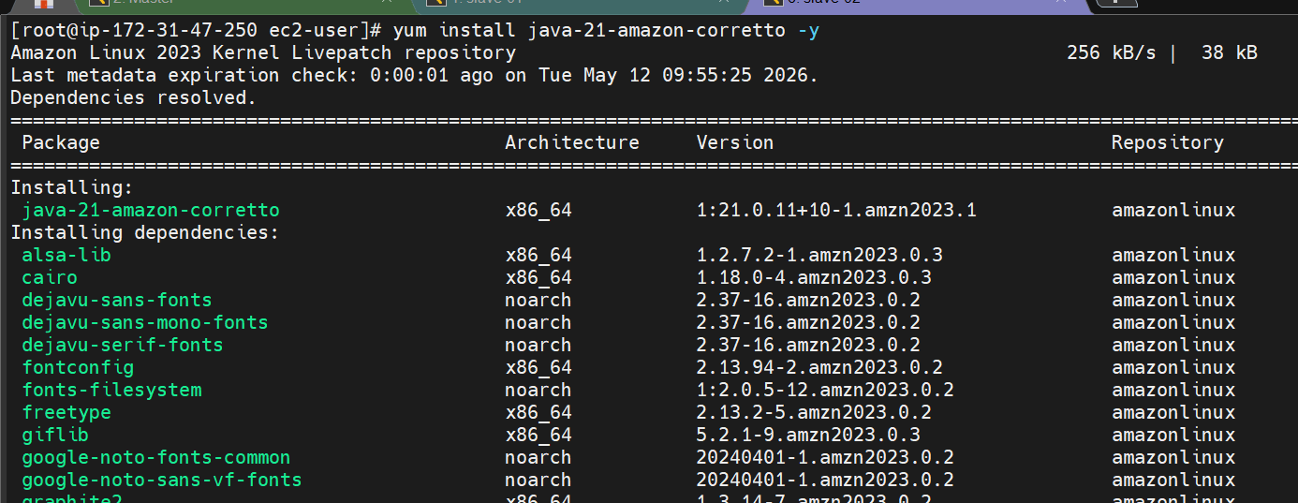
Java is now installed on both the slaves

Now lets setup our first slave
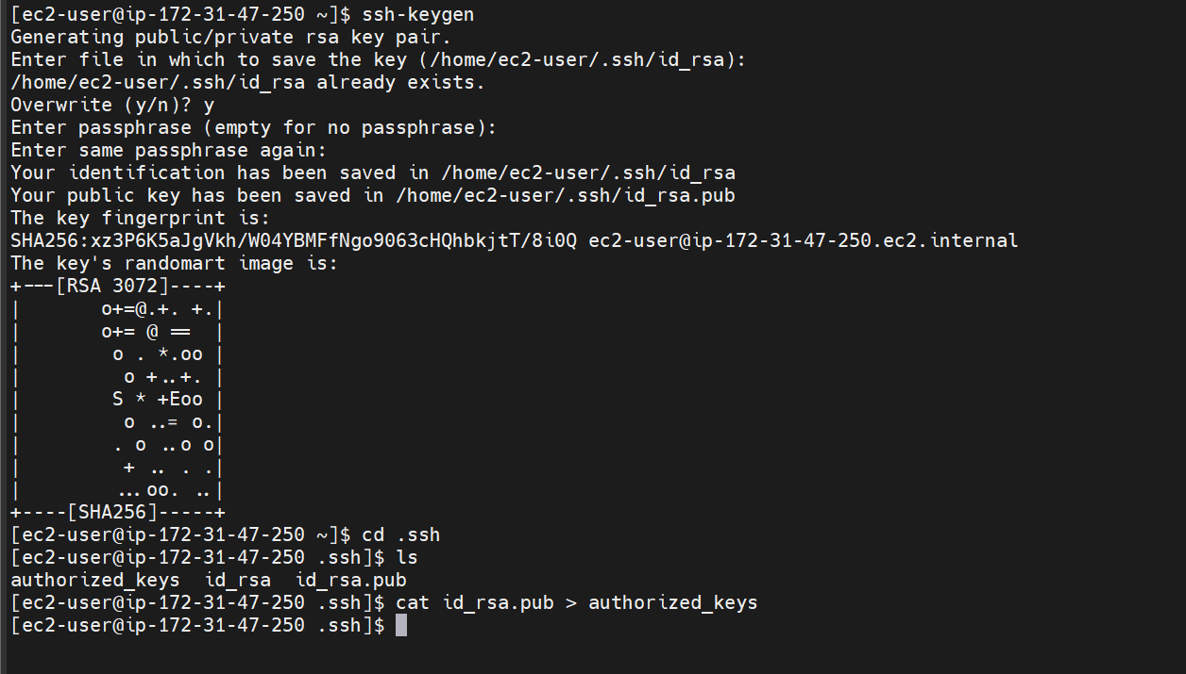
Generating ssh key and copying it to authorized keys
Now go to the master server
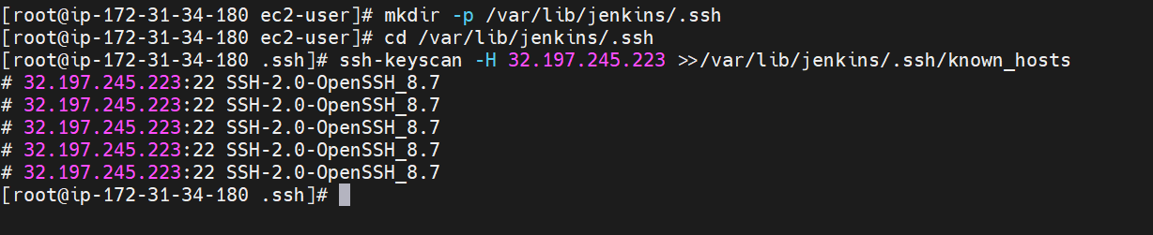
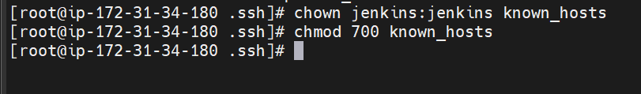
Changing the owner of known_hosts file to jenkins and modifying permission
Now go to the Jenkins GUI for the remaining setup
Go to manage jenkins
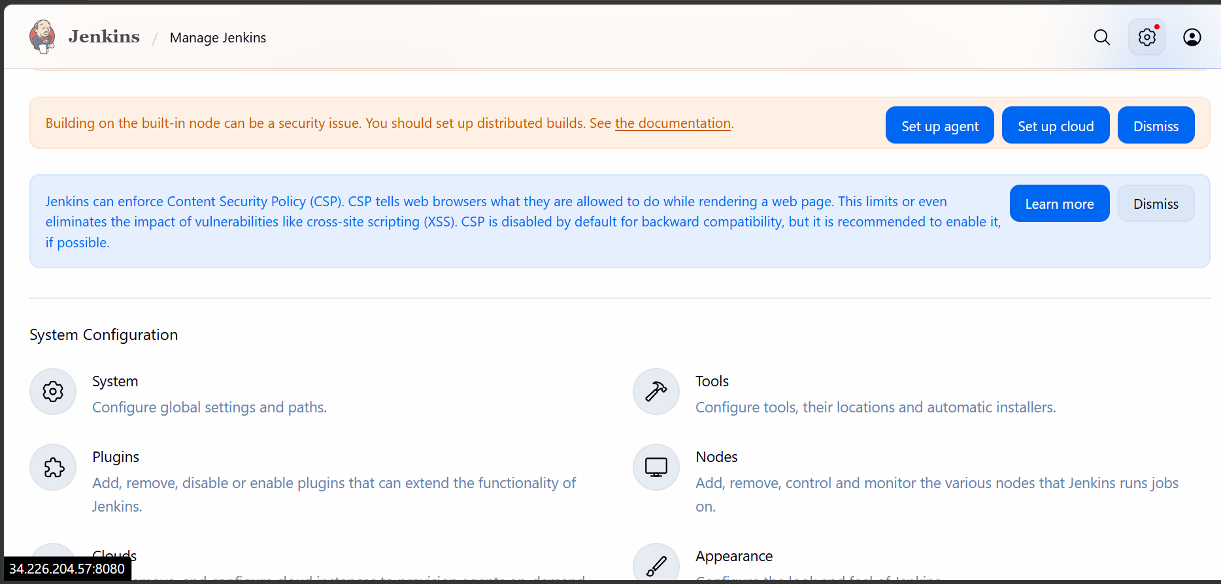
Click on nodes
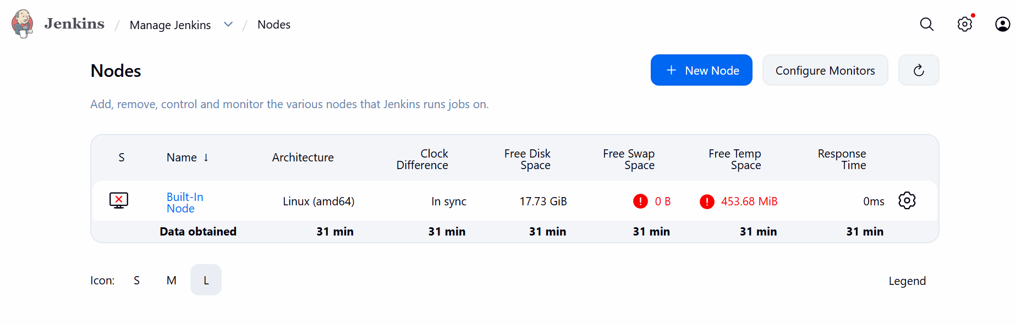
Click on new node
Give a name and create
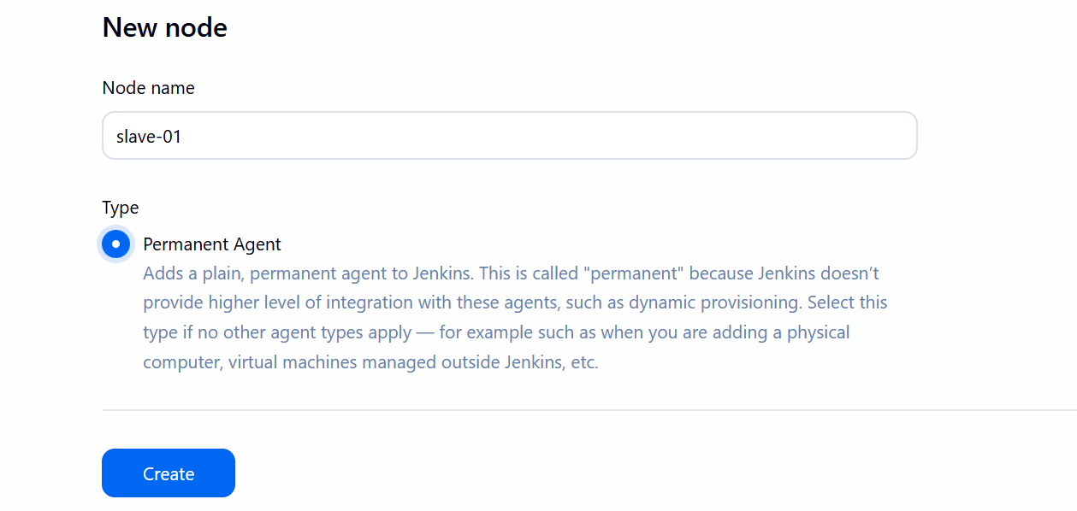
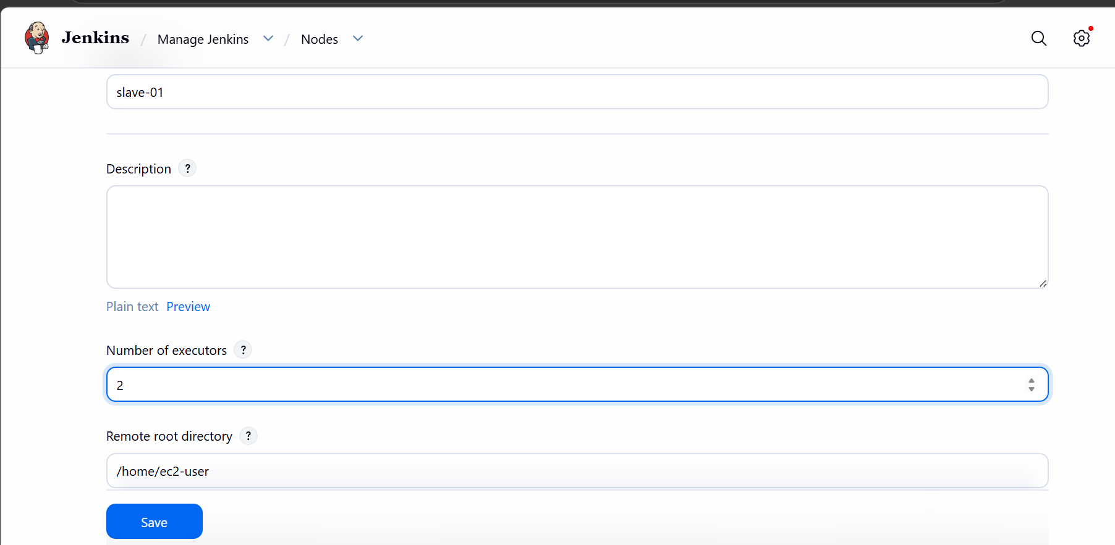
Select no of executers and root directory
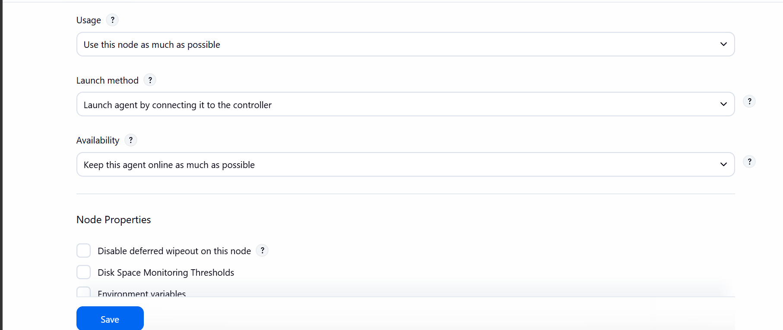

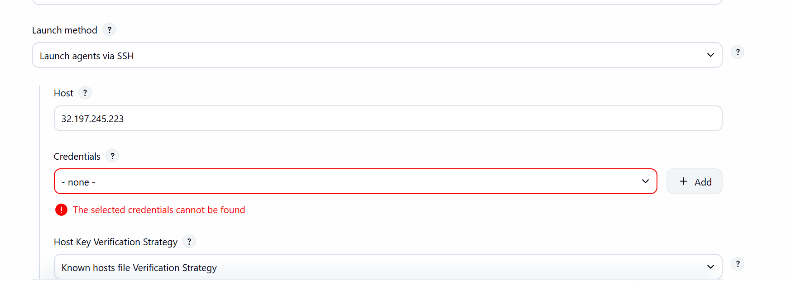
Select launch agents via ssh
Give hostname of your slave instance
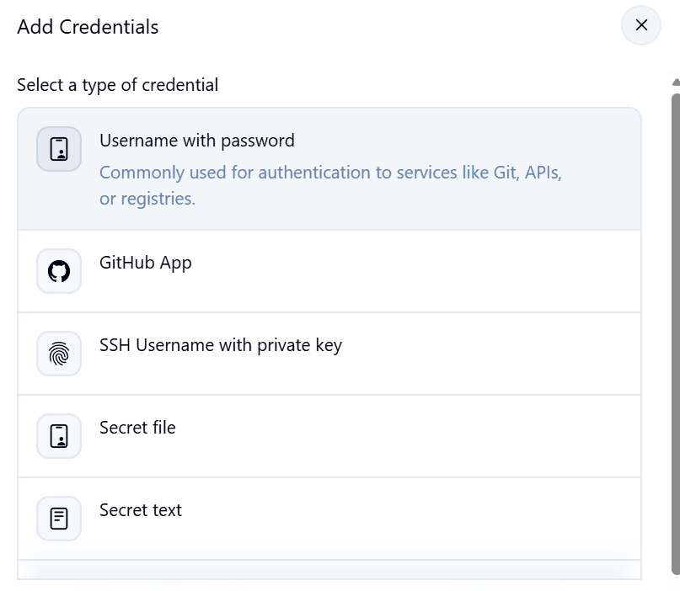
Add credentials select ssh usesrname with private key
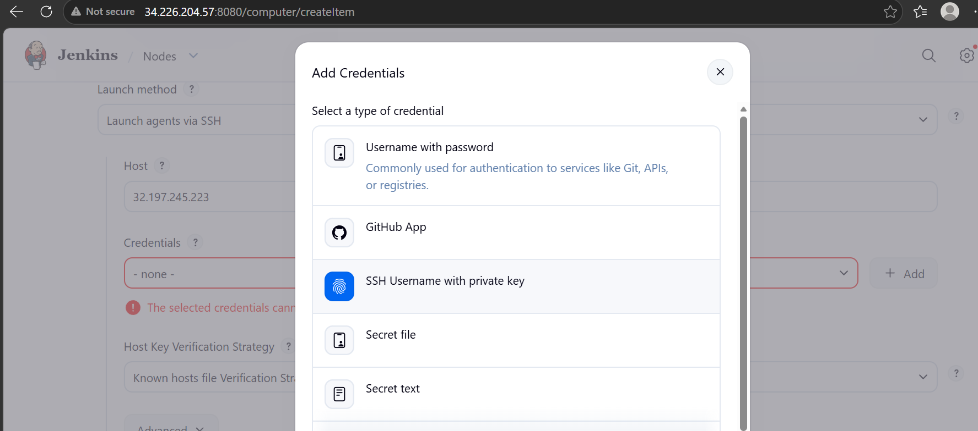
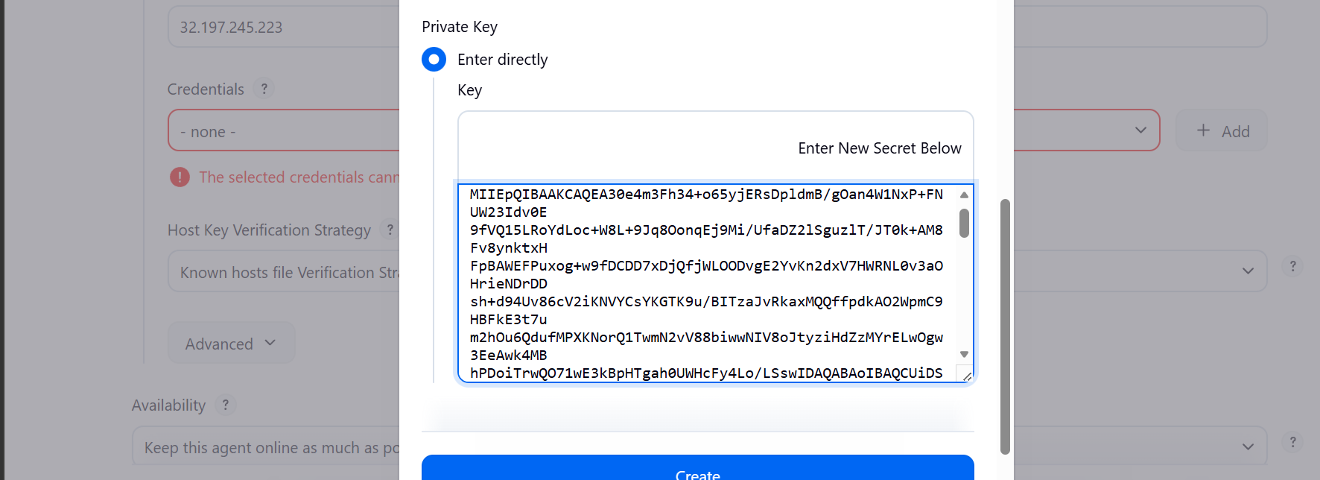
Paste the key
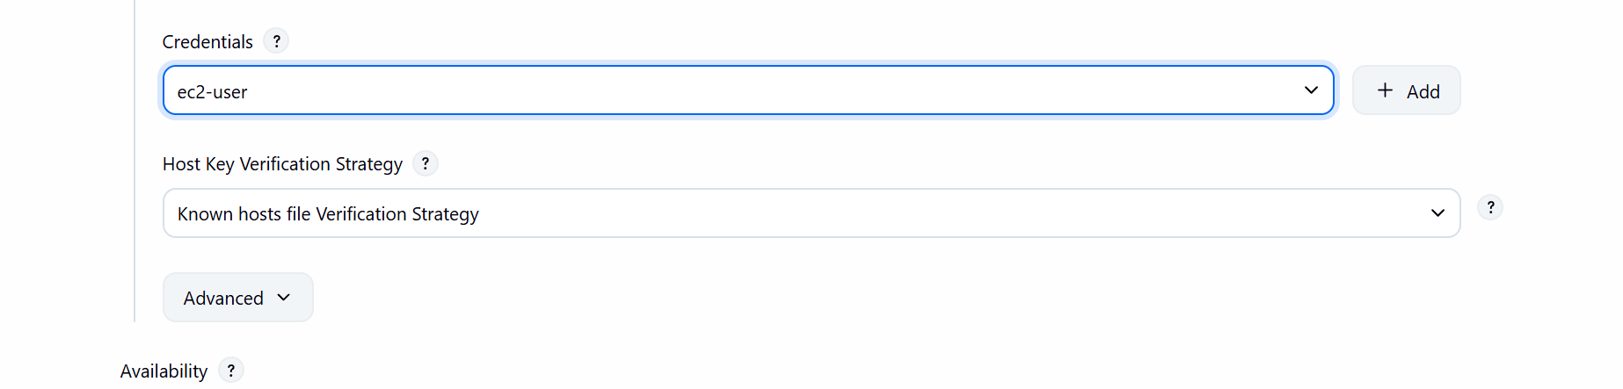
Select the key now
The setup is now done for slave-01
Now lets do it for another
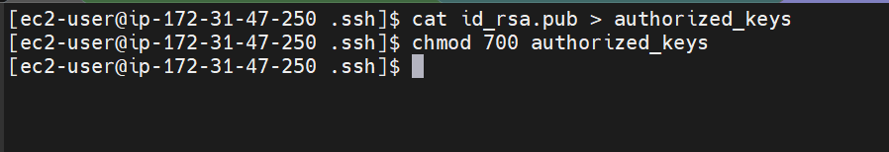
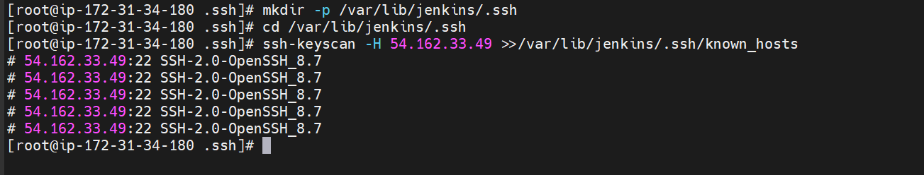
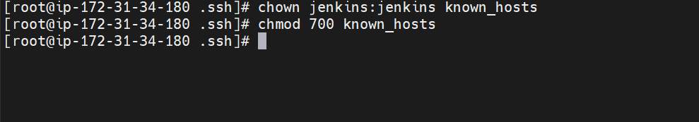
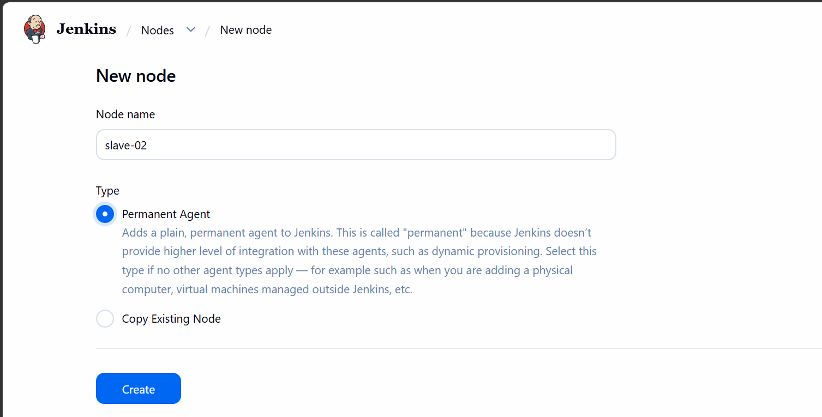
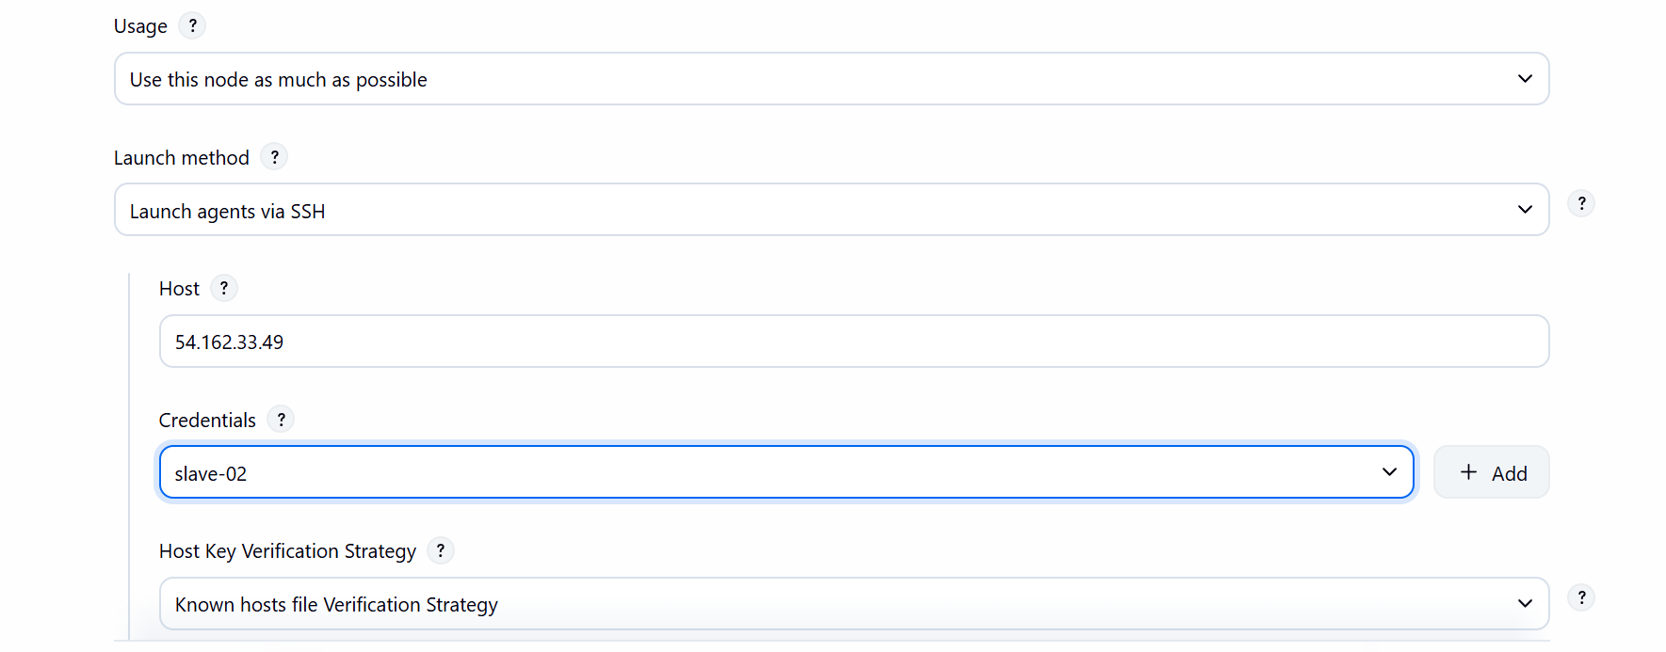
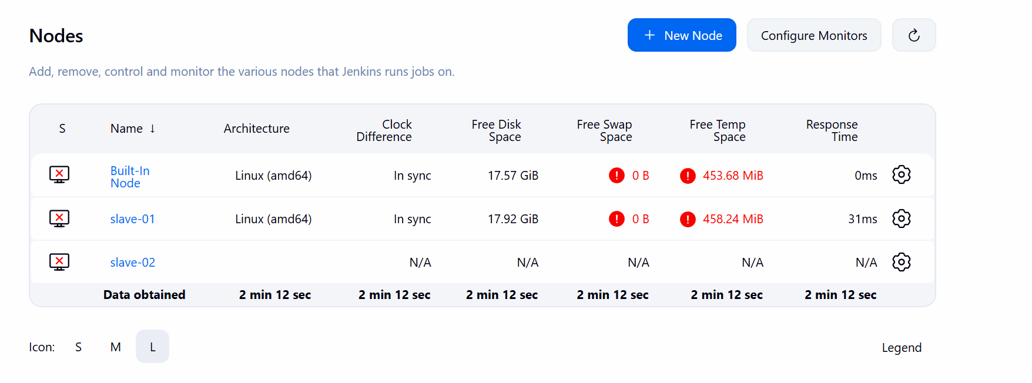

We have now setup both the instances

- Configure webhooks to the Jenkins job
Go to Jenkins GUI
Click on manage Jenkins
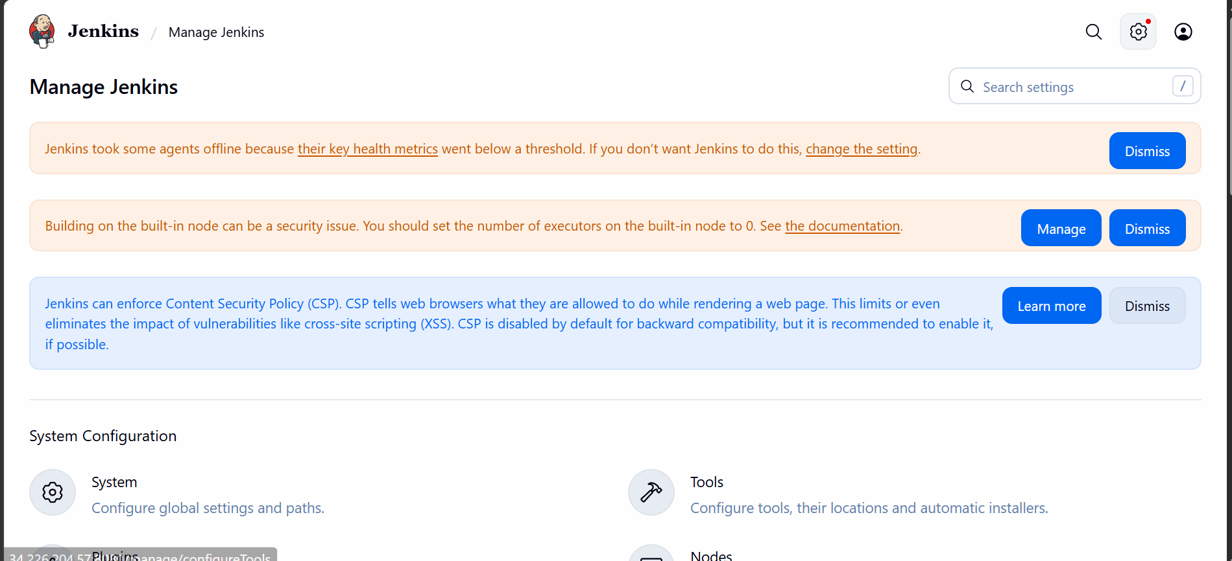
Click on plugins

See if the git plug ins are installed already
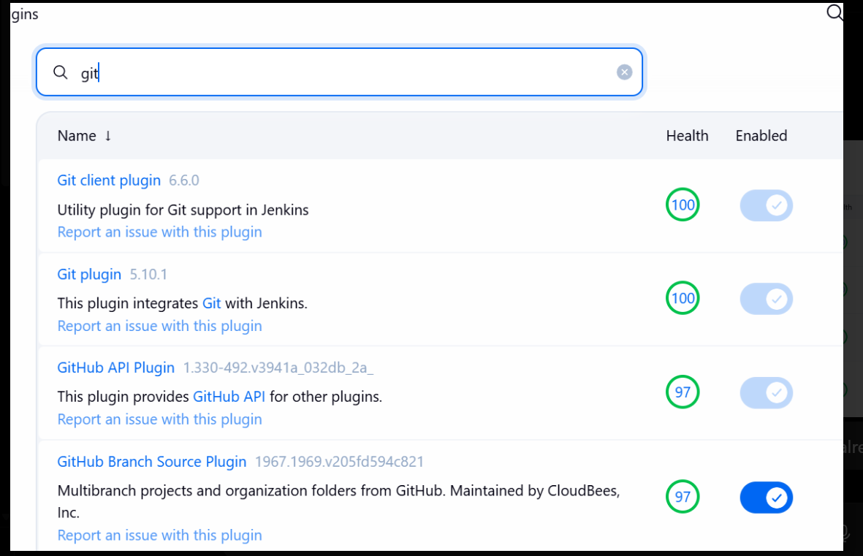
Now create a new job
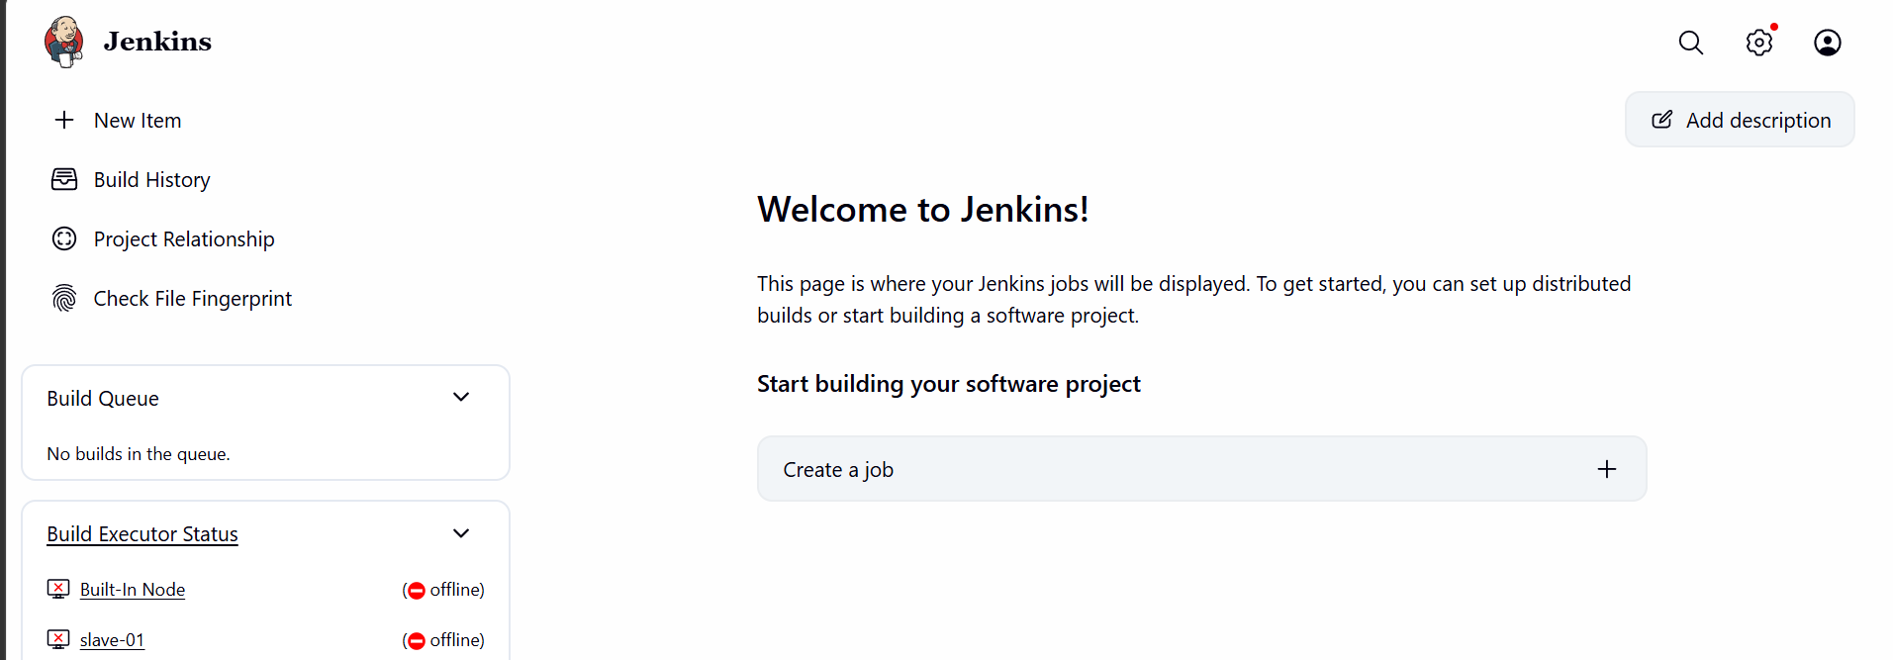
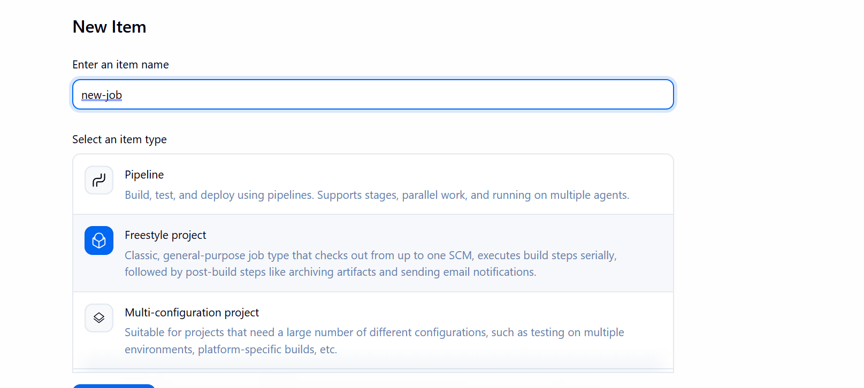

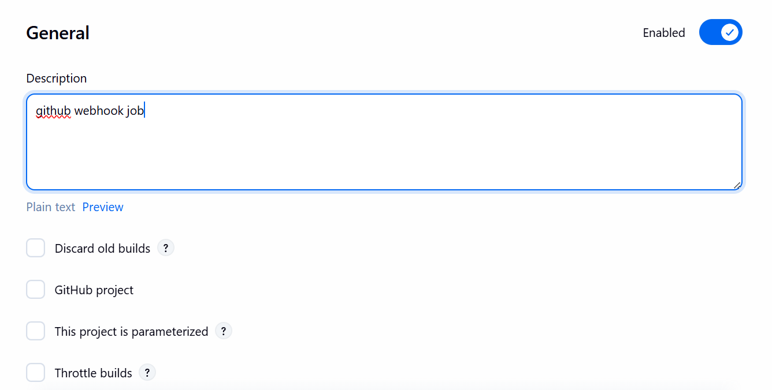

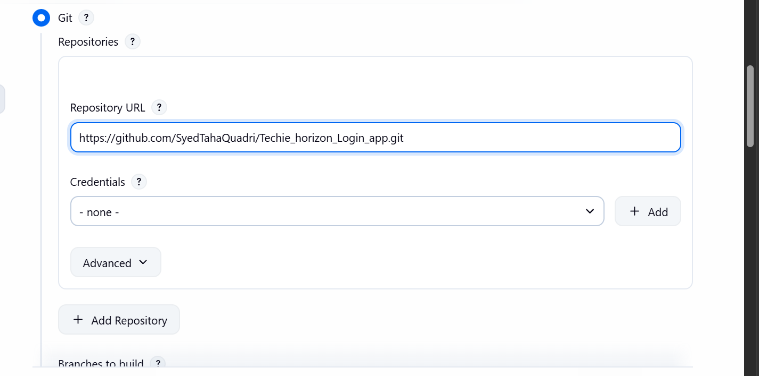

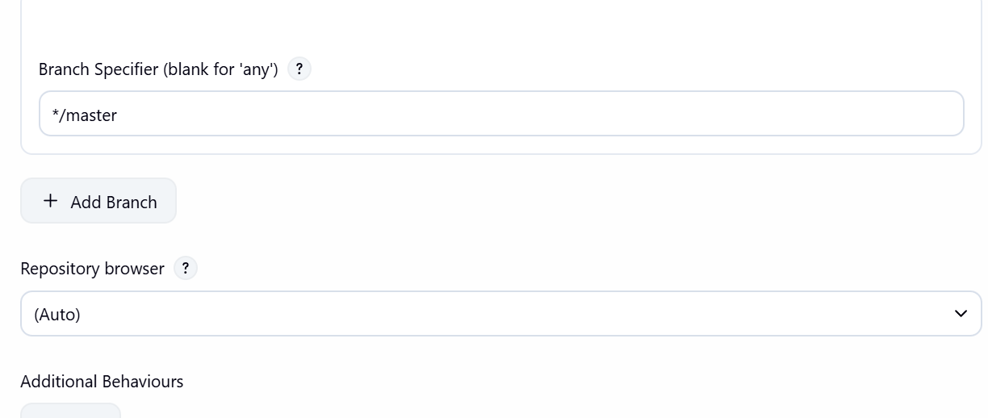
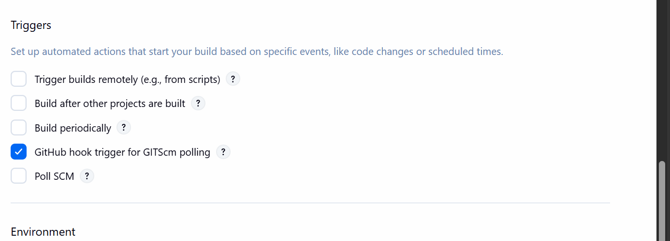
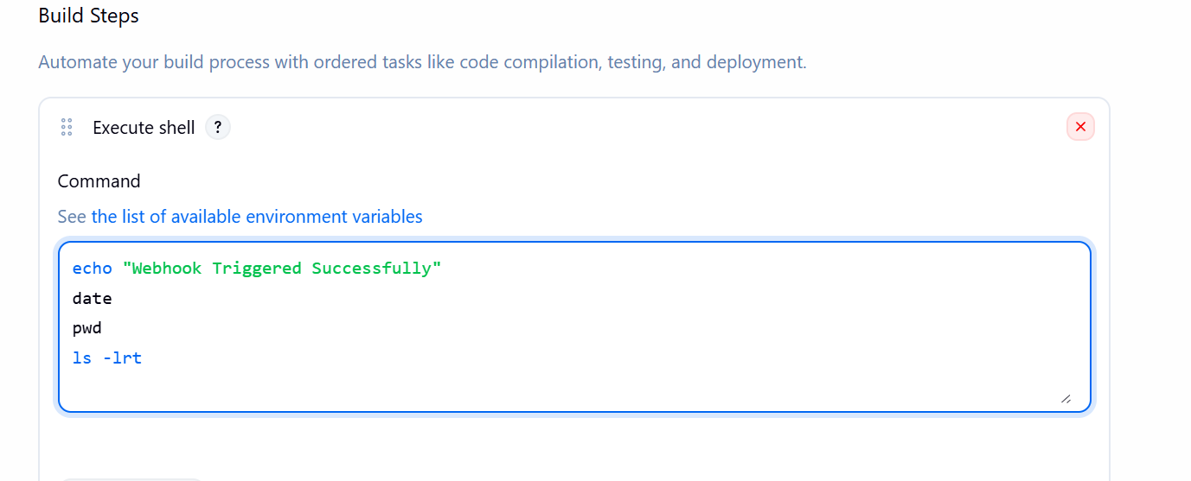

Save it now
Now go to the repository settings and create a webhook
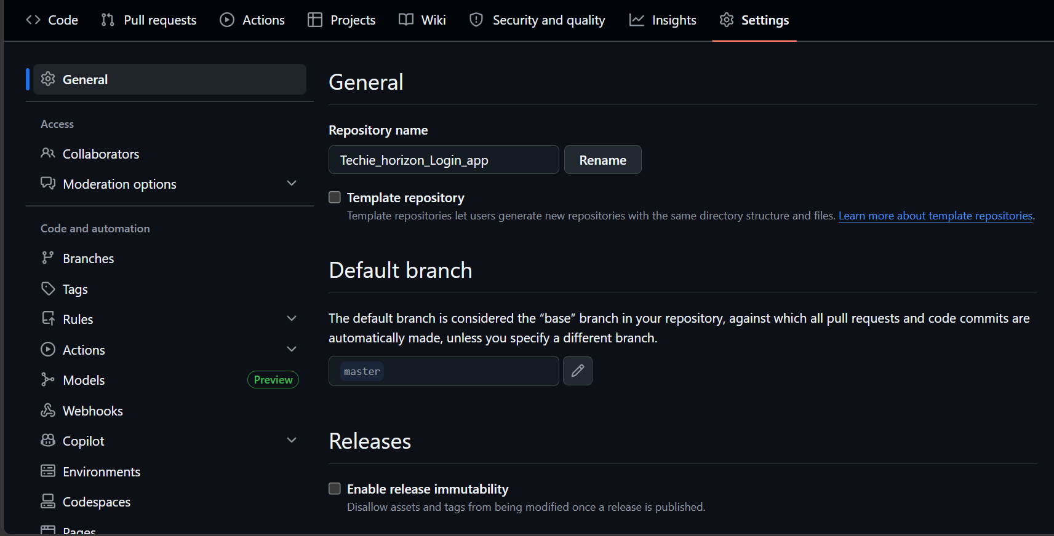
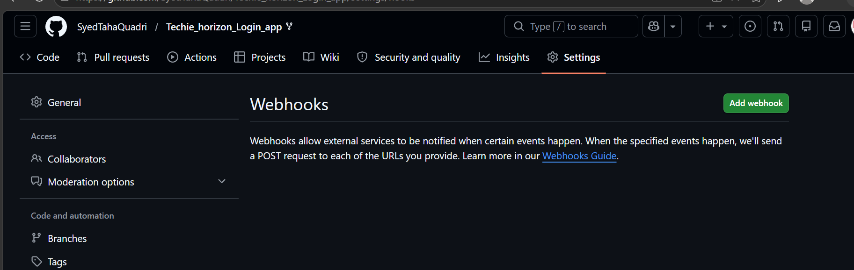
Click on add webhook
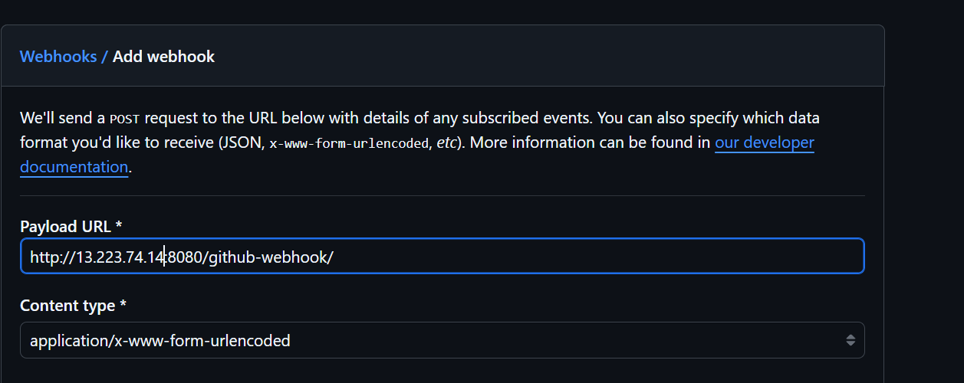

Payload url is ur Jenkins server ip, port number/github-webhook
Select on what event that build should trigger

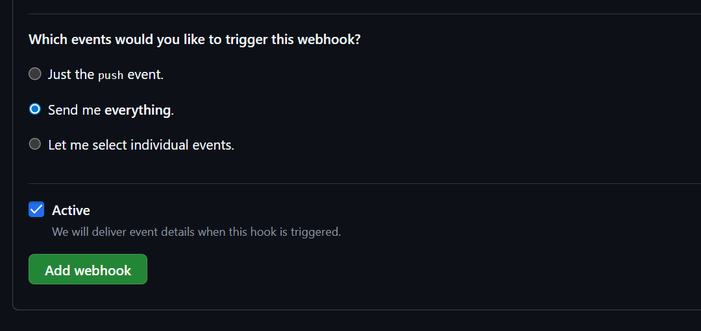
Now add webhook
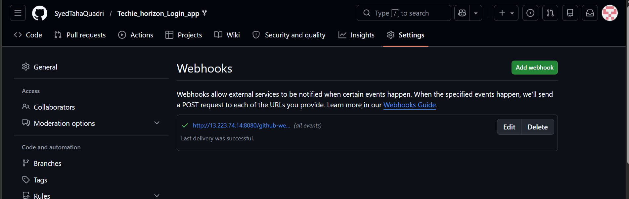
the webhook setup is now done
lets do some change to our repo and check if it is working
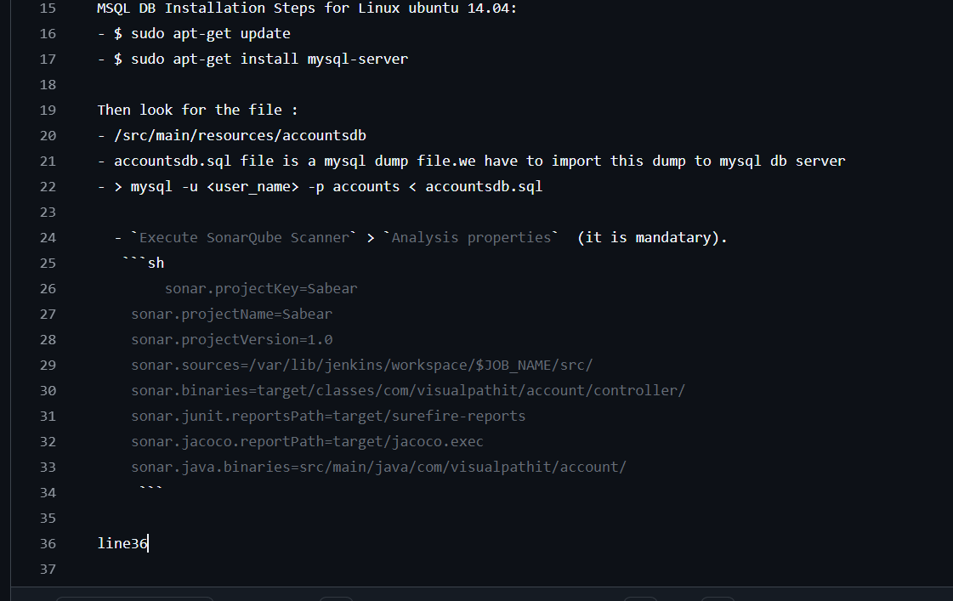
Added a change in readme file
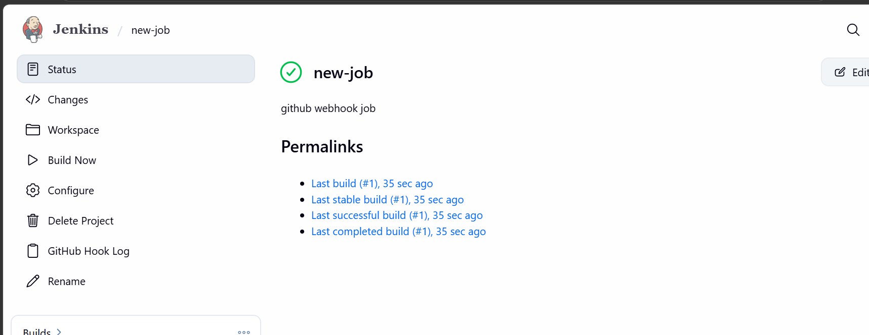
We can see that job is built
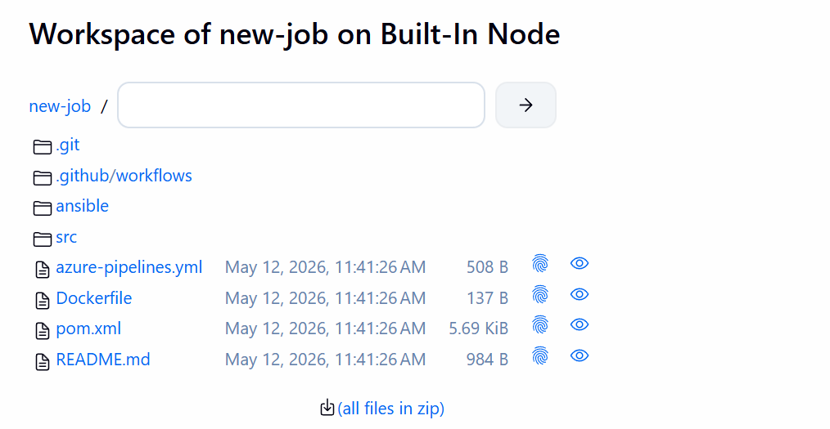
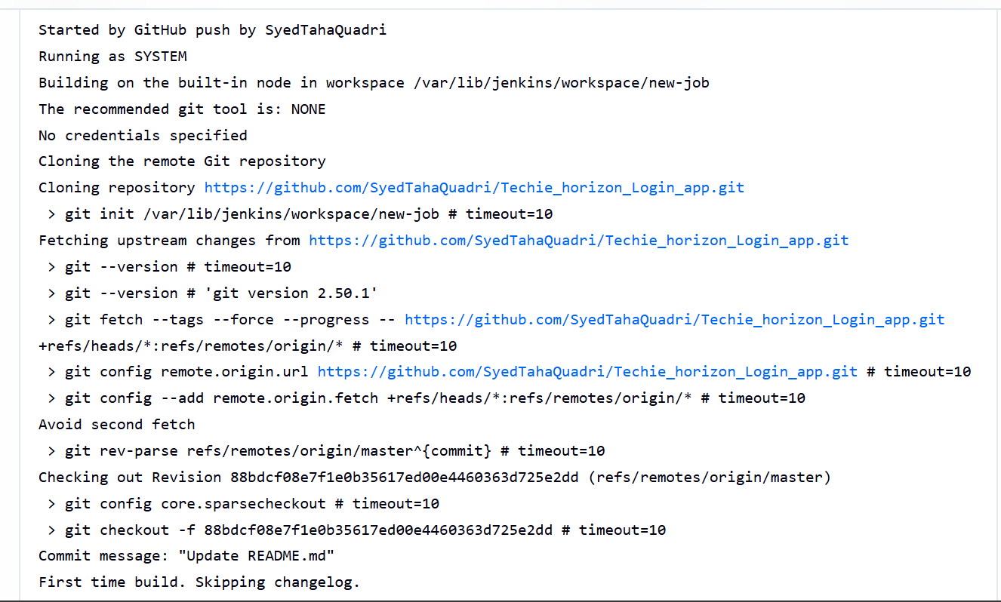

The github webhook setup worked perfectly fine.

- ConfigurePoll SCMandBuild Periodicallyoptions in the Jenkins job.

Go to the Jenkins GUI and create a new item
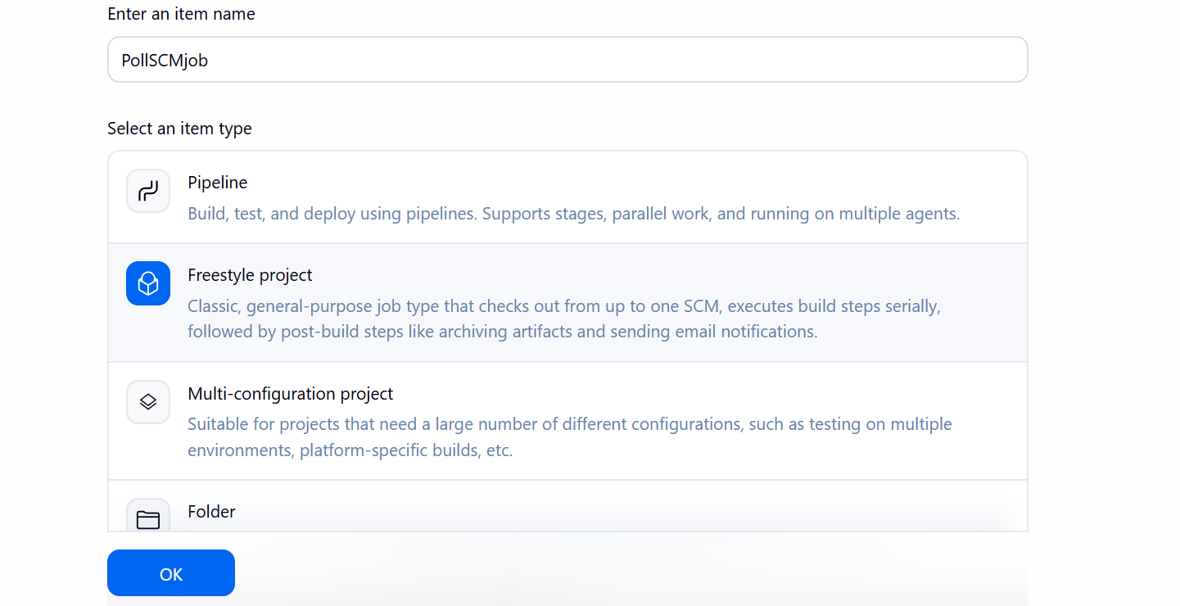
Give a name and select freestyle project
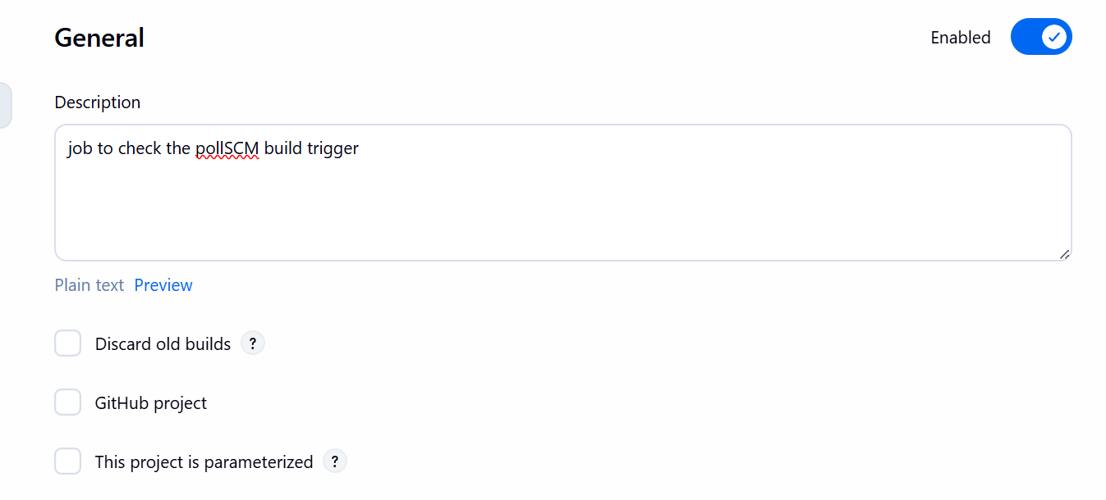
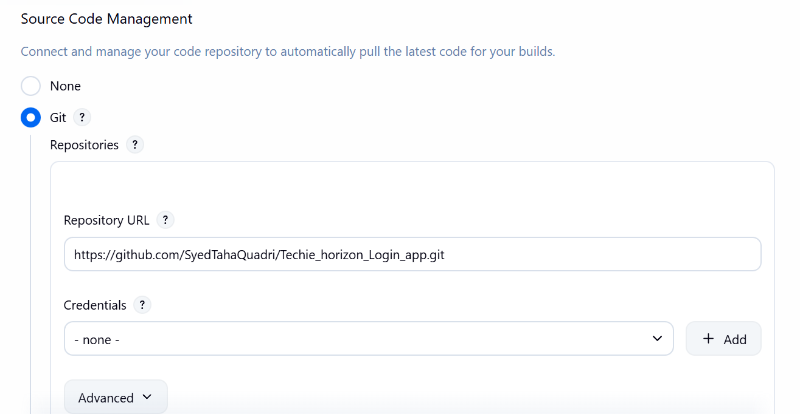

Selecting the git repo
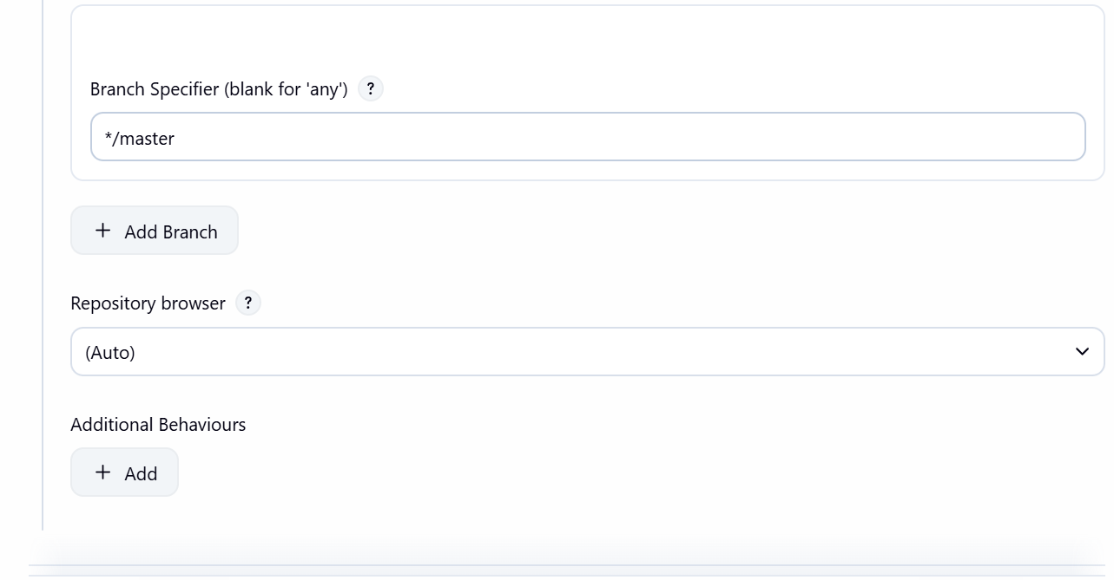

In build triggers select Poll SCM
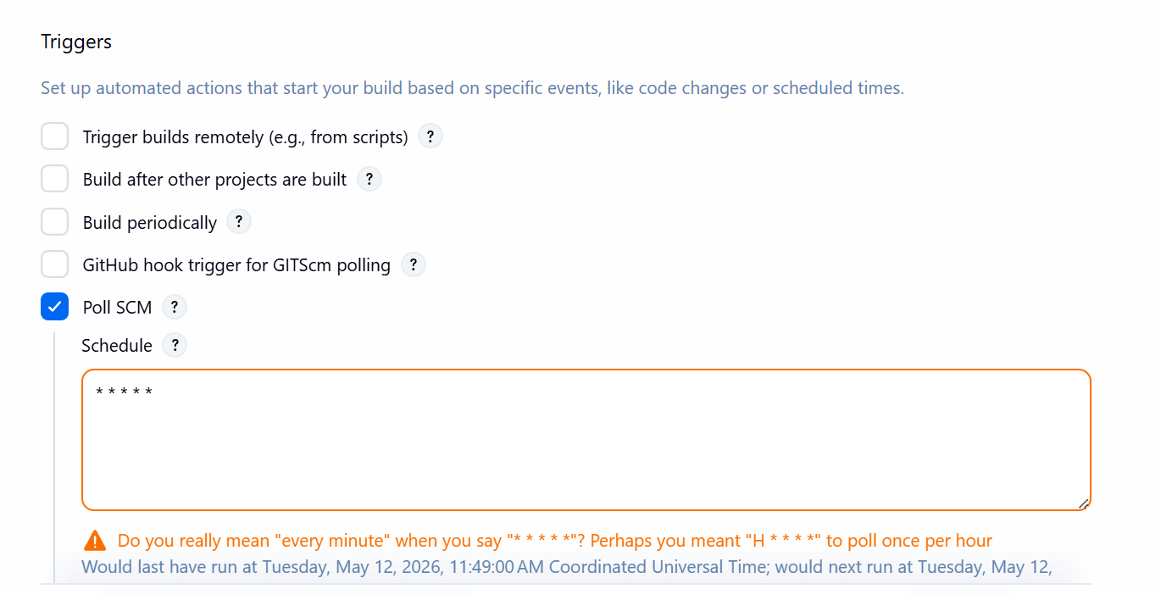

And we have scheduled it to run every minute every hour every day for testing
It means if there is any change in our github repo then the job will run
Now save it
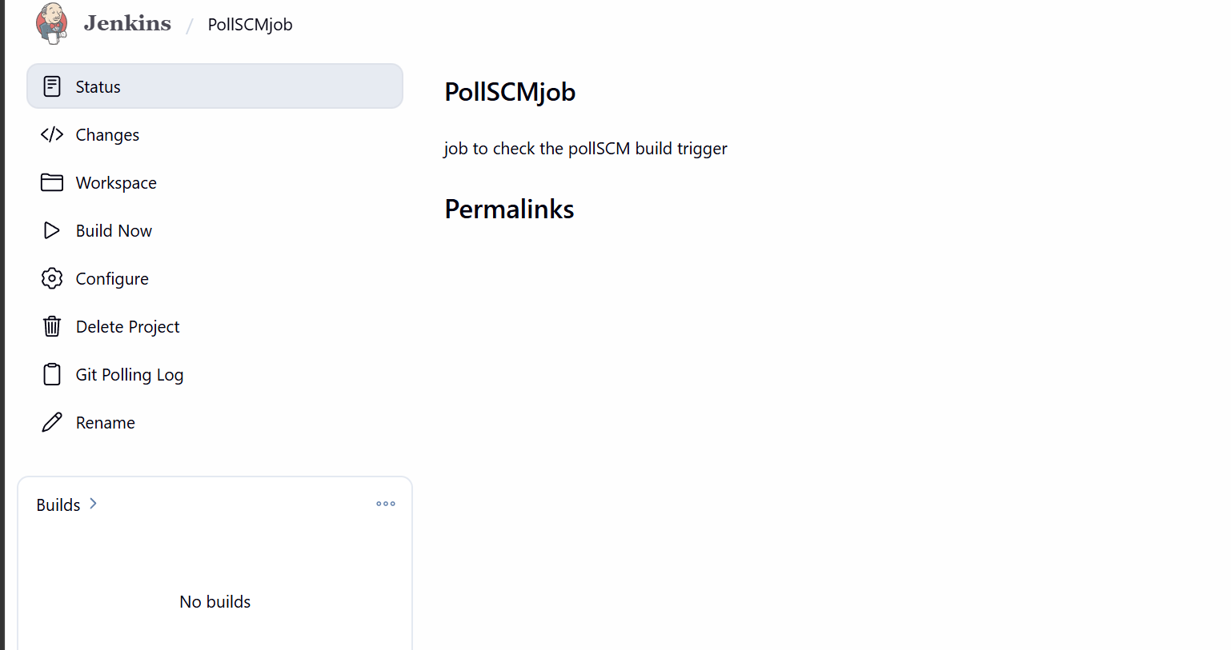

The job is now created now lets do some changes in our repo
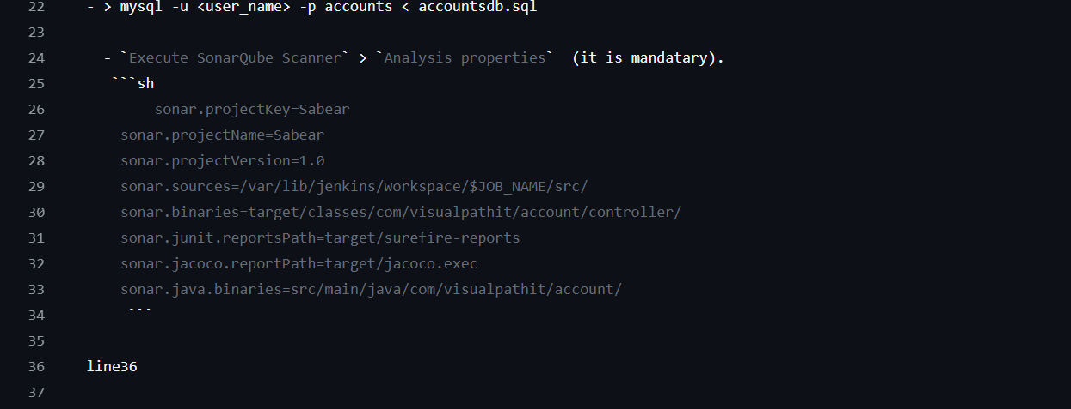

Lets remove the line36 which we added earlier
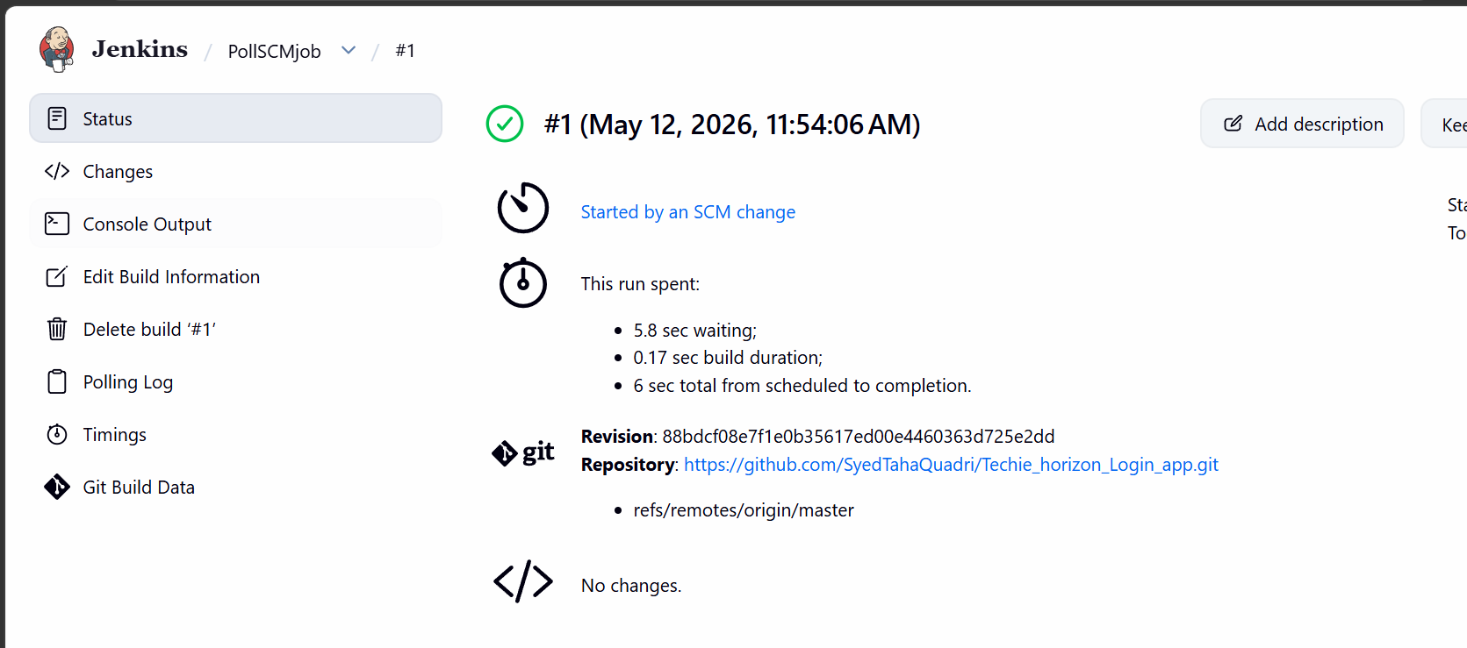
We can see the build is triggered now
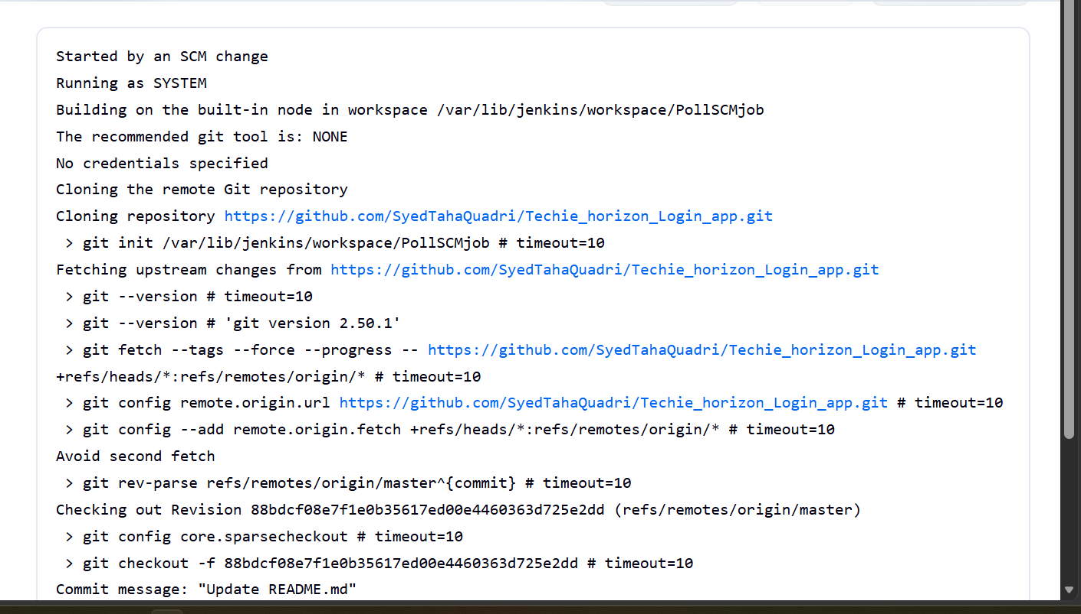

Now lets do build periodically
Go to gui and create a new item
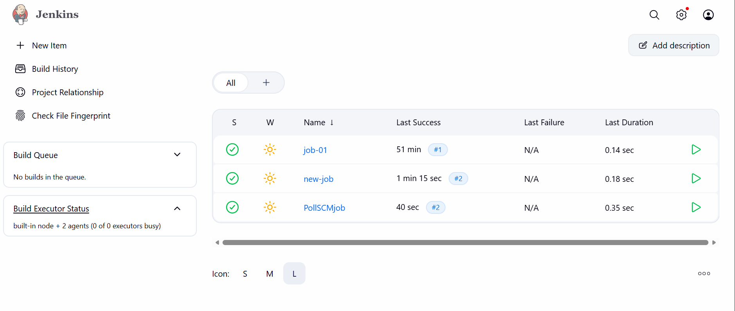

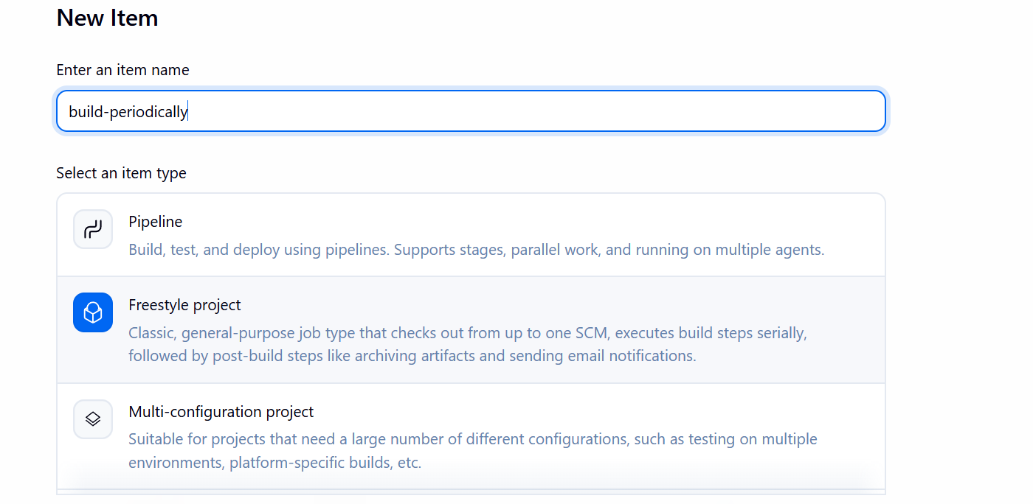

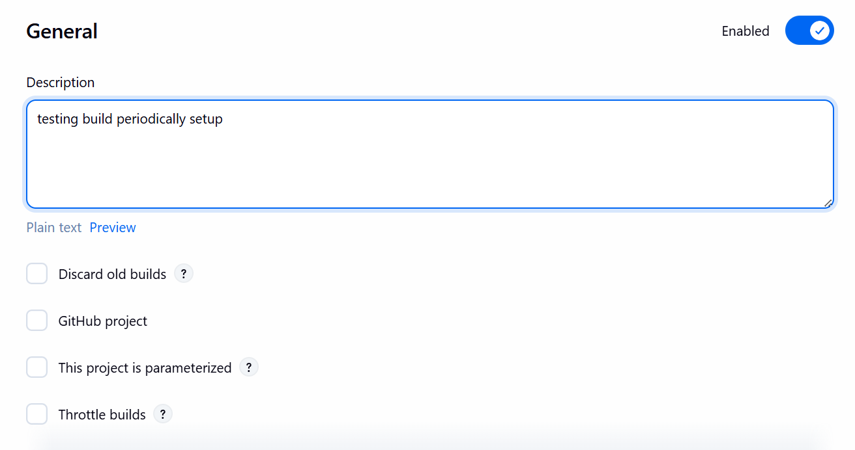
Selecting the git repo

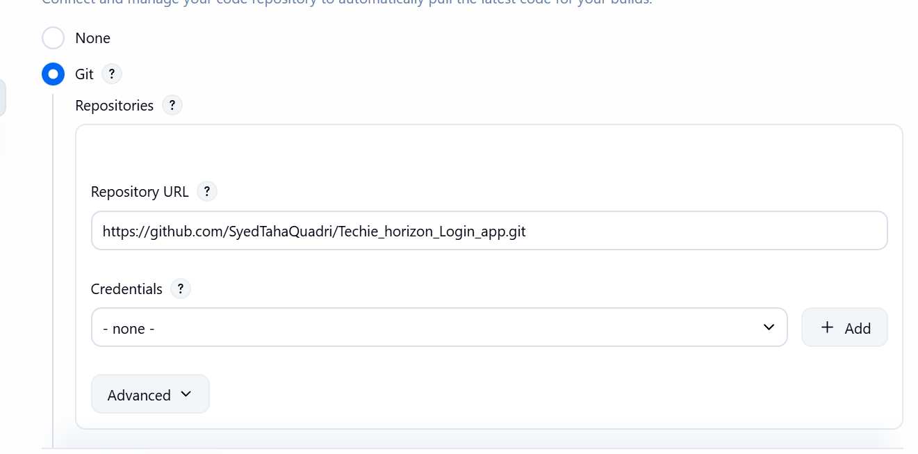

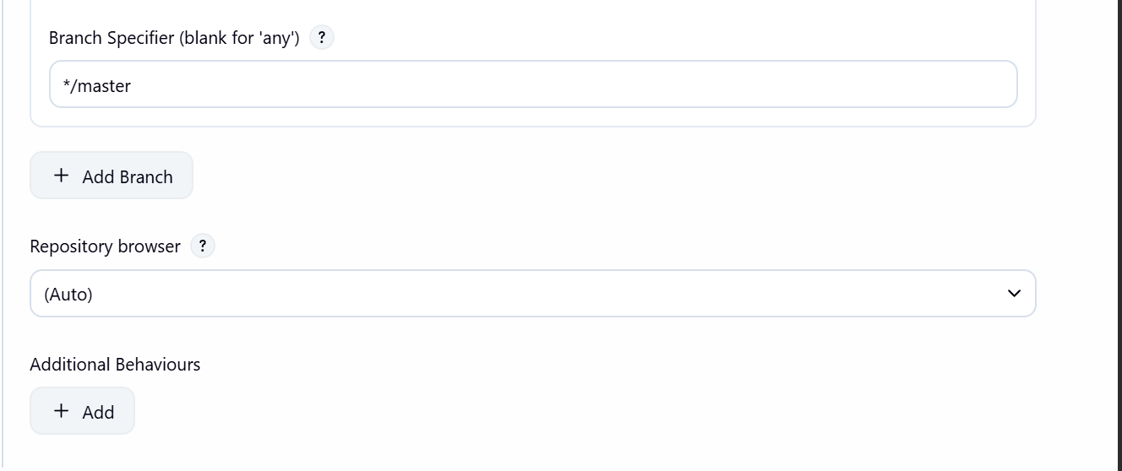

\ 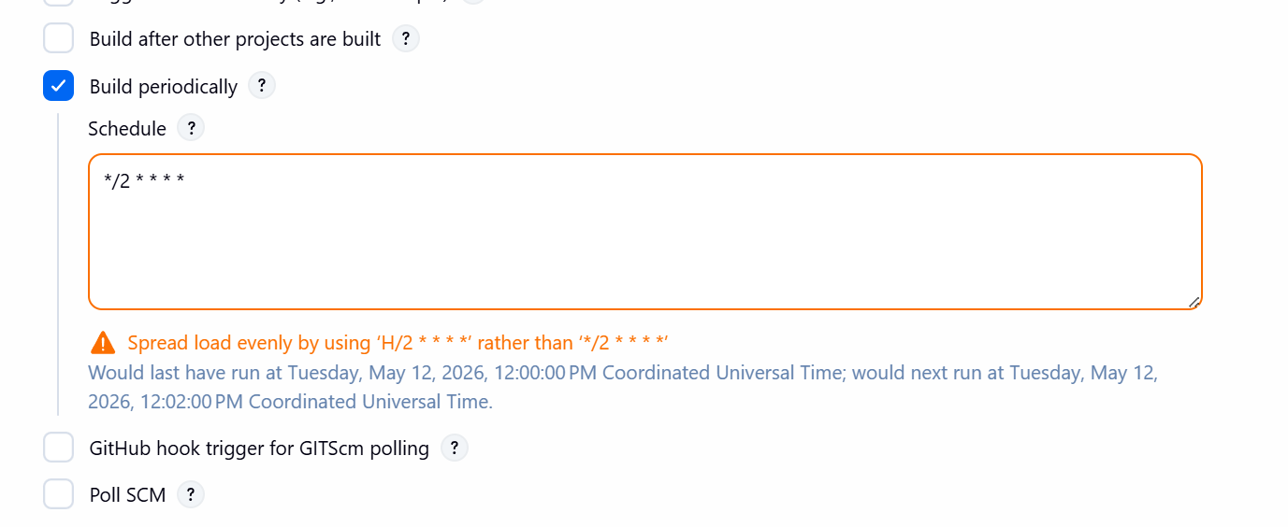

Now lets see if is working in every two minutes
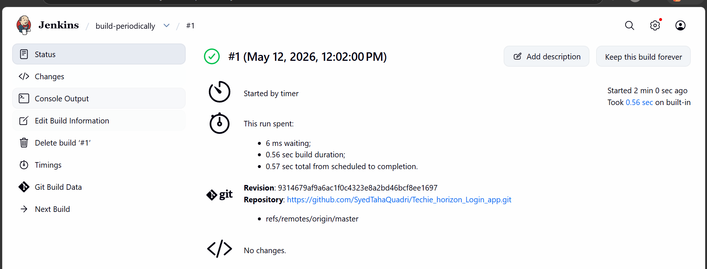

Now we can see that the job ran in 2 minutes automatically
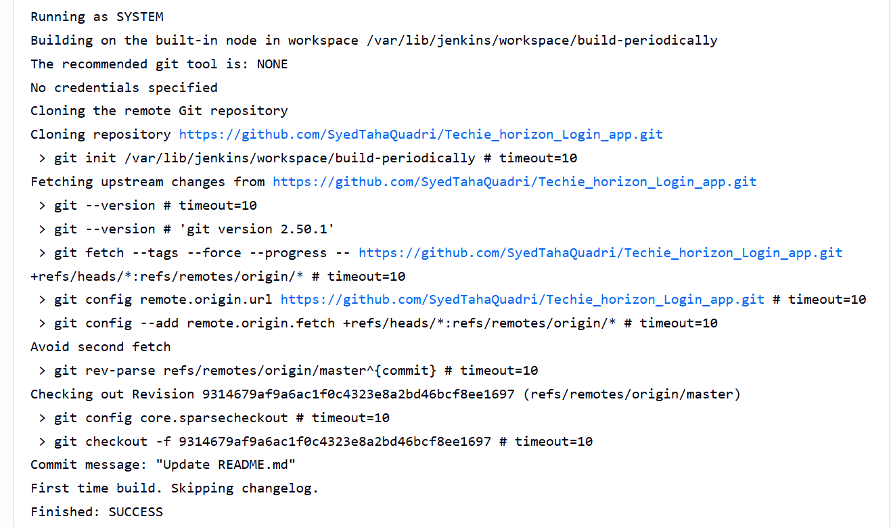

One more is triggered in another two minutes
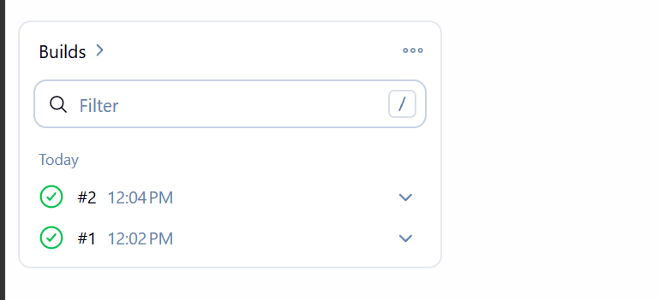

The difference is build periodically will execute the job irrespective of any changes in repo in contrast to the poll SCM which will only trigger if any changes happened to our repo.

- Create a bash script to take a backup of Jenkins server

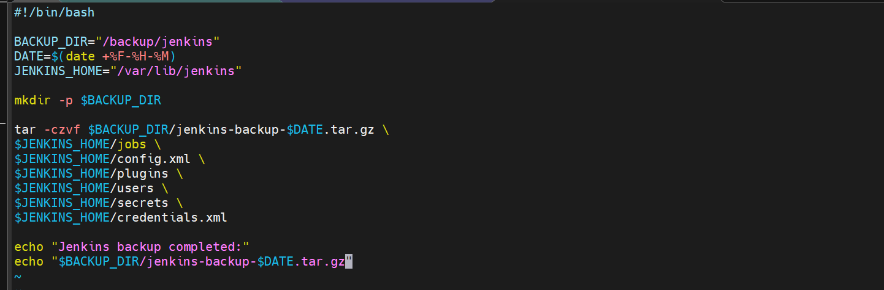

This is the script to take a backup of our server
Giving the permission
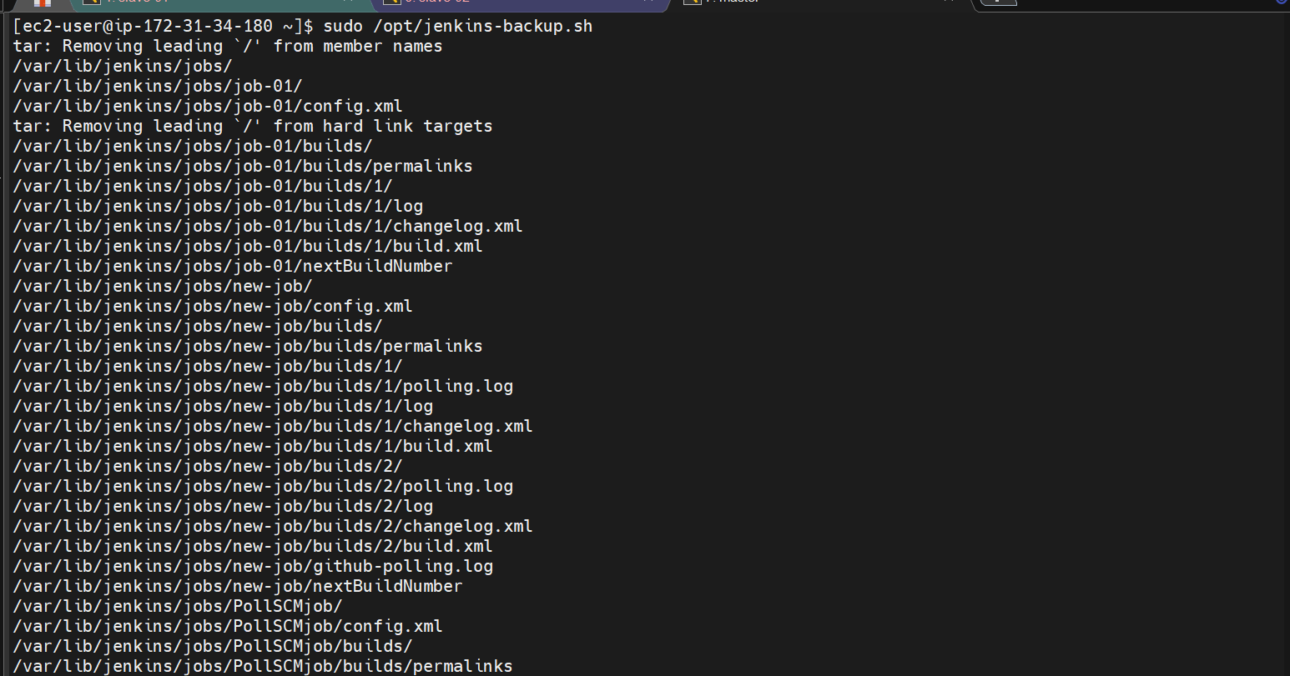

When we execute the script the backup is now created
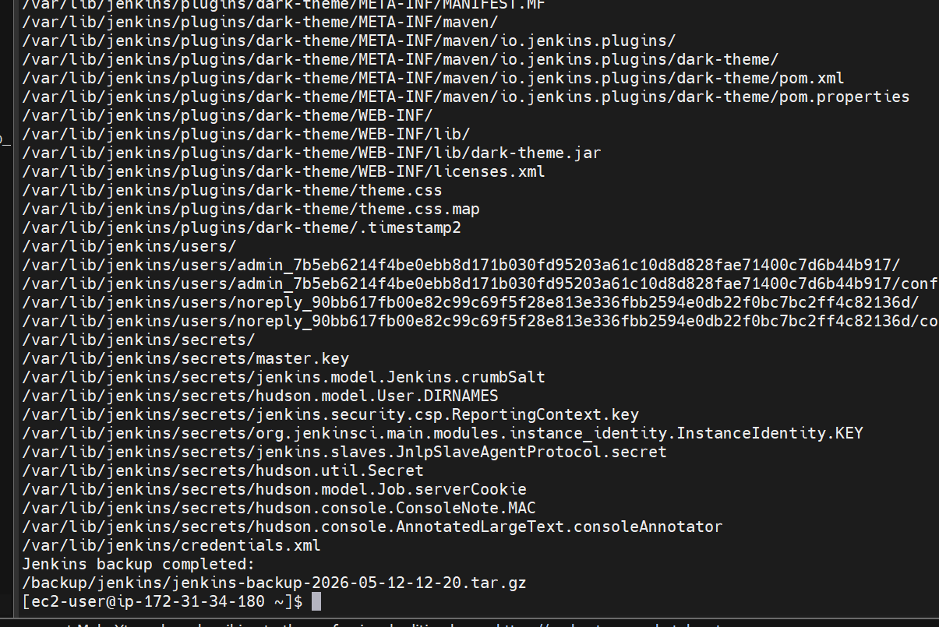

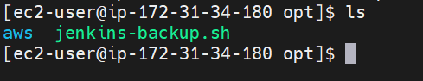

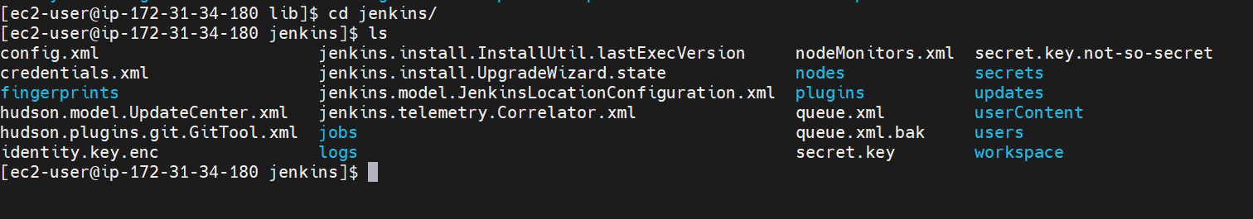
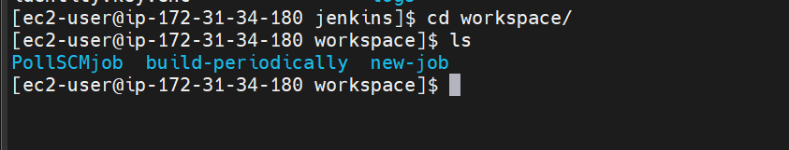

These are the files we have in our workspace folder

- Take a backup of Jenkins using theThinBackupplugin.

First lets see if we have the plug-in installed or not
If not then lets install it

Go to manage Jenkins and plugins
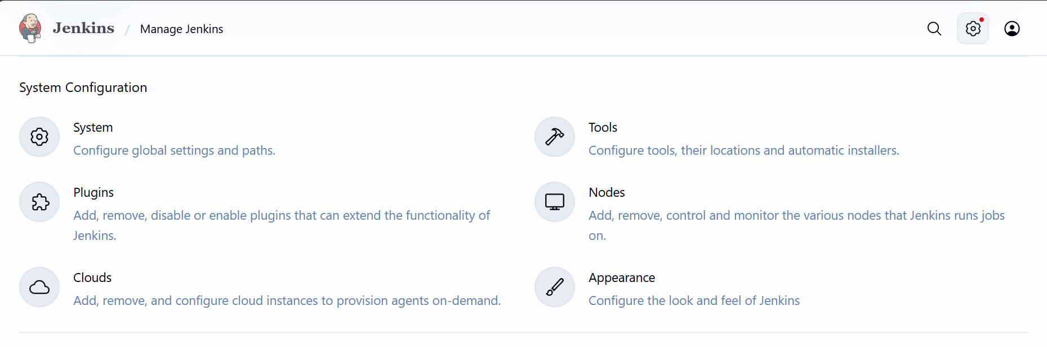

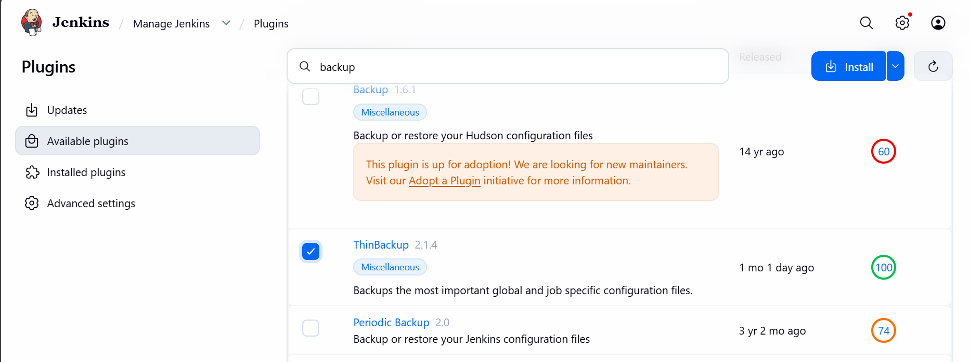

Now install plug-in
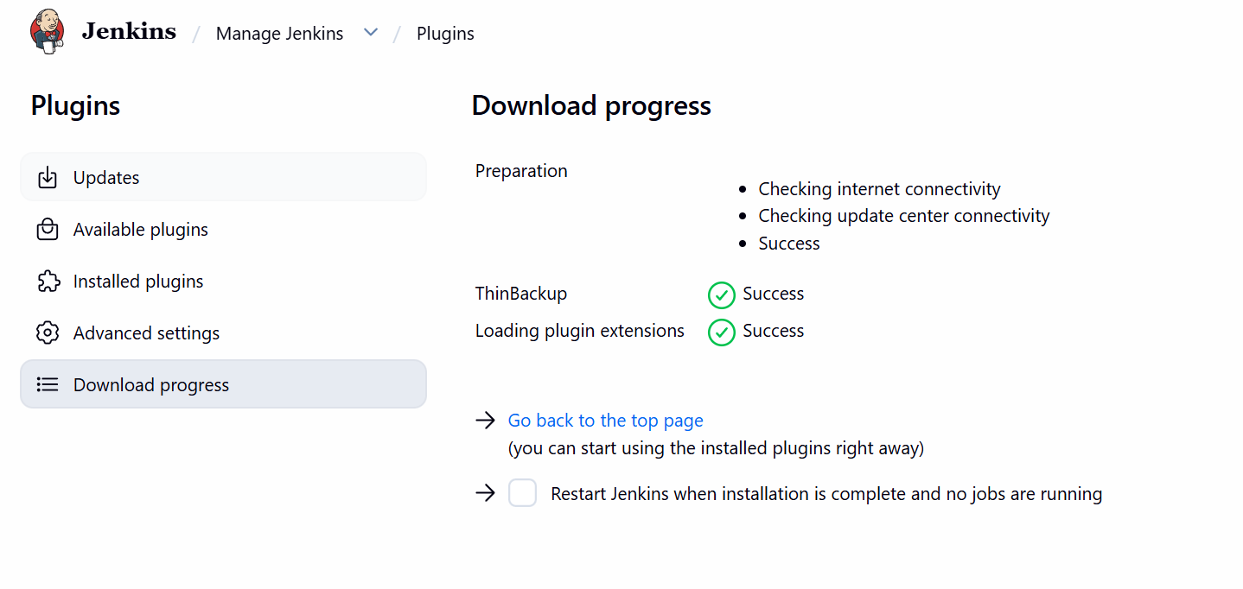
Plugin installed
Now go to manage Jenkins
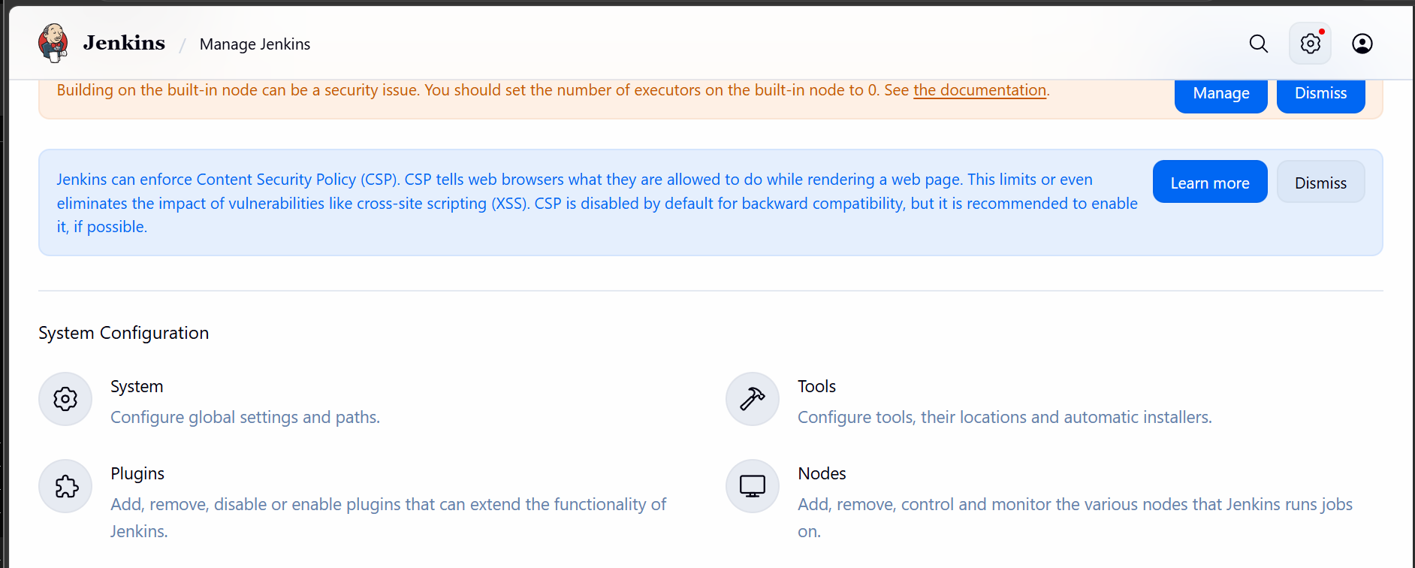

Click on system
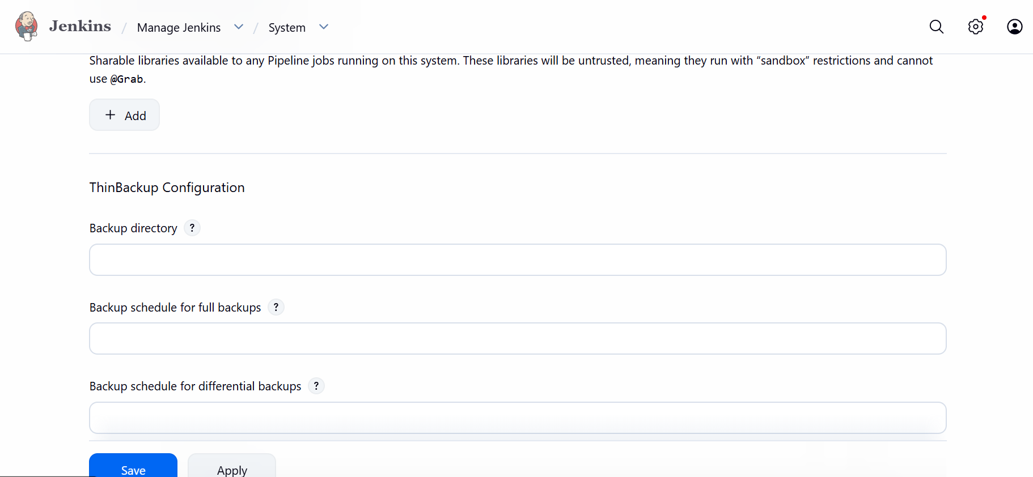

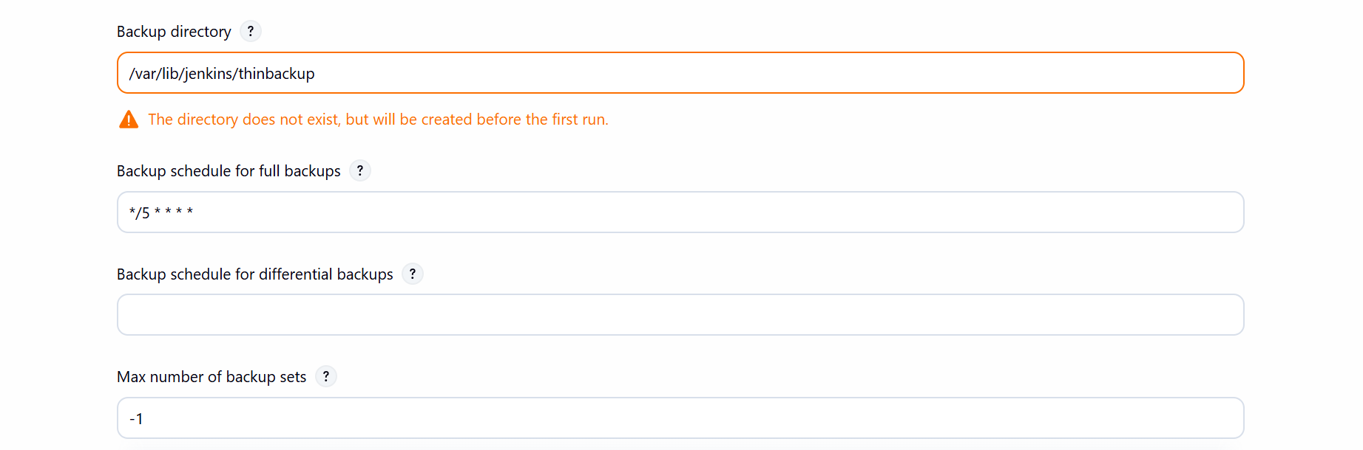

Creating backup directory and scheduling it for every 5 mins means the backup will
Be taken every 5 mins
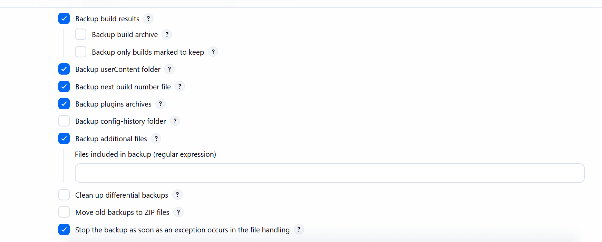

The backup is now setup
Now lets go to manage Jenkins and manually create a backup
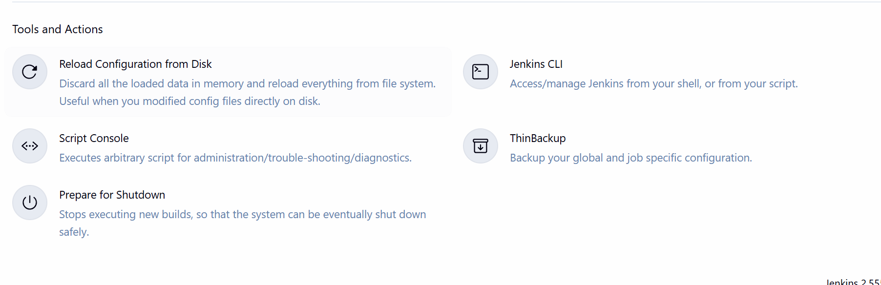
Under tools and actions there is an option thinbackup click on it
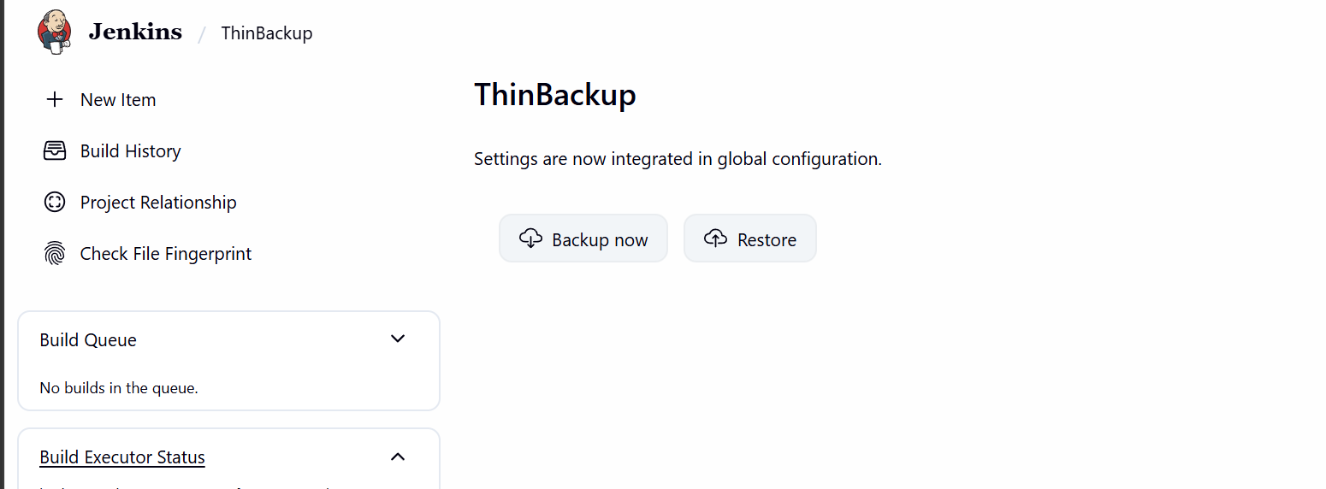
Click on backup now
Lets now verify it in our Jenkins server

We can see the backup files are now created
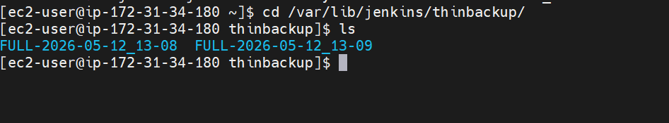

- Set up a new Jenkins server and restore the backup taken in task 4.

First lets setup our new Jenkins server
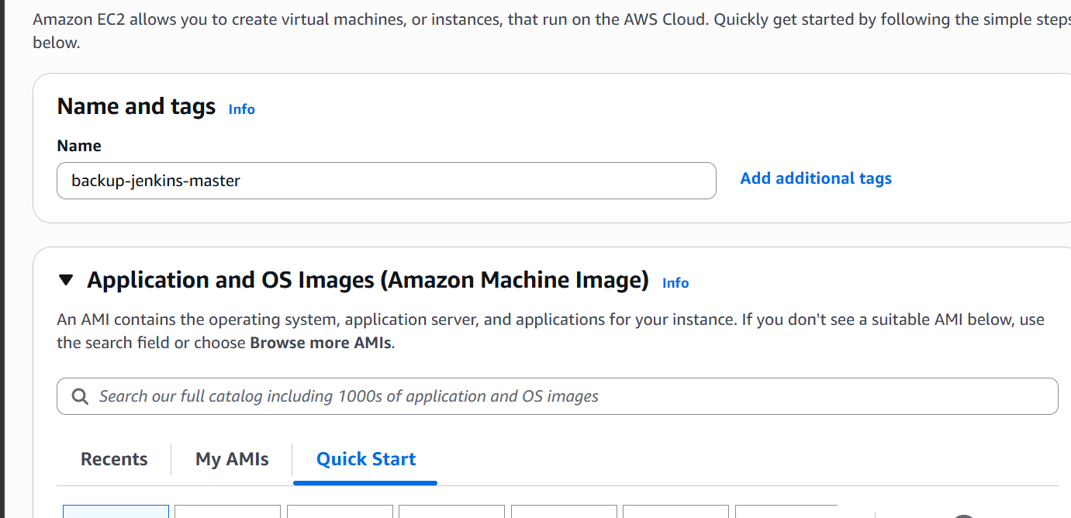

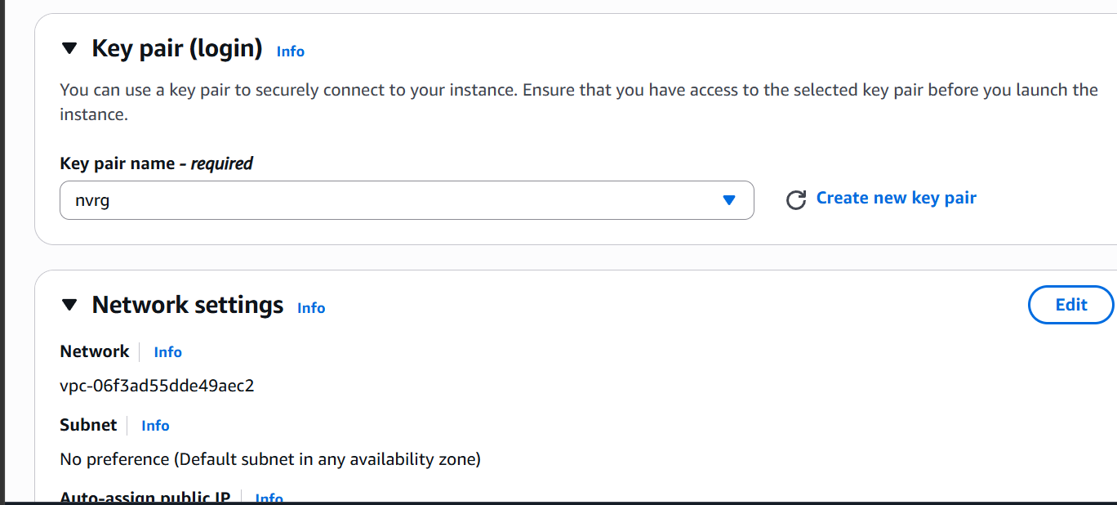

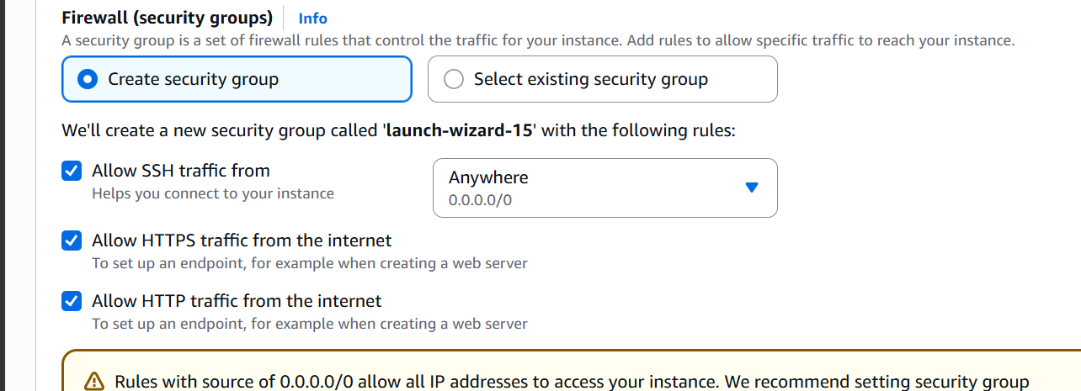

Lets ssh into the new server
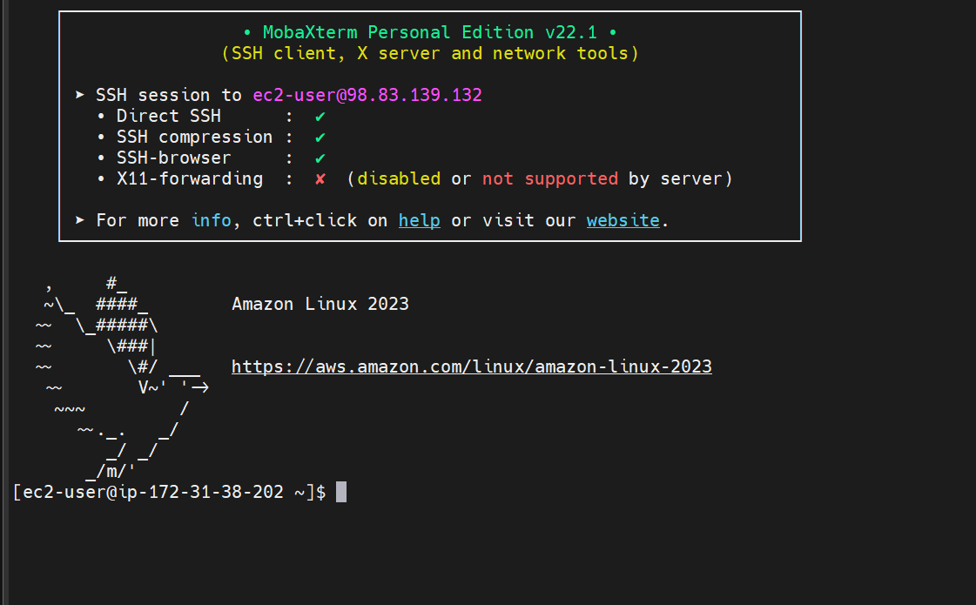

Updating package and downloading the Jenkins package
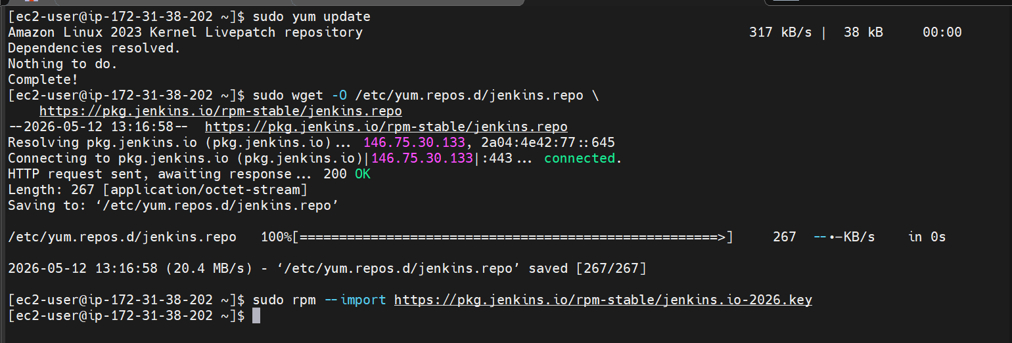
Installing java
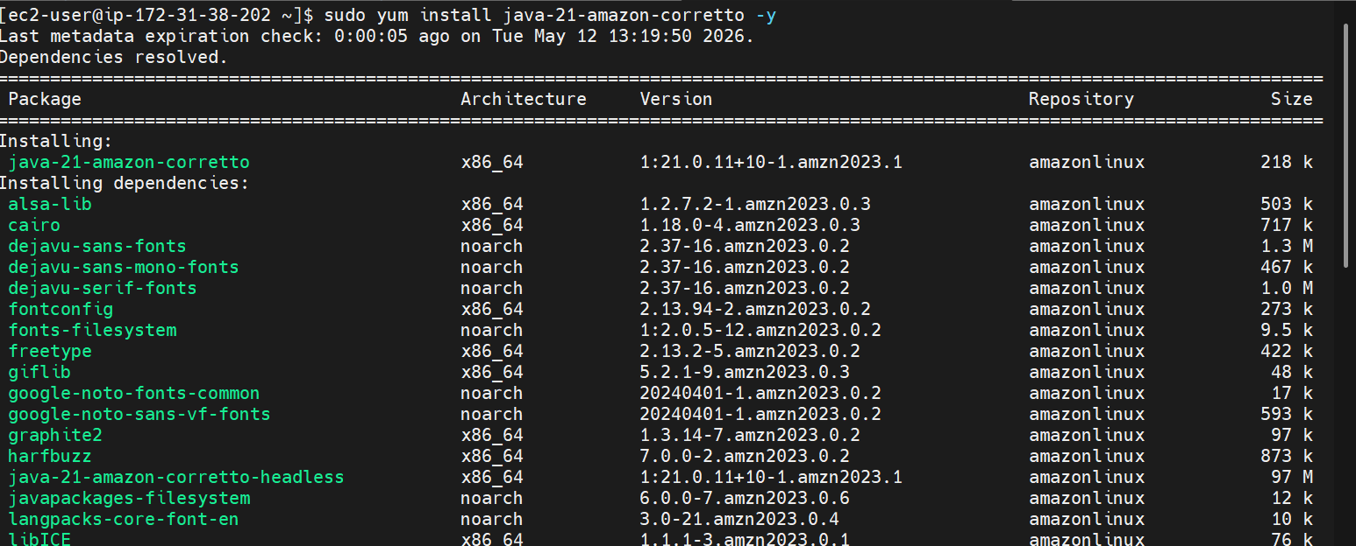

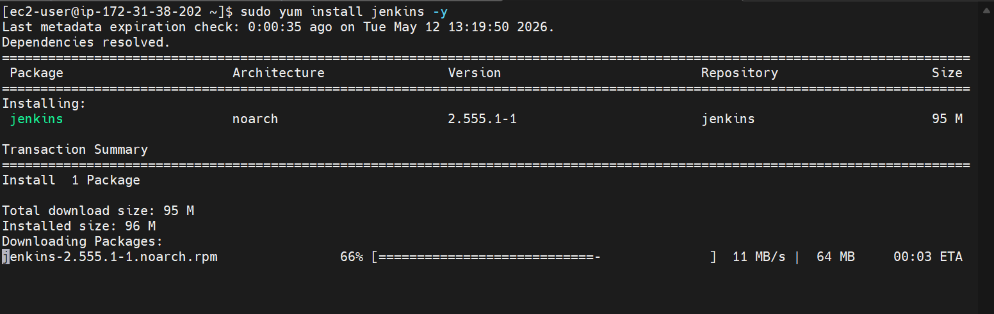

Installing Jenkins

Enable and start Jenkins
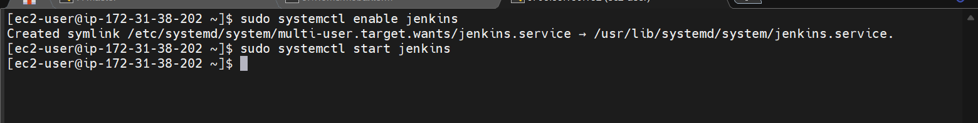
Now go to Jenkins master and copy the backup to the new server
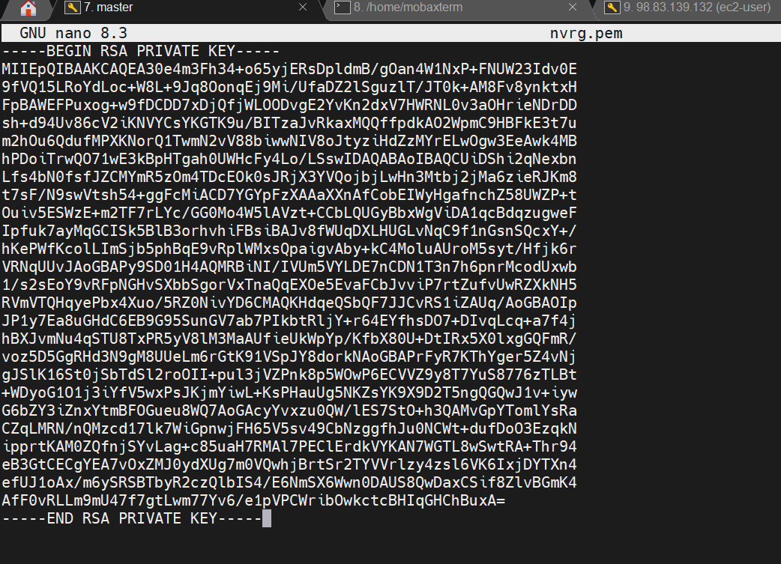

Copy the pem key to the server master server

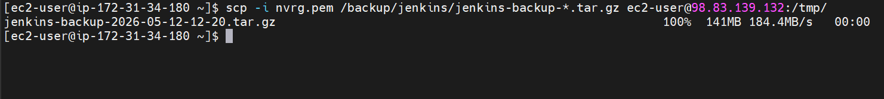

The file is now copied to the new server
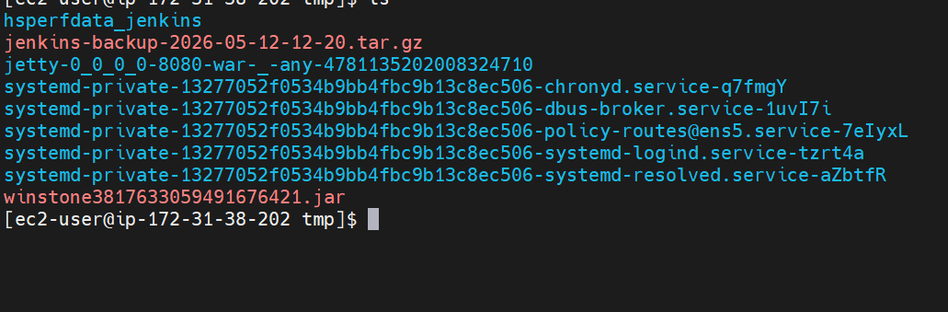
We can see the Jenkins backup file here

Stop Jenkins on new server
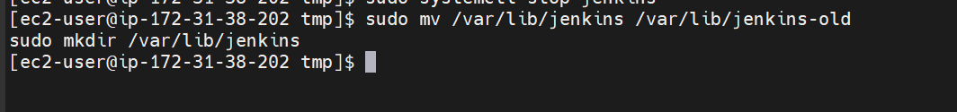

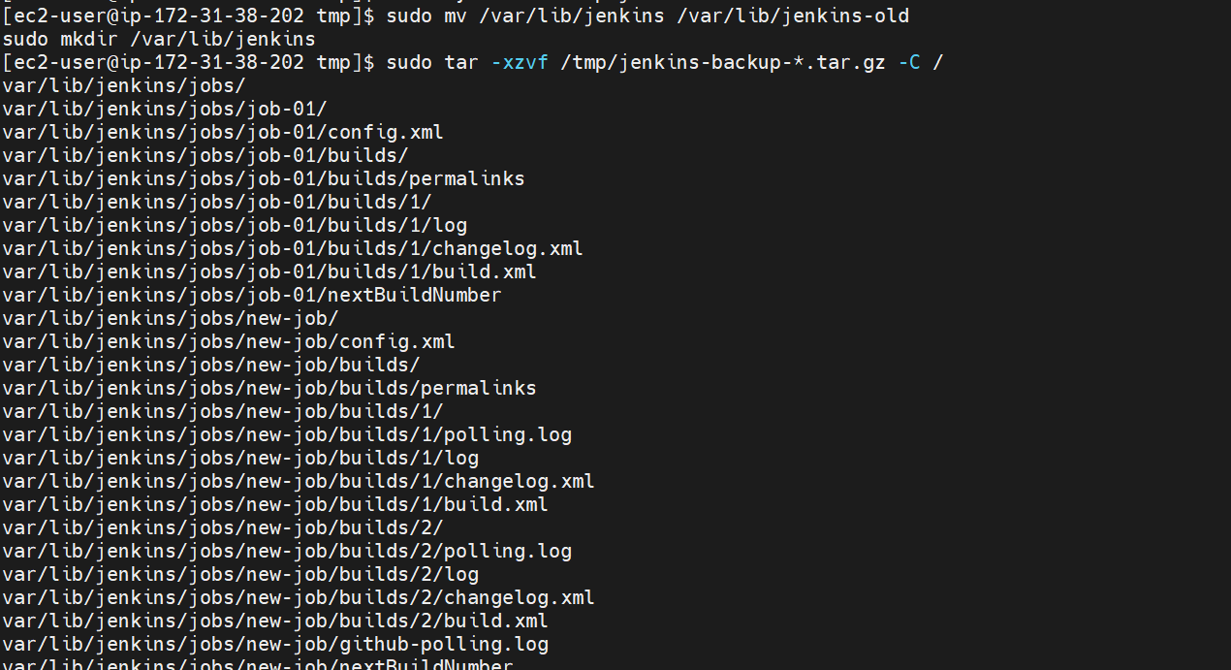
Extracting the backup

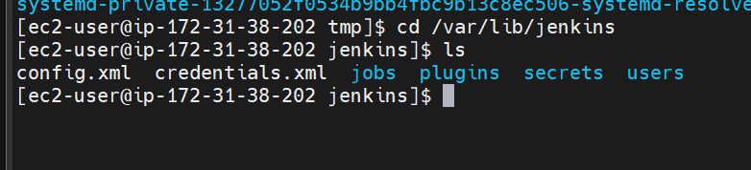
We can see that backup is
Now lets start Jenkins on new server
Lets now verify the backup in Jenkins GUI
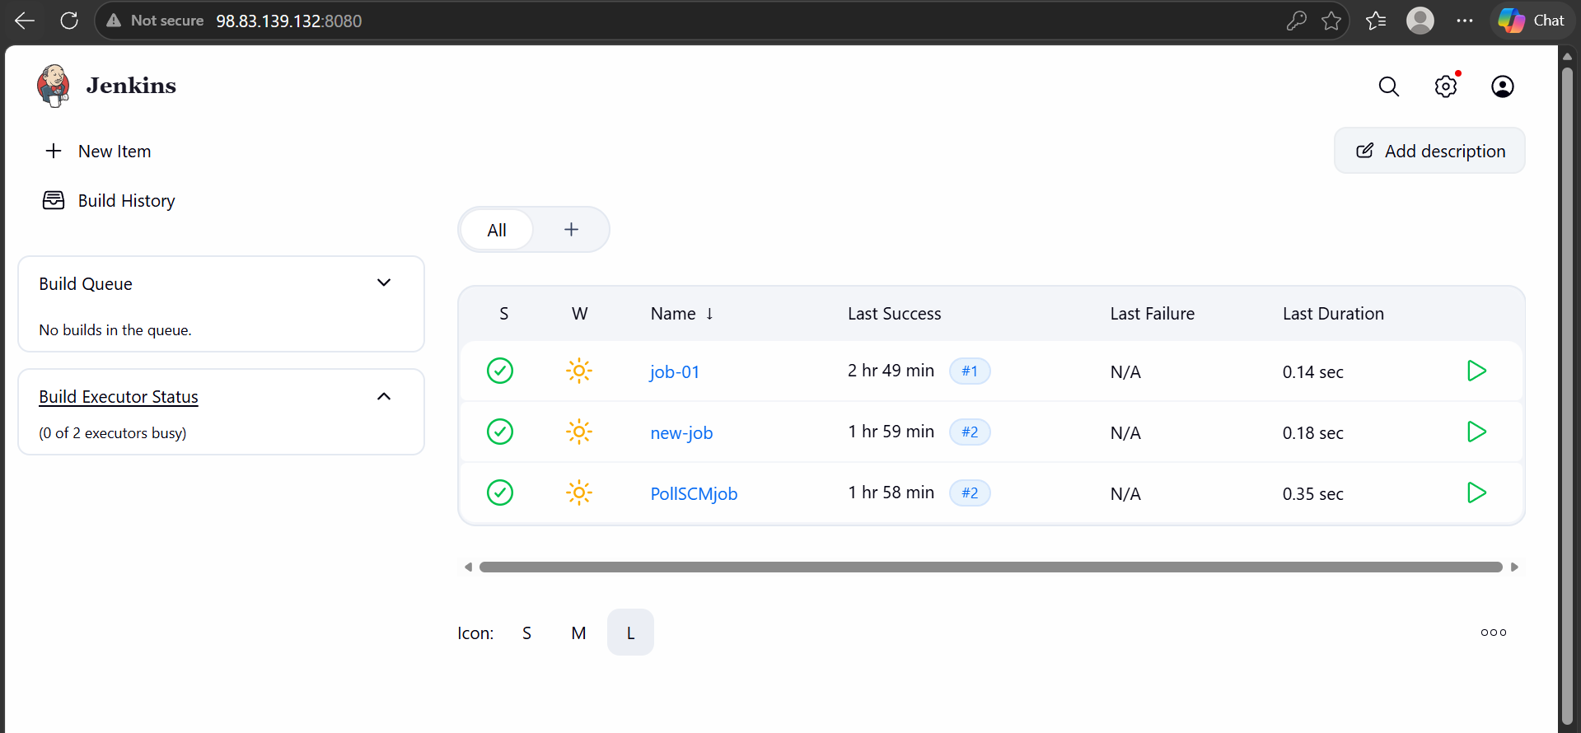

We can see the new backup is created in the new server

