Download and install Jenkins
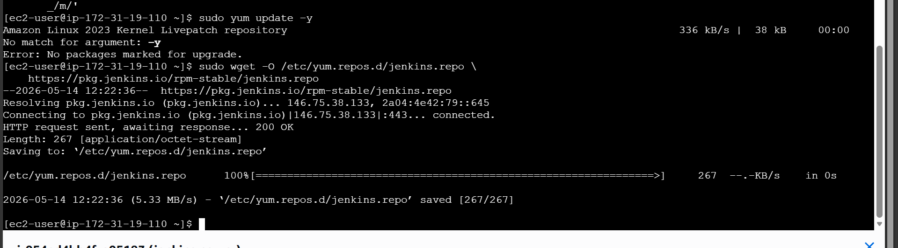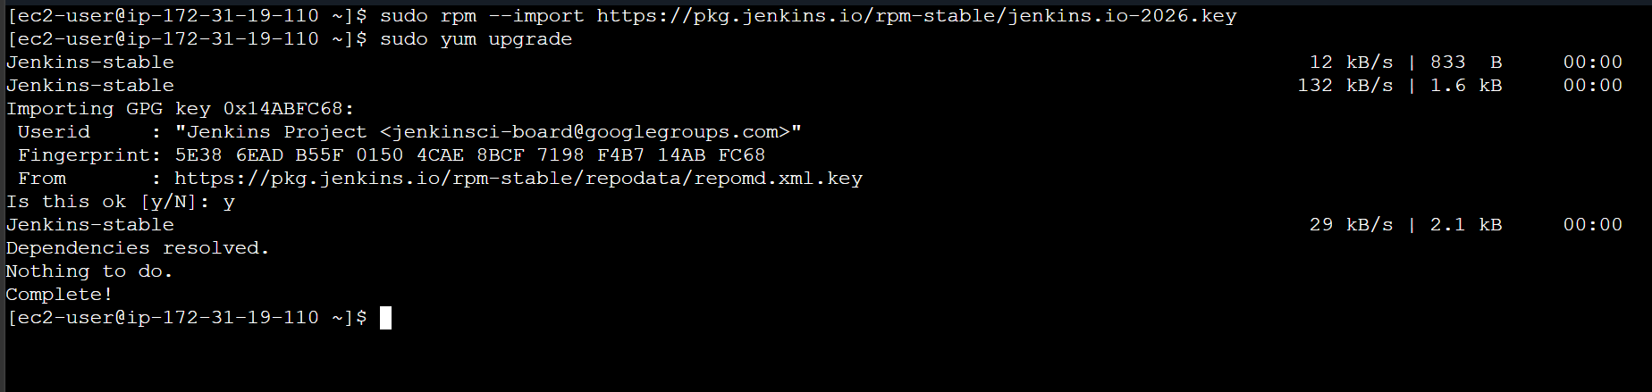
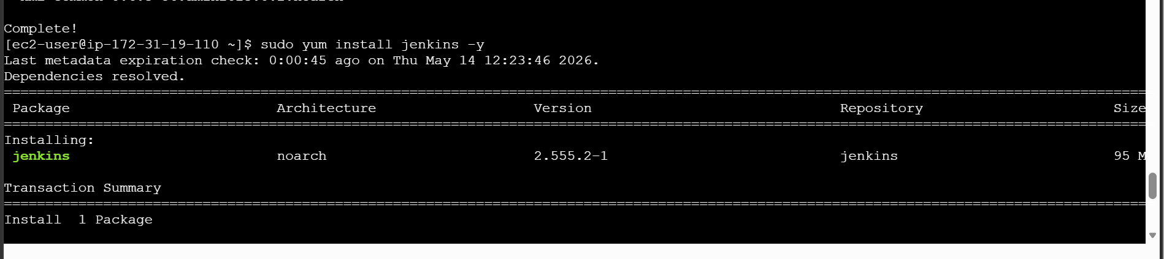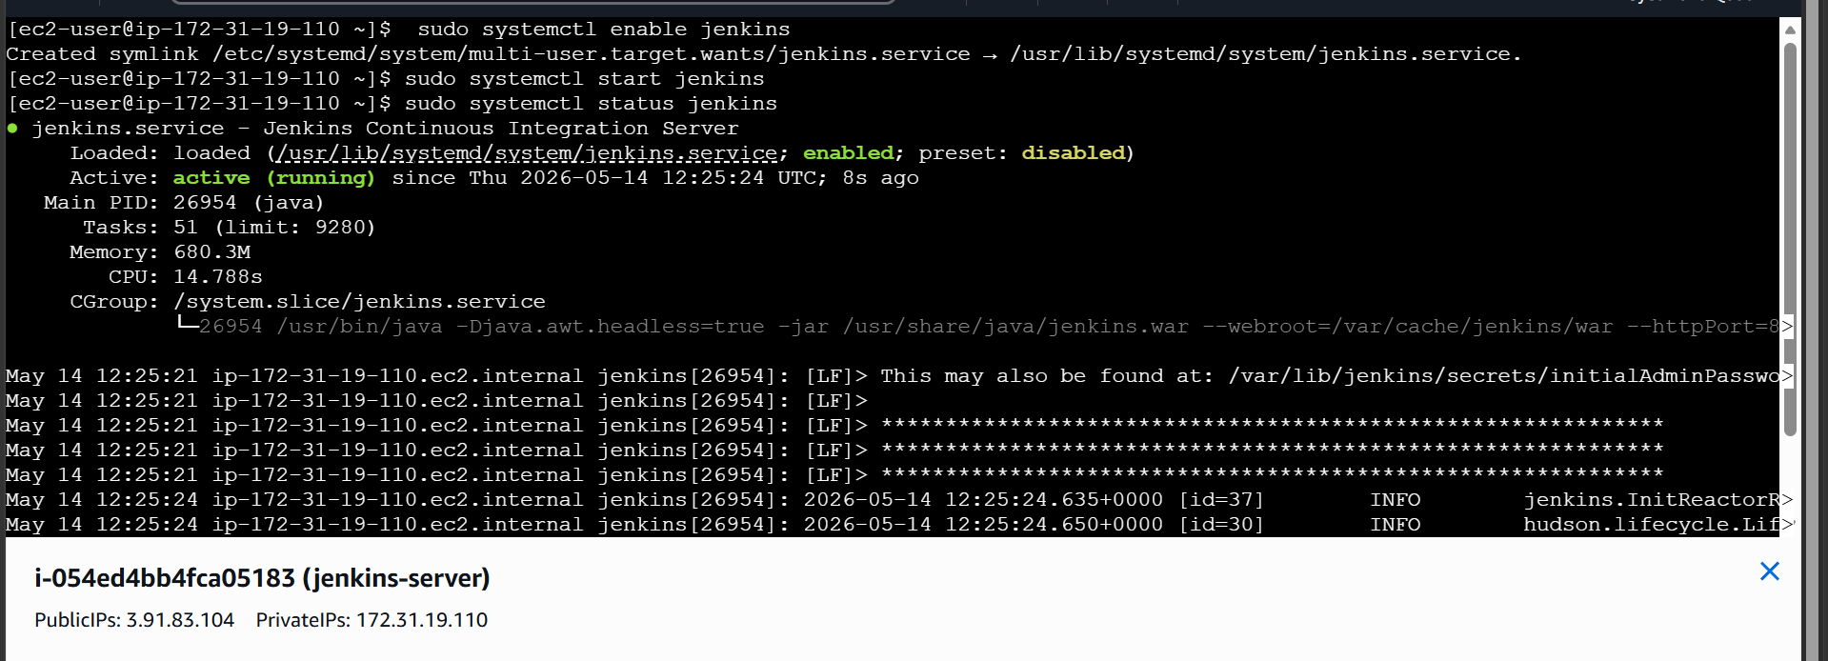
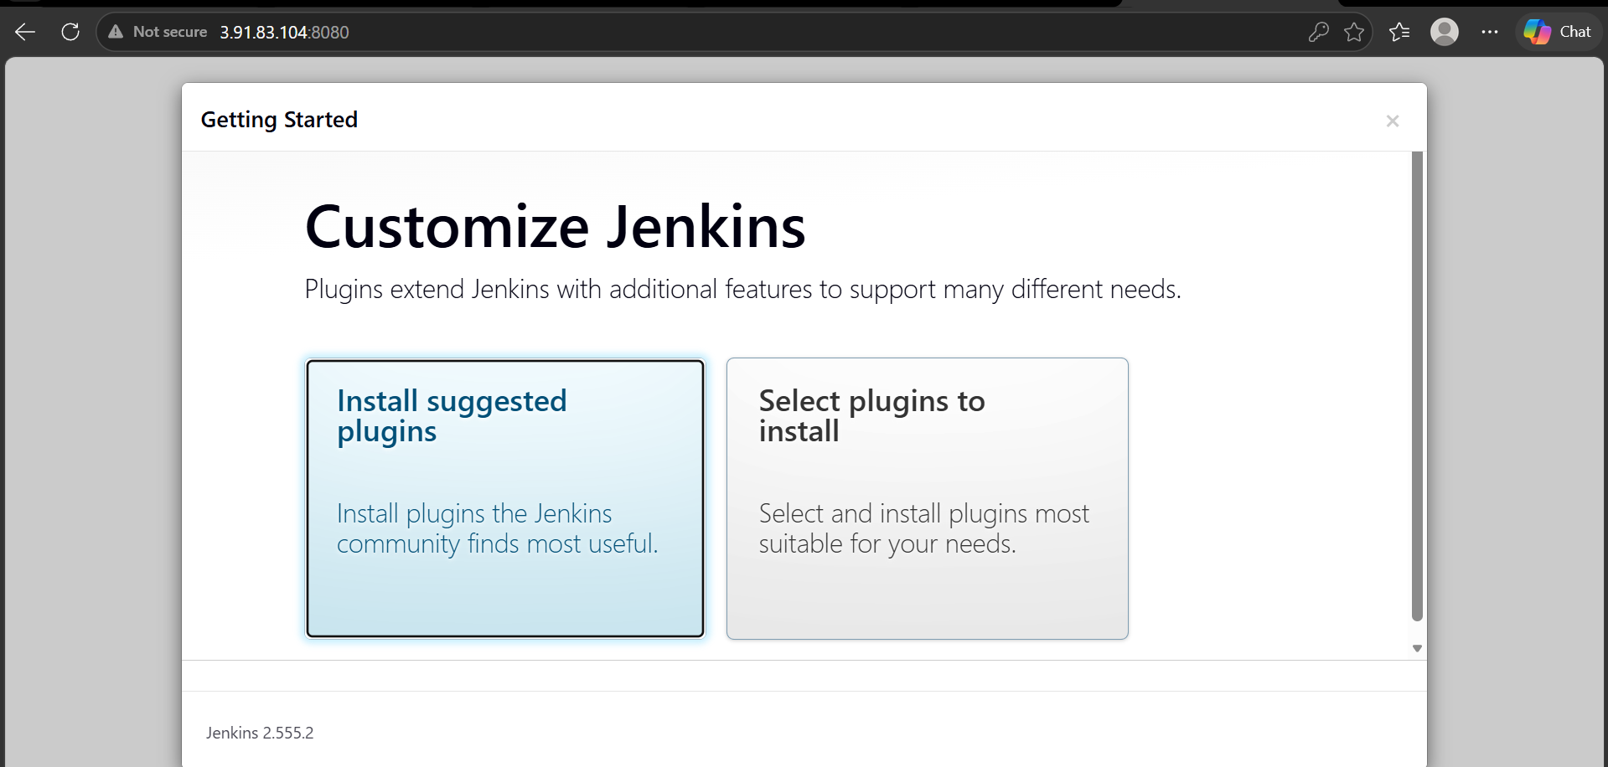
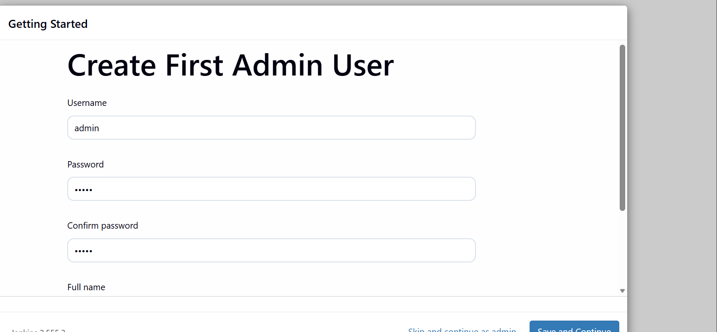

Clone a git repository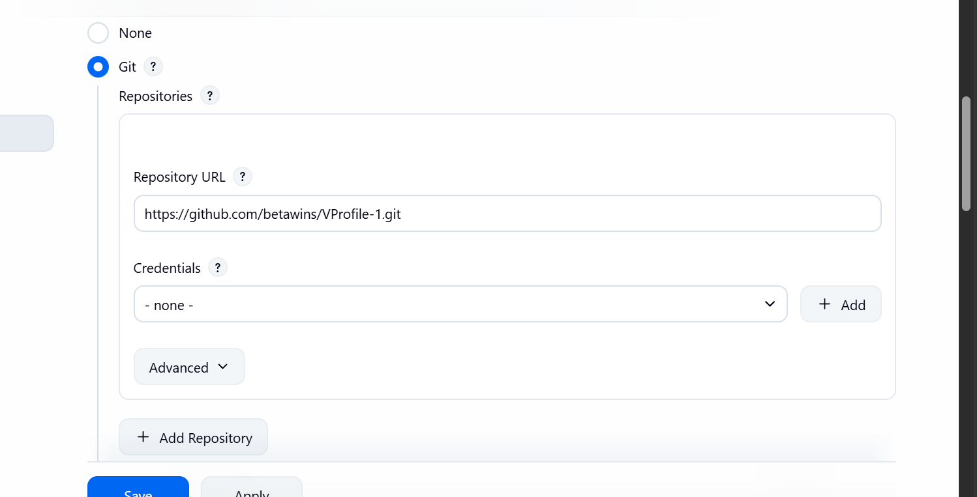
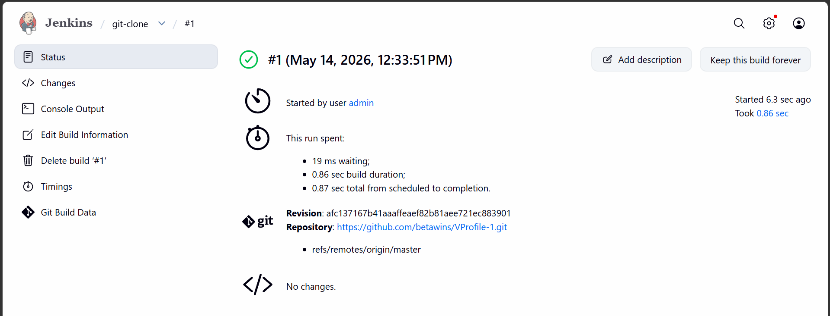

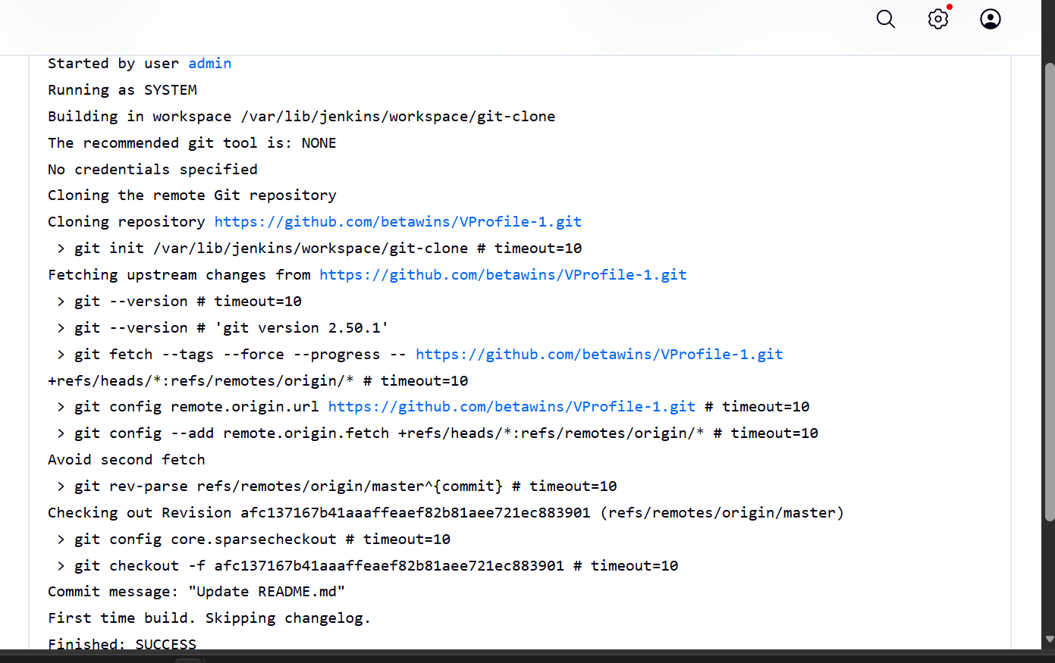

Now lets setup the sonarqube server

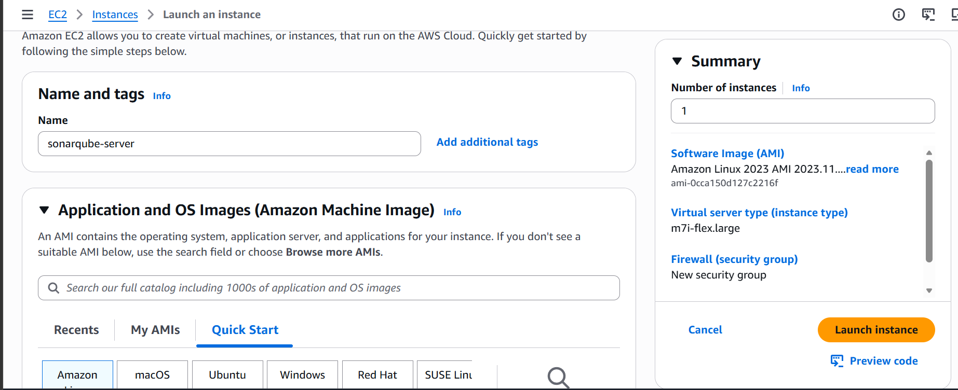
Java 1.8 installation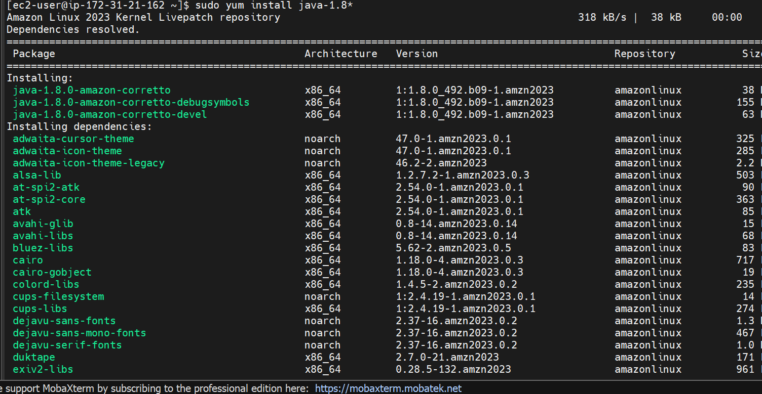

Download and install mysql server
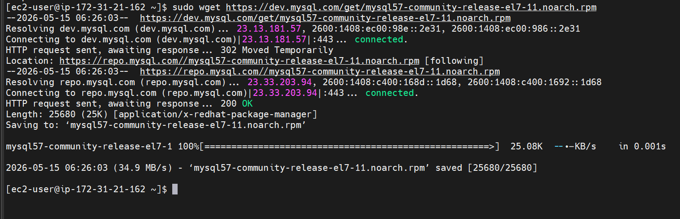
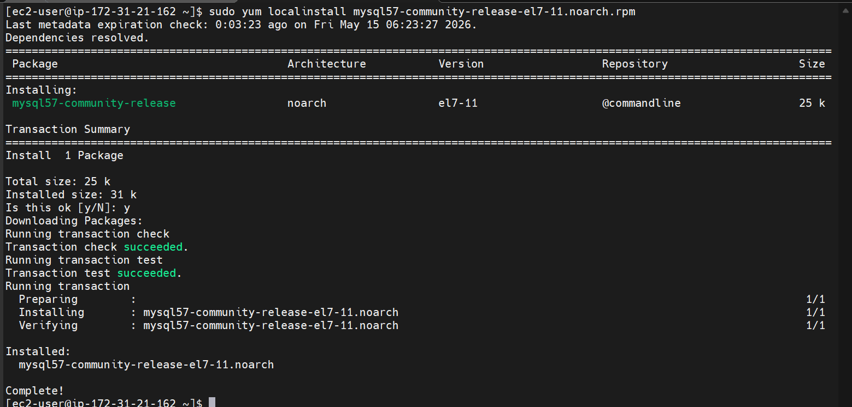
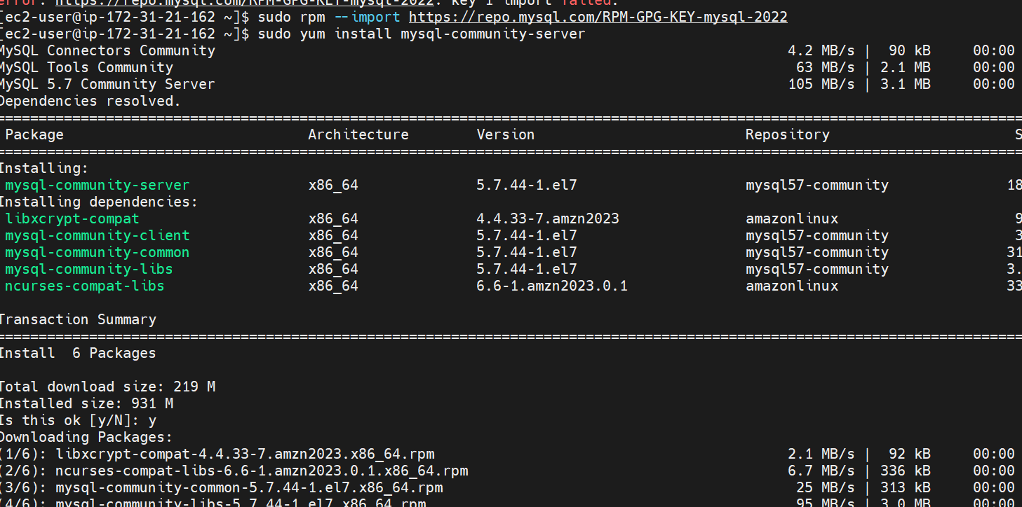
Starting and enabling mysql server
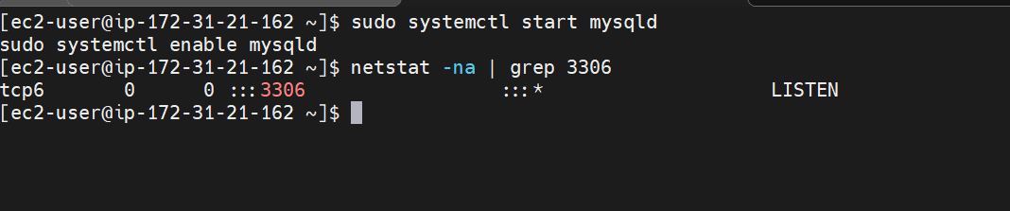
Generating a temporary password
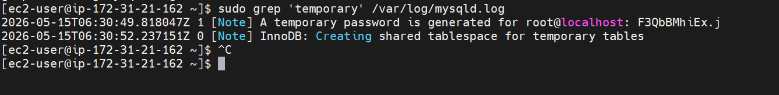
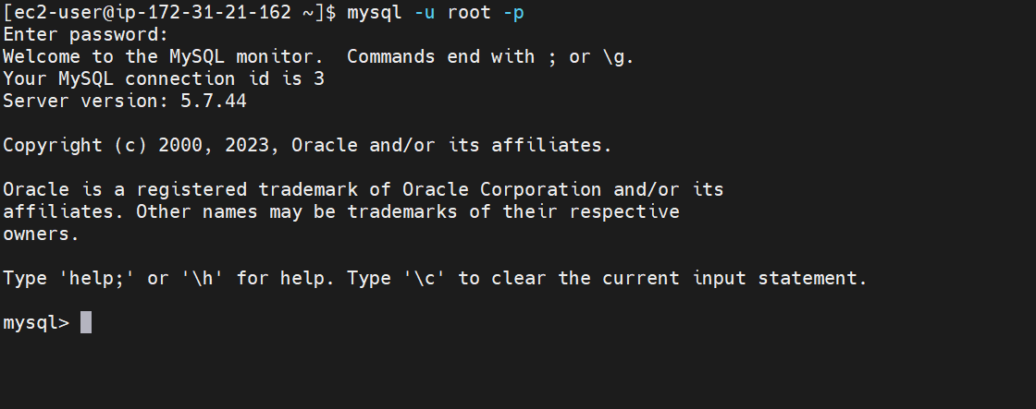
Generate a new password like this
ALTER USER 'root'@'localhost' IDENTIFIED BY 'Admin@123';
flush privileges;

download and install sonarqube 6
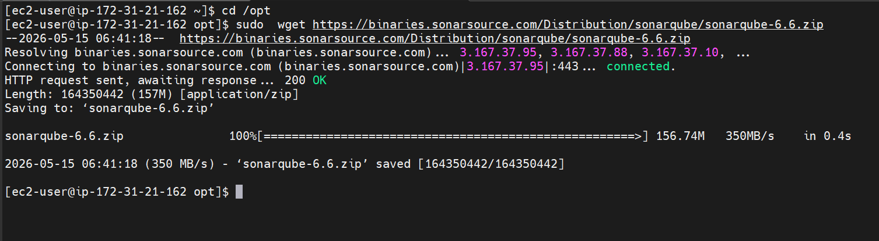
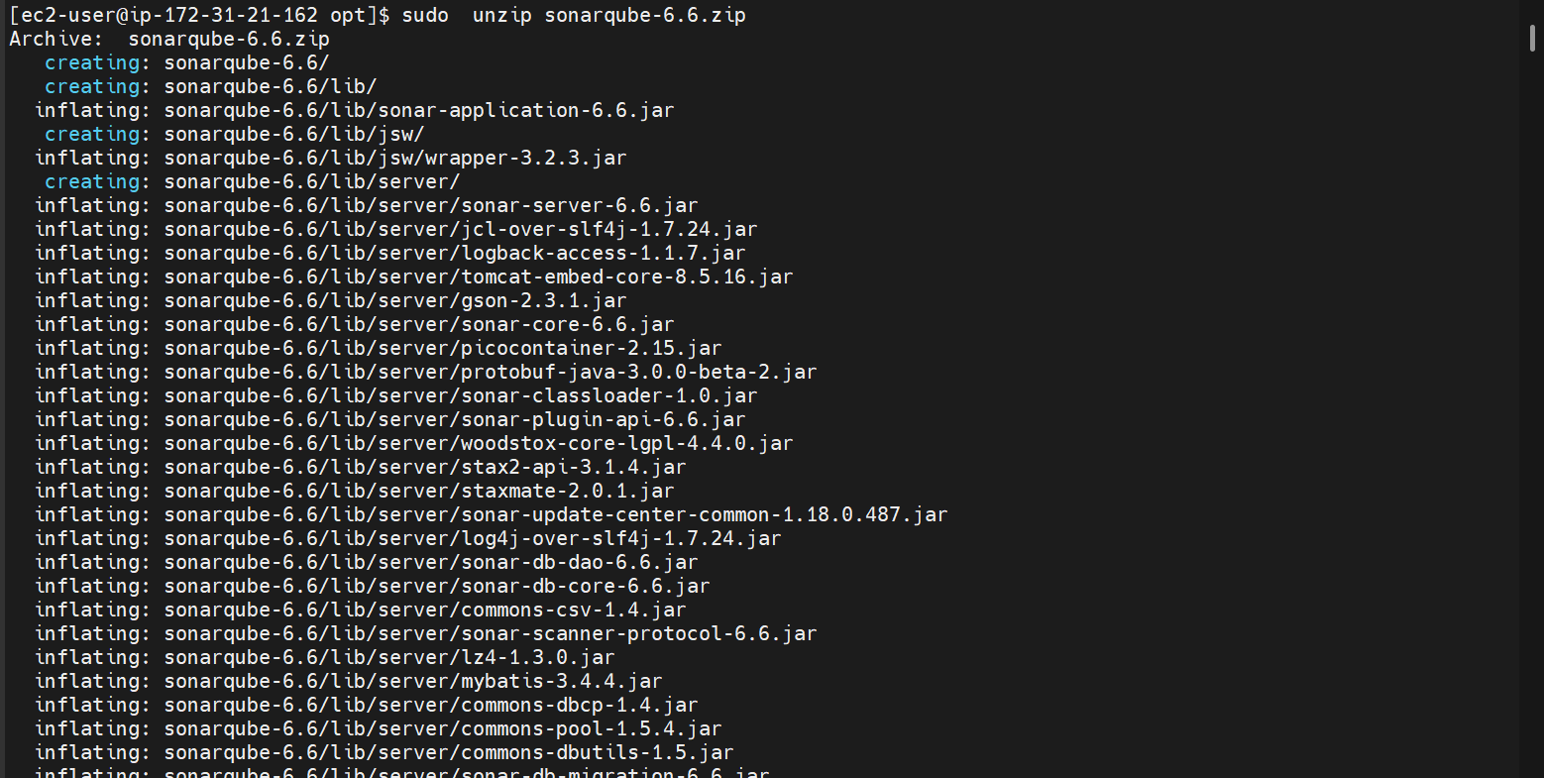
Renaming
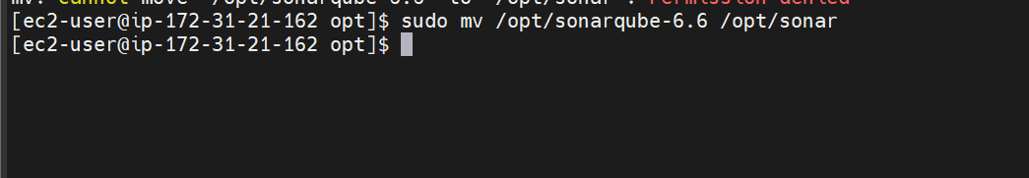
Now login to mysql server and create a database for sonarcube
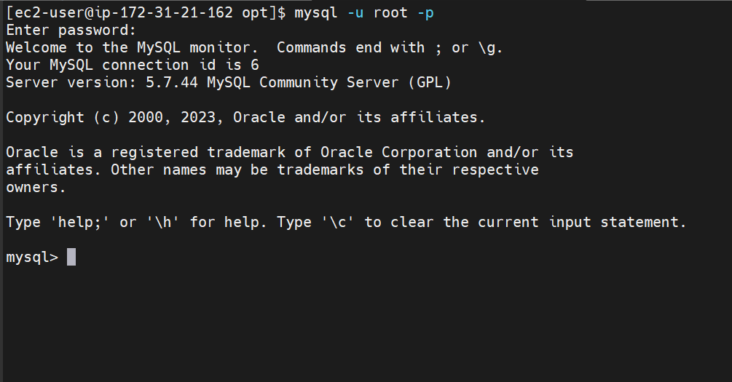
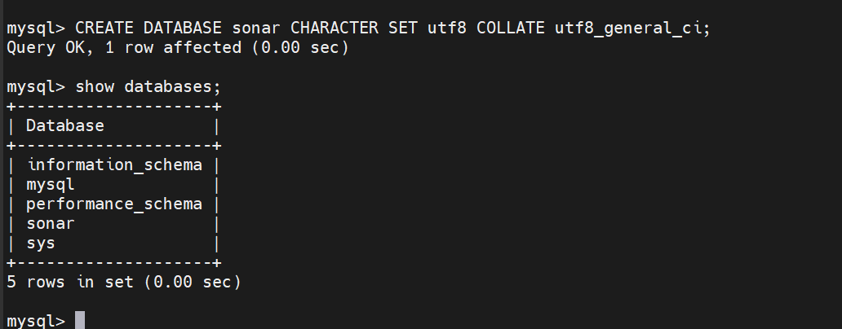
Create a local and remote user
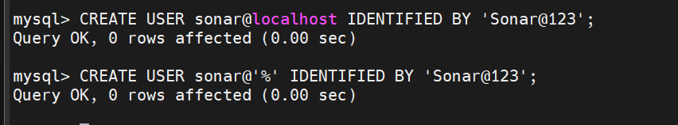
Granting all the permissions
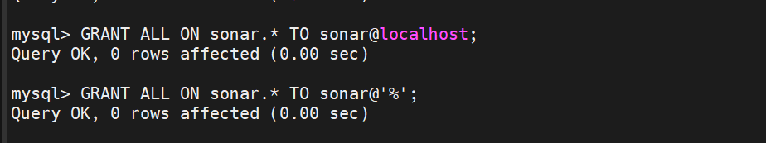
Databases and users
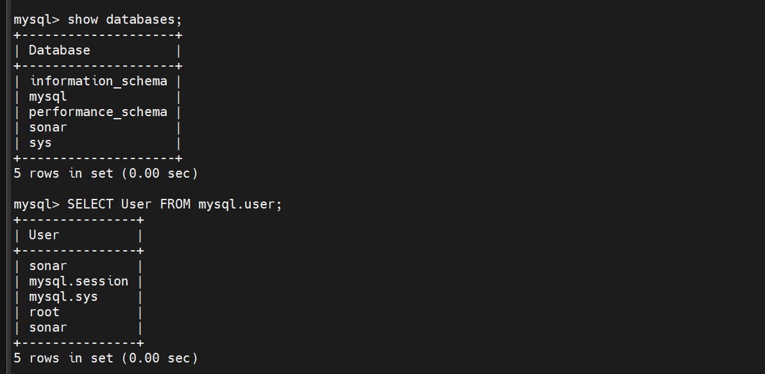
Now the database configuration for sonarqube are done lets get back and enable SonarQube properties file to connect to the database
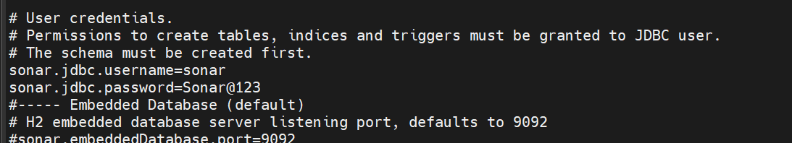
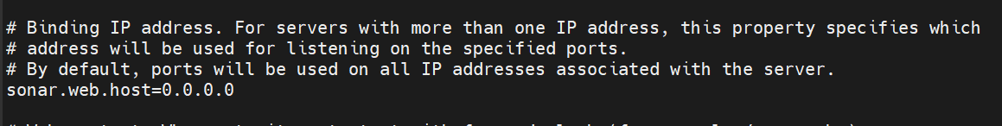
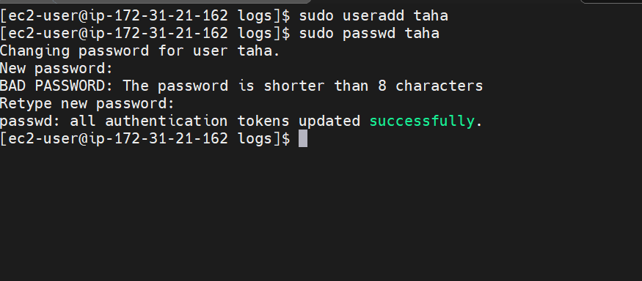 creating a new user
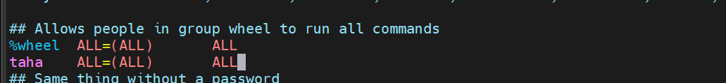
Adding user to sudoers file

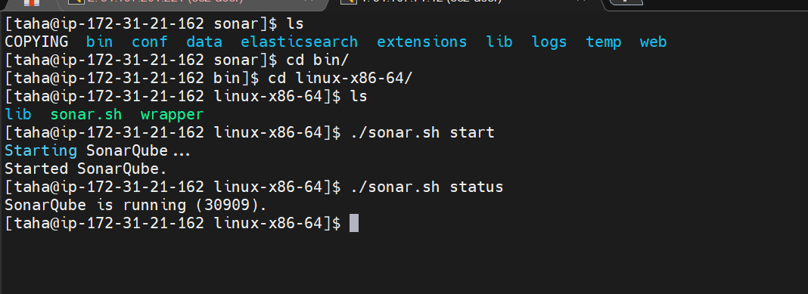
Started the sonarqube server it is running now
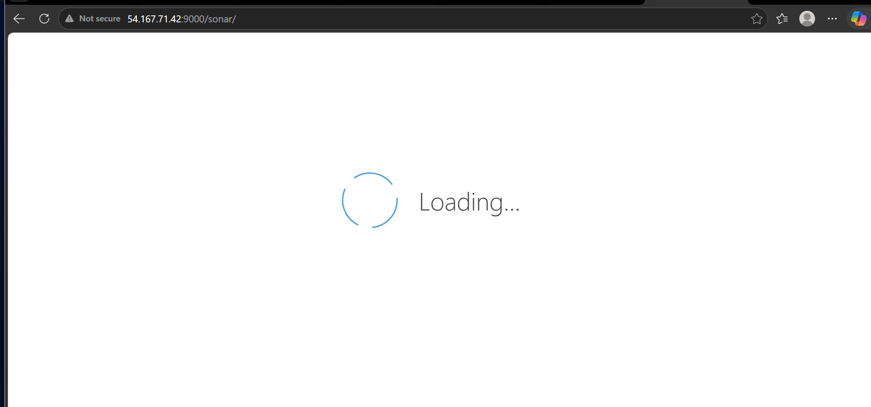

Logged in to sonarqube server
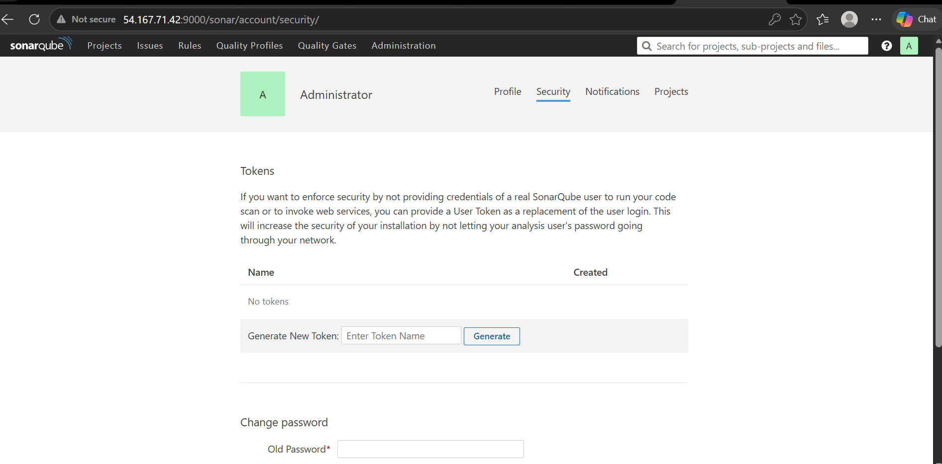

Go to security and generate a token
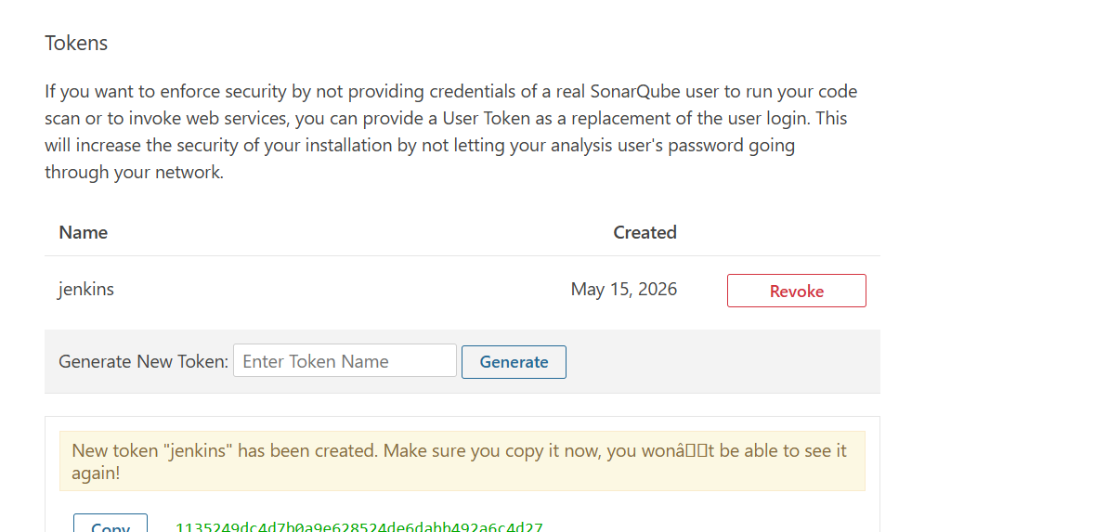
Copy it and add it in Jenkins credentials
1135249dc4d7b0a9e628524de6dabb492a6c4d27
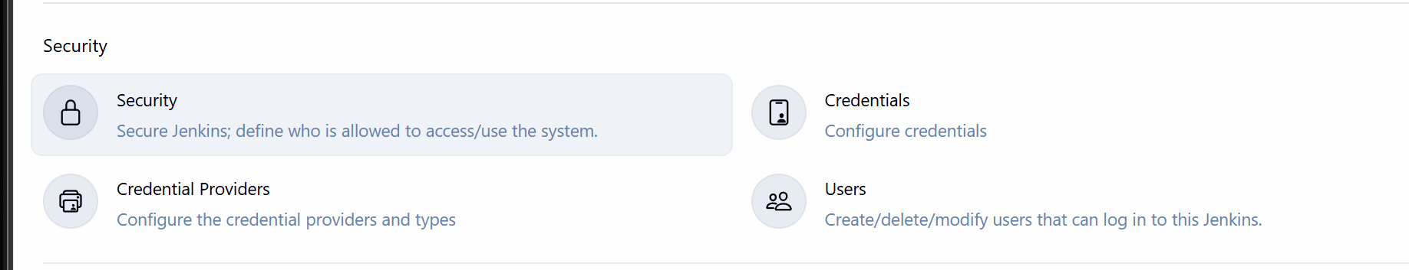
Go to credentials
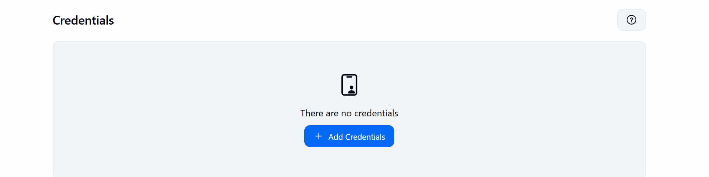
Add credentials

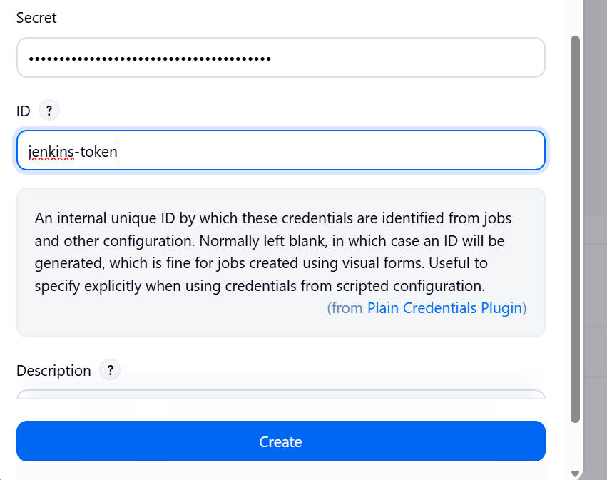

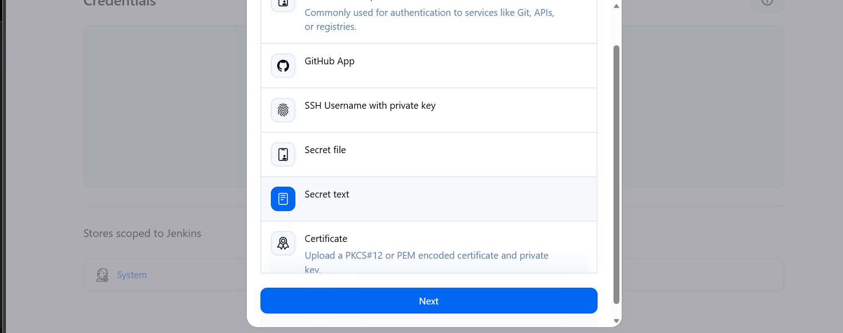
Select secret text

Lets install sonarqube scanner plugin now
Go to manage Jenkins and then plugins
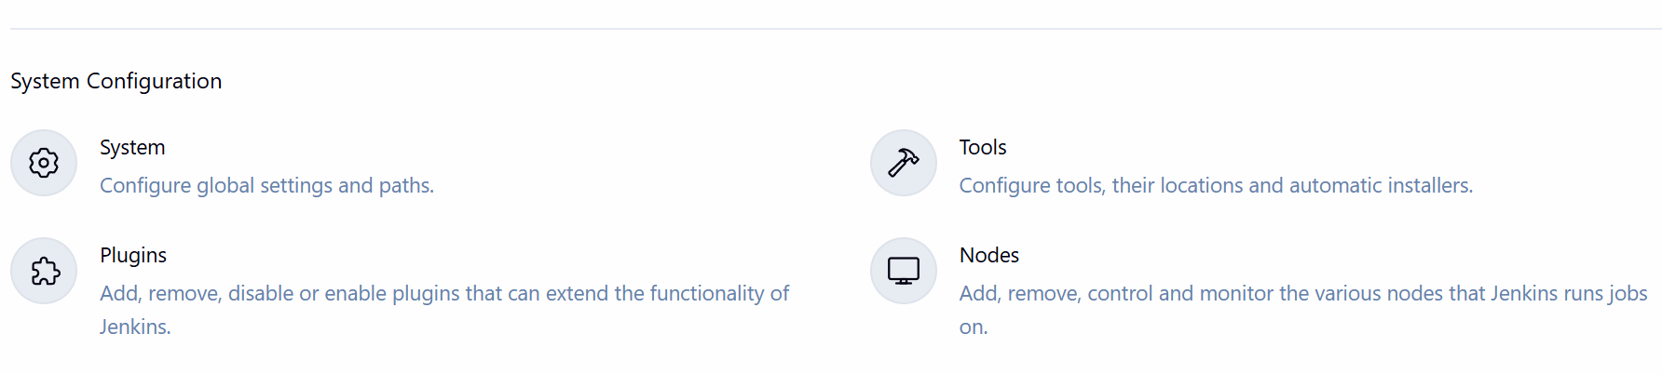
Search for sonarscanner in available plugins
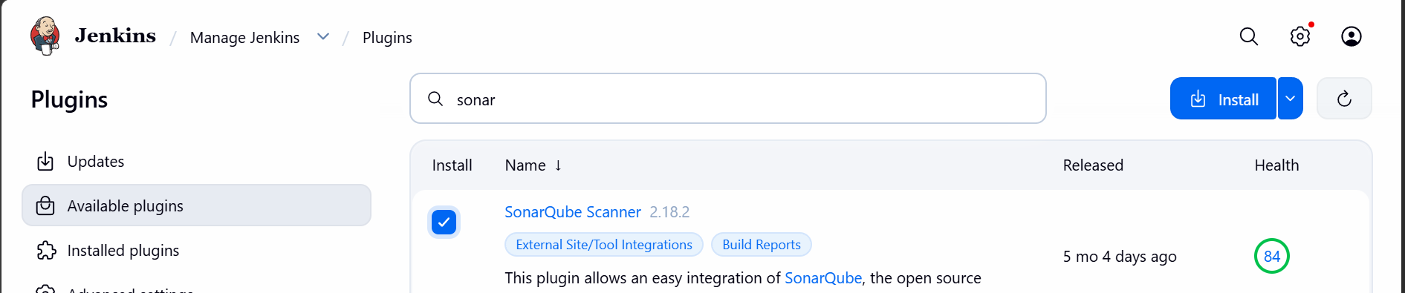
Install it
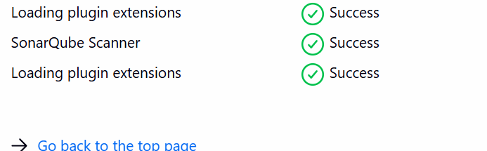

Now go the job and build section select execute sonar scanner
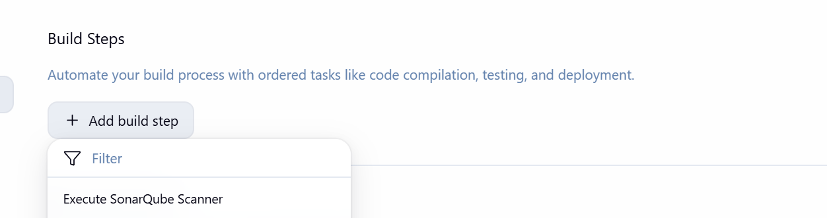
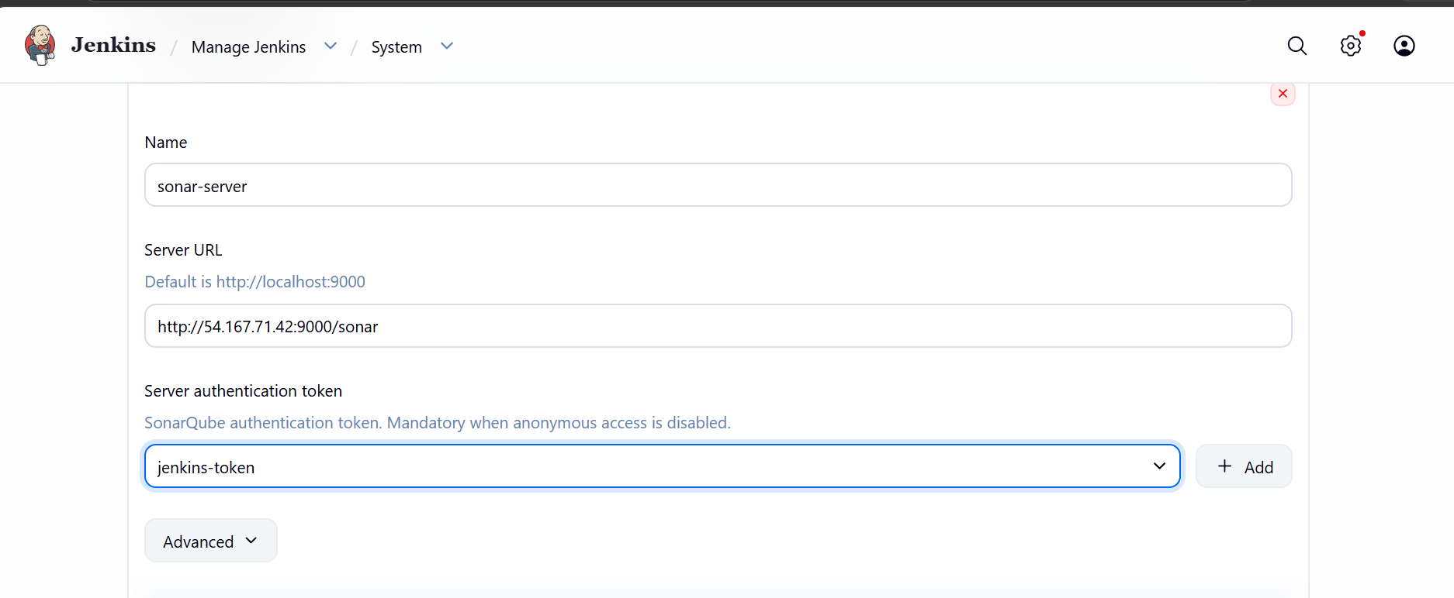
Go to manage Jenkins, system and give an add sonarqube server by giving url
save
On Jenkins master install sonarqube scanner on Jenkins master
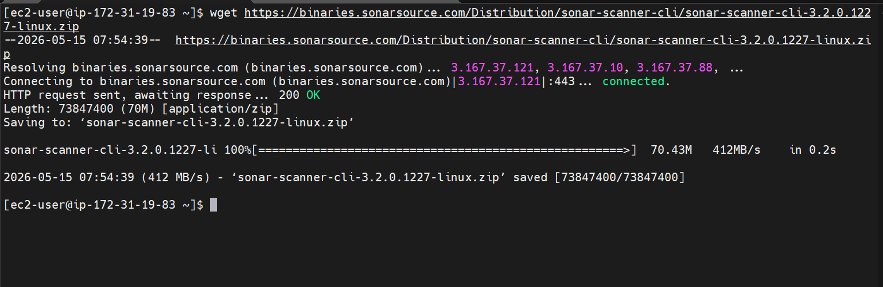
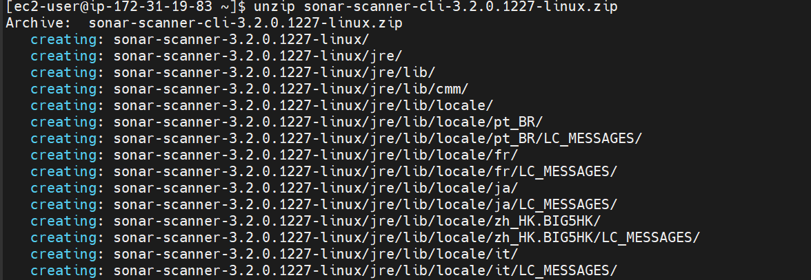
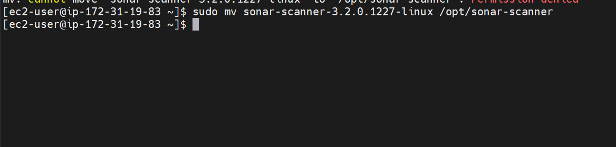
Adding sonarqube scanner
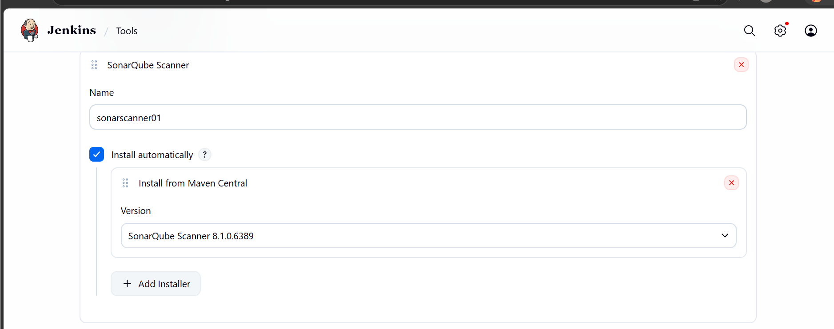
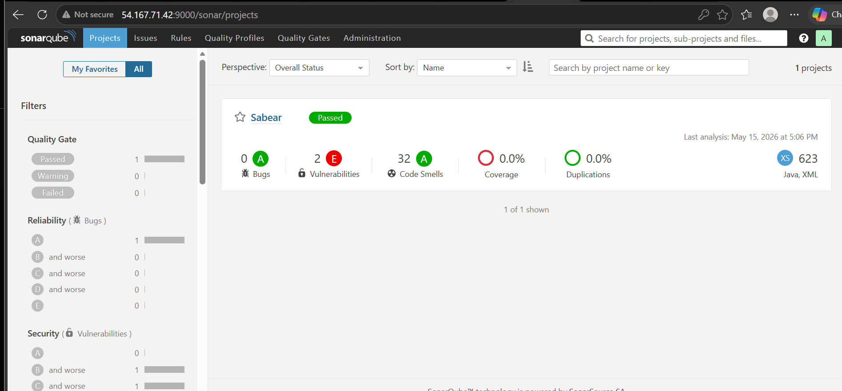

Jenkins sonarqube integration is done now
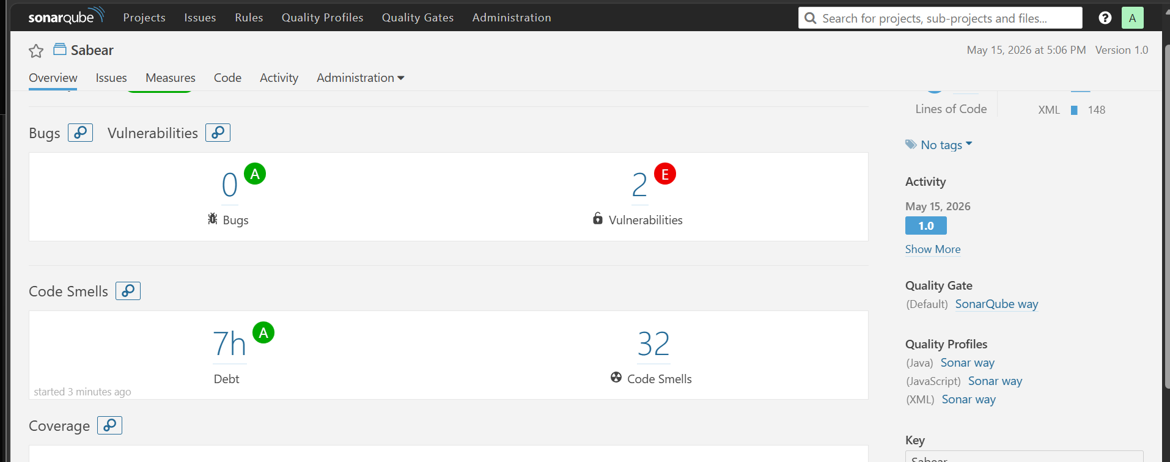

Lets now do the slack integration
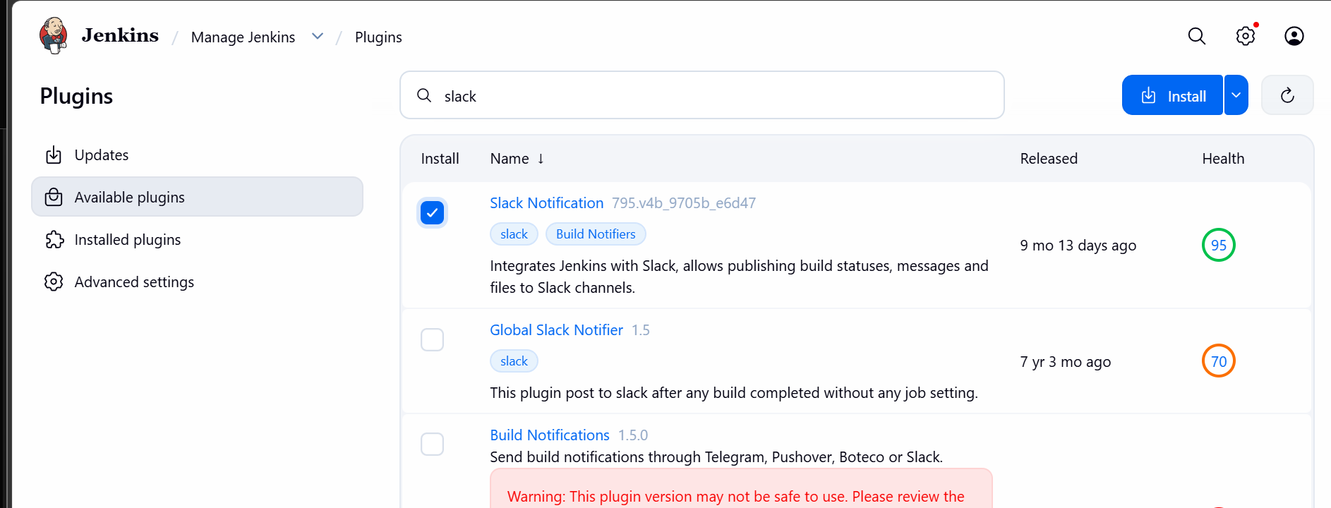
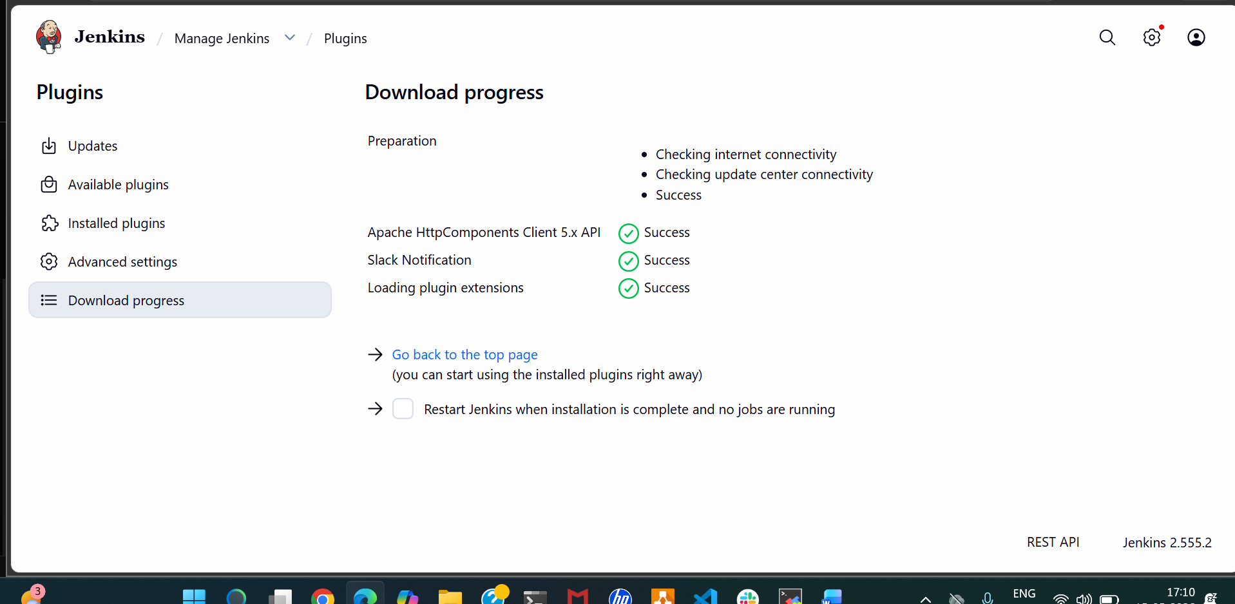
We have created a new workspace in slack

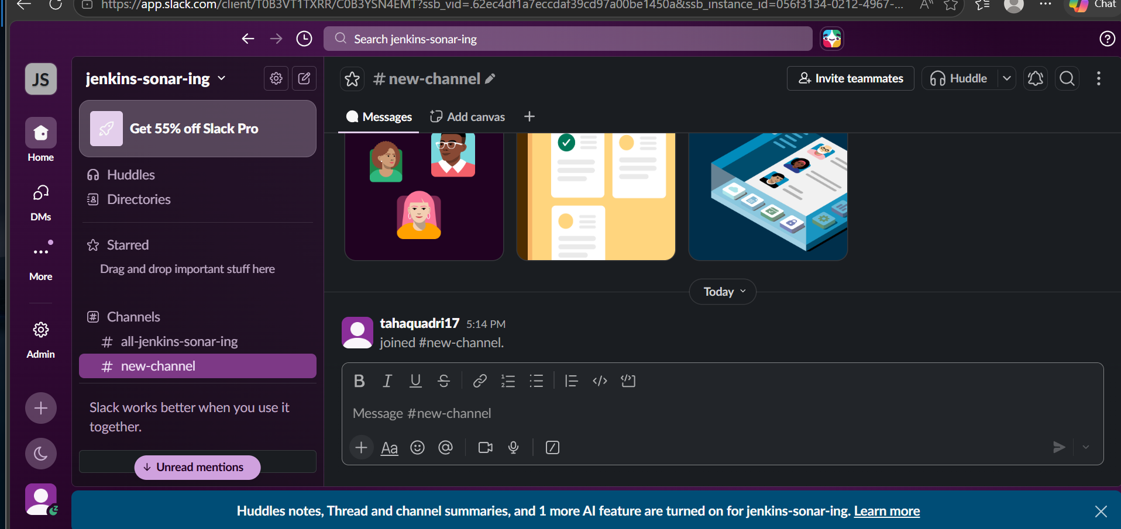

Search for Jenkins ci in apps and install and select the workspace created

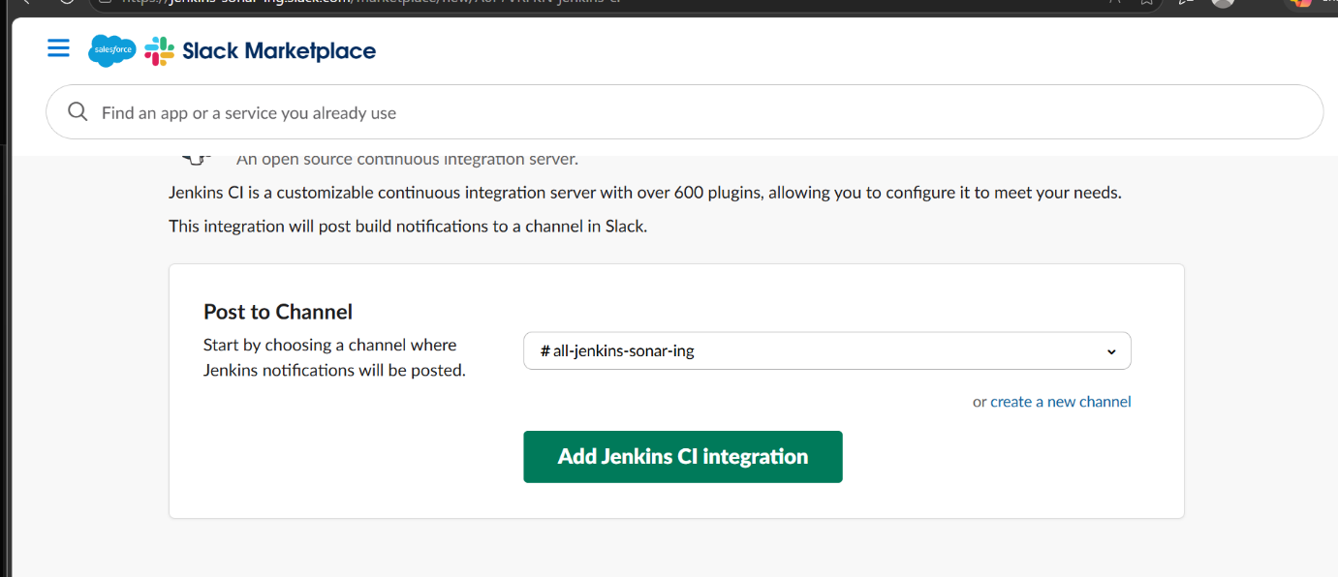
slack is now integrated with Jenkins
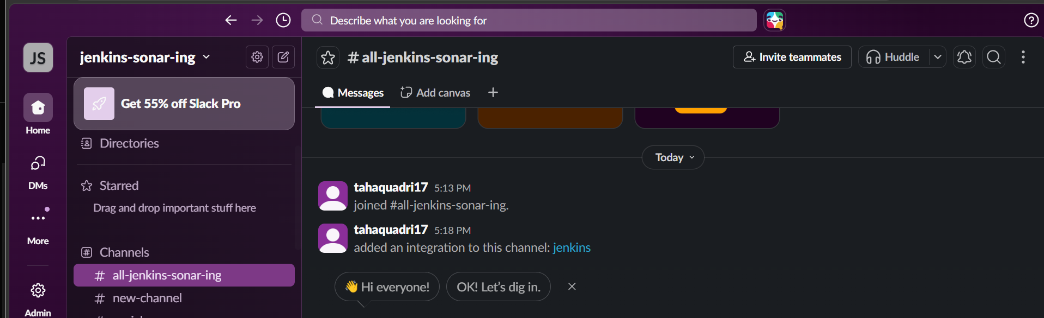

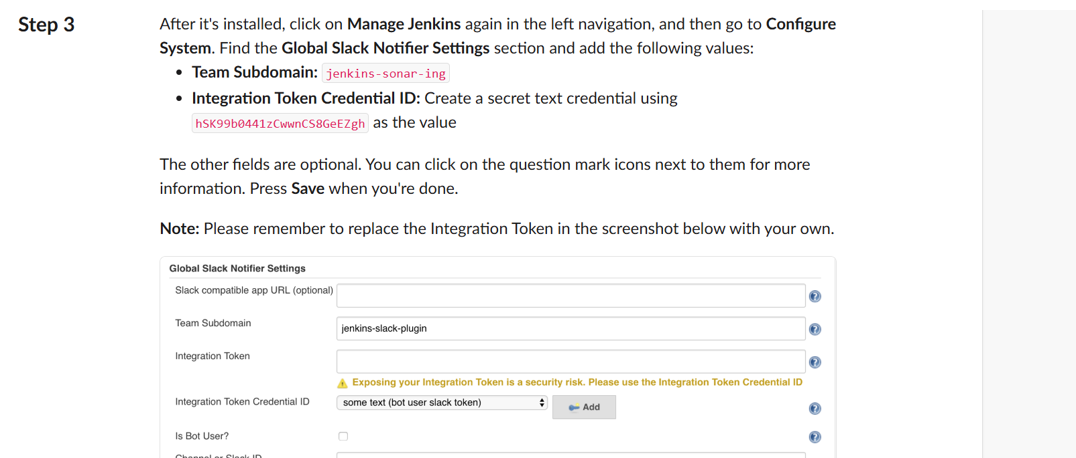

Add the token in Jenkins credentials
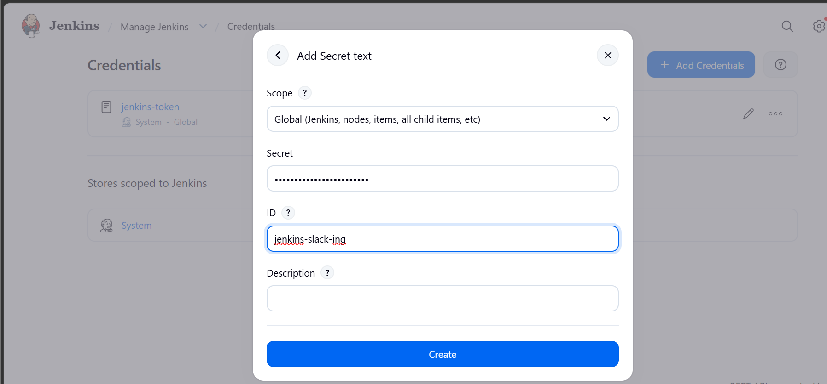
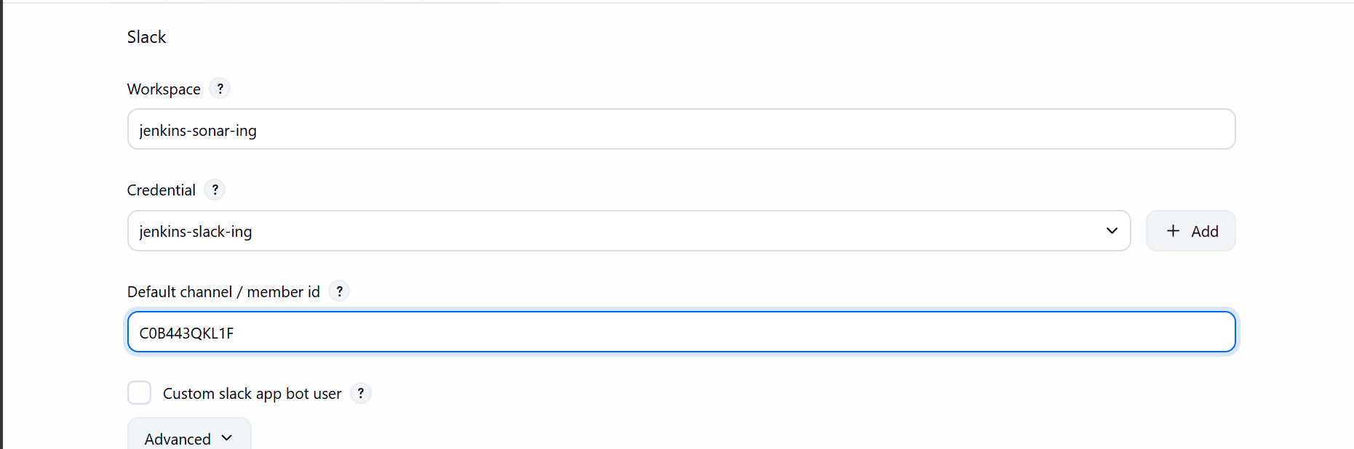

Connecting slack to Jenkins
Now go to build configuration and select post build actions and slack notifications

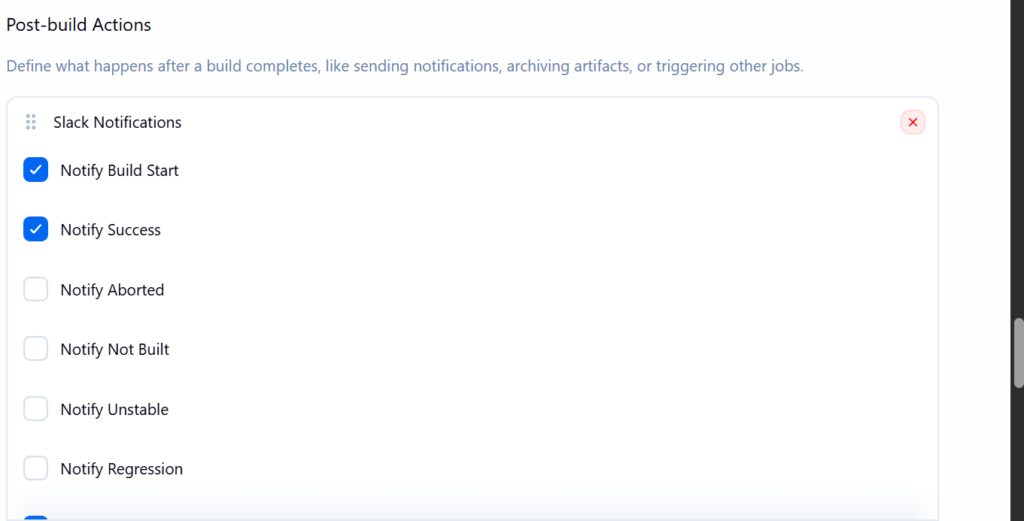

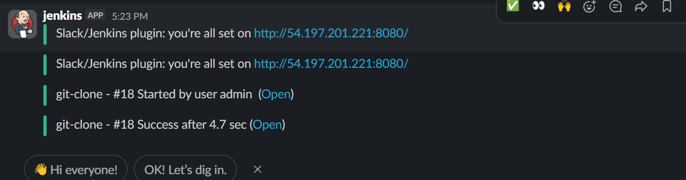

Slack is now integrated with Jenkins

Now lets create one more job for another repository

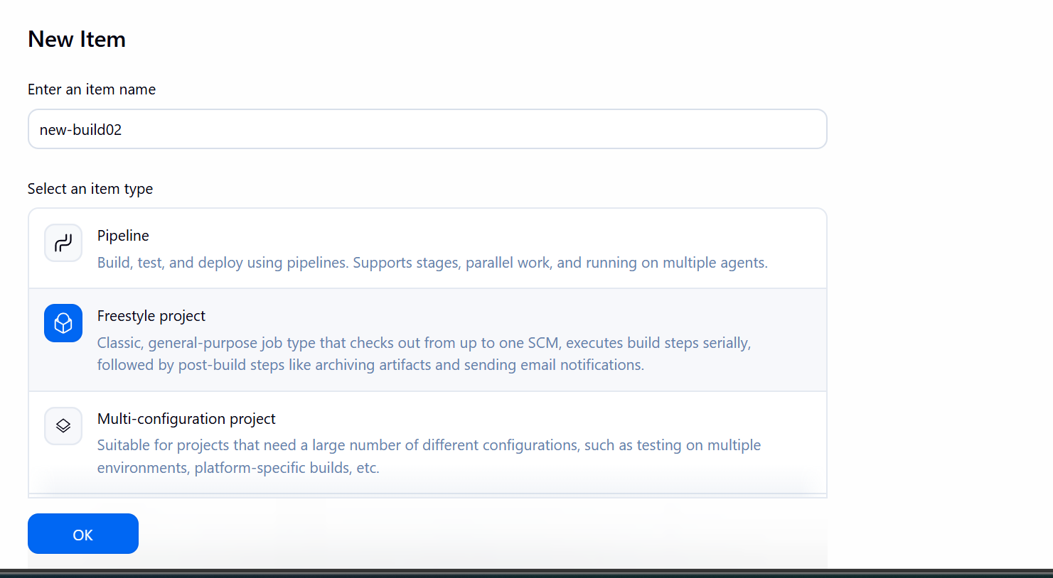
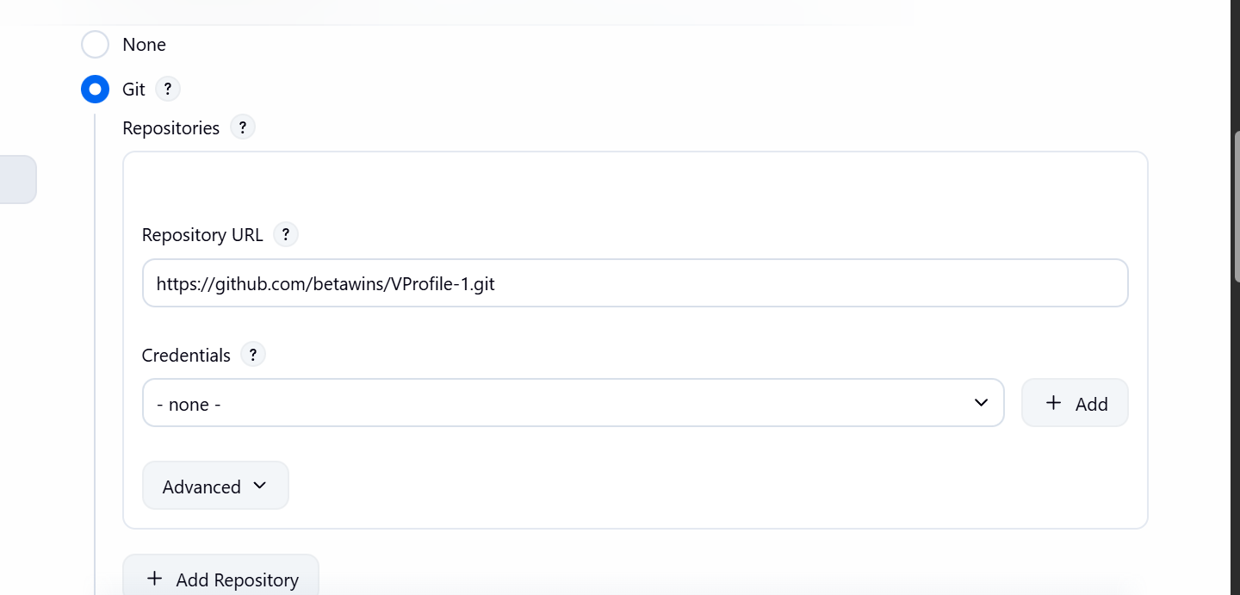

Cloning a repo

Now build the job
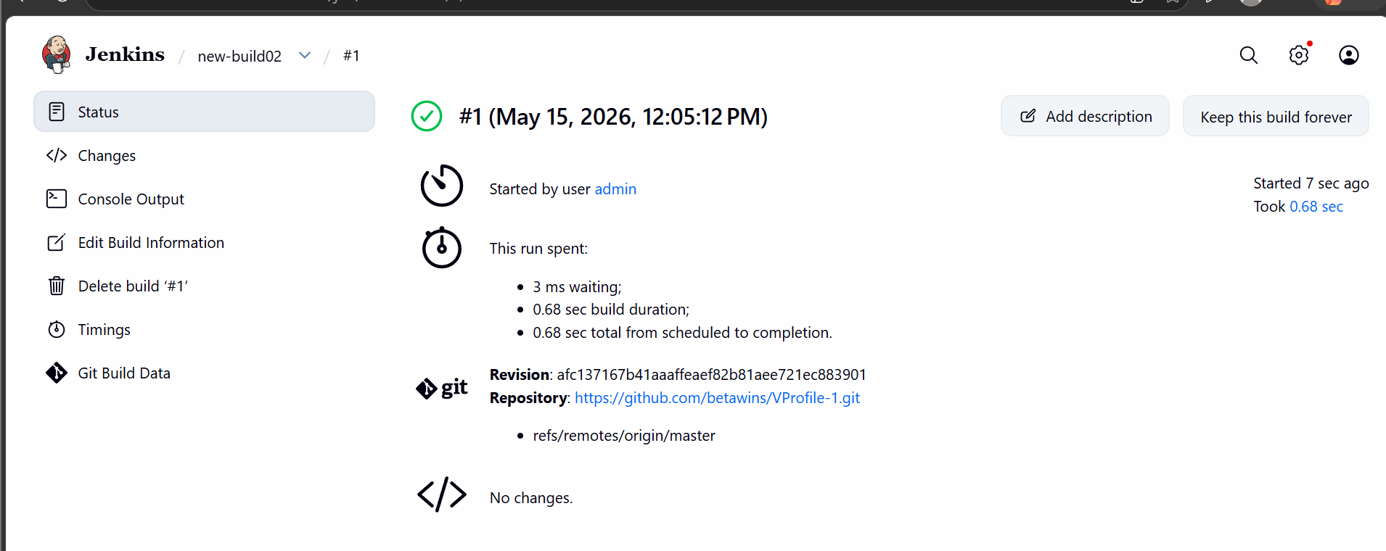
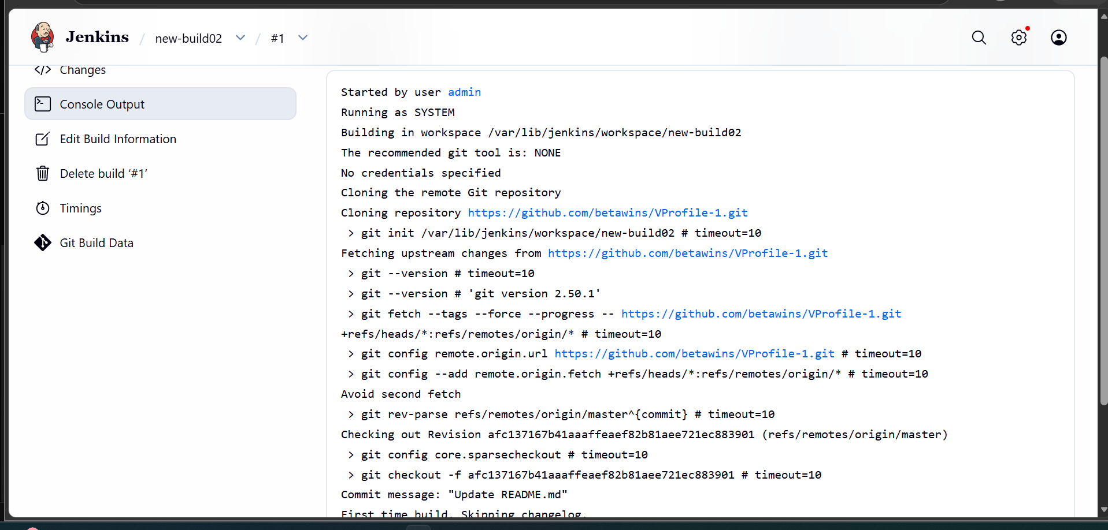

Now lets integrate sonarqube and post build notifications using slack
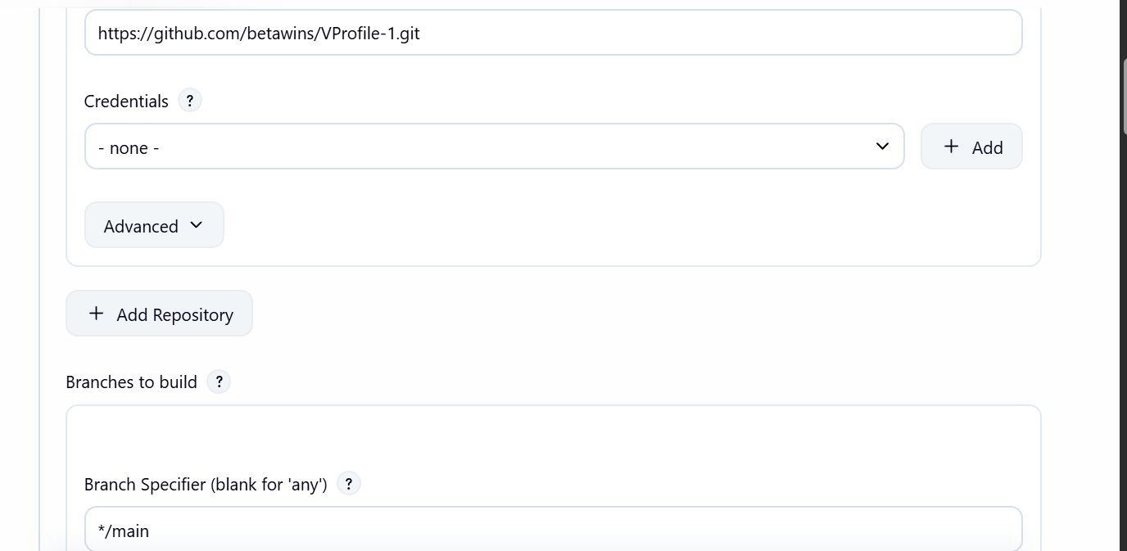
Now go to build steps and add analysis properties

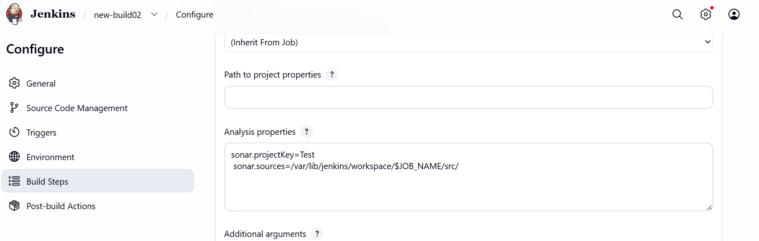

Adding post build notifications
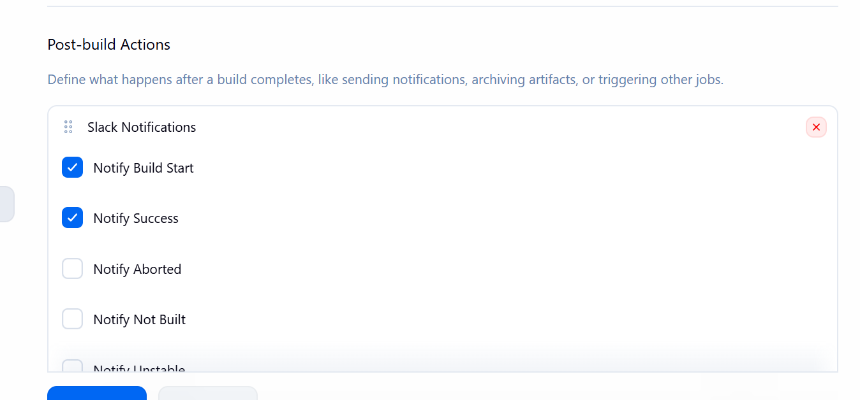
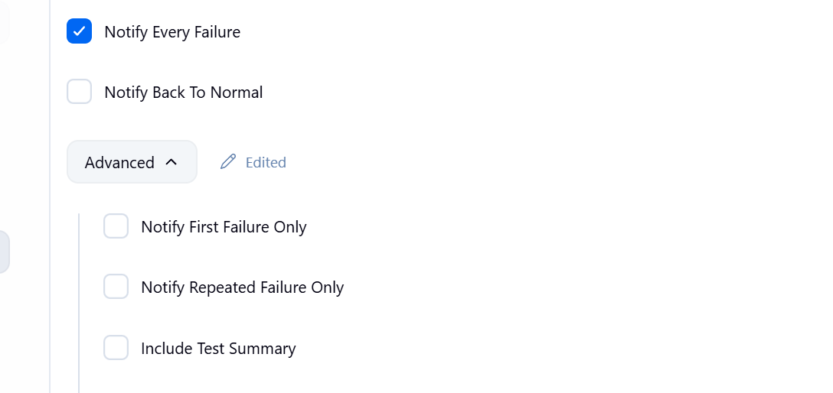

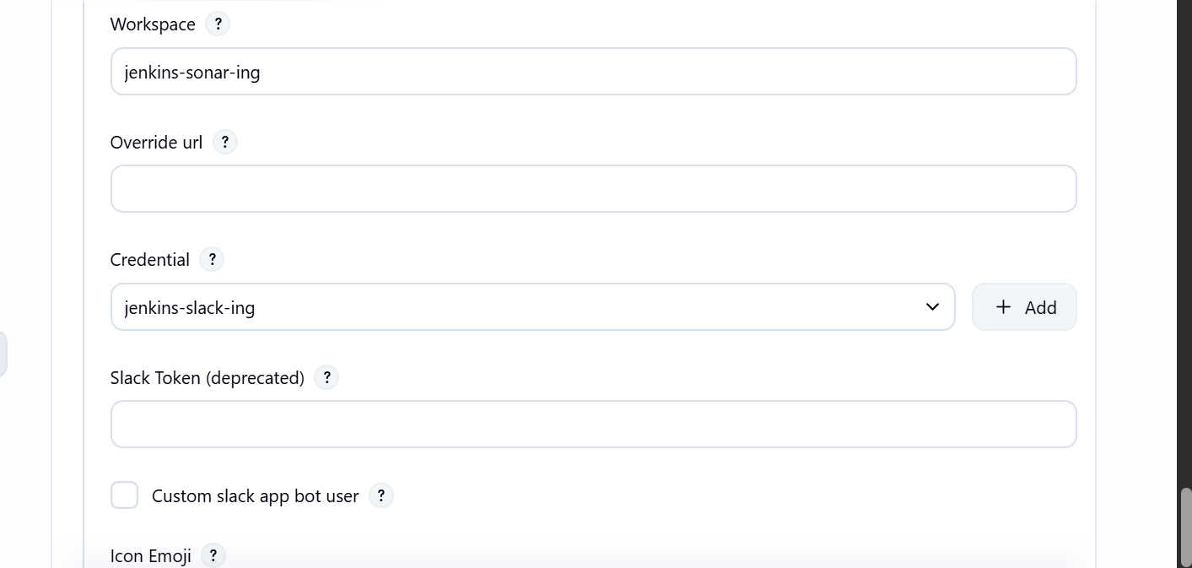

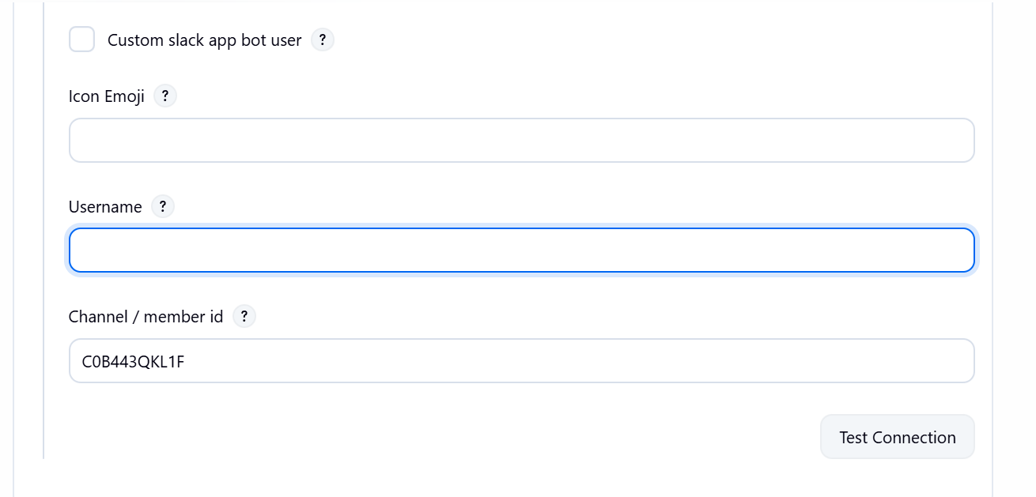

Lets now build and validate the integration
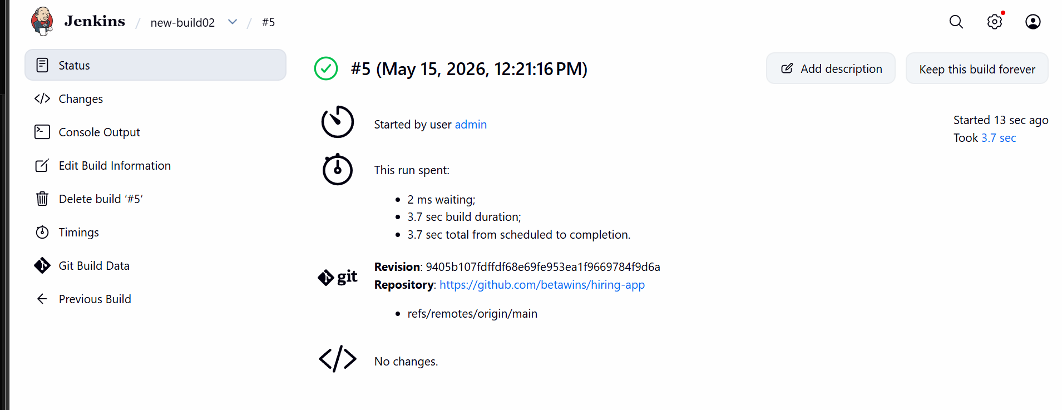
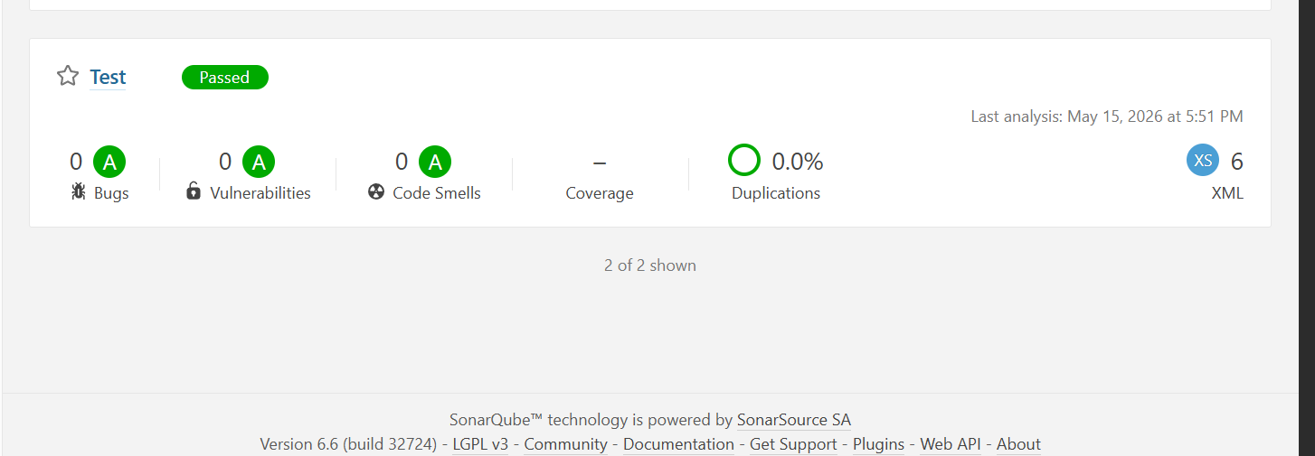

We can see the test is passed

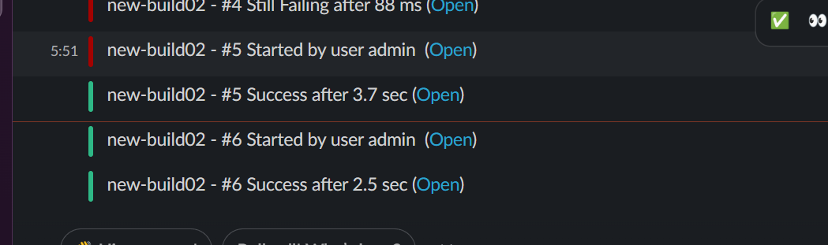

Now the slack integration is working as well we can see the alerts

Failed to start sonarqube
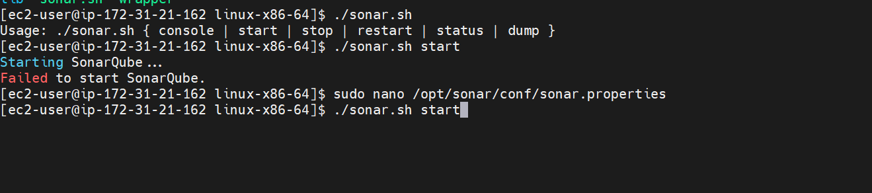

Checked the logs
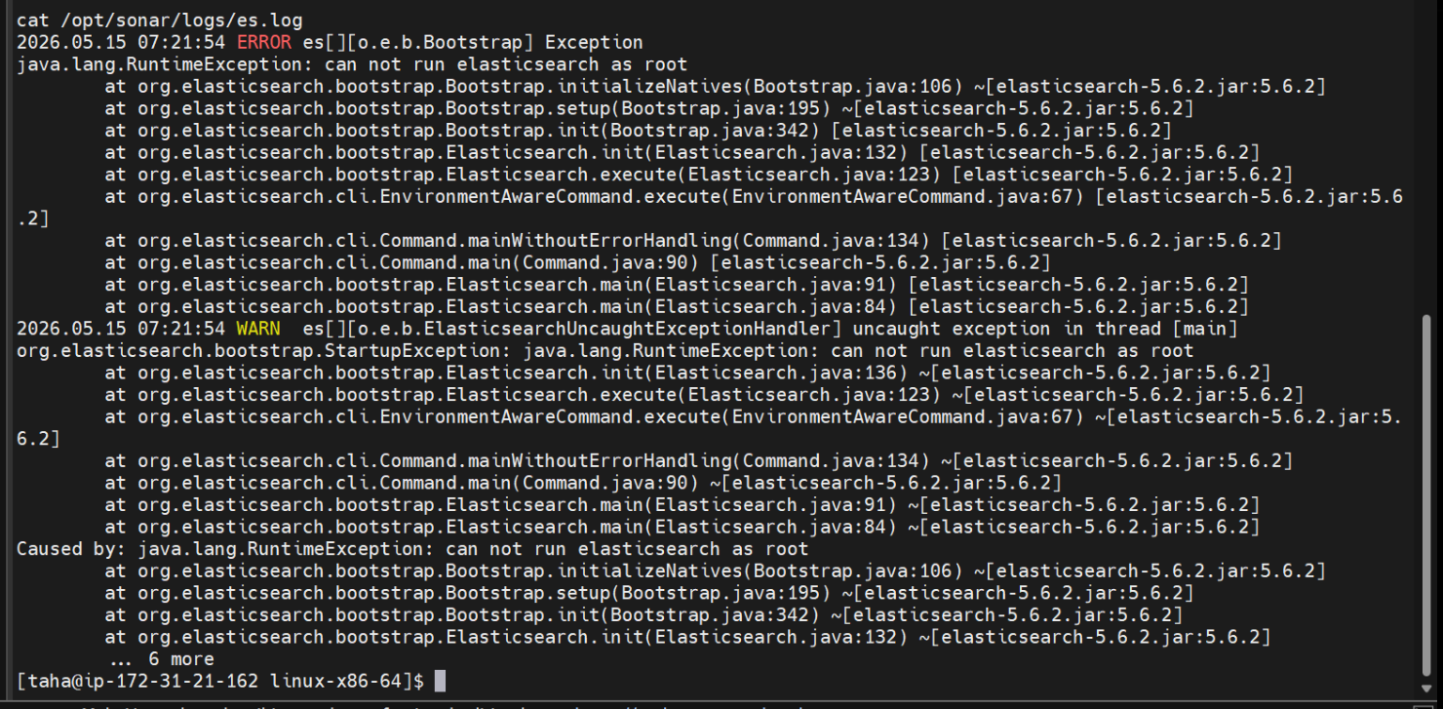
It says the can not run elastic search as root

The user did not taha did not had the ownership so the sonarqube server was not starting

Made taha user the owner of the sonar then it ran
