Objective:
The goal of these tasks is to gain practical experience in Linux by working on everyday operations like managing users, handling files, monitoring systems, and setting up servers such as Apache Tomcat, Apache HTTP Server, and MySQL.
This helps build real-world skills needed for DevOps roles.
Prerequisites
1.A Linux system (Ubuntu preferred) or an Amazon Web Services EC2 instance
2.Basic knowledge of Linux commands
3.Sudo (admin) access
4.Internet connection for installing packages

Linux Task:
1.Creating a user in Linux:
01: Creating a user named techie and providing sudo access to it:
Command is : sudo useradd techie

The user named techie is created:
To give our user sudo privileges we need to add that user to sudo group in sudores file.
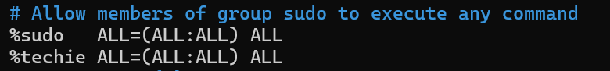
After successfully adding the user in sudoers file we will be able to execute high privilege commands.
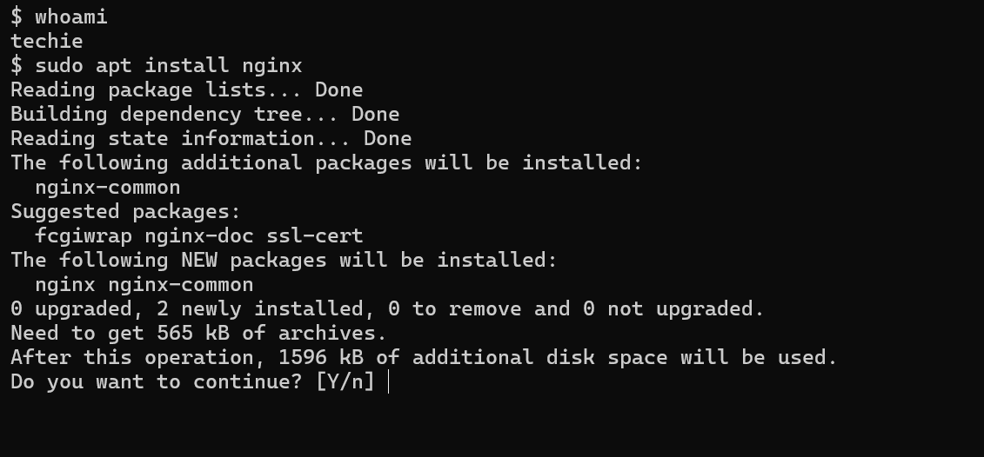

2.Navigating to home directory:
We can use command:
cd home or cd ~
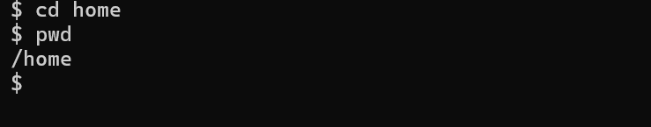

3,.Creating a new directory:
mkdir is the command to create a directory:
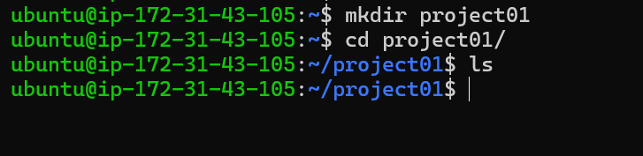

4.List the contents of a directory:
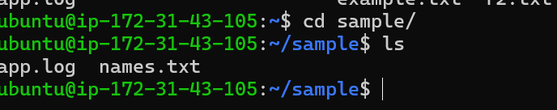
Here we have created a new directory navigated there and listed the content as it is newly created directory there are no files in that.

5.Changing to another directory:
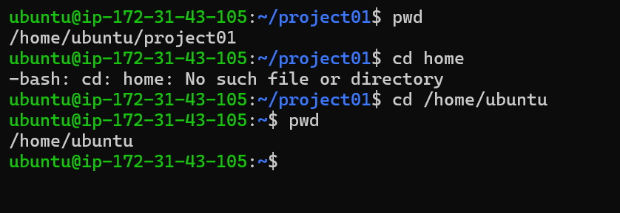
Here we have changed directory from project01 to /home/ubuntu.

6.Creating a new empty file:
touch is the command to create a new empty file.
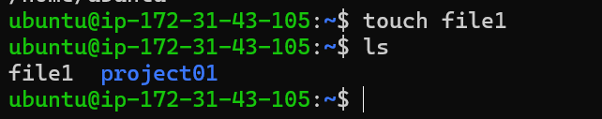

7.To view content of a file we can use cat command:
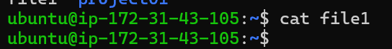
As it is a newly created file there is no content in that.

8.Copying file to another location:
cp is the command to copy a file.

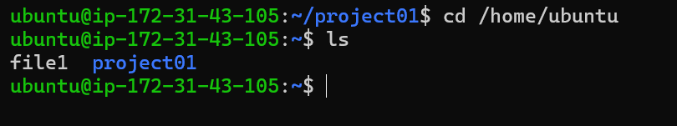
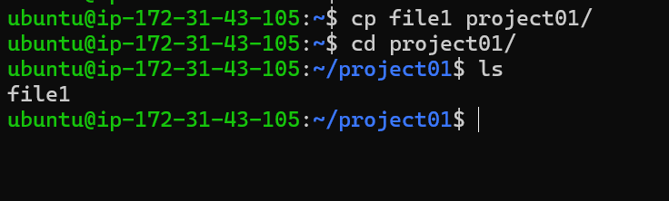
Here we have copied the file from /home/ubuntu to project01 directory. The copied file will be available at both the locations.

9.Moving a file to another location:
mv is the command to move a file from one location to another.
We have created a new file at /home/ubuntu location.
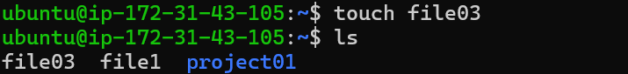
In the below picture we have moved the file03 from home to project01 folder
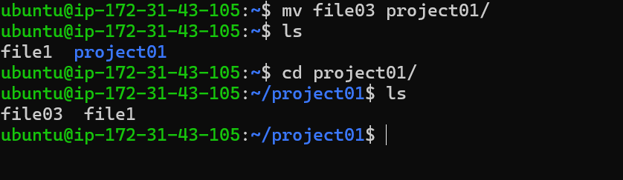

10.The same (mv) command can also be used to rename a file.
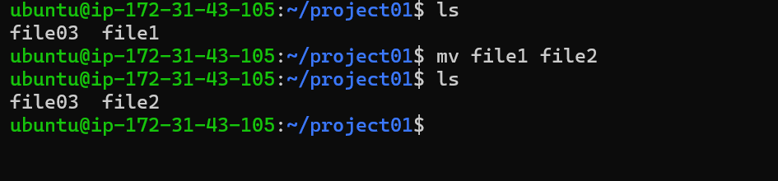

11.Deleting a file:
rm command can be used to delete a file.
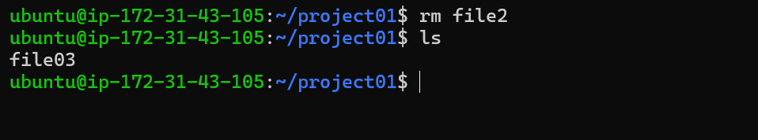
The file2 has been deleted.
12.Granting or Revoking permissions on a file or directory.
chmod is the command to modify permissions.
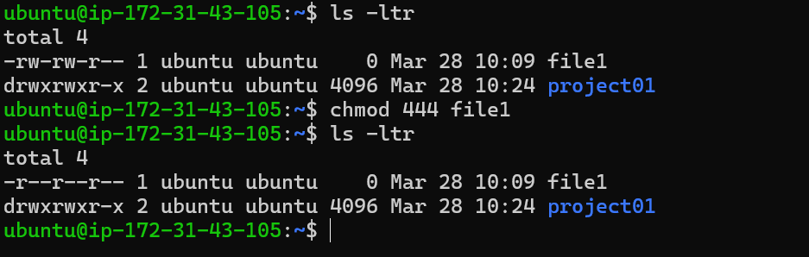
Here we have changed permissions for all the users to read if we want to give all the permissions to root and read permissions to group and other users it can be done like this.
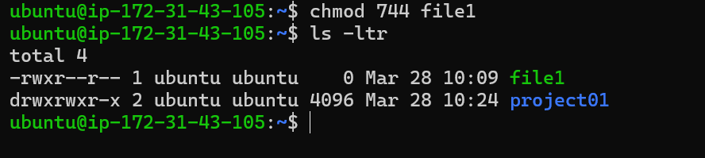

13.Viewing date and time:
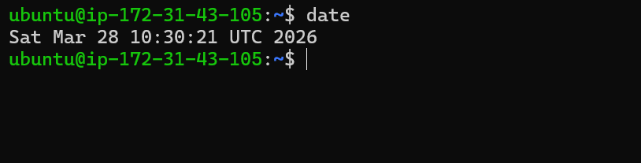

14.Checking the system uptime:
uptime is the command to check the system uptime.
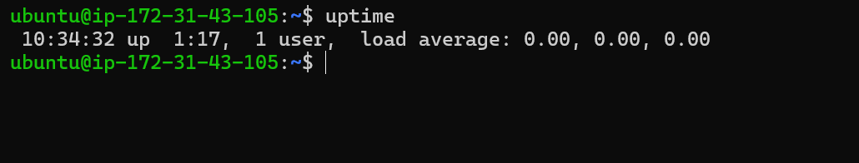

15.Command to check running processes.
ps -ef is the command to check the currently running processes.
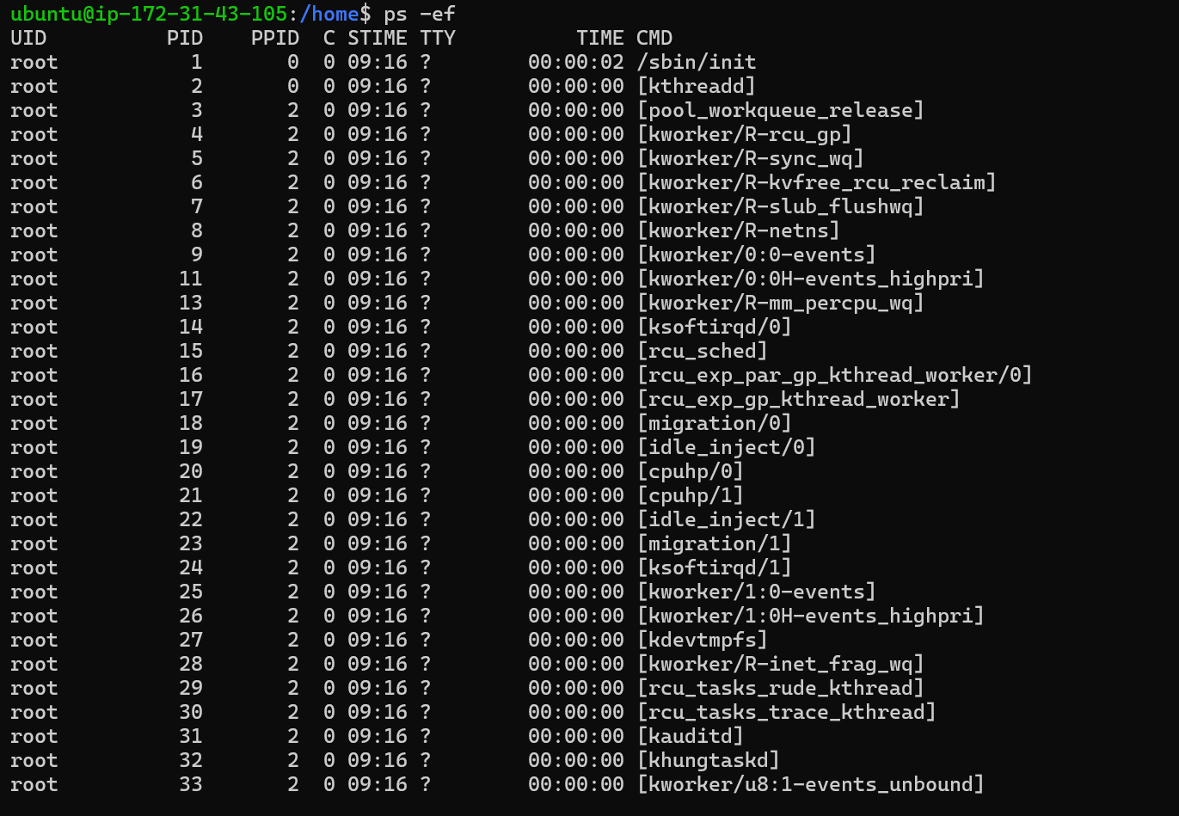

16.Killing a process:
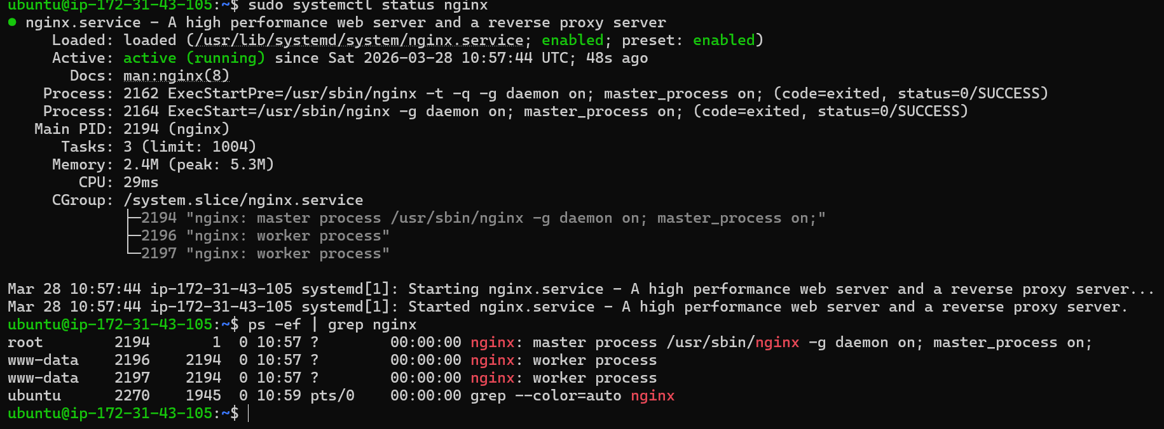
Currently the service nginx is running;
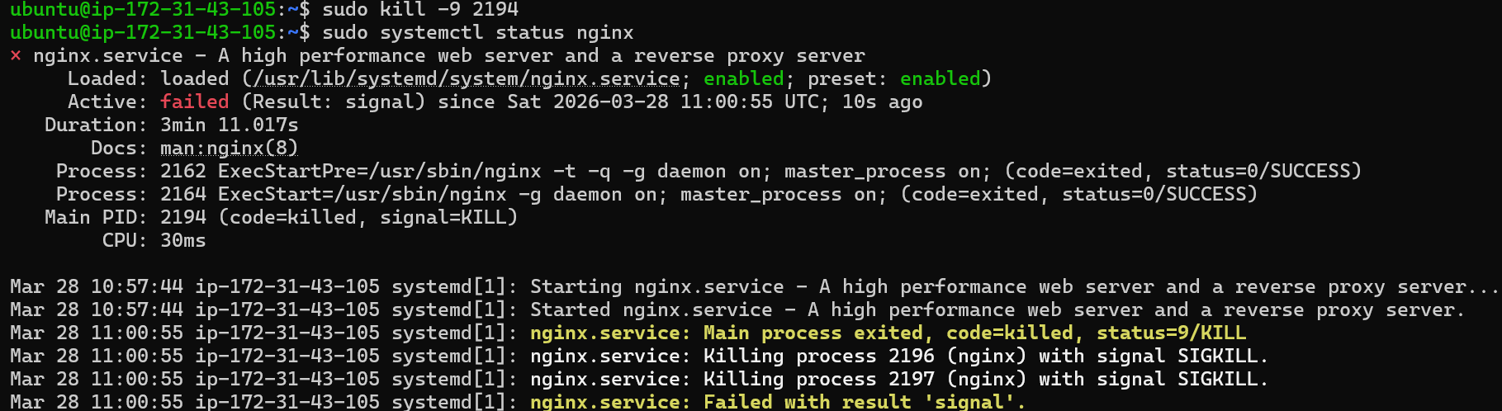
The kill command kills the service or a process we need to mention the process id.
17.Installing the system packages:
apt install is the command to install packages in linux.
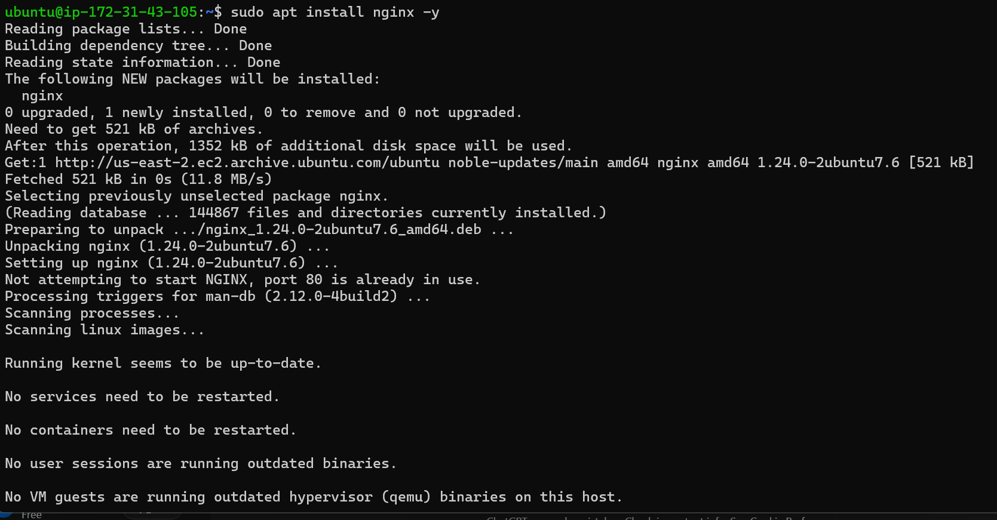
18.Update the system packages.
sudo apt update is the command
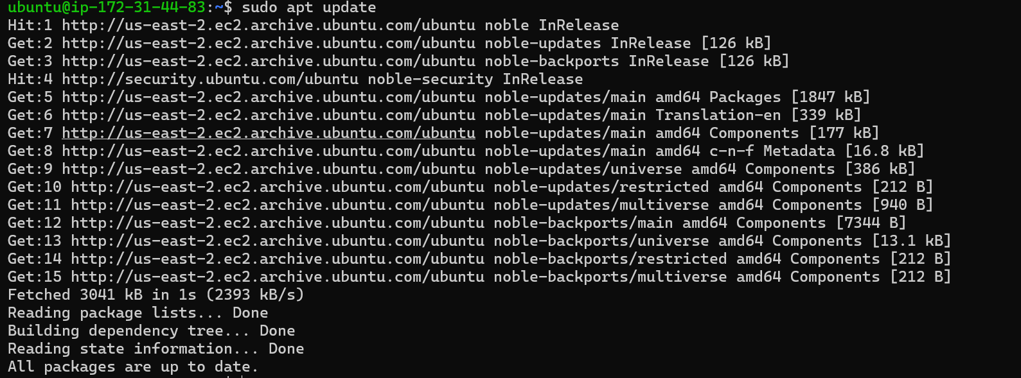

19.Creating a symbolic link:
ln -s is a command to create a symbolic link in linux
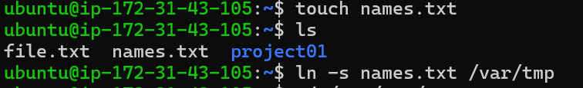
Here we have created a file names.txt and also, we have created a symbolic link in /var/tmp folder
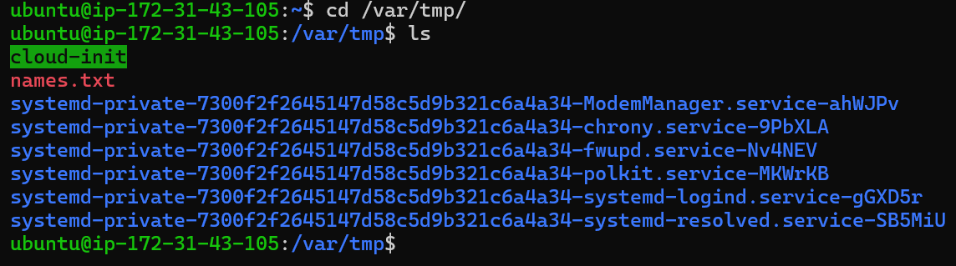

20.Searching for files or folders in linux:
Find command can be used to find a file or directory in linux below is the example of searching a directory by name parameter.
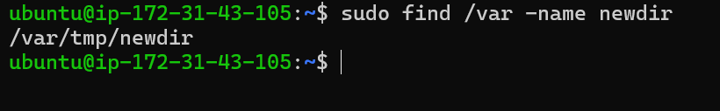

21.Compressing or depressing files using tar:
We can compress directories or files in linux using tar command:
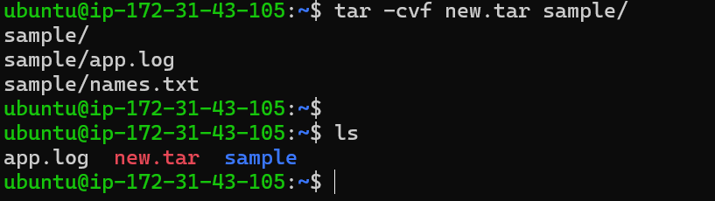
Here we have created a tar file of a folder named sample which has two files app.log and names.txt

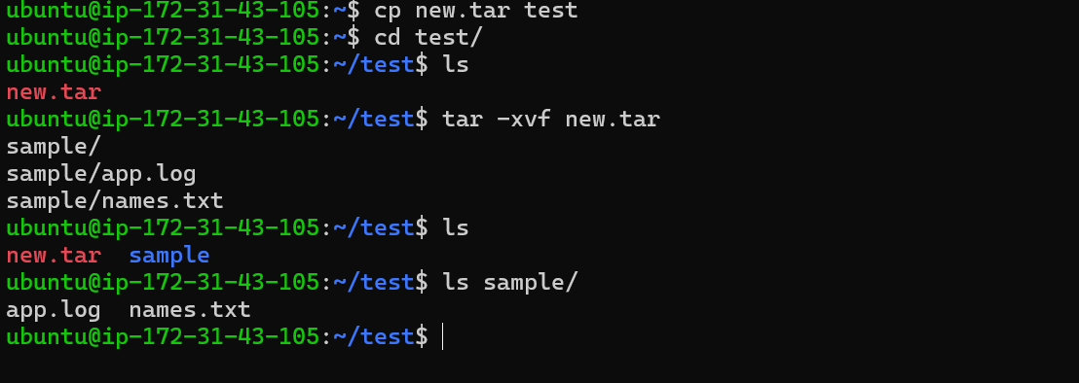
Here we copied our compressed file to a new directory named test and we have decompressed the tar file the same can be seen in the output of ls command the directory named sample and the files app.log and names.txt are available there.

22.Monitoring system resources with top and htop:
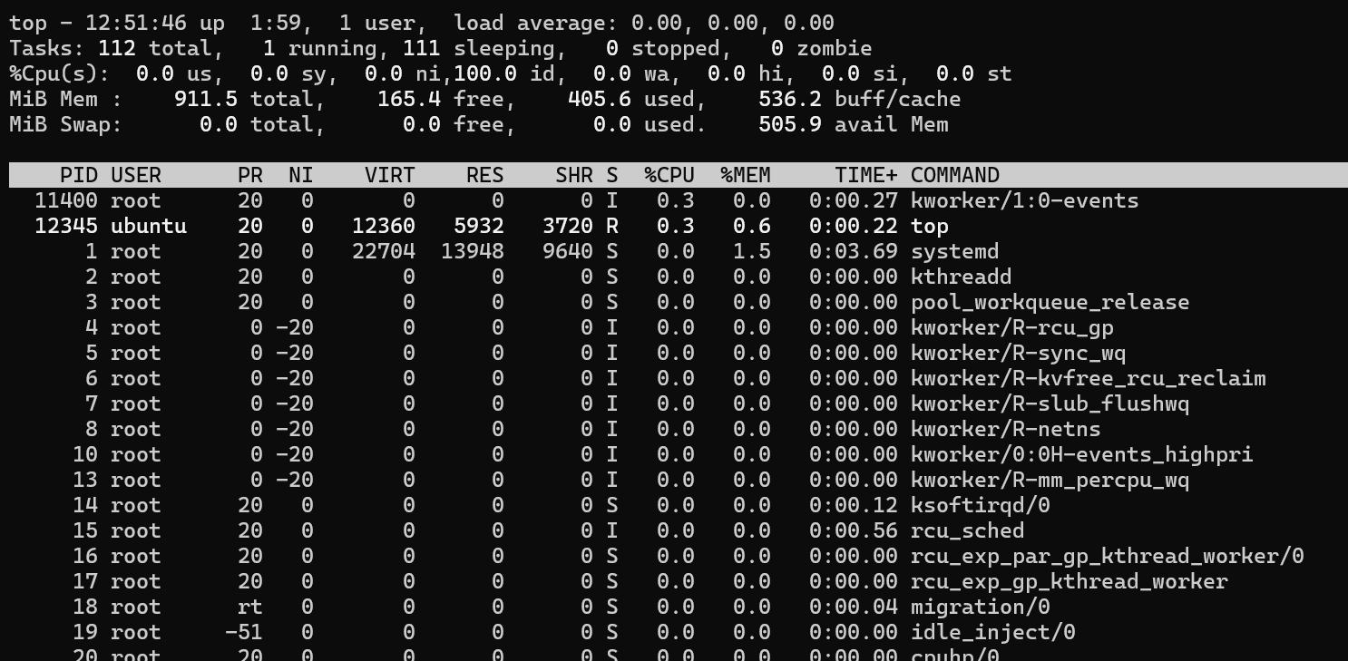
Top command allows us to see CPU usage, memory usage running processes and their process ids.
htop is another command to do the same thing in a more human readable format:
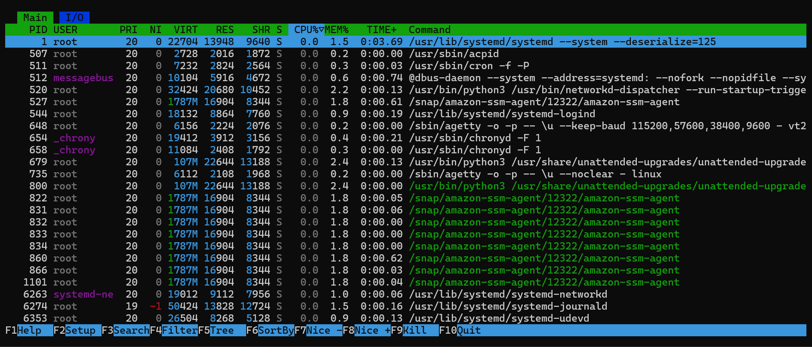

23.Creating and managing user groups:
groupadd is the command to create a new group in linux
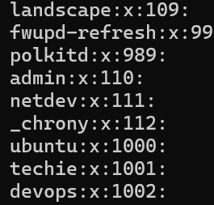
As we can see that the group named devops has been created.
We have added the user techie in devops group here.

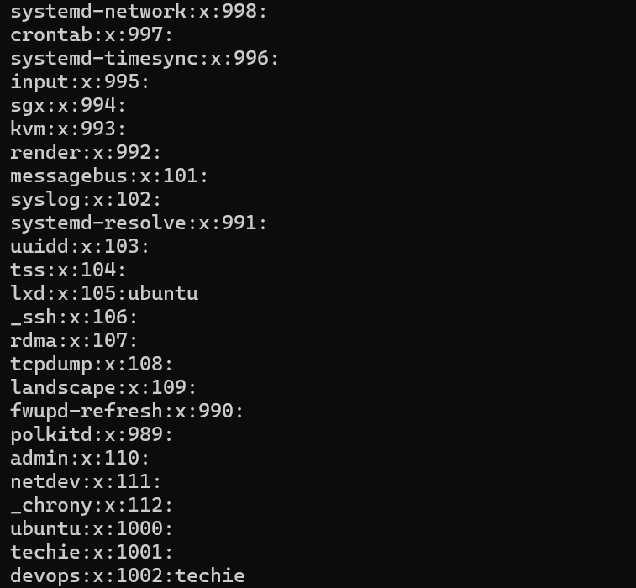

24.Setting up SSH password less authentication:
Here we are setting up ssh password less authentication from our local machine means we will able to securely connect to the remote server without having the need to enter the password.
First we need to generate ssh key on our local machine:
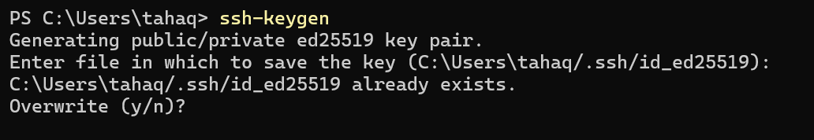
ssh-keygen is the command for that
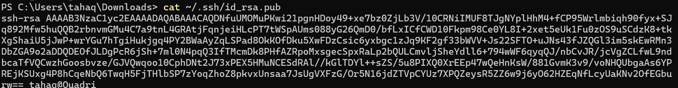

Then we need to copy this file to the remote server at .ssh/authorizedkeys
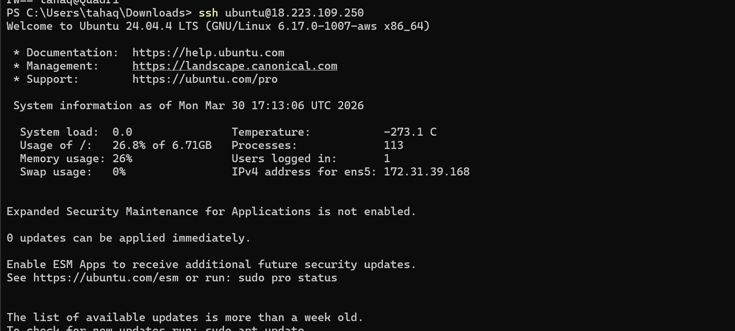
Now we can ssh directly without using a password just by entering username or ip address.

25.Monitor log files using tail or grep:
We can monitor log file using tail command which gives the last few lines of the file according to our input. Also we can use grep command to filter out log based on error or warning etc
Here we have a file named app.log
As we can see by using grep command we have filtered out only error logs with the help of grep command
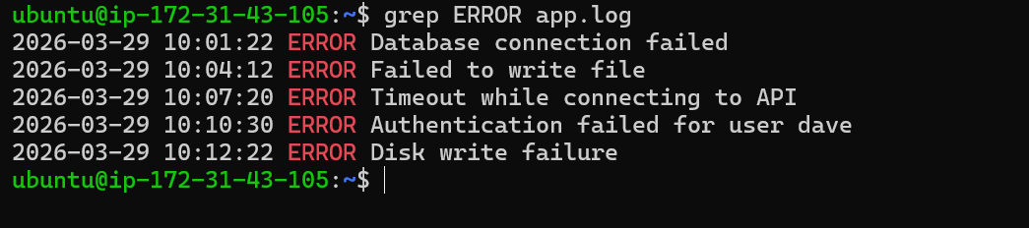
We can also check the count of a particular log like this
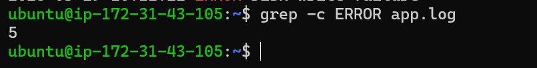
Here we have 5 error logs in the app.log file.

Tail command:
This command is very handy when we want to check the last few lines of any file especially a log file as we can see in the below screenshot the last 5 lines of app.log files are displayed.
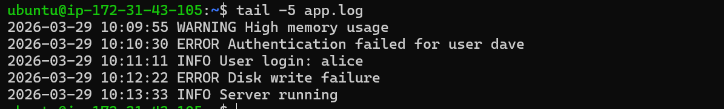
tail -f app.log command can be used for real time monitoring.
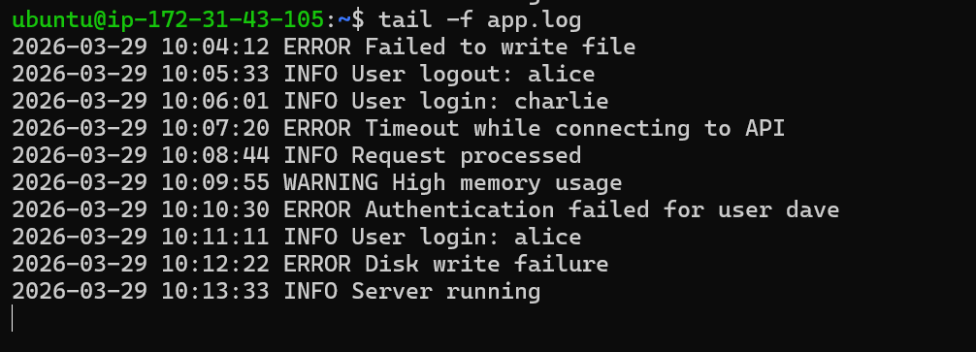
I have entered a new line in the app.log file
The same can be seen in the output of the command
The command will keep displaying the real time logs.

26.Setting Up Apache2 Webserver:
First, we need to install apache2 webserver in our machine.
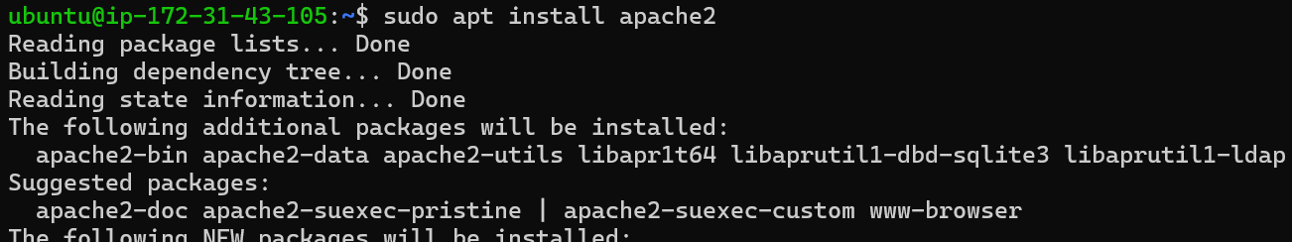
sudo apt install is the command to install packages in ubuntu.
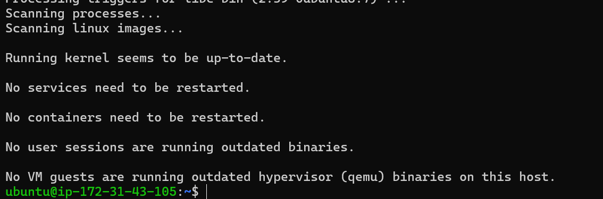
Installation is done.
We need to start the apache2 server:
systemctl start apache2 is the command
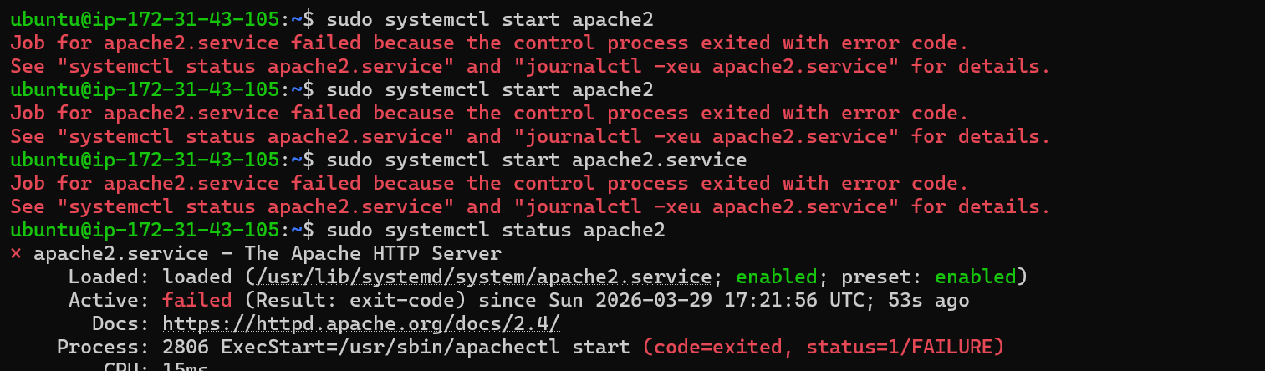
When I tried to start the apach2 service it failed because nginx was using the port number already.
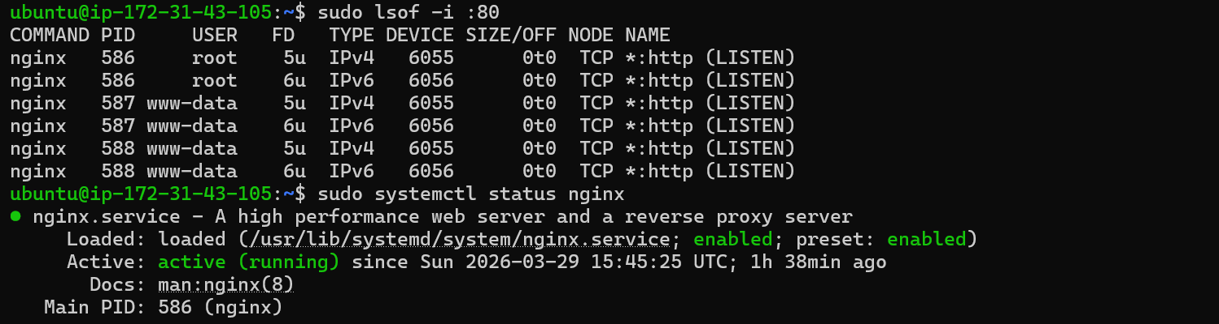
Then I stopped the nginx service.
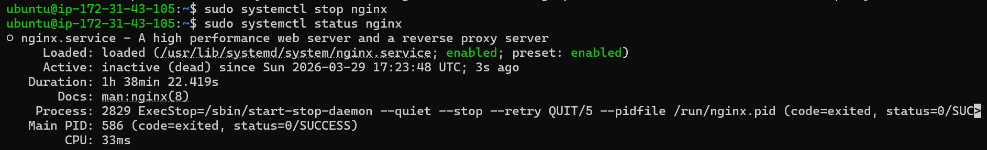
Now started the apache2 service.
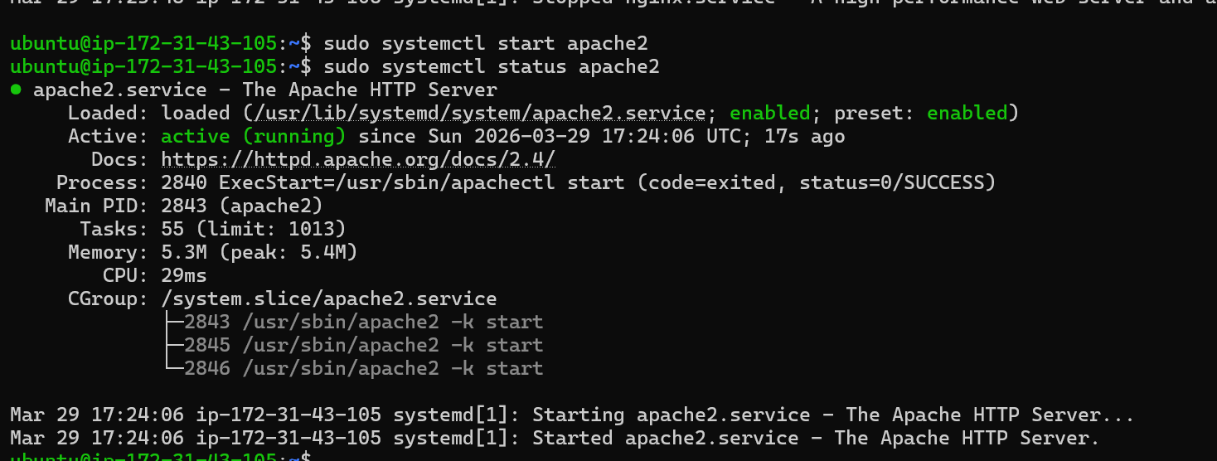
Now we can test the webserver by checking the port number and public ip of our machine.
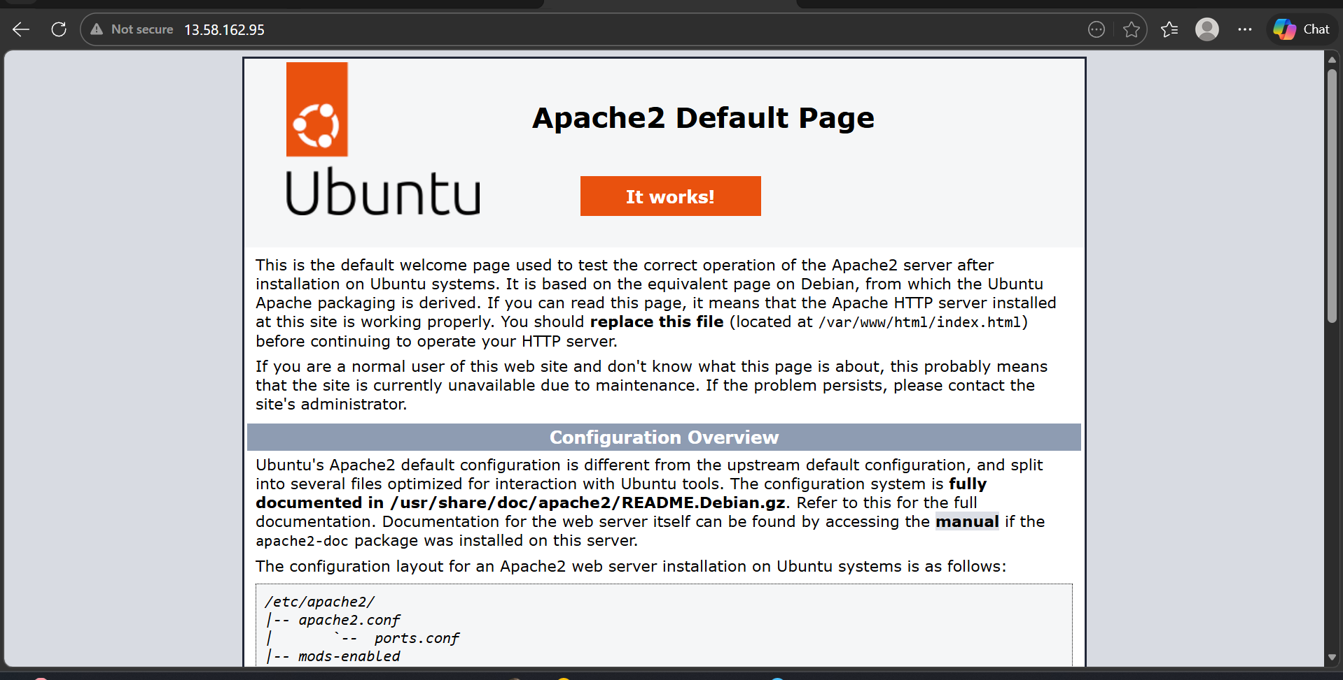

27.Configuring and securing MySQL database:
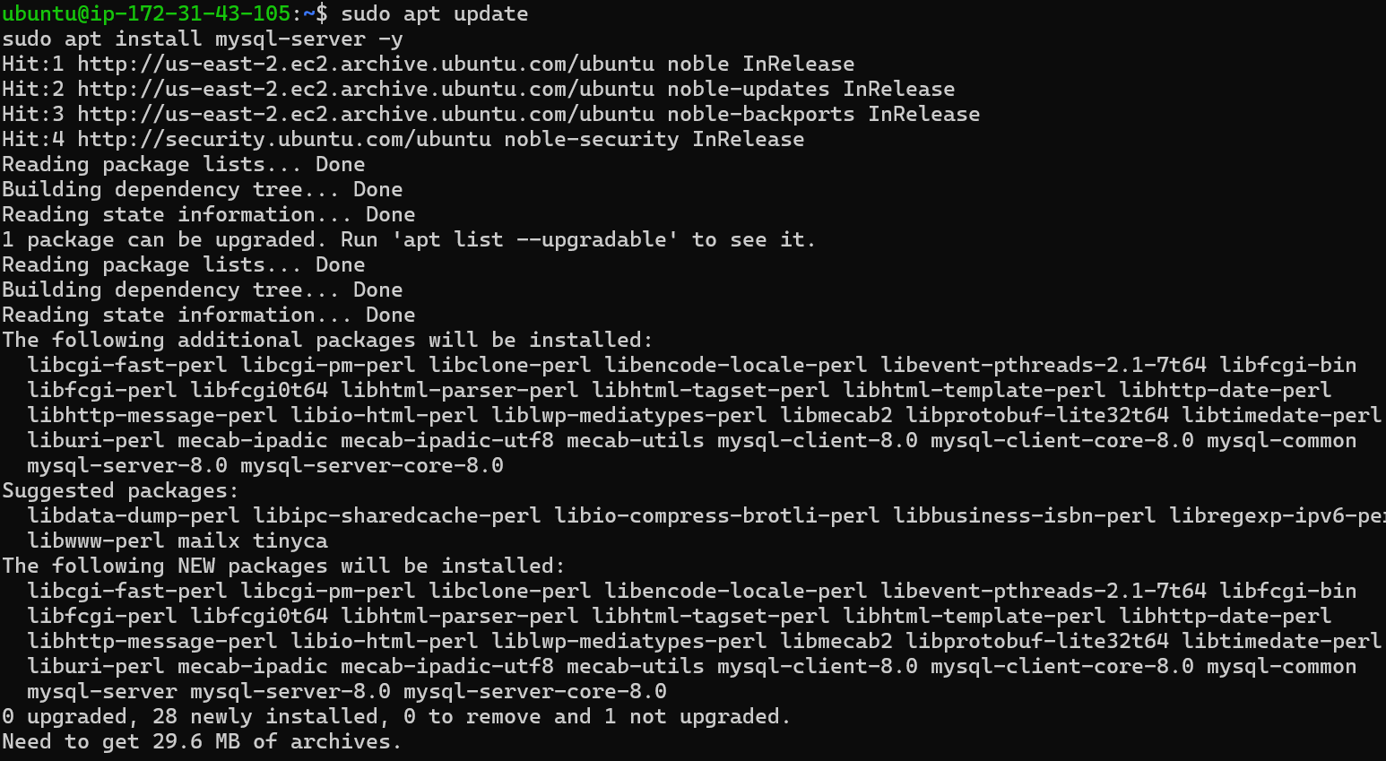
We have installed the database and started the service
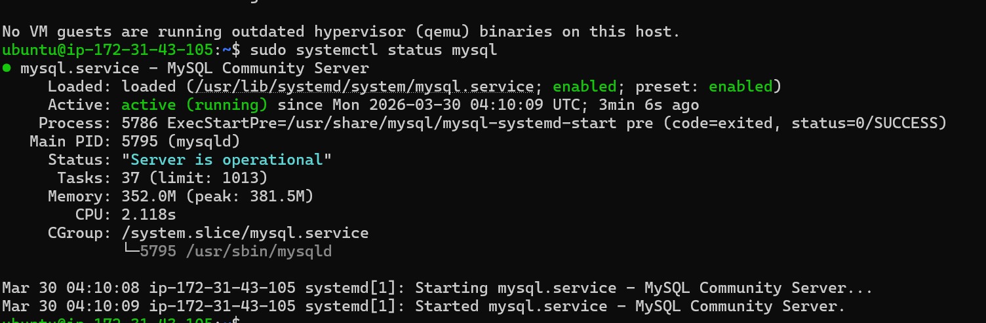

MySQL has a built-in helper for secure installation.
This will set a strong root password
Remove anonymous users
Disable remote root login
Remove test databases
Reload privilege tables

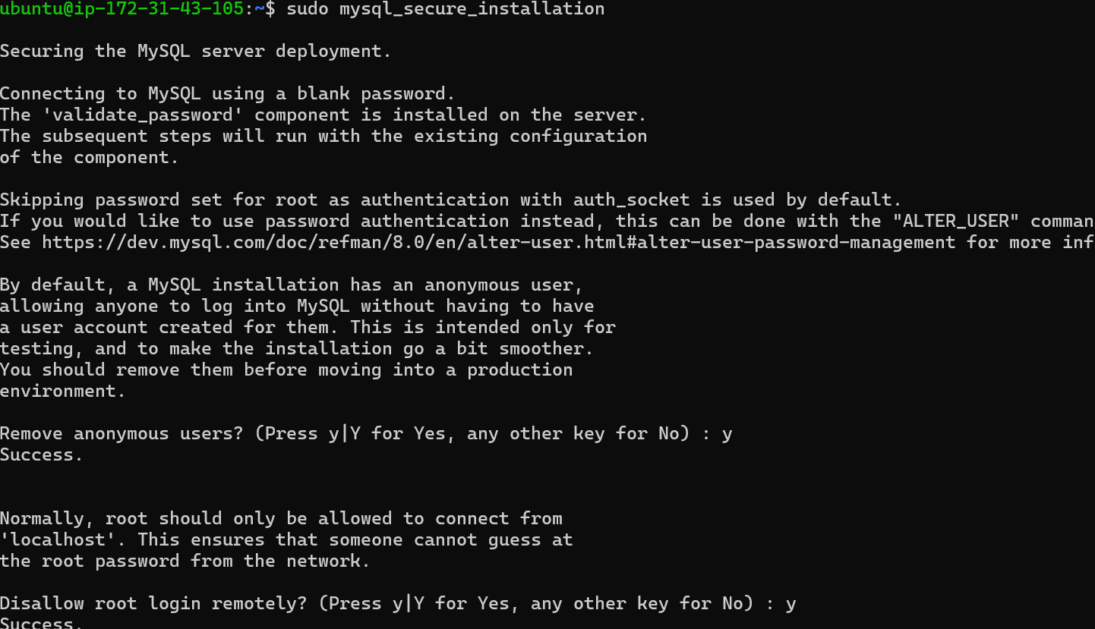

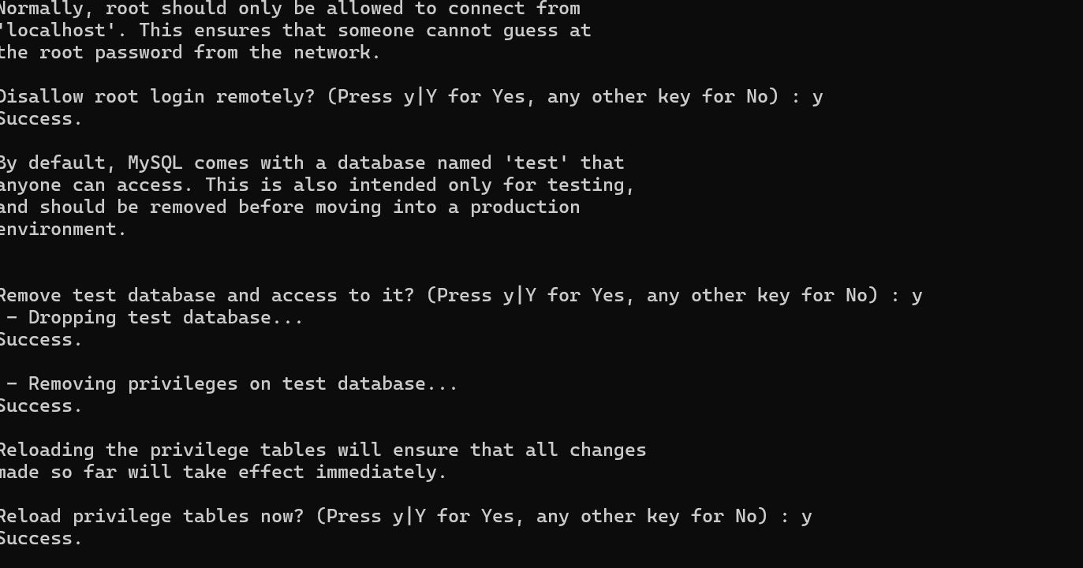

We can now connect to the MySQL database server
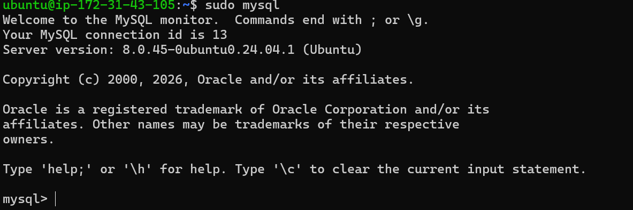

28.Setting Up Application Server(Tomcat):
To set up tomcat app server we need to install jdk first(java development kit)
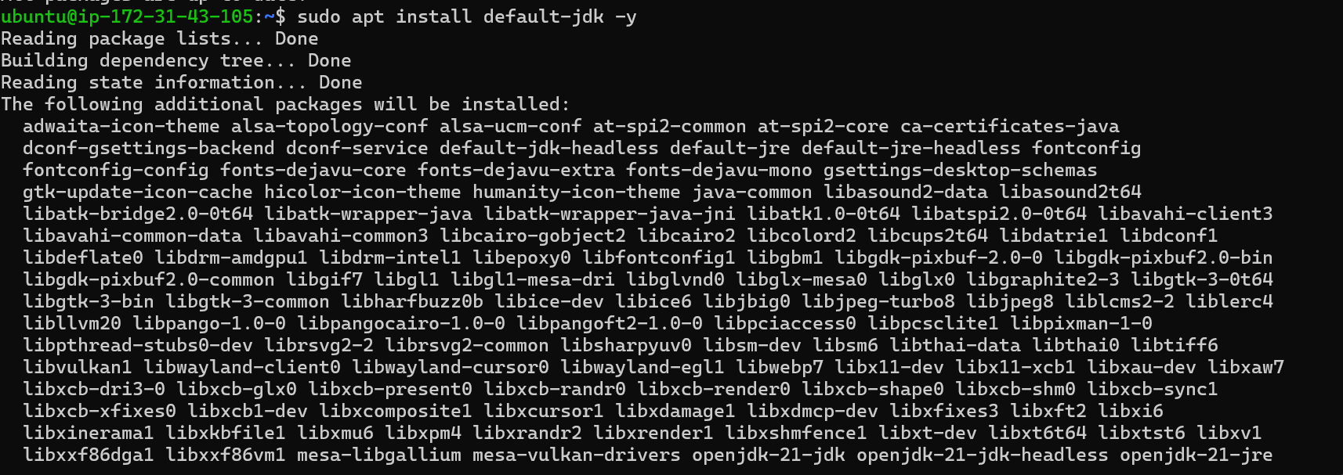
Java is now installed we can confirm it by using java -version command.
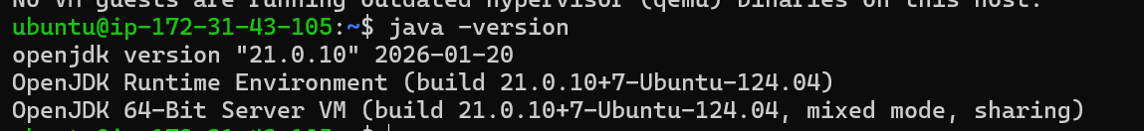
Now we need to download and install apache tomcat.
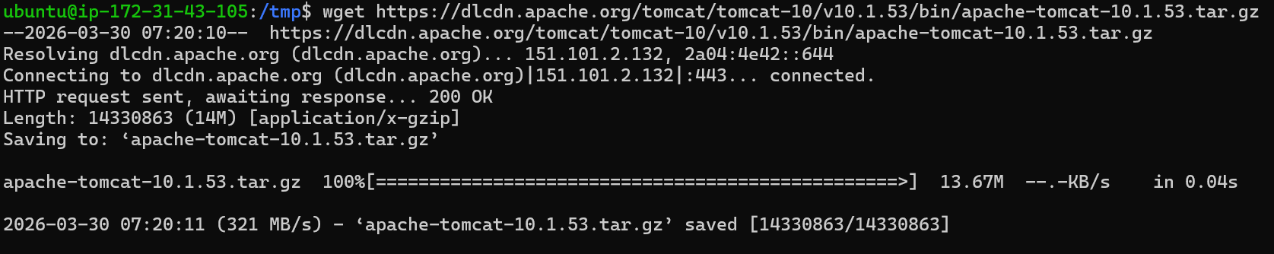
Tomcat is now downloaded and we have also decompressed the tar file which we downloaded.
We have decompressed the tar file here
We are moving the apache tomcat package to /opt/tomcat directory which we created just now.
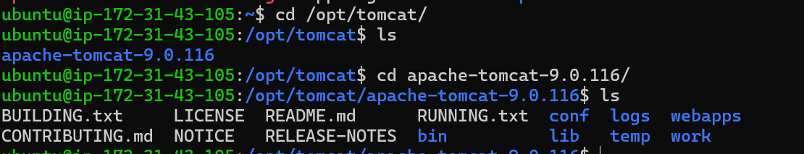
We need to go to the bin folder and execute the startup script which will start our tomcat server.
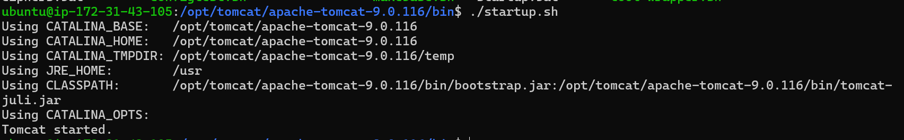
Tomcat server is now stared.
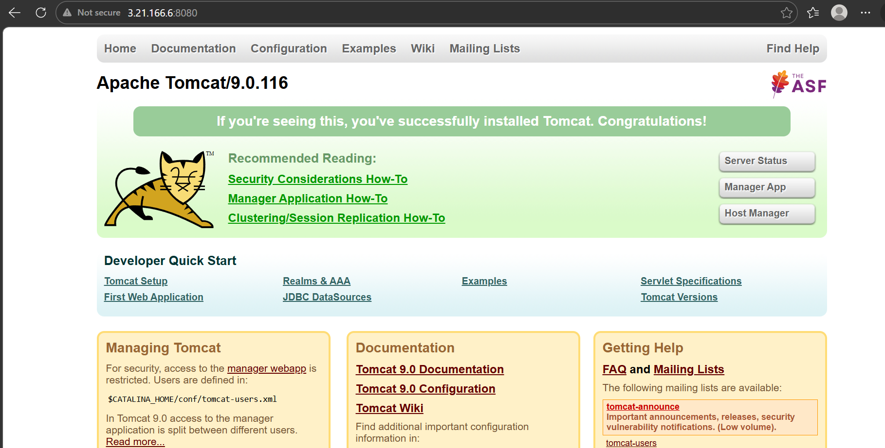

29.Create a service file or apache tomcat
Creating a systemd service file
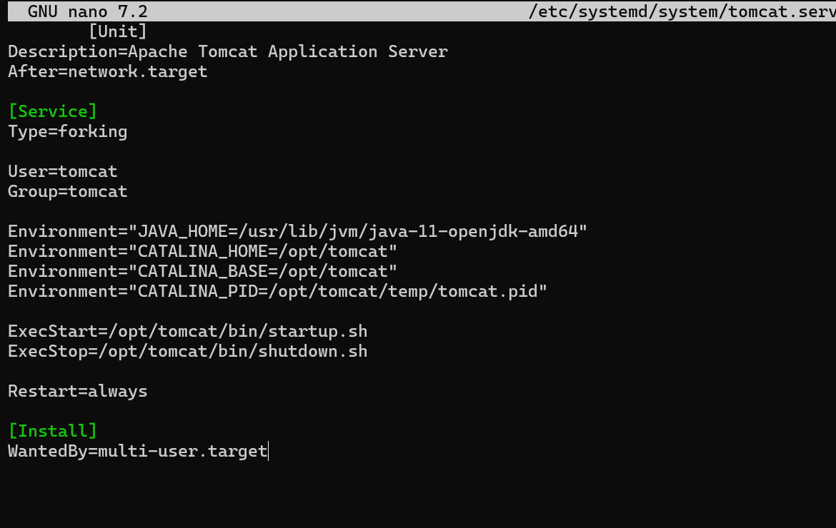
We need to reload daemon
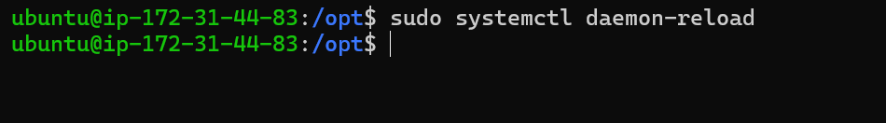
We need to ensure scripts are executable by giving proper permissions
We can now go to the /opt/tomcat/bin directory from there we can execute our startup script service file
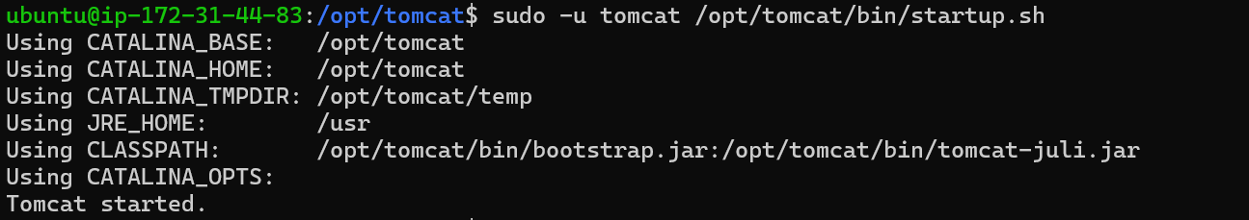
Here we have executed the script as tomcat user.
As we can see the tomcat server is running now.
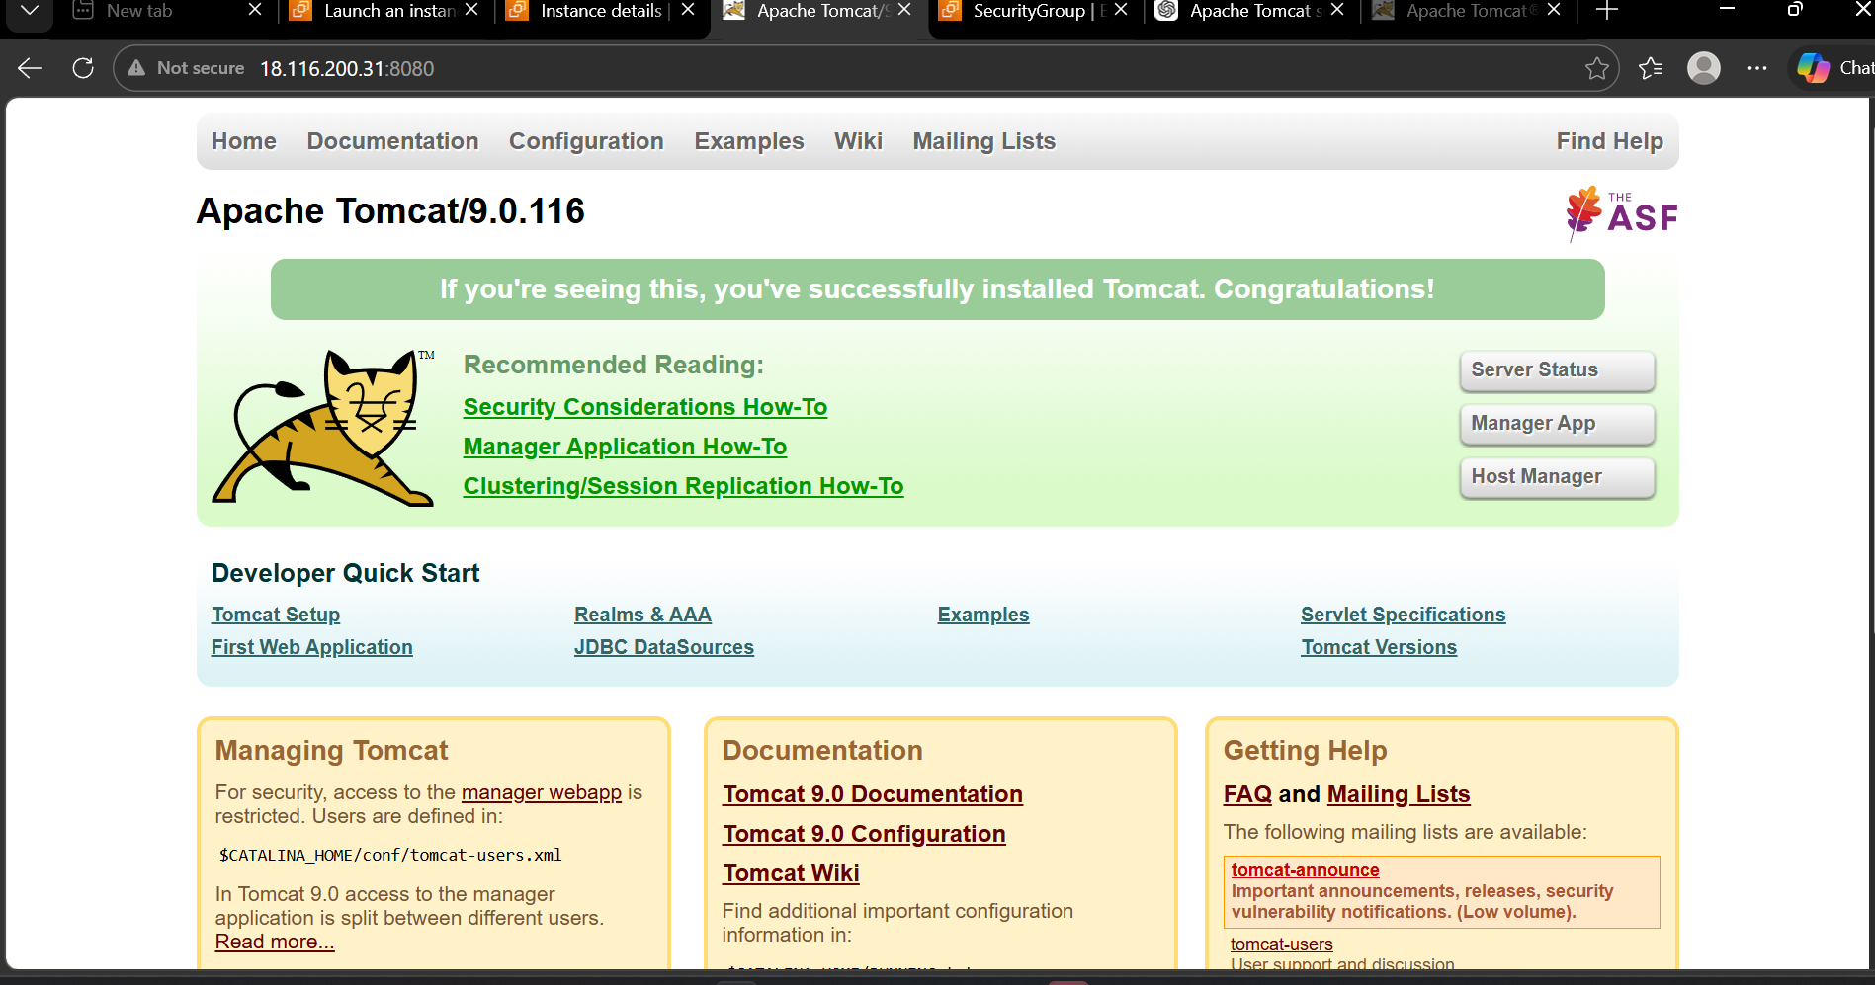

30.Print specific columns from a delimited file:
Cut is the command to print a specific column from a file.
Here we have a file data.txt
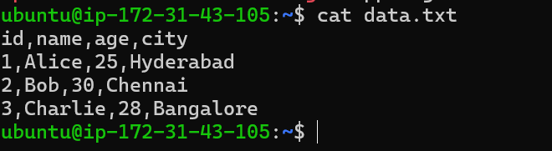
we can print out the specific columns using the cut command.
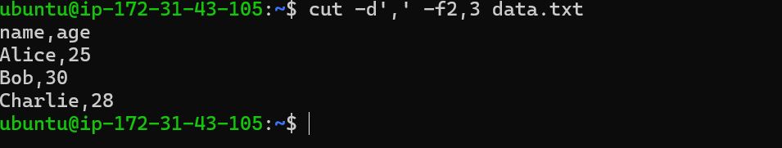
Here we have printed the 2nd and 3rd columns of data.txt

31. Filter and print lines based on pattern or condition
We can achieve this by using grep command
Here we have a sample log file from which we can filter our output.
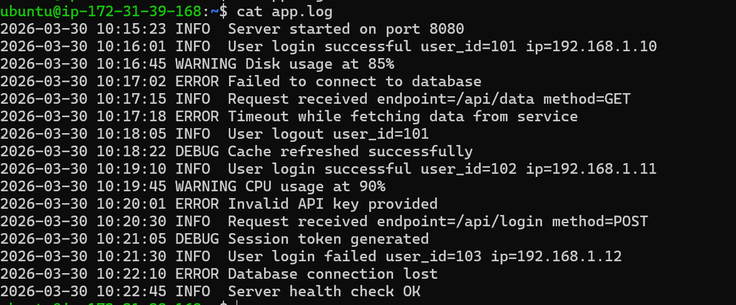
Here we have filtered out only error logs.
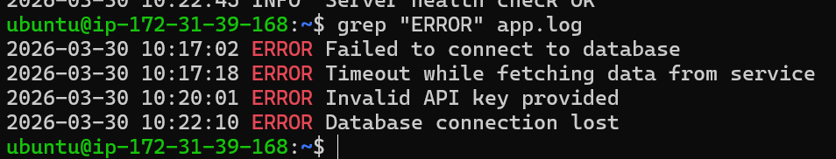
32.Calculate and print the average, sum or other statistics of a column.
We have a file named math.txt
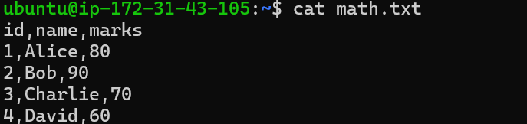
Finding sum of the third column

Finding the average of the column:

Finding minimum and maximum of the column:
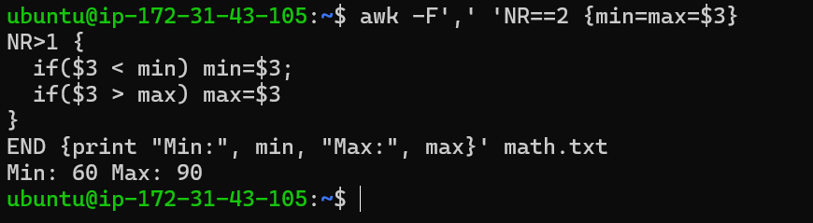

33.Performing string manipulation such as extracting substrings or changing case.
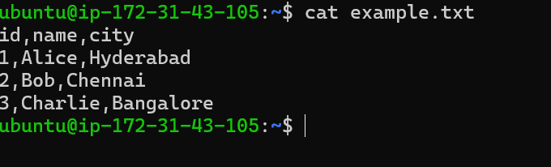

Here we have a file named example.txt we are printing the first 3 letters of the name column
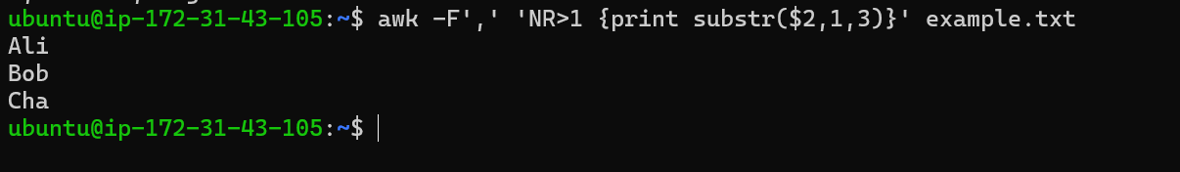
Converting the case:
We have converted the second column to upper cases of example.txt
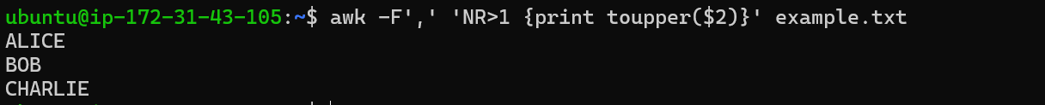

34.Count the occurrences of a specific pattern.
We can get the count of the particular pattern like this.
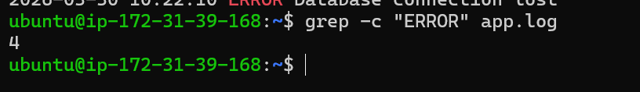

35.Sort lines based on a specific field or column.
On the same example.txt file we are going to perform sorting.
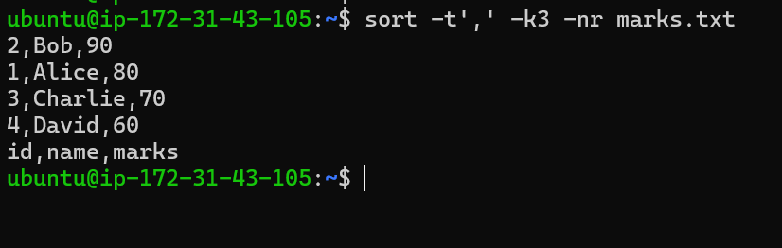
The file is now sorted in descending order
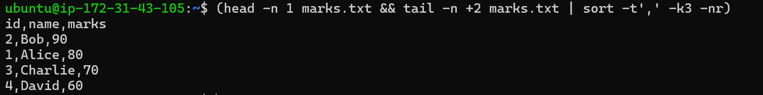
The above is the sort by keeping head at the top.

36.Merge multiple files based on a common field or column.
We can use sort and join command to achieve this
Now we can use join command to merge similar column
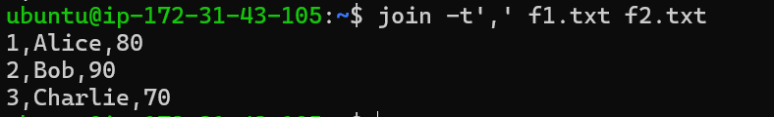

37.Substitute text in a file using search and replace:
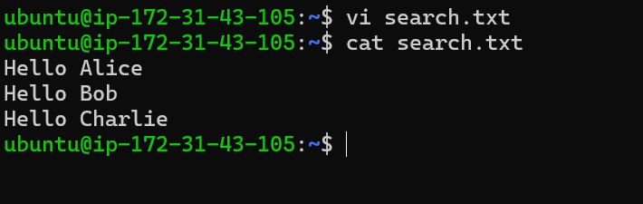
Here we have a file search.txt where we are going to perform our operations.
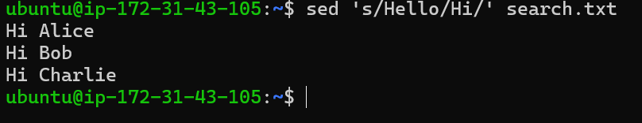
The first word hello has been replaced by hi.
38.Delete specific lines based on the pattern or line number:
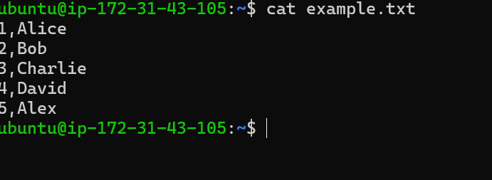
We have the file example.txt on.
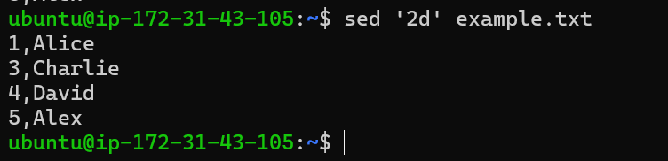
The second line has been deleted by the file using the number.
Deleting by text pattern:
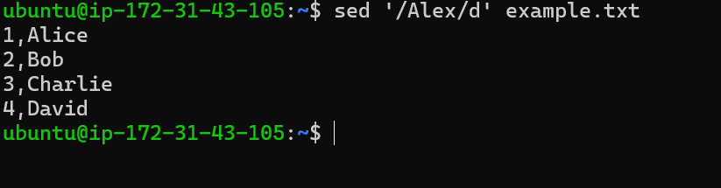
Here we have deleted the name Alex by pattern.

39.Append or insert text before or after a specific patter or line.
Here we have a file names.txt
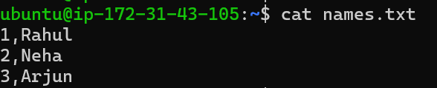

Appending text after the 2 line
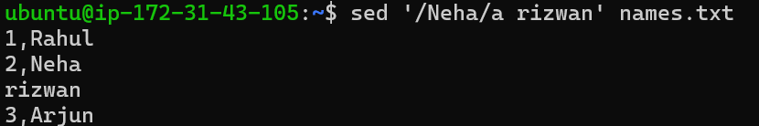
Here we have added Rizwan after the 2 line.
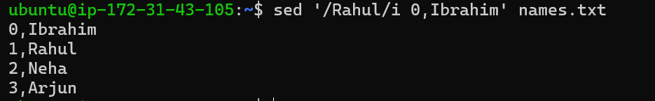
This is the example of appending text before the pattern.

40.Printing only specific lines from a file:
we can use sed command for this as well i.e to print specific lines from a file
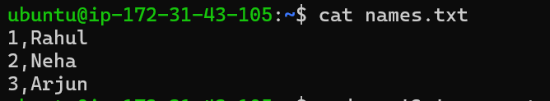
Here we have a file names.txt which contains 3 names
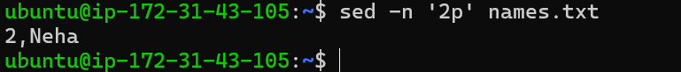
By using sed we have printed only the second line

41.Copying file from windows to Linux:
Scp is the command to securely copy from local machine to remote instance
Here we can see that the file named tahanew.pdf is successfully copied from local machine to remote machine.

42. 5 use cases of AWK and 5 use cases for SED:
We have a file data.txt with the below content
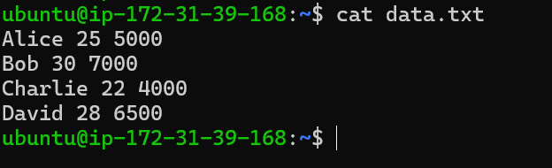
Filter rows based on condition
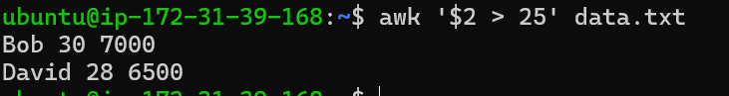
Print specific columns
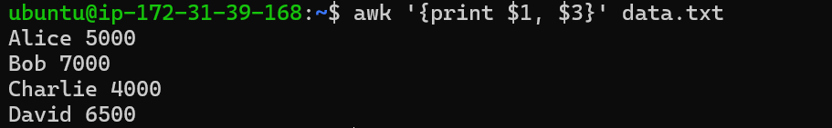
Applying multiple conditions.
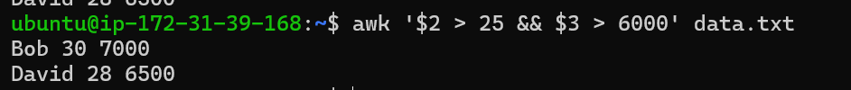
Add computed column.
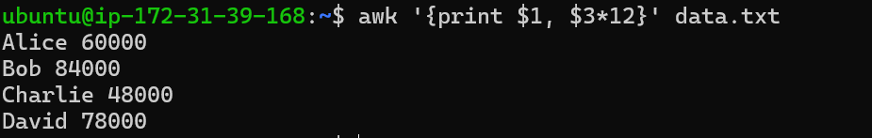
Count matching rows.

5 use cases for sed:
Here we have a file file.txt
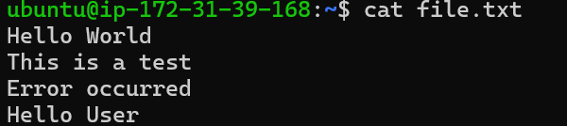
Global substitution.
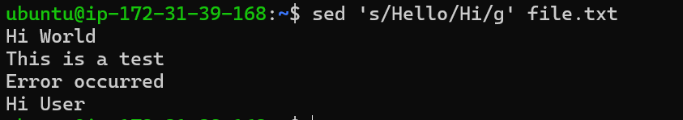
Delete specific lines.
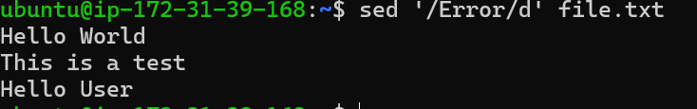
Print only matching lines.
Replace only in specific line.
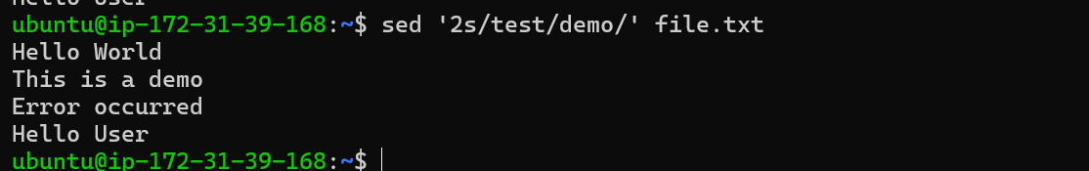

Insert Before a line.
