Simple Storage Service(S3)

- Create an S3 Bucket and upload some objects to S3.

To create an S3 bucket we should first search for S3 service

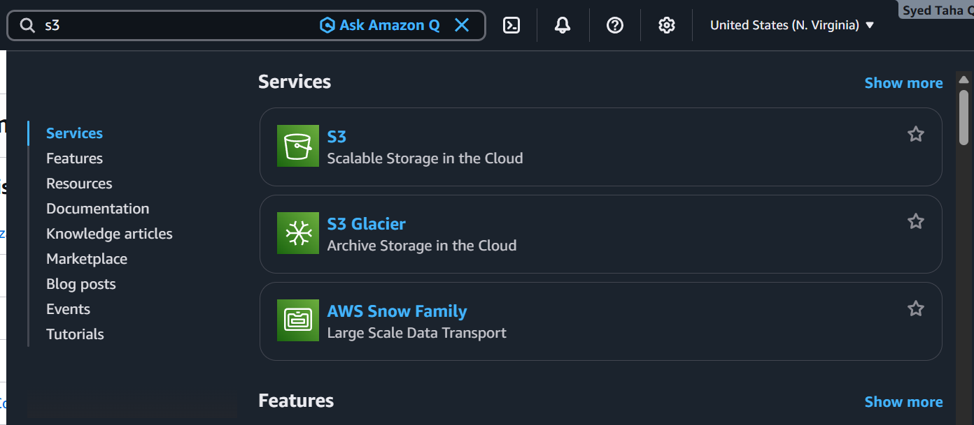

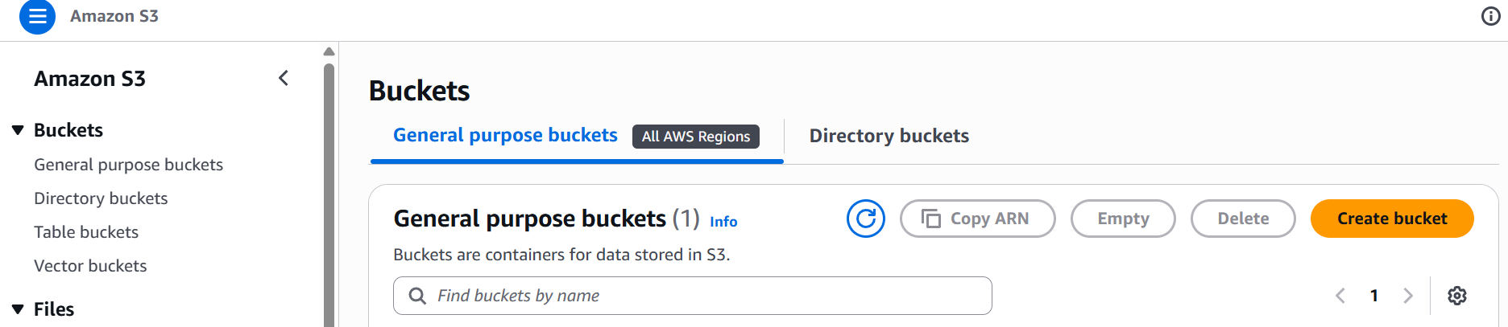

Now let us create a bucket

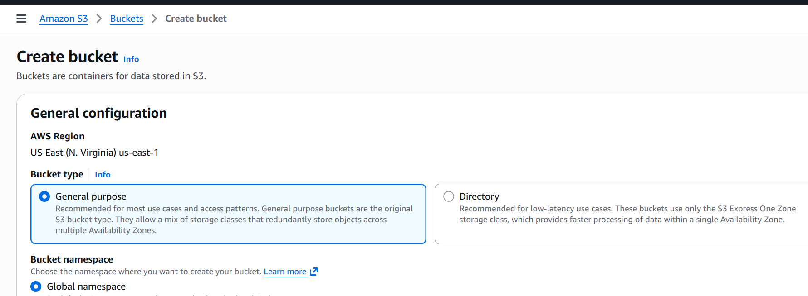

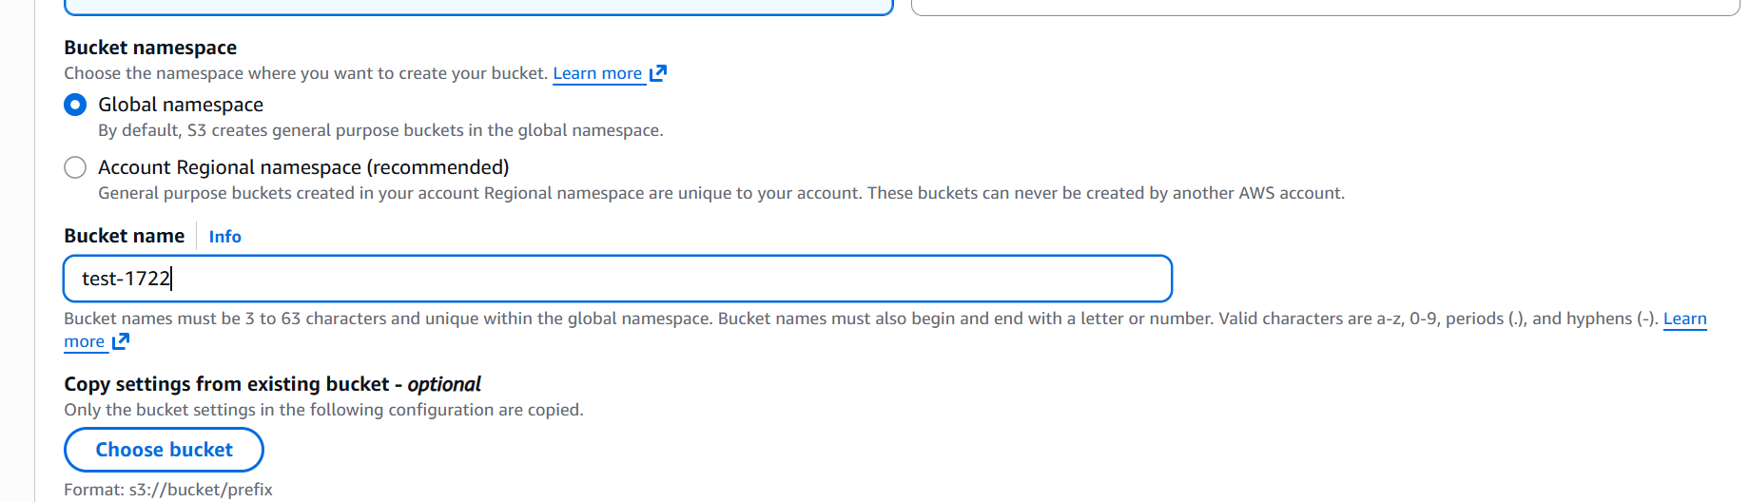

We can leave everything default

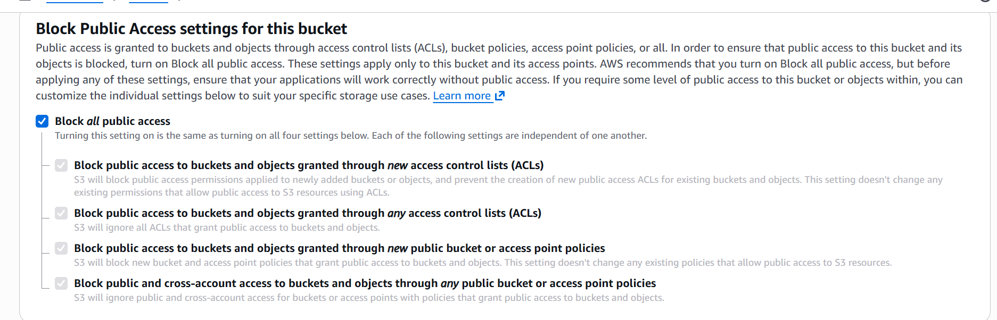

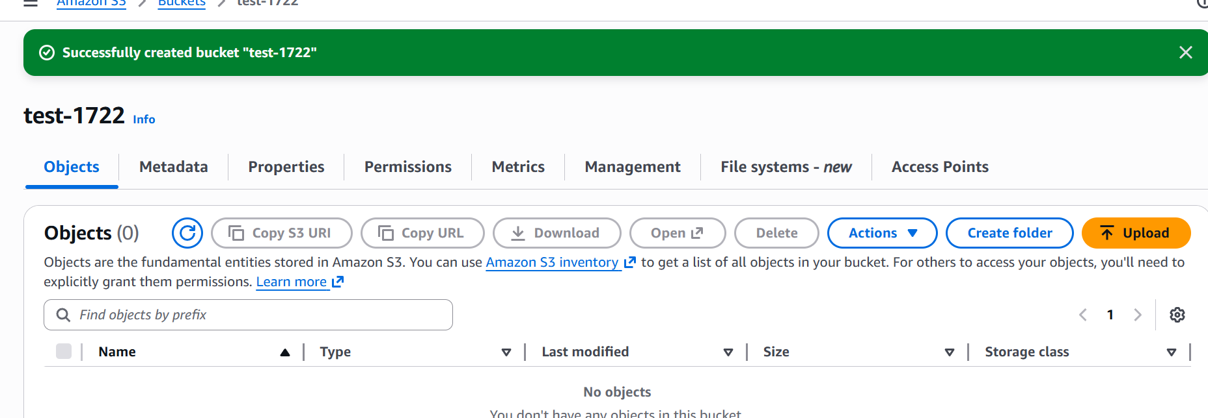

The bucket named test-1722 is now created.

Let us now upload a file we need to click on upload button.
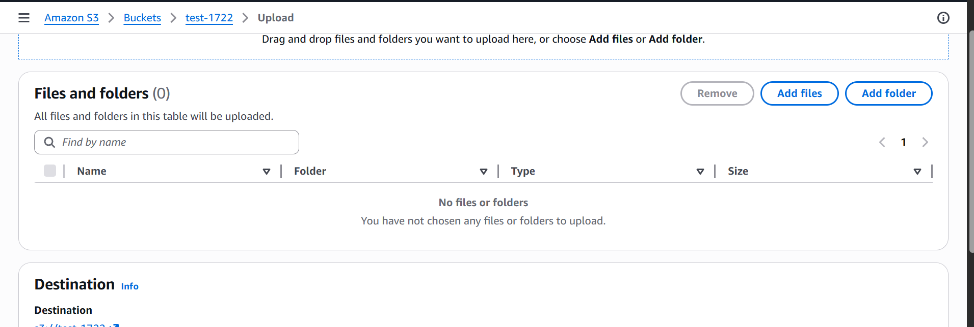

Click on add files.
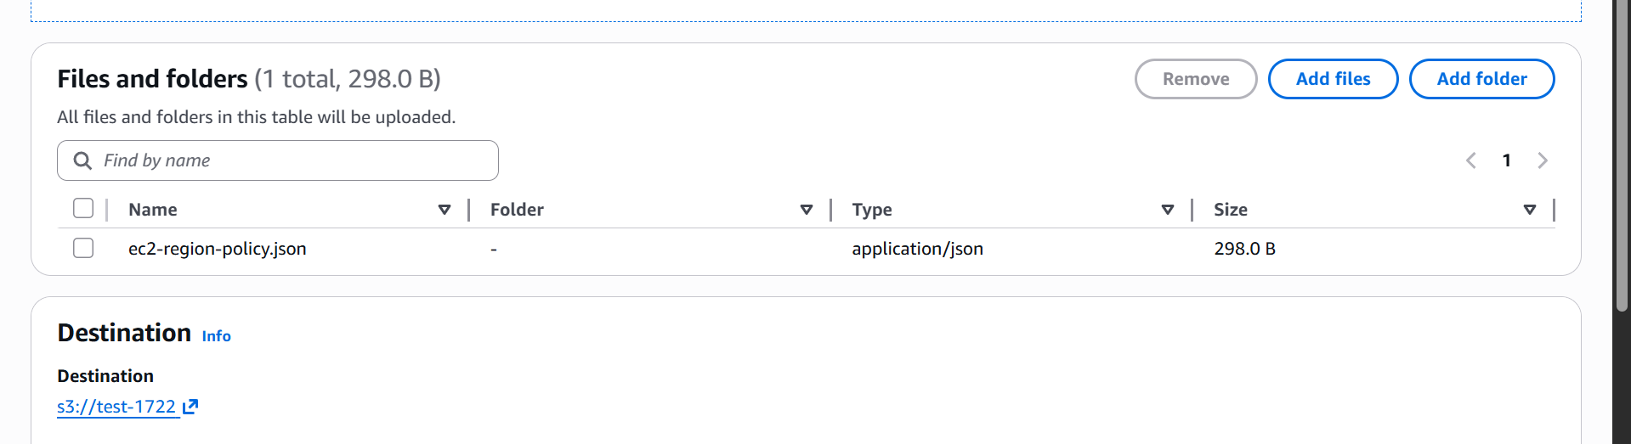

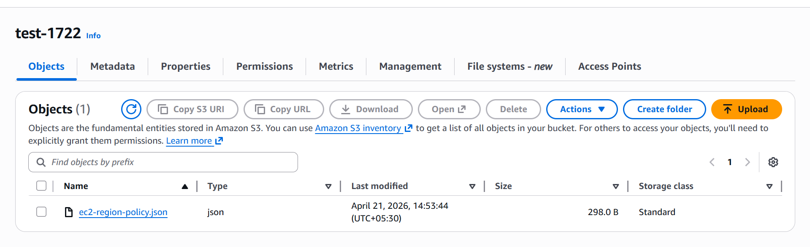

The file is now uploaded.

- Deploy a static website in the S3 bucket.

First let us create a new bucket for this task.

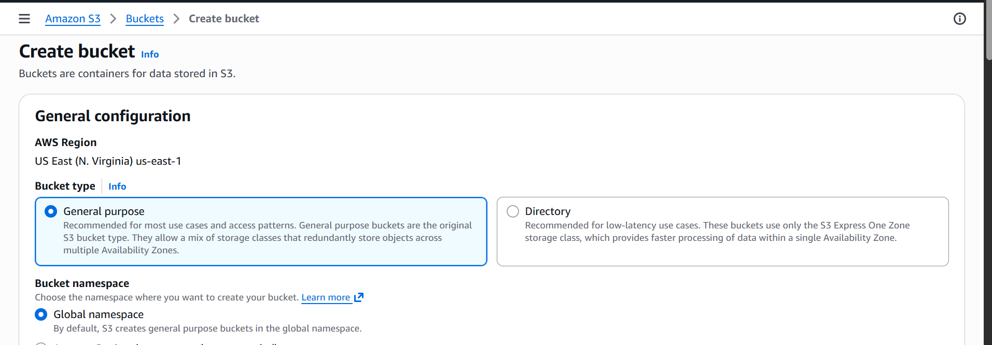

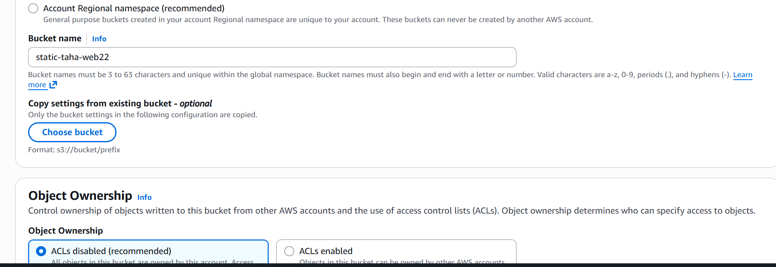

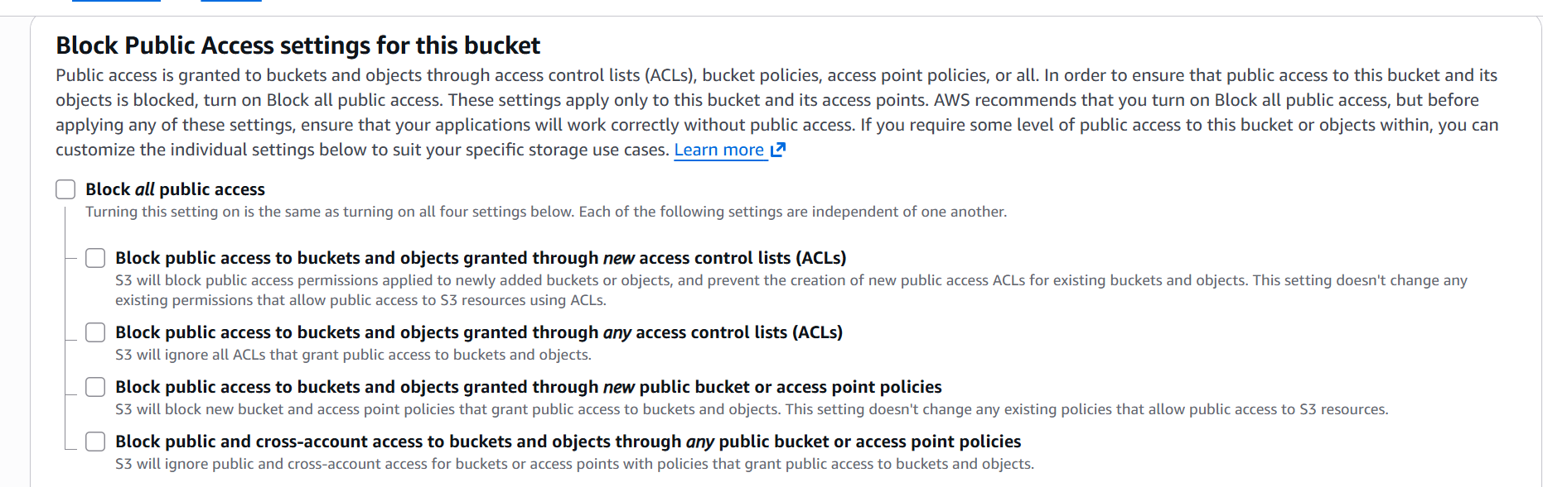

Unchecking the block all public access box to make sure our website is accessible publicly.
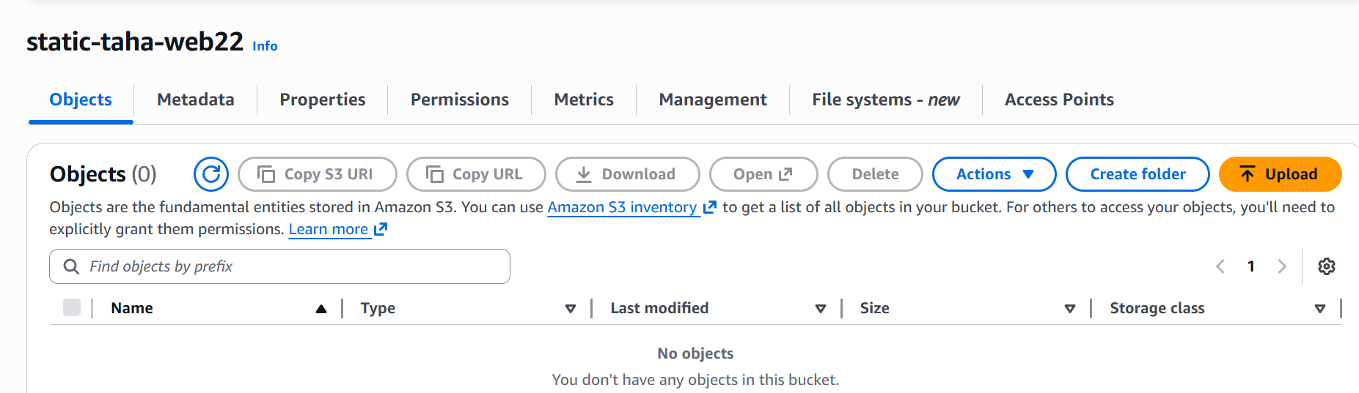

Now go to properties and enable static website hosting.

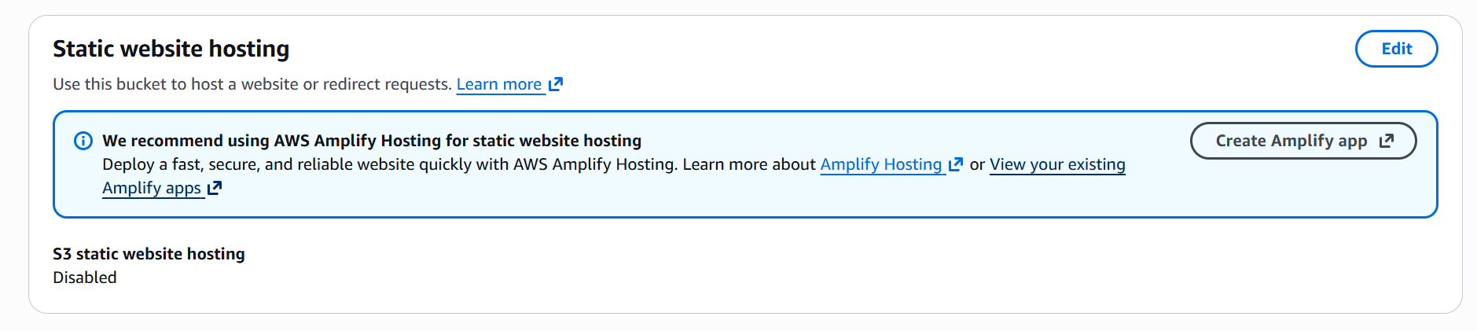

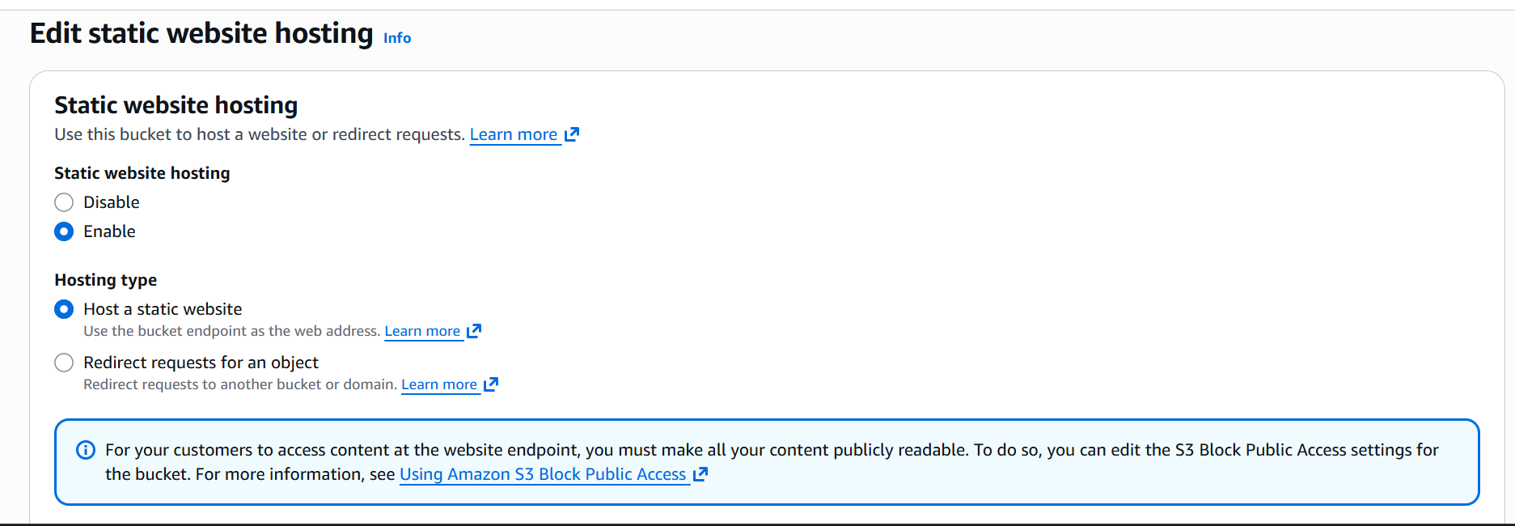

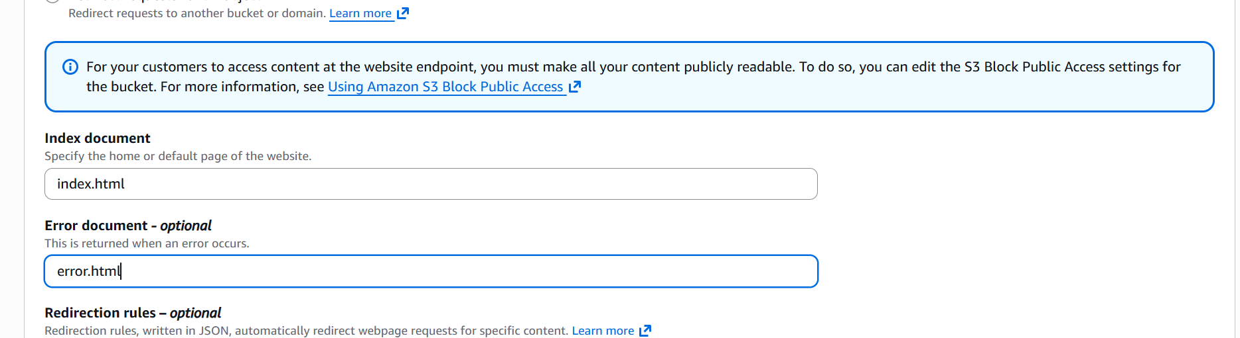

Now let us upload the html files.
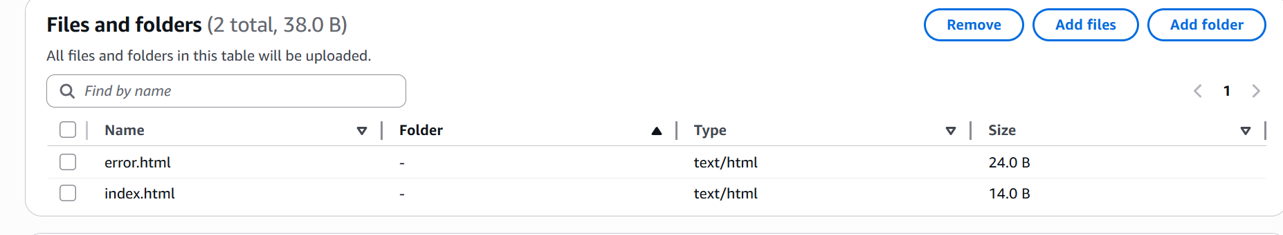

Now let us add the bucket policy

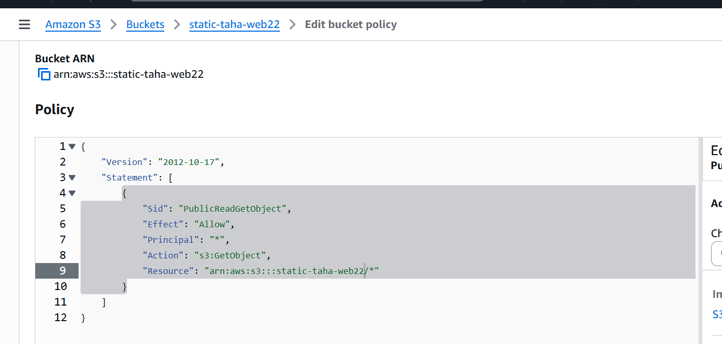

We have updated the bucket policy now let us check if our website is working.

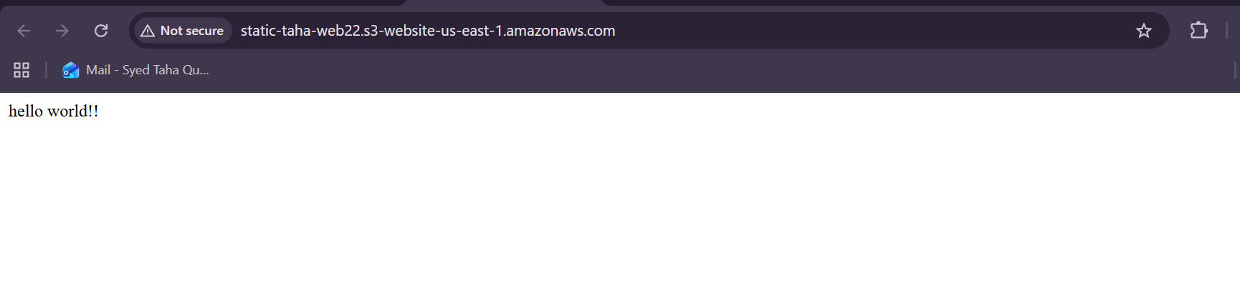

Our static website is working properly.

- Enable cross region replication on S3 Bucket.

Let us create two buckets in two different region with versioning enabled.
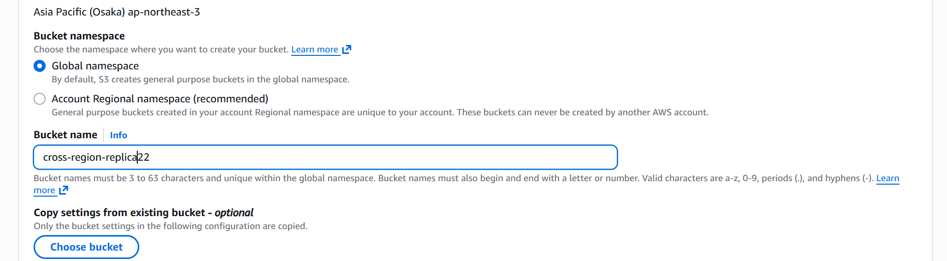

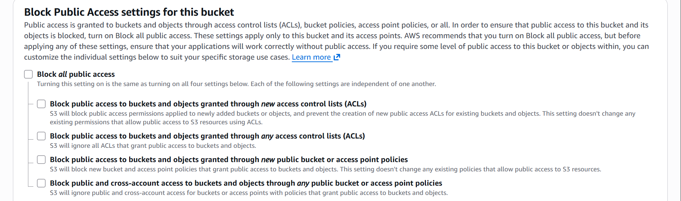

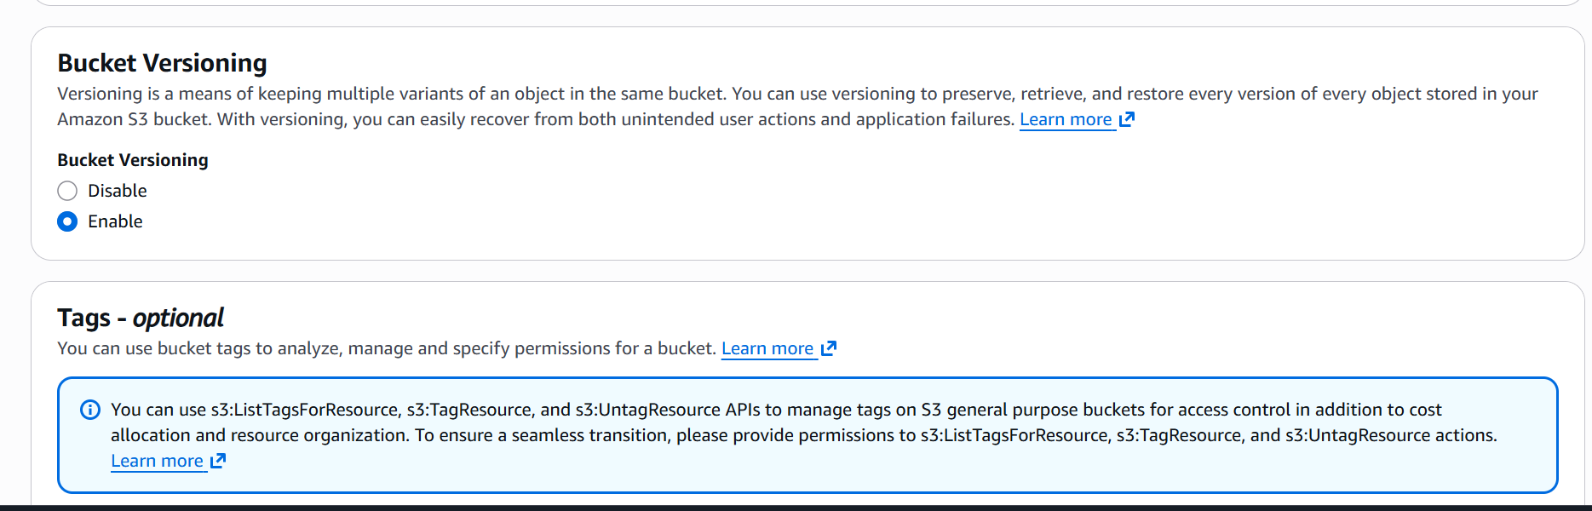
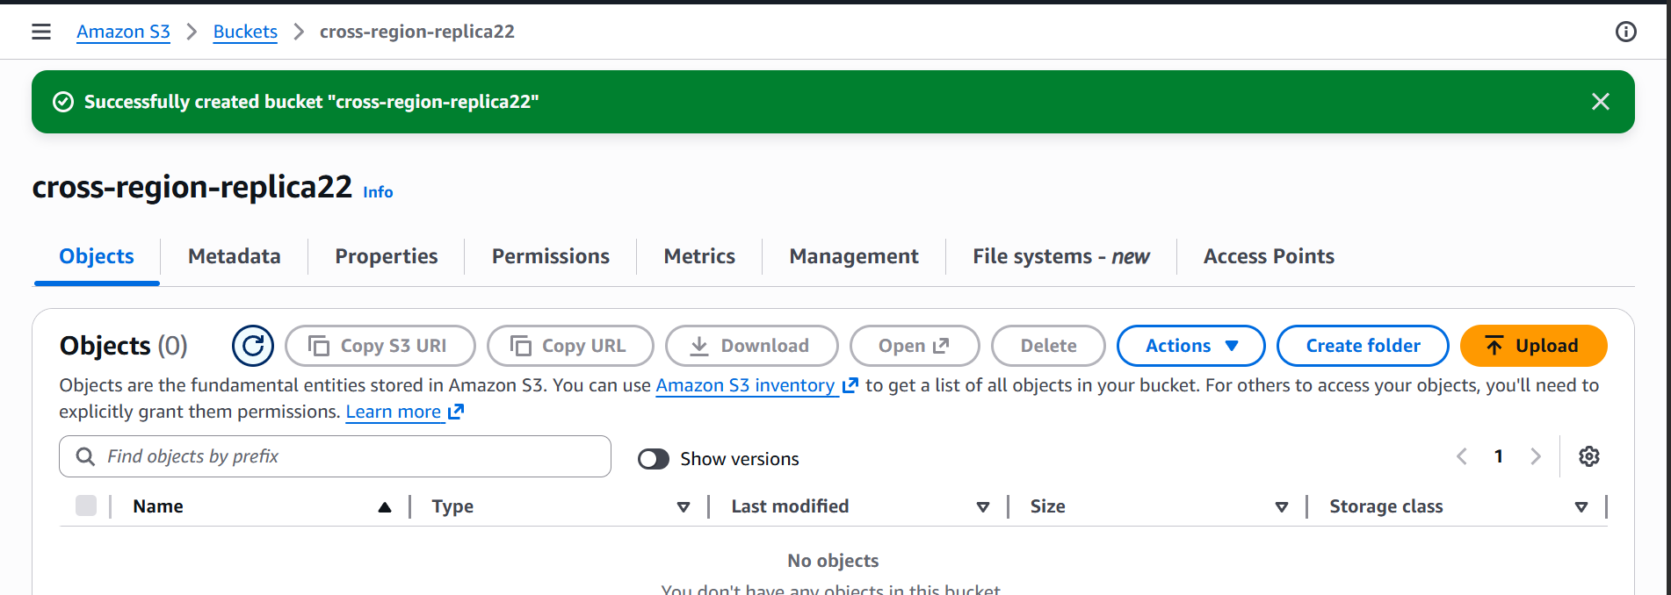
One bucket created in asia pacific Osaka region

now let us create another bucket in Hyderabad
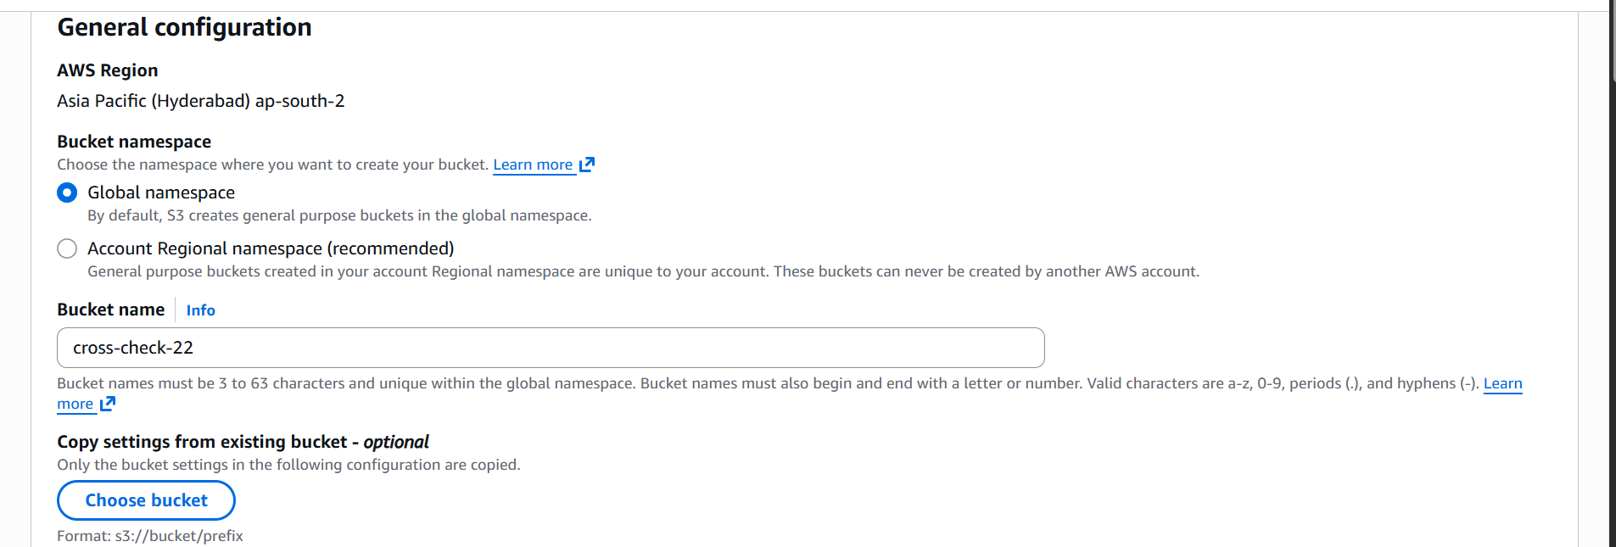

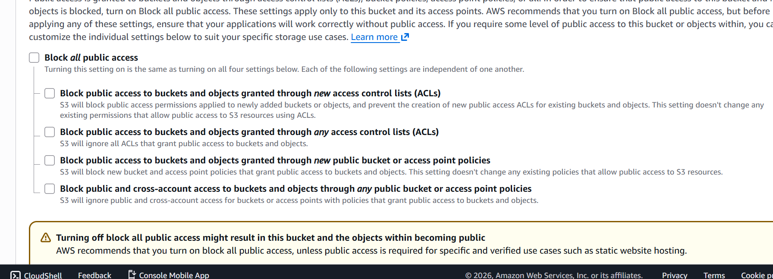
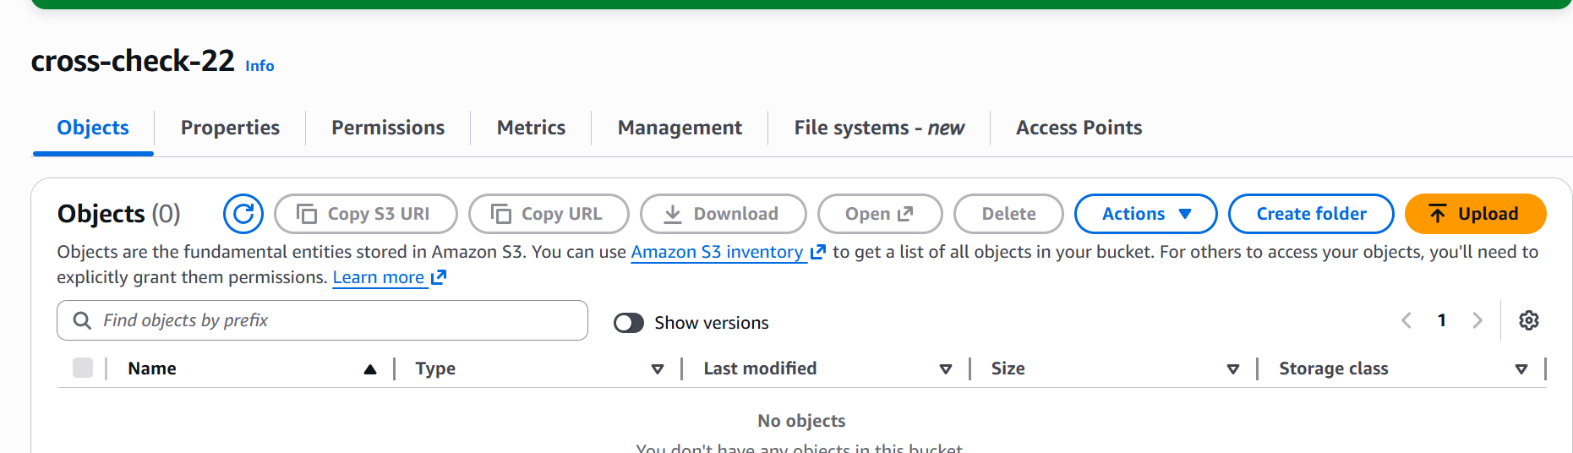
Created another bucket

Now let us create a replication rule.
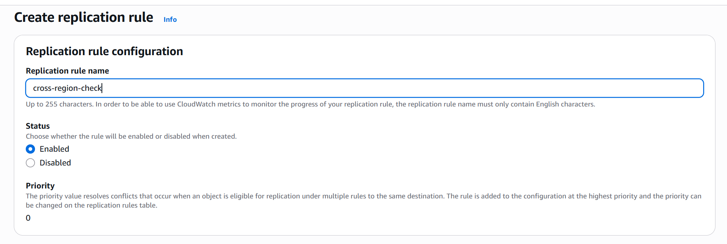

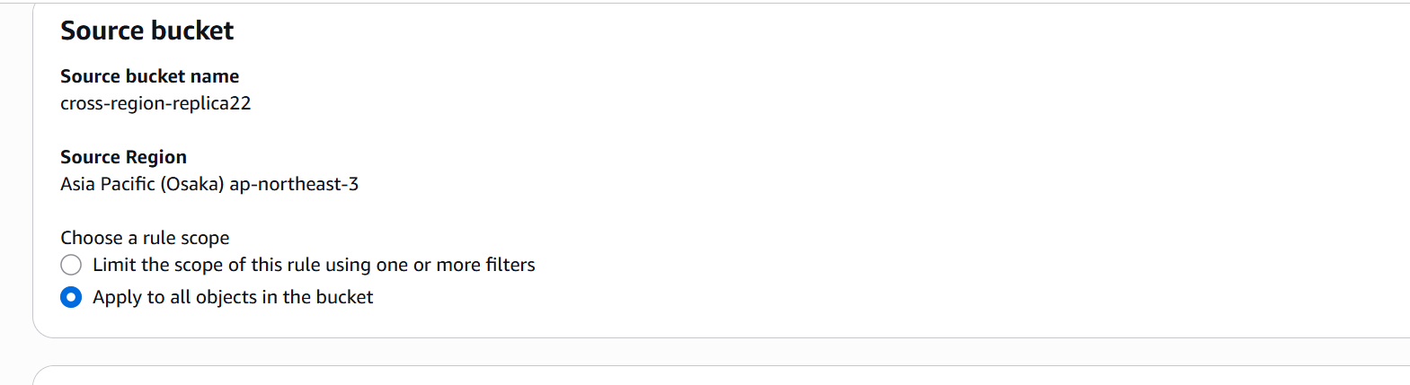

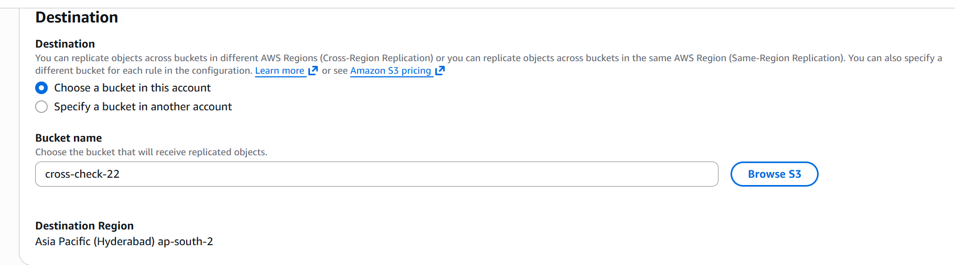

AWS will automatically generate a role with the permissions needed.

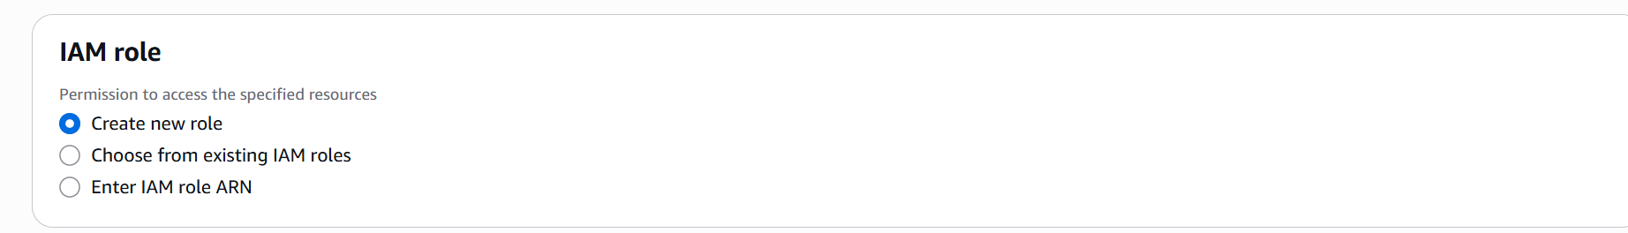

Now let us create the replication rule
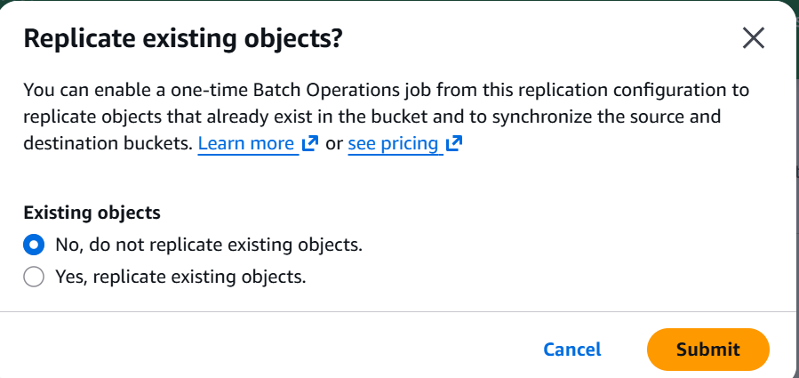
As we do not have any objects in our source bucket let us keep as no.

Let us now upload objects in source bucket and confirm if it works or not.

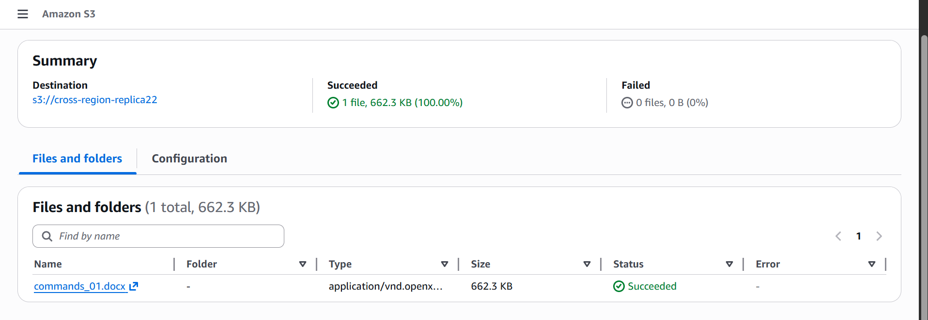

Uploaded a file in source bucket let us now confirm if it reflects in the destination bucket as well.
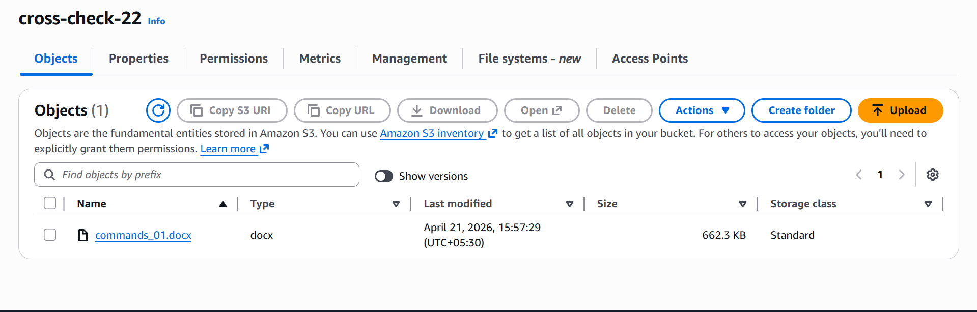

We can now see that the same object is replicated in the destination bucket as well.

- Configure a bucket policy so only the Admin user can see the objects of the S3 bucket.

Let us now first edit the bucket policy of our existing bucket.

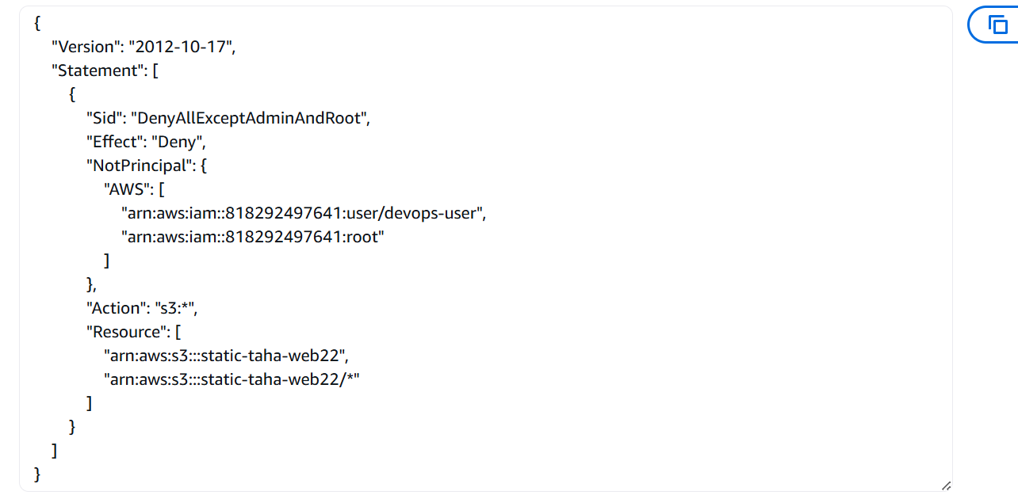

The account owner and devops-user has the access to the bucket static-taha-web22

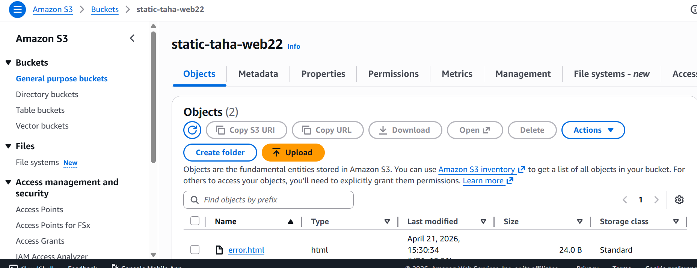

As I am the owner I am able to access the bucket.

Let us now create a new user and give s3 permissions and try to access the bucket from there.
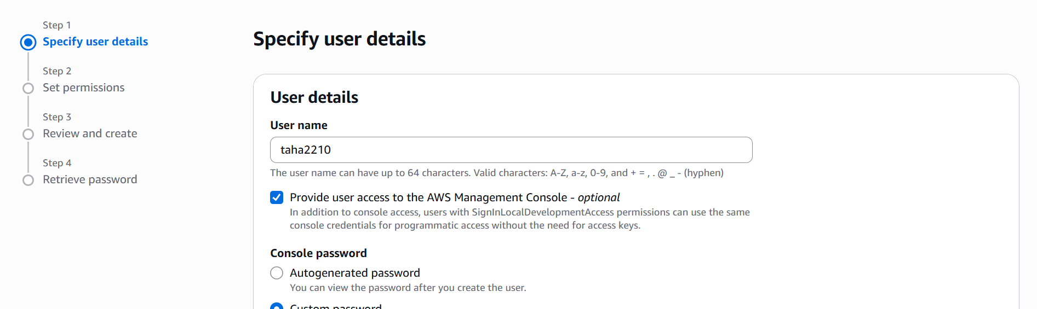

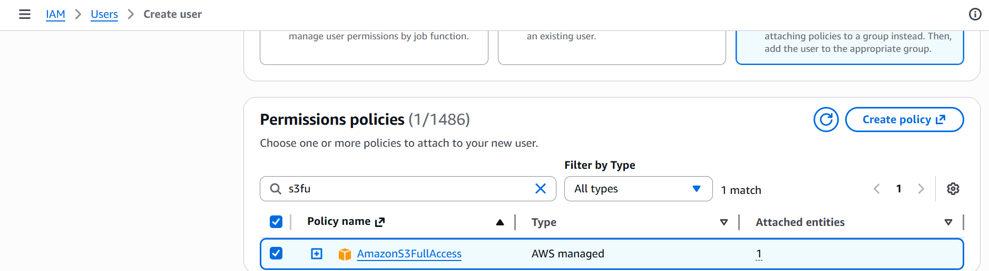

We have now created the user taha2210 with s3 full access. Lets login to that user and check if we are able to access our bucket.

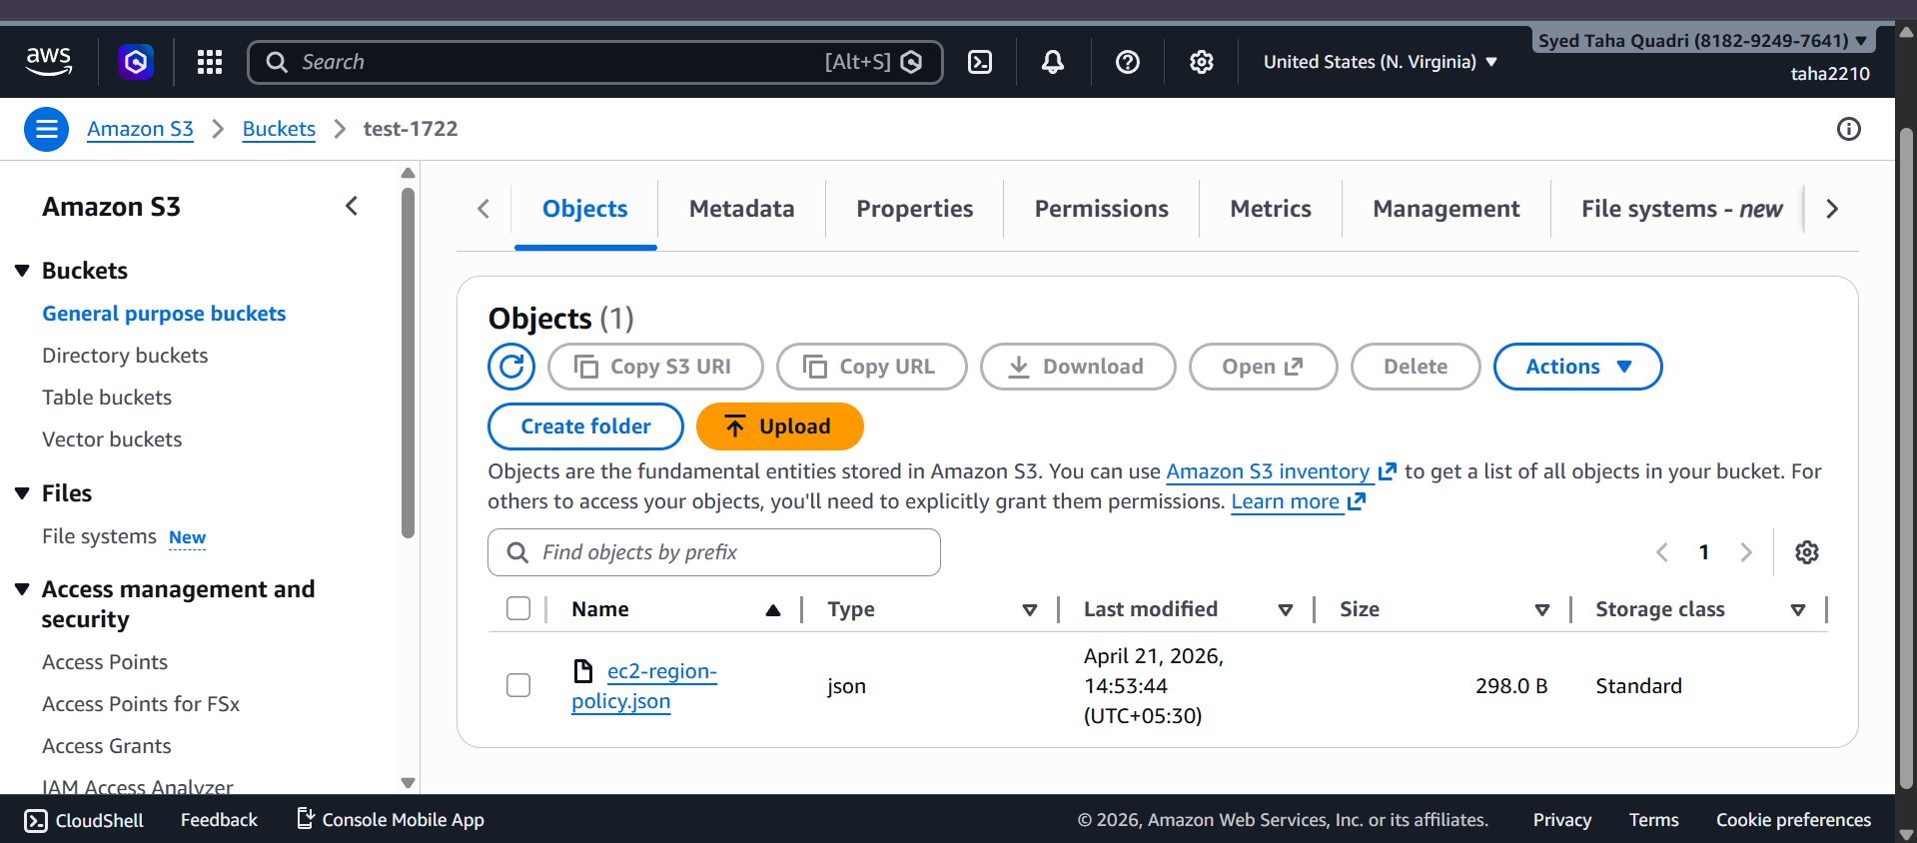

The user is able to access other bucket test-1722

But is unable to access the bucket static-taha-web22
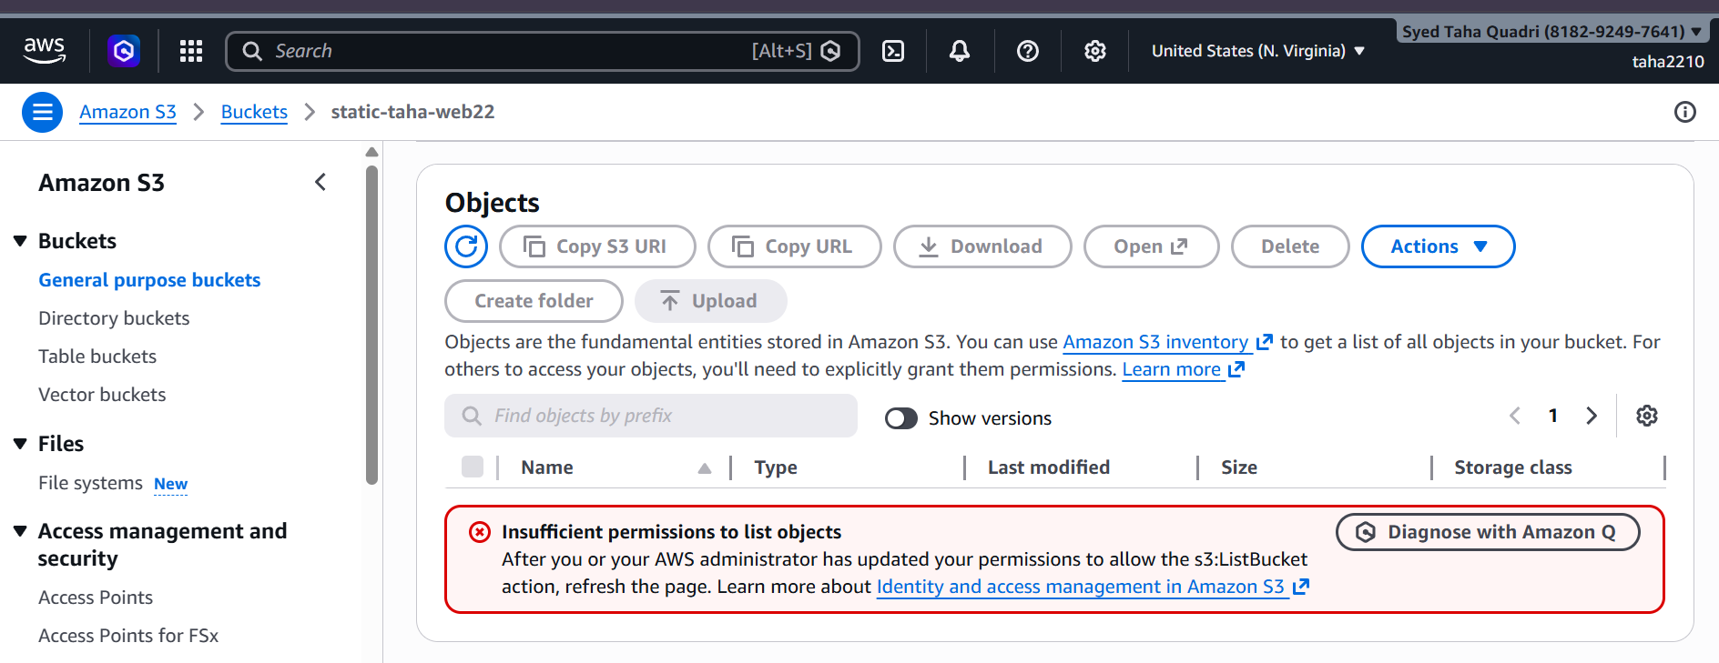

- Set up lifecycle policies to automatically transition or delete objects based on specific criteria.

First let us go to our bucket test-1722
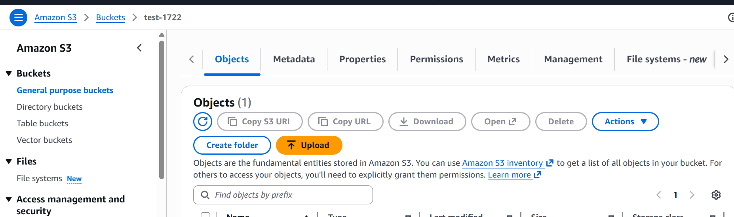

Now let us create the lifecycle rule my going to management tab.
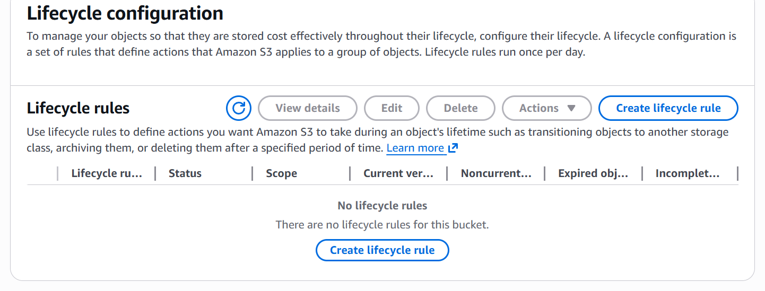

Click on create lifecycle rule.

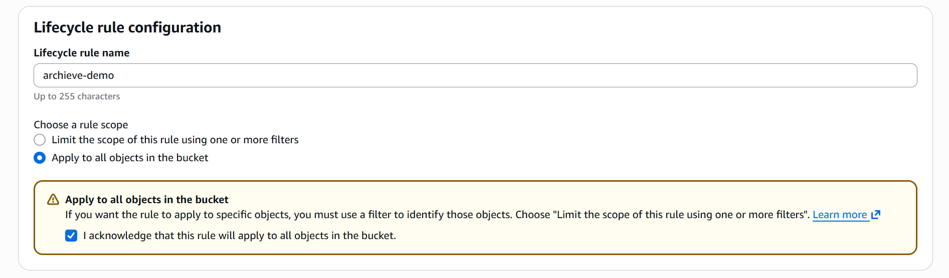

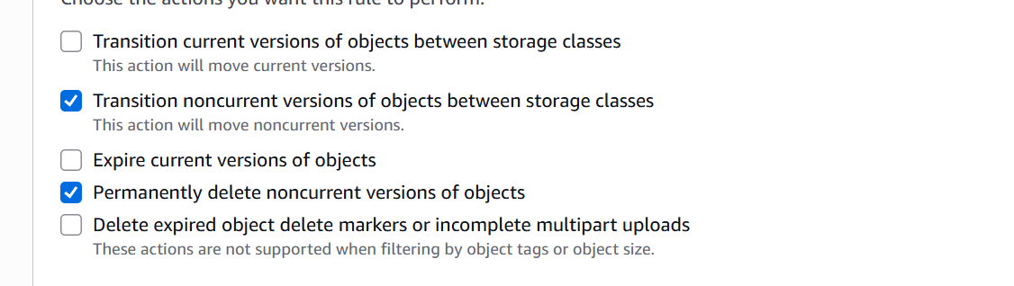

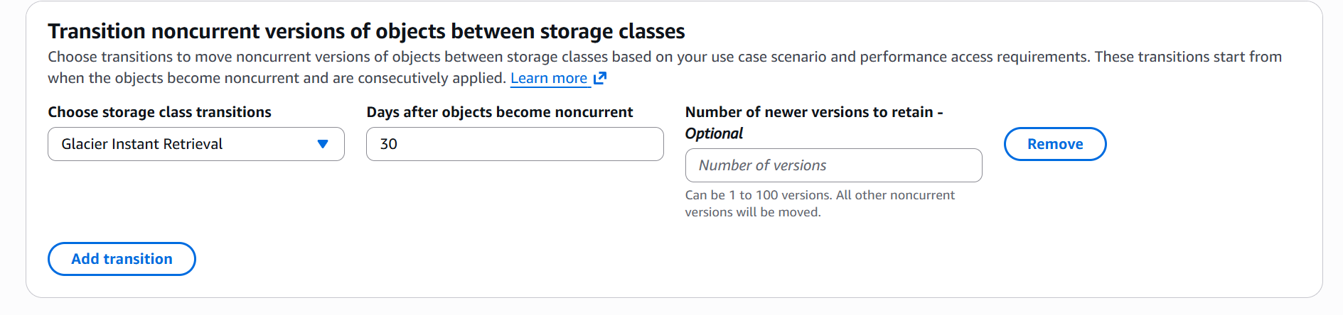

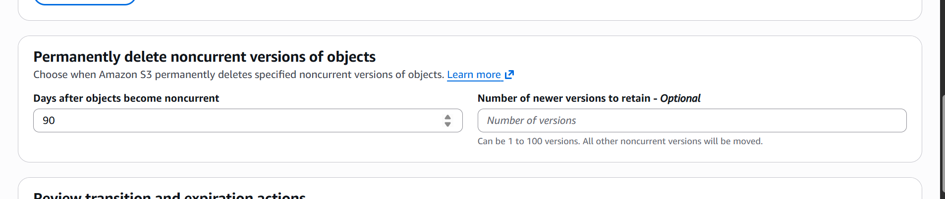

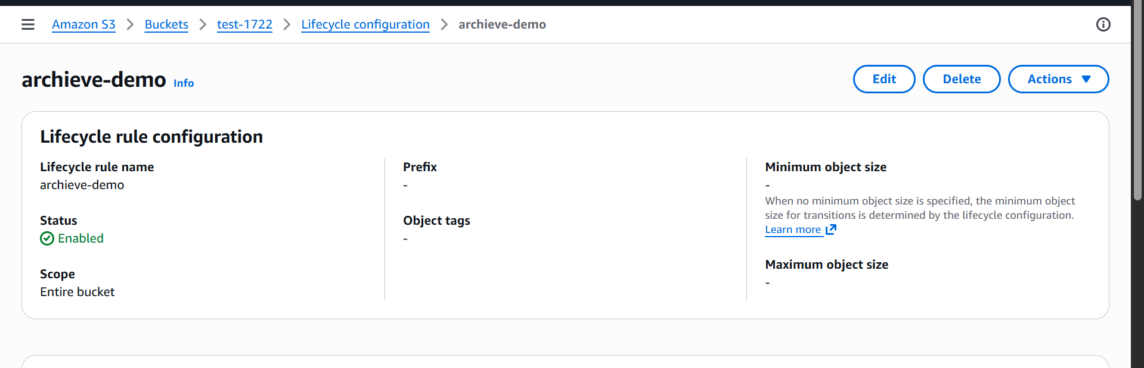

We have now created a lifecycle policy which will transition non-current object versions to S3-IA after 30 days and performs a final permanent deletion after 90 days.

- Push some objects to S3 using AWS CLI

Here we are copying our file from local machine to S3 bucket test-1722

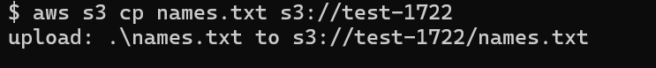

The file has been uploaded successfully.

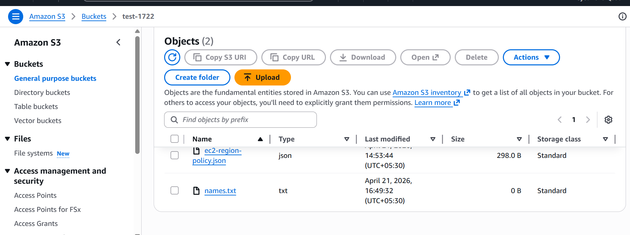

- Write a Bash script to create an S3 Bucket.

Script to create an S3 bucket.

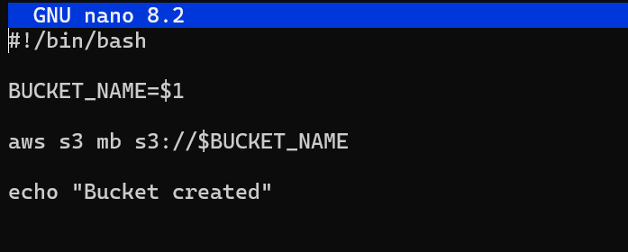

Giving execute permission

The bucket is now created

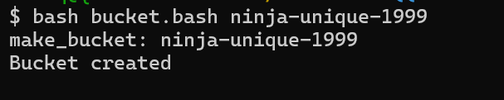

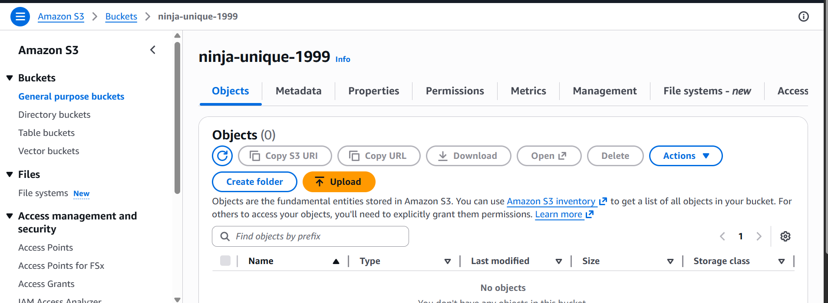

- Upload a 1 GB file to S3 using the CLI.

Let’s first create a 1gb file

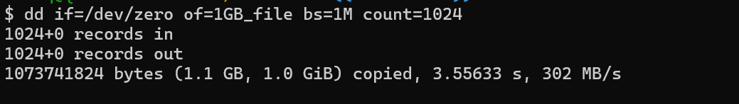
We can use the aws s3 cp command to upload 1GB file.
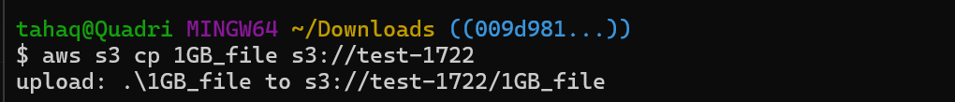

We have uploaded a 1gb file to our s3 bucket

The same is reflecting in our bucket as well.

