VPC Challenge
Setting up Transit gateway and VPC end point for a Multi-VPC Architecture.

Step 01: Create 3 VPCs
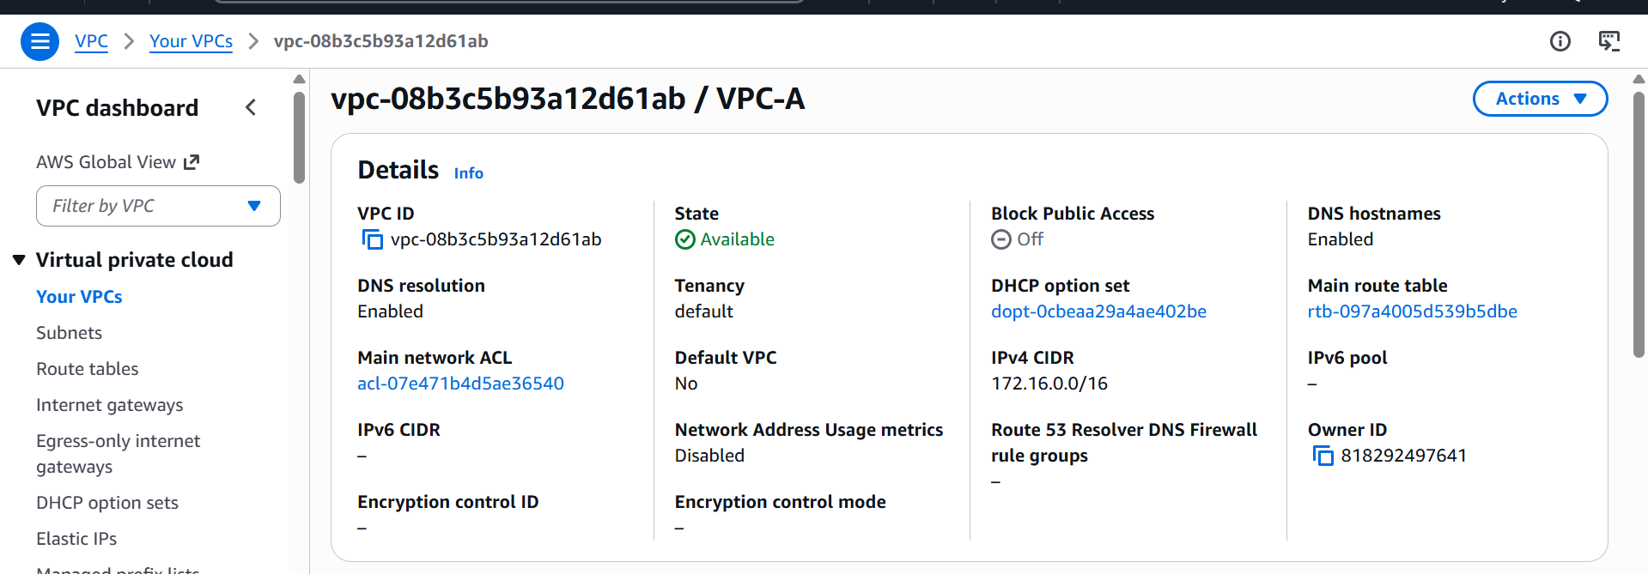

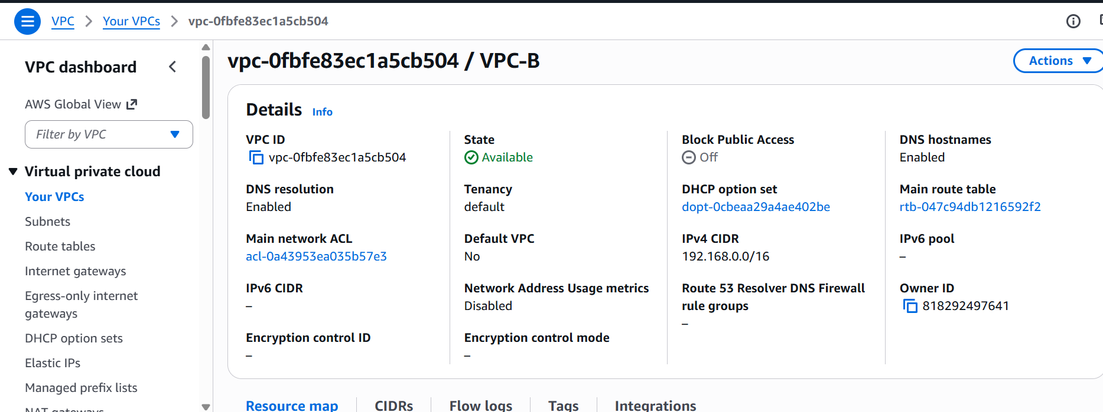

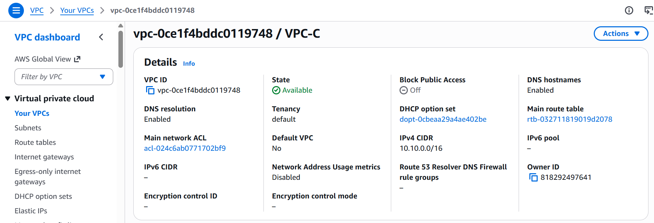
We now have 3 VPCs with 1 public and 1 private Subnet each.

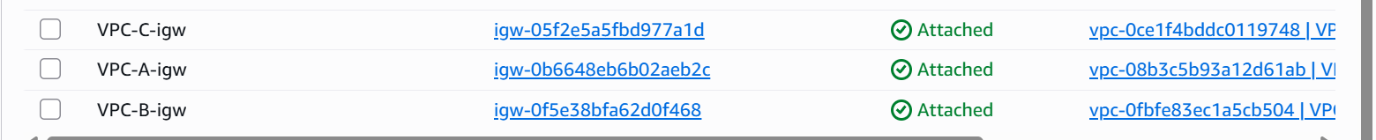

Also internet gateway is attached to all the VPCs

Now lets go ahead and create transit gateways

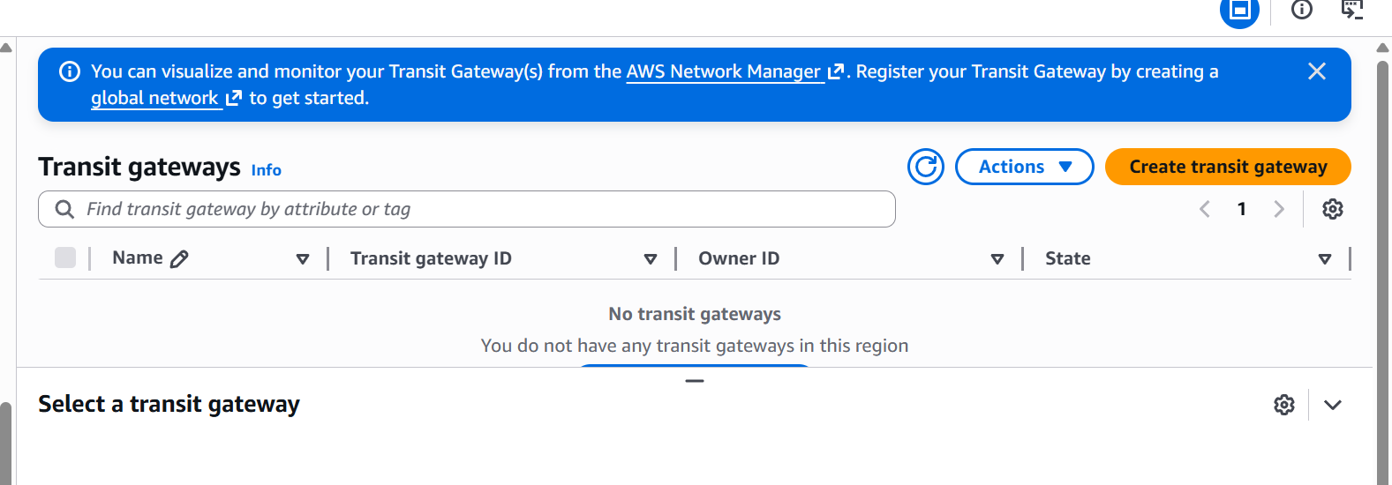
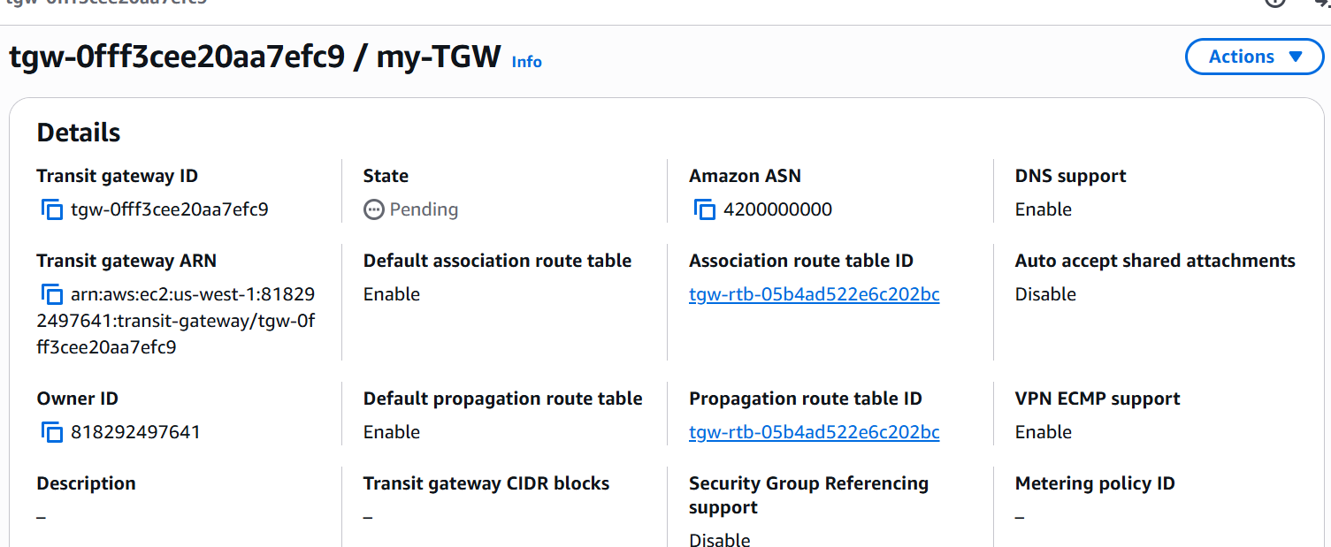
A transit gateway has not been created lets now attach this to our VPCs.
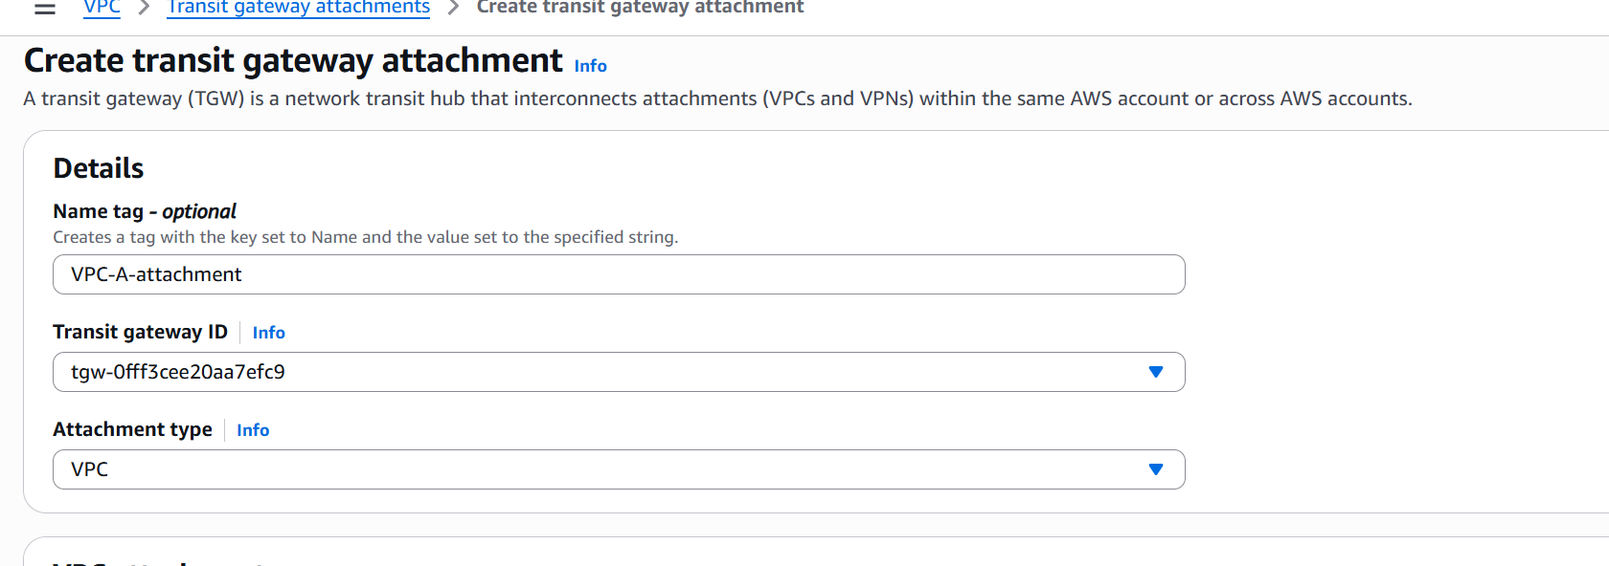
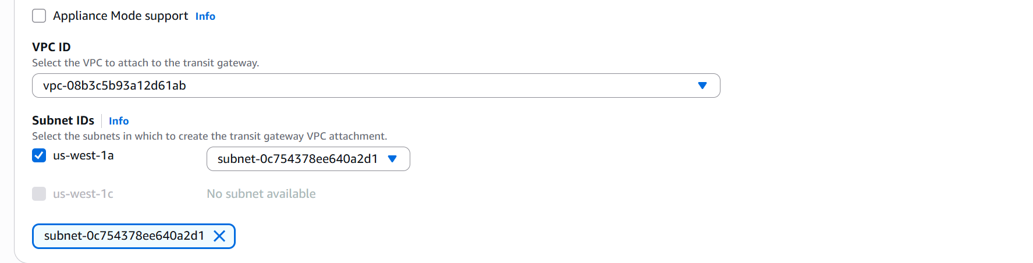

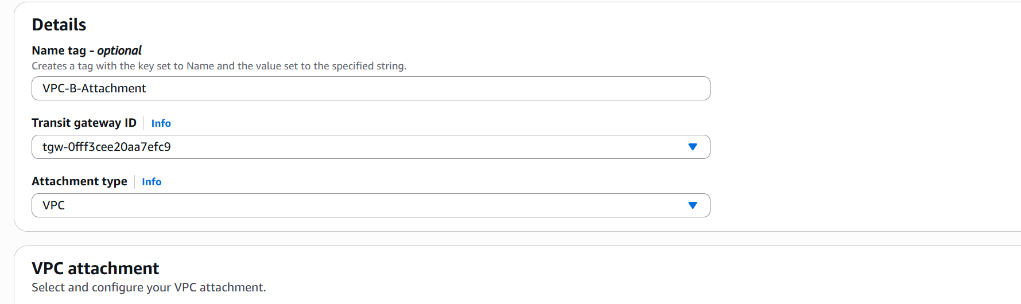

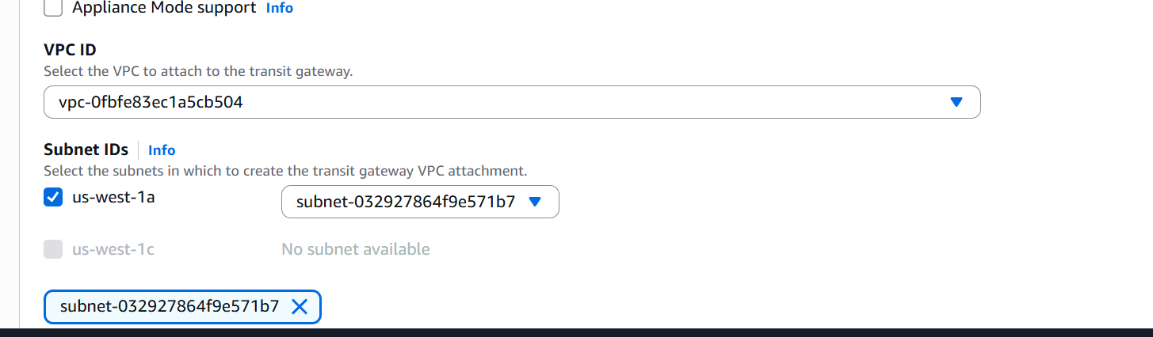

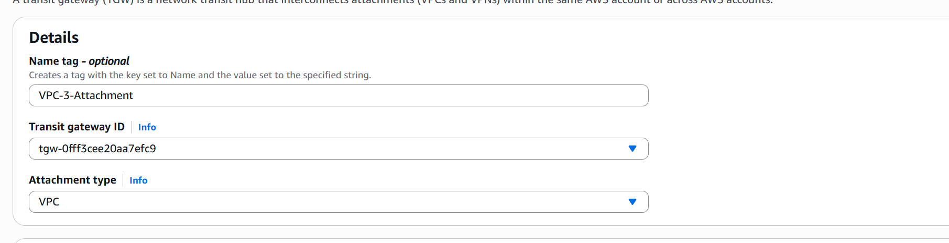

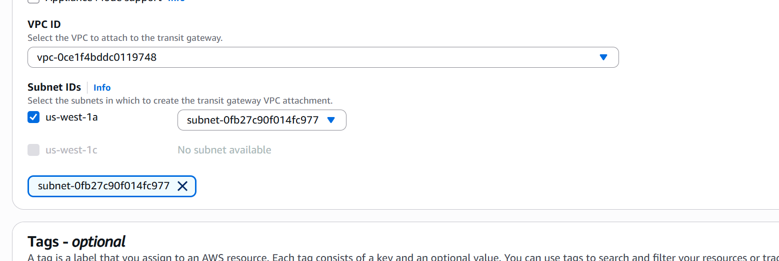

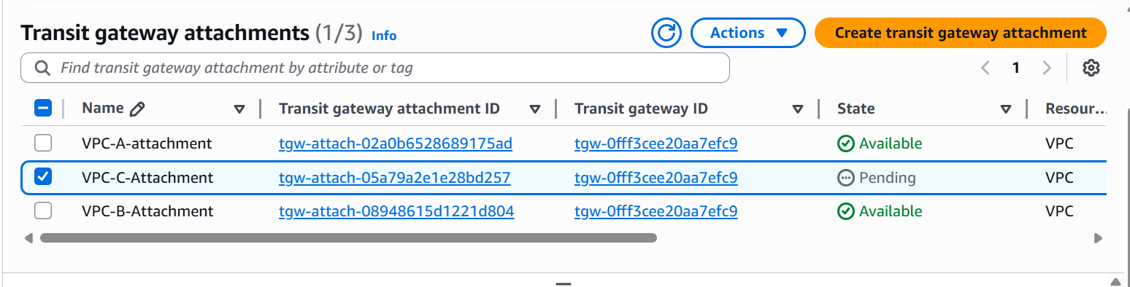

Now lets add the routes in route tables.
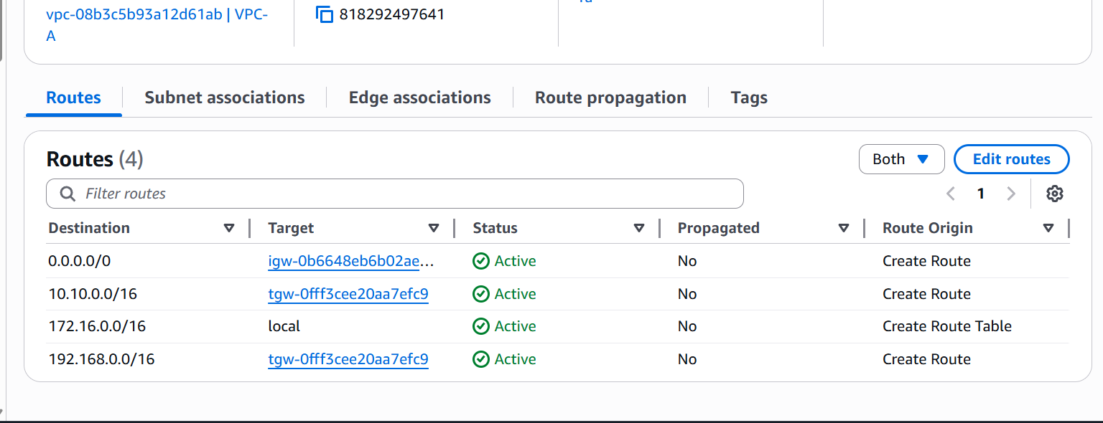

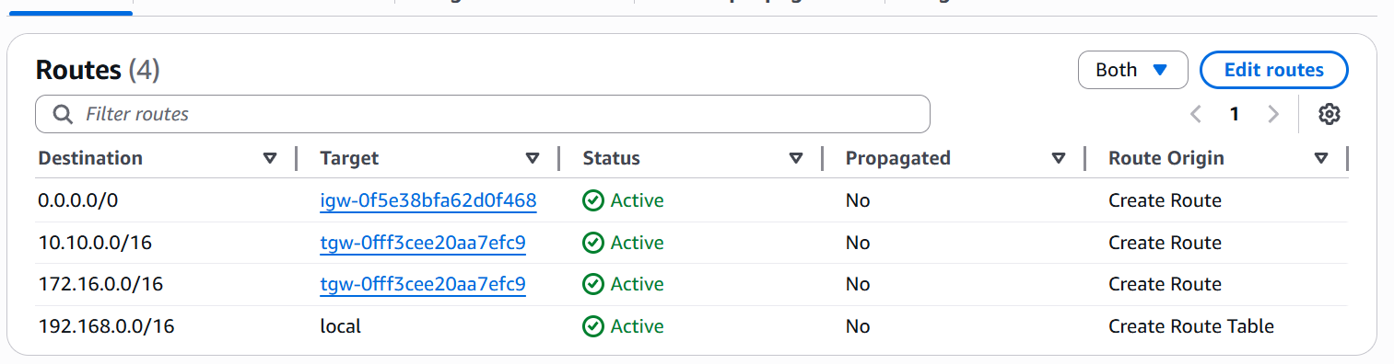

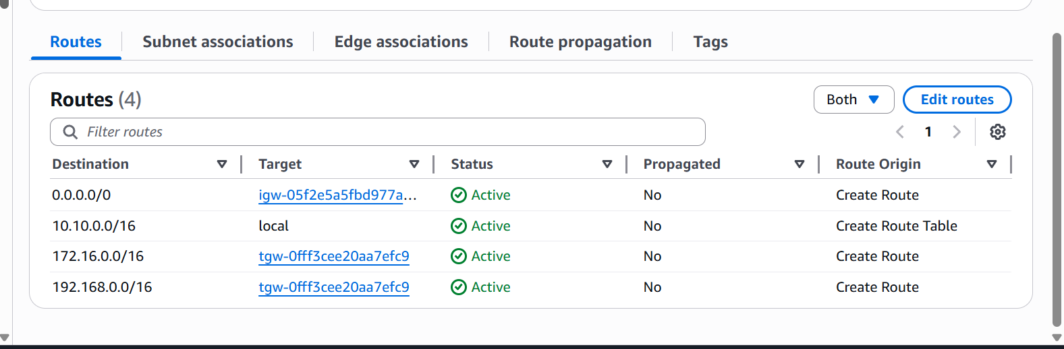

Now let us launch instances in each vpc and check the connectivity.

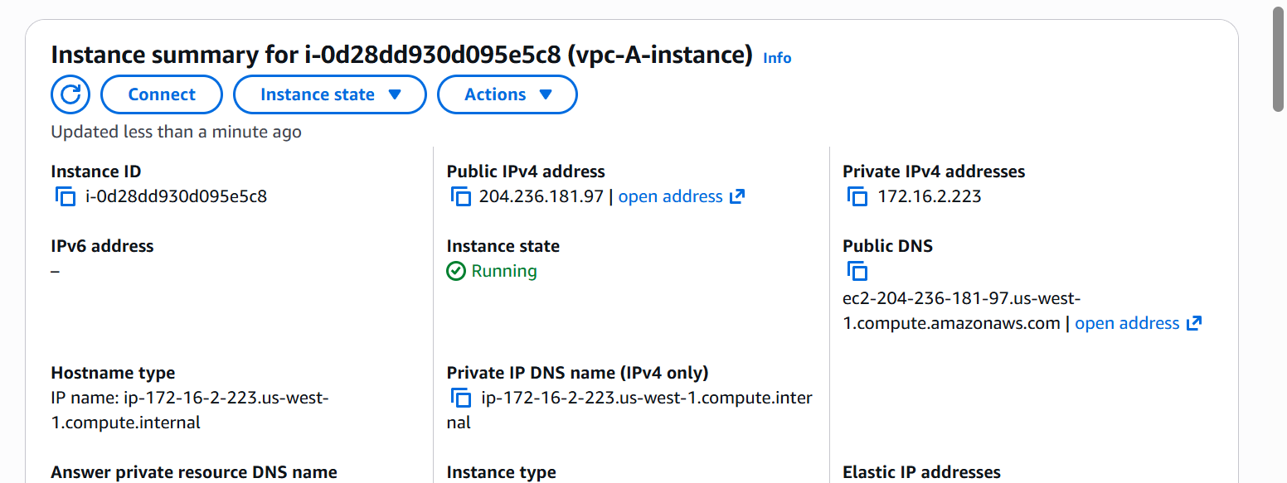
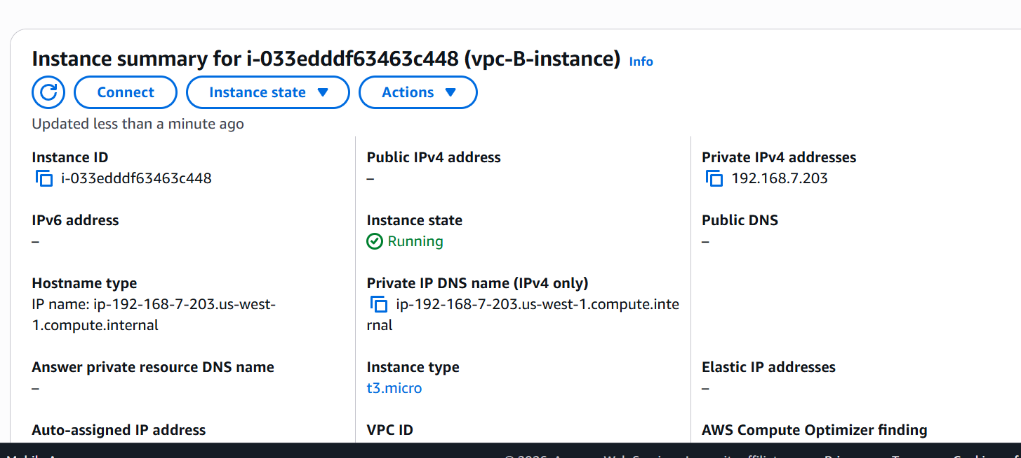
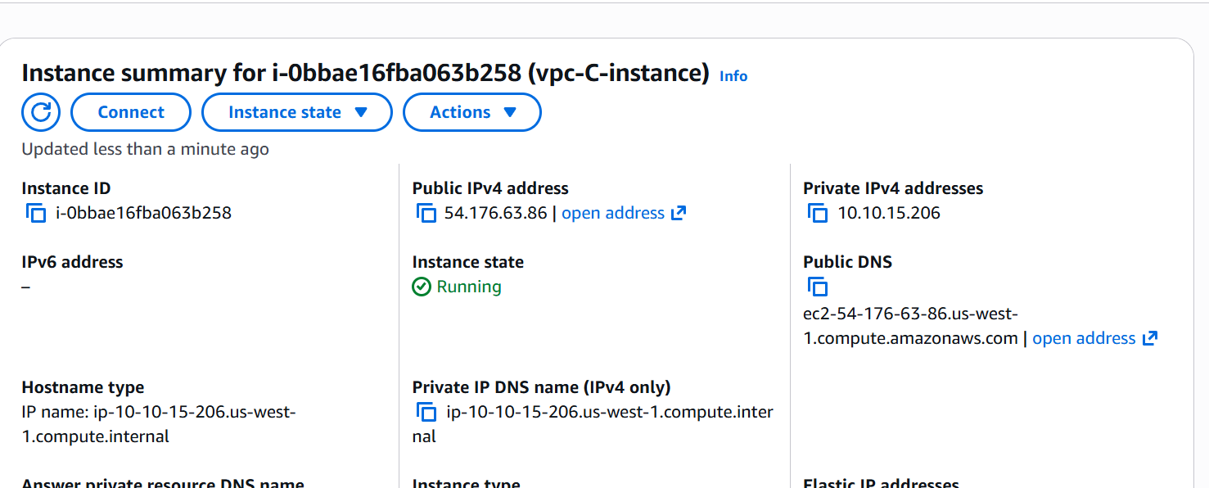

We now have 3 ec2 instances in 3 different VPCs

Lets now check the connectivity
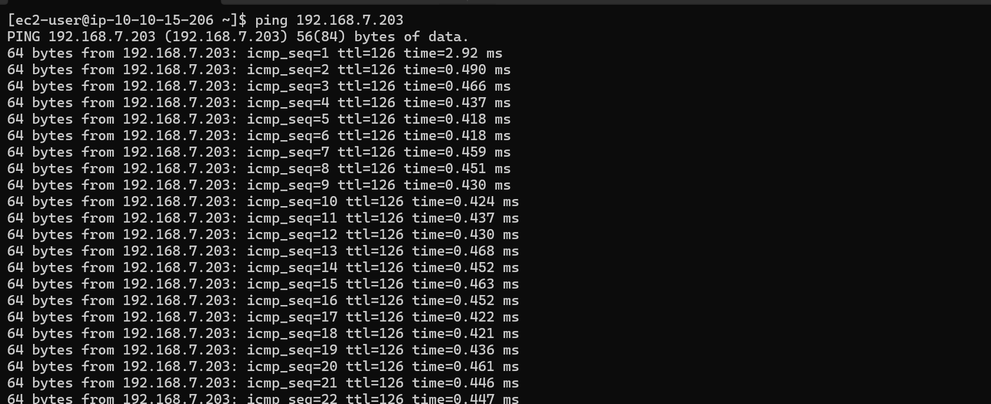

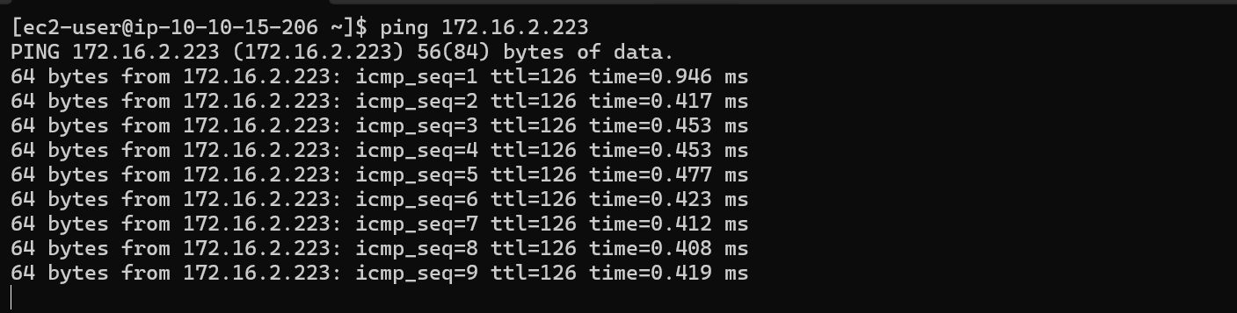

We are now able to establish connectivity between two instances.

Lets do this from another instance as well.

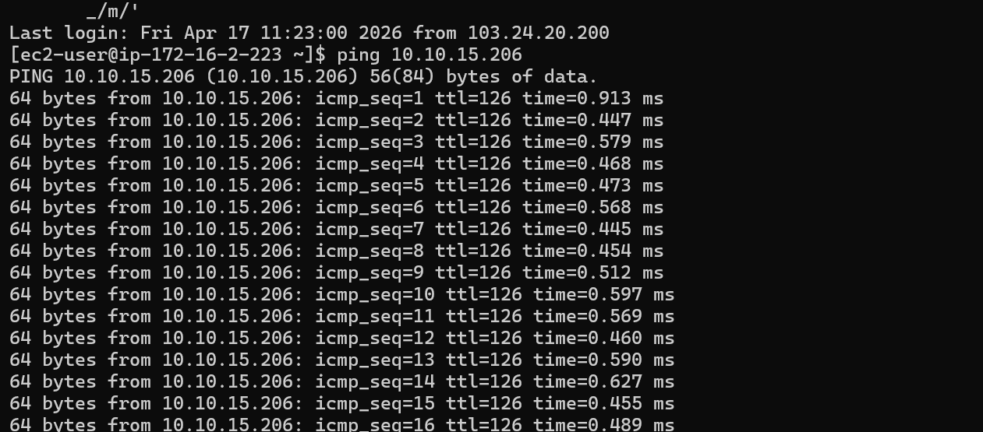

We are able to access from this instance as well.

2.Configure VPC endpoints to securely access AWS services without internet gateways or NAT gateways, ensuring data privacy and minimizing exposure to external threats.

Lets create a VPC
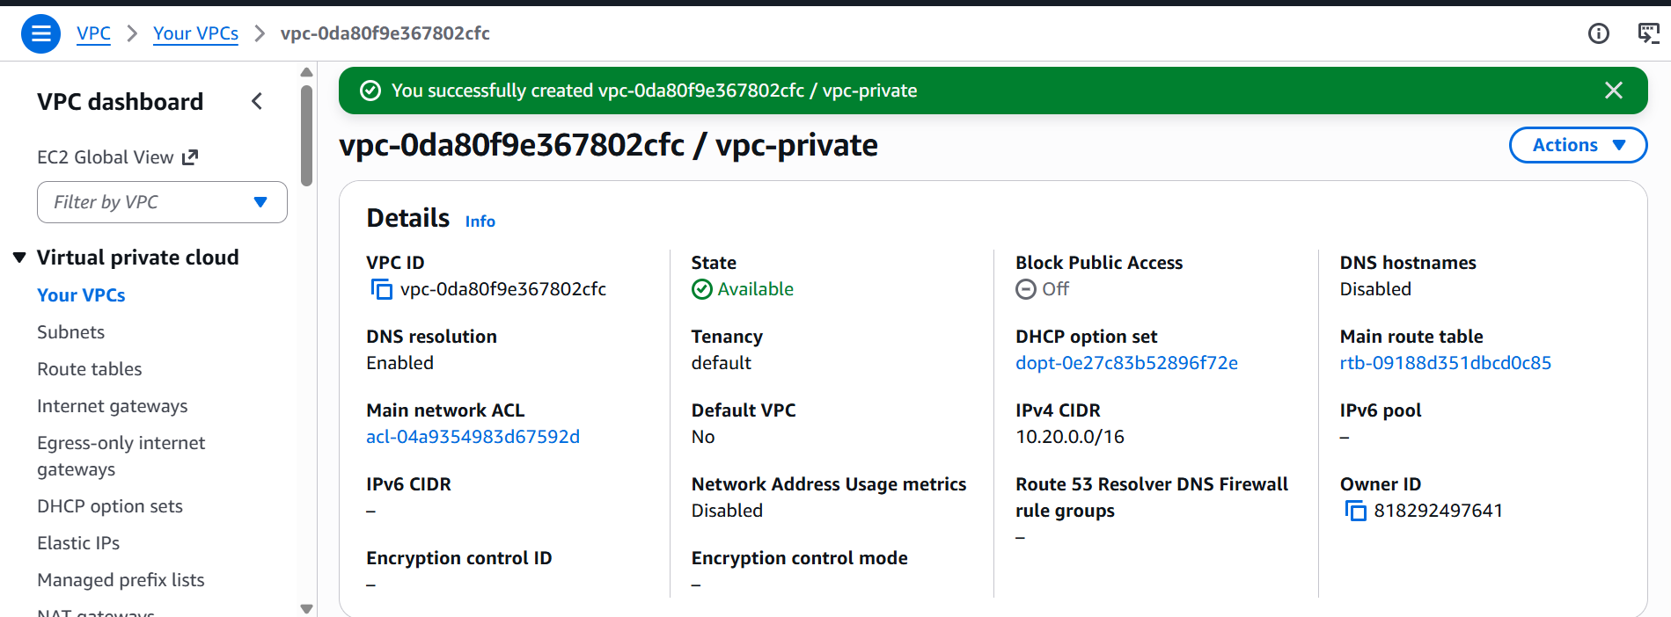

We now have one VPC named vpc-private

Lets now create a private subnet
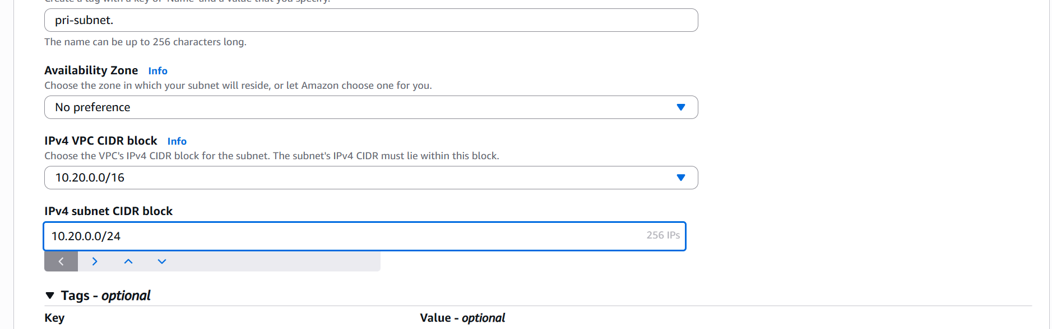

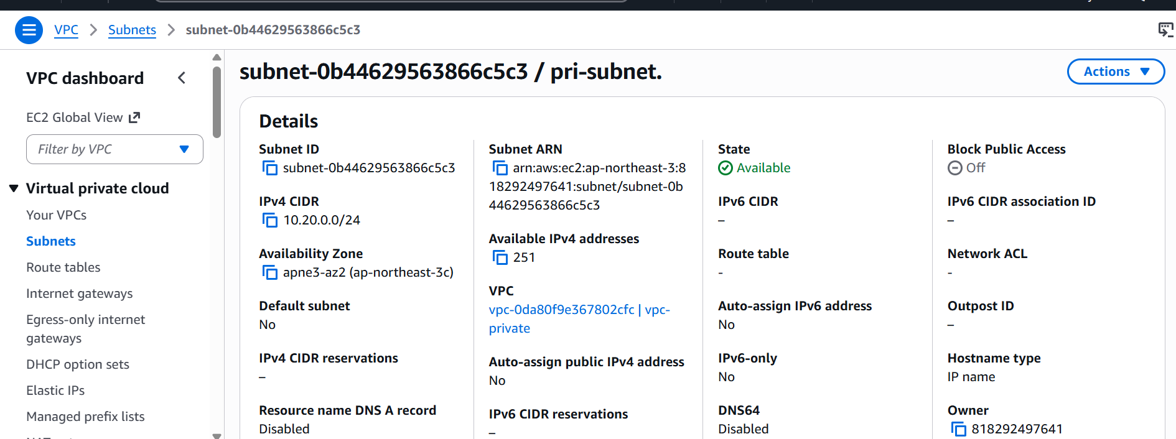

Lets us now create I am role
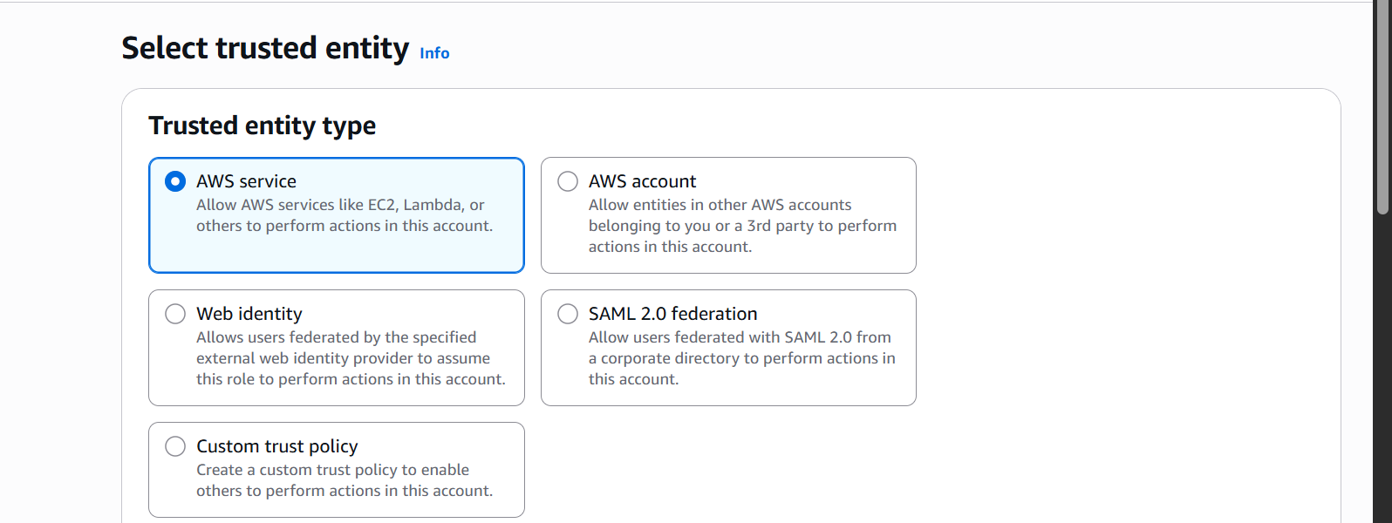

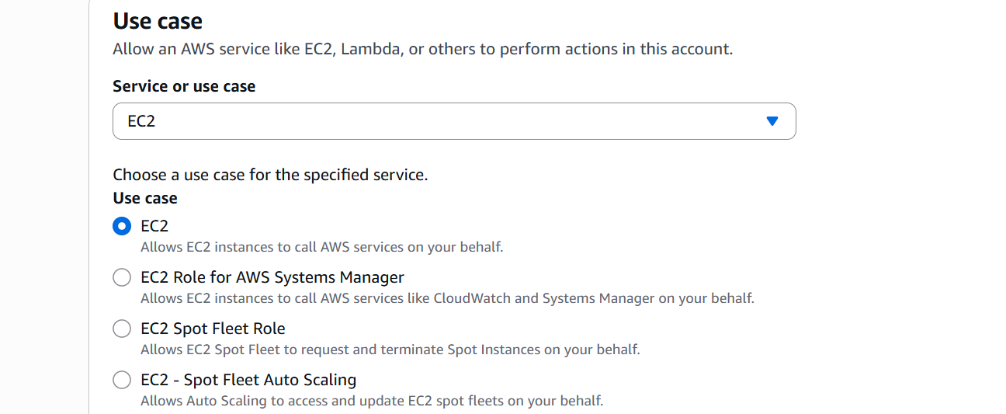

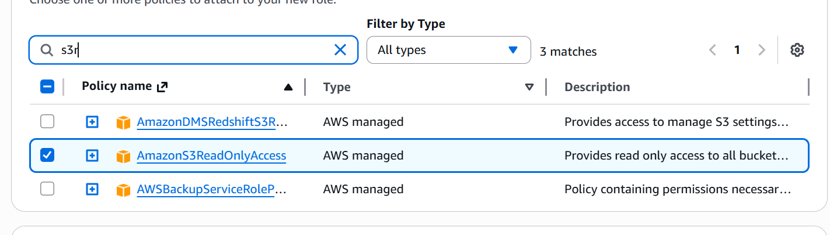

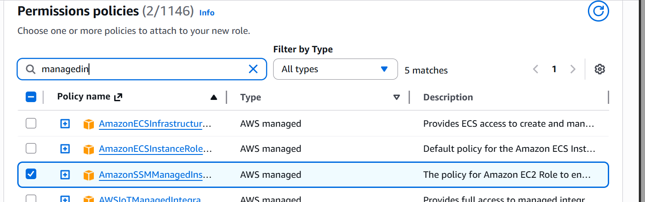
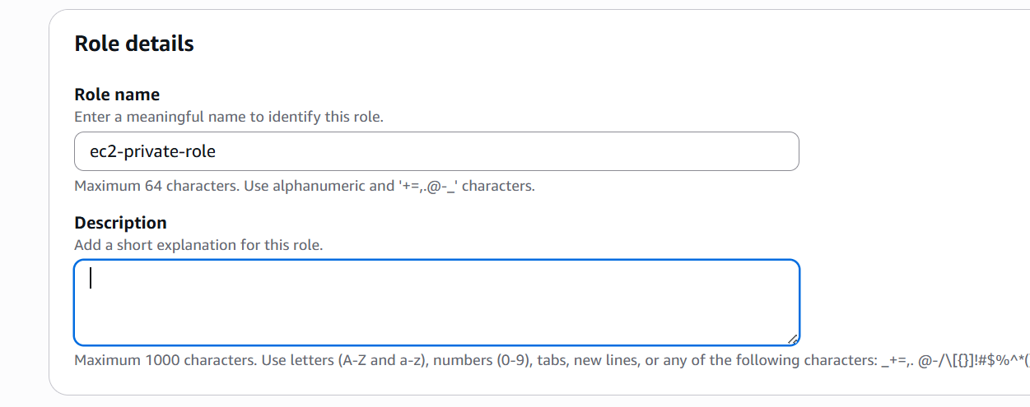

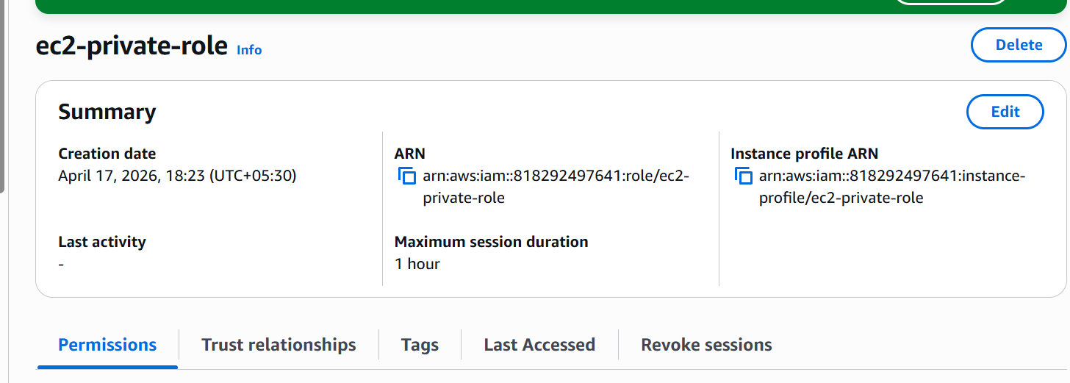

Lets now launch an ec2 instance
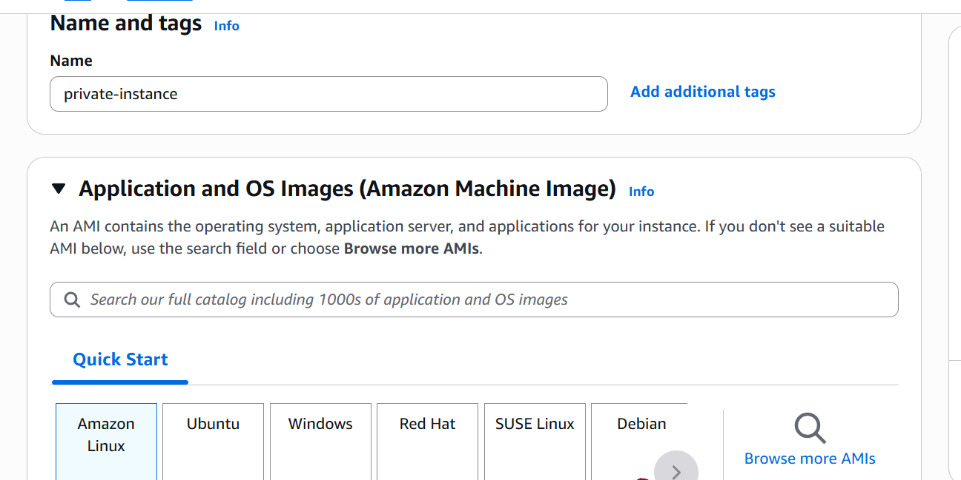

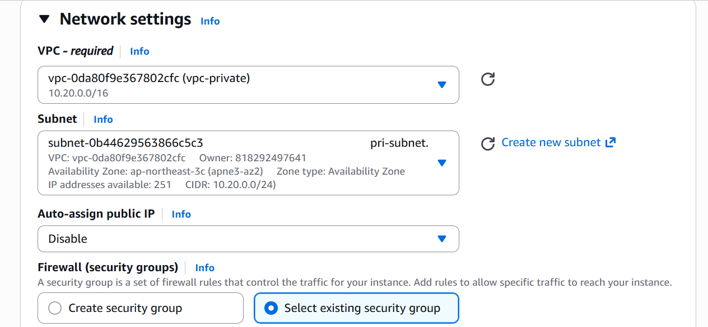
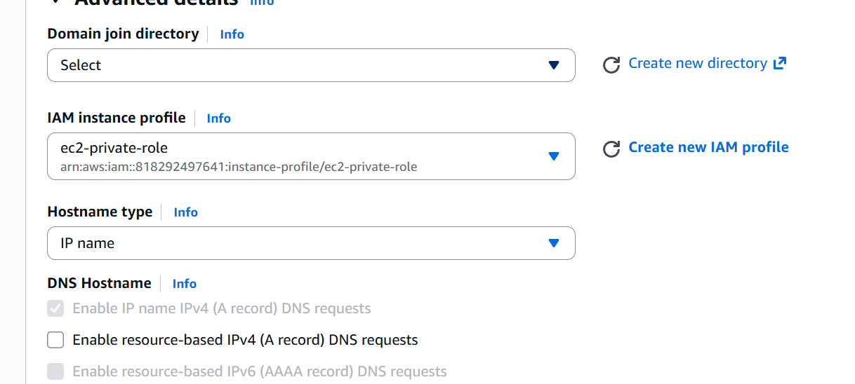

We have now launched an ec2 instance
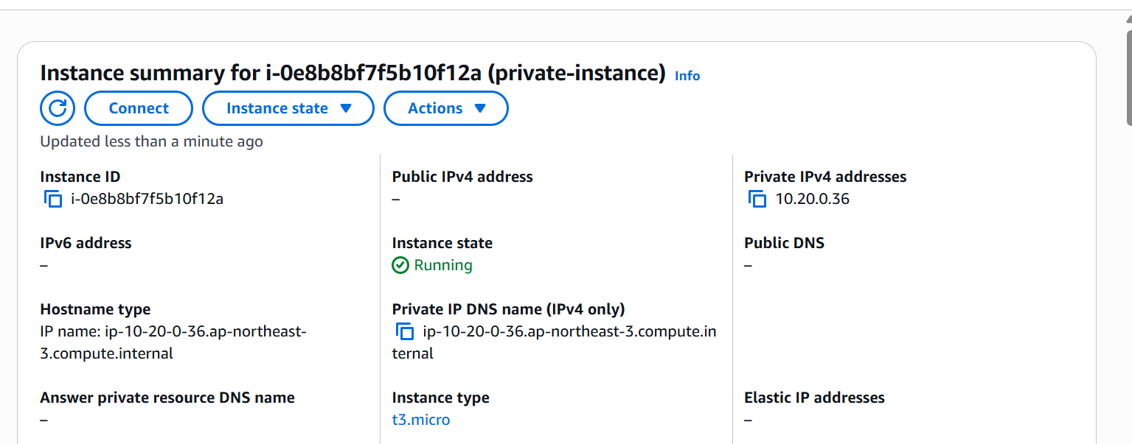

Now lets create VPC Endpoint:
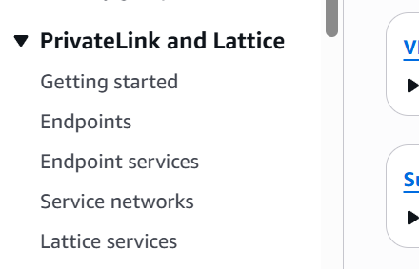

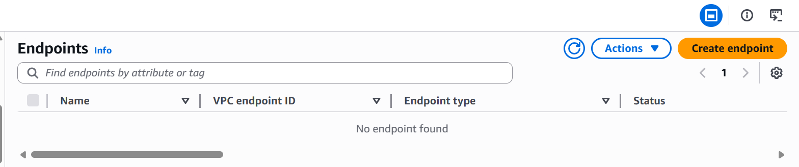

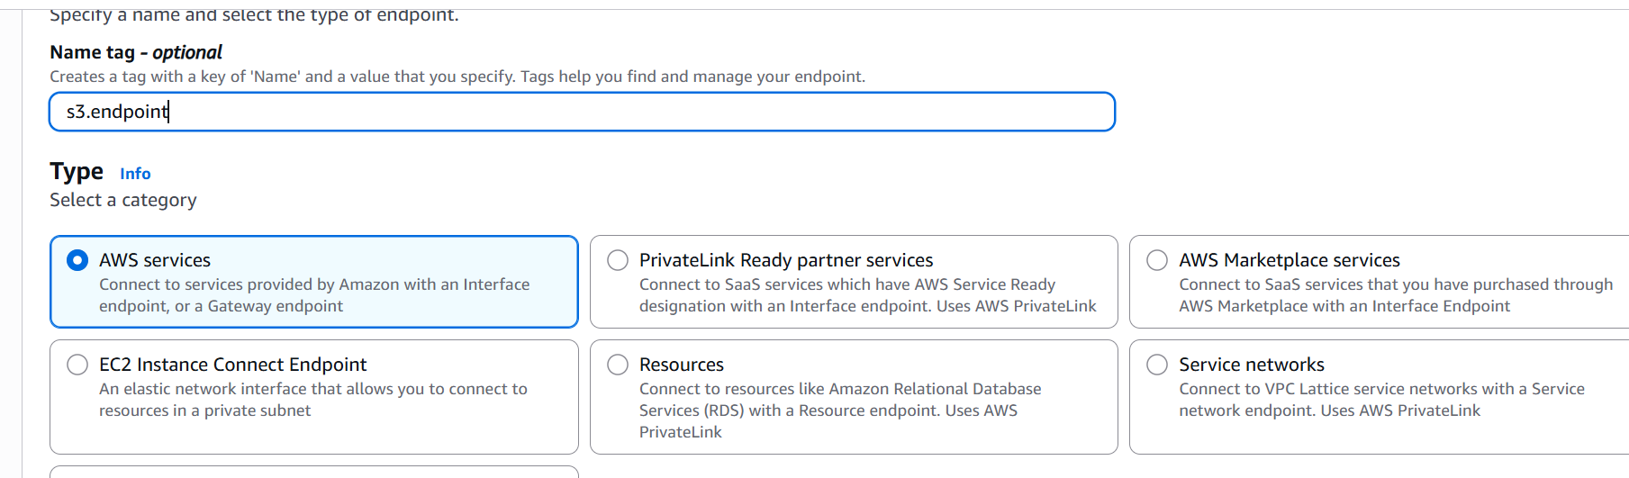

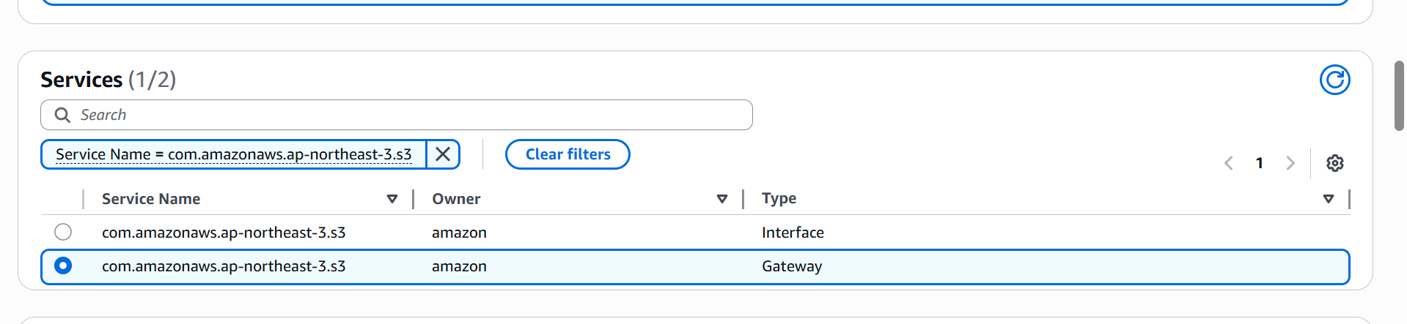
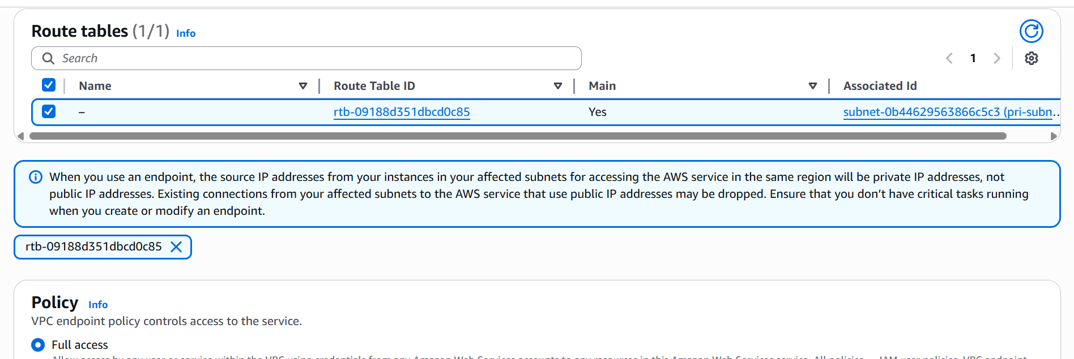
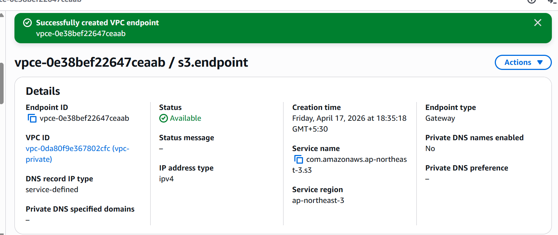

VPC endpoint created.

Lets create ssm endpoints now

We are doing this to connect to our instance using session manager as we do not have internet access we won’t be able to ssh.
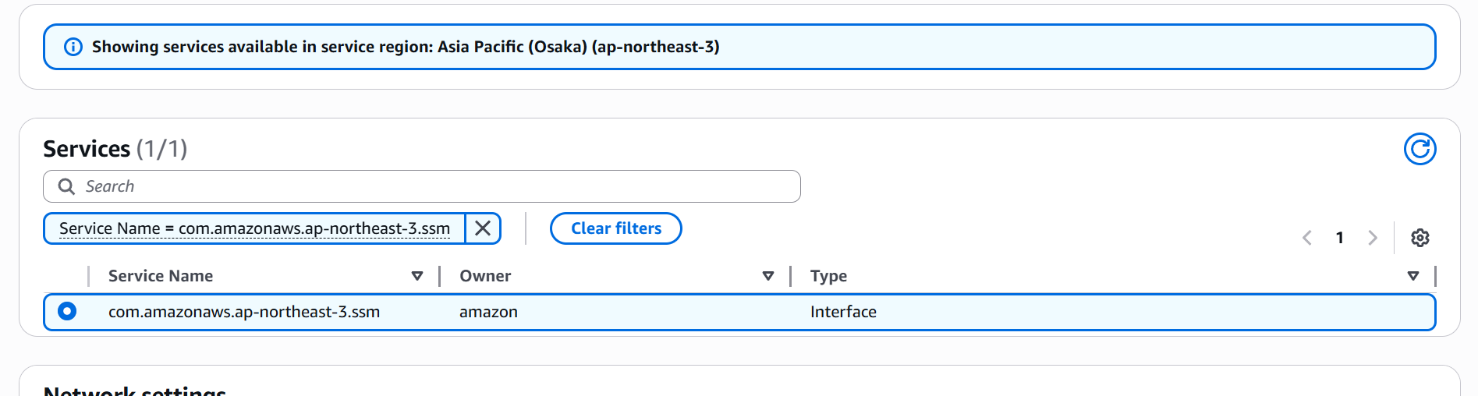

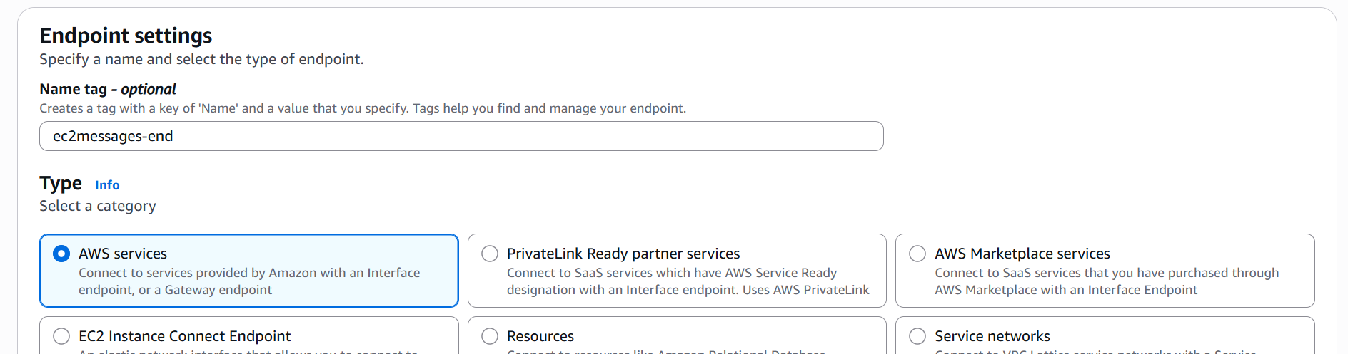

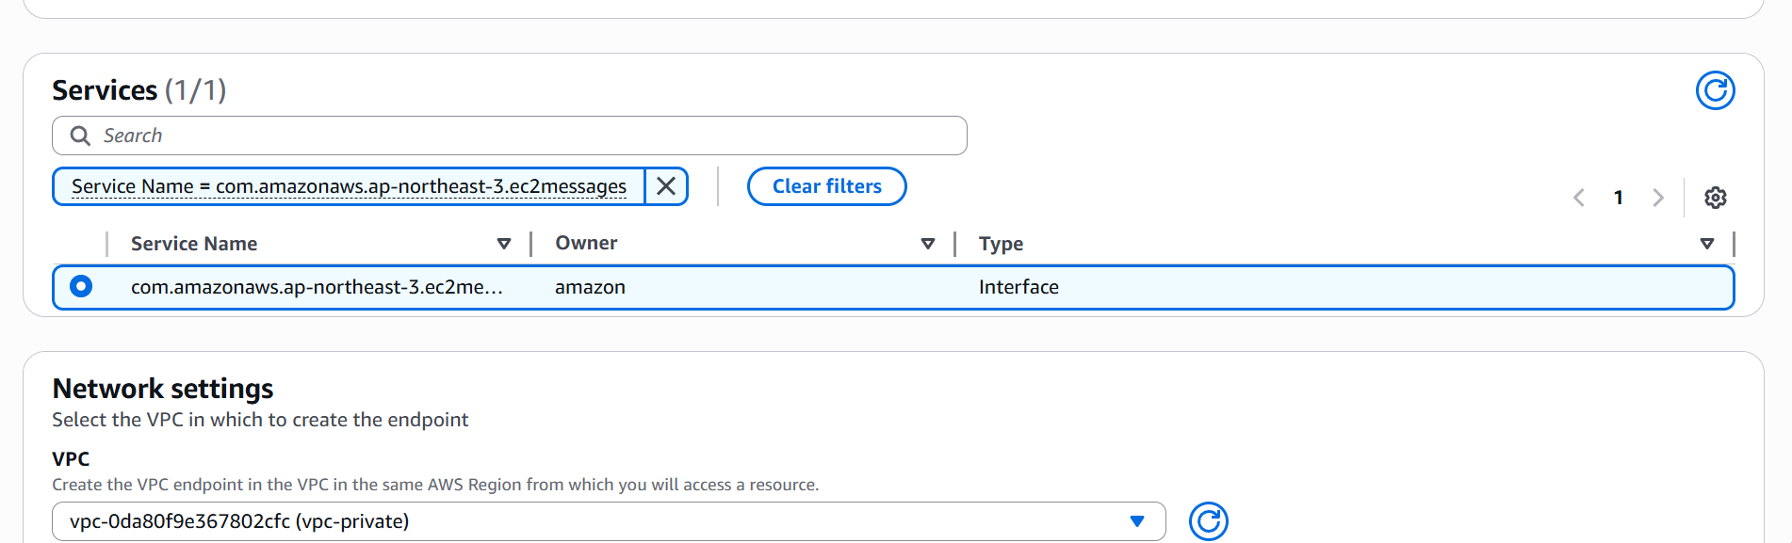
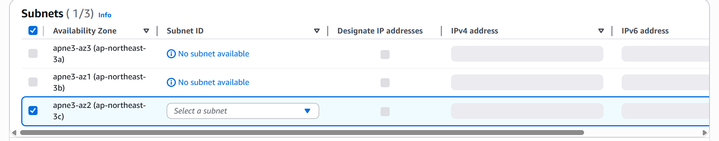
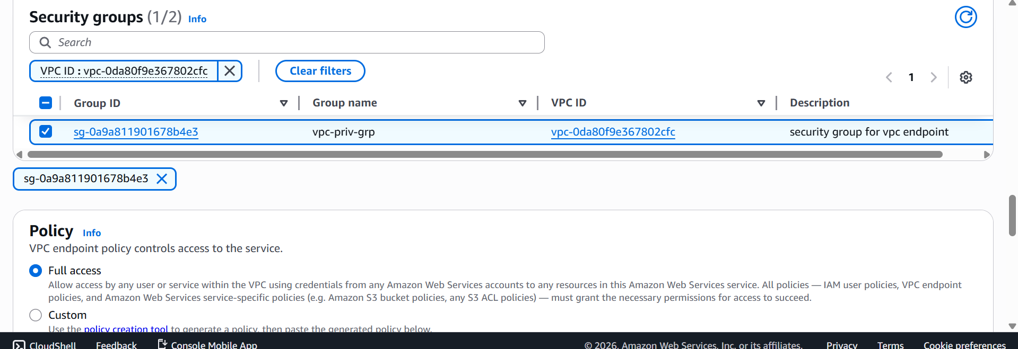

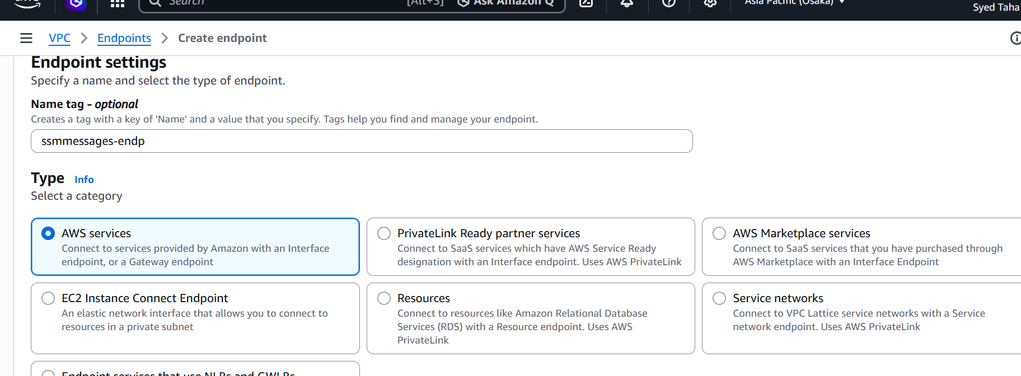

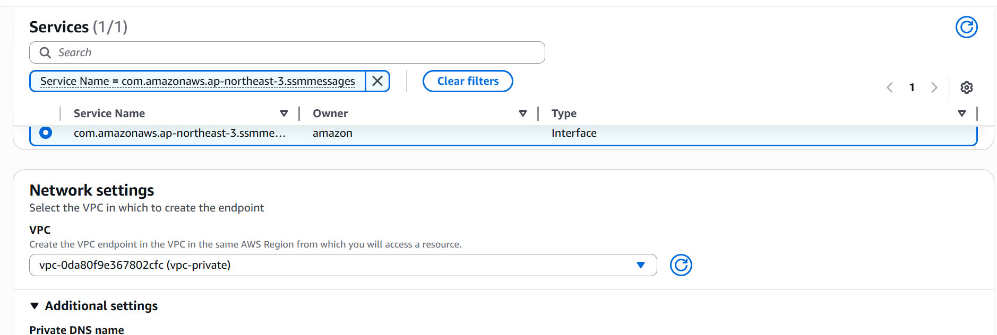
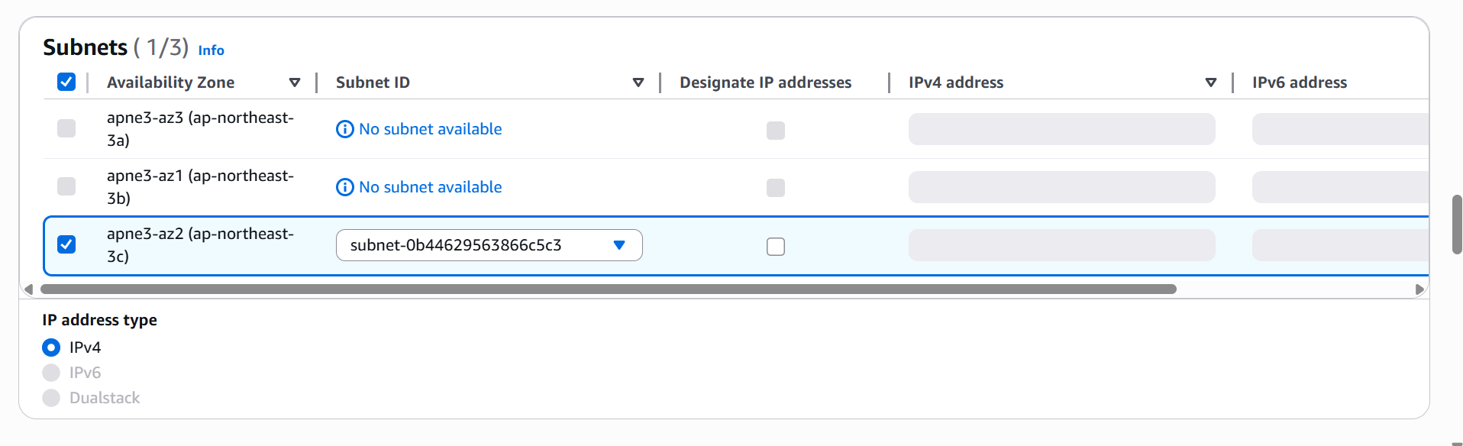

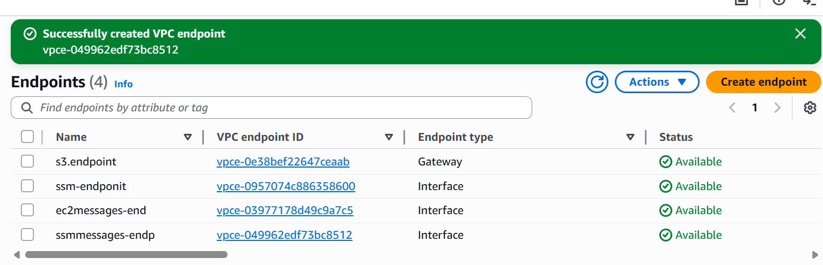

We now have 4 endpoints.
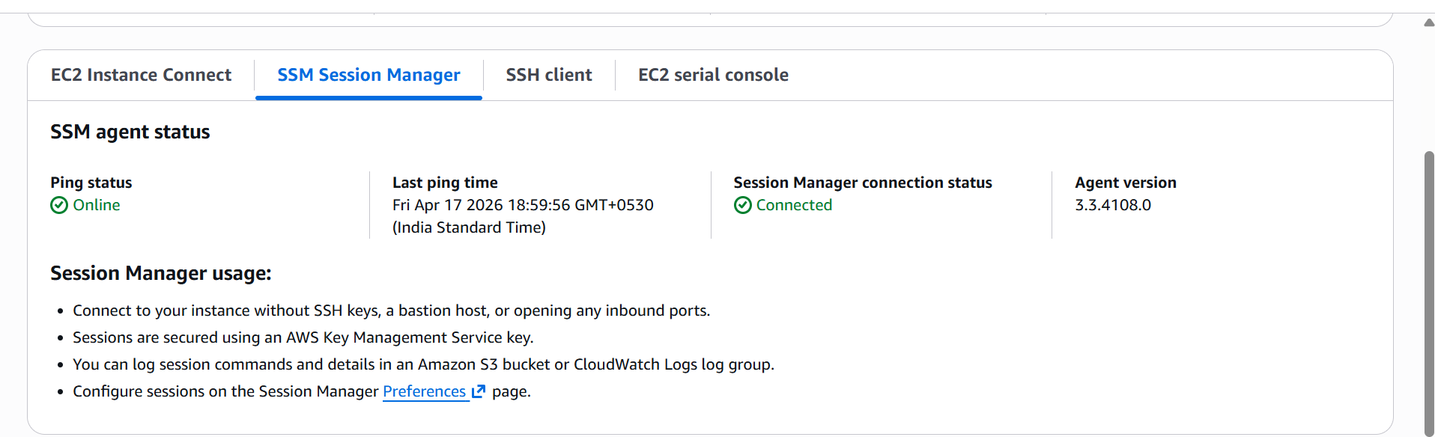

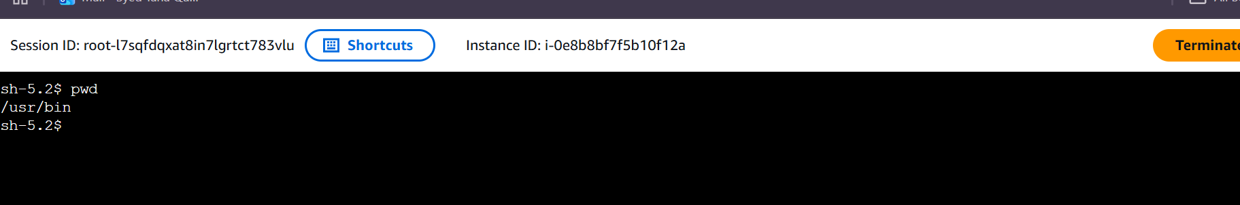

We are able to connect to ec2 instance through ssm
We can even see the access the list of buckets as well
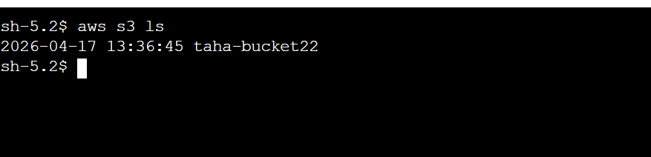

We designed a private VPC architecture without Internet or NAT gateways and enabled secure access to AWS services using VPC endpoints.
This ensures all traffic remains within the AWS network, improving security and minimizing exposure to external threats.

