VPC: Stands for virtual private cloud it is a logically isolated network in AWS where we can control the IP Address range, subnets , routing and security.
It is like our own section in AWS cloud.

- Create a VPC with 2 public subnets and 2 Private subnets.
First we need to go to the VPC service.
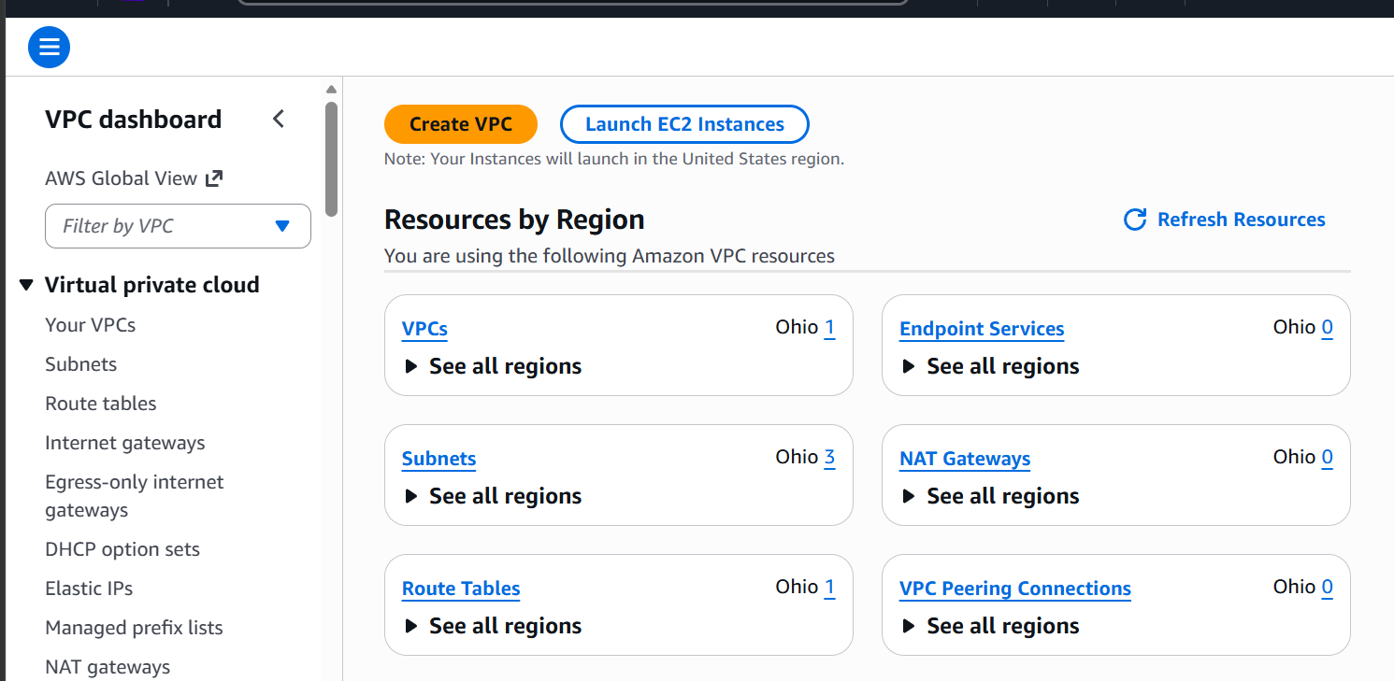
And then click on create VPC.
Let’s create a VPC
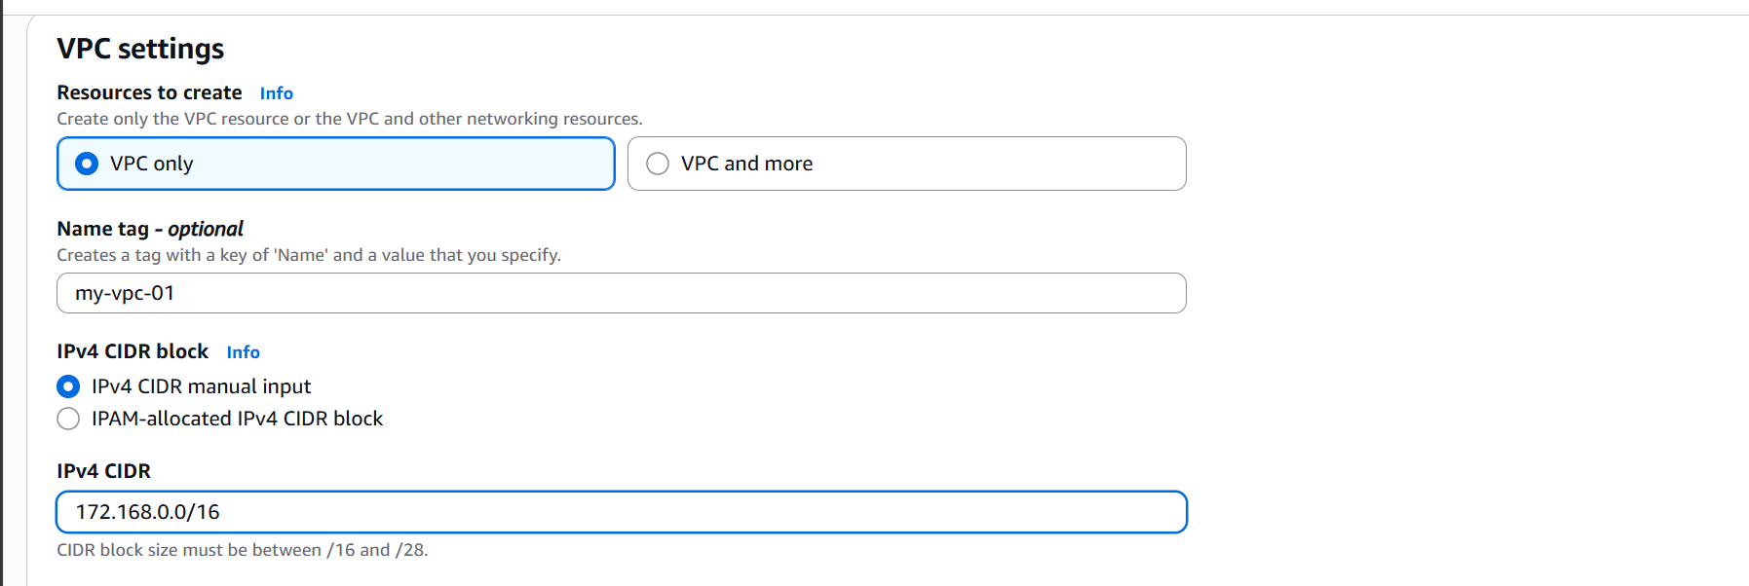

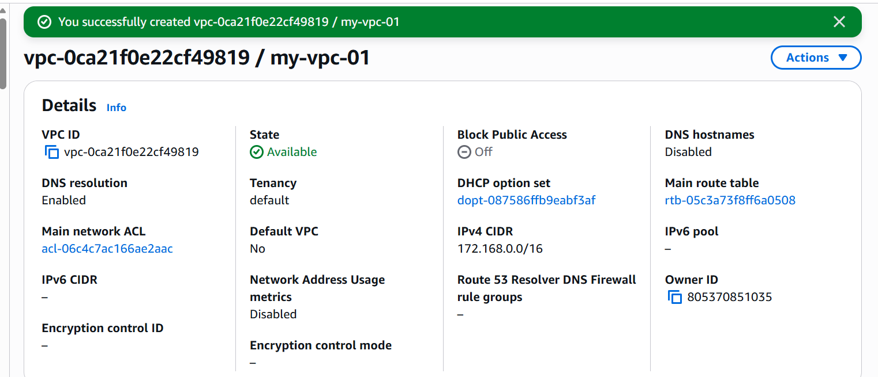
We have a created a VPC with CIDR range of 172.168.0.0/16

Now let’s create two private and two public subnets.

We need to click on create subnet
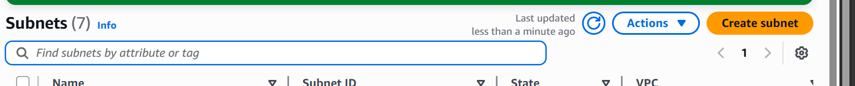

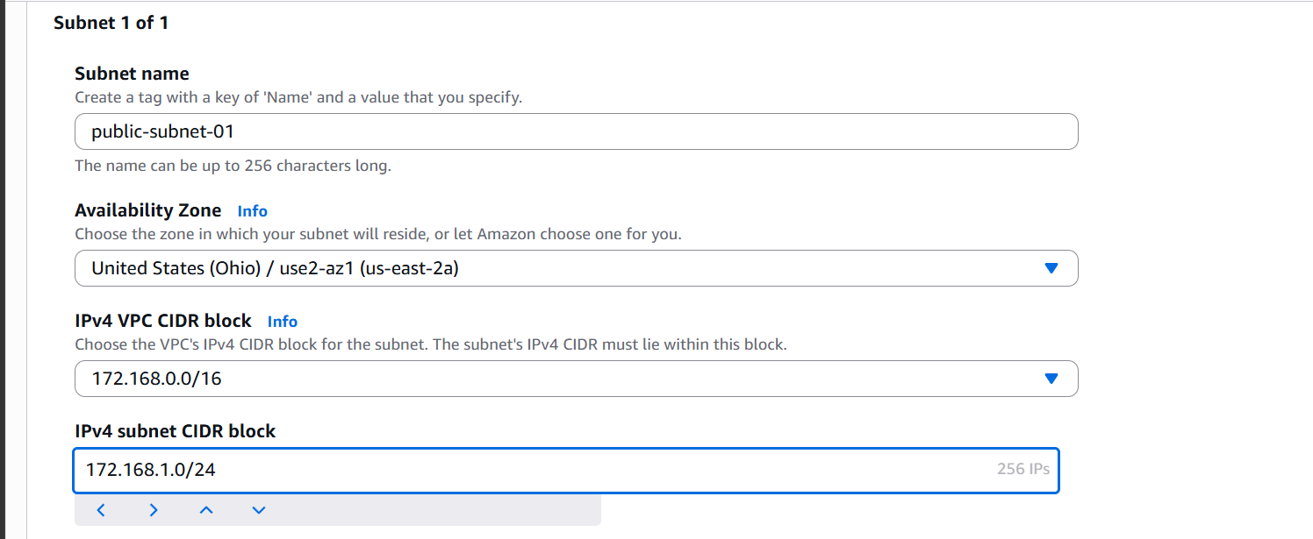
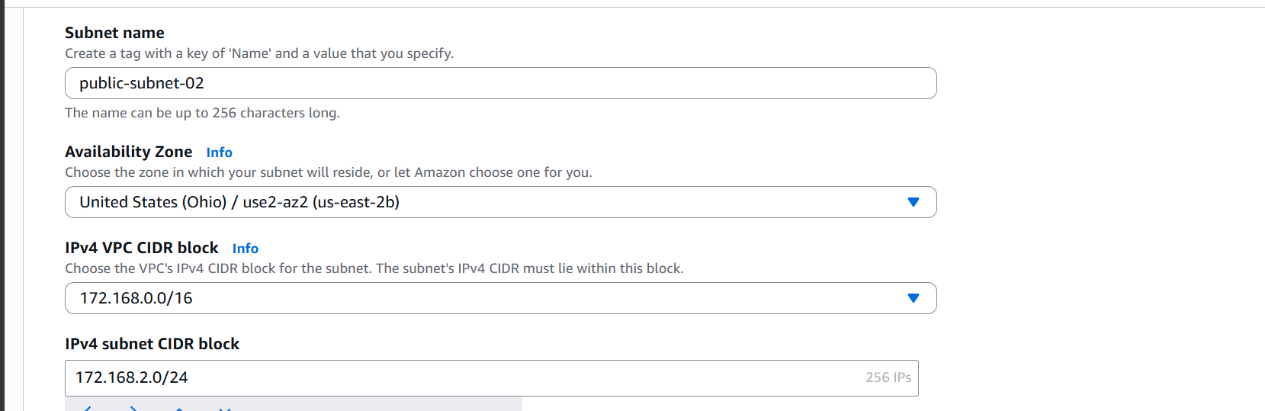
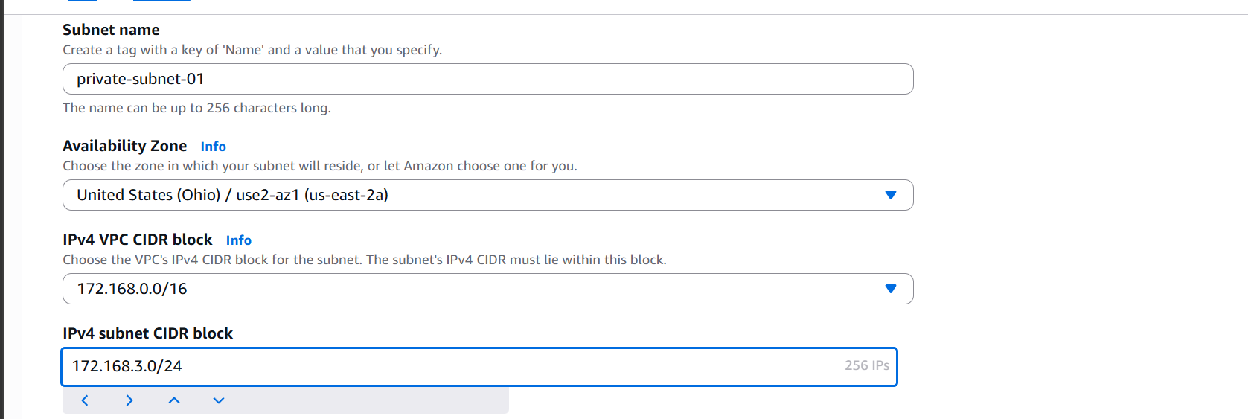
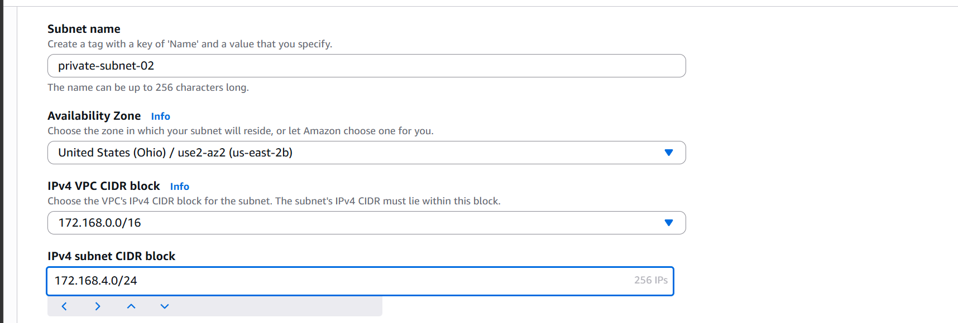

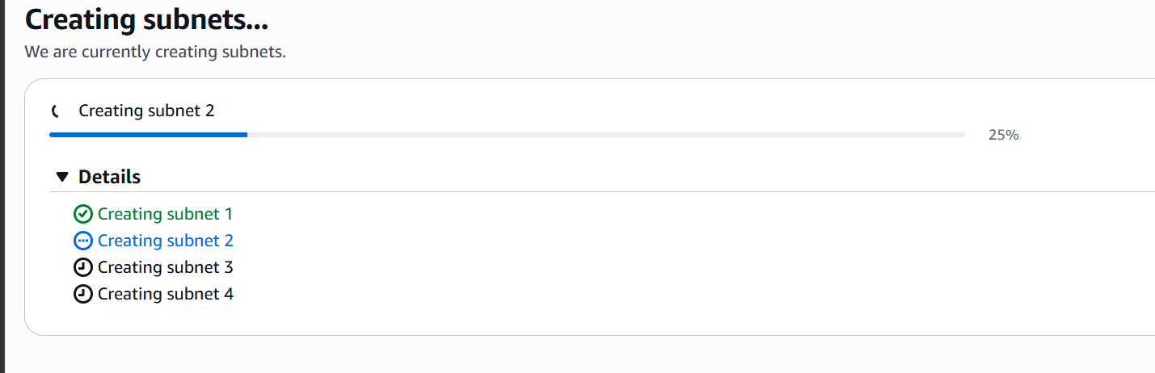

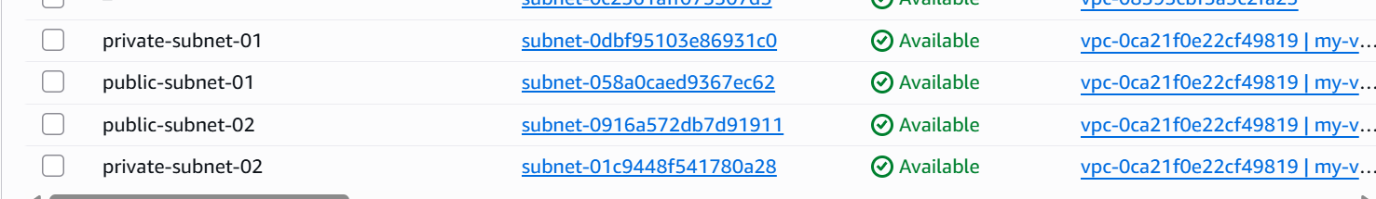

The 4 subnets are now created.
Let’s attach an internet gateway to our vpc
Under vpc we need to click on internet gateways.
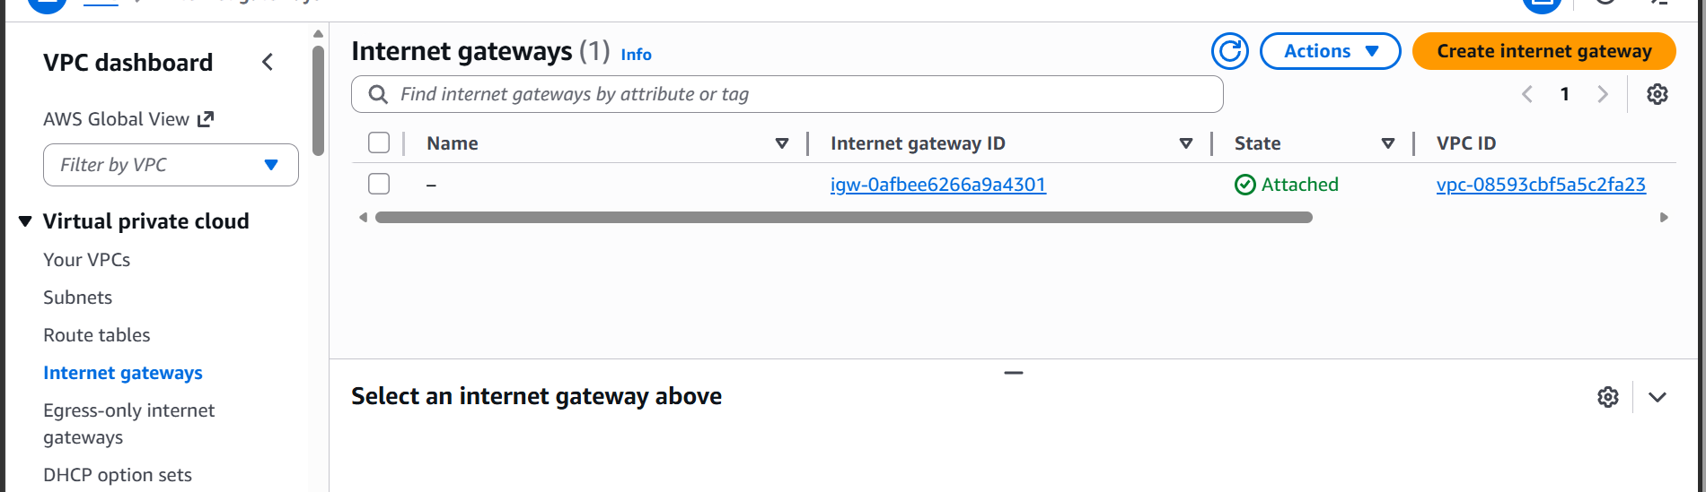
Now click on create internet gateway.
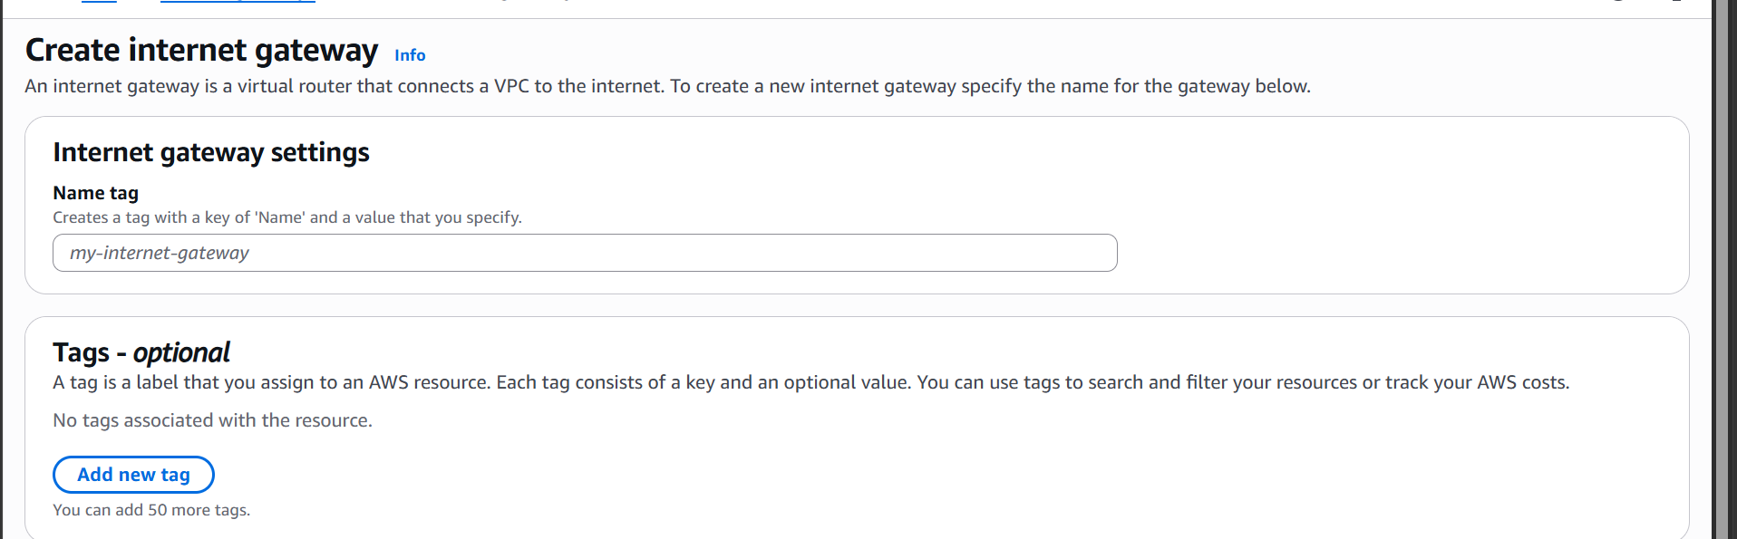
And now let’s assign it to our vpc by clicking on actions
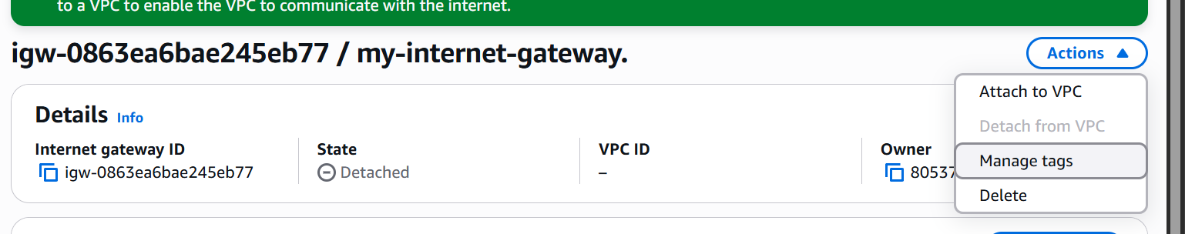
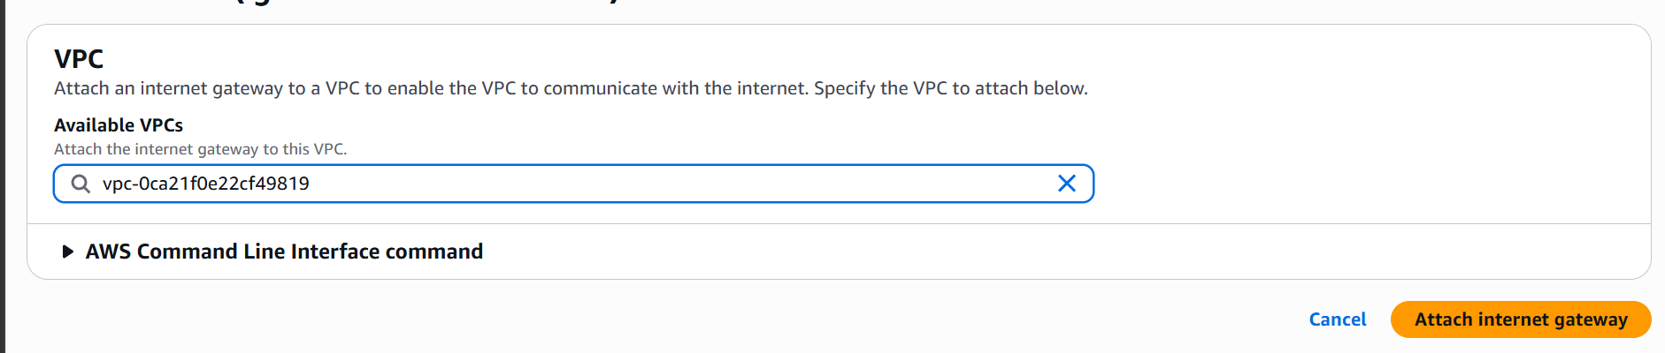
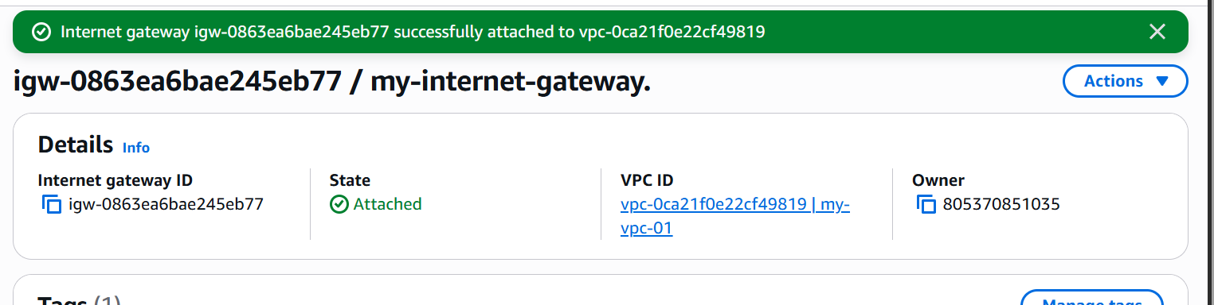
The IGW is now attached to our VPC.

A route table is already attached to our vpc.
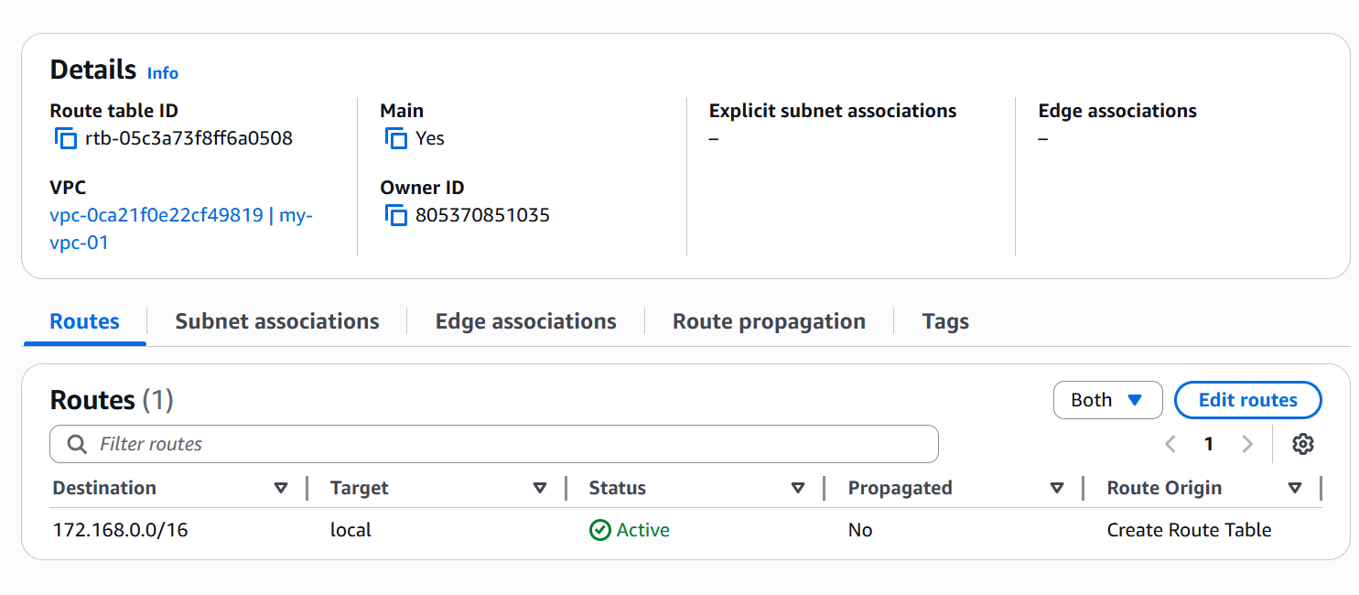

Now let’s edit routes and add our internet gateway there.
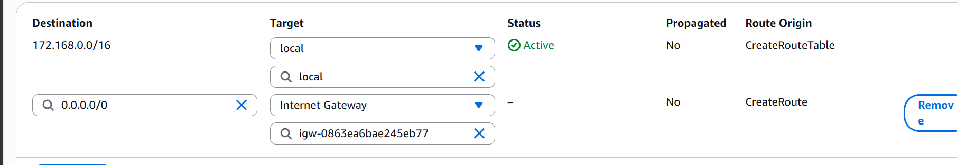
And now let’s associate the route table with the public subnets.
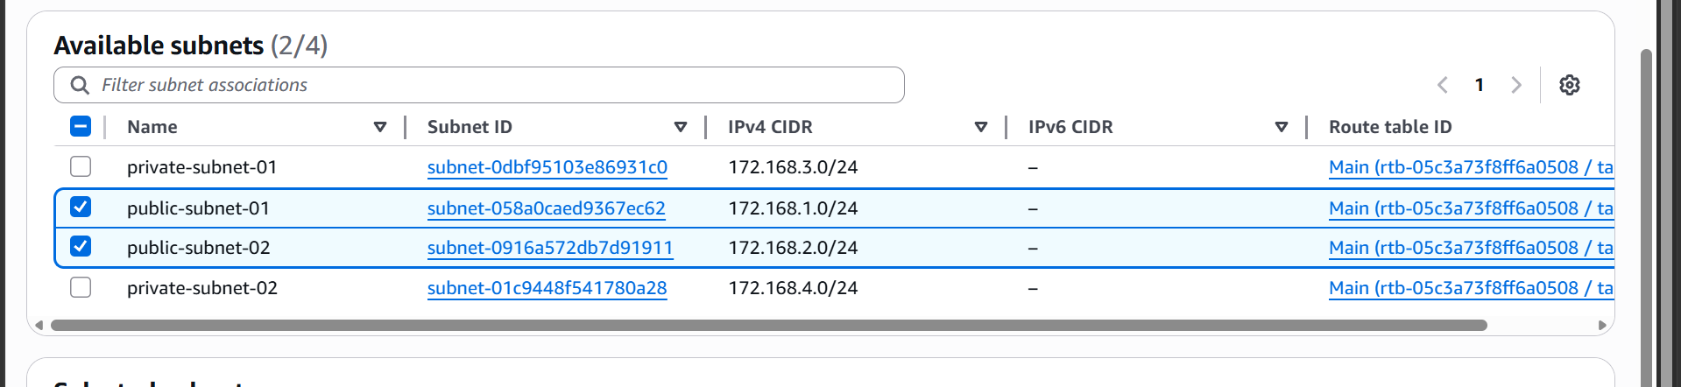
We have now created a vpc with 2 public subnets and two private subnets.

- Enable DNS Hostname in VPC:

For this we need to go to the vpc settings.

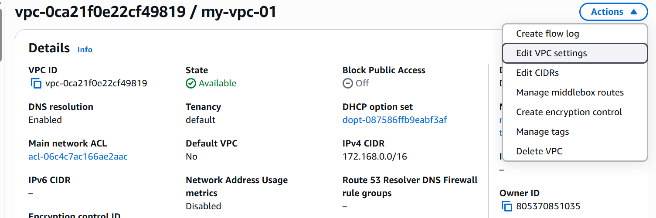
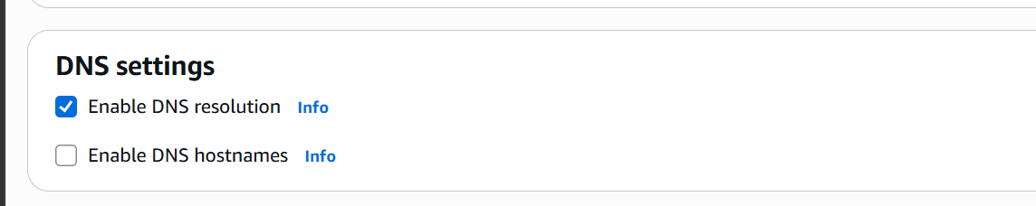

Here in DNS settings we can enable DNS hostnames.

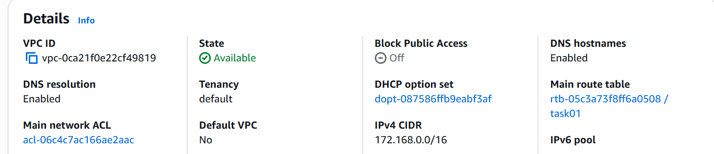

We have now enabled DNS hostnames for our VPC.

- Enable Auto assign Public IP in 2 public subnets.

Lets go to our two public subnets and edit the settings.

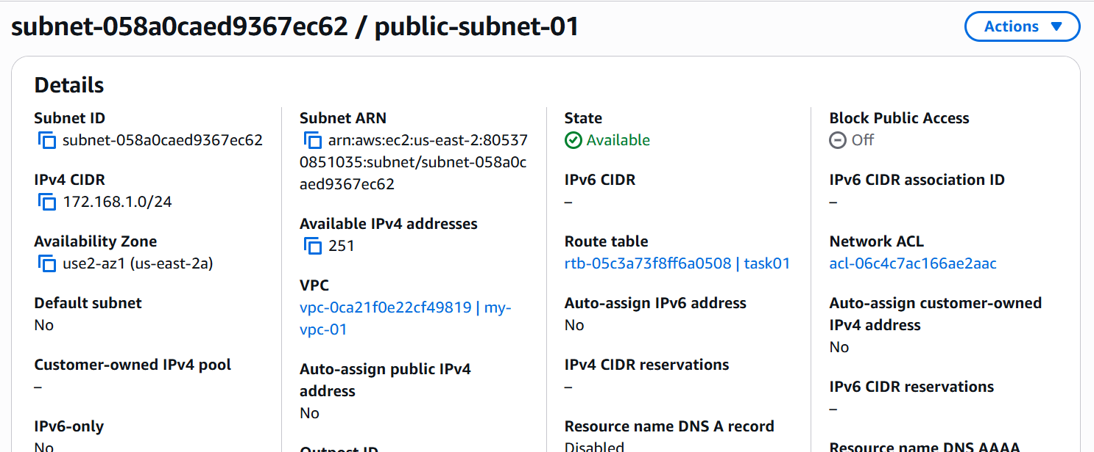

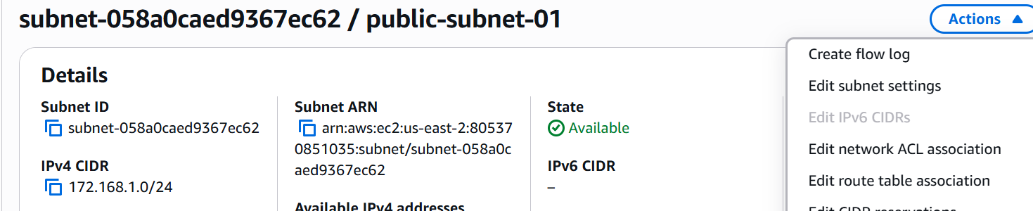

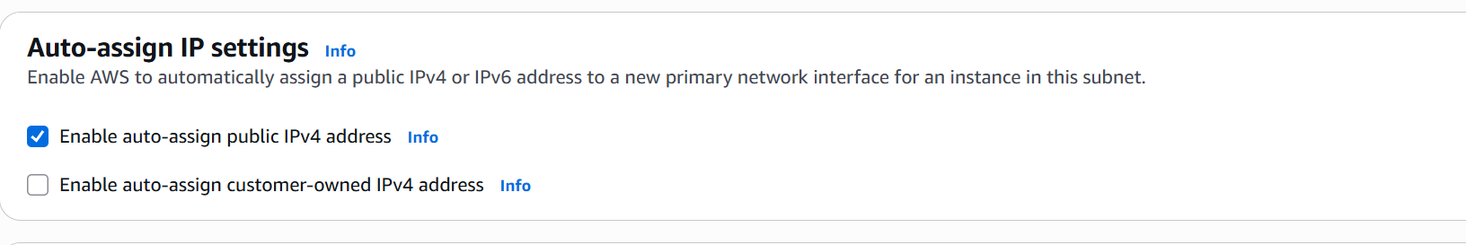

We need to select the option enable auto assign.
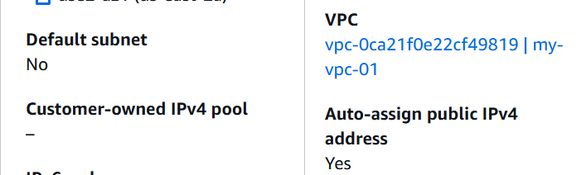

We have enabled auto assign public ipv4 in public subnet 1 lets do the same in another subnet.
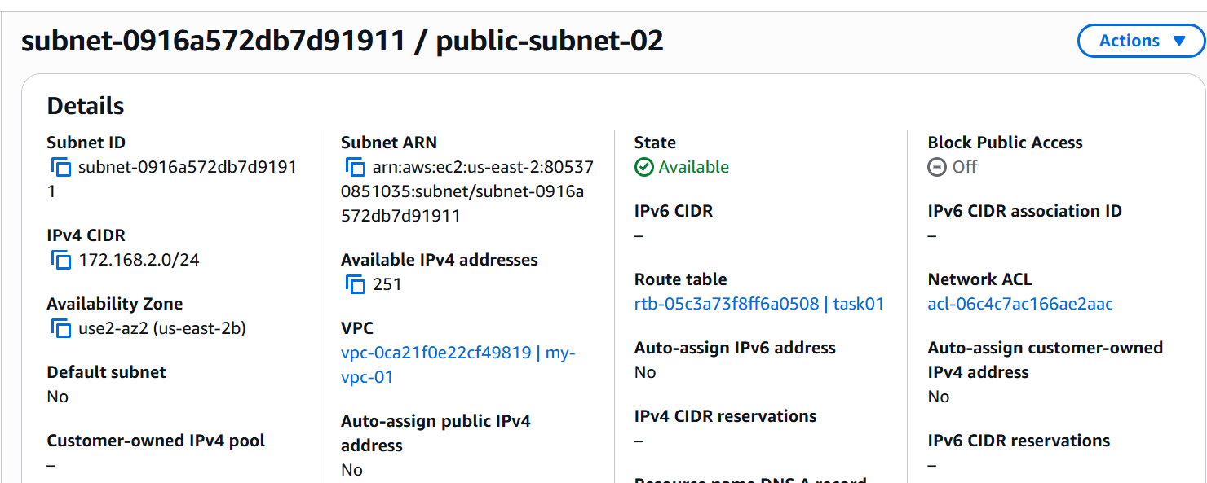

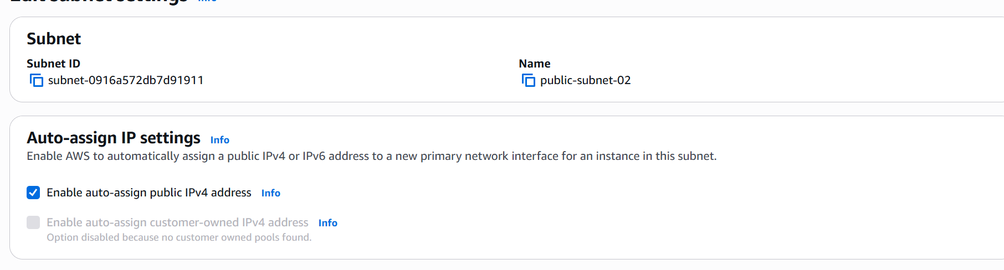

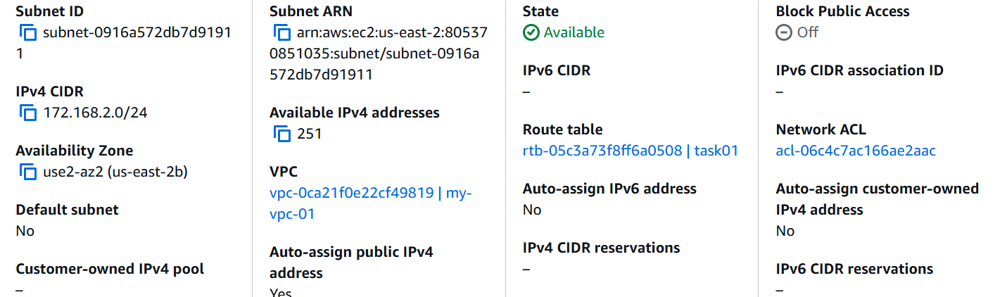

We have now enabled the auto assign public ip to public subnet 2 as well.

- Add two private subnets in private route table.

Lets create a nat gateway

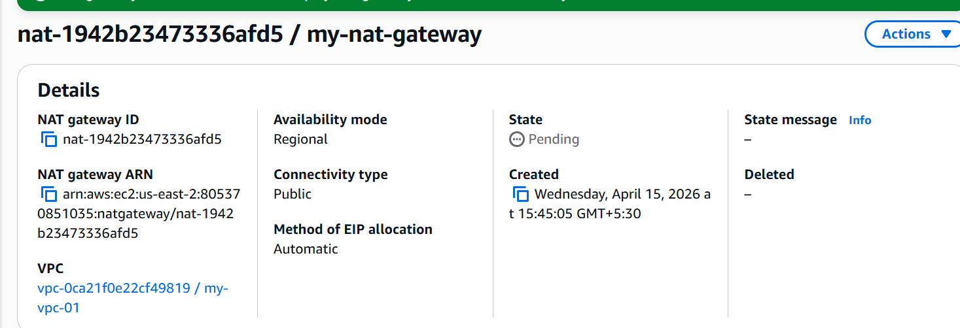

We have created a nat gateway let’s add this in our private route table.
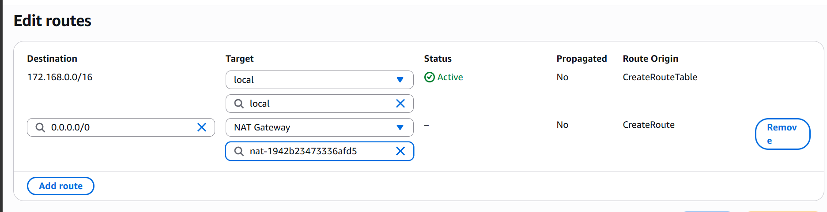

Now let’s associate this with our private subnets.
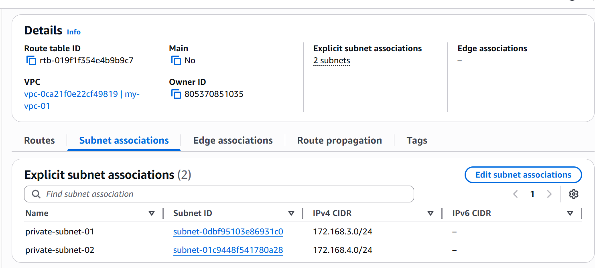
- Add two public subnets in public route table.
Lets create a Internet gateway

Lets attach it to vpc
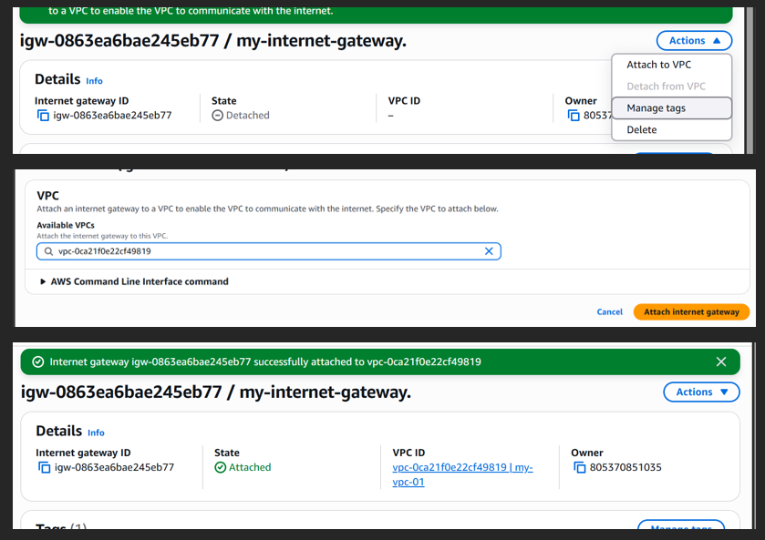

A route table is already attached to our vpc

Lets add out internet gateway in route:

Now lets associate this route table to our public subnets

We have now added our two public subnets to a route table with internet gateway and local.
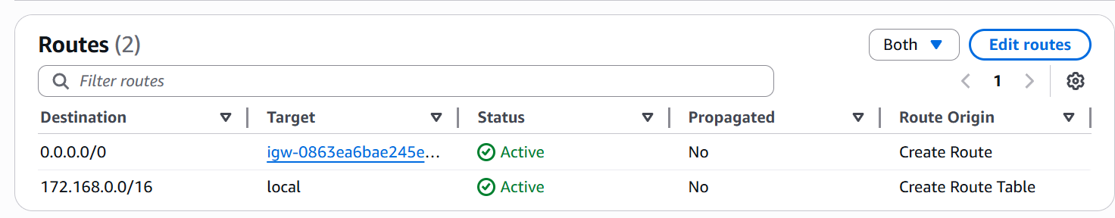

- Create EC2 in public subnet with t2.micro and install php
Lets first the instance
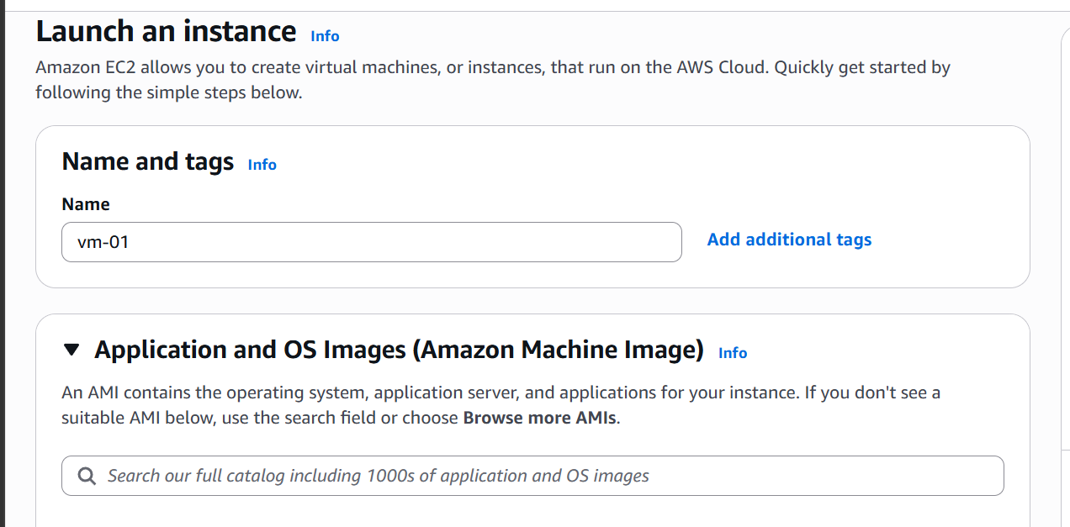
Now lets select our vpc and public subnet
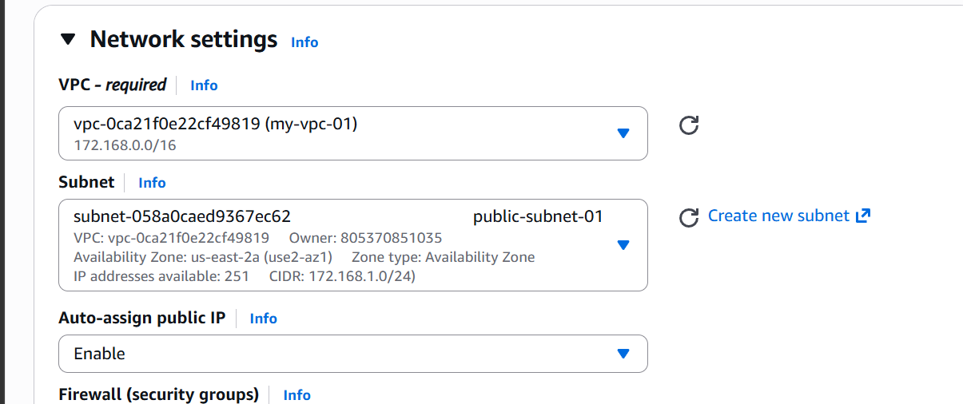

We have now launched an ec2 instance in public subnet
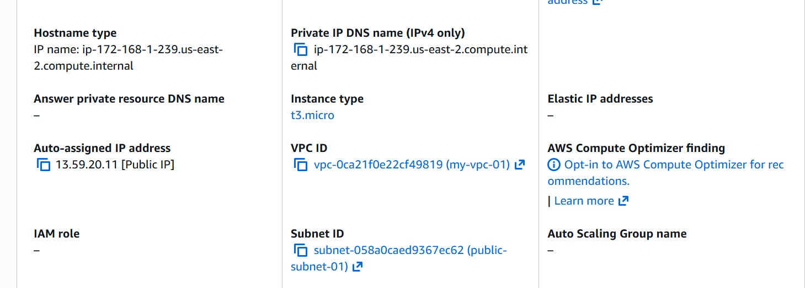

Now lets connect to it and install php
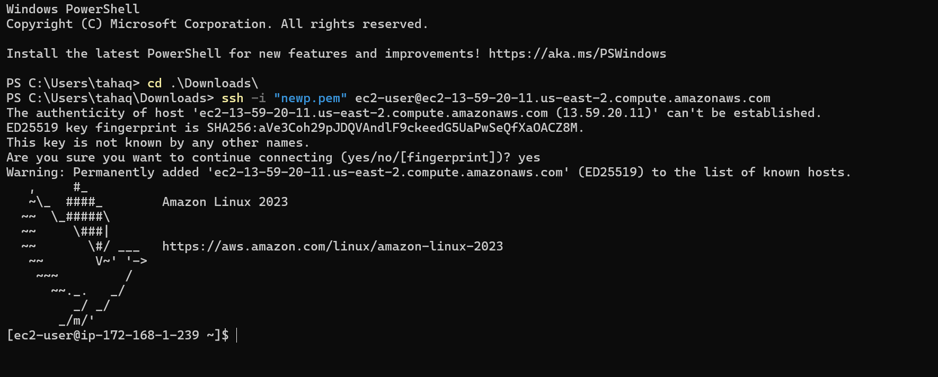
Let’s update the packages first.
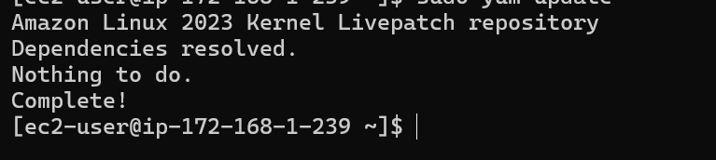

Installing php
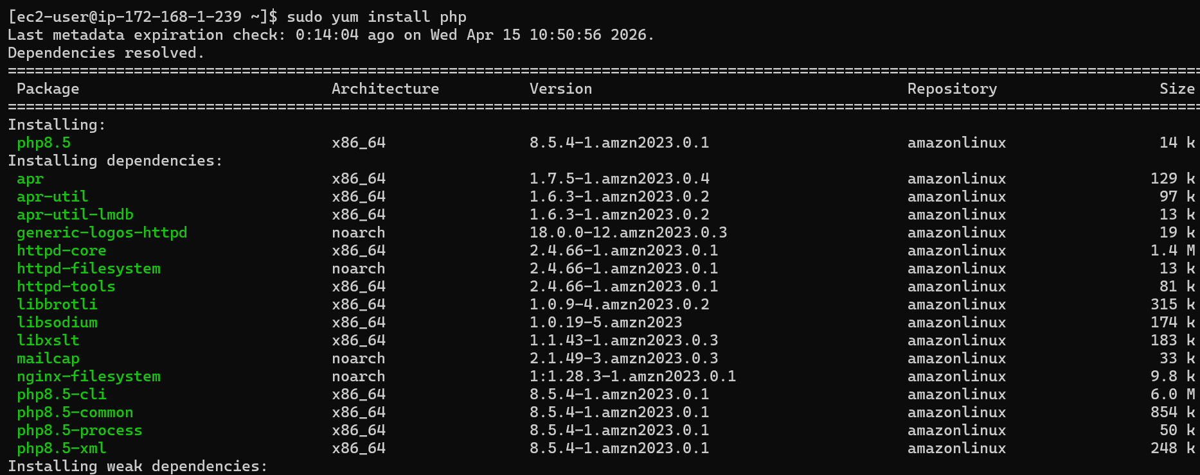
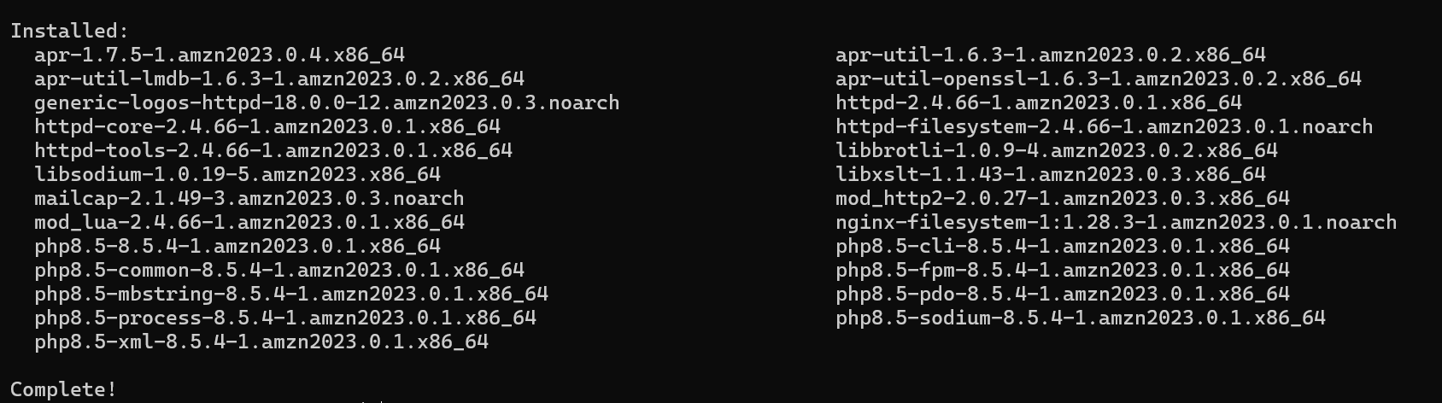
Php is installed.
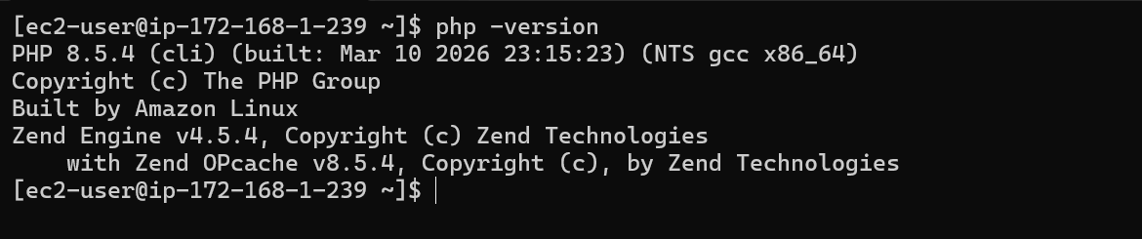

- Configure NAT gateway in public subnet and connect to private instance.

Let’s first create a new route table.

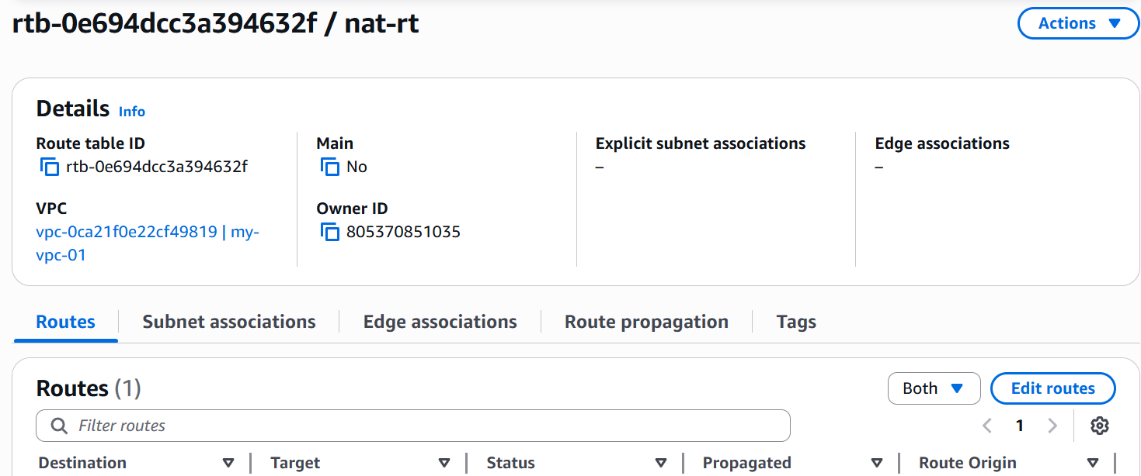

Now lets edit routes and add nat gateway to our public subnet.
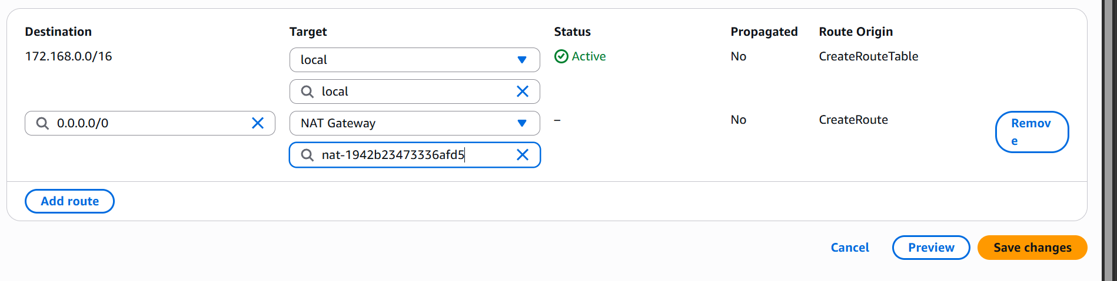

We have added a nat gateway to our public subnet.

Now lets launch a ec2 instance in private subnet.

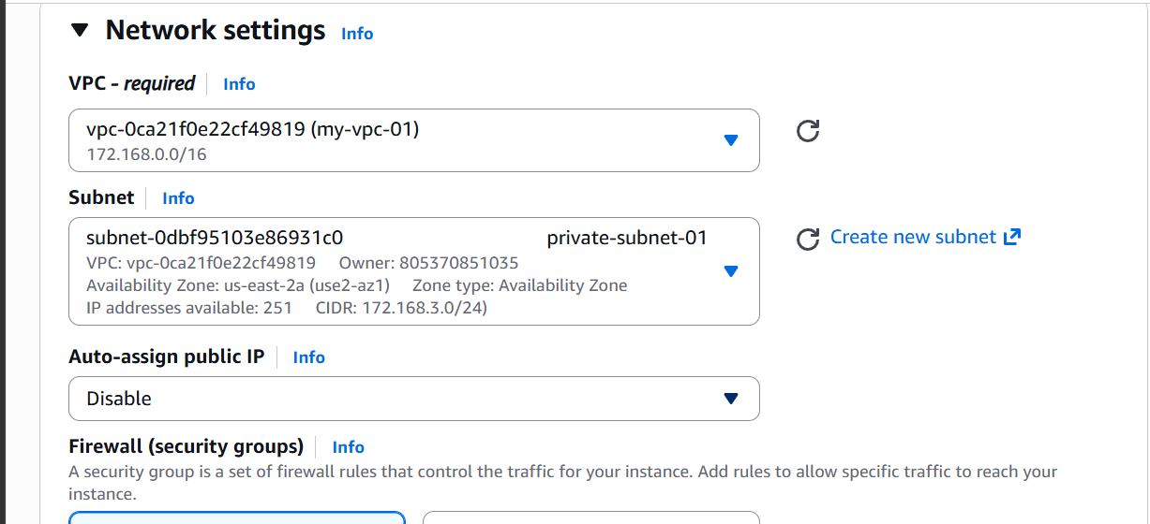

We have now created an ec2 instance in private subnet
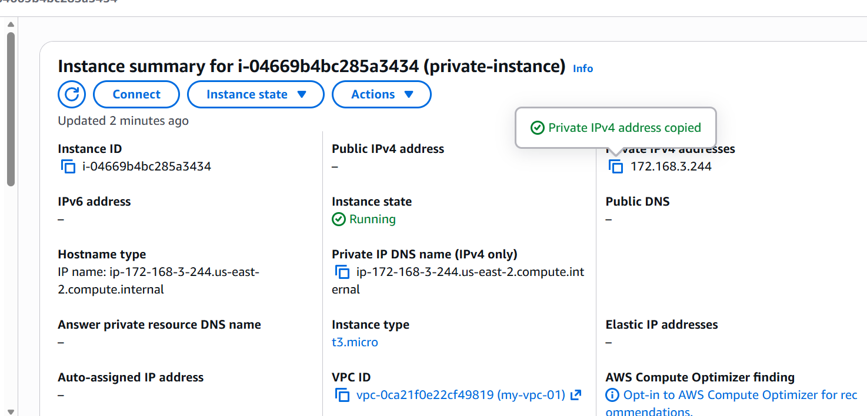

We won’t be able to ssh to the instance as it will not have a public ip address associated with it.

Now lets try to ssh from our ec2 instance which is in public subnet with nat gateway.
We need to copy the .pem file as well

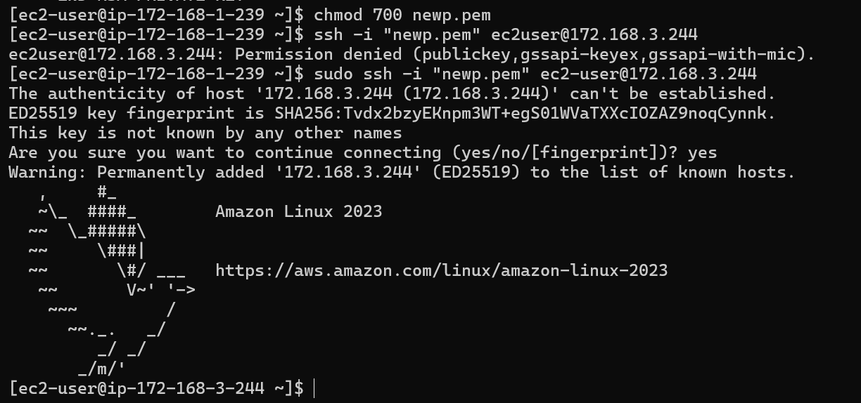
Now we are able to ssh to our ec2 instance from our public instance and we have used our public server as a jump server/ bastion host.

- Install apache tomcat in private instance and deploy a sample web app

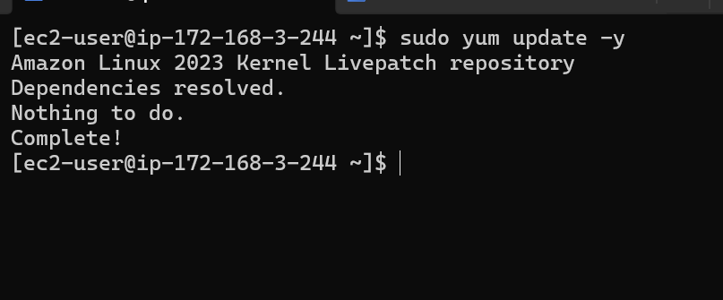

Lets update the repository first.

Now let’s install java
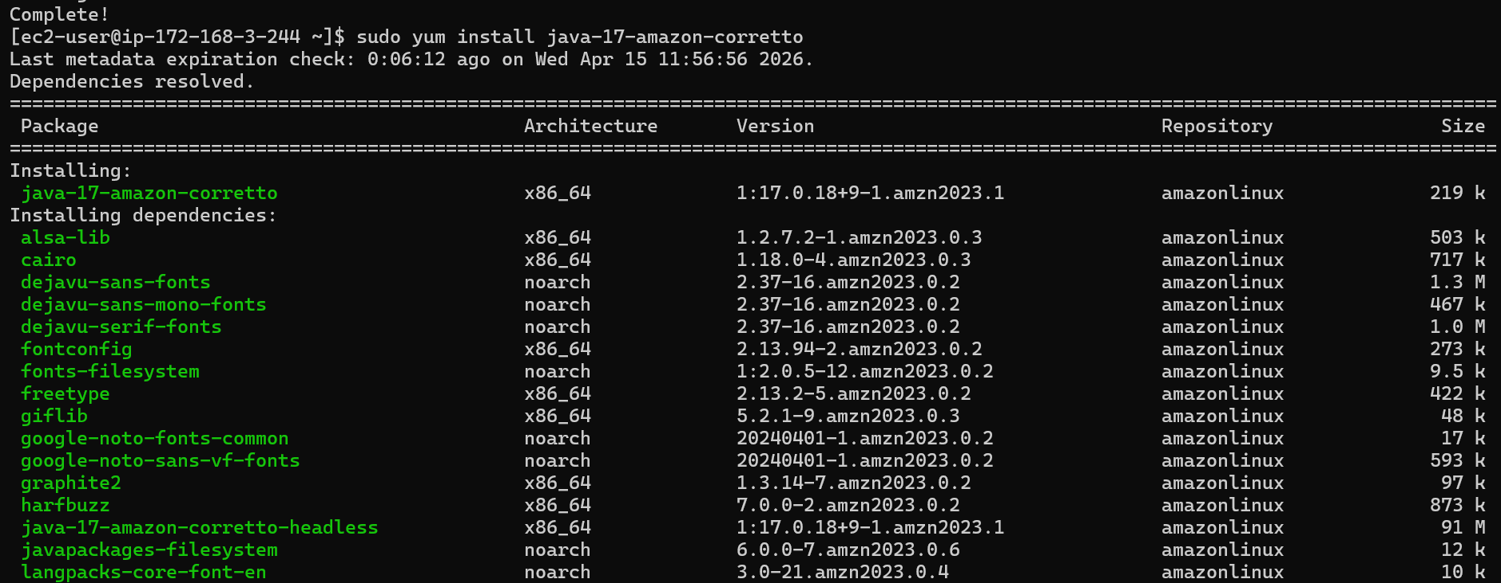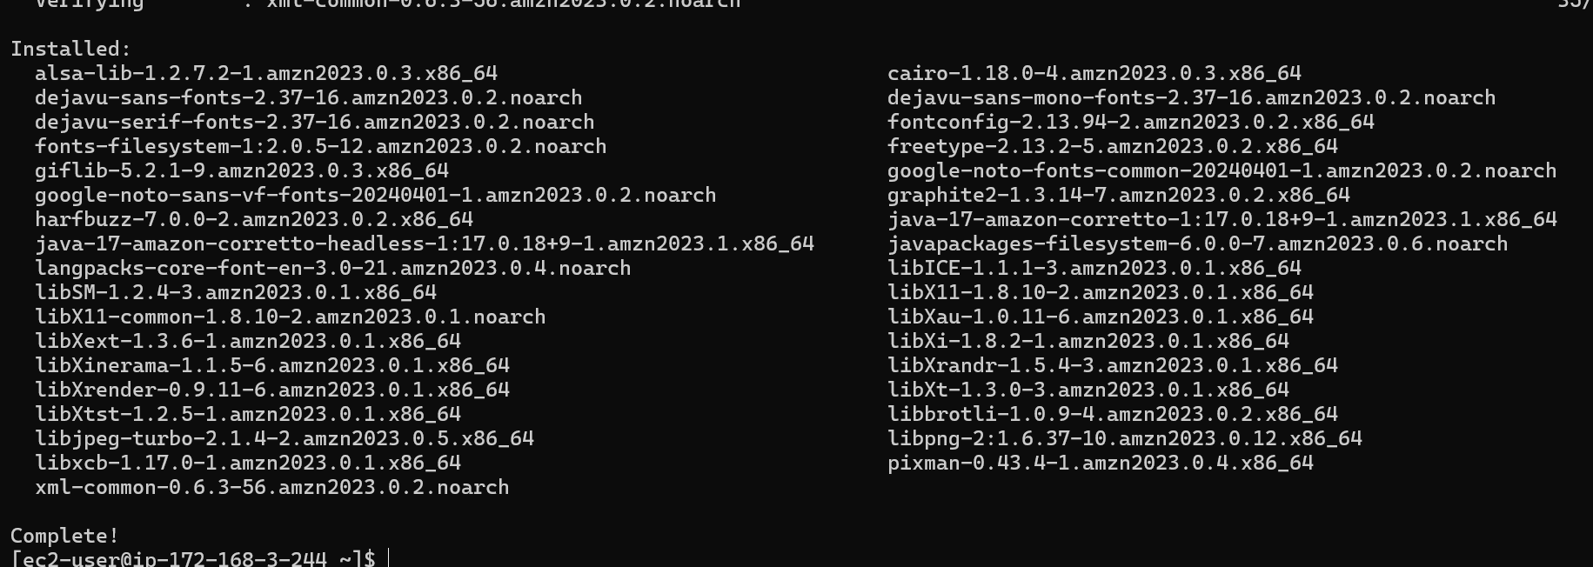

Java is now installed

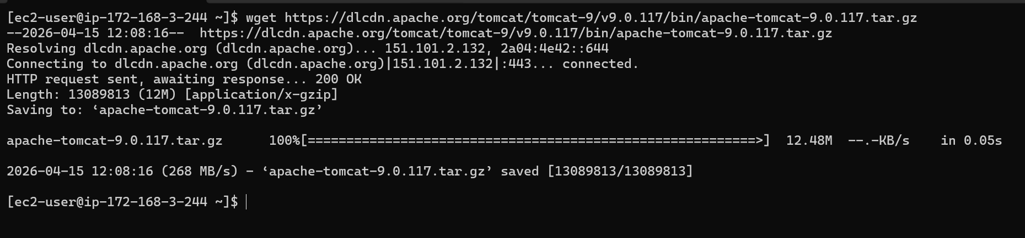

Tomcat is now downloaded
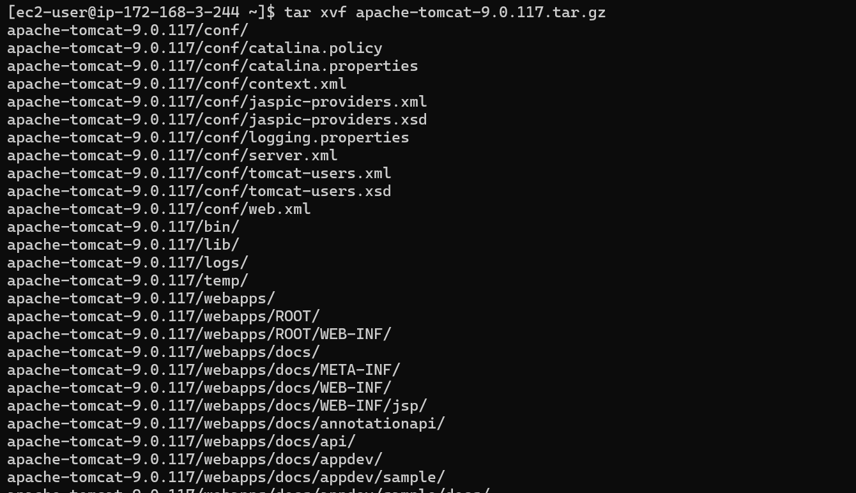
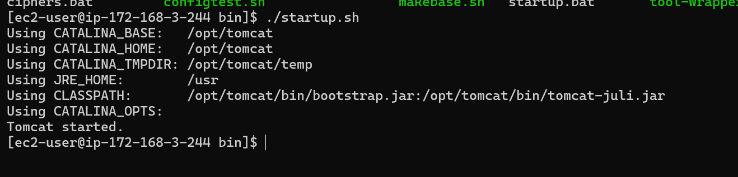
Tomcat is now installed and started.

Deploying a sample web app
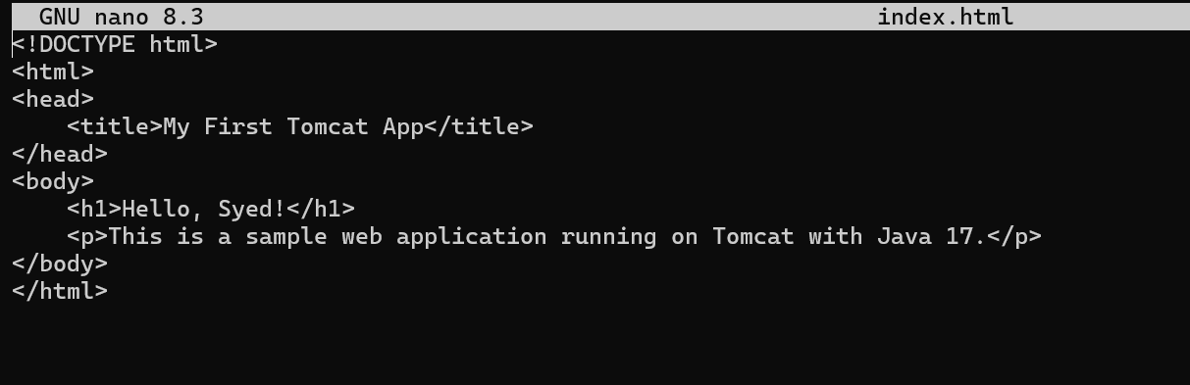
we have deployed our sample web app at root directory in webapps directory

Tomcat is now stared
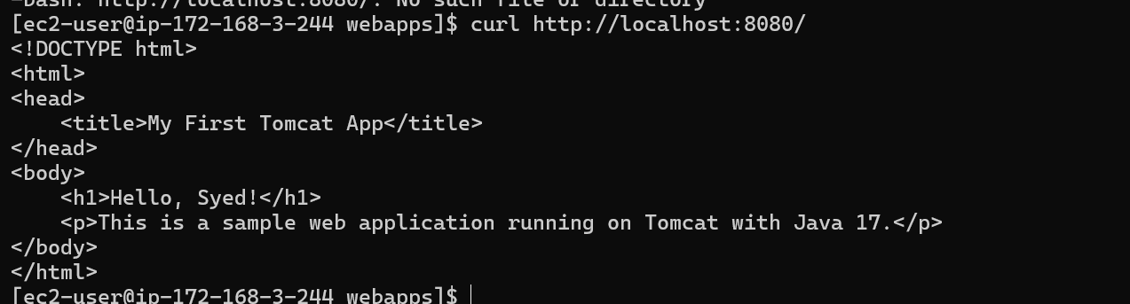

- Configure vpc flow logs and store the logs in S3 and cloudwatch

First lets go to our vpc
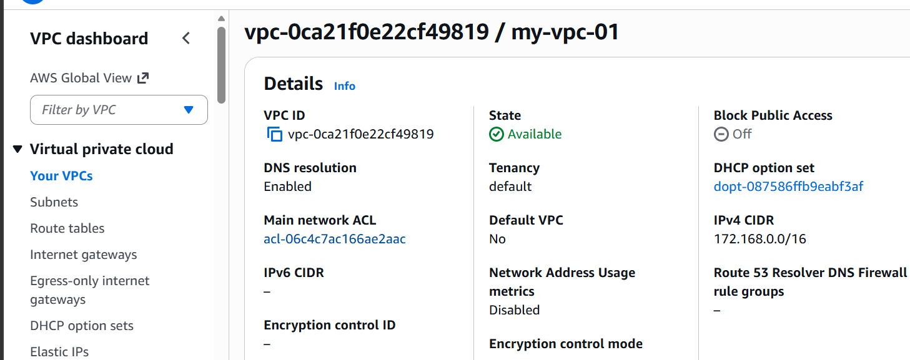
Then we need to click on create flow log
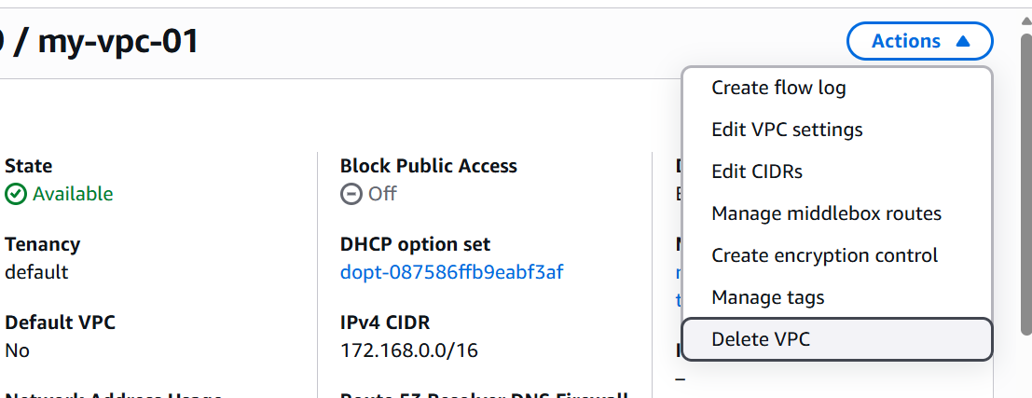

Lets give it a name and select send to cloud watch
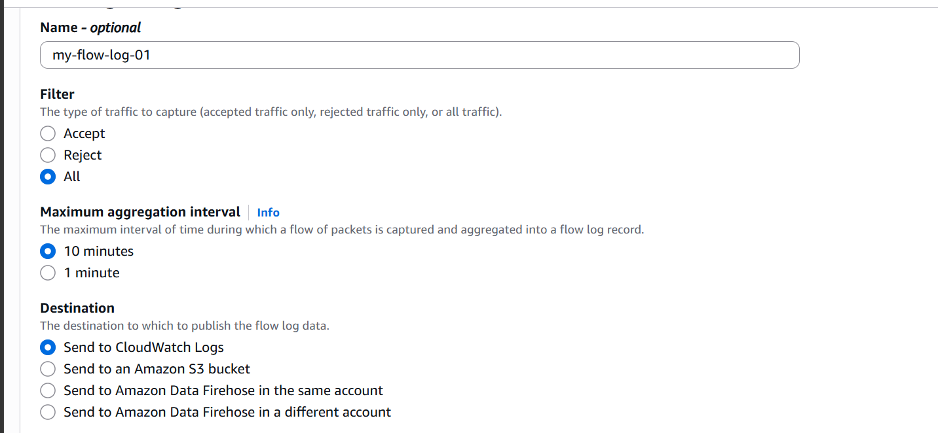

Now lets create a service role and use it
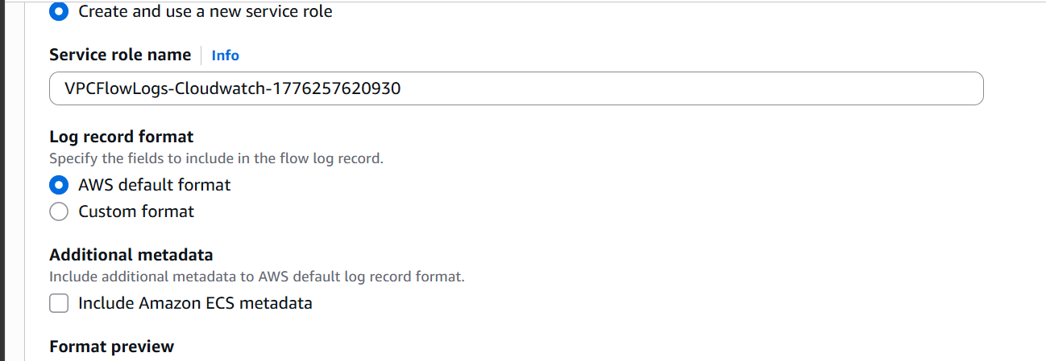

Our flow log for cloudwatch is now created.
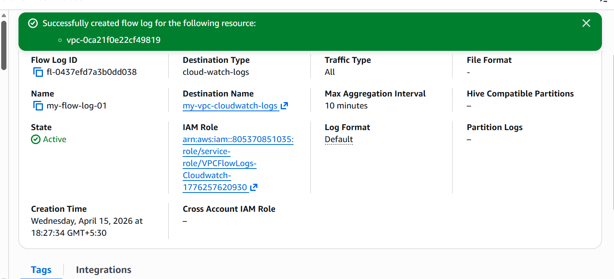

Lets create for s3
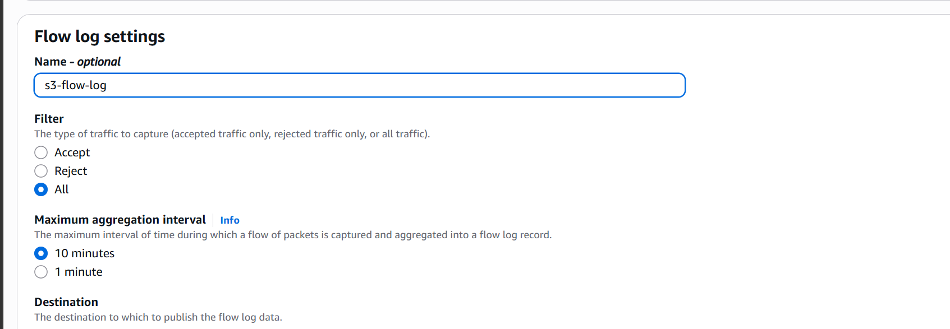
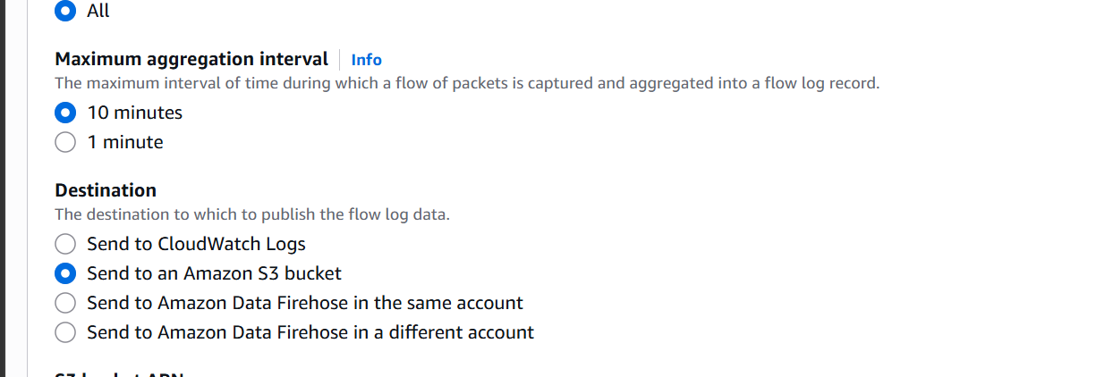

Now lets give the url to s3 bucket

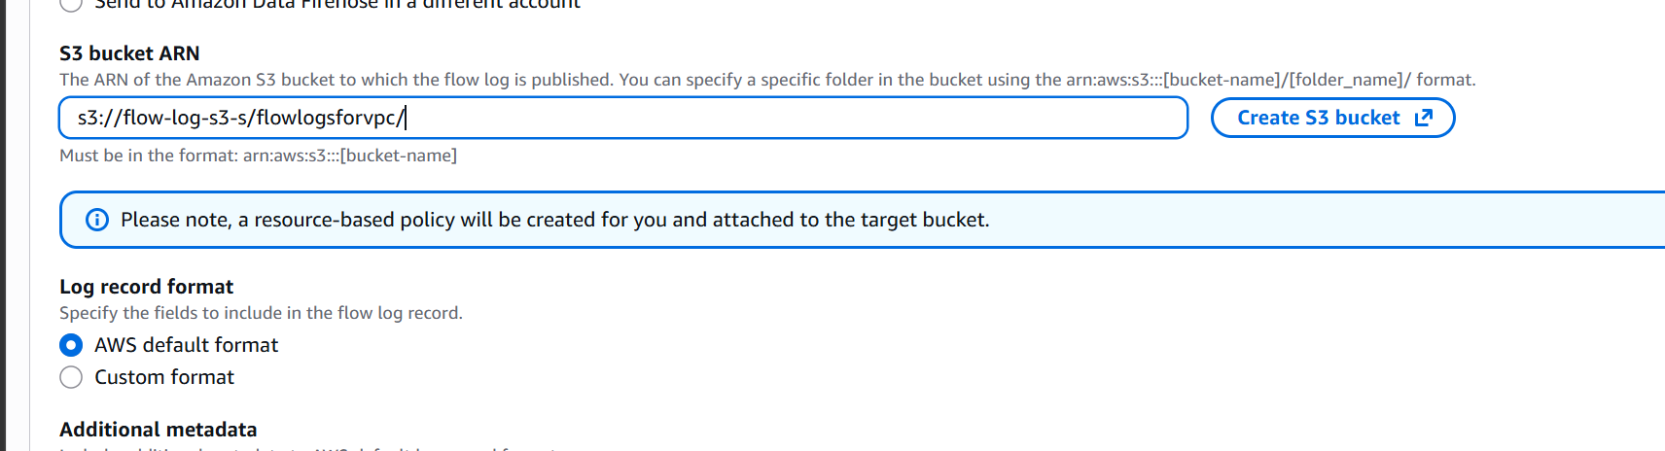

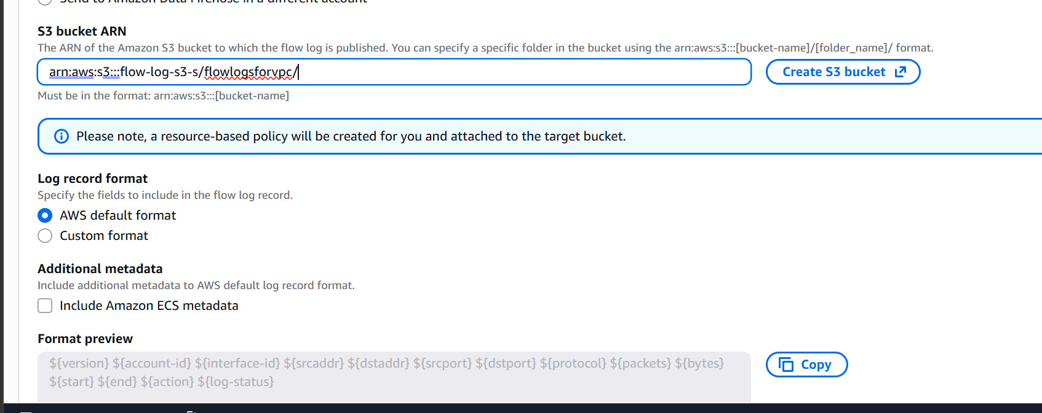

We have now created a vpc flow log on s3
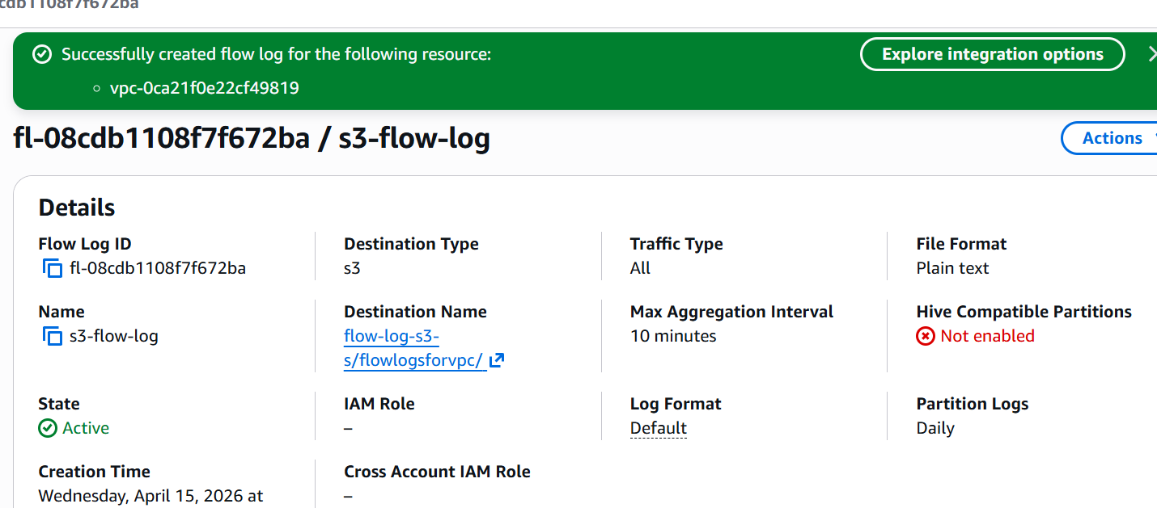

We have now configured flowlogs on both s3 and cloudwatch.

