Virtual Private Cloud.
- Create one VPC with one private subnet and public subnet.

Let’s go to the VPC dashboard and create a VPC

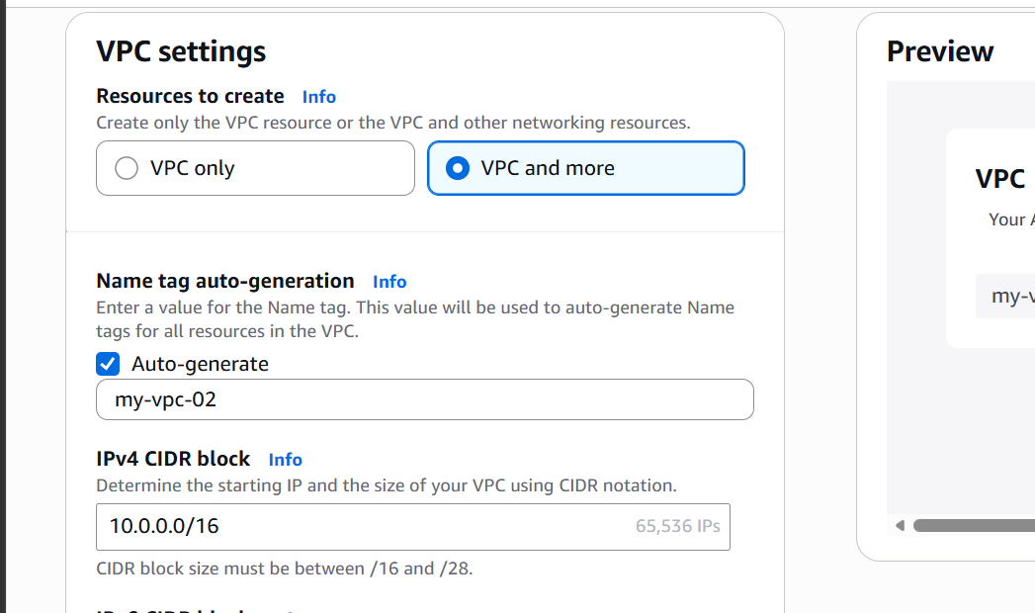

Selecting number of private and public subnets
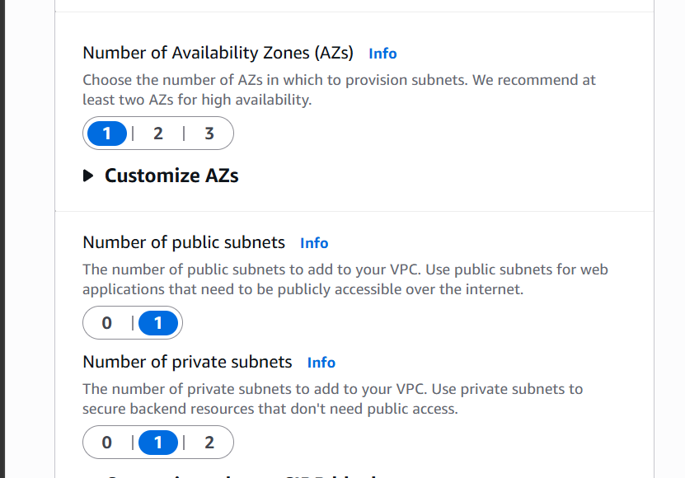
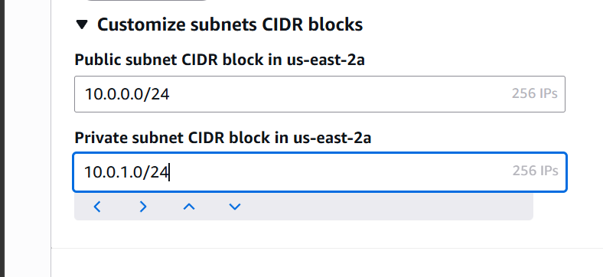

Giving subnet range for public and private subnets

We have now created a VPC with one public and private subnet
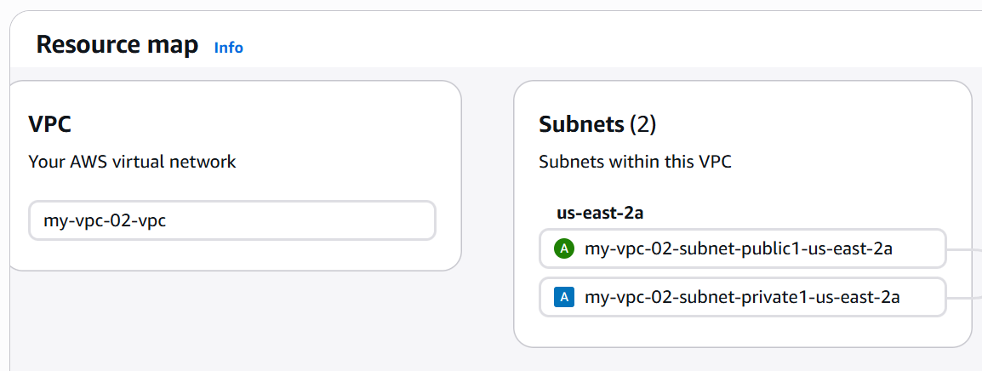

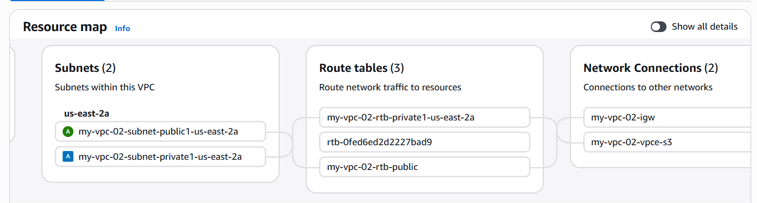

- VPC Peering / Cross Region

We have two VPCs
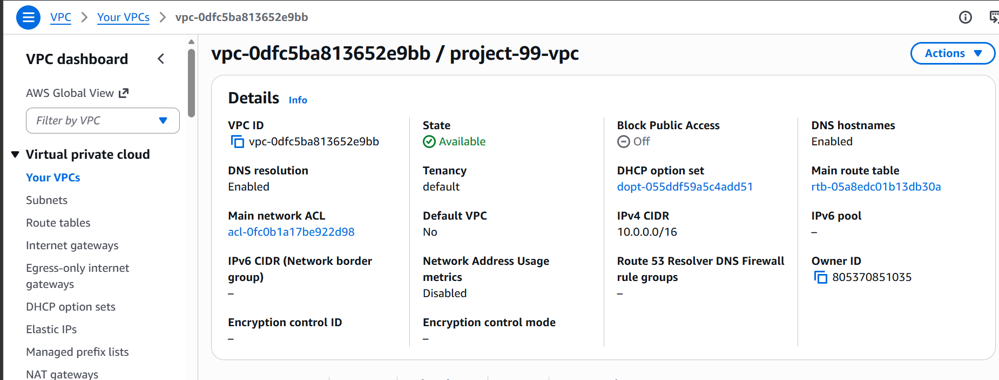

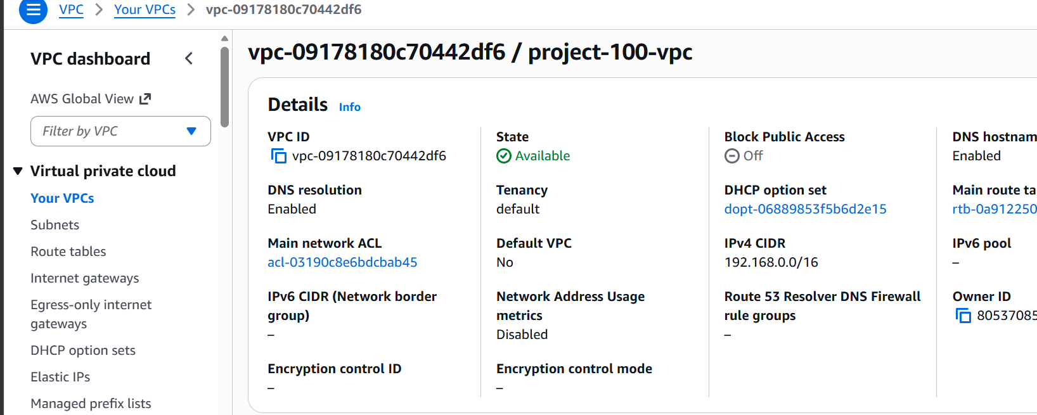

Lets add vpc peering
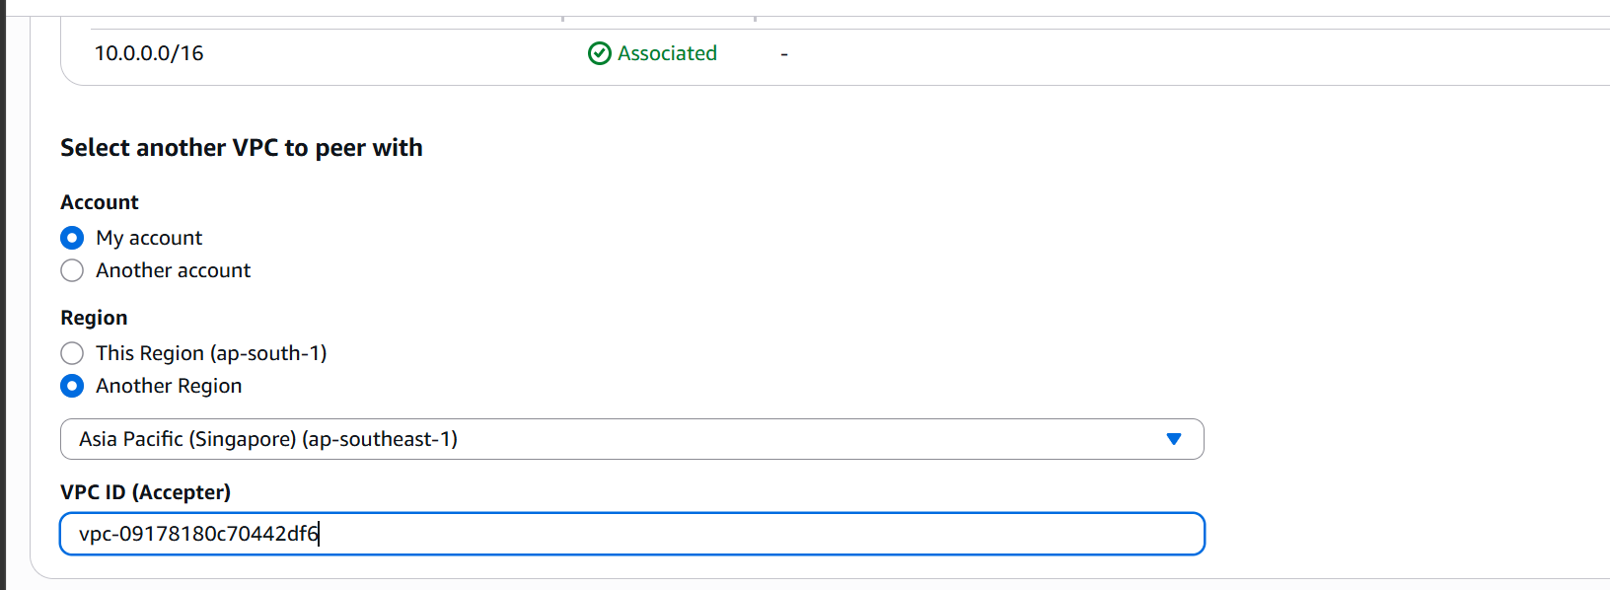
Connection request sent;
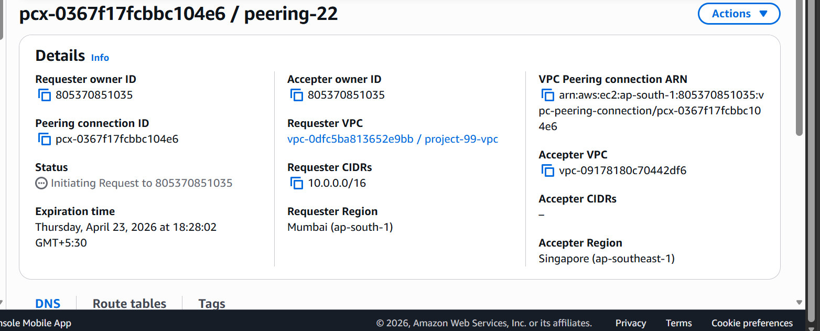

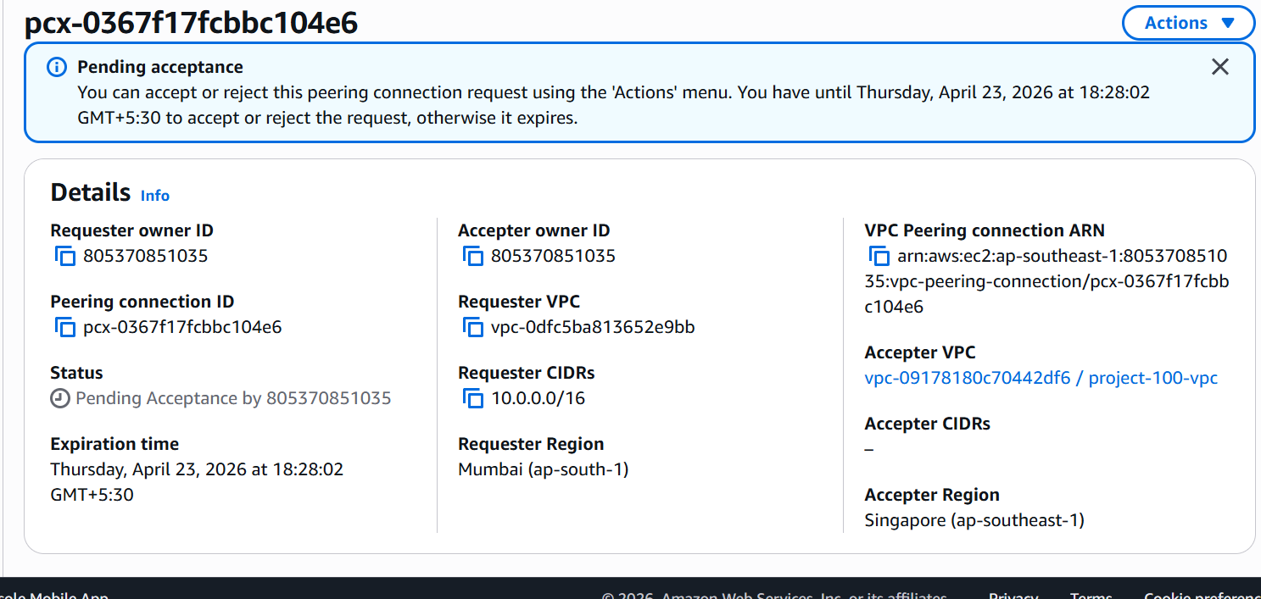

Connection is now established
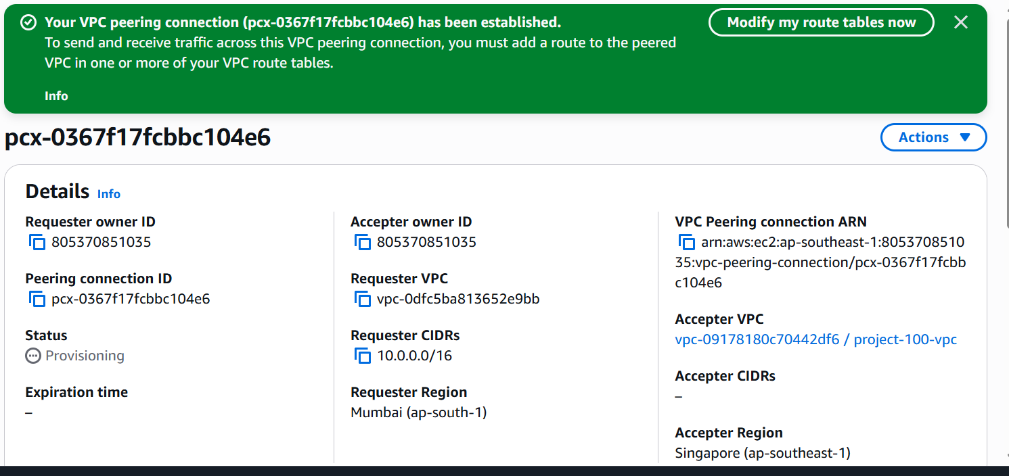

Adding entries in route tables

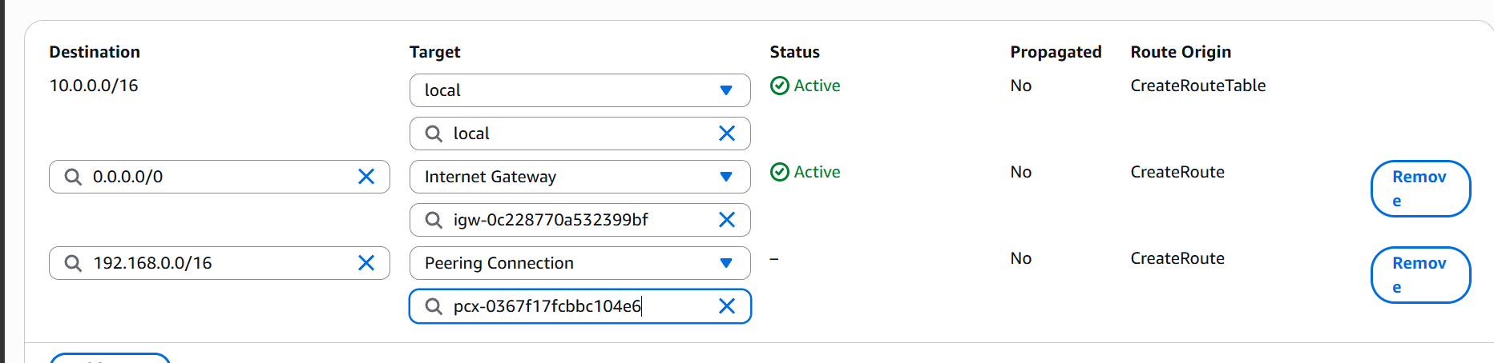

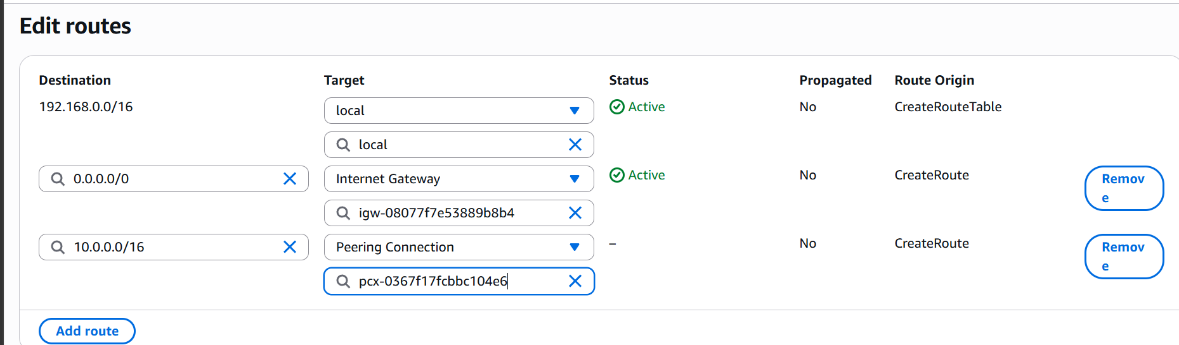

Now lets create ec2 instance in both vpcs

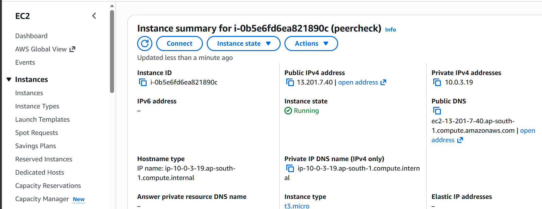

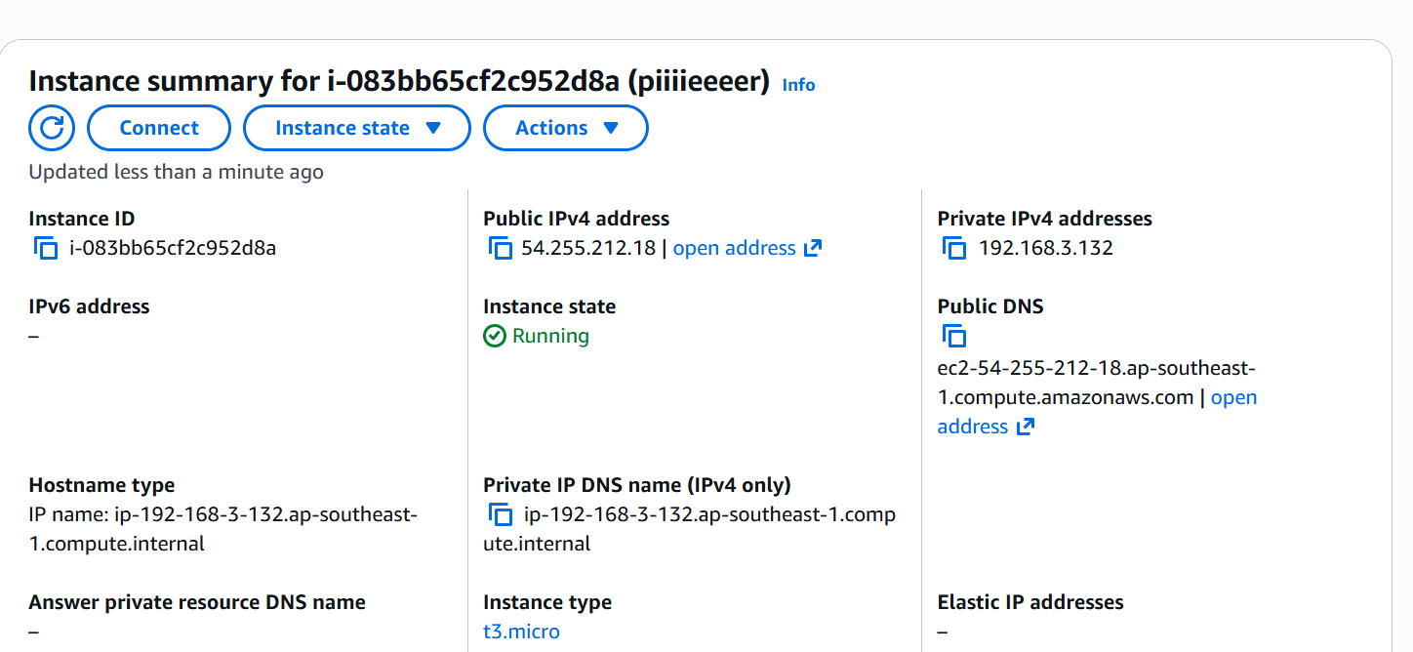

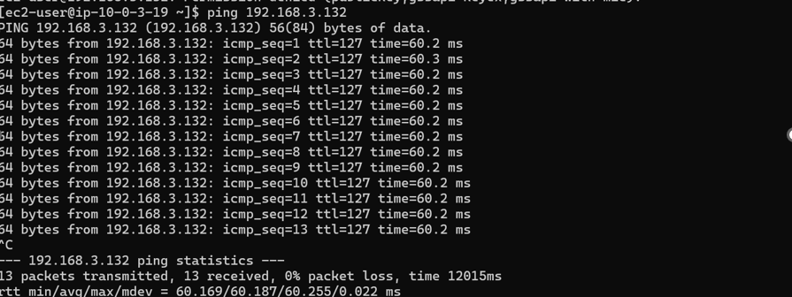

We are able to ping from our one instance to another instance using its private ip

- Cross Account VPC Peering:

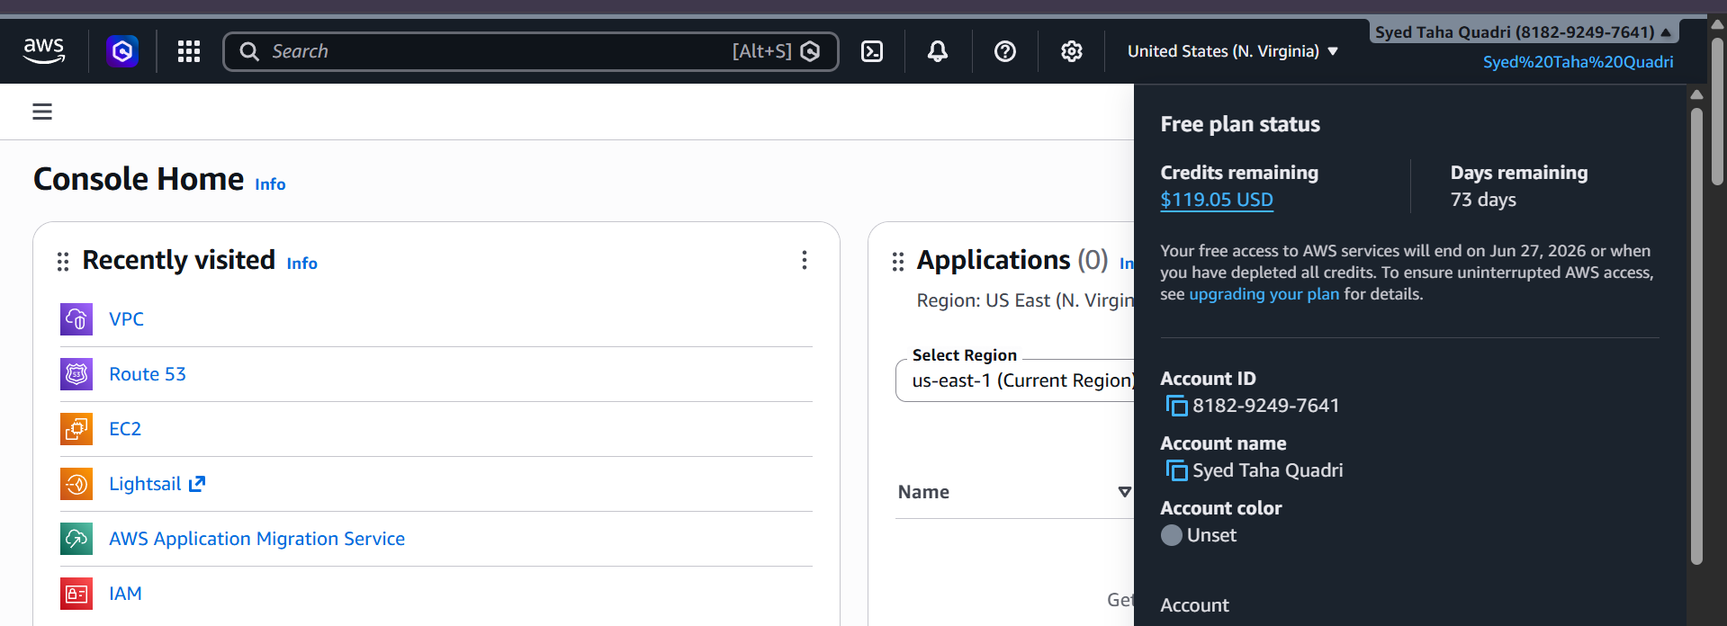

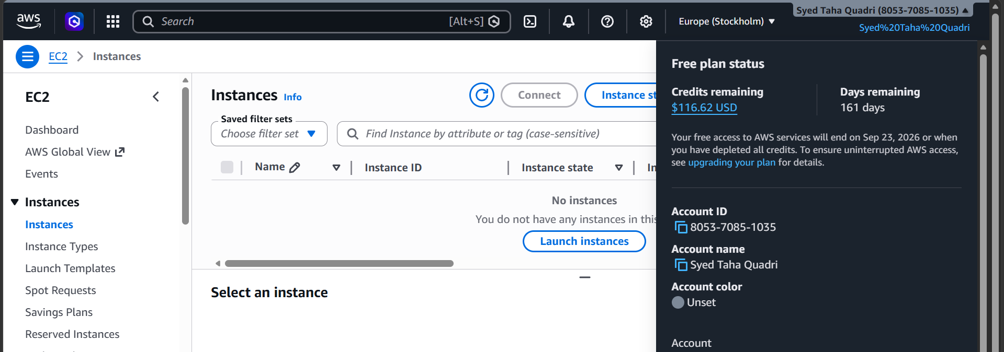

These are the two accounts in which we need to create a peering

First lets create VPCs in both the accounts

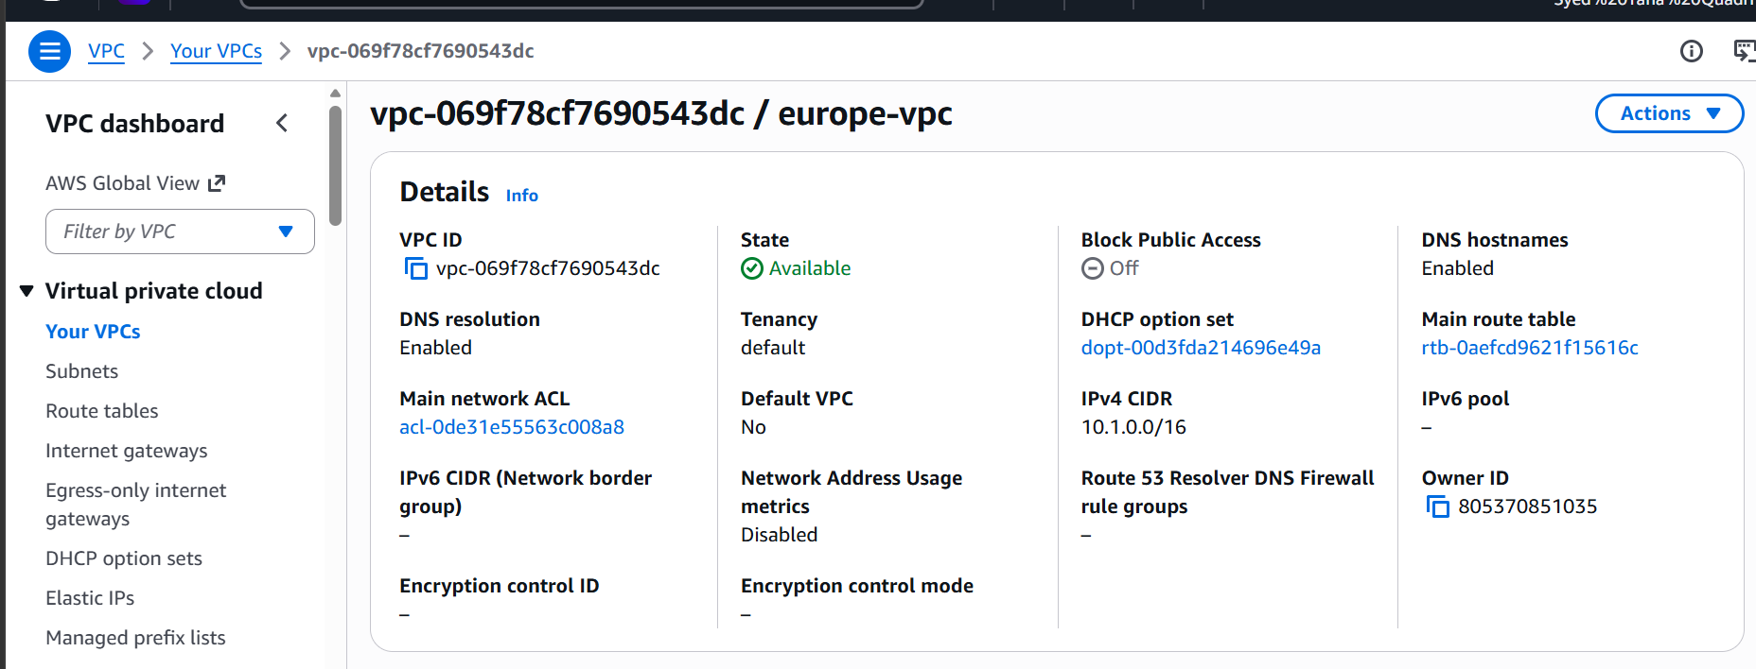

VPC created in one account in Europe region

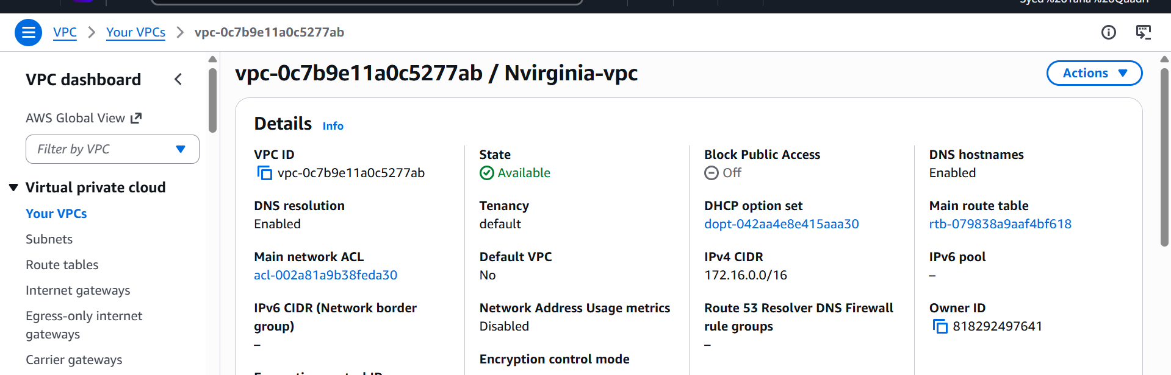

Another VPC created in north virginia region.

Let us now establish peering connection

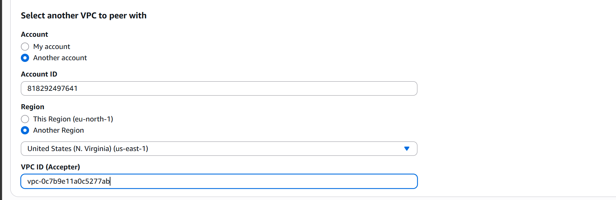

The request now goes to another account for peering.
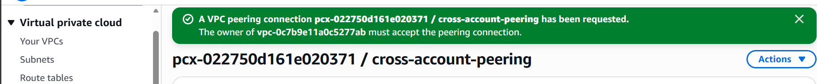

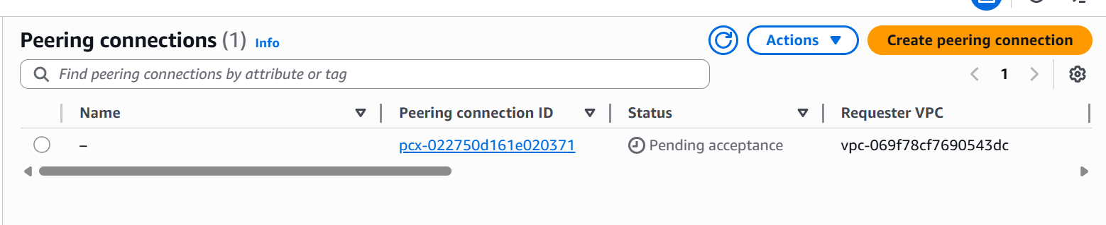

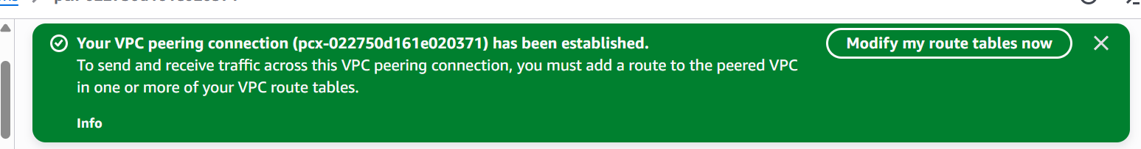

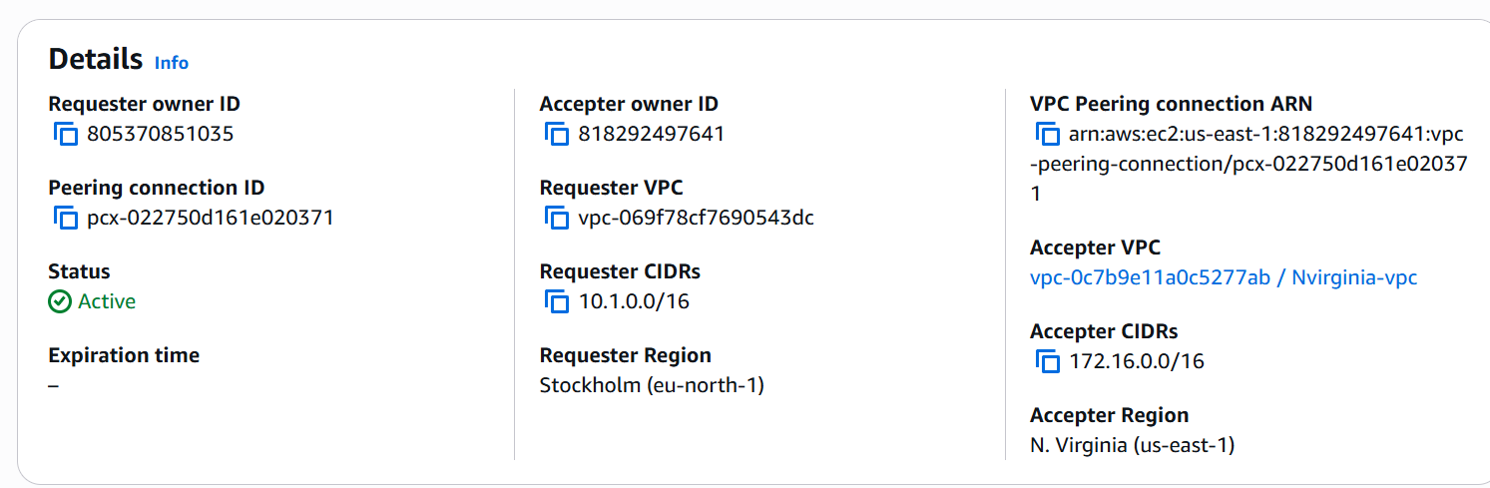

Peering connection is now active

Now lets edit the route
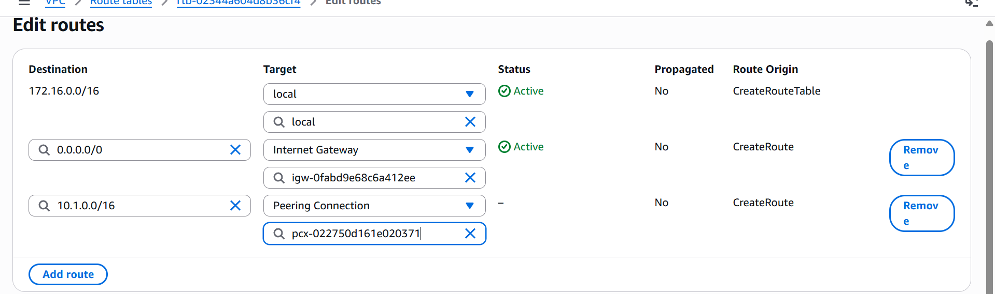

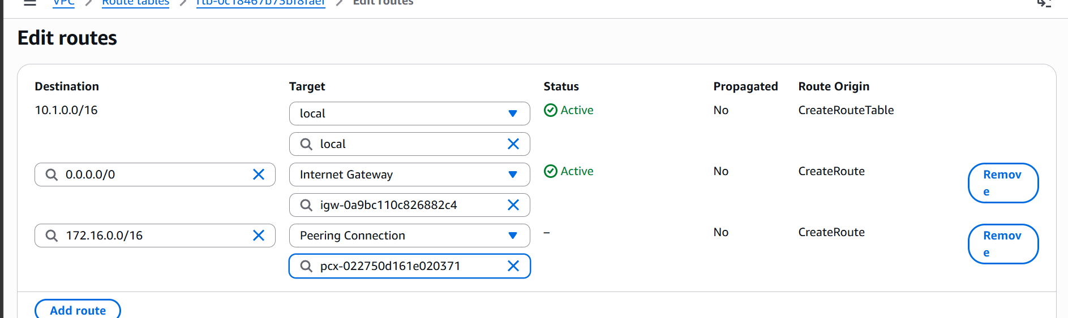

Now lets launch instances in both the VPCs

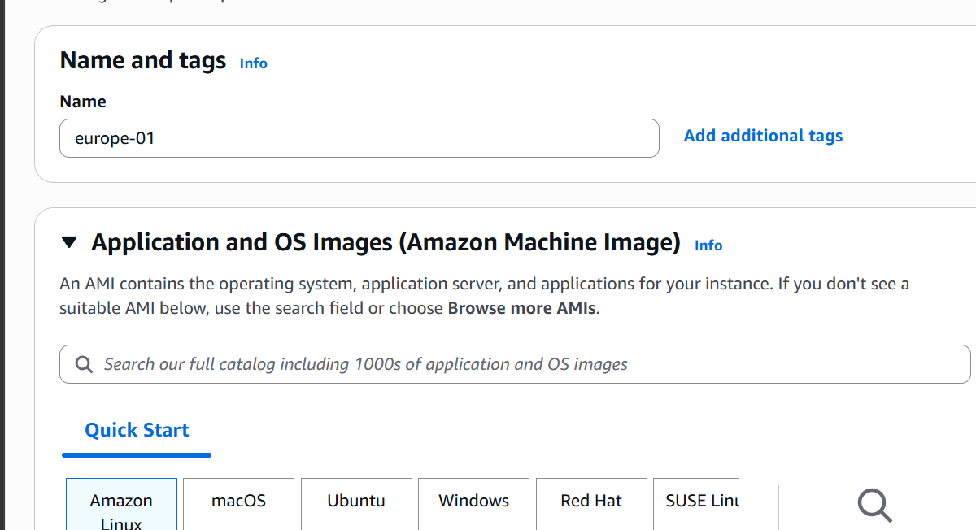

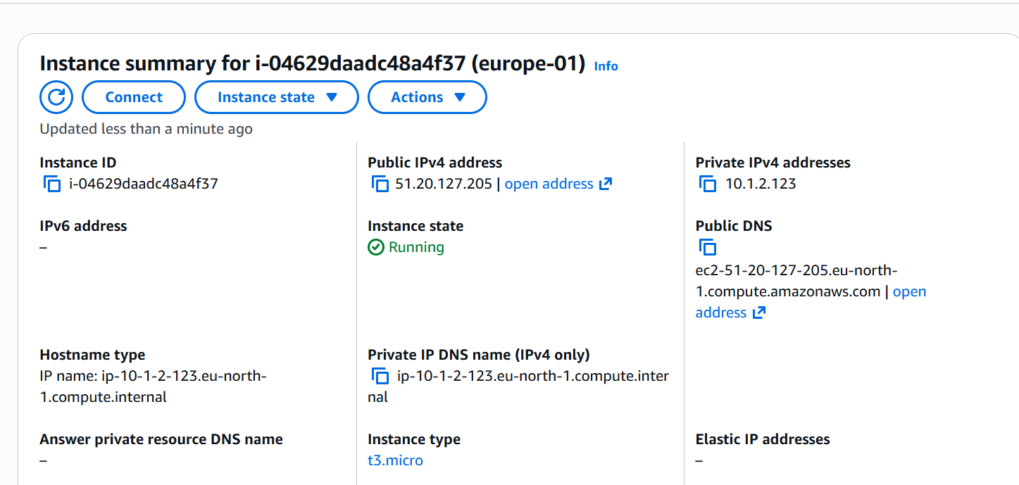

Instance in Europe

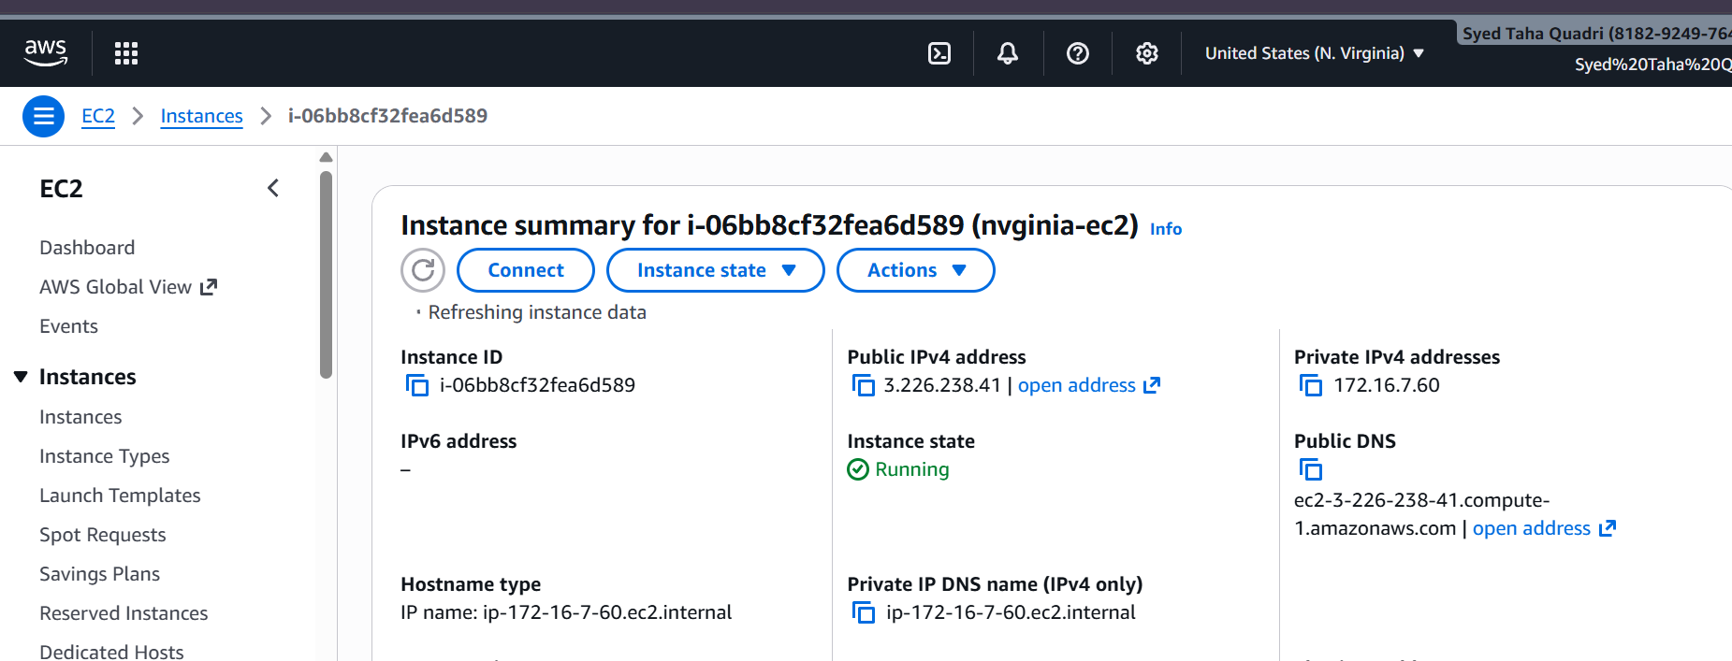

Instance in nvginia

Lets now ssh to instance and check connectivity

We are now able to connect using ssh through private ip
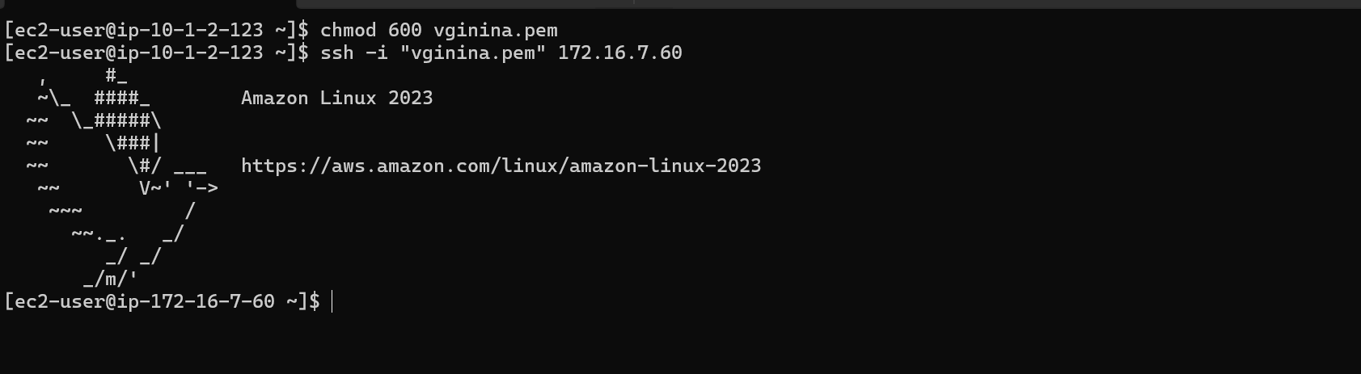
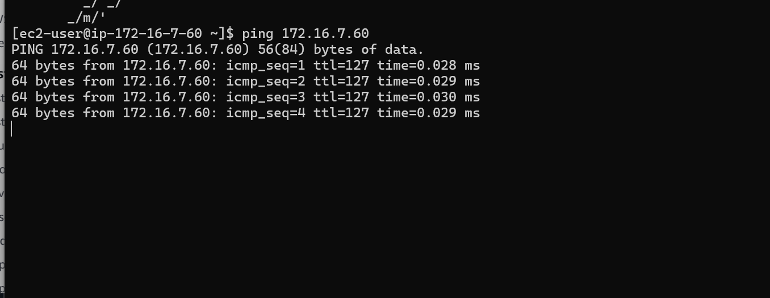
Ping is working as well.

- Set up a VPC transit Gateway.

First let’s create 3 VPCs with non over lapping CIDR
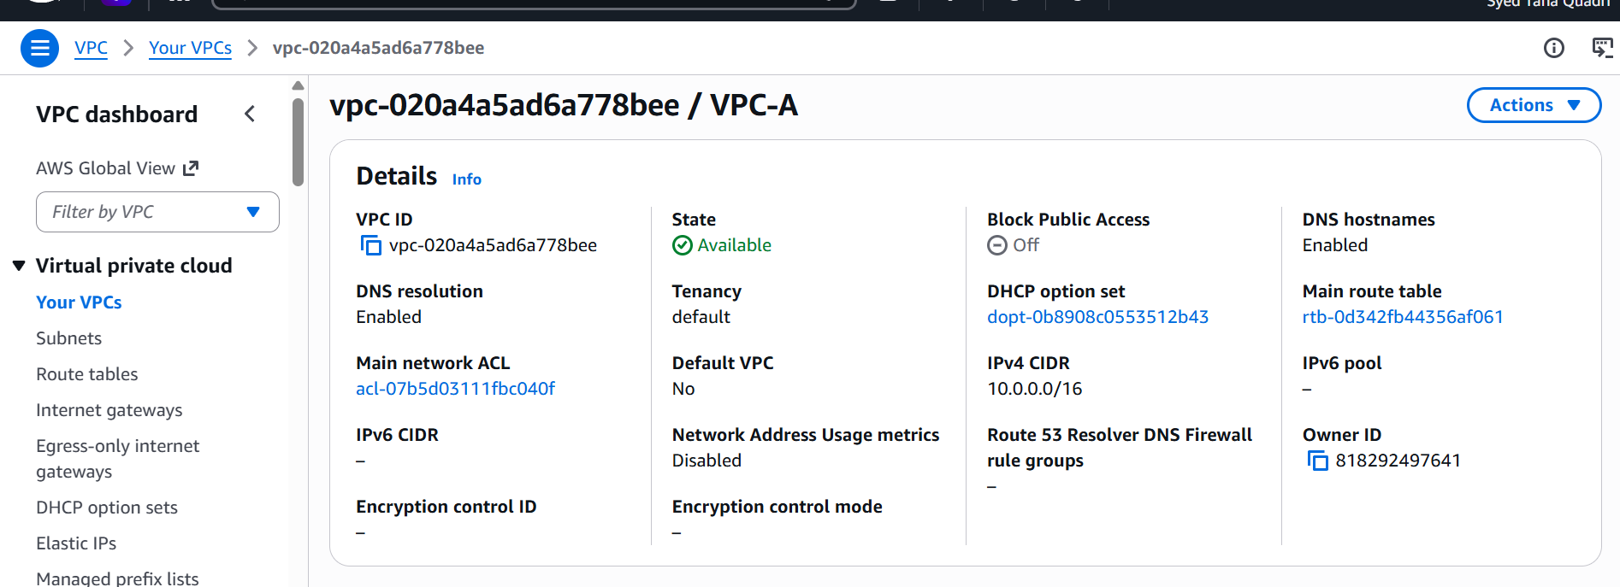

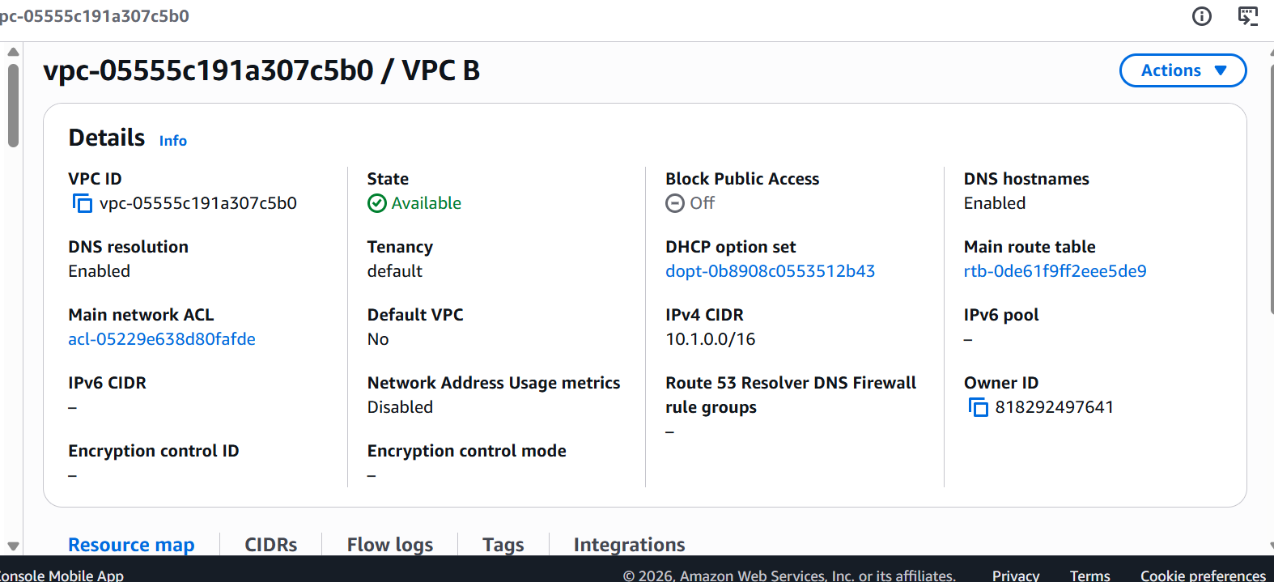
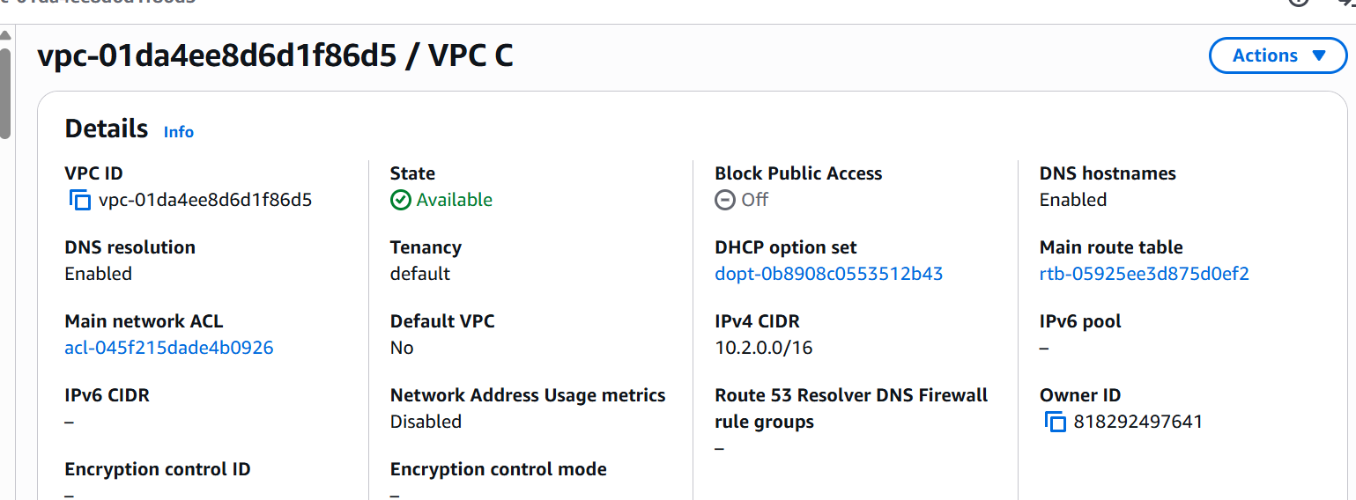

We have 3 VPCs now

VPC A : 10.0.0.0/16
VPC B : 10.1.0.0/16
VPC C : 10.2.0.0/16

Lets now create transit gateway:
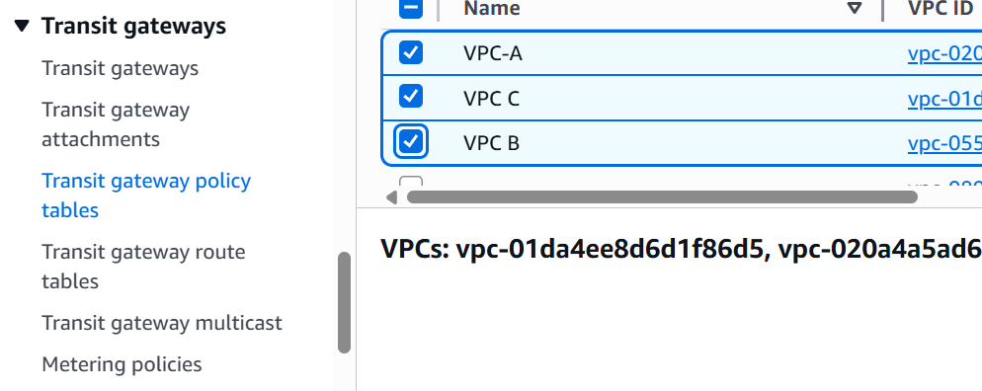

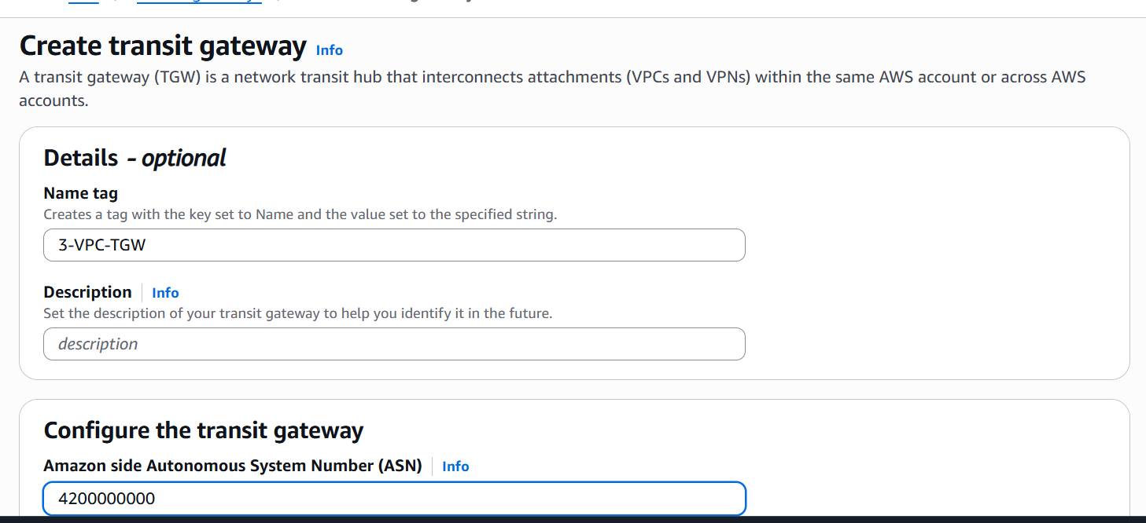

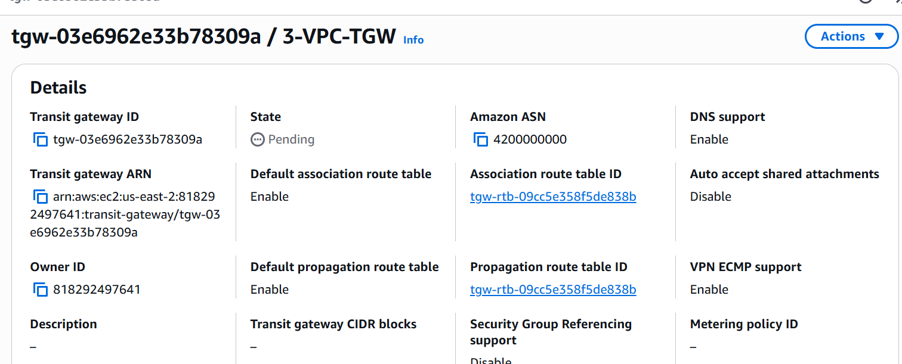

Transit Gateway is now created.

Now lets attach the transit gateway to VPCs
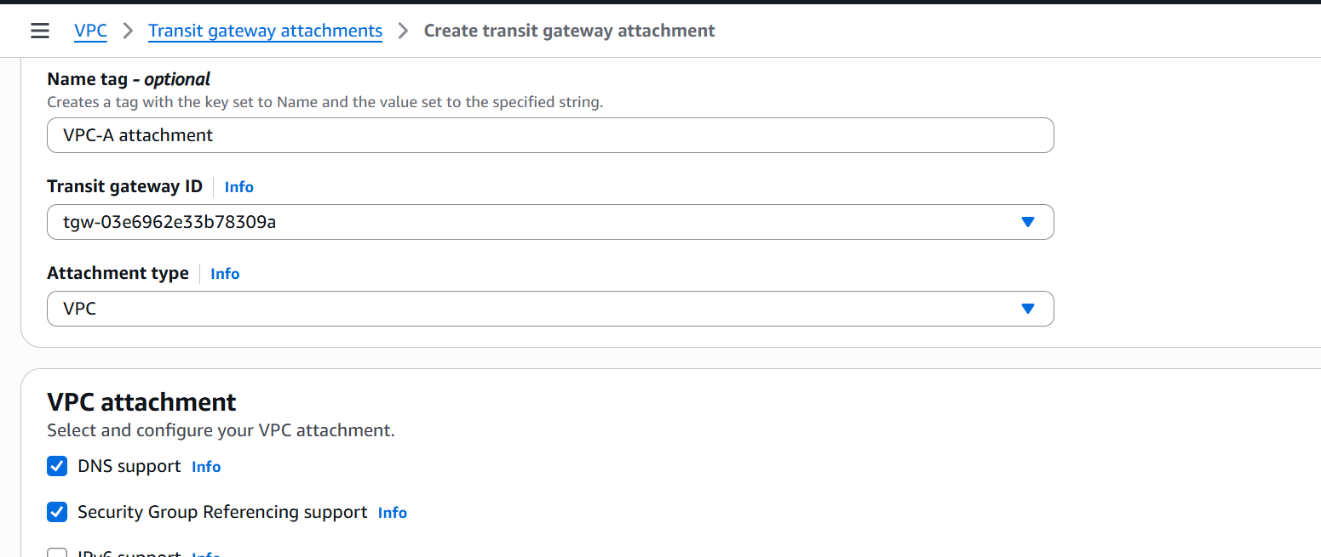

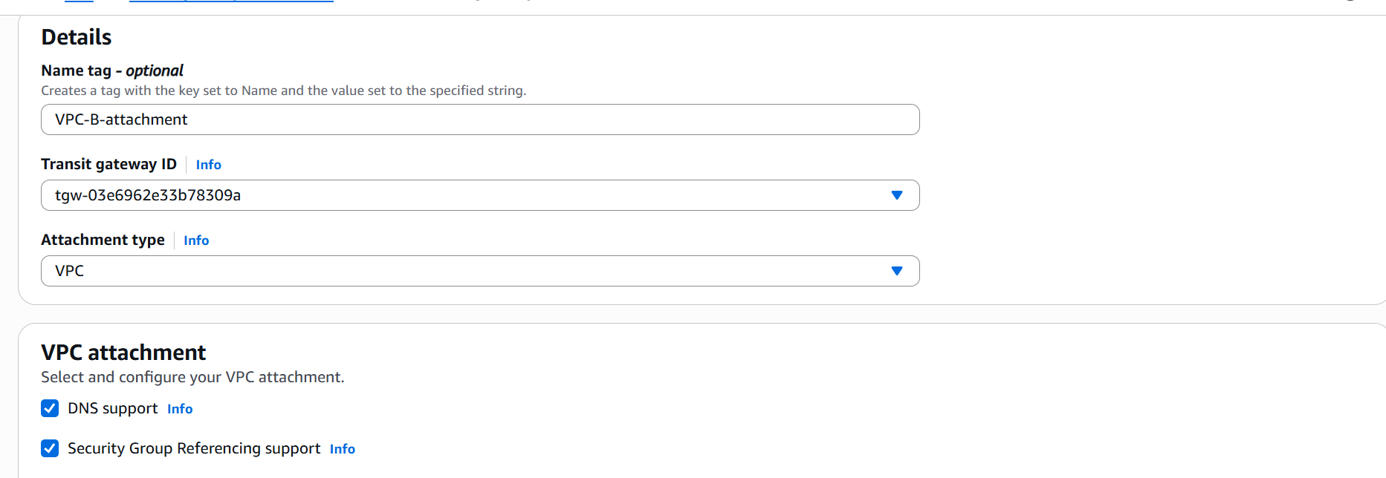

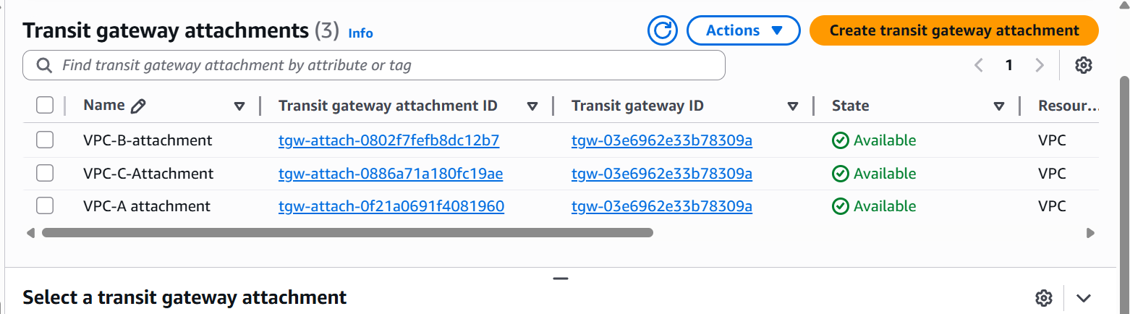

We have now attached our transit gateway to our VPCs

Now lets update the Transit Gateway Route Table

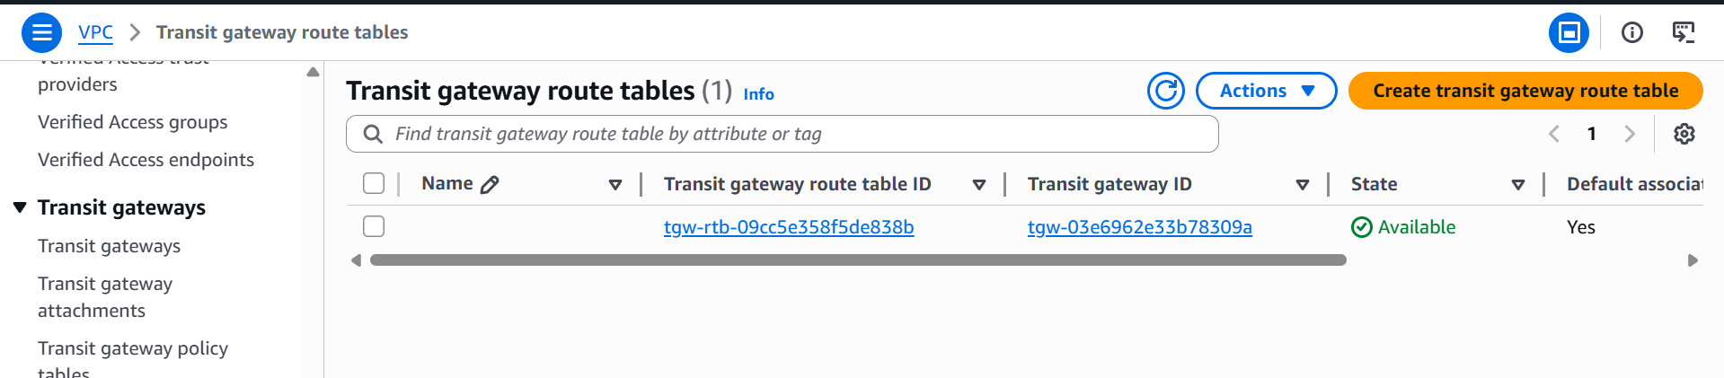

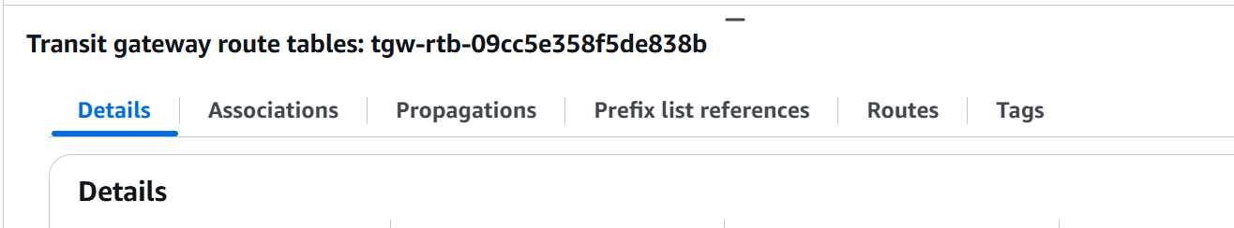

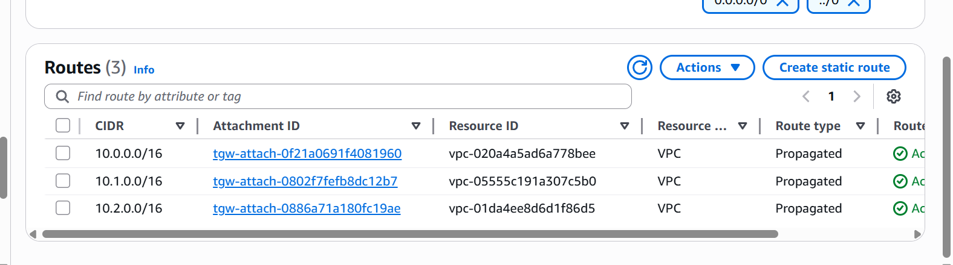

transit gateway routes are updated

now lets go to vpc route table and update them.

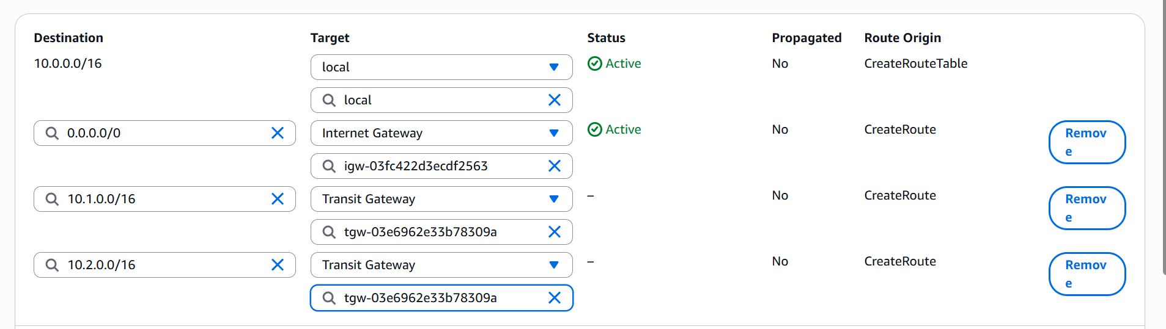

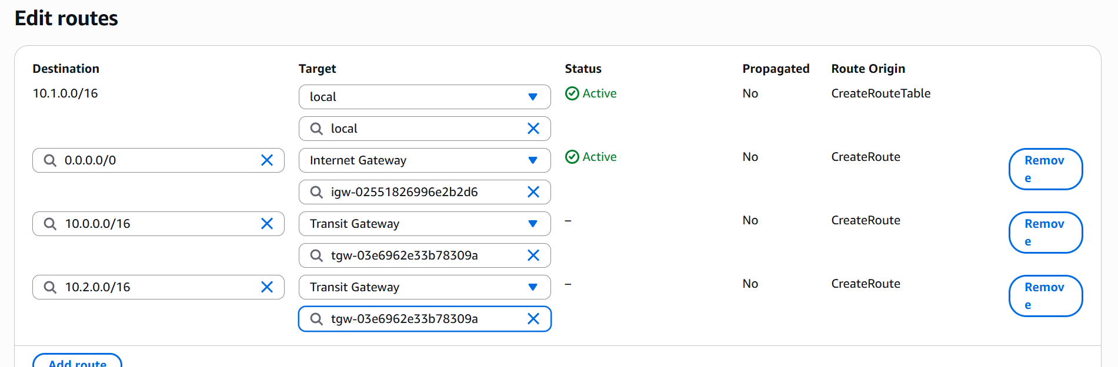

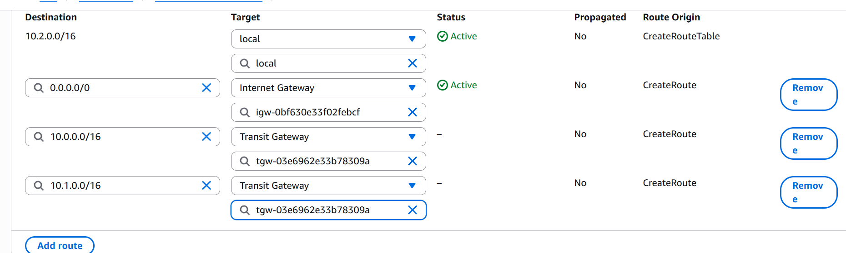

We have now updated the vpc route tables as well.

Now lets create ec2 instances in each of these vpcs and check connectivity.

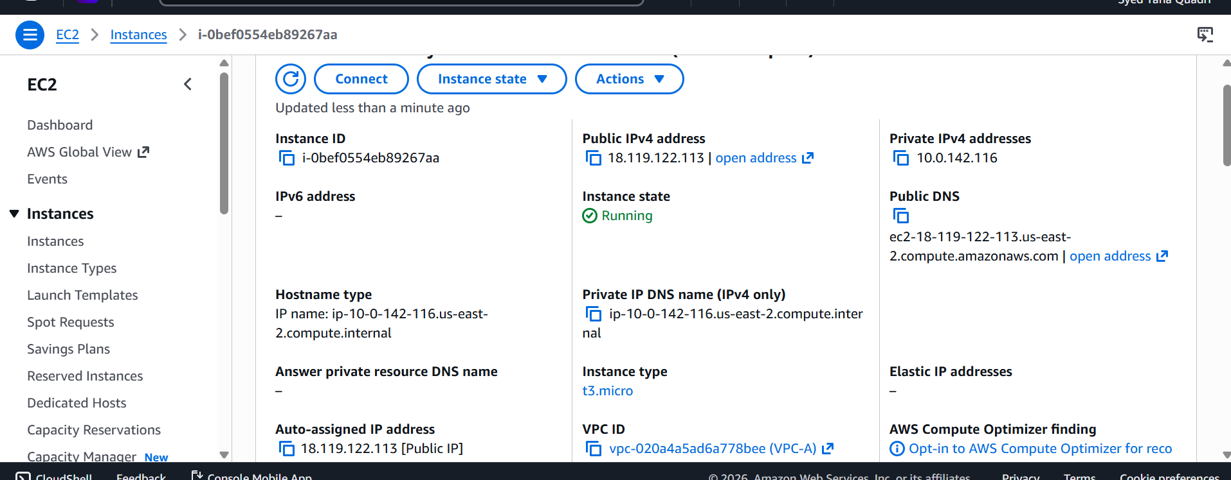
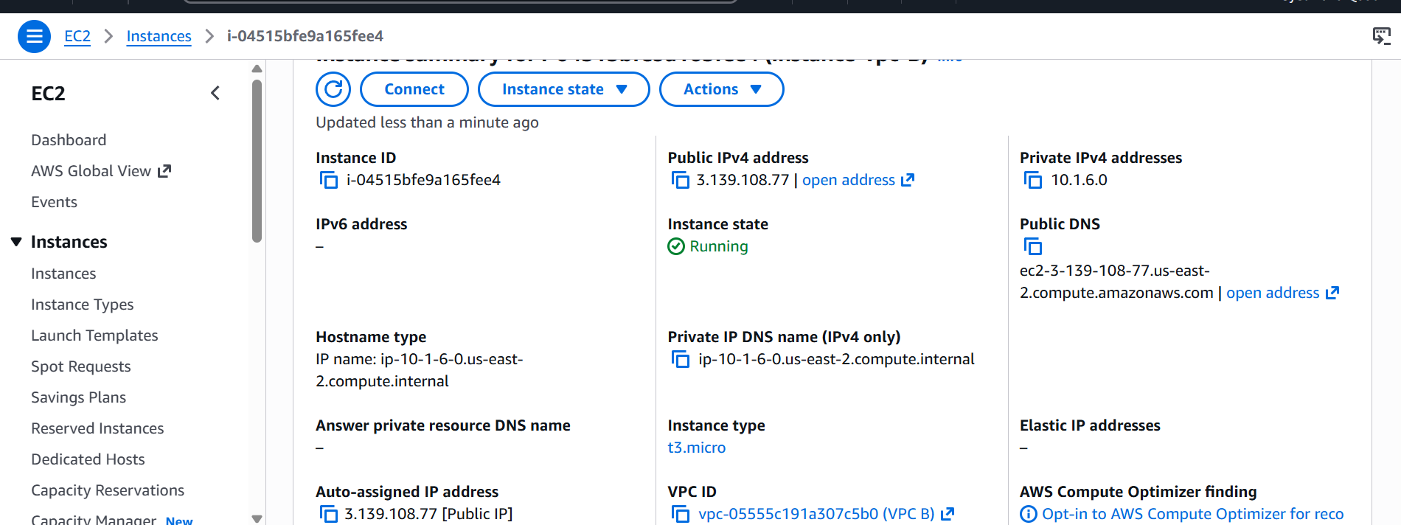
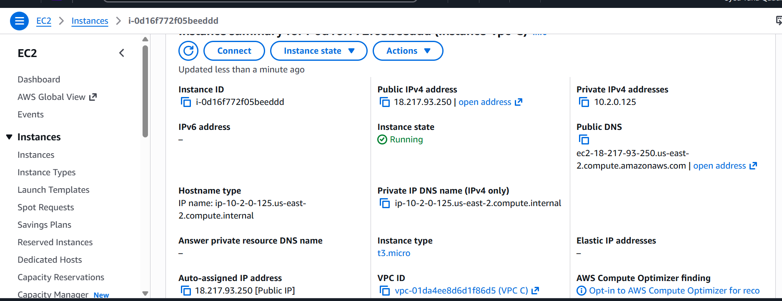

We have now launched 3 instances in 3 different vpcs now let us now ssh to one instance and check if we are able to communicate with the other instances.
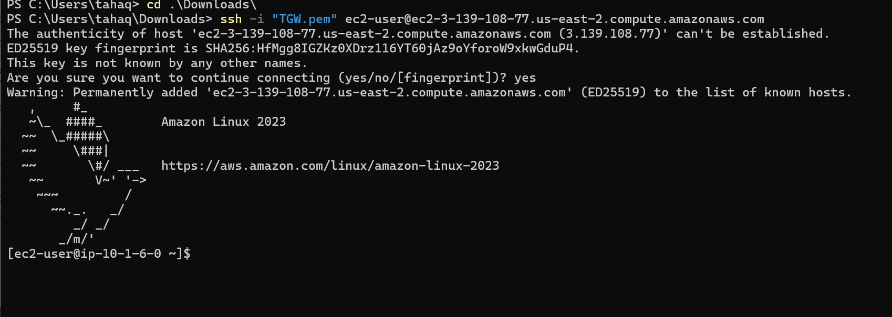

We are now able to ping from one instance to another

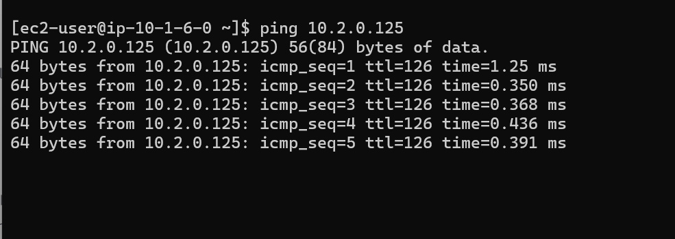

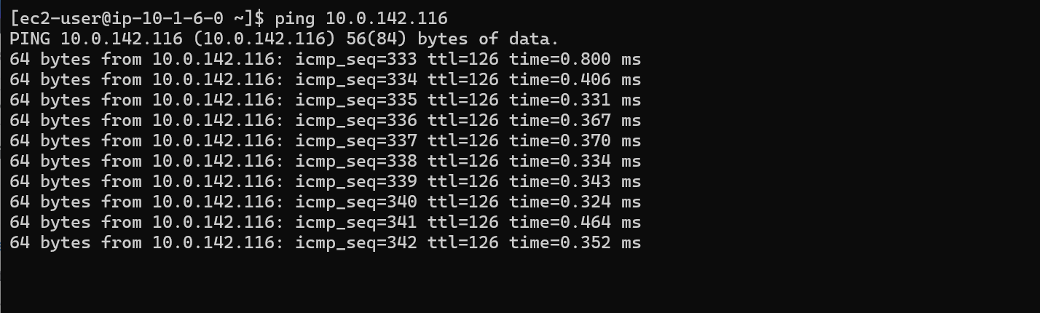

- Set up a VPC endpoint:
Lets create a VPC
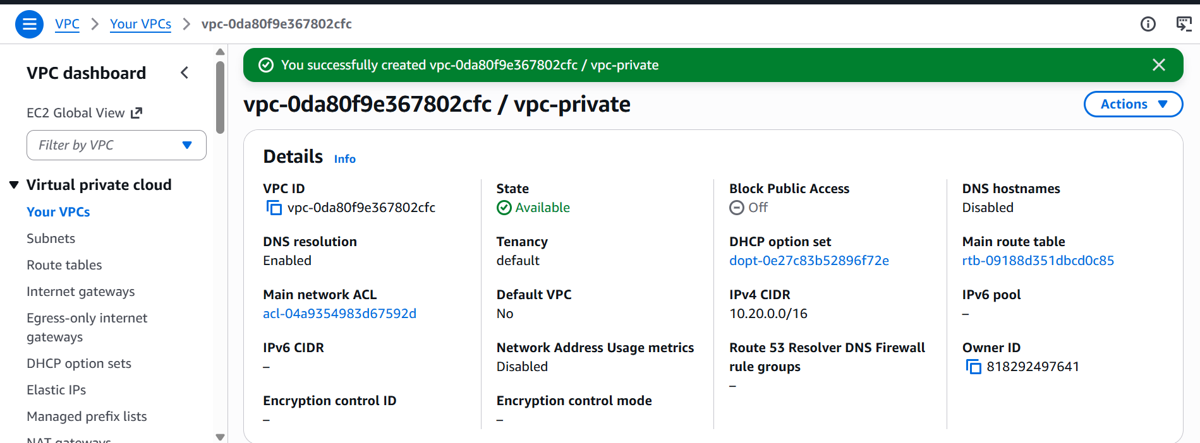

We now have one VPC named vpc-private

Lets now create a private subnet
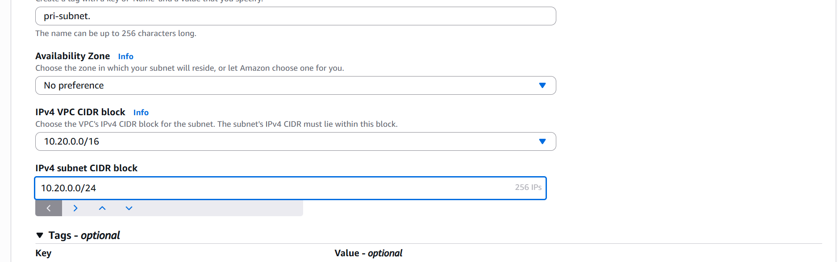

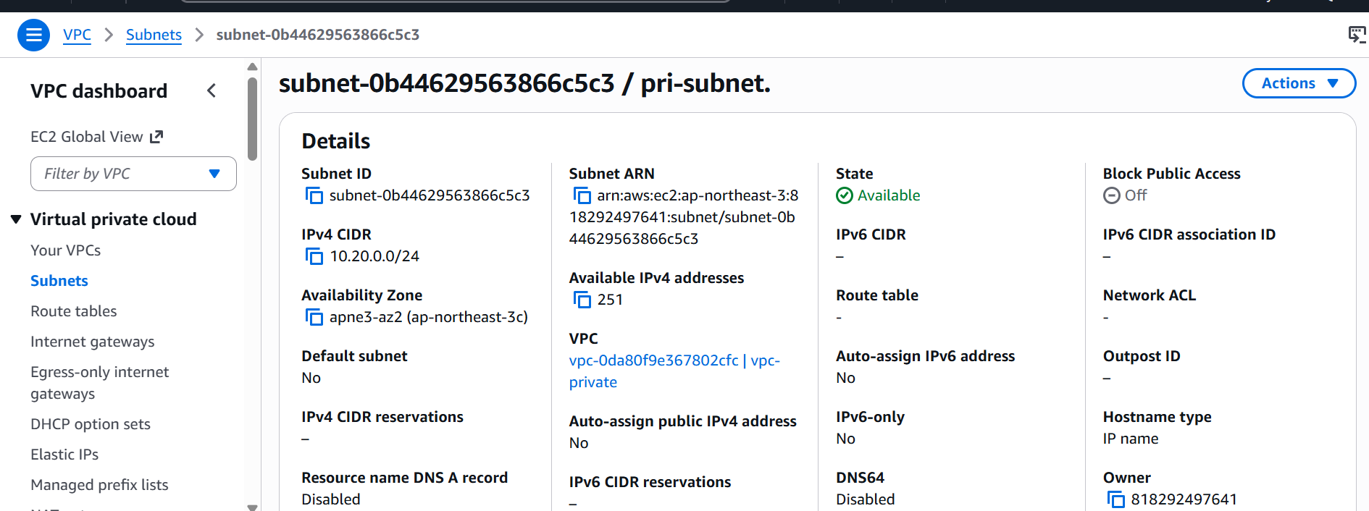

Lets us now create I am role
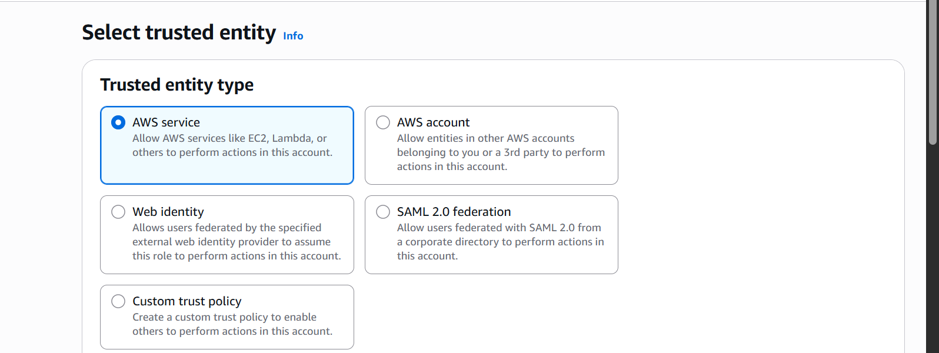

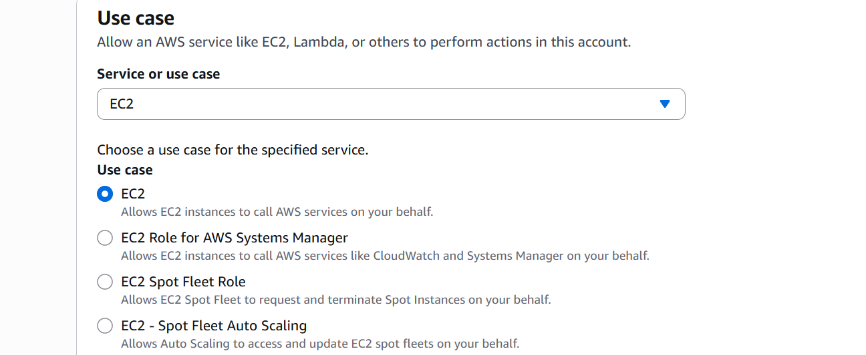

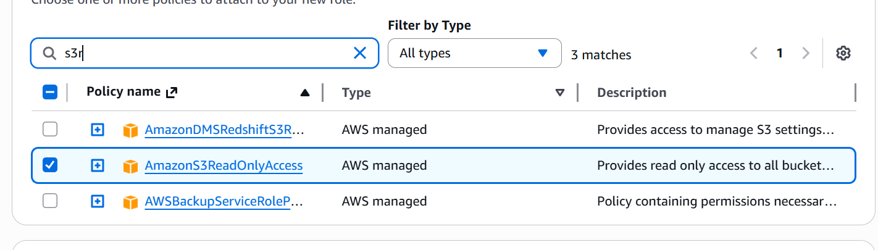

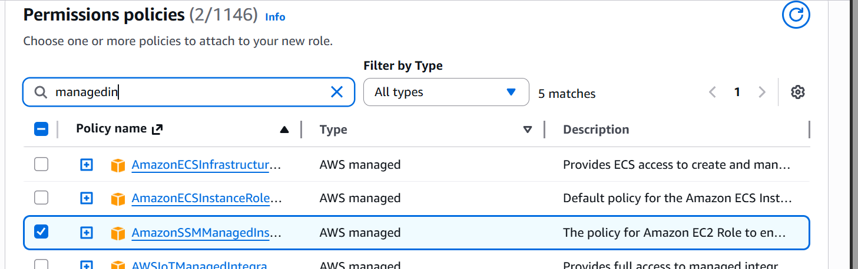
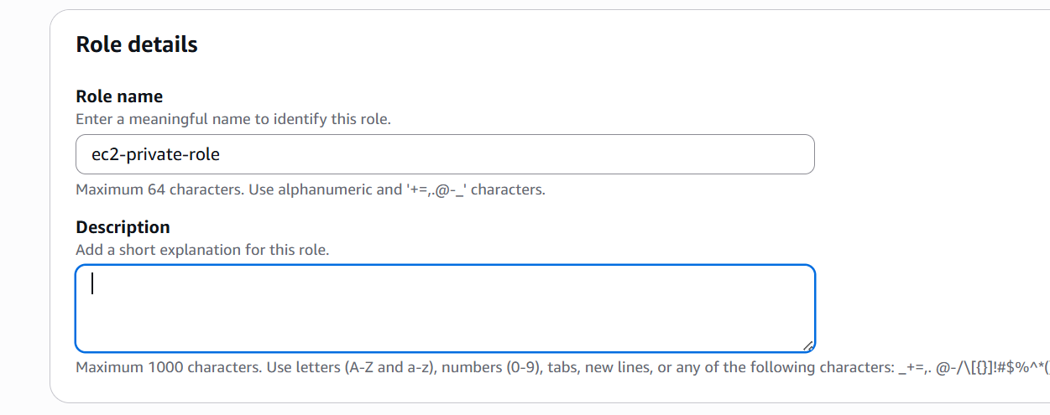

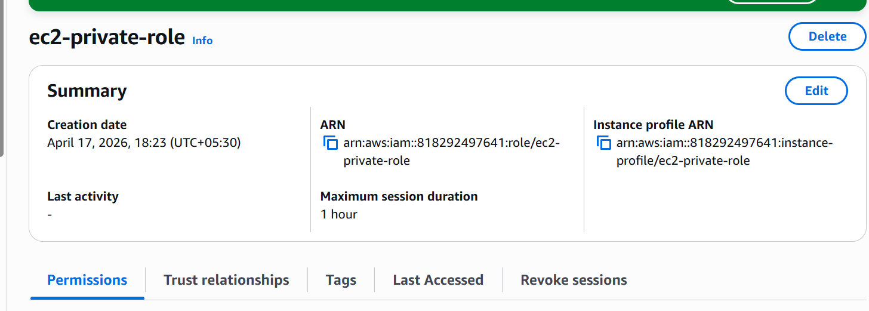

Lets now launch an ec2 instance
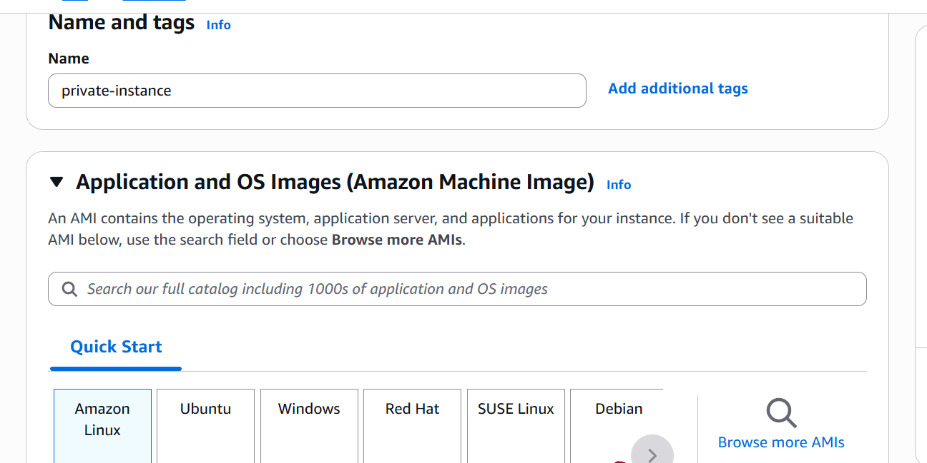

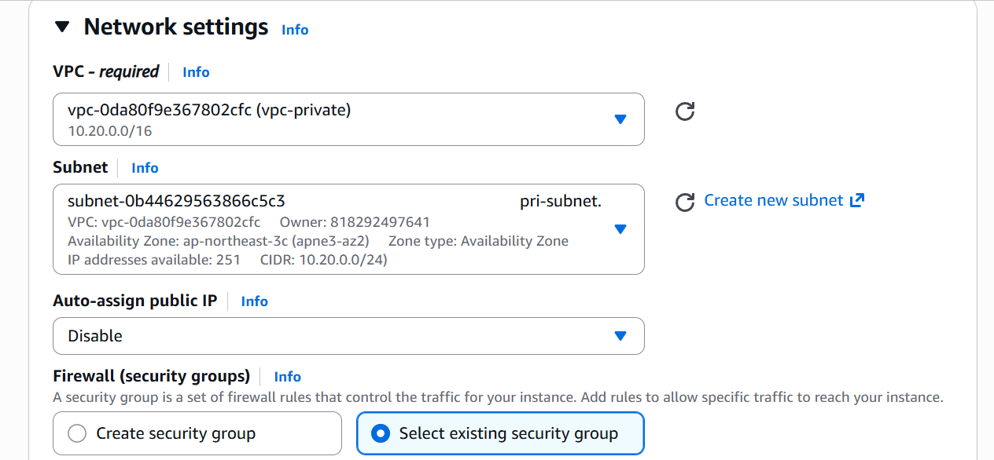
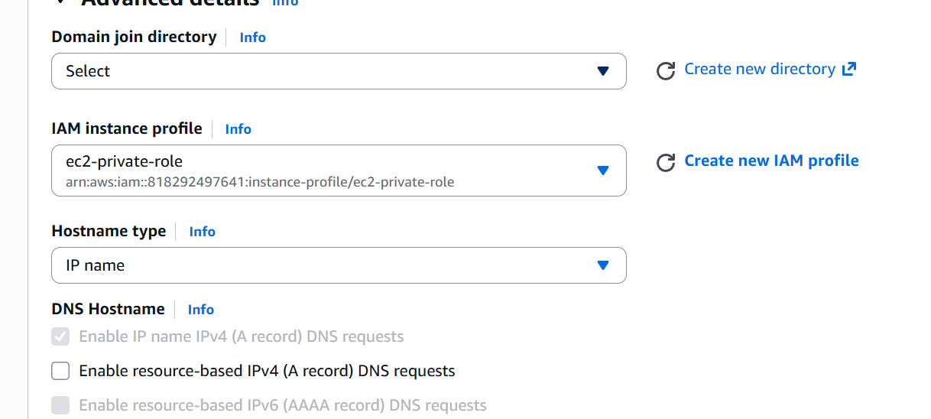

We have now launched an ec2 instance
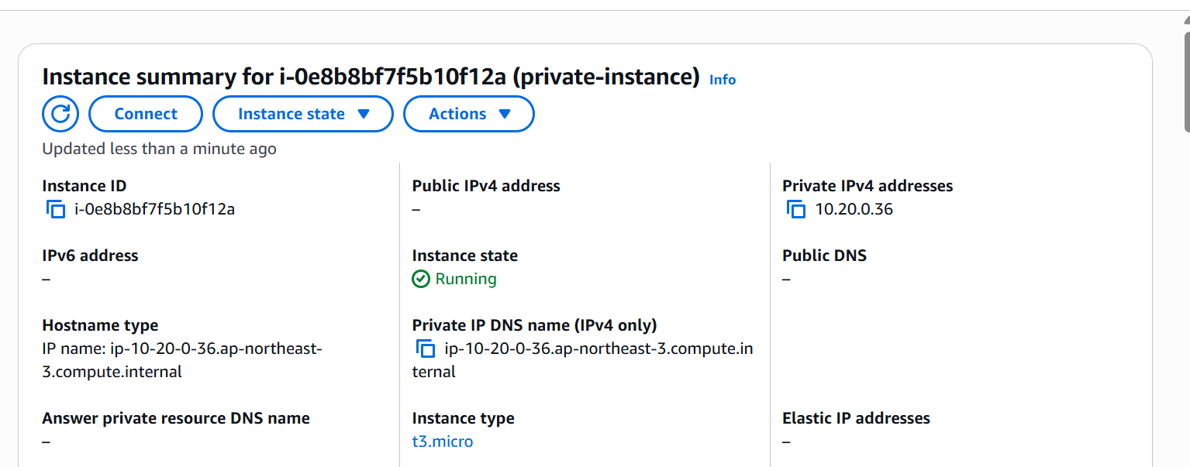

Now lets create VPC Endpoint:
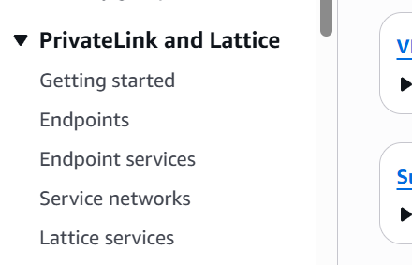

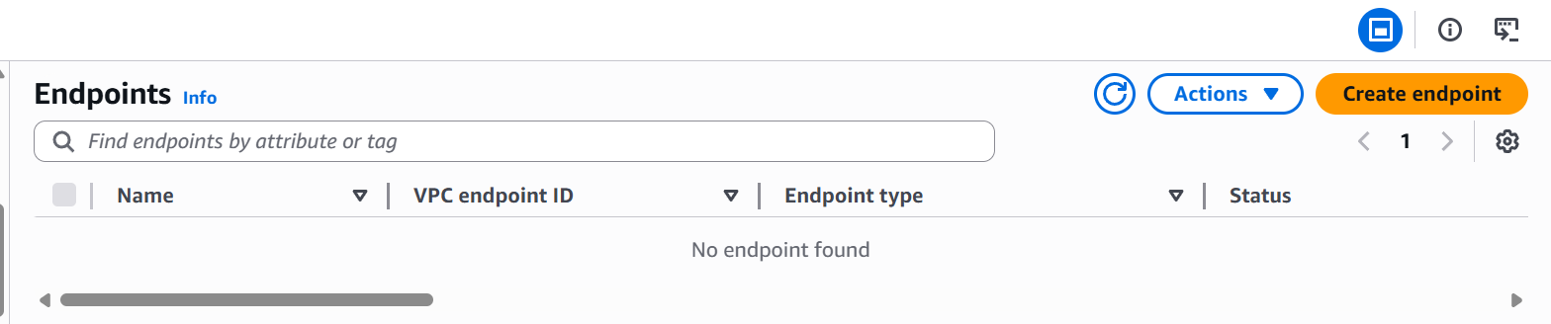

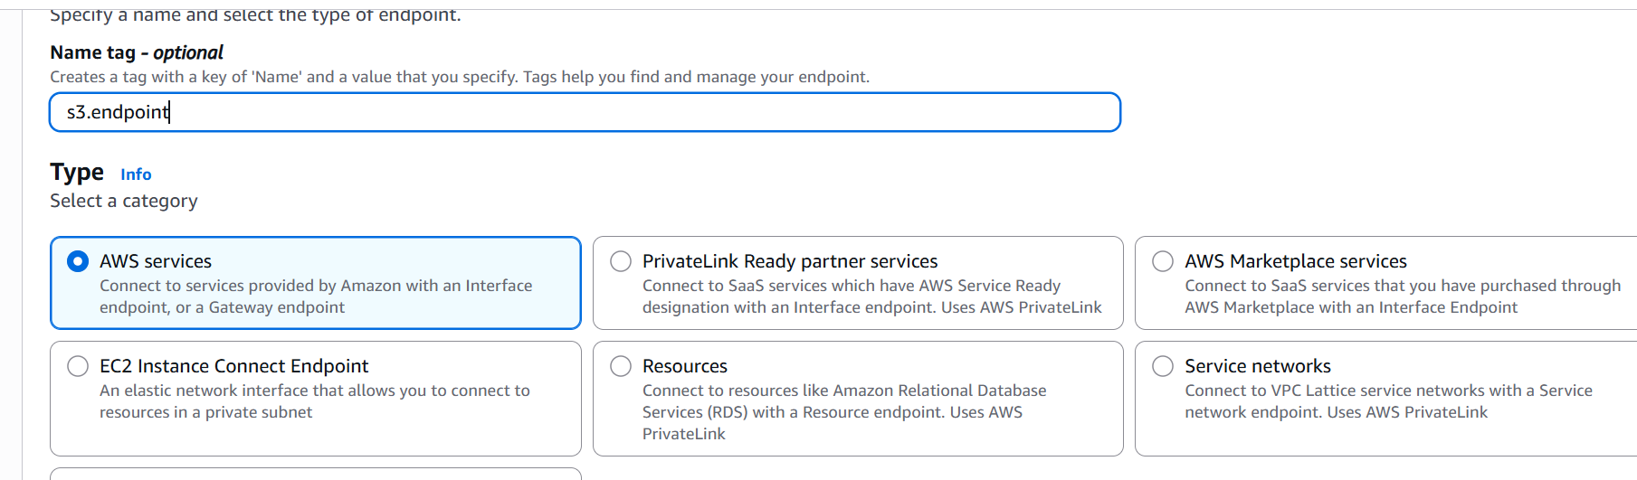

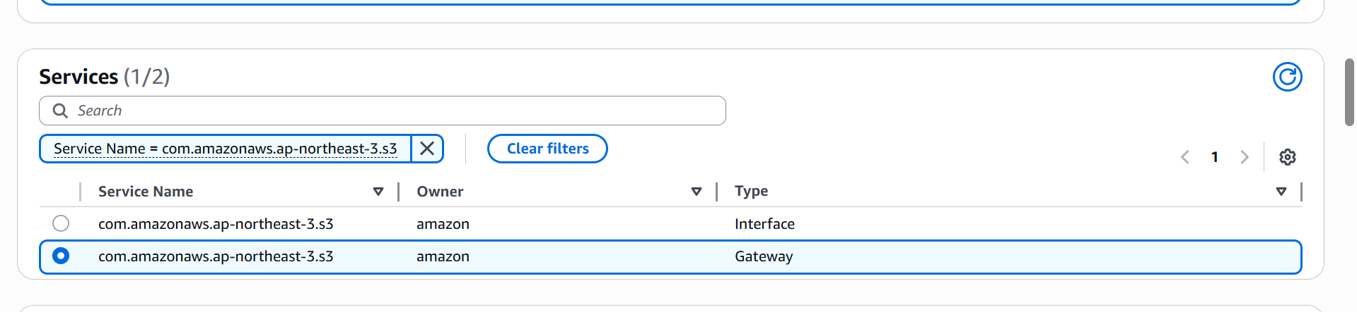
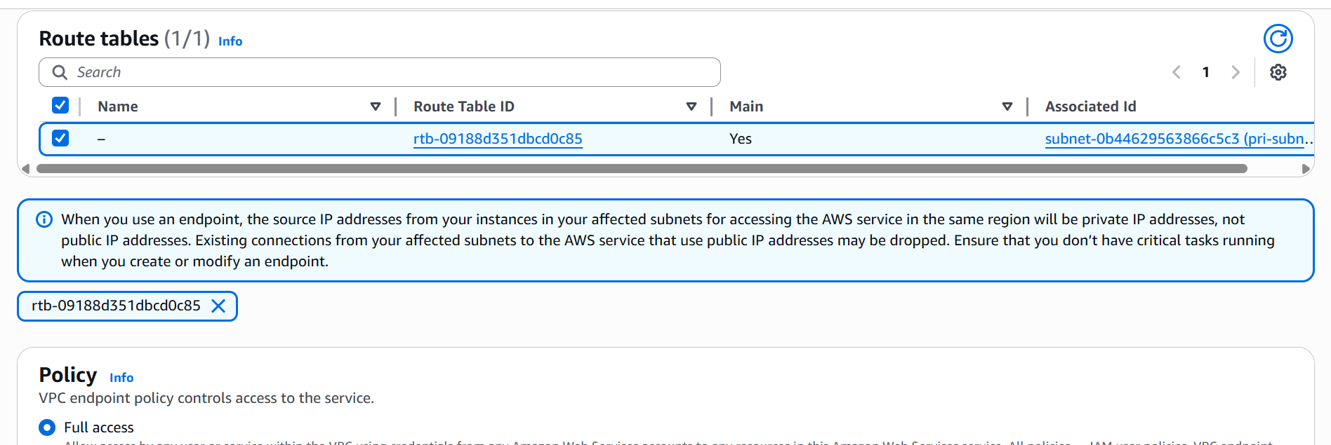
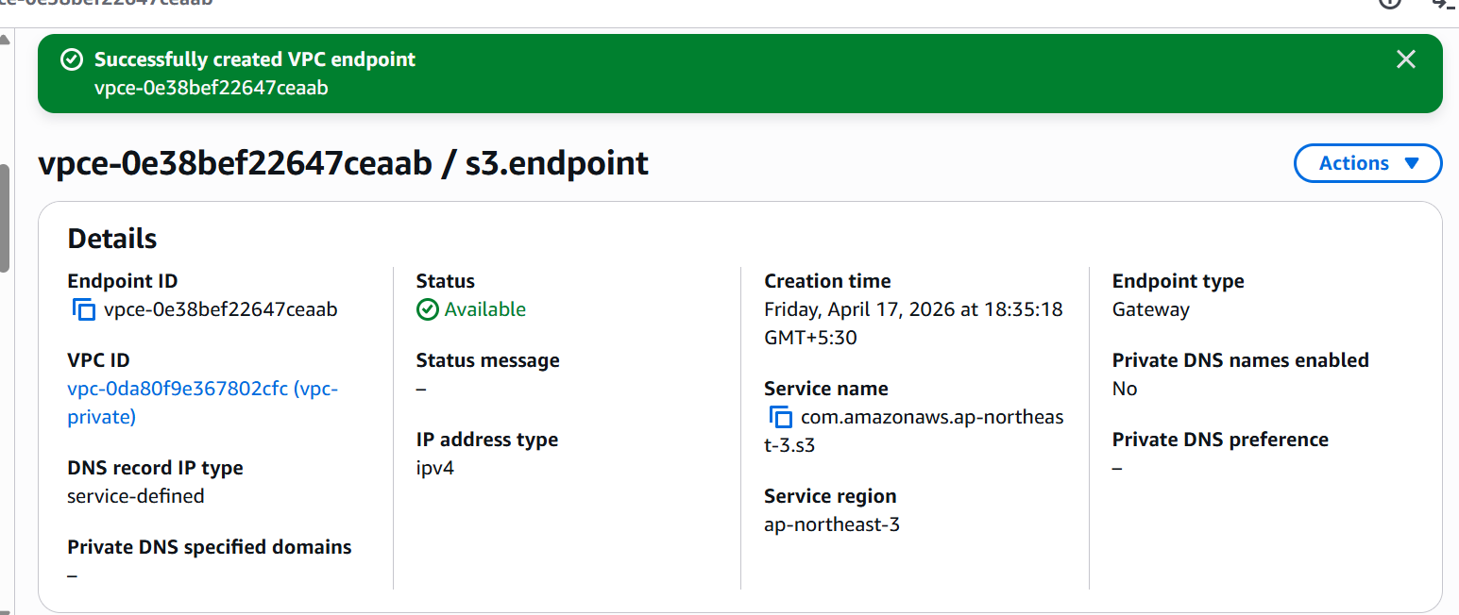

VPC endpoint created.

Lets create ssm endpoints now

We are doing this to connect to our instance using session manager as we do not have internet access we won’t be able to ssh.
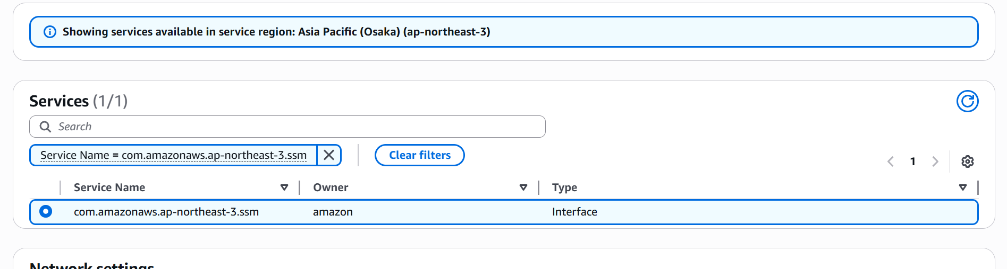

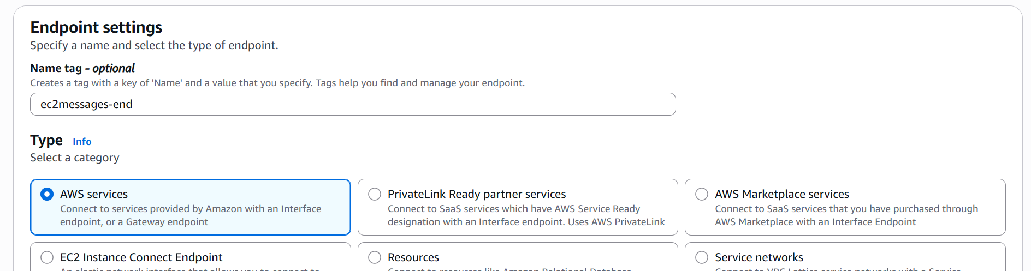

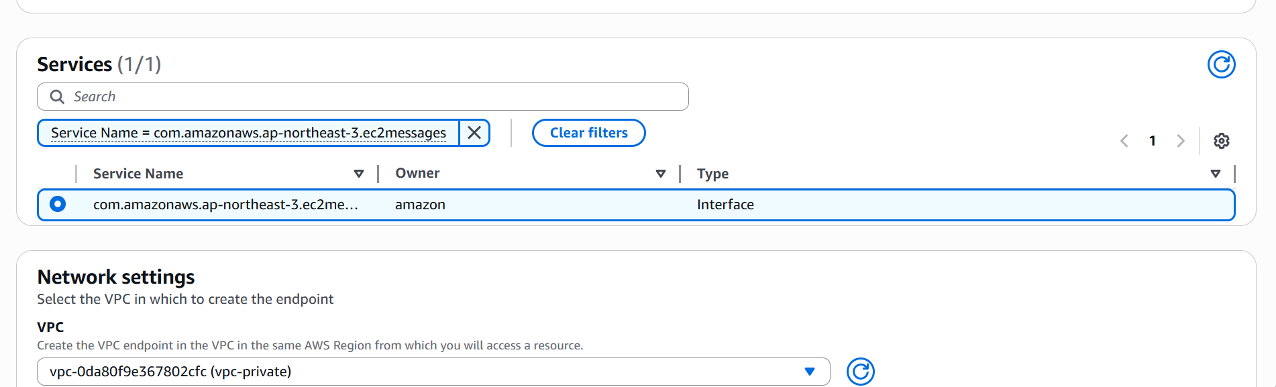
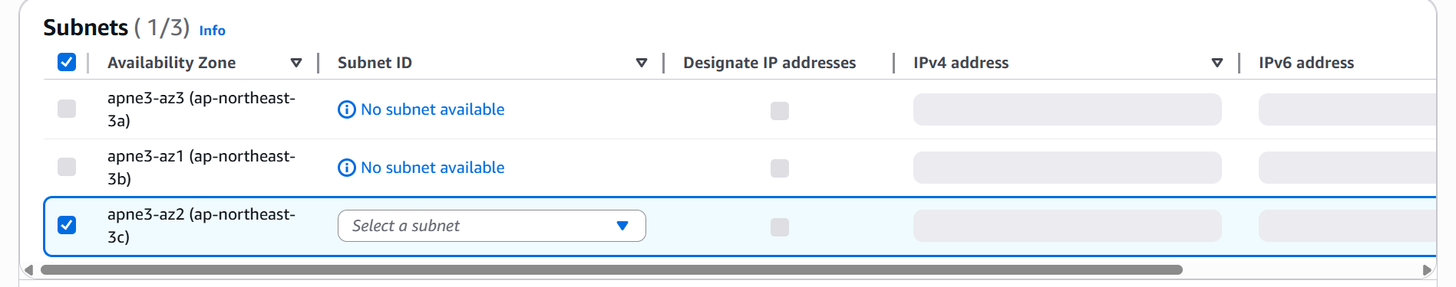
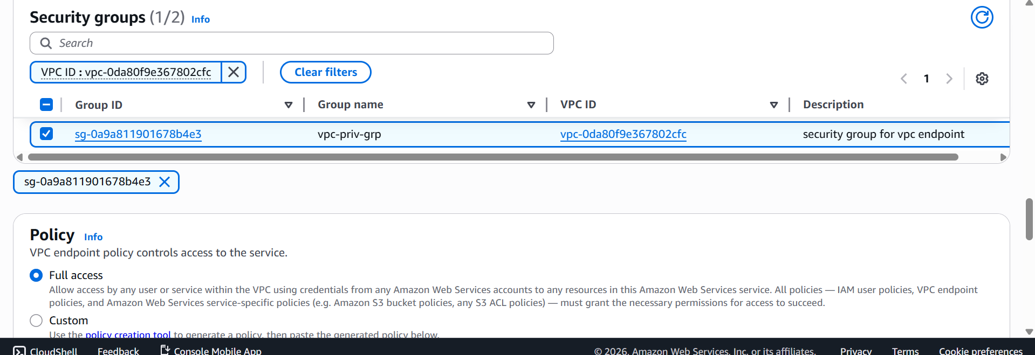

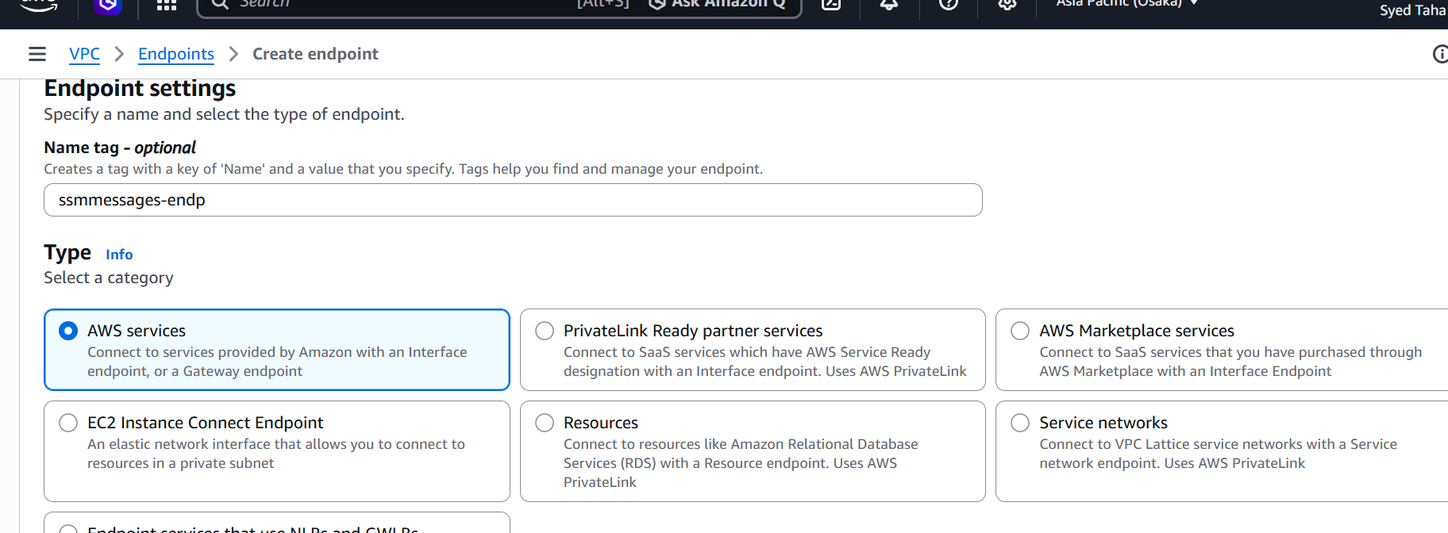

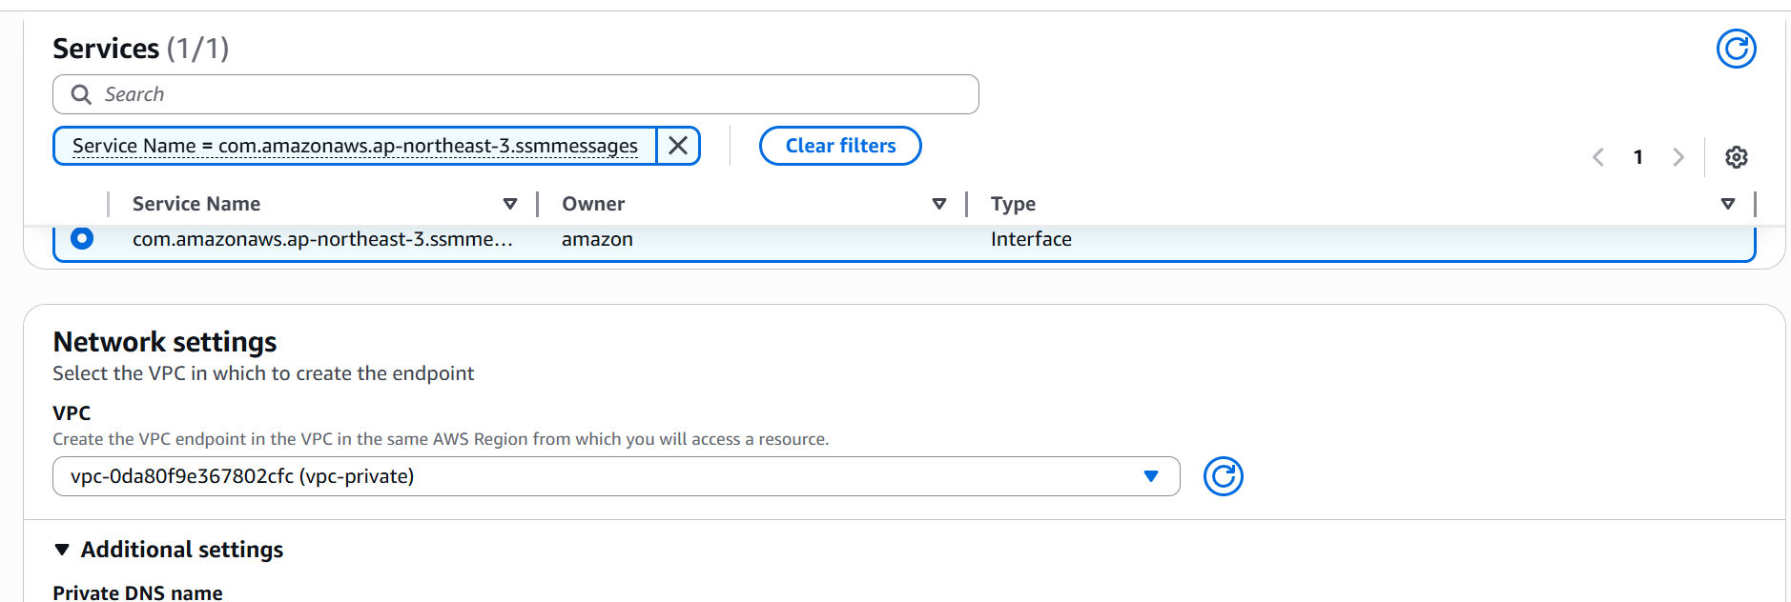
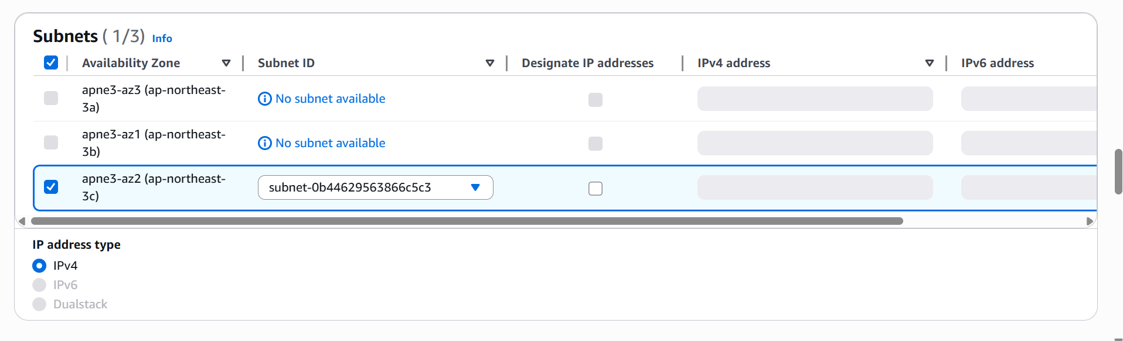

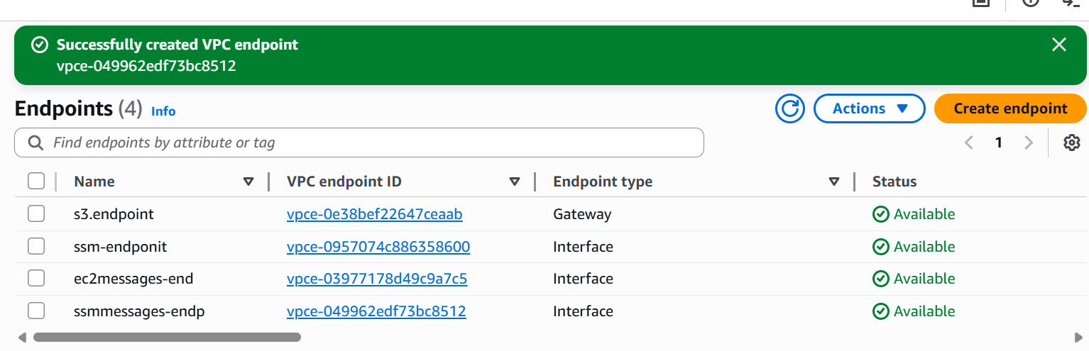

We now have 4 endpoints.
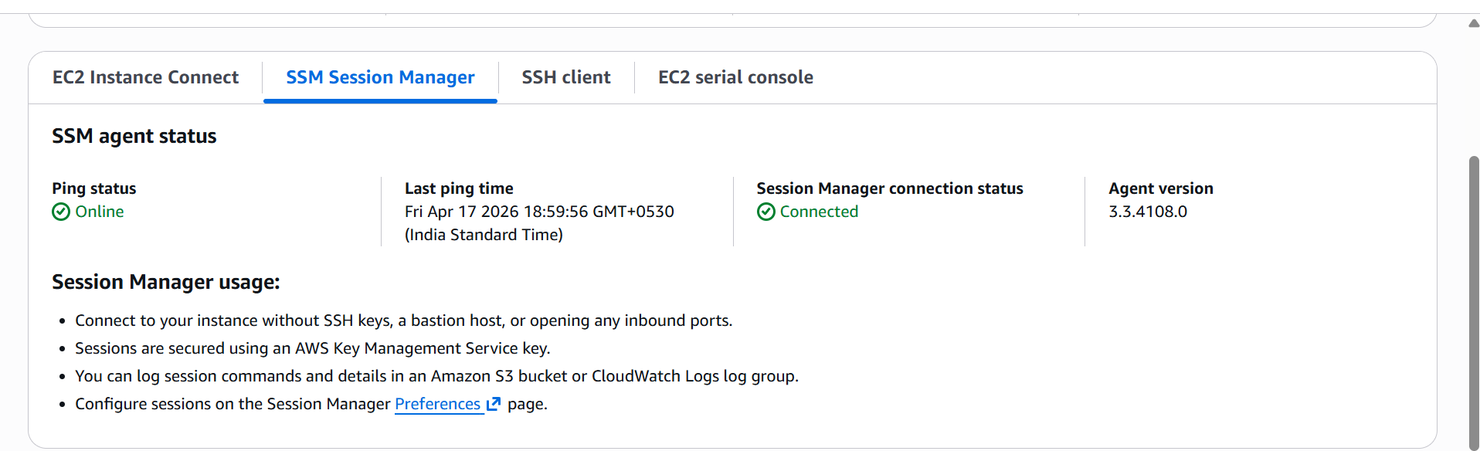

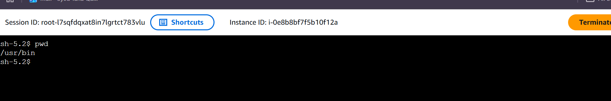

We are able to connect to ec2 instance through ssm
We can even see the access the list of buckets as well
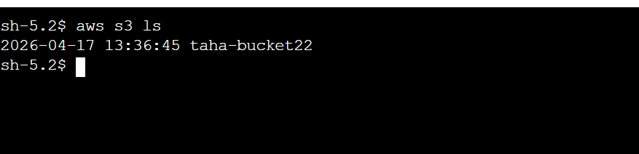

We designed a private VPC architecture without Internet or NAT gateways and enabled secure access to AWS services using VPC endpoints.
This ensures all traffic remains within the AWS network, improving security and minimizing exposure to external threats.

